**Relational Database Design Process**

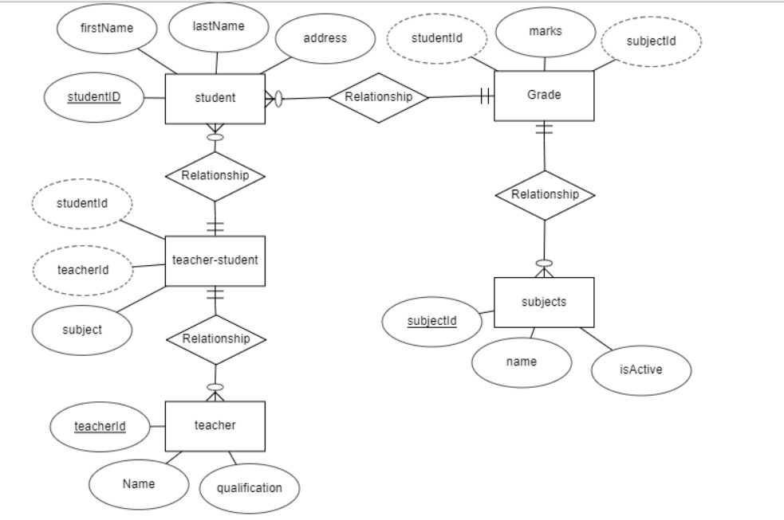

**Data Definition Language Scripts**

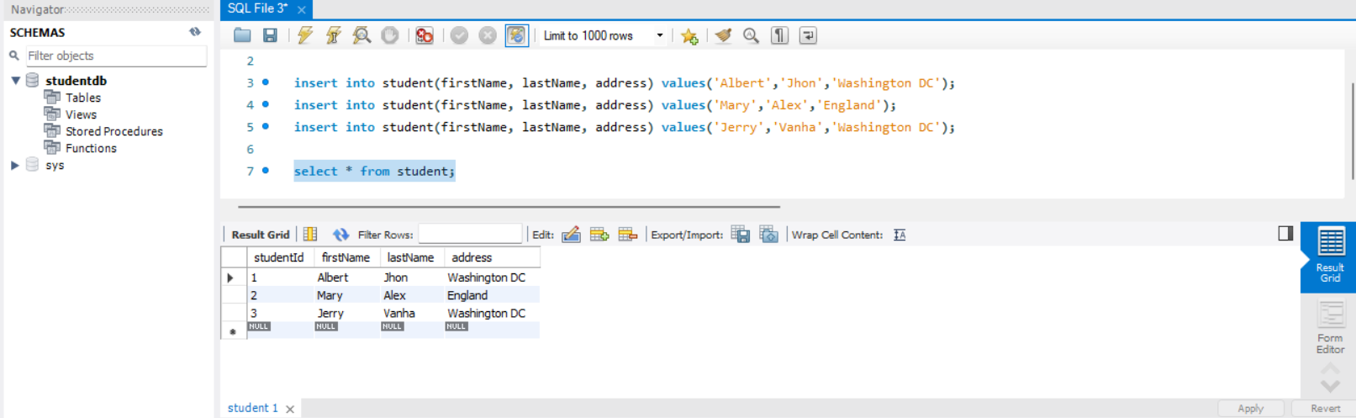

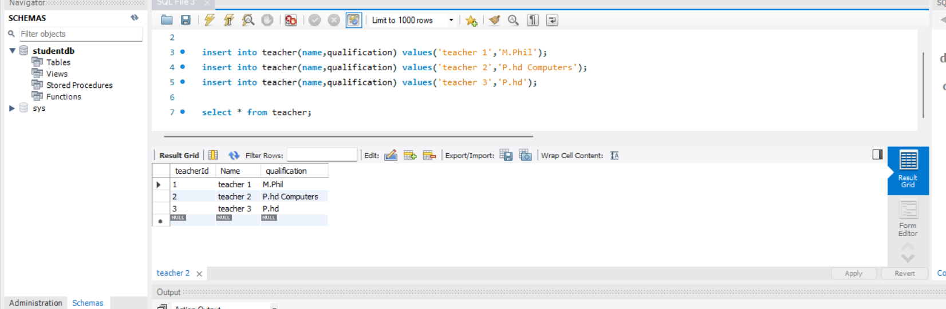

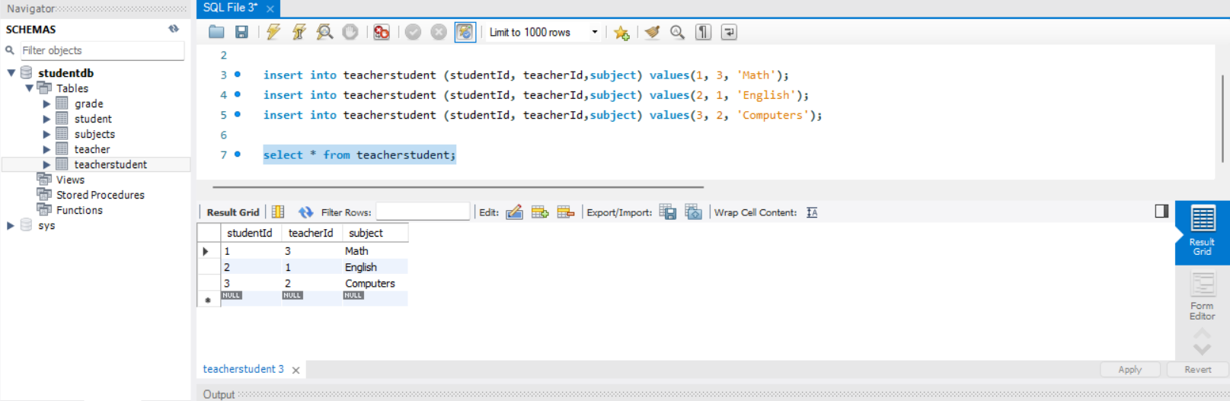

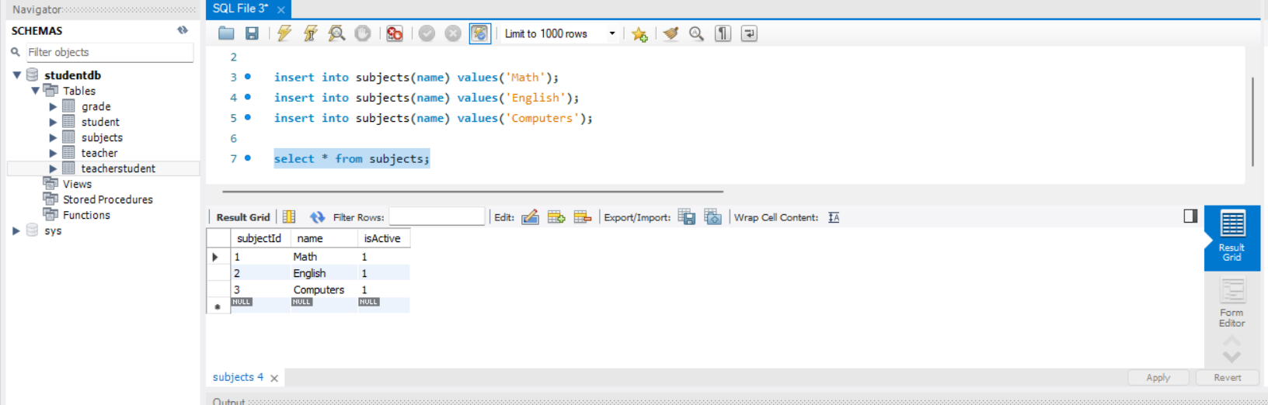

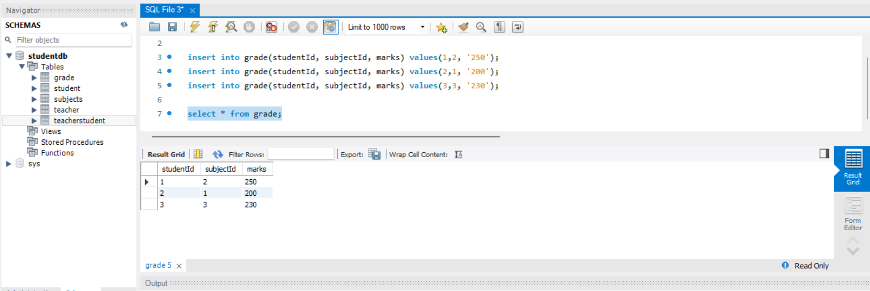

**Data Manipulation Language Scripts**

insert into student(firstName, lastName, address) values('Elsa','Rub','Washington DC');

insert into teacher(name,qualification) values('teacher 4','P.hd Computers');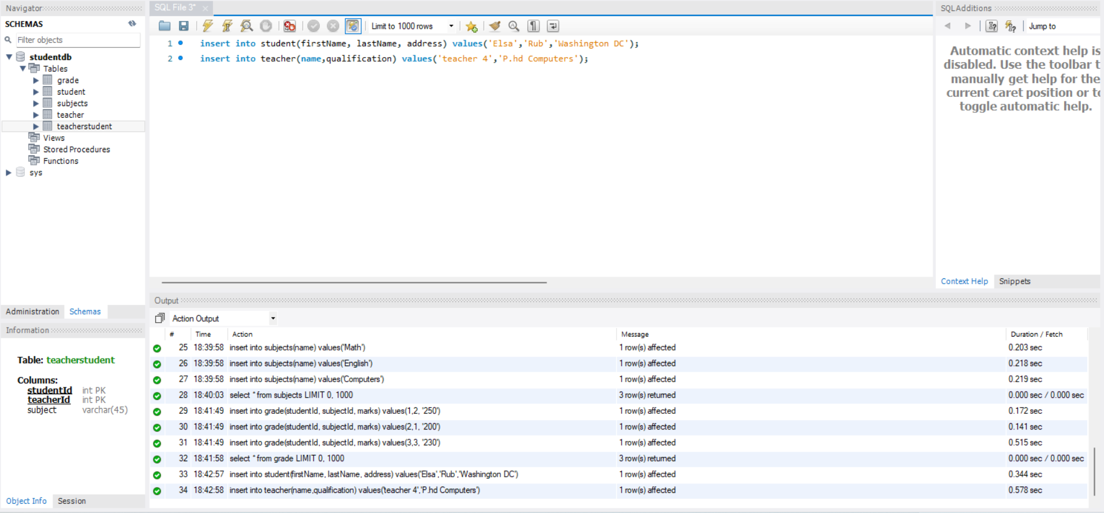

update teacherstudent set teacherId=4 where studentId=1;

update grade set marks='260' where studentId=3;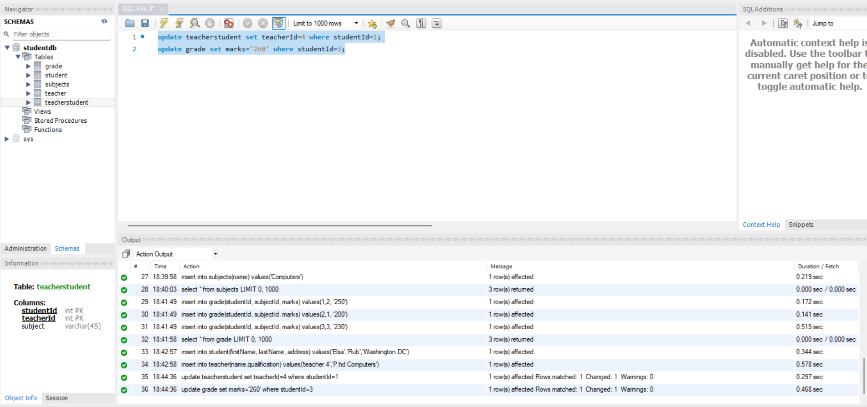

delete from teacher where teacherid=3;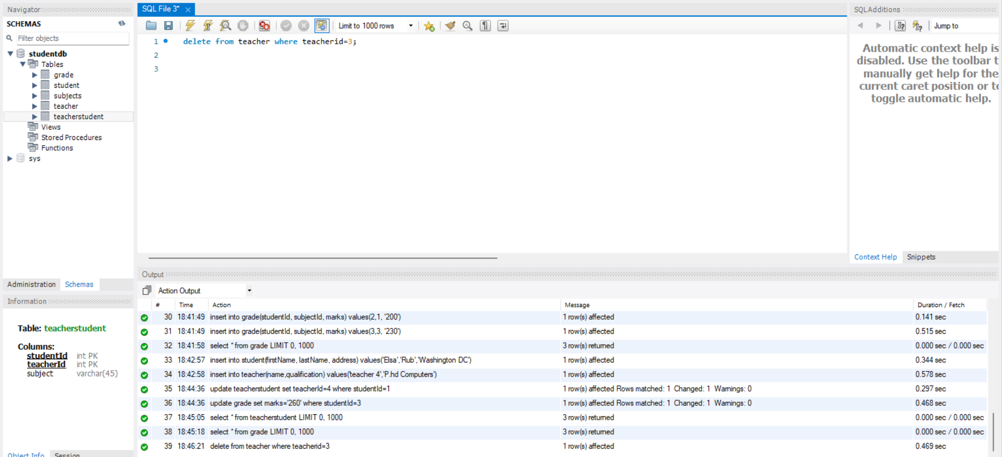

select * from teacherstudent;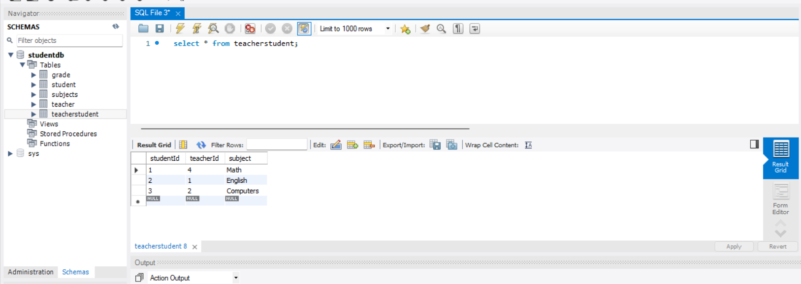

select * from teacher t, teacherstudent ts where t.teacherid = ts. teacherid;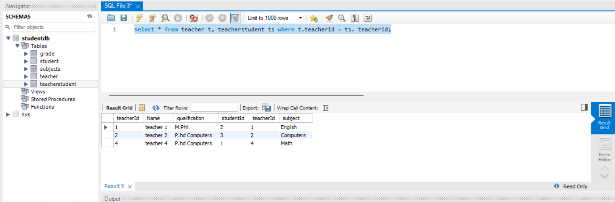

select s.firstName, g.marks from student s join grade g on s.studentId = g.studentId;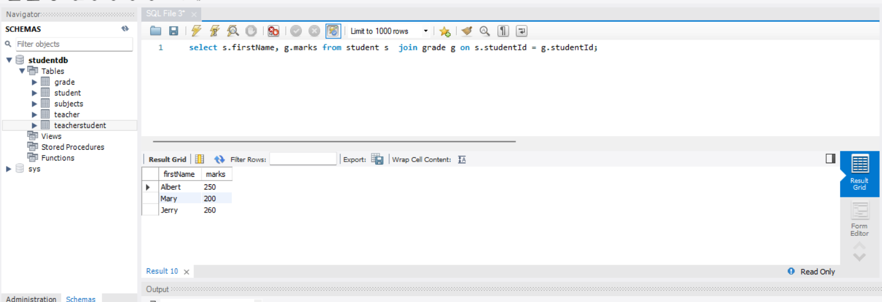

select * from student s, grade g where s.studentId=g.studentId;

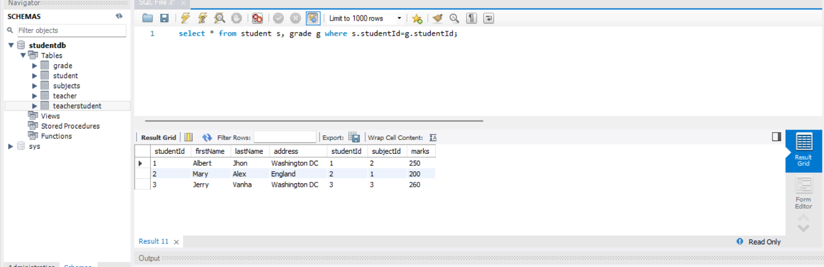

select * from subjects where subjectId=3;

