Breast Cancer Detection from Diagnostic Measurements using a Multi-Layer Perceptron (MLP) Neural Network
Problem Statement:
Breast cancer is one of the most common cancers among women worldwide, and early detection greatly improves the chance of successful treatment. In a clinical workflow, a Fine Needle Aspiration (FNA) of a breast mass is digitized and the cell nuclei are measured (radius, texture, perimeter, area, smoothness, compactness, concavity, etc.). Interpreting these numeric measurements manually is time-consuming and subjective, and it is difficult to scale in regions with a shortage of trained pathologists.
There is, therefore, a need for an automated, fast and accessible system that can analyse the measurements of a breast mass and classify it as Benign or Malignant with a measurable confidence score, so that suspected cases can be flagged early for a specialist's review. This project designs and implements a web-based Breast Cancer Classification system that performs data cleaning, feature scaling and feature selection, and classification using a Multi-Layer Perceptron (MLP) neural network, and evaluates the trained model using standard classification metrics (Accuracy, Precision, Recall, F1-Score, ROC-AUC and Confusion Matrix).
Objectives:
- To load and clean the Wisconsin Diagnostic Breast Cancer (WDBC) dataset and split it into training and test sets.
- To scale the 30 numeric features and select the 15 most informative features using the ANOVA F-test.
- To design, train, and save a Multi-Layer Perceptron (MLP) neural network classifier using the selected features.
- To build a Flask-based backend and web front-end that lets a user enter tumour measurements and view the diagnosis.
- To evaluate the trained model on an unseen test set and report Accuracy, Precision, Recall, F1-score, ROC-AUC and the Confusion Matrix.
- To persist every prediction (label, class, confidence, timestamp) in an SQLite database for record-keeping.
Software / Hardware Required:
- Operating System: Windows / Linux / macOS
- IDE: Visual Studio Code
- Language: Python 3.x
- Backend Framework: Flask (REST API)
- Machine Learning: scikit-learn (MLPClassifier, SelectKBest, StandardScaler)
- Data Handling / Plots: pandas, NumPy, Matplotlib, joblib
- Database: SQLite3
- Frontend: HTML5, CSS3, JavaScript
- Dataset: Wisconsin Diagnostic Breast Cancer (WDBC) - 569 samples, 30 features, 2 classes (Malignant / Benign)
- Version Control: Git
Project Directory Structure:
The project (“BreastCancerClassifier”) is organized as a Flask backend with separate dataset, ml (model code), trained-model, templates/static (frontend) and database folders, as shown below.
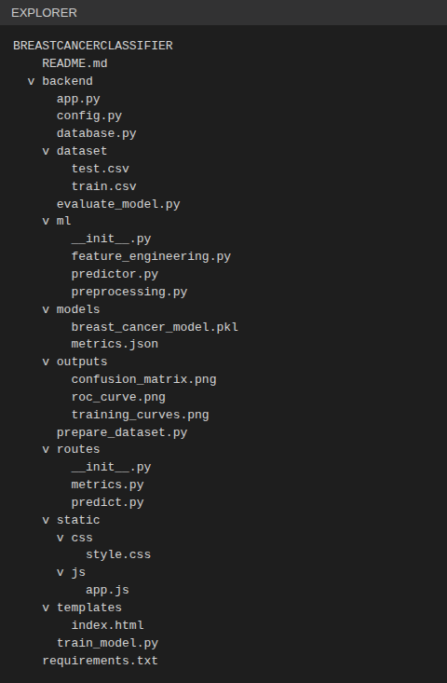
Fig 1: Project directory structure of BreastCancerClassifier in Visual Studio Code
Procedure:
- Collect the labelled WDBC dataset and organize it into backend/dataset/train.csv and backend/dataset/test.csv.
- Run prepare_dataset.py to clean, remove duplicates and perform a stratified 80/20 train-test split (455 training and 114 test samples).
- Launch the Flask application (app.py) and open the web front-end in the browser.
- Enter the 30 tumour measurements, or load a benign / malignant sample record, through the interface (Step 1).
- Preprocess the data — handle missing / infinite values with the column median and standardize every feature (zero mean, unit variance) using StandardScaler.
- Select the top 15 features using SelectKBest with the ANOVA F-test (f_classif) to reduce noise and redundancy.
- Train the Multi-Layer Perceptron (64-32 hidden neurons, ReLU) with the Adam optimizer and L2 regularization (alpha = 0.001) for 100 epochs using train_model.py, and save the trained pipeline to backend/models/breast_cancer_model.pkl.
- Feed the feature vector of the entered sample to the trained model to obtain the predicted class (Benign / Malignant) with a confidence percentage (Step 2).
- Evaluate the trained model on the held-out test set with evaluate_model.py and compute Accuracy, Precision, Recall, F1-score, ROC-AUC and the Confusion Matrix (Step 3).
- Log every prediction (label, predicted class, confidence, timestamp) into the SQLite database (database/breast_cancer.db) and display the prediction history (Step 4).
Implementation Code:
Key modules used in the project. The complete source code is provided in the project folder / ZIP file.
1. Dataset Preparation (backend/prepare_dataset.py)
"""Step 1 - Create the project dataset (train / test CSV files).

Loads the WDBC dataset bundled with scikit-learn, and performs a stratified
80/20 split so both classes appear in the same proportion in train and test.
"""
import pandas as pd
from sklearn.datasets import load_breast_cancer
from sklearn.model_selection import train_test_split

from config import TRAIN_CSV, TEST_CSV, RANDOM_STATE

def main():
data = load_breast_cancer(as_frame=True)
df = data.frame.copy() # 30 features + 'target'
df = df.drop_duplicates().reset_index(drop=True)

train_df, test_df = train_test_split(
df, test_size=0.20, stratify=df["target"], random_state=RANDOM_STATE)

TRAIN_CSV.parent.mkdir(parents=True, exist_ok=True)
train_df.to_csv(TRAIN_CSV, index=False)
test_df.to_csv(TEST_CSV, index=False)

print(f"Total samples : {len(df)}")
print(f"Train samples : {len(train_df)} -> {TRAIN_CSV}")
print(f"Test samples : {len(test_df)} -> {TEST_CSV}")
print("Class balance (train):")
print(train_df['target'].map({0: 'Malignant', 1: 'Benign'}).value_counts())

if __name__ == "__main__":
main()

2. Data Preprocessing (backend/ml/preprocessing.py)
"""Data loading and cleaning."""
import numpy as np
import pandas as pd

def load_dataset(csv_path):
"""Read a CSV and return (X dataframe, y array)."""
df = pd.read_csv(csv_path)
y = df["target"].values
X = df.drop(columns=["target"])
return X, y

def clean_data(X):
"""Replace inf with NaN, fill missing values with the column median."""
X = X.replace([np.inf, -np.inf], np.nan)
return X.fillna(X.median(numeric_only=True))

3. Scaling, Feature Selection and MLP Model (backend/ml/feature_engineering.py)
"""Scaling + feature selection (built as one scikit-learn Pipeline)."""
from sklearn.feature_selection import SelectKBest, f_classif
from sklearn.neural_network import MLPClassifier
from sklearn.pipeline import Pipeline
from sklearn.preprocessing import StandardScaler

from config import TOP_K_FEATURES, RANDOM_STATE

def build_pipeline():
"""StandardScaler -> SelectKBest(ANOVA F-test) -> MLP (Adam, L2)."""
return Pipeline([
("scaler", StandardScaler()),
("select", SelectKBest(score_func=f_classif, k=TOP_K_FEATURES)),
("mlp", MLPClassifier(
hidden_layer_sizes=(64, 32),
activation="relu",
solver="adam",
alpha=0.001, # L2 regularization
learning_rate_init=0.001,
max_iter=300,
random_state=RANDOM_STATE)),
])

def selected_feature_names(pipeline, feature_names):
mask = pipeline.named_steps["select"].get_support()
return [f for f, keep in zip(feature_names, mask) if keep]

4. Model Training (backend/train_model.py)
"""Step 2 - Train the MLP and save it.

Trains epoch-by-epoch (partial_fit) so training / validation accuracy and loss
can be logged and plotted for every epoch.
"""
import json
import joblib
import numpy as np
from sklearn.metrics import accuracy_score, log_loss
from sklearn.model_selection import train_test_split

from config import (TRAIN_CSV, MODEL_PATH, METRICS_PATH,
RANDOM_STATE)
from ml.preprocessing import load_dataset, clean_data
from ml.feature_engineering import build_pipeline, selected_feature_names

EPOCHS = 100

def main():
X, y = load_dataset(TRAIN_CSV)
X = clean_data(X)
feature_names = list(X.columns)

X_tr, X_val, y_tr, y_val = train_test_split(
X, y, test_size=0.2, stratify=y, random_state=RANDOM_STATE)

pipe = build_pipeline()
scaler, select, mlp = (pipe.named_steps[k] for k in ("scaler", "select", "mlp"))
Xt = select.fit_transform(scaler.fit_transform(X_tr), y_tr)
Xv = select.transform(scaler.transform(X_val))

classes = np.array([0, 1])
y_tr = np.asarray(y_tr)
history = {"train_acc": [], "val_acc": [], "train_loss": [], "val_loss": []}
rng = np.random.RandomState(RANDOM_STATE)
print(f"{'Epoch':>5} | {'Train Loss':>10} | {'Train Acc':>9} | {'Val Loss':>8} | {'Val Acc':>7}")
for epoch in range(1, EPOCHS + 1):
idx = rng.permutation(len(Xt))
mlp.partial_fit(Xt[idx], y_tr[idx], classes=classes)
tl = log_loss(y_tr, mlp.predict_proba(Xt), labels=classes)
vl = log_loss(y_val, mlp.predict_proba(Xv), labels=classes)
ta = accuracy_score(y_tr, mlp.predict(Xt))
va = accuracy_score(y_val, mlp.predict(Xv))
for k, v in zip(history, (ta, va, tl, vl)):
history[k].append(float(v))
if epoch % 5 == 0 or epoch == 1:
print(f"{epoch:>5} | {tl:>10.4f} | {ta:>9.4f} | {vl:>8.4f} | {va:>7.4f}")

MODEL_PATH.parent.mkdir(parents=True, exist_ok=True)
joblib.dump({"pipeline": pipe, "feature_names": feature_names}, MODEL_PATH)

sel = selected_feature_names(pipe, feature_names)
METRICS_PATH.write_text(json.dumps({"history": history,
"selected_features": sel,
"epochs": EPOCHS}, indent=2))
print(f"\nFinal validation accuracy: {history['val_acc'][-1]:.4f}")
print(f"Selected features ({len(sel)}): {sel}")
print(f"Model saved to {MODEL_PATH}")

if __name__ == "__main__":
main()

5. Model Evaluation (backend/evaluate_model.py)
"""Step 3 - Evaluate on the held-out test set and save plots + metrics."""
import json
import joblib
import numpy as np
import matplotlib
matplotlib.use("Agg")
import matplotlib.pyplot as plt
from sklearn.metrics import (accuracy_score, precision_score, recall_score,
f1_score, confusion_matrix, roc_curve, auc,
classification_report)

from config import TEST_CSV, MODEL_PATH, METRICS_PATH, OUTPUT_DIR, CLASSES
from ml.preprocessing import load_dataset, clean_data

OUTPUT_DIR.mkdir(parents=True, exist_ok=True)

def plot_history(h):
ep = range(1, len(h["train_acc"]) + 1)
fig, ax = plt.subplots(1, 2, figsize=(10, 3.8))
ax[0].plot(ep, h["train_acc"], label="Train"); ax[0].plot(ep, h["val_acc"], label="Validation")
ax[0].set_title("Accuracy per epoch"); ax[0].set_xlabel("Epoch"); ax[0].legend(); ax[0].grid(alpha=.3)
ax[1].plot(ep, h["train_loss"], label="Train"); ax[1].plot(ep, h["val_loss"], label="Validation")
ax[1].set_title("Loss per epoch"); ax[1].set_xlabel("Epoch"); ax[1].legend(); ax[1].grid(alpha=.3)
fig.tight_layout(); fig.savefig(OUTPUT_DIR / "training_curves.png", dpi=150); plt.close(fig)

def plot_confusion(cm):
fig, ax = plt.subplots(figsize=(4.2, 3.8))
ax.imshow(cm, cmap="Blues")
ax.set_xticks([0, 1]); ax.set_yticks([0, 1])
ax.set_xticklabels(CLASSES); ax.set_yticklabels(CLASSES)
ax.set_xlabel("Predicted"); ax.set_ylabel("Actual"); ax.set_title("Confusion Matrix")
for i in range(2):
for j in range(2):
ax.text(j, i, cm[i, j], ha="center", va="center", fontsize=16,
color="white" if cm[i, j] > cm.max() / 2 else "black")
fig.tight_layout(); fig.savefig(OUTPUT_DIR / "confusion_matrix.png", dpi=150); plt.close(fig)

def plot_roc(fpr, tpr, roc_auc):
fig, ax = plt.subplots(figsize=(4.2, 3.8))
ax.plot(fpr, tpr, label=f"AUC = {roc_auc:.3f}"); ax.plot([0, 1], [0, 1], "k--")
ax.set_xlabel("False Positive Rate"); ax.set_ylabel("True Positive Rate")
ax.set_title("ROC Curve"); ax.legend(loc="lower right"); ax.grid(alpha=.3)
fig.tight_layout(); fig.savefig(OUTPUT_DIR / "roc_curve.png", dpi=150); plt.close(fig)

def main():
bundle = joblib.load(MODEL_PATH)
pipe = bundle["pipeline"]
X, y = load_dataset(TEST_CSV)
X = clean_data(X)

y_pred = pipe.predict(X)
y_prob = pipe.predict_proba(X)[:, 0] # probability of Malignant (class 0)

# "Positive" class = Malignant (the clinically important one): flip labels
y_true_m = (y == 0).astype(int); y_pred_m = (y_pred == 0).astype(int)
acc = accuracy_score(y_true_m, y_pred_m)
prec = precision_score(y_true_m, y_pred_m)
rec = recall_score(y_true_m, y_pred_m)
f1 = f1_score(y_true_m, y_pred_m)
cm = confusion_matrix(y, y_pred, labels=[0, 1])
fpr, tpr, _ = roc_curve(y_true_m, y_prob); roc_auc = auc(fpr, tpr)

print(classification_report(y, y_pred, target_names=CLASSES))
print(f"Accuracy : {acc*100:.2f}%\nPrecision : {prec*100:.2f}%\n"
f"Recall : {rec*100:.2f}%\nF1-Score : {f1*100:.2f}%\nAUC : {roc_auc:.4f}")
print("Confusion matrix [rows=actual, cols=pred] (Malignant, Benign):\n", cm)

m = json.loads(METRICS_PATH.read_text())
m["test"] = {"accuracy": round(acc*100, 2), "precision": round(prec*100, 2),
"recall": round(rec*100, 2), "f1": round(f1*100, 2),
"auc": round(roc_auc, 4), "confusion_matrix": cm.tolist(),
"n_test": int(len(y))}
METRICS_PATH.write_text(json.dumps(m, indent=2))

plot_history(m["history"]); plot_confusion(cm); plot_roc(fpr, tpr, roc_auc)
print(f"Plots saved in {OUTPUT_DIR}")

if __name__ == "__main__":
main()

6. Prediction Module (backend/ml/predictor.py)
"""Load the saved model once and make predictions from a feature dict."""
import joblib
import numpy as np
import pandas as pd

from config import MODEL_PATH, CLASSES

_bundle = None

def _load():
global _bundle
if _bundle is None:
_bundle = joblib.load(MODEL_PATH)
return _bundle

def feature_names():
return _load()["feature_names"]

def predict_from_dict(values):
"""values: {feature_name: number}. Returns a result dict."""
bundle = _load()
names = bundle["feature_names"]
missing = [n for n in names if n not in values]
if missing:
raise ValueError(f"Missing features: {missing[:3]}...")
row = pd.DataFrame([[float(values[n]) for n in names]], columns=names)
if not np.isfinite(row.values).all() or (row.values < 0).any():
raise ValueError("All feature values must be non-negative numbers.")
proba = bundle["pipeline"].predict_proba(row)[0]
idx = int(proba.argmax())
return {
"prediction": CLASSES[idx],
"confidence": round(float(proba[idx]) * 100, 1),
"malignant_prob": round(float(proba[0]) * 100, 1),
"benign_prob": round(float(proba[1]) * 100, 1),
}

7. Prediction Route (backend/routes/predict.py)
from flask import Blueprint, request, jsonify
import pandas as pd

from config import TEST_CSV
from database import log_prediction, get_history, clear_history
from ml.predictor import predict_from_dict, feature_names

predict_bp = Blueprint("predict", __name__)

@predict_bp.route("/features")
def features():
return jsonify(feature_names())

@predict_bp.route("/sample/<kind>")
def sample(kind):
"""Return a real test-set record (benign / malignant) to try the system."""
df = pd.read_csv(TEST_CSV)
target = 1 if kind == "benign" else 0
row = df[df["target"] == target].sample(1).iloc[0].drop("target")
return jsonify({k: round(float(v), 5) for k, v in row.items()})

@predict_bp.route("/predict", methods=["POST"])
def predict():
data = request.get_json(force=True, silent=True) or {}
label = str(data.get("patient_label") or "Anonymous")[:60]
try:
result = predict_from_dict(data.get("features", {}))
except (ValueError, TypeError) as e:
return jsonify({"error": str(e)}), 400
log_prediction(label, result["prediction"], result["confidence"])
return jsonify(result)

@predict_bp.route("/history", methods=["GET"])
def history():
return jsonify(get_history())

@predict_bp.route("/history", methods=["DELETE"])
def history_clear():
clear_history()
return jsonify({"status": "cleared"})

8. Saving Prediction History (backend/database.py)
"""SQLite helper - stores every prediction."""
import sqlite3
import datetime

from config import DB_PATH

def _conn():
DB_PATH.parent.mkdir(parents=True, exist_ok=True)
conn = sqlite3.connect(DB_PATH)
conn.row_factory = sqlite3.Row
conn.execute("""CREATE TABLE IF NOT EXISTS history (
id INTEGER PRIMARY KEY AUTOINCREMENT,
patient_label TEXT,
prediction TEXT,
confidence REAL,
created_at TEXT)""")
return conn

def log_prediction(patient_label, prediction, confidence):
with _conn() as conn:
conn.execute(
"INSERT INTO history (patient_label, prediction, confidence, created_at) "
"VALUES (?, ?, ?, ?)",
(patient_label, prediction, confidence,
datetime.datetime.now().strftime("%Y-%m-%d %H:%M:%S")))

def get_history(limit=50):
with _conn() as conn:
rows = conn.execute(
"SELECT * FROM history ORDER BY id DESC LIMIT ?", (limit,)).fetchall()
return [dict(r) for r in rows]

def clear_history():
with _conn() as conn:
conn.execute("DELETE FROM history")

9. Flask Application (backend/app.py)
"""Step 4 - Flask application entry point. Run: python app.py"""
from flask import Flask, render_template, send_from_directory

from config import OUTPUT_DIR
from routes.predict import predict_bp
from routes.metrics import metrics_bp

def create_app():
app = Flask(__name__)
app.register_blueprint(predict_bp)
app.register_blueprint(metrics_bp)

@app.route("/")
def index():
return render_template("index.html")

@app.route("/outputs/<path:name>")
def outputs(name):
return send_from_directory(OUTPUT_DIR, name)

return app

if __name__ == "__main__":
create_app().run(debug=True, port=5000)

Output (Step-by-Step Screenshots):
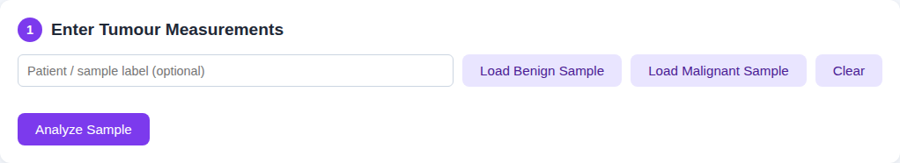
Fig 2: Step 1 — Enter tumour measurements: interface with 30 input fields and sample-loading buttons
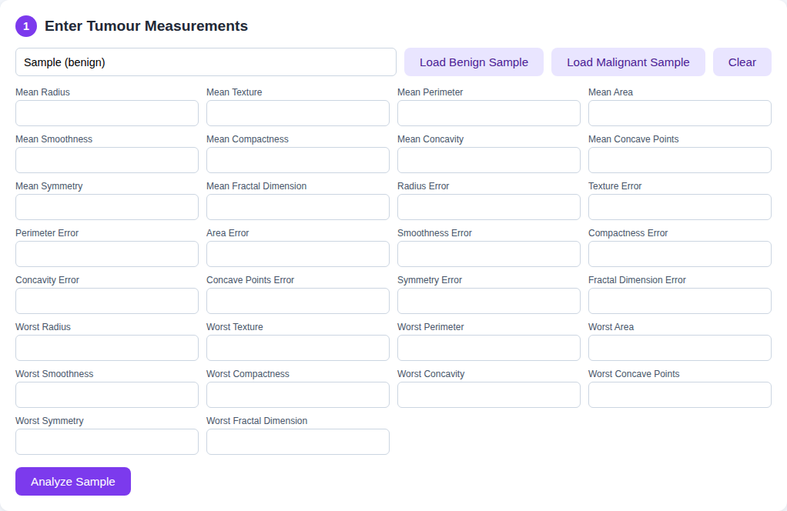
Fig 3: Step 1 — Input form after loading a benign sample record
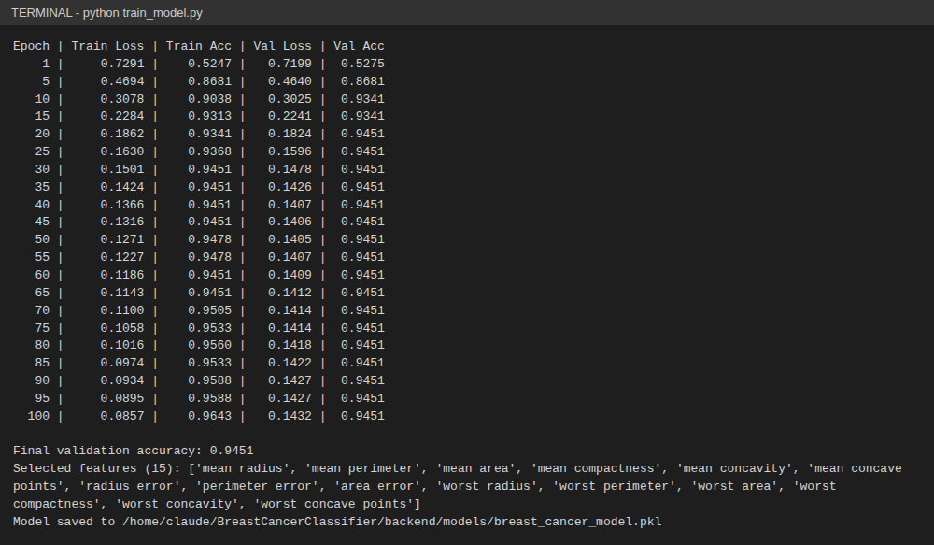
Fig 4: Step 2 — Model training: epoch-by-epoch log (Adam optimizer, L2 regularization, 100 epochs) and selected features
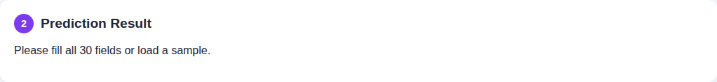
Fig 5: Step 2 — Classification result: Benign (Non-cancerous) tumour with confidence score
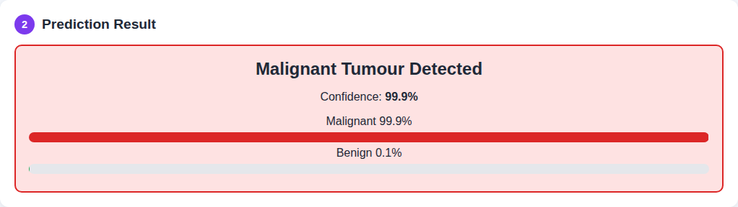
Fig 6: Step 2 — Classification result: Malignant tumour detected with confidence score
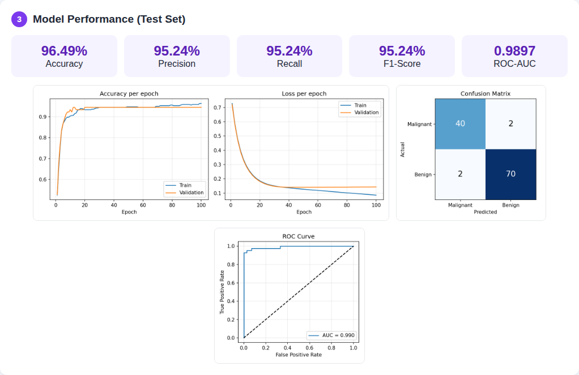
Fig 7: Step 3 — Performance evaluation (Accuracy 96.49%, Precision 95.24%, Recall 95.24%, F1-Score 95.24%), training curves, confusion matrix and ROC curve
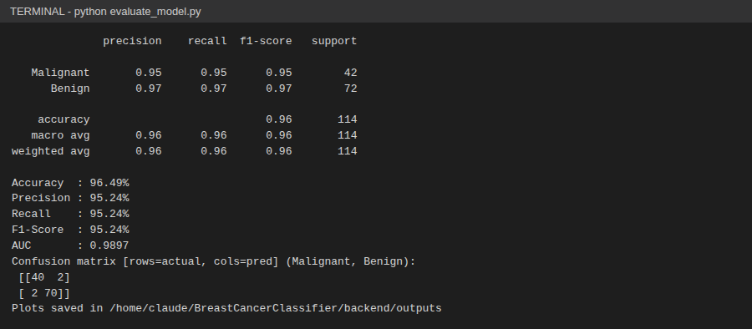
Fig 8: Step 3 — Evaluation output (classification report and confusion matrix) in the terminal
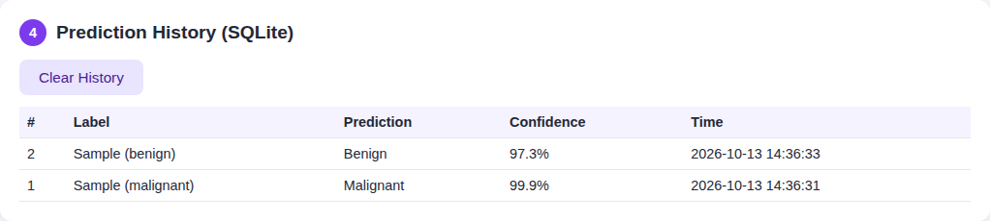
Fig 9: Step 4 — Prediction history log persisted in the SQLite database
Result:
A web-based Breast Cancer Classification system was successfully designed and implemented using a Flask backend, an MLP neural network classifier (scikit-learn), and an SQLite database. The 30 tumour measurements are cleaned, standardized, reduced to the 15 most informative features, and classified by the MLP as Benign or Malignant with a confidence score. On the held-out test set of 114 samples, the model achieved an Accuracy of 96.49%, Precision of 95.24%, Recall of 95.24%, an F1-Score of 95.24% and a ROC-AUC of 0.9897, with only 4 misclassified samples (confusion matrix: 40 true malignant, 70 true benign, 2 false negatives, 2 false positives). Every prediction is logged to a diagnostic history database.
Note: Precision, Recall and F1-Score are reported with Malignant as the positive class. This system is for educational purposes and is not a replacement for clinical diagnosis.

