EMPLOYEES ANALYSIS REPORT

**1. Title Page**

* **Title**: Employees Analysis Report
* **Prepared by**: Mohannad Mismar/Estarta
* **Date**: 8/10/2025

**2. Key Findings**

* Gender Distribution: **48.2% Male, 51.8% Female** workforce
* Highest paid department: **Marketing** ($130K avg salary)
* Largest pay gap: **USA** employees earn 45% less than average
* Service years bonus: Employees with less than **20 years** get more bonuses

**3. Data Highlights**

**Top Average Salary by Department**

|  |  |
| --- | --- |
| **Department** | **Avg Salary** |
| Marketing | 130k |
| Accounting | 123k |
| Finance | 121k |

**Gender Distribution**

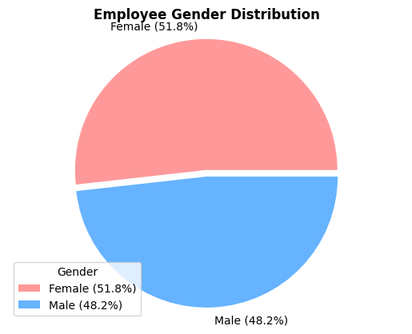

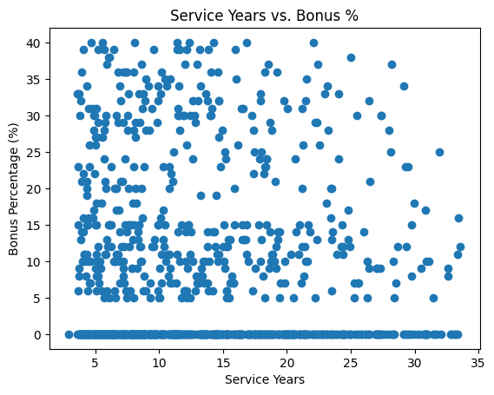**Bonuses Distribution**

**4. Recommendations**

* Standardize salaries by role, not location - pay top talent equally worldwide with cost-of-living adjustments for fairness.
* Introduce seniority-based bonuses for employees with 20+ years of service

**5. Appendix**

