Expense Tracker — Phase 1
Backend API Test Report (Postman)
Dalil Training Academy — Full Stack Web Development

1. Overview
This report documents the testing of the 5 backend endpoints built in Phase 1 of the Expense Tracker project (Node.js + Express + PostgreSQL). Every endpoint was tested with Postman for both its success case and its expected error cases (invalid input, invalid id, and not-found id).
Method | Path | Function | Success | Errors
GET | /api/expenses | Return all expenses | 200 | —
GET | /api/expenses/:id | Return one expense | 200 | 400, 404
POST | /api/expenses | Add a new expense | 201 | 400
PUT | /api/expenses/:id | Update an expense | 200 | 400, 404
DELETE | /api/expenses/:id | Delete an expense | 200 | 400, 404

2. Sample Requests & Responses

2.1 GET /api/expenses — Get All Expenses
Returns every expense stored in the database, with amount as a proper number and date in YYYY-MM-DD format. Status: 200 OK.
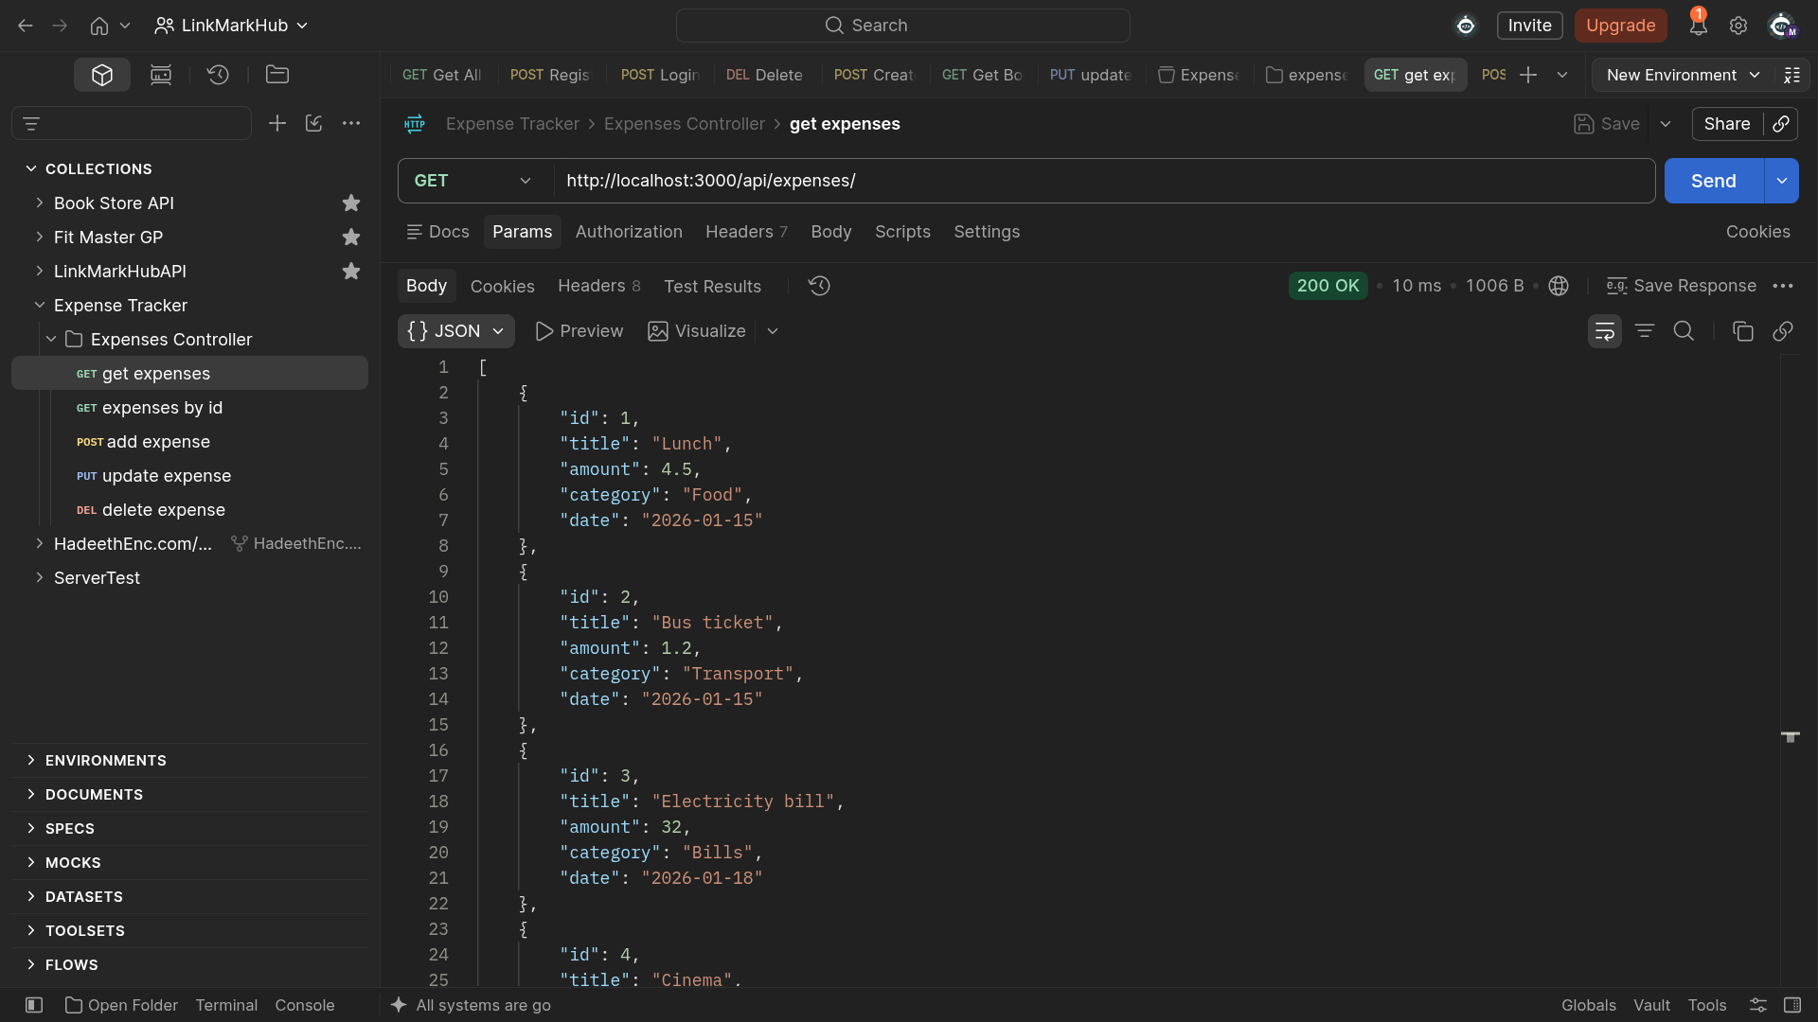

2.2 GET /api/expenses/:id — Get Expense by ID
Returns a single expense matching the given id. Status: 200 OK.
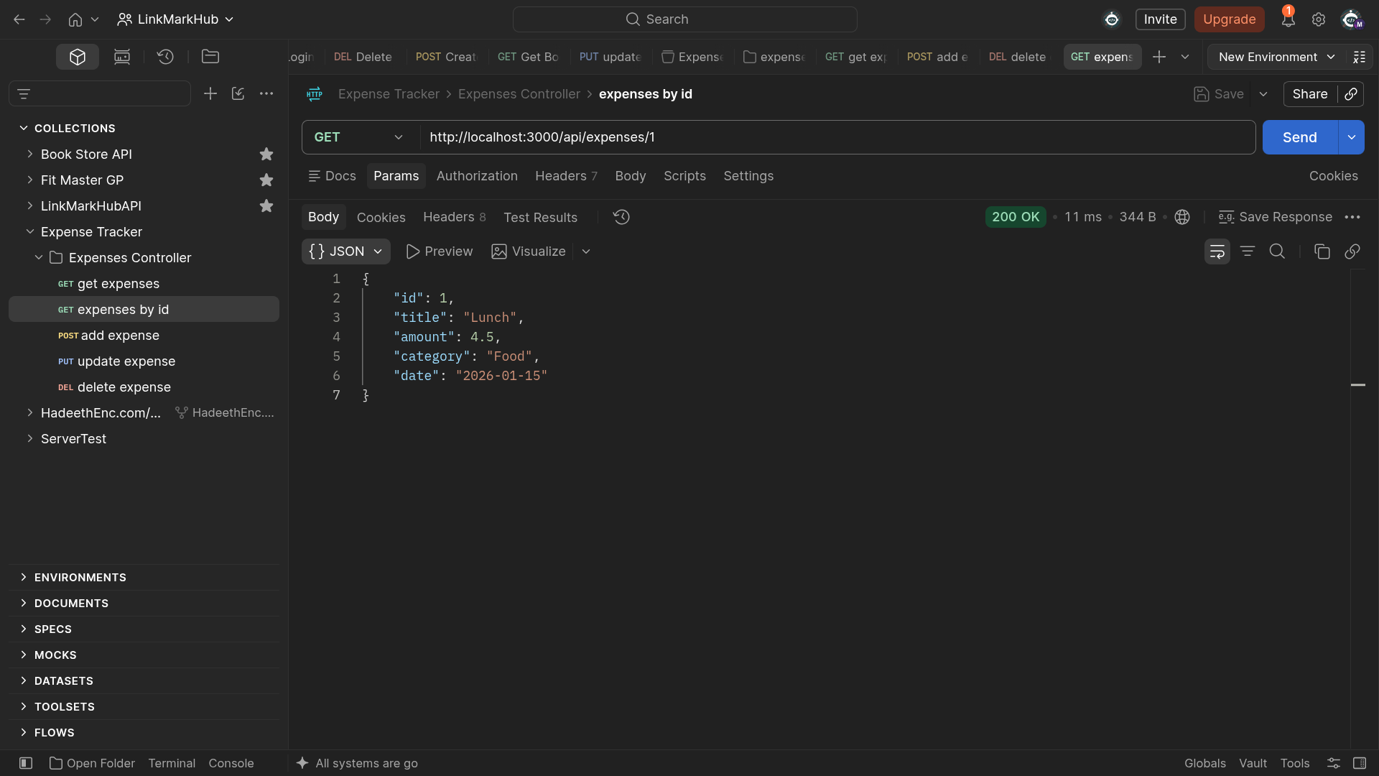

2.3 GET /api/expenses/:id — Invalid ID (400)
Requesting a non-numeric id (e.g. /api/expenses/abs) is rejected before it ever reaches the database, returning a clear 400 error.
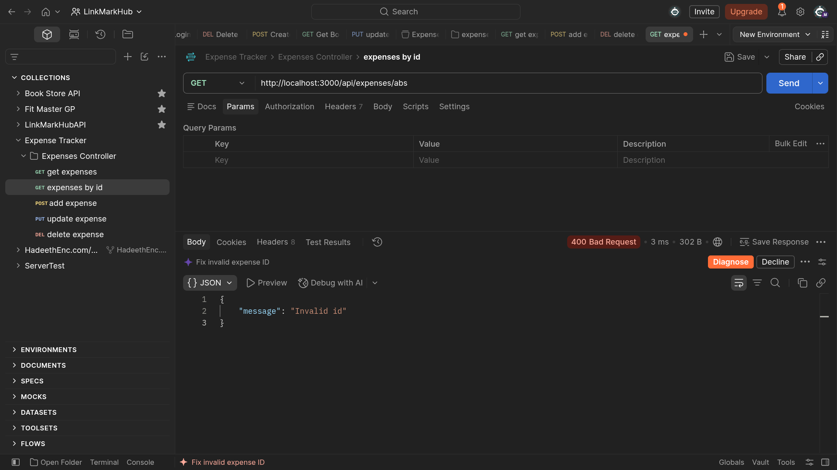

2.4 GET /api/expenses/:id — Not Found (404)
Requesting an id that is valid but doesn't exist in the table (e.g. /api/expenses/99) returns 404 with a clear message.
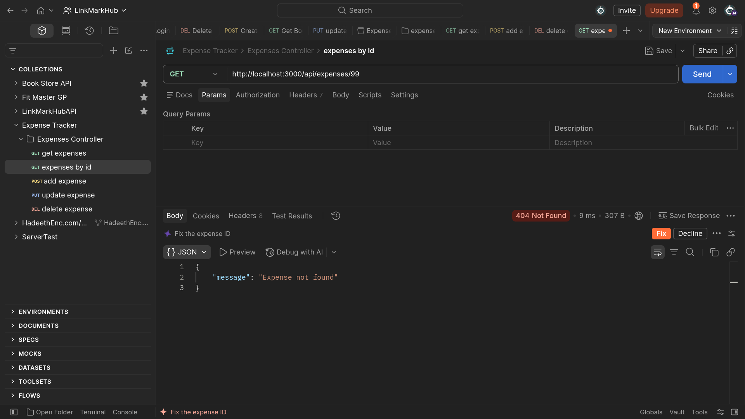

2.5 POST /api/expenses — Add Expense (Success)
Sending a valid expense object returns 201 Created along with the new row, including the id generated by the database.
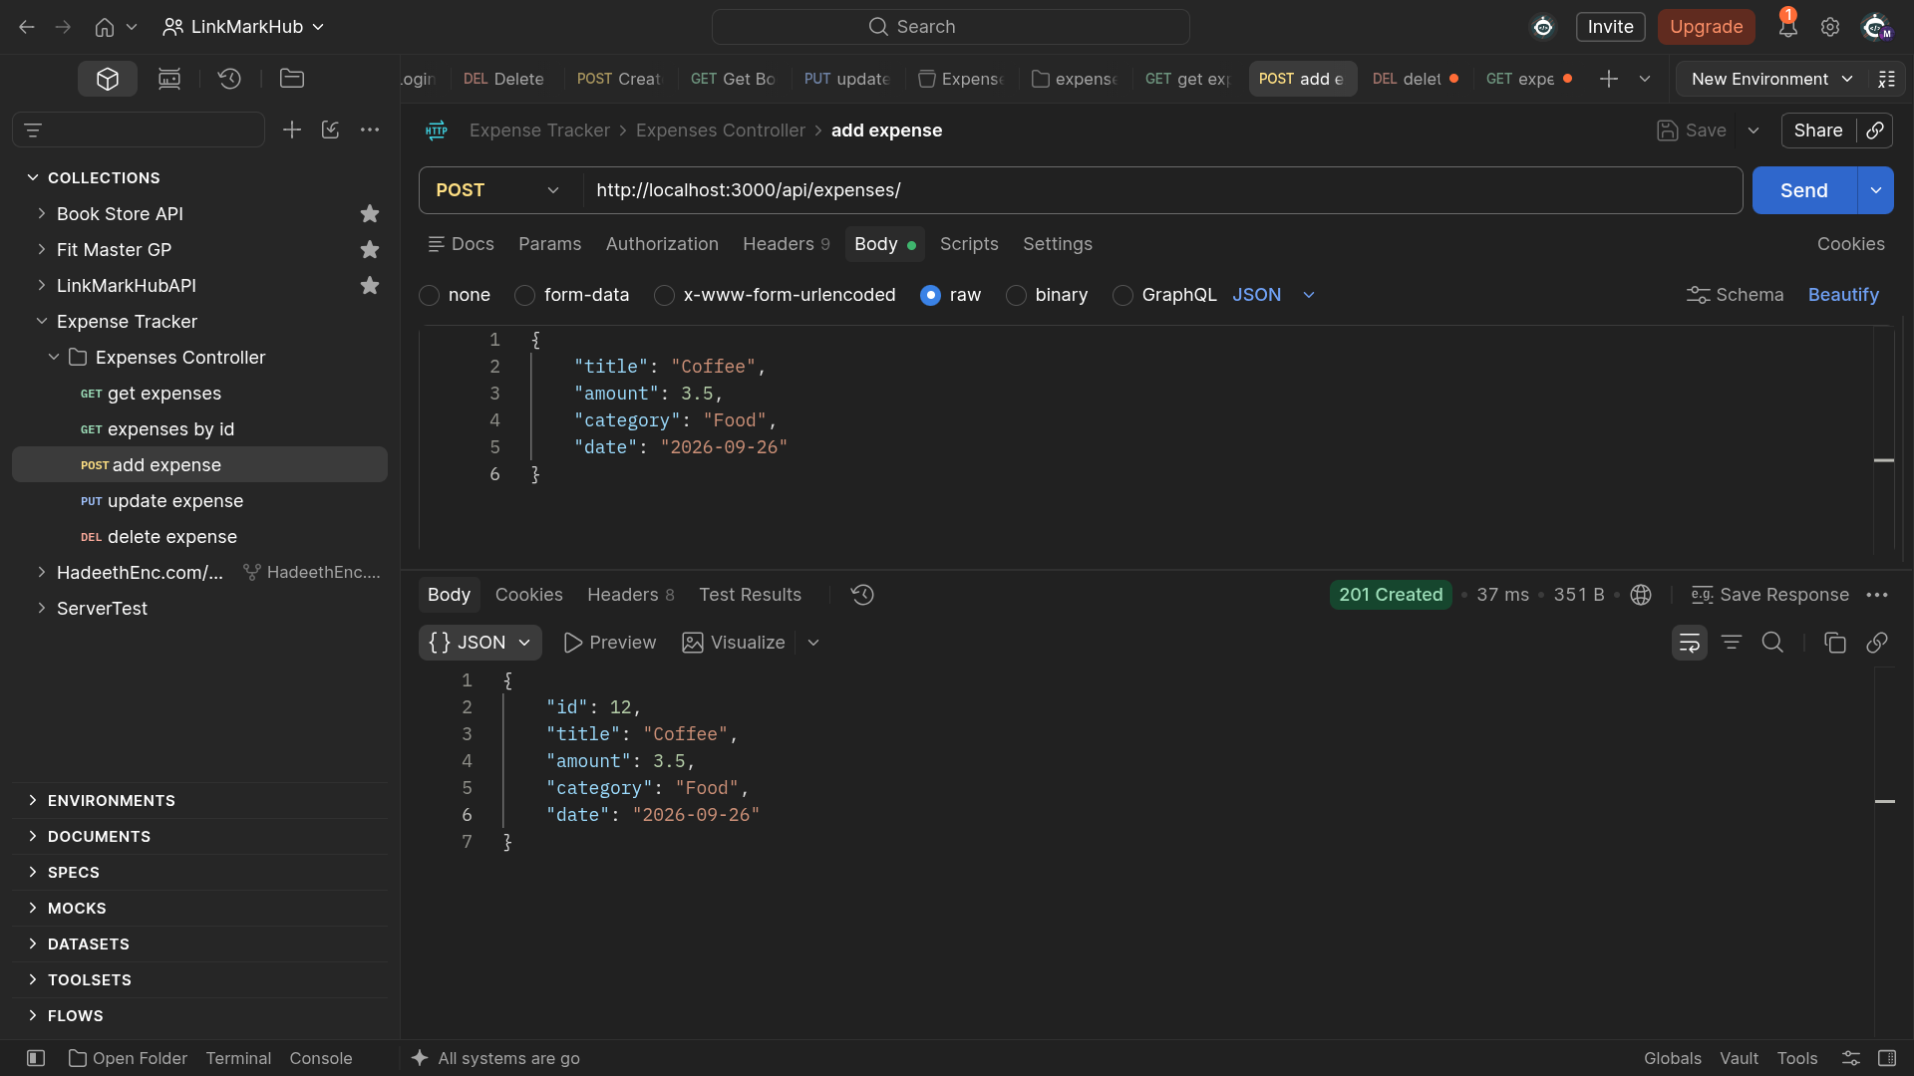

2.6 POST /api/expenses — Empty Title (400)
Submitting an empty title fails validation and returns 400 with a message explaining the problem, before any database write happens.
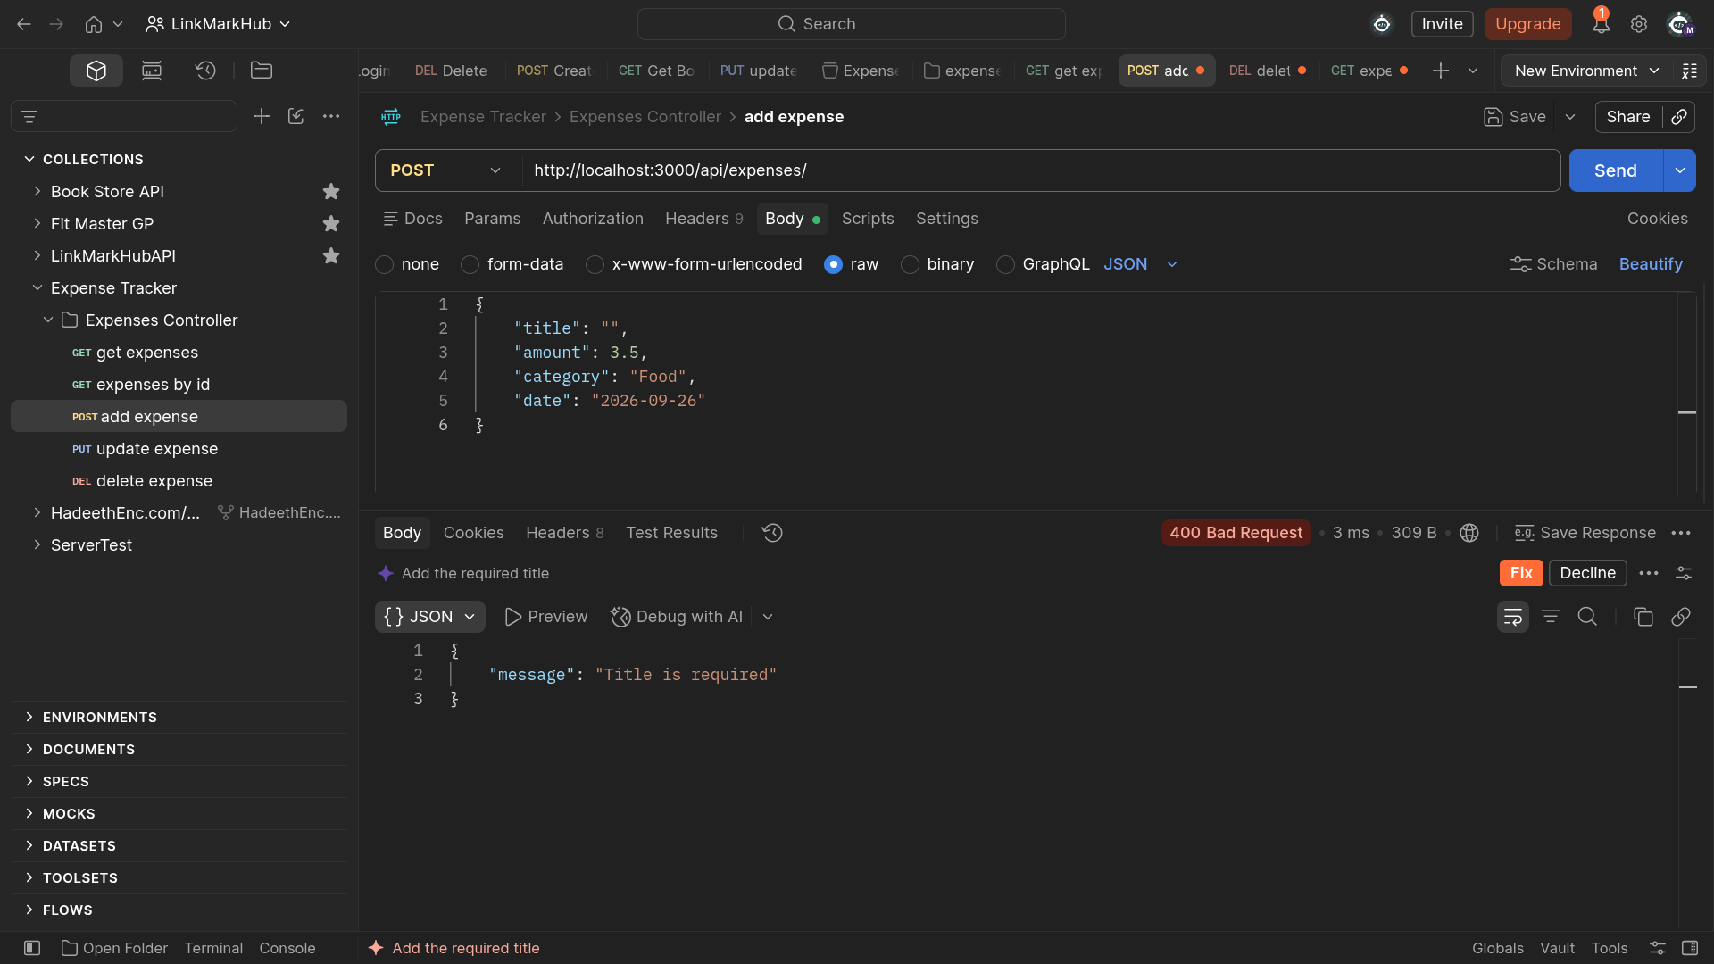

2.7 POST /api/expenses — Invalid Category (400)
A category outside the five allowed values (Food, Transport, Bills, Entertainment, Other) is rejected with 400.
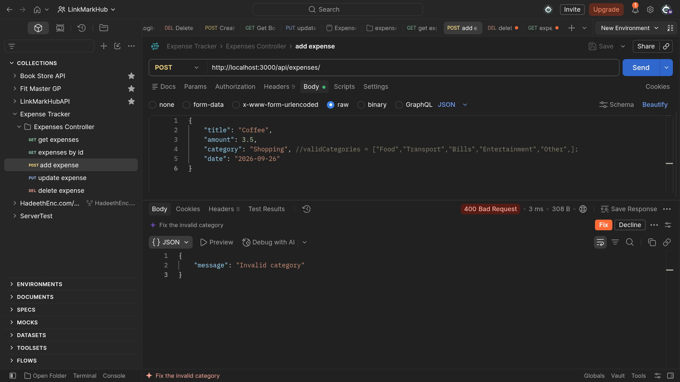

2.8 POST /api/expenses — Negative Amount (400)
An amount of zero or less fails validation and returns 400.
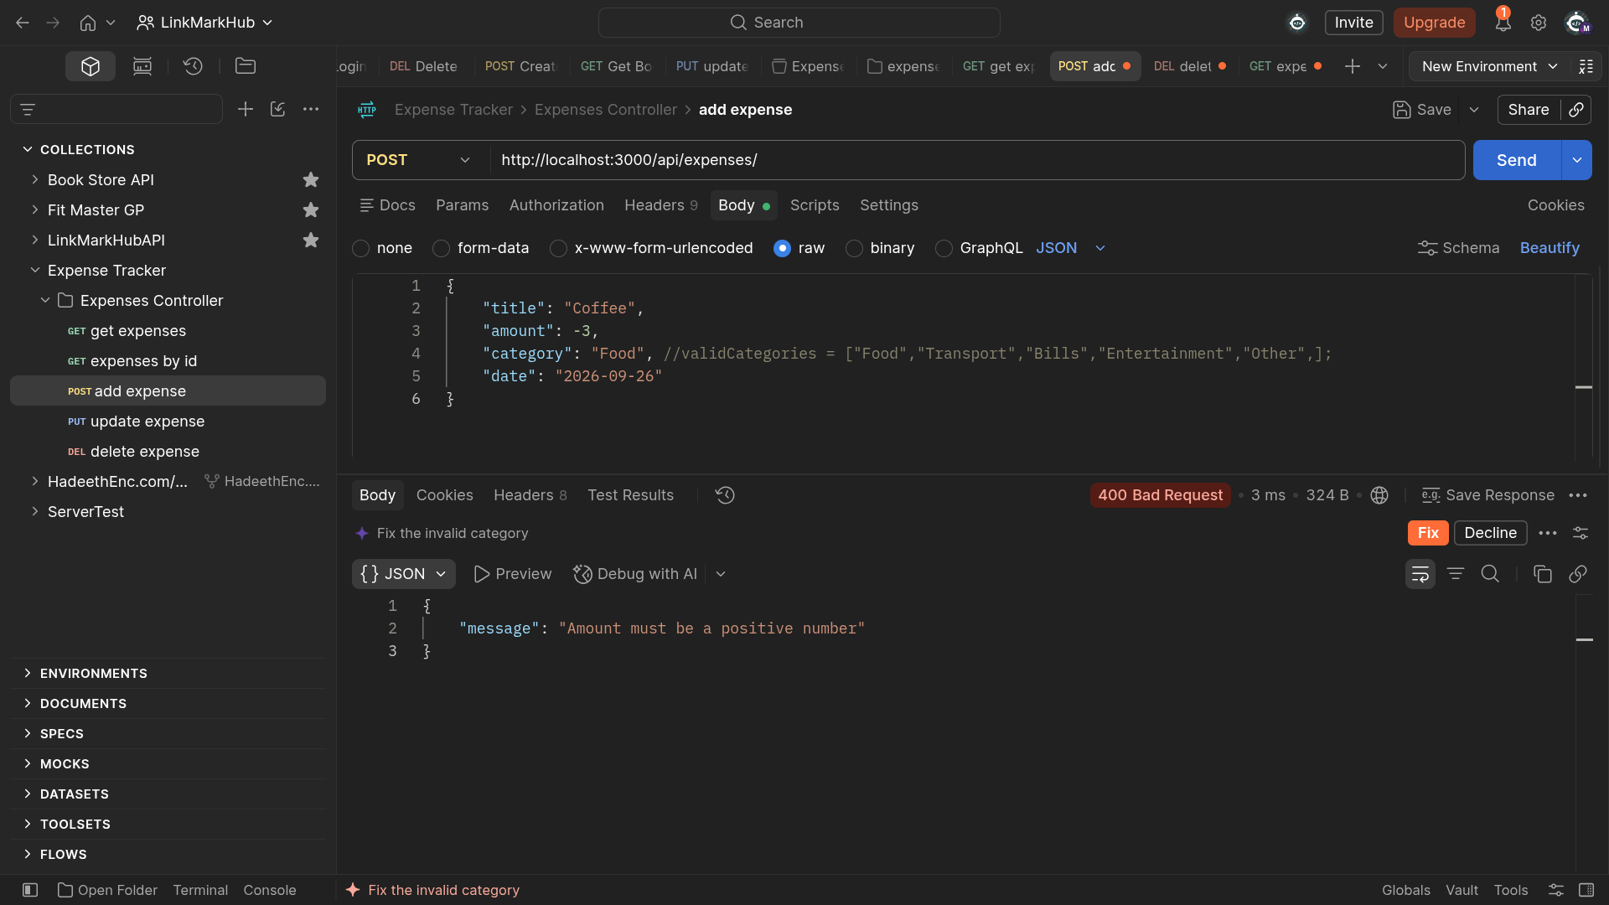

2.9 Verifying the Insert
Calling GET /api/expenses again after the successful POST confirms the new expense (id 12, "Coffee") is now persisted in the database.
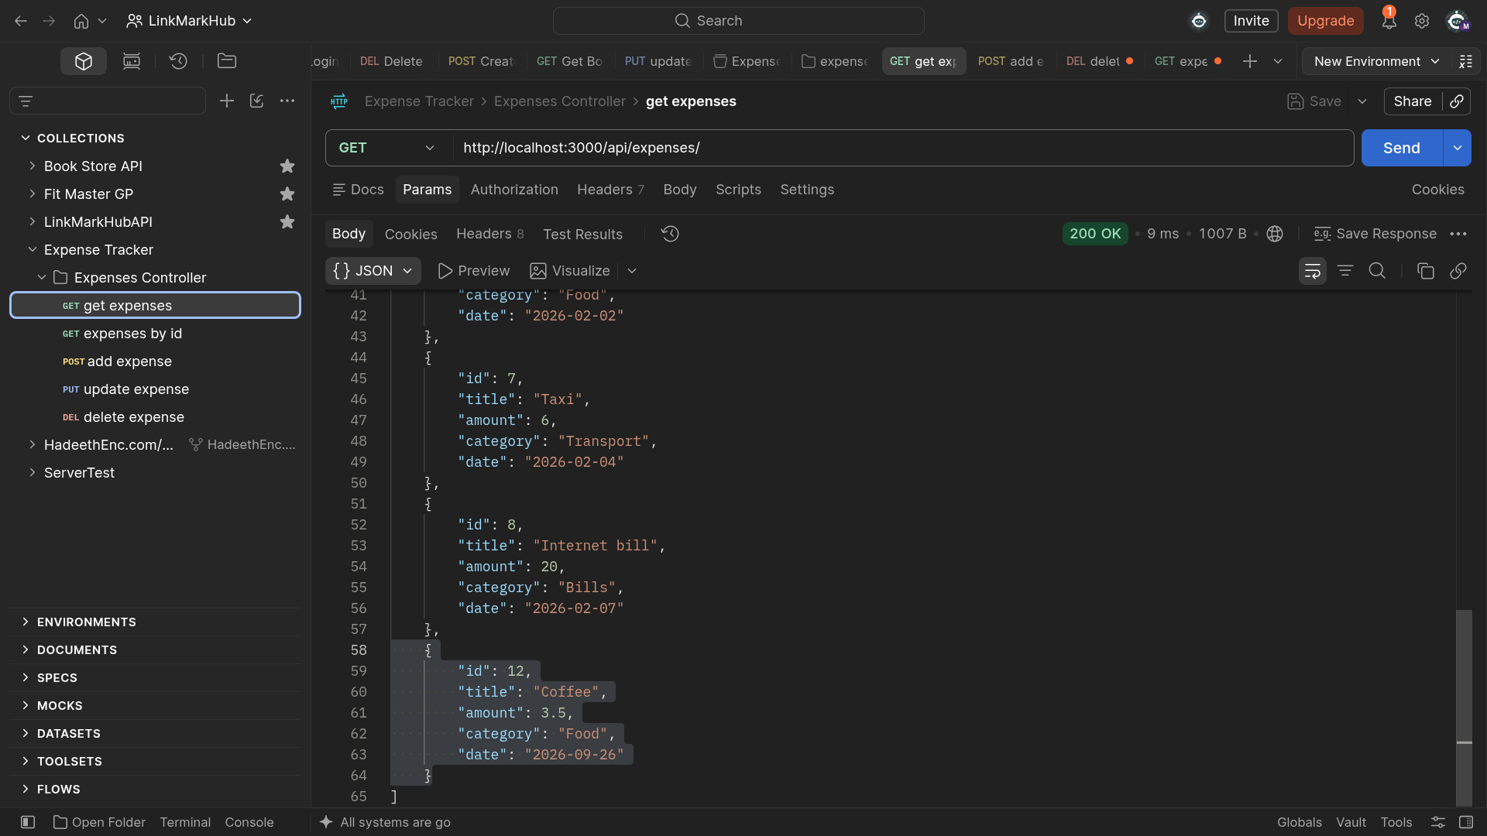

2.10 PUT /api/expenses/:id — Update Expense (Success)
Updating the amount of an existing expense returns 200 OK with the updated row.
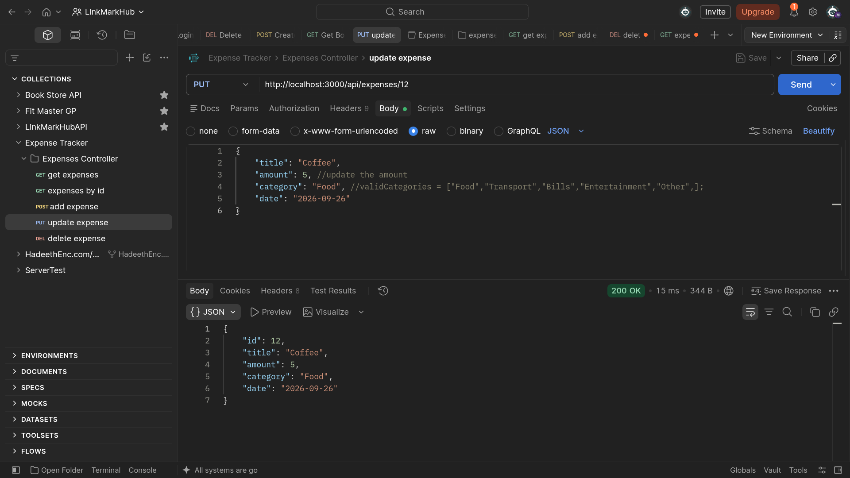

2.11 PUT /api/expenses/:id — Not Found (404)
Trying to update an id that doesn't exist returns 404, instead of silently doing nothing or crashing the server.
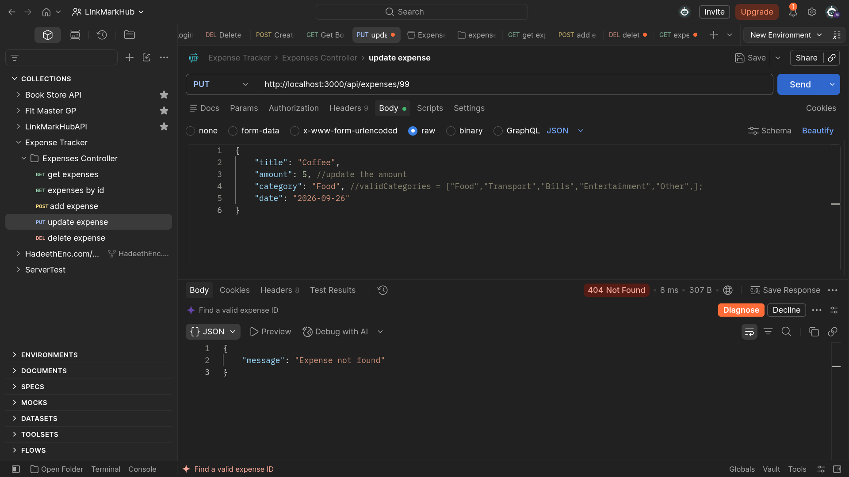

2.12 DELETE /api/expenses/:id — Delete Expense (Success)
Deleting an existing expense returns 200 OK along with the row that was removed.
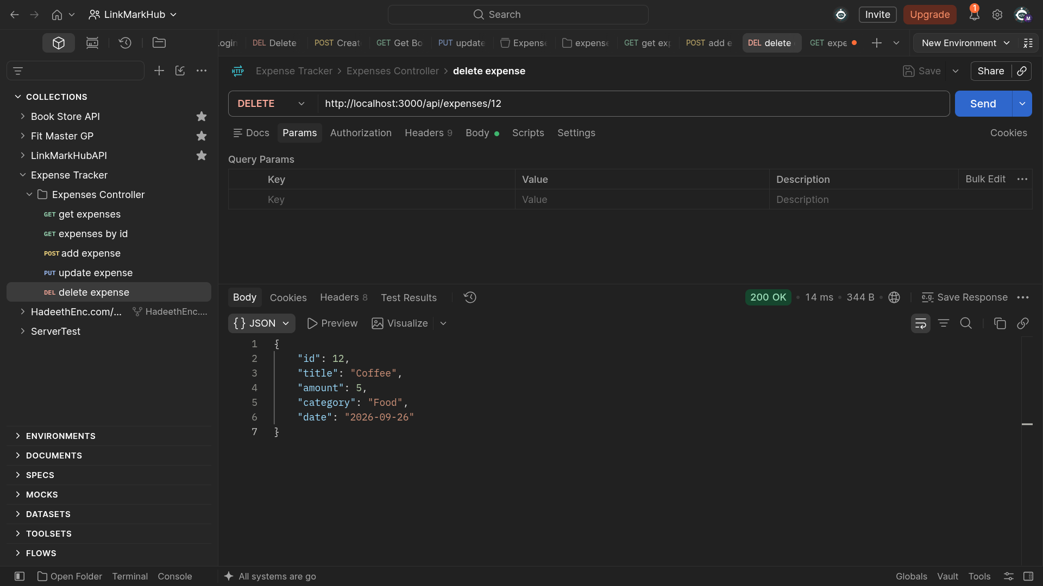

2.13 DELETE /api/expenses/:id — Not Found (404)
Deleting the same id a second time (already removed) correctly returns 404 instead of a false success.
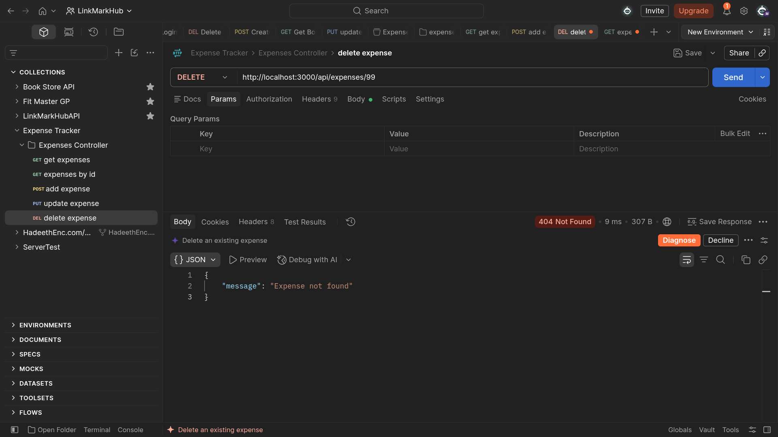

2.14 Verifying the Deletion
Calling GET /api/expenses again confirms the deleted expense no longer appears in the list.
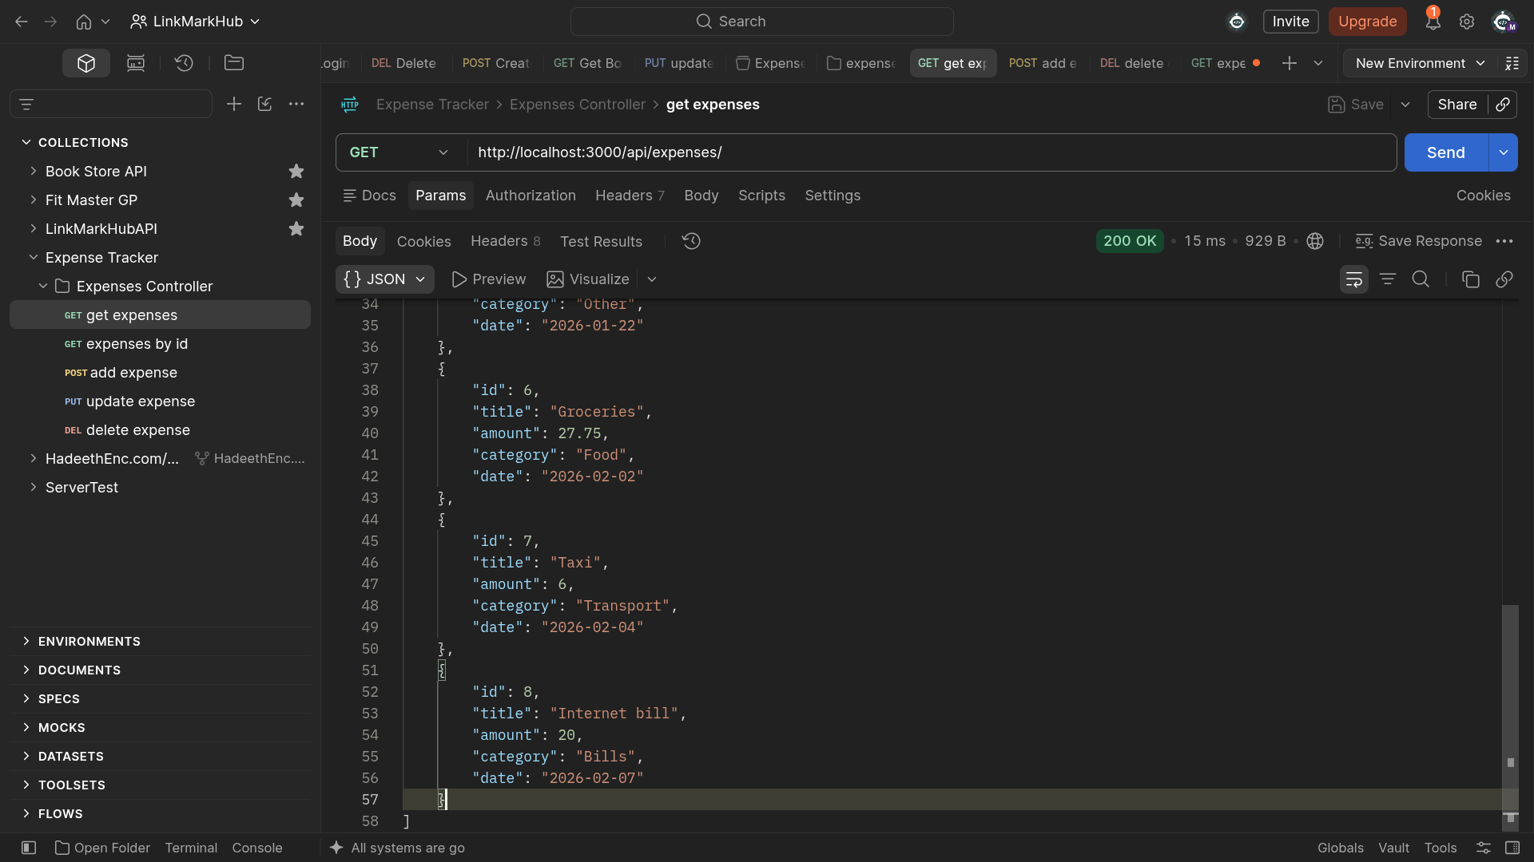

3. HTTP Status Codes Used
The same status codes were used consistently across all 5 endpoints, and every error response returns a JSON body with a clear message field — never a raw HTML error page.
Code | Meaning | When it happens
200 OK | Success | GET, PUT, and DELETE operations that succeed
201 Created | Resource created | POST /api/expenses with valid data
400 Bad Request | Invalid input | Missing/invalid title, amount, category, date, or a non-numeric id
404 Not Found | Resource missing | GET, PUT, or DELETE with an id that doesn't exist
500 Internal Server Error | Server error | Unexpected failure caught by try/catch

4. Conclusion
All 5 endpoints (GET all, GET by id, POST, PUT, DELETE) were tested for both their success path and their main failure paths (invalid id, missing/invalid body fields, and not-found id). Every query uses parameterized values ($1, $2, ...), amount and date are returned in clean, usable formats, and no request produces an unhandled server crash.

