**Software Methods and Tools**

**Home Assignment # 3**

**Name : Saud Mohammed Ali Alqahtani**

**Student ID: 1375**

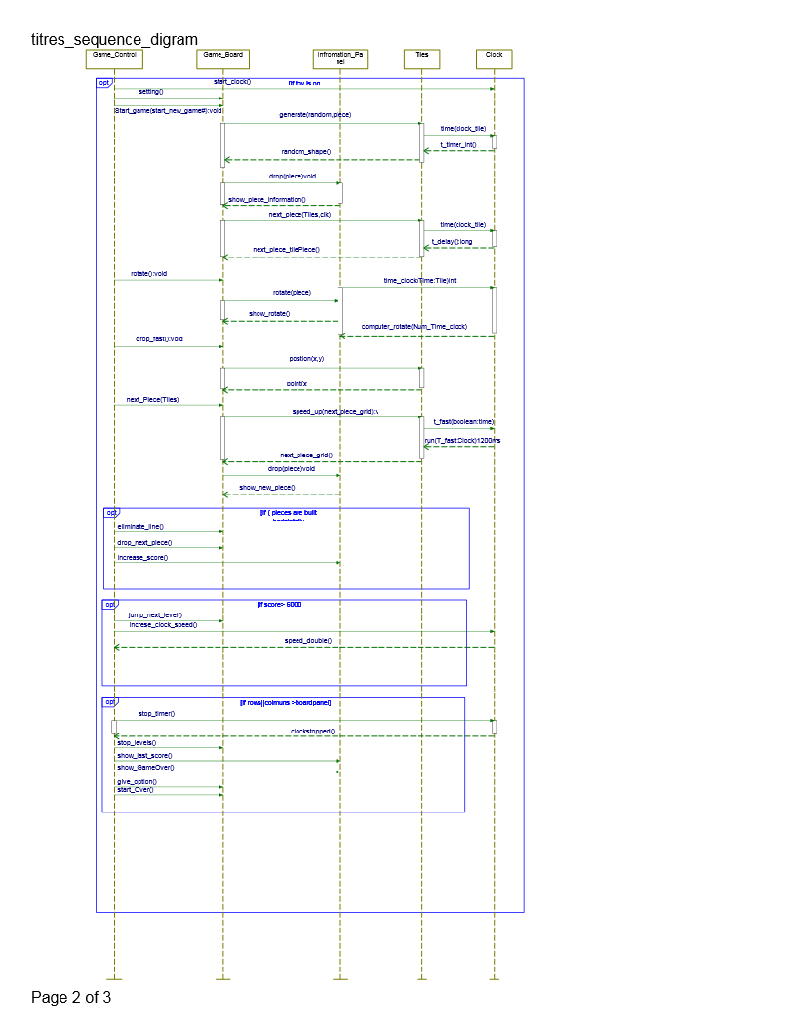

In the sequence diagram above, the Tetris game starts with if statement, it looks like a toy game. If the toy is turned on, the game control sends a request to the clock to start the time. Second, may the game plyer required to make some setting like voice, level, or structure. The game control will send the setting request and start game option to the game board. Game board sends will get a random tiles, pieces, from Tiles instance. Tiles receives a random shape request. Tiles needs to start running the clock cycle to organize generating tiles based on clock. Tiles can send a random shape to the game board. If the game player sends moving the piece left or right, the game control will send rotate, move left or other control options to the game board. Next, the game board is organized based on points like X,Y. based on the player option, piece will be dropped in (x,y) positions. The game control will ask the next piece from the tiles and tile will forward that next to the game board. When the player drop the piece fast the game control will send to the Tile and tiles to clock increase the speed by t_fast:Boolean and the clock provides “ run(T-fast:clock)1200ms. If there is one or more full horizontal lines, the game control sends to gameboard to eliminate them and show new score to the informational panel. Game control can add the speed of pieces based on the score. For example, after increasing the score by 500 the speed change to the double and so on. Finally, if the pieces accumulate above each other until the highest level of board, the game control sends stopping game to the game board, showing the highest score and showing the other options to the player.

2)

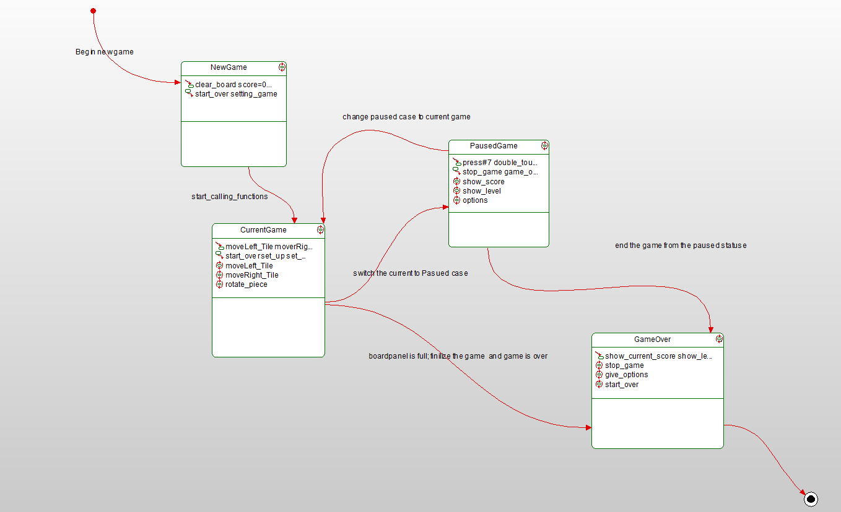

In the diagram above, we have four states for Tetris game. First, new game state, which is the state that has the initial parameters for the game. For example, make score =0, level= 0, and clear the board. During the play, the new game upgraded to a current game. Current game has the main control function that control and manage the tiles in the board. Like move left or right, arrange the next piece, and give conditions like if (tiles>board_peak) stop and show the game is over. The third state is paused state. The player has the option to pause the game. In that option it can be clearly stopped the game and get back to the same arrival level and score. Moreover, it can be displayed the score, level and more other options like setting. Last, the GameOver state. There are other two options as well like to get back to the current game or end by GameOver. Last GameOver, this state occure by the player option or once the game board is filled out with pieces. Finalized the game, stop the clock of the game, showing the high score and levels.