*Sea Animals Classification and Detection*

Yahia Khaled   
Computer Engineering  
AAST  
Alexandria, Egypt  
Yahiakhaled49@gmail.com   
  
Mahmoud Mostafa  
Computer Engineering  
AASTAlexandria, Egypt  
Mahmoudramadn22@gmail.com

Mohannad Taman   
Computer Engineering  
AASTAlexandria, Egypt  
Mohannadtaman@gmail.com

Ahmed Refaat  
Computer Engineering  
AASTAlexandria, Egypt  
[Ahmedrefaat1201@gmail.com](mailto:Ahmedrefaat1201@gmail.com)

*Abstract-*Sea Animals make about 15% of all animal species on earth yet scientists estimates that we haven’t discovered 91% of all sea animals and creatures so that opens the door for the problem of detection and classification of sea animals to help scientists classify sea animals allowing for more focusing on the other fields related to the sea animals. For this problem we introduced 2 models one uses the MobileNet pretrained Model which produced 93% validation Accuracy.

***Keywords****—***Sea animals; Classification; AI; CNN; Detection; MobileNet*.***

# Introduction

There is an amazing range of marine life in the vast and enigmatic world of the oceans, from minute animals to majestic giants that prowl the depths. Since it is the cornerstone of efforts to conserve and safeguard marine ecosystems, the identification and comprehension of these sea species is crucial for ecologists, conservationists, and marine biologists. However, manually identifying marine species using conventional methods can be a difficult and time-consuming operation. The nexus of marine biology and artificial intelligence (AI) has opened the door for creative approaches to this problem in recent years. The use of AI algorithms for the image-based classification of marine life is one such innovative discovery. Through the utilization of deep learning algorithms, these models are capable of precisely identifying and classifying a wide range of marine species by analyzing complex patterns, forms, and properties present in photos.

This paper explores 1 AI model created especially for classifying sea species from picture data. We will learn about these AI model’s architecture, training procedure, and possible uses in the field of marine biology as we explore its complexities.

# Literature review

As a part of our study we had a look at different articles concerning image detection and classification modules some of us even took the pride in tackling a small course concerning TensorFlow and CNN to learn more about how to use them efficiently Also we researched the domain of our study which is marine life and sea animals and we aim this research in helping biologists detect and classify multiple species of marine life to help them from the risks of being endangered species and better understand their contribution to the ecosystem overall.

# Related Work

MobileNet is a family of efficient convolutional neural network architectures designed for mobile and edge devices with limited computational resources. These models are particularly well-suited for tasks such as image classification, object detection, and semantic segmentation on devices like smartphones, embedded systems, and IoT devices. The MobileNet architecture was introduced by Google researchers in a paper titled "MobileNets: Efficient Convolutional Neural Networks for Mobile Vision Applications" in 2017. The primary goal of MobileNet is to provide a lightweight and efficient neural network architecture that can achieve good performance on computer vision tasks while being computationally efficient and having a small memory footprint.so at the end To sum up MobileNetV2 is a convolutional neural network that is 53 layers deep where you can load a pretrained version of the network trained on more than a million images from the ImageNet database as the pretrained network can classify images into 1000 object categories Also, it incorporates inverted residuals and linear bottlenecks to enhance the expressiveness of the network while maintaining efficiency.

# Proposed Model

#### MobileNet

This Model is Based on MobileNetV2 architecture, pre-trained on the ImageNet dataset With Input shape: (224, 224, 3) (It expects input images with dimensions 224x224 pixels, and 3 color channels (RGB)) Also Global average pooling is applied after the convolutional layers, resulting in a tensor with shape (None, 1280), as MobileNetV2's last layer has 1280 output channels then Flatten Layer is added to convert the 3D output of the MobileNetV2 into a 1D vector followed by a Dense layer with 512 units and ReLU activation is added as this layer introduces non-linearity and learns complex patterns in the flattened feature vector then a Dropout Layer with a dropout rate of 0.2 is added as

Dropout helps prevent overfitting by randomly setting a fraction of input units to zero during training then finally an Output Layer with 6 units defining the final goal of classification into 6 classes and softmax activation is

used for multi-class classification to produce probability distributions over the classes.

To Understand More look at the next summary of the Model.

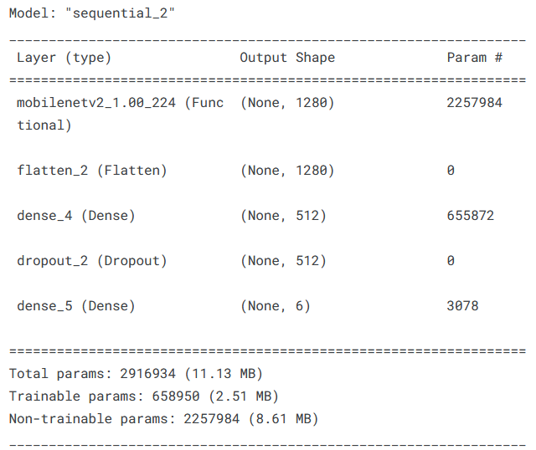

Figure 1 MobileNet Model Summary

# Experimental Work

As A part of our project, we focused on exploring many datasets related to sea animals available on Kaggle till we chose the Sea Animals Dataset published by Marionette which is the best fit for our domain of study.

#### Dataset

Sea Animals The dataset contains different images of marine animals. Some images were taken from pixabay.com and requires no license or attribution when used. Other images were taken from flickr.com where attribution to the original authors will be required when used commercially. Currently, there are 23 different classes available and may be extended further in the future but for a trail in this project we took a subset of this data exactly 6 classes out of 23 to base our analysis and see how can we make the classification work for us also the images vary in sizes and orientations so we took each image and processed it to be all in the same size of 200 X 200 pixels RGB images also we down sampled the data to be balanced as each class is represented with 498 pictures total in the model furthermore each class in this dataset represents a sea animal.  
Have A look at the data Files below:

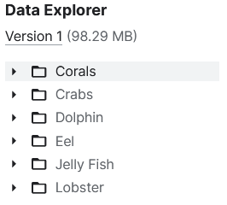

Figure 2 Data Classes

Now after knowing the classes, we need to see how the data is represented and available in each class.  
Look at the next graph to see more.

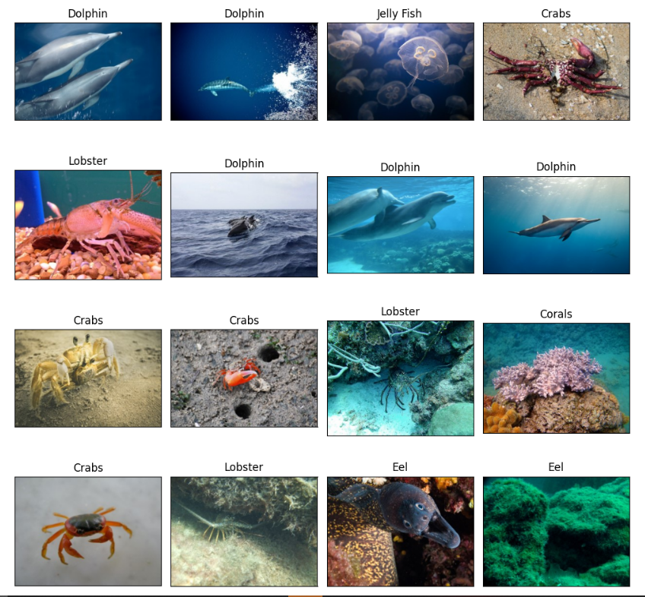

Figure 3 Data Before Augmentation and Labelling

As you see the data is unbalanced where there are 2 classes dolphin and jelly fish have higher counts than the other 4 classes so to tackle this problem, we under sampled each of the classes to reach exactly 498 as that would be matching the counts of the least class.

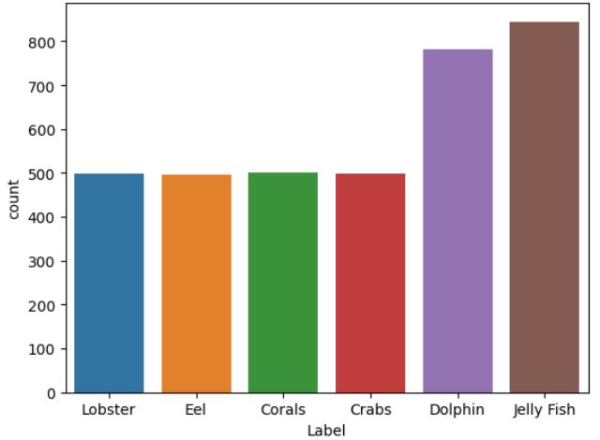

Figure 4 Counts of each Data Class (Unbalanced)

Look at the next figure.

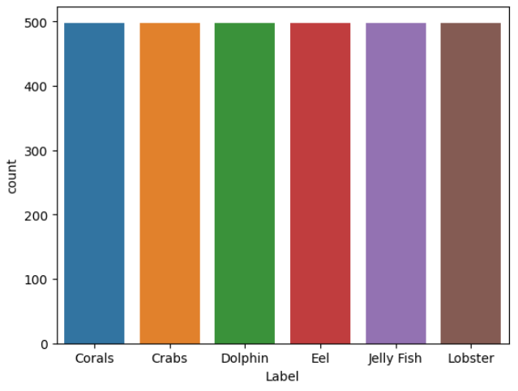

Figure 5 Counts of each Data Class (Balanced)

Also, we faced another problem with images as most of them were of different sizes and orientations so to standardize the input for the model we used the image data generator library to use it to apply the built in function to manipulate the data entering the model as following.

With that done we were ready to proceed with data as it’s labeled and ready for the processing phase.

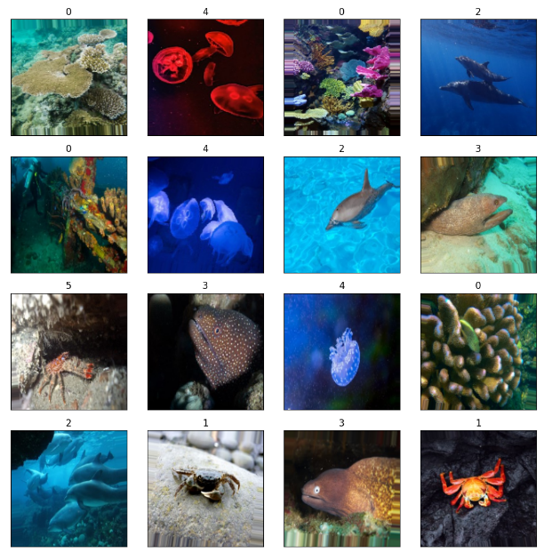

Figure 6 Data After Augmentation and Labelling

**Table 1**  
*Data Augmentation Parameters*

|  |  |  |  |  |
| --- | --- | --- | --- | --- |
| Rescale | Rotation | Zoom Range | Shear Range | Horizontal Flip |
| 1/255 | 40 | 0.2 | 0.2 | True |

Look at the Next Figure for data after Augmentation.

**Table 4**

*Batch Size VS Performance for MobileNet Model*

|  |  |  |  |
| --- | --- | --- | --- |
|  | Accuracy | Precision | Sensitivity |
| 16 | 91.59 | 92.64 | 93.0 |
| 32 | 91.78 | 92.31 | 92.31 |
| 48 | 92.19 | 93.0 | 93.0 |

#### Evaluation Metrices

After preparing the data we proceeded to think more about how we are going to assess our model and check the performance. We got the answer on using the available state of the art tools implemented in the library of SKlearn as this classification is of multiclass so we had to focus on metrics and configure many hyper parameters furthermore we used cross validation in the models to reduce the overfitting problem as much as we can.

**Table 2**  
*Hyper Parameters for MobileNet Model*

|  |  |  |  |
| --- | --- | --- | --- |
| Seed Value | Split Ratio | No of folds | No of epochs |
| 42 | 80/20 | 4 | 30 |

look at the next table for the MobileNet Model.

As per the table after setting our hyper parameters we choose 3 measures of performance to test the models with which are Accuracy, Precision, and Sensitivity. With that set we proceeded to test and evaluate the models and fine tuning the other parameters related to the models. We tested the models on changeable batch sizes and different optimizers So to have a closer look on the MobileNet Performance

Look at the next tables.

**Table 3**

*Optimizers VS Performance for MobileNet Model*

|  |  |  |  |
| --- | --- | --- | --- |
|  | Accuracy | Precision | Sensitivity |
| Adam | 92.56 | 93.96 | 93.96 |
| SGD | 91.92 | 92.20 | 92.20 |
| RMSprop | 89.79 | 93.53 | 93.53 |

As stated in the previous tables we should use the optimizer Adam and a Batch Size of 48 to achieve the best performance. So that’s it for the Evaluation procedures we took before taking out the results.

#### Results

So, to finalize our findings we reached a very interesting average validation accuracy across both of the models so to start with our findings we reached a validation accuracy score of 92.56 in the MobileNet model and Produced an acceptable curve for us.

Look at the next curve.



Figure 8 Curve Results for MobileNet Model

That curve indicates a good result for the model in classifying the images, but it shows that there is an overfitting problem due to the spikes ploted in the curve which is a problem to be tackled more in our future work.

# Conclusion

This paper discusses some of the improvements that happened over the years to the classification models using images giving an example of a model that classifies sea animals using images. So, to sum it up we need to work more on the classification techniques and bring more of the potential of CNN to the models proposed.

# Future Work

We intend to publish the model online and integrate it within a web application to help biologists with their studies also we intend to work more on the 2 models to make them more robust and increase their dataset by using more image augmentation techniques. We can say that we need to try to make our prediction with the help of a Neural network to see if it can yield better results and fine tune it more.

# References

1. Lopez-Vazquez, V., Lopez-Guede, J.M., Chatzievangelou, D., et al. (2023). Deep learning based deep-sea automatic image enhancement and animal species classification. Journal of Big Data, 10(1), 37. <https://doi.org/10.1186/s40537-023-00711-w>
2. K. Dong, C. Zhou, Y. Ruan and Y. Li, "MobileNetV2 Model for Image Classification," 2020 2nd International Conference on Information Technology and Computer Application (ITCA), Guangzhou, China, 2020, pp. 476-480, doi: 10.1109/ITCA52113.2020.00106.