Assignment3

* Insert into Employee table:

insert into employee (firstname,lastname,phonenumber,email,Role) values ('Mohannad', 'Jaradat','079797979','moh@gmail.com','devopsENG');

insert into employee (firstname,lastname,phonenumber,email,Role) values ('Ahmad', 'Mohammad','079797970','Ahmad@gmail.com','cloudENG');

insert into employee (firstname,lastname,phonenumber,email,Role) values ('Hamza', 'Omar','079797079','Hamza@gmail.com','softwareENG');

insert into employee (firstname,lastname,phonenumber,email,Role) values ('Omar', 'Ali','079707979','Omar@gmail.com','front_endENG');

insert into employee (firstname,lastname,phonenumber,email,Role) values ('Amro', 'Hassan','070797979','Amro@gmail.com','back_endENG');

* Results:

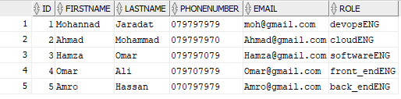

* Insert into patient table:

insert into Patient (firstname,lastname,age,condition) values ('Yousef', 'Ahmad',35,'Diabetes');

insert into Patient (firstname,lastname,age,condition) values ('Motaz', 'Fadel',40,'Brain tumor');

insert into Patient (firstname,lastname,age,condition) values ('Yaser', 'Saad',45,'Headache');

insert into Patient (firstname,lastname,age,condition) values ('Mohammad', 'Mustafa',50,'Stomachace');

insert into Patient (firstname,lastname,age,condition) values ('Hashem', 'Noor',55,'broken leg');

* Results:

* Update patient table:

update patient set condition = 'pain in right arm' where id=2;

update patient set age = 51 where id=4;

* Results:



* Insert into empPatient:

INSERT INTO EmpPatient (PatientID, EmpID) VALUES (1, 3);

INSERT INTO EmpPatient (PatientID, EmpID) VALUES (2, 5);

* Results:

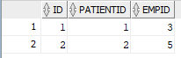

* Delete from Patient table:

DELETE FROM Patient WHERE ID = 1;

* Results:

