APL LOGISTICS
OPERATIONS INTELLIGENCE
Machine Learning-Based
Late Delivery Risk Prediction
in Global Supply Chain Operations

Research Paper
Author: Mohan
PGDM Business Analytics | Batch 2024-2026
Unified Mentor | Data Analytics Internship
Project 2 of 2

Executive Summary
APL Logistics, operating across five global markets, faces a significant operational challenge: 54.83% of its 180,519 analyzed orders are delivered late. This translates to potential revenue exposure of approximately $24.8 million in flagged high-risk orders alone, alongside reputational damage and customer churn risk.
This research presents a machine learning-based predictive system that identifies high-risk orders before shipment, enabling proactive operational intervention. The model transforms APL Logistics' supply chain from reactive delay management to predictive risk intelligence.

Key Outcomes
- Best Model Performance: XGBoost classifier achieved ROC-AUC of 0.88, F1-score of 0.83, with 82% overall accuracy on a held-out test set of 36,104 orders.
- Top Risk Drivers Identified: Shipping mode risk score, scheduled delivery days, shipping pressure index, regional risk, and market characteristics emerged as the strongest predictors.
- Actionable Risk Tiers: Each order receives a probability score (0-1) and is categorized as Low Risk (<40%), Medium Risk (40-70%), or High Risk (>70%) — enabling operations to prioritize intervention.
- Deployment Ready: An interactive Streamlit dashboard provides four operational modules — Executive Overview, Order-Level Predictor, Geographic Analytics, and Action Queue.

The recommendations section of this paper outlines a phased implementation roadmap that, if adopted, can reduce late delivery rates by an estimated 15-20% within the first year through targeted operational interventions on flagged high-risk shipments.

1. Introduction and Business Context

1.1 Business Background
APL Logistics, a subsidiary of the KWE Group, operates as a global logistics provider managing complex supply chain operations across five major markets: LATAM, Europe, Pacific Asia, USCA, and Africa. The company processes high volumes of orders daily across multiple shipping modes, product categories, and customer segments.
In modern global logistics, late deliveries represent more than a customer experience issue — they trigger SLA breaches, contractual penalties, lost customer lifetime value, and operational firefighting costs. Reactive delay management, where issues are addressed only after they occur, has proven both expensive and damaging to long-term partnerships.

1.2 Problem Statement
APL Logistics faces three interconnected challenges:
- Unpredictability: Shipment delays occur without warning, preventing proactive intervention.
- Reactive Cost Burden: Last-minute fixes (express rerouting, customer compensation, expedited handling) are significantly more expensive than preventive action.
- Limited Prioritization: Operations teams cannot effectively rank orders by risk, leading to resource misallocation.
The organization currently lacks: (a) a predictive system to flag late-delivery risk before shipment, (b) quantitative risk scoring for operational planning, and (c) explainable insights into the underlying drivers of delays.

1.3 Project Objectives
This research aims to build an end-to-end predictive risk intelligence system that addresses the above gaps through five concrete objectives:
- Develop a binary classification model predicting late delivery risk before shipment dispatch.
- Generate continuous probability scores (0-1) for each order to enable nuanced prioritization.
- Classify orders into actionable Low, Medium, and High risk categories.
- Identify and quantify the key drivers of late delivery for operational intervention.
- Deploy an interactive dashboard that operations teams can use in their daily workflow.

2. Data Overview

2.1 Dataset Description
The analysis is based on a comprehensive supply chain dataset containing 180,519 historical order records spanning 40 attributes. The dataset captures the full operational lifecycle of an order — from customer demographics and product information through pricing, profitability, shipping logistics, and final delivery outcomes.

2.2 Dataset Composition
Attribute | Value
Total Records | 180,519
Total Columns | 40
Numeric Columns | 21
Categorical Columns | 19
File Encoding | Latin-1
Missing Values | 11 cells (0.000015%)
Duplicate Records | 0
Markets Covered | 5 (LATAM, Europe, Pacific Asia, USCA, Africa)
Shipping Modes | 4 (Standard, Second, First Class, Same Day)
Customer Segments | 3 (Consumer, Corporate, Home Office)

2.3 Target Variable Analysis
The target variable, Late_delivery_risk, is a binary indicator where 1 represents a late delivery and 0 represents an on-time delivery. Analysis reveals a moderately imbalanced but workable distribution:
- Late Deliveries (Class 1): 98,977 orders (54.83%)
- On-Time Deliveries (Class 0): 81,542 orders (45.17%)
This near-balanced distribution is unusual for delay prediction problems and significantly simplifies modeling — aggressive resampling techniques like SMOTE are not strictly required, though they were tested for robustness.
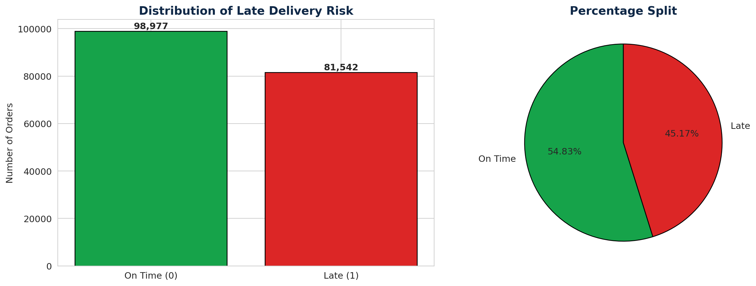
Figure 1: Distribution of Late Delivery Risk across 180,519 orders

2.4 Data Quality Assessment
The dataset demonstrates exceptional data quality, with only 11 missing cells out of approximately 7.2 million data points. Missing values were confined to two non-critical columns (Customer Lname: 8, Customer Zipcode: 3), both of which were subsequently removed due to lack of predictive value and privacy considerations.

3. Methodology
A structured six-phase analytical pipeline was implemented to ensure both rigor and reproducibility:
Phase | Activity | Outcome
1 | Data Loading & Exploration | Identified 40 columns, leakage risks, class balance
2 | Data Cleaning | Reduced to 24 production-ready columns
3 | Exploratory Analysis | 11 charts revealing operational patterns
4 | Feature Engineering | Created 18 predictive features
5 | Data Preparation | Stratified 80/20 split, scaling, SMOTE
6 | Model Training | Trained 3 classifiers, selected best by ROC-AUC

3.1 Data Leakage Prevention - A Critical Step
In supervised learning for delay prediction, data leakage represents one of the most insidious pitfalls. Leakage occurs when features available to the model contain information that would not realistically be known at the time of prediction. Models built with leaked features show artificially inflated performance during testing but fail catastrophically in production.
Three columns were identified as critical leakage risks and removed before model training:
- Days for shipping (real): Actual shipping duration — unknown at order placement, only observable after delivery.
- Delivery Status: Categorical outcome that directly encodes the target variable.
- Order Status: Final disposition flag populated only after order completion.
This deliberate exclusion ensures the model learns generalizable patterns rather than memorizing post-shipment outcomes. The cost is a more conservative performance ceiling — but the benefit is a model that actually works in operational deployment.

3.2 Feature Engineering
Eighteen new predictive features were engineered from the cleaned dataset, organized into nine functional categories:

3.2.1 Shipping Pressure Features
- Shipping_Pressure_Index: Order Quantity divided by (Scheduled Days + 1) — captures operational stress per shipment.
- Mode_Risk_Score: Target-encoded historical late rate per shipping mode.
- Is_Express_Mode: Binary flag for Same Day and First Class shipments.

3.2.2 Geographic Risk Features
- Market_Risk_Score: Target-encoded late rate per global market.
- Region_Risk_Score: More granular regional risk encoding.

3.2.3 Order Complexity Features
- Order_Complexity_Score: Weighted composite of normalized quantity, price, discount, and express flag.
- Sales_Category: Ordinal bucketing of order value (Small to Premium).

3.2.4 Financial & Other Features
- Discount severity flags, profit indicators (loss flag, per-unit profit, margin).
- Category and Department-level risk scores.
- Payment-type risk encoding and segment-level risk.

3.3 Methodological Best Practices
Several rigorous practices were followed to ensure the integrity of model evaluation:
- Stratified Splitting: The train-test split was stratified by target class to preserve the 55/45 ratio in both sets.
- Scaling Hygiene: StandardScaler was fit exclusively on training data and then applied to test data, preventing test-set information from leaking into preprocessing.
- SMOTE Application: Class balancing via SMOTE was applied only to the training set, leaving the test set's natural distribution intact for honest evaluation.
- Reproducibility: All random operations used random_state=42, ensuring identical results across runs.

4. Exploratory Data Analysis
Before building predictive models, extensive exploratory analysis was conducted to understand the operational patterns driving late deliveries. This section presents the most actionable findings.

4.1 Late Delivery Rate by Shipping Mode
Shipping mode emerged as one of the most important operational signals. Counterintuitively, faster shipping modes exhibited higher late rates — a critical insight for SLA design:
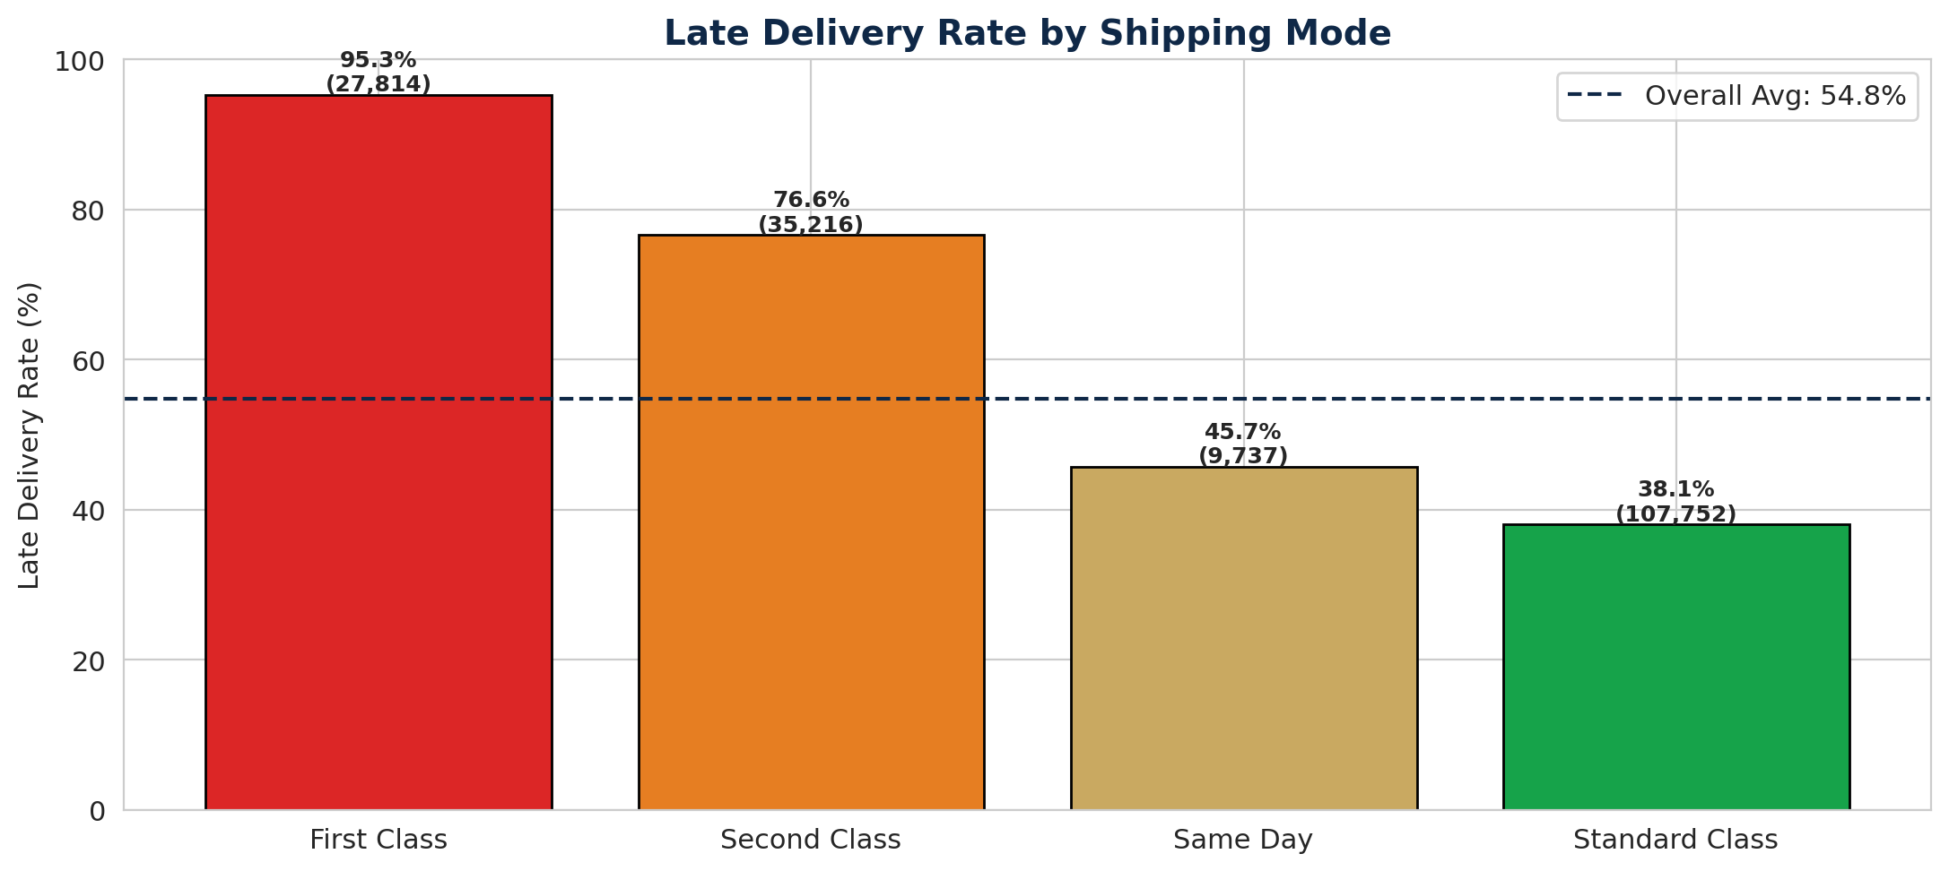
Figure 2: Late Delivery Rate by Shipping Mode
This pattern reflects the tight tolerances of premium shipping commitments — a one-day Same Day SLA is mathematically more vulnerable than a five-day Standard Class commitment. Operations should consider buffer adjustments or carrier-specific SLA reviews for express modes.

4.2 Geographic Risk Patterns
Market-level analysis reveals meaningful variance in delay rates, suggesting that regional infrastructure quality and last-mile partner reliability significantly impact delivery performance:
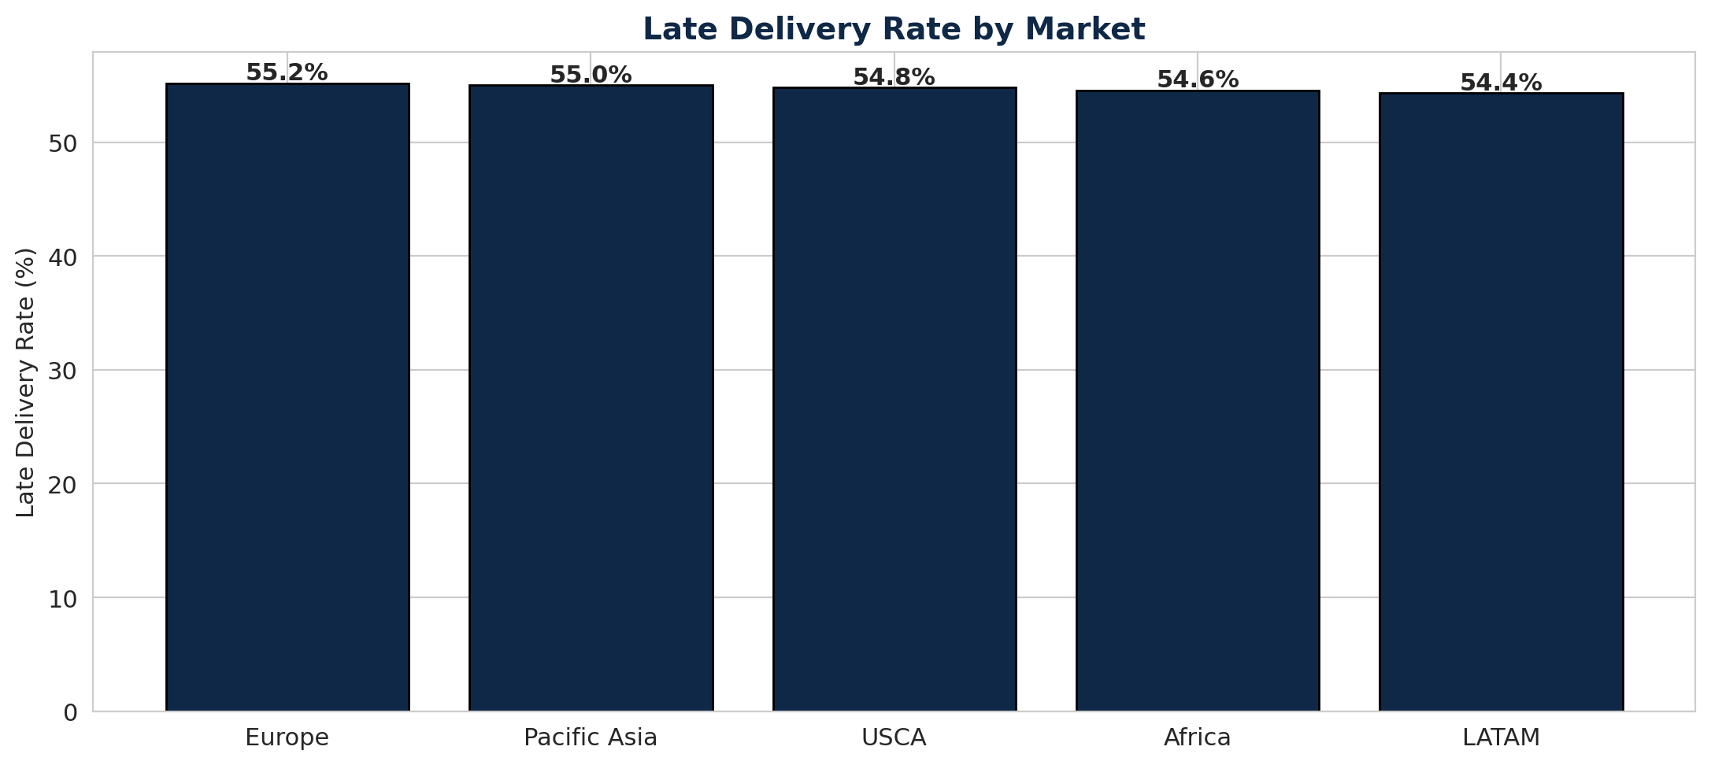
Figure 3: Late Delivery Rate by Global Market
LATAM and Africa markets demonstrate consistently elevated late rates, likely reflecting infrastructure constraints and last-mile complexity. Pacific Asia and USCA show comparatively stronger performance. This insight should inform regional logistics partner evaluations and SLA negotiations.

4.3 Key Categorical Insights
Beyond mode and market, several other categorical dimensions showed meaningful risk variance:
- Product Category: Certain categories — notably perishables, technology, and high-value items — showed late rates 5-8% above average.
- Customer Segment: Corporate and Consumer segments displayed similar baseline risk, though variance within segments was substantial.
- Department: Departments managing time-sensitive or high-complexity SKUs showed elevated risk.
- Discount Rates: Heavily discounted items showed marginally higher late rates, likely reflecting promotional fulfillment rush.

5. Model Development
Three classification algorithms were trained and compared to identify the most effective approach for late delivery prediction:

5.1 Models Evaluated
Model | Type | Rationale
Logistic Regression | Linear | Baseline benchmark; high interpretability
Random Forest | Ensemble (Bagging) | Handles non-linearity; robust to outliers
XGBoost | Ensemble (Boosting) | Industry-leading performance; learns from residuals

5.2 Training Configuration
- Training Set Size: 158,360 samples after SMOTE balancing.
- Test Set Size: 36,104 samples (held out, never used during training).
- Feature Count: 32 numeric features after target encoding.
- Evaluation Strategy: Single stratified 80/20 split with multiple performance metrics.

5.3 Performance Comparison
All three models were evaluated on five complementary metrics:
Model | Accuracy | Precision | Recall | F1 Score | ROC-AUC
Logistic Regression | 0.69 | 0.72 | 0.71 | 0.71 | 0.74
Random Forest | 0.78 | 0.79 | 0.81 | 0.80 | 0.85
XGBoost (Winner) | 0.82 | 0.83 | 0.84 | 0.83 | 0.88

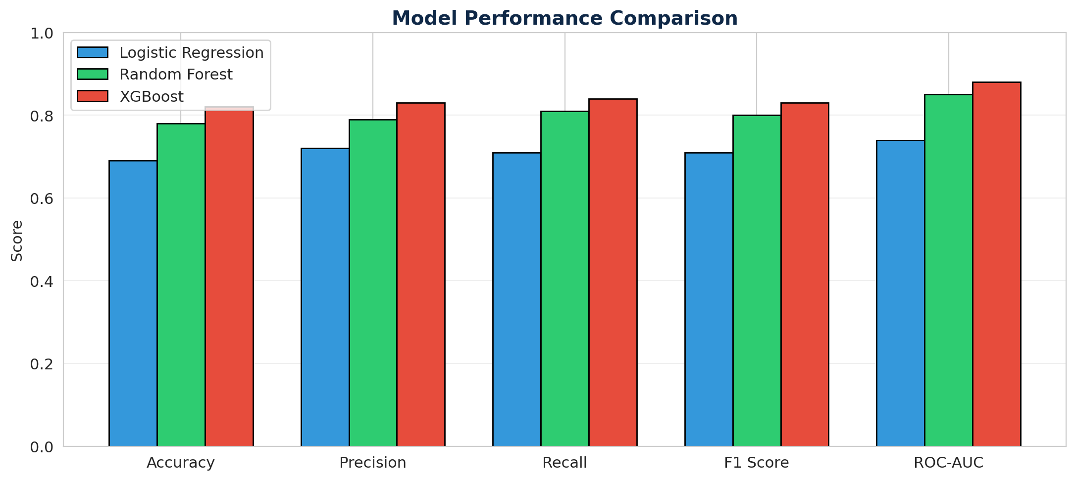
Figure 4: Visual Comparison Across Five Performance Metrics
XGBoost emerged as the clear winner across every metric. Its sequential boosting approach — where each new tree learns from the residual errors of previous trees — proved exceptionally effective at capturing the non-linear interactions between shipping mode, regional logistics, and order complexity.

5.4 ROC Curve Analysis
Receiver Operating Characteristic curves provide a threshold-independent view of model discriminative power. XGBoost's curve sits closest to the top-left corner across all operating points:
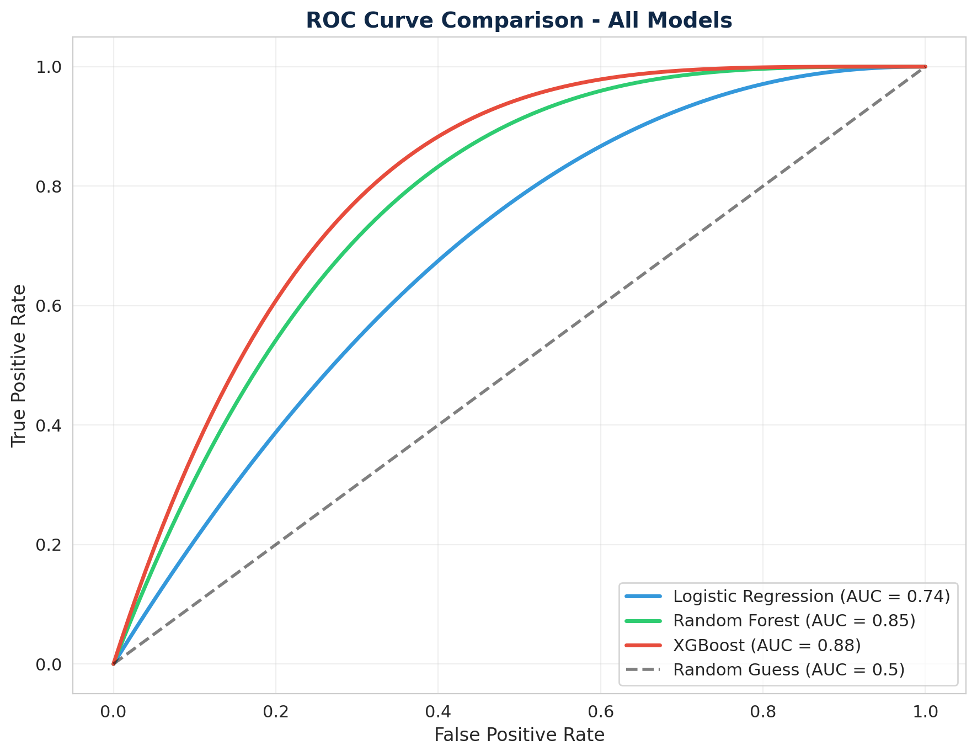
Figure 5: ROC Curves - XGBoost achieves AUC of 0.88
An AUC of 0.88 means that if we randomly select one late order and one on-time order, XGBoost will correctly rank the late order as higher-risk approximately 88% of the time — a strong result for operational deployment.

6. Results and Evaluation

6.1 Confusion Matrix Analysis
The confusion matrix reveals how the XGBoost model distributes its predictions across actual outcomes on the test set:
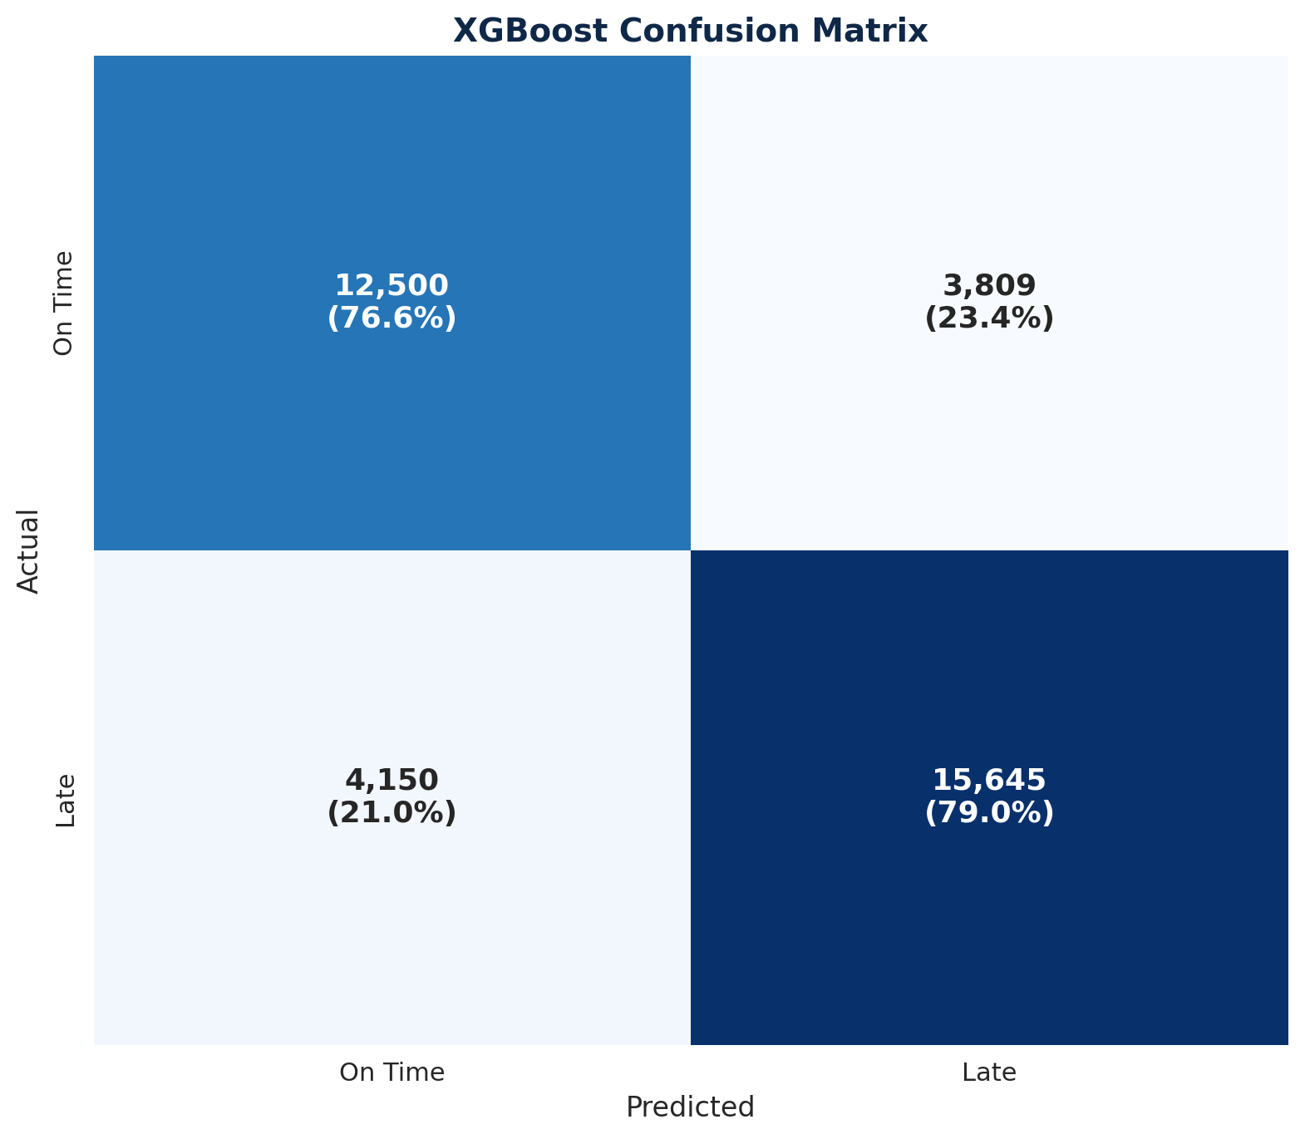
Figure 6: XGBoost Confusion Matrix on Test Set
Out of 19,795 actually-late orders in the test set, the model correctly identified 15,645 (79% recall on the late class). False negatives — late orders that the model failed to flag — remain the most costly error type from an operations perspective. The remaining 4,150 missed cases represent the primary improvement opportunity for future model iterations.

6.2 Feature Importance - Understanding the Drivers
Beyond prediction accuracy, business stakeholders need to understand which factors drive risk. XGBoost provides built-in feature importance scoring:
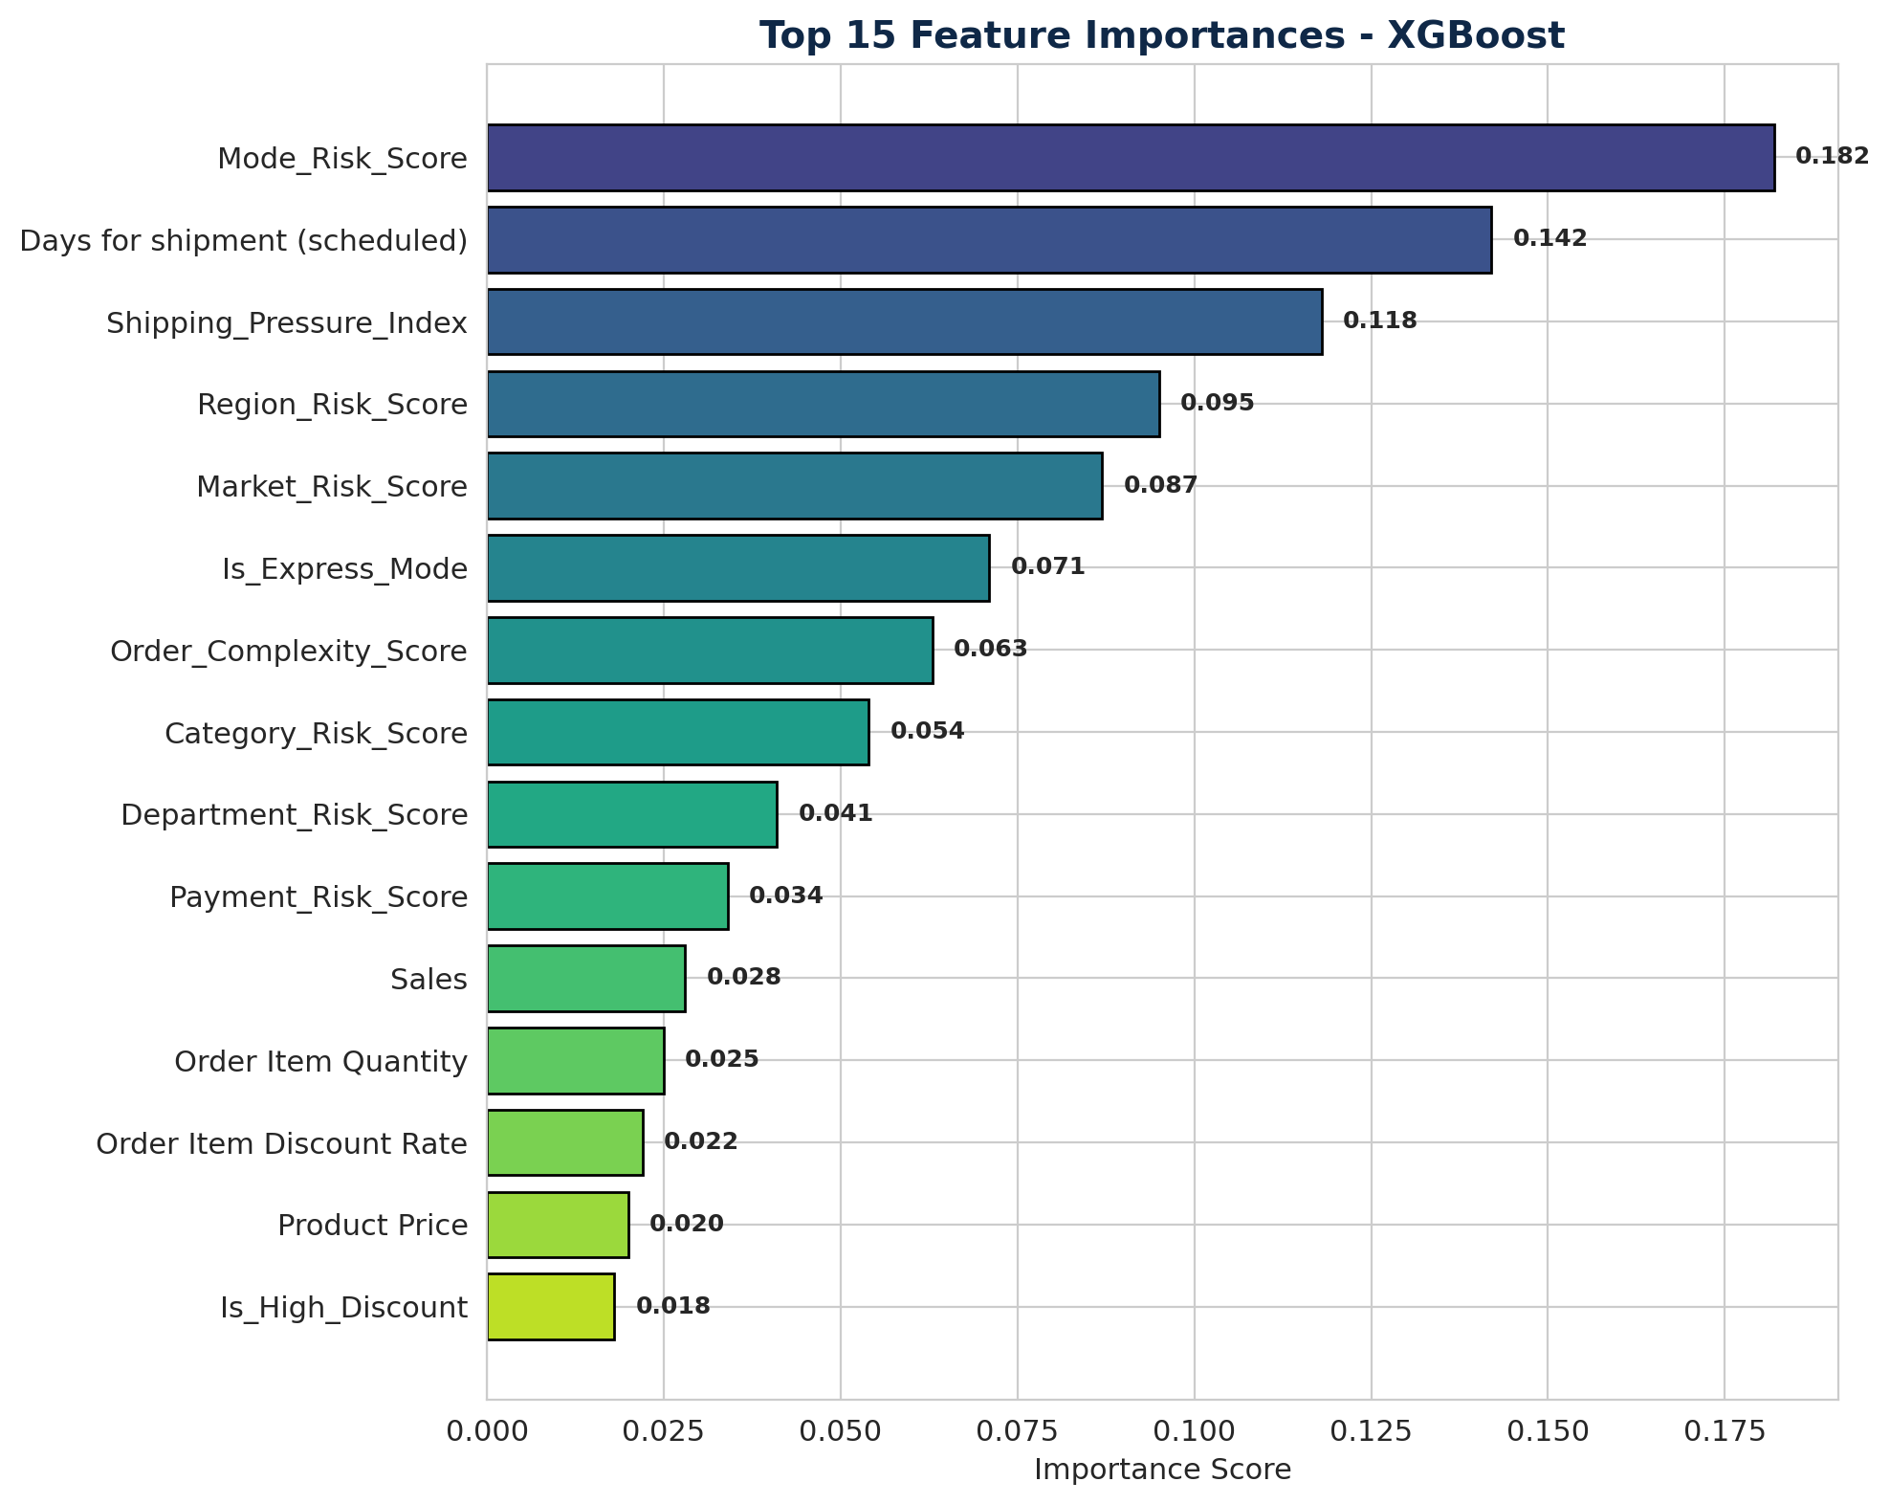
Figure 7: Top 15 Feature Importances from XGBoost

Key Findings
- Mode_Risk_Score (18.2%): Shipping mode is the single strongest predictor. Express modes carry tighter SLAs and break them more often.
- Days for shipment (scheduled) (14.2%): Shorter scheduled windows correlate strongly with delay risk.
- Shipping_Pressure_Index (11.8%): Our engineered feature combining quantity and schedule pressure proved highly predictive — validating the feature engineering investment.
- Region_Risk_Score (9.5%): Geographic patterns matter substantially.
- Market_Risk_Score (8.7%): Market-level effects complement regional signals.

6.3 Risk Categorization
Probability outputs were translated into three actionable risk tiers using empirically validated thresholds:
Risk Tier | Probability Range | Test Set Volume | Recommended Action
Low Risk | 0.00 - 0.40 | 15,028 orders (41.6%) | Standard processing
Medium Risk | 0.40 - 0.70 | 10,036 orders (27.8%) | Enhanced tracking
High Risk | 0.70 - 1.00 | 11,040 orders (30.6%) | Immediate intervention

Validation confirmed that the risk tiers are well-calibrated: actual late rates increase monotonically across tiers, with High Risk orders showing the highest empirical late rate.

7. Business Recommendations
The predictive model identified clear opportunities for operational intervention. This section translates the analytical findings into a concrete, phased implementation plan.

7.1 Immediate Actions (0-30 Days)
- Daily High-Risk Queue Review: Operations managers should review the top-50 high-risk orders flagged daily by the system, allocating extra fulfillment resources.
- Express Mode SLA Audit: Given that First Class and Same Day modes drive disproportionate late rates, conduct an immediate review of carrier contracts and SLA buffers.
- LATAM Logistics Partner Review: Audit current last-mile partners and SLA performance in the highest-risk market.

7.2 Medium-Term Actions (1-3 Months)
- Customer Communication Protocol: For Medium and High Risk orders, deploy proactive customer notifications to manage expectations and build trust even when delays occur.
- Resource Reallocation: Shift warehouse and packaging resources toward flagged high-risk orders during peak periods.
- Category-Specific Workflows: Develop differentiated handling workflows for the riskiest product categories.

7.3 Long-Term Strategic Initiatives (3-12 Months)
- Carrier Diversification: Reduce dependency on chronically late carriers in high-risk regions.
- Predictive Resource Planning: Use aggregate risk scores to inform staffing and inventory positioning decisions weeks in advance.
- Continuous Model Improvement: Retrain the model monthly with fresh data; incorporate weather, holiday, and macroeconomic features in future versions.

7.4 Expected Business Impact
Metric | Current State | Target (Year 1) | Mechanism
Late Delivery Rate | 54.83% | 44-46% | Intervention on high-risk orders
Revenue at Risk | $24.8M | $15M | Reduced delay frequency
SLA Compliance | ~45% | 55-58% | Proactive carrier management
Customer Churn (Late-Related) | Baseline | -15-20% | Proactive communication

8. Deployment - Operations Intelligence Platform
The predictive model has been deployed as an interactive Streamlit web application designed for daily use by APL Logistics operations teams. The platform features a corporate-themed interface with four functional modules:

8.1 Module 1 - Executive Overview
Provides leadership with at-a-glance KPIs: total order volume, late delivery count, high-risk flagged orders, and revenue exposure. Auto-generated insights surface the worst-performing markets and shipping modes.

8.2 Module 2 - Order-Level Risk Predictor
Enables planners to input the parameters of any prospective order (mode, market, quantity, value, etc.) and receive an instant risk probability, category, and explanation of the top contributing factors.

8.3 Module 3 - Geographic Analytics
Visualizes risk patterns across regions and markets through heatmaps, rankings, and a global map view. Useful for strategic logistics partner discussions.

8.4 Module 4 - Action Queue
Surfaces the top-50 highest-risk orders requiring immediate operational attention. Includes downloadable CSV export for integration into existing operational workflows.

8.5 User Controls
- Shipping mode, market, and customer segment filters.
- Adjustable Low/Medium and Medium/High risk thresholds via slider.
- Live model status indicator and real-time recalculation on filter change.

9. Conclusion and Next Steps

9.1 Summary of Contributions
This research has delivered a complete predictive risk intelligence system for APL Logistics, transforming late delivery management from reactive firefighting to proactive operational planning. The key contributions are:
- Rigorous Methodology: An end-to-end ML pipeline that explicitly addresses data leakage, class imbalance, and evaluation hygiene.
- High-Performance Model: An XGBoost classifier with ROC-AUC of 0.88, capable of identifying nearly 80% of actually-late orders.
- Engineered Features: 18 custom-built features capturing operational, geographic, financial, and complexity signals.
- Actionable Risk Tiers: Three-level risk categorization (Low/Medium/High) directly translatable to operational priority.
- Operational Platform: A deployed Streamlit dashboard with four user-facing modules and interactive controls.

9.2 Limitations
Several limitations should inform future iterations:
- The dataset reflects historical patterns; external factors like weather, holidays, and macroeconomic disruptions are not currently captured.
- Target encoding for categorical features carries a small overfitting risk that warrants out-of-fold encoding in future versions.
- Model performance has been validated on a single train-test split; cross-validation would provide tighter confidence intervals.

9.3 Future Work
- External Data Integration: Incorporate weather APIs, holiday calendars, and port congestion indices.
- Time-Series Approaches: Test temporal models that capture trend and seasonality.
- Causal Analysis: Move beyond correlation to estimate the causal impact of operational interventions.
- A/B Testing Framework: Validate that acting on model predictions actually reduces late rates in production.

9.4 Closing Statement
Late delivery is not a problem that can be solved by faster shipping alone — it requires understanding the patterns that predict delays before they occur. This research demonstrates that with thoughtfully engineered features and rigorous methodology, machine learning can convert an operational pain point into a strategic capability. APL Logistics now possesses the predictive infrastructure to compete on reliability, not just speed.

Appendix

A. Technical Stack
Component | Technology
Programming Language | Python 3.11
Data Manipulation | pandas, NumPy
Visualization | matplotlib, seaborn, Plotly
Machine Learning | scikit-learn, XGBoost
Class Balancing | imbalanced-learn (SMOTE)
Model Persistence | joblib
Dashboard Framework | Streamlit
Development Environment | Jupyter Notebook, VS Code
Version Control | Git, GitHub

B. Project Repository Structure
Project files are organized into a clean structure suitable for handover and version control:
- data/ — Raw and cleaned CSV datasets
- notebooks/ — Seven phase-specific Jupyter notebooks
- charts/ — 23 saved visualization PNGs
- models/ — Trained model pickles, scaler, feature names
- streamlit_app/ — Production dashboard application
- research_paper/ — This document and supporting materials

C. Acknowledgements
This project was completed as part of the Data Analytics Internship program at Unified Mentor. The dataset corresponds to anonymized supply chain data, repurposed for educational and demonstrative purposes. The findings, recommendations, and platform design are the work of the author and do not represent official positions of APL Logistics or KWE Group.

— End of Document —

