Smart Auto
Graduation project — diagrams and explanations

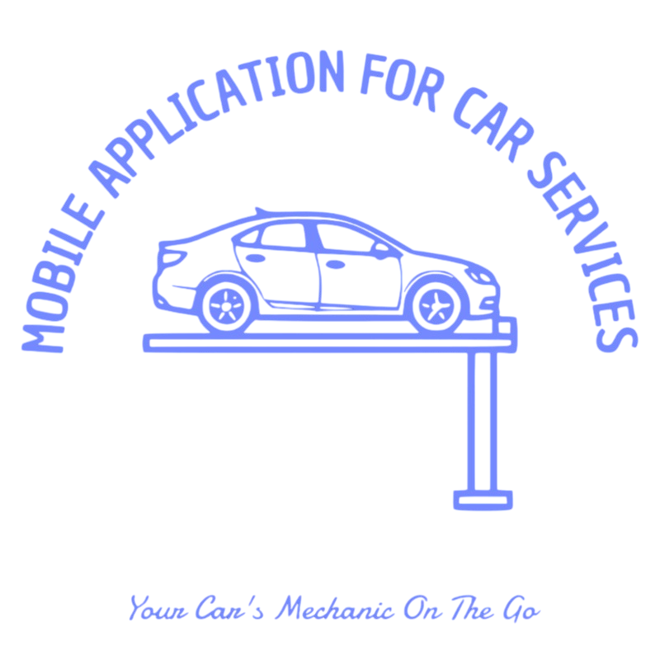

This document belongs to the Smart Auto mobile project. It includes the project logo and exported UML diagrams from the Supabase database design. Each diagram is explained in plain English for your graduation report or defense.

How to read these diagrams
ERD = data structure. Use case = actors and goals. Activity = steps in order. Block = big components. Sequence = who talks to whom and in what order.

1. Entity–Relationship Diagram (ERD)
This diagram shows the main database tables for Smart Auto and how they connect.
Each person who signs up gets a row in profiles (linked to Supabase auth.users). issues stores AI diagnosis runs (text, photo, voice links, and the AI JSON answer). requests are “help me” posts. request_responses links a driver to a request (pending or accepted). chats has one chat per request, and messages stores each chat line with sender and optional read time.
The lines between boxes are foreign keys: data stays consistent when rows are deleted (cascade rules in SQL).

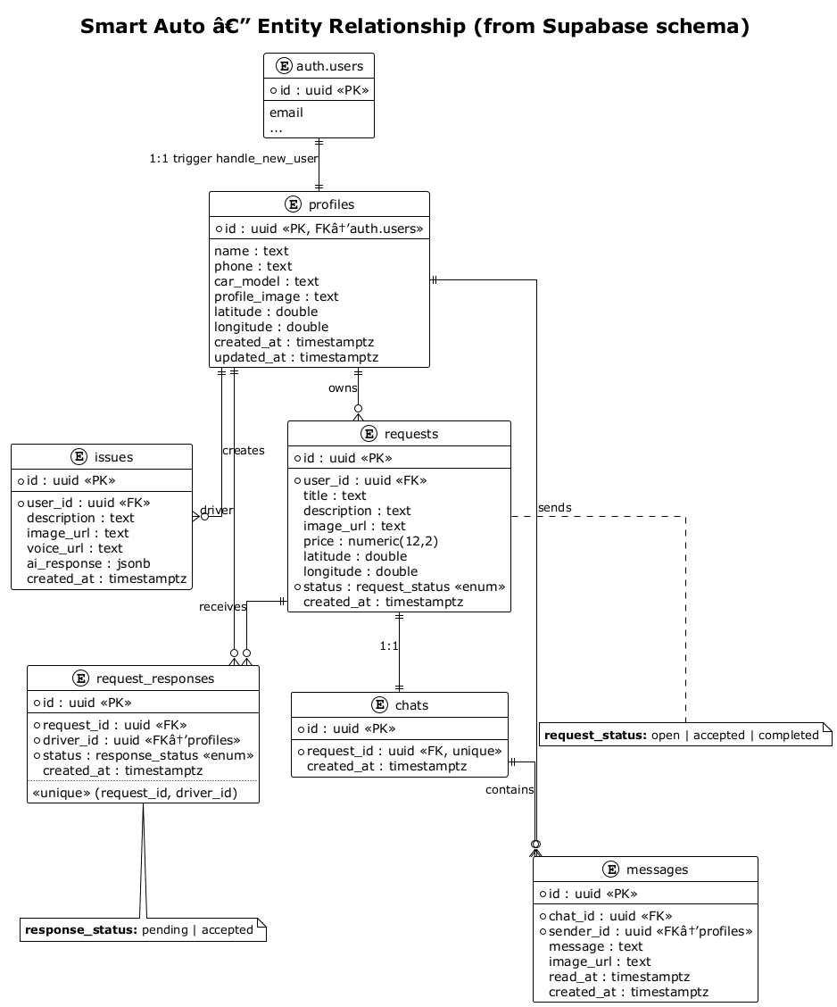

2. Use Case Diagram
This diagram shows who uses the app and what they can do in simple blocks.
Guests can only reach sign-in. Logged-in users can manage their profile, create AI issues, create and browse help requests, respond to requests, chat, and receive realtime updates.
Supabase appears as security (RLS) and file storage because those features sit behind the scenes for almost every action.

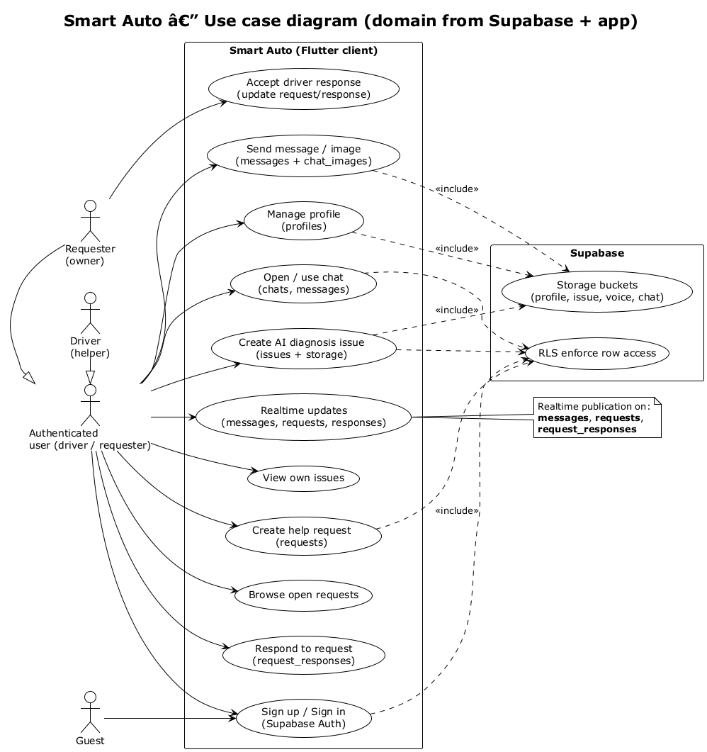

3. Activity Diagram (help request flow)
This is the step-by-step flow for the “community help” feature.
The requester registers, gets a profile automatically, and creates an open request. A driver lists open requests and sends a response. The requester accepts one driver; then the system can open a chat tied to that request. Both sides can send messages.
Notes on the diagram mention database rules (RLS) and realtime messages.

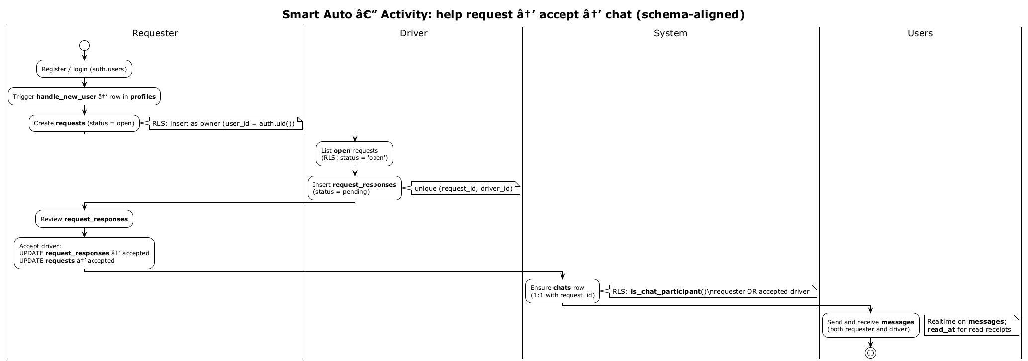

4. Block Diagram (system overview)
This diagram is a high-level map of the whole system—not code detail, just the big boxes.
The Flutter app talks to Supabase for login, database (PostgreSQL), file storage, and realtime channels. It also talks to Maps for location and to an AI service (e.g. Gemini) for diagnosis.
Dotted lines show logical links: auth syncs with profile data, the database stores file URLs, and realtime pushes live updates.

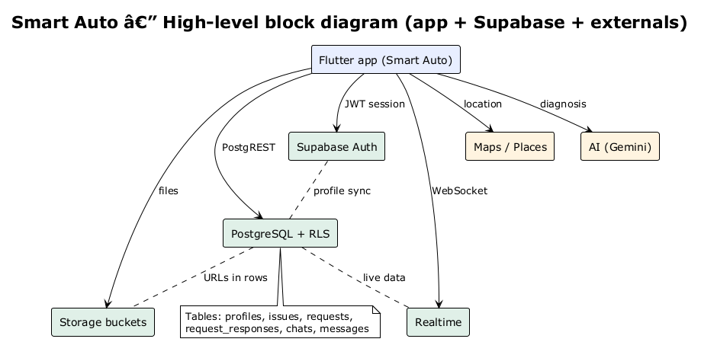

5. Sequence Diagram — Sign up and profile
This diagram shows the order of messages when a new user registers.
The app calls Supabase Auth. When auth.users gets a new row, a database trigger runs and inserts a matching profiles row (function handle_new_user).
Later, the user can update their profile; the database only allows changes to their own row (RLS).

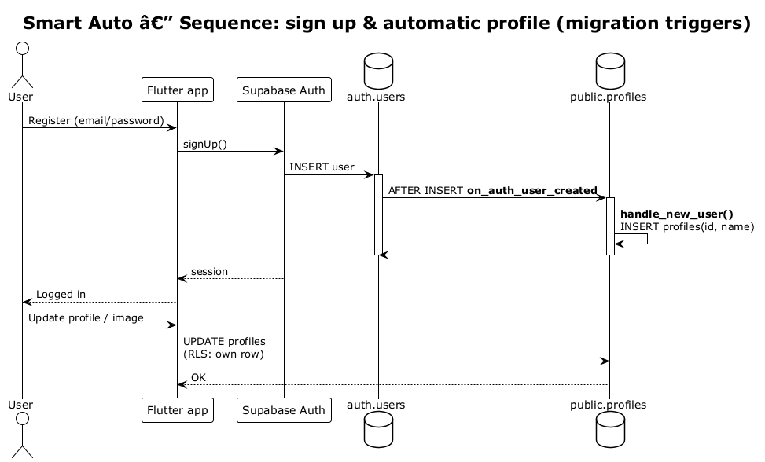

6. Sequence Diagram — Request, accept, and chat
This diagram follows time from top to bottom for the help-request and chat scenario.
The requester creates a request; the driver reads open requests and inserts a response. The requester accepts; both update request and response status.
A chat row is tied to the request. When either side inserts a message, Supabase Realtime can notify the other user so the UI updates quickly.

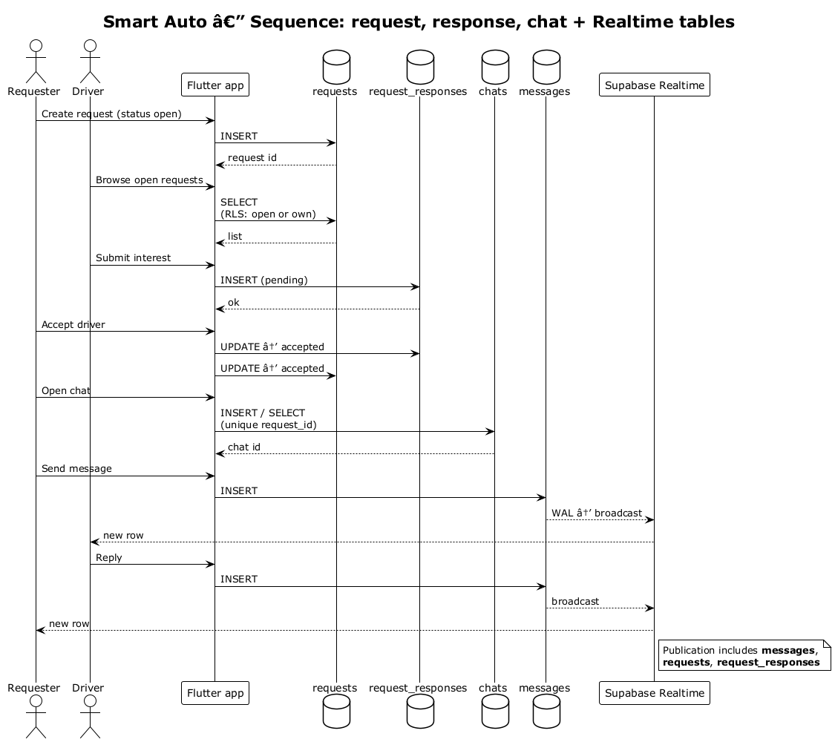

7. Sequence Diagram — AI issue and storage
This diagram shows how an AI diagnosis issue is stored.
The user picks a photo or records voice. The app uploads files to the correct storage bucket (paths scoped by user id in the project rules).
The app inserts a row in issues with the file URLs, calls the AI API, then saves the structured answer in the ai_response JSON field.

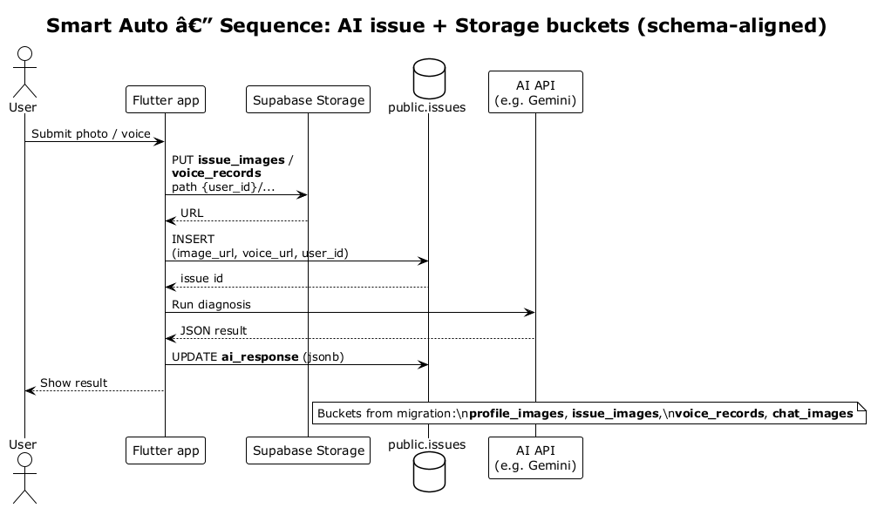

Tools used (short list)
- Flutter & Dart — mobile app
- Supabase — auth, PostgreSQL, storage, realtime
- Google Maps / Geolocator — location
- Google Generative AI (Gemini) — diagnosis
- Riverpod, go_router, Lottie, flutter_animate — UI and navigation
- PlantUML — diagrams (sources in docs/plantuml/)

