**Reel Reviews Table of Contents**

A CSCI 313 project

DR. Ahmed Fathy El Nokrashy

Eng: Rahma Mohamed Ahmed

**Name: Reem Hussin Mostafa ID: 221000241**

**Name: Mohanned Mahmoud ID: 221000703**

**Name: Mahmoud Essa ID: 221001619**

**Name: Ibrahim Alaa ID: 221000837**

**Name: Farida Salah ID: 221000123**

**Name: Abdelrahman Abdelnasser ID: 221001768**

**1 Abstract ----------------------------------------------------------- 3**

**2 introduction**

**2.1 Project Idea ---------------------------------------------------------------- 3**

**2.2 Problem Statement ----------------------------------------------------------- 4**

**2.3 User Personas ---------------------------------------------------------------- 4**

**3 Functional Requirements**

**3.1 User** **Authentication & Account Management ------------------- 4**

**3.2 Game Logic & Mechanics ------------------------------------------------------ 5**

**3.3 Scoring & Leaderboard ------------------------------------------------- 5**

**3.4 Social Features ----------------------------------------------------------------------- 5**

**4 Non-Functional Requirements**

**4.1 Performance ------------------------------------------------------------------------ 6**

**4.2 Scalability --------------------------------------------------------------------------- 6**

**4.3 Usability ----------------------------------------------------------------------------- 6**

**4.4 Reliability ---------------------------------------------------------------------------- 6**

**4.5 Security --------------------------------------------------------------------------- 6**

**4.6 Maintainability------------------------------------------------------------ 6**

**4.7 Accessibility ------------------------------------------------------------------------- 7**

**4.8 Localization ------------------------------------------------------------------ 7**

**5 Diagrams**

**5.1 use case diagram ------------------------------------------------------------**

**5.1.1use case diagram scenarios --------------------------------------------------**

**5.2 class diagram --------------------------------------------------------------**

**5.3 sequence diagram ---------------------------------------------------------**

**1. Abstract**

Traditional Tic-Tac-Toe games are simple and lack variations to engage users. The proposed "Ultimate Tic-Tac-Toe" seeks to solve this by providing a more challenging and engaging gameplay experience with local multiplayer over the same network. The goal is to allow players to enjoy a modern, feature-rich version of Tic-Tac-Toe with personalized themes, enhanced interactivity, and local network support.

**2. introductions**

**2.1. Project Idea**

The goal of the **Ultimate Tic Tac Toe** project is to create a unique twist on the traditional Tic Tac Toe game by expanding the board into a multiple grid of smaller grids. Each player's move will determine where their next move can be made, adding more layers of strategy and complexity to the game. The platform will offer both single-player and multiplayer modes, an intuitive user interface. The game will be developed using a modern web framework to ensure a smooth and interactive user experience. The objective is to create a fun, challenging, and dynamic game that players of all levels will enjoy.

**2.2. Problem Statement**

While Tic Tac Toe is a widely recognized game, it lacks the complexity and depth to keep players engaged for extended periods. The challenge lies in creating an enhanced experience that offers more strategic gameplay, making it more exciting and engaging than the traditional version. Additionally, many online multiplayer games suffer from poor interaction mechanics and lack the intelligent systems and interactive features that improve the user experience. **Ultimate Tic Tac Toe** aims to bridge this gap by offering a game that is fun, flexible, and complex enough to keep players entertained, whether playing solo or with friends.

* 1. **. User Personas**

Person Player

* **Goals:**
  + Compete in games that require strategic thinking.
  + Play with friends to test its skills in a challenging environment.
  + Track progress and achieve consecutive victories.
* **Challenges**:
  + Hard to use interface.
  + Finds basic games repetitive and too easy.

**3. Functional Requirements**

**3.1. Choose Game Mode:**

* With AI or with friends.

**3.2. Game Logic & Mechanics**

* **3x3 Grid Structure:** The game is played on a 3x3 grid of smaller grids, adding complexity and strategy.
* **Move Restrictions:** Each player's move determines where they can place their next piece based on the opponent's previous move.
* **Multiplayer Mode:** Users can play against each other in real-time.

**3.3. Scoring & Leaderboard**

* **Game Win Condition:** A player wins by completing a row, column, or diagonal across the larger 3x3 grid.
* **Leaderboard:** A leaderboard will display top scores and global rankings.

**3.4. End of Game**

* + Display winner with animations and provide options to restart or exit.

**4 Non-Functional Requirements**

**4.1. performance**

* + The platform should support up to 1000 users without delays in gameplay actions.
  + The system should handle multiple simultaneous games with minimal latency.

**4.2. scalability**

* + The platform should be able to handle more players and games as it grows.

**4.3. usability**

* + The user interface should be simple, intuitive.

**4.4. reliability**

* + The system should be stable and available at all times, ensuring no interruptions to gameplay.

**4.5. security**

* + HTTPS should be implemented to ensure secure communication between the server and the user.

**4.6. maintainability**

* + The codebase should be clean, and well-documented to allow easy updates and feature additions.

**5. Diagrams**

**5.1. use case diagram**

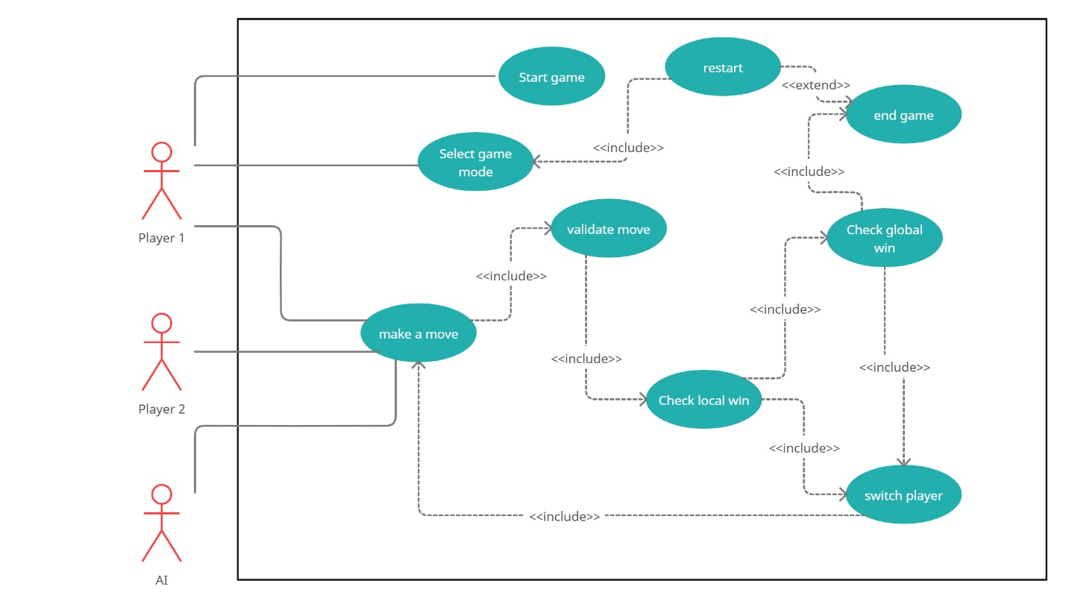

**5.2. class diagram**

**5.3. sequence diagram**

