1) Create on Bash script to check if a directory is available or not.

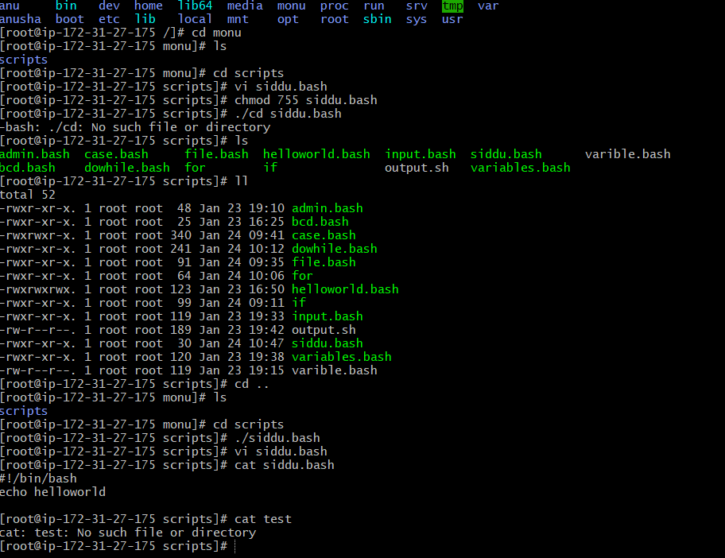

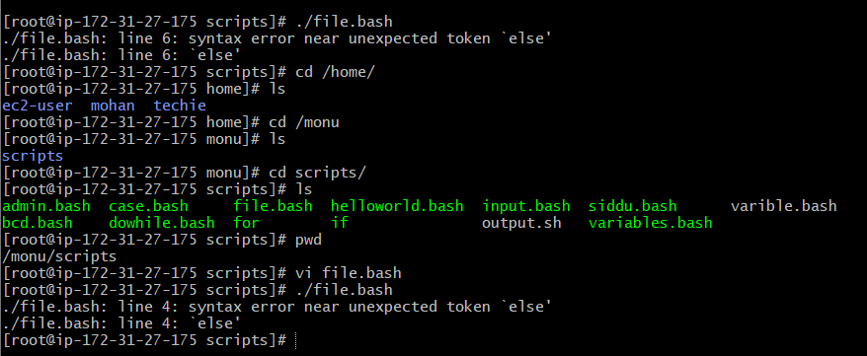

2) Create a bash script which will create multiple files

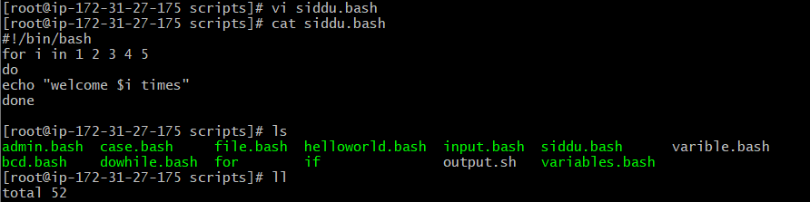

3) Create a bash script to take backup of a directory.

4) Create a bash script to install nginx in ec2 server.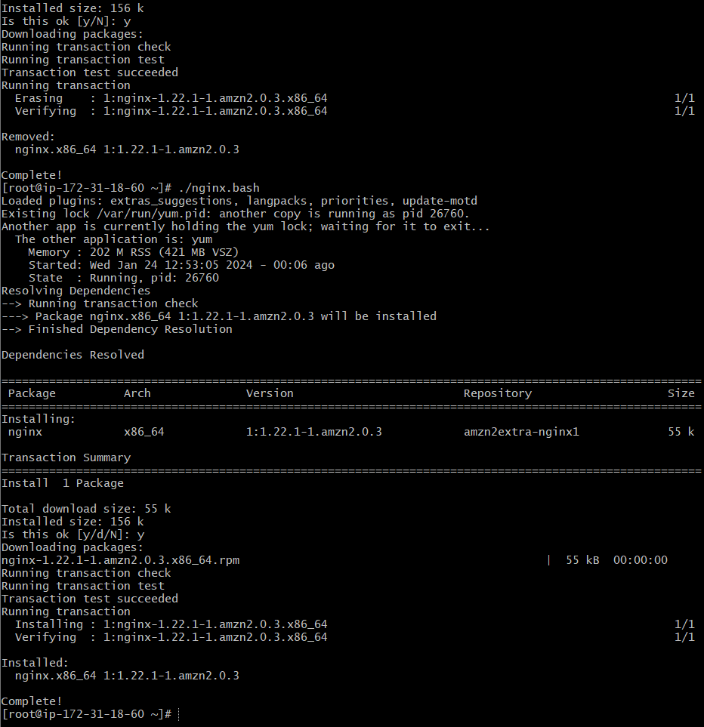

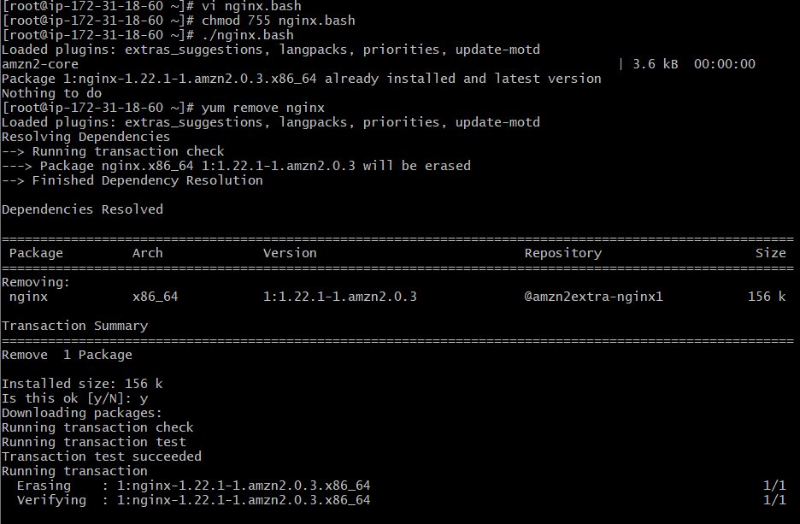

5) Create a bash script to install ApacheTomcat in ec2 server.

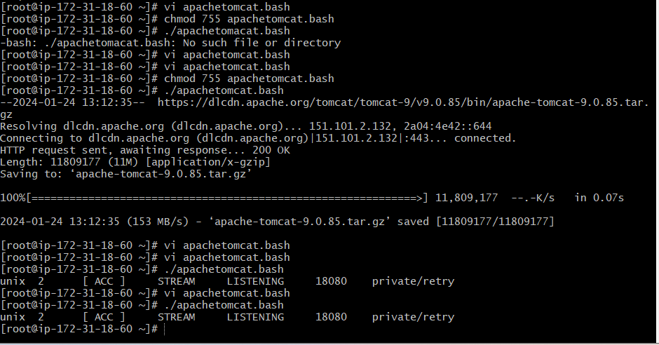

6) Create a bash script to check list if nginx service is running or not,if not running

then script should start the service.