

{{PROJECT}} Delivery Release Notes
Release_{{SNO}}
{{DATE}}

Copyright Notices
Copyright © 2018 MetricStream Inc., All Rights Reserved.
This document as well as the software described within it, is furnished under license and may only be used or copied within the terms of that license.
Except as permitted by license, no part of this publication may be reproduced, stored in a retrieval system, or transmitted, in any form or by any means – electronic, mechanical, recording, or otherwise – without the prior written permission of MetricStream, Inc.
Written and designed at MetricStream, Inc., 2600 East Bayshore Road, Palo Alto, CA 94303, U.S.A.
Printed in U.S.A.
MetricStream Proprietary, Confidential Information - Use Restricted by Contract

CAUTION
This document contains proprietary, confidential information that is the exclusive property of MetricStream, Inc. If you do not have a valid contract with MetricStream for the use of this document or have not signed a non-disclosure agreement with MetricStream, then you receive this document in an unauthorized manner and are not legally entitled to possess or read it.
Use, duplication, and disclosure are subject to restrictions stated in your contract with MetricStream, Inc. Use, duplication, and disclosure by the Government are subject to restrictions on commercial software and shall be deemed to be Restricted Rights software under Federal Law.

Document Control
This page and the signature page should be erased in released document. Do not delete page since that will impact numbering – simply leave the page empty

Change Record
Date | Author | Release Version | Change Reference | Change Details
{{DATE}} | {{AUTHOR}} | Release_{{SNO}}

Signatures
Date | Name | Signature
{{DATE}} | Rabindranath Das | Rabindranath Das

{{PROJECT}} Release_{{SNO}}_Patch Release Notes

Purpose
This document provides the Delivery checklist and other pertinent details for Install/Patch for {{PROJECT}} Release_{{SNO}}

Release Summary
{{RELEASE_TABLE}}

Impacted Areas
{{IMPACT}}

Scope of Testing:
{{RELEASE_TABLE}}

Additional Changes:
NA

Open Issue:
NA

Descoped Items:
{{DESCOPED}}

Out of Scope:
{{OOS}}

Impacted Queries:
NA

Data Model Impact:
No Impact

Files required to Install the patch:
{{JAR_DETAILS}}

Installation:
Pre-Installation Steps:
{{PRE_INSTALLATION}}
Installation:

For QA deployment follows CMT deployment process (done by dev):

Jenkins URL for CMT: QA Pipeline [Jenkins] : login with full email id

1.Login to Jenkins Select the project name Click on QA Pipeline Build with Parameters
Select the customer, Sprint 1 and Release 117,118,119
-> Move the applied installers to right under
Listo Installers -> Build ->Example is below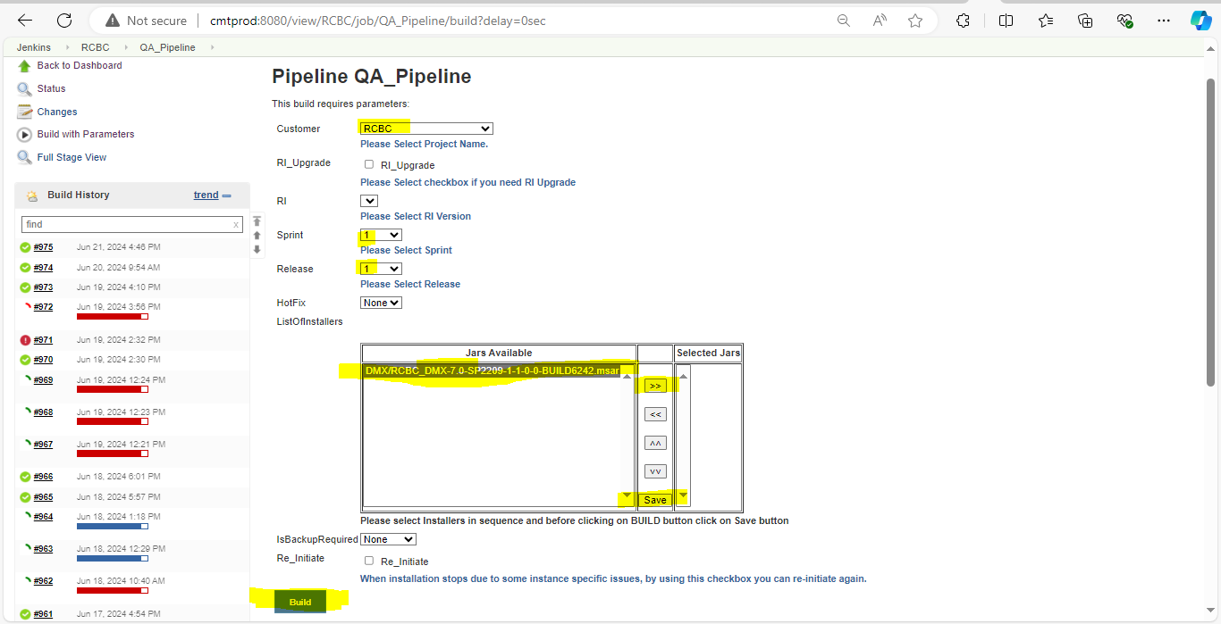

After Build the registered QA should approve accordingly and finally approve the Mark deliver after the testing part is successful.

For UAT and Prod deployment follow the regular deployment process as below

- Stop Application Services (Apache and Tomcat)
- Provide the File names in <MetricStream_Home>/metricstream-installer-app/ms-
packages/installer-list.txt” in the following order.

- JAR 1

- Navigate to “<MetricStream_Home>/metricstream-installer-app/” path and run the below
command to start installation of MSAR files.

Post-Installation Steps:
{{POST_INSTALLATION}}

Script(s):

Schedule Infolet:

Additional Document:

Details of Release:

Accompanying Documentation

Unit Test case path

Modified Objects List path

Known Limitations:

Internal Open Defect List:
NA

Appendix A:
NA

