**Name**: P.Mohan Sai Nikil

**Mail** : mohanchowdary1404@gmail.com

Vcube Batch No:125(10AM)

**Github**: https://github.com/Mohansainikil-2003

**Task: Cross Replication**

1. Go to AWS Console login ->login to account.
2. Go to S3 then search buckets .
3. Now create buckets(sourse & destination) in different regions .
4. Enable the versioning for both buckets in their regions

Then go to create Replication edit the details.

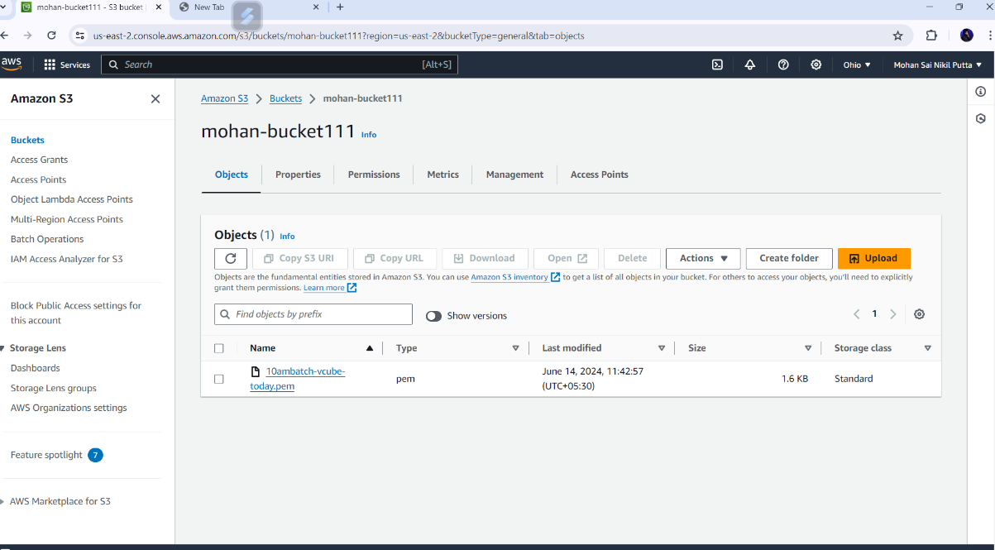

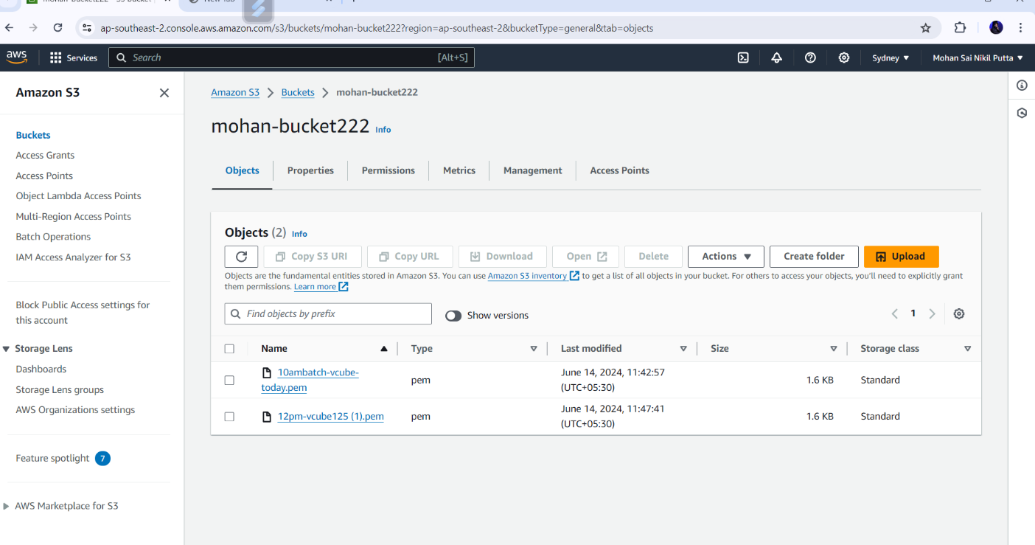

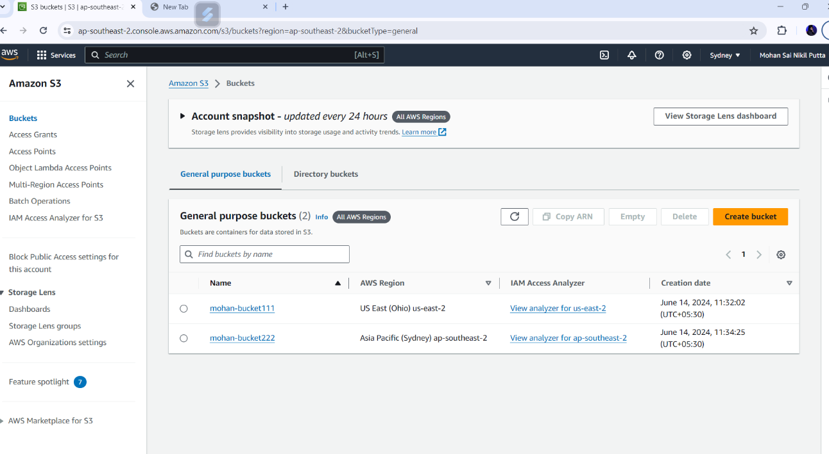

* Sourse bucket files transfer into destination bucket.
* By this way we replicate the buckets.