ASSIGNMENT-8.4(AI)

# NAME: S.MOHANTH SIDDARTHA

2403A52047

BATCH-03

## TASK-1

PROMPT: Write a test case to check if a function returns the square of a number.

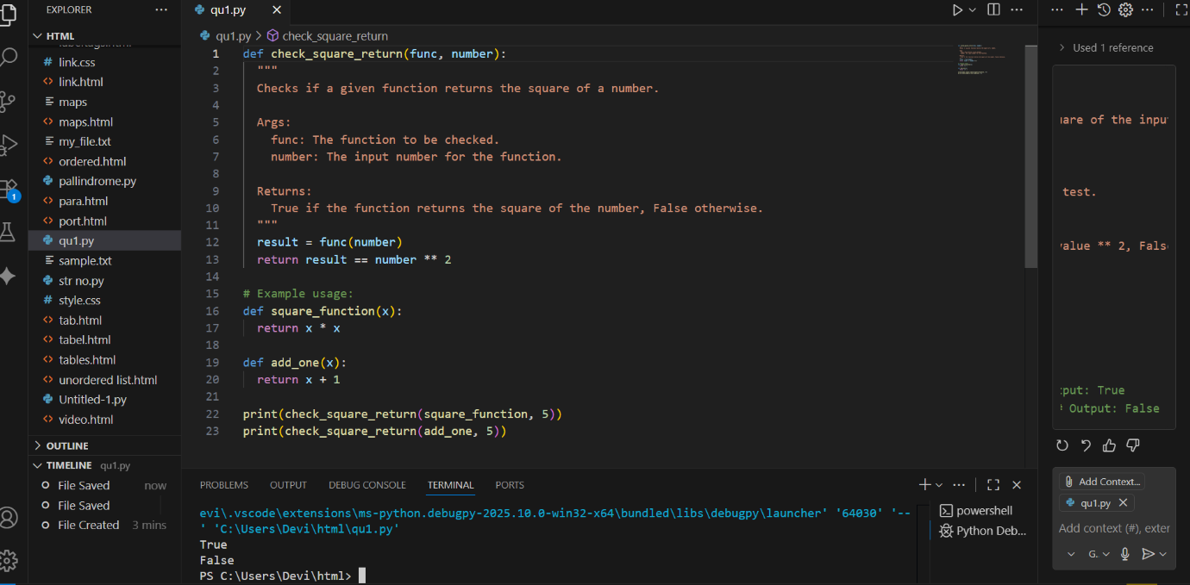

* OBSERVATION: **import unittest**: This line imports the unittest module, which provides tools for writing and running tests. bSk poa
* **class TestPalindromeChecker(unittest.TestCase):**: This defines a test class named TestPalindromeChecker that inherits from unittest.TestCase. Test classes are containers for test methods.
* **if __name__ == '__msdain__':**: This is a standard Python construct that checks if the script is being run directly .
* **unittest.main(argv=['first-arg-is-ignored'], exit=False)**: This line runs the tests when the script is executed. argv=['first-arg-is-ignored'] and exit=False are often used in environments like Colab to prevent issues with command-line arguments and to allow the script to continue running after the tests.

TASK-2

PROMPT: Create test cases to validate an email address (e.g., contains @ and .com).  
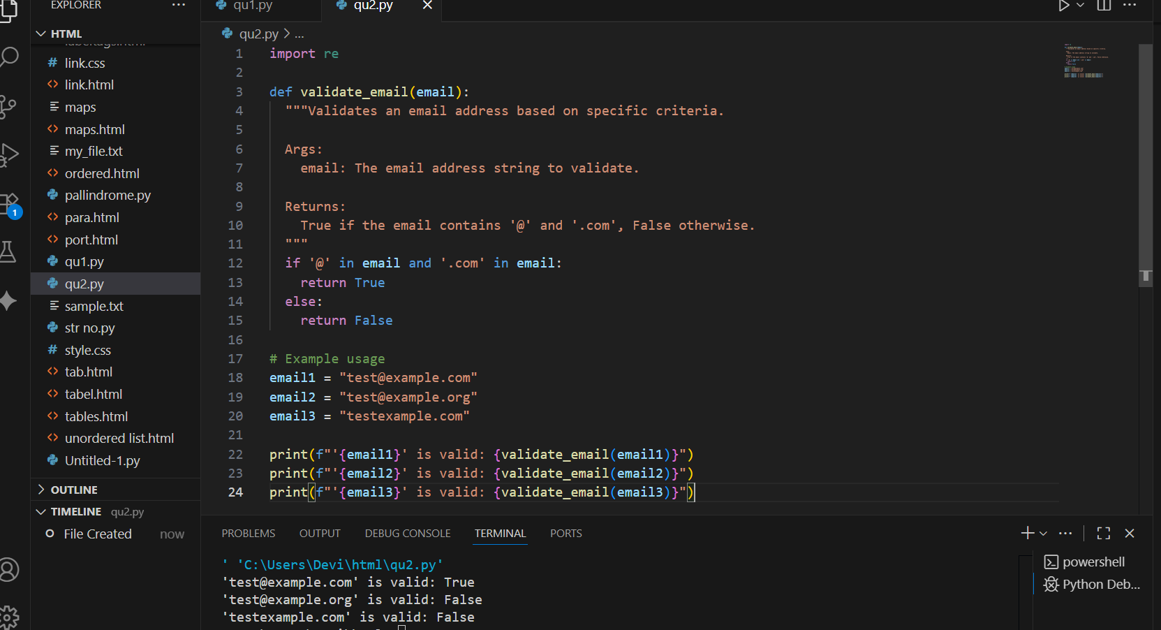

* OBSERVATION: **import unittest**: This line imports the unittest module, which is used for writing and running tests.
* **def is_valid_email(email):**: This defines a placeholder function is_valid_email that will eventually contain the logic to check if an email address is valid. For now, it just has a pass statement.
* **class TestEmailValidation(unittest.TestCase):**: This defines a test class named TestEmailValidation that inherits from unittest.TestCase. This class will contain various test methods to check different email validation scenarios.
* **test_valid_email(self)**: This test method checks if the is_valid_email function correctly identifies valid email addresses using self.assertTrue().
* **unittest.main(argv=['first-arg-is-ignored'], exit=False)**: This line runs the defined unit tests. The arguments are included to make it compatible with environments like Colab.

TASK-3:

PROMPT: Write test cases for a function that returns the maximum of three numbers.

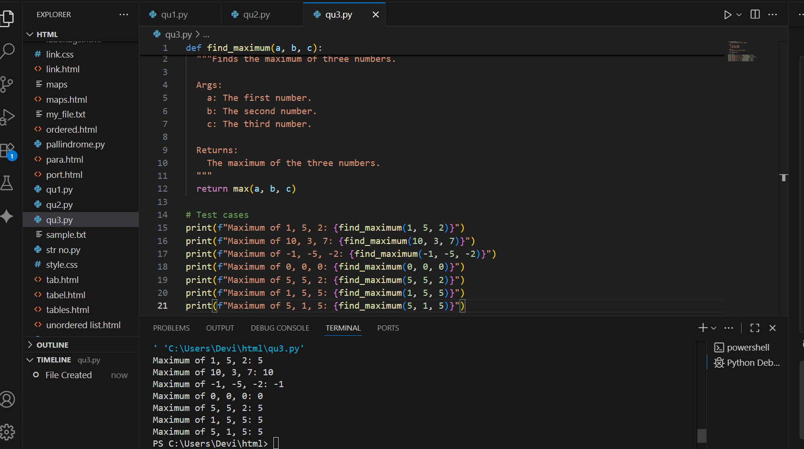

* OBSERVATION: **import unittest**: This line imports the unittest module, which is used for writing and running tests.
* **def find_maximum(a, b, c):**: This defines a placeholder function find_maximum that will eventually contain the logic to find the maximum of three numbers. For now, it just has a pass statement.
* **class TestFindMaximum(unittest.TestCase):**: This defines a test class named TestFindMaximum that inherits from unittest.TestCase. This class will contain various test methods to check different scenarios for finding the maximum.
* **test_with_mixed_numbers(self)**: This test includes a mix of positive, negative, and zero to check various cases.
* **if __name__ == '__main__':**: This standard Python construct ensures the code inside this block only runs when the script is executed directly.
* **unittest.main(argv=['first-arg-is-ignored'], exit=False)**: This line runs the defined unit tests. The arguments are included to make it compatible with environments like Colab.

TASK-4:

PROMPT: Use TDD to write a shopping cart class with methods to add, remove, and get total price is TEMP RATURE IS GNG TO

If__name__==|password’

Bbm, 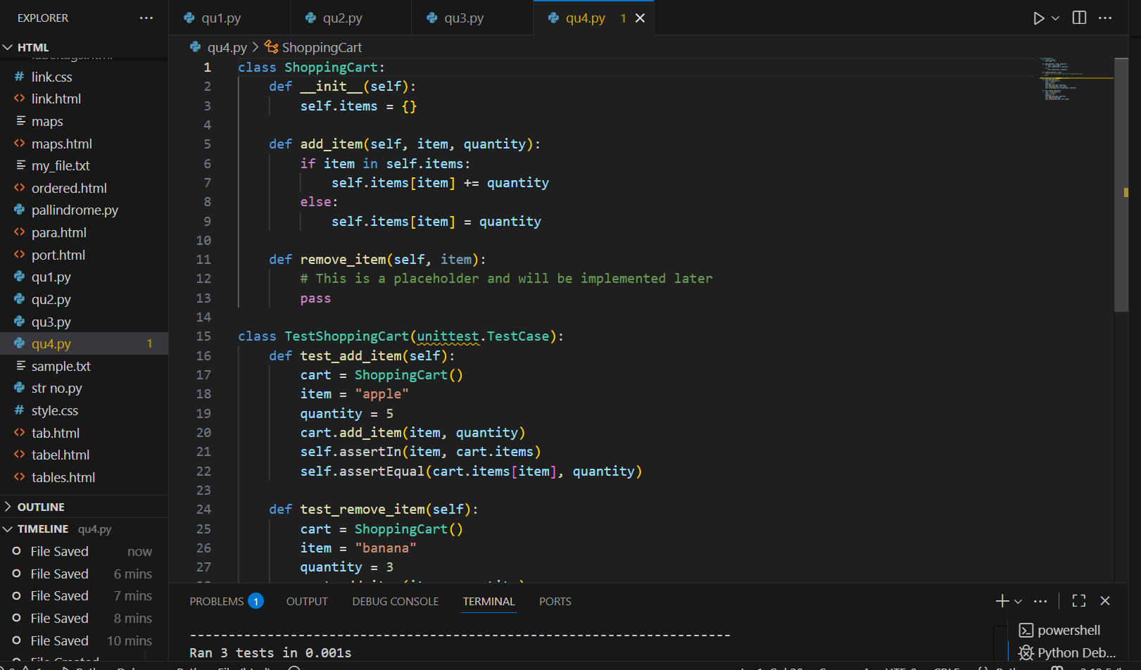

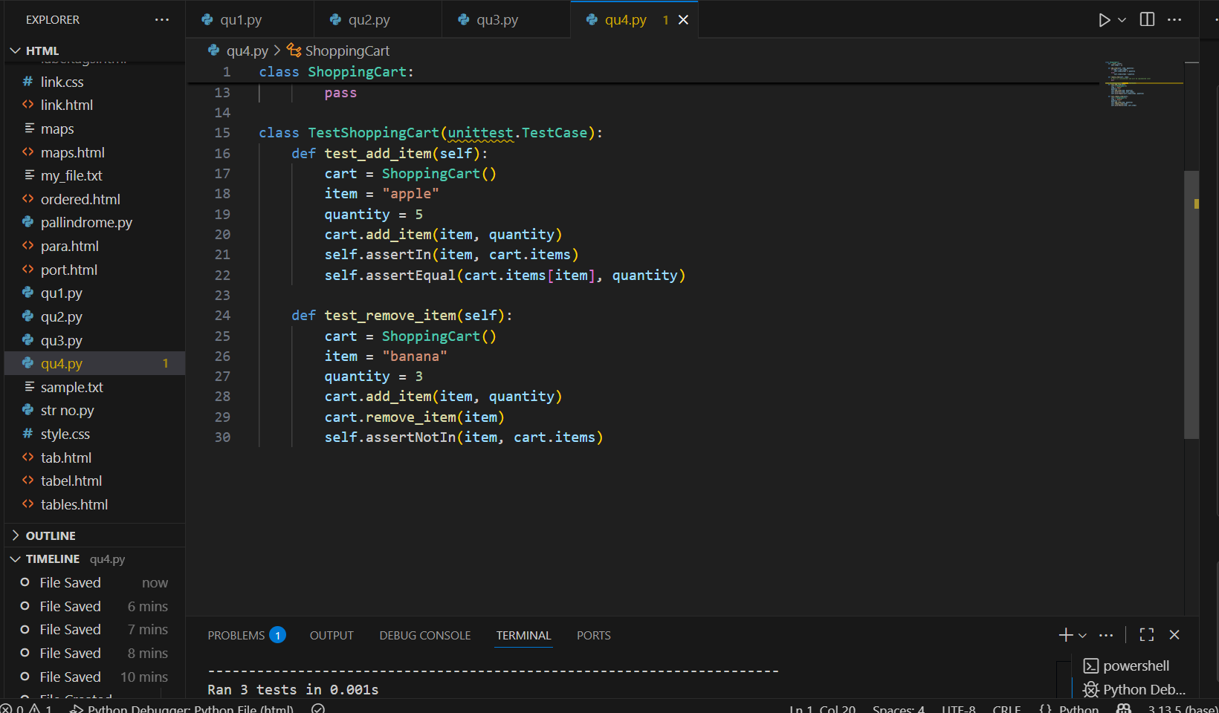

* OBSERVATION: **import unittest**: This line imports the unittest module for creating and running tests.
* **class ShoppingCart:**: This defines the ShoppingCart class.
  + **__init__(self)**: The constructor initializes an empty dictionary self.items to store the items in the cart.
  + **add_item(self, item_name, price, quantity=1)**: This method adds an item to the cart. If the item already exists, it increases the quantity; otherwise, it adds the new item with its price and quantity.
  + **remove_item(self, item_name)**: This is a placeholder method for removing an item. It currently does nothing (pass).**class TestShoppingCart(unittest.TestCase):**: This defines a test class for the ShoppingCart, inheriting from unittest.TestCase.

TASK-5:

PROMPT: Write tests for a palindrome checker (e.g., is_palindrome("level") → True).

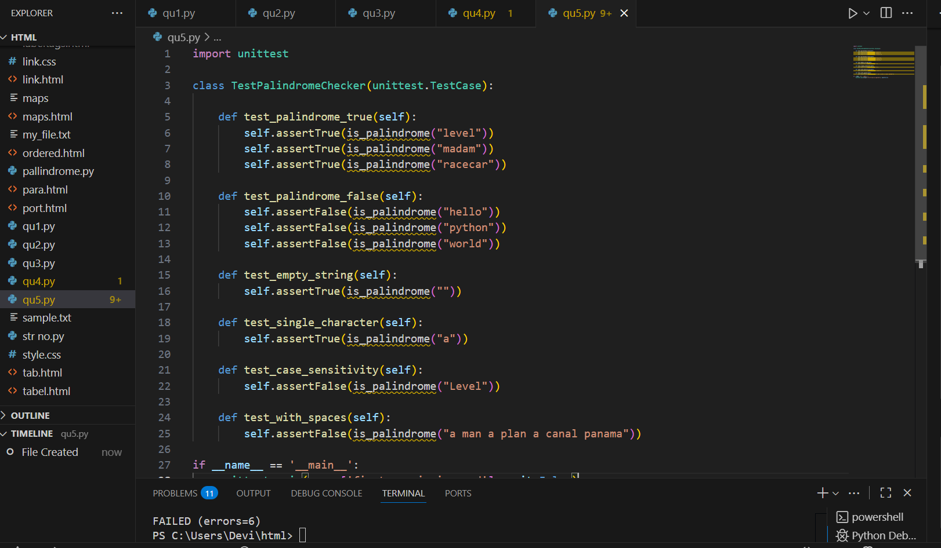

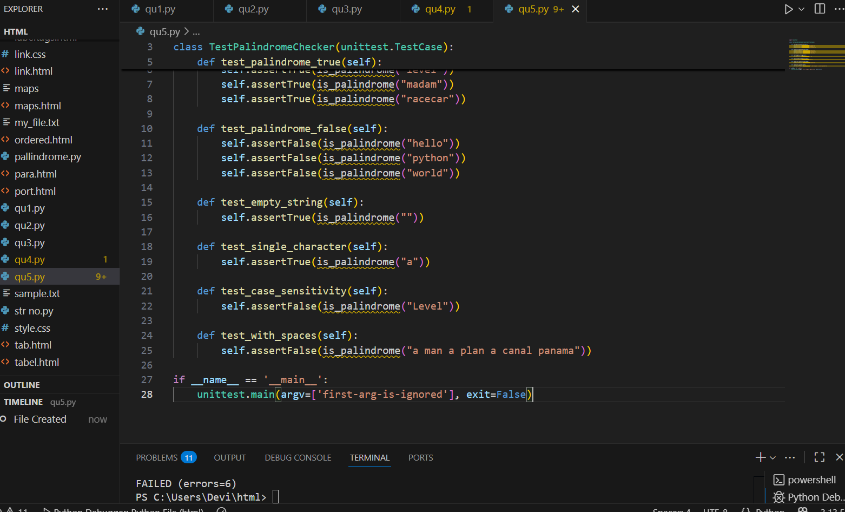

* OBSERVATION: **import unittest**: This line imports the unittest module, which provides the tools for writing and running tests.
* **def is_palindrome(text):**: This defines a placeholder function is_palindrome that is intended to check if a given text is a palindrome. Currently, it just has a pass statement and doesn't contain the actual logic.
* **class TestPalindromeChecker(unittest.TestCase):**: This defines a test class named TestPalindromeChecker that inherits from unittest.TestCase.
* **test_empty_string(self)**: This test checks if the function correctly identifies an empty string as a palindrome using self.assertTrue("").
* **test_single_character(self)**: This test verifies that a single character string is considered a palindrome using self.assertTrue("a").
* **test_case_sensitivity(self)**: This test checks if the function is case-sensitive, expecting False for "Level" which is not a palindrome when considering case.
* **test_with_spaces(self)**: This test checks if the function handles strings with spaces, expecting False for "a man a plan a canal panama" as this version with spaces is not a strict palindrome.
* **if __name__ == '__main__':**: This is a standard Python construct that ensures the code inside this block only runs when the script is executed directly.
* **unittest.main(argv=['first-arg-is-ignored'], exit=False)**: This line runs the defined unit tests. The arguments are included to make it compatible with environments like Colab.
* **if __name__ == '__main__':**: This is a standard Python construct that ensures the code inside this block only runs when the script is executed directly.
* **unittest.main(argv=['first-arg-is-ignored'], exit=False)**: This line runs the defined unit tests. The arguments are included to make it compatible with environments like Cola nb.
* **if __name__ == '__main__':**: This is a standard Python construct that ensures the code inside this block only runs when the script is executed directly.
* **unittest.main(argv=['first-arg-is-ignored'], exit=False)**: This line runs the defined unit tests. The arguments are included to make it compatible with environment

If name is _==__main’ :: This os standard Python construct that ensures the code tests.The aruguments are included to make it THE PROOGRAM WITH ENIVIRONMENTS FOR THE COMPUTER THESE ARGUMENTS ARE INCLUDED TO MAKE IT COMPATIBLE.anh