1.C-program for Fibonacci series:

#include<stdio.h>

int fib(int n)

{

if (n <= 1)

return n;

return fib(n-1) + fib(n-2);

}

int main()

{

int num, n = 0, i;

printf("Enter number of terms:");

scanf("%d",&num);

printf("\nFibonacci series:\n");

for ( i = 1 ; i <= num ; i++ )

{

printf("%d\n",fib(n));

n++;

}

}

OUTPUT:

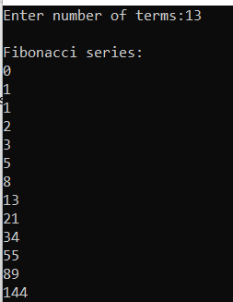

2.C-Program for ODD number series up to N=50

Program:

#include<stdio.h>

int main()

{

int a=21;

int num;

printf("enter the max number value:");

scanf("%d",&num);

printf("the odd numbers in the list are");

while(a<=num)

{

printf("%d\t",a);

a=a+2;

}

}

OUTPUT:



3.C-Program to find the factorial of n

Program:

#include<stdio.h>

unsigned int factorial(unsigned int n)

{

if(n==0)

return 1;

return n*factorial(n-1);

}

int main()

{

int num;

printf("enter the number values:");

scanf("%d",&num);

printf("factorial of %d and %d",num,factorial(num));

return 0;

}

Out put:



4.C-program given number is amstrong or not.

Program.

#include<stdio.h>

int main()

{

int n,r,sum=0,temp;

printf("enter the number");

scanf("%d",&n);

temp=n;

while(n>0)

{

r=n%10;

sum=sum+(r*r*r);

n=n/10;

}

if(temp==sum)

printf("armstrong number");

else

printf("not armstrong number");

return 0;

}

OUTPUT:





5.C-Program to print the reverse a number.

Program.

#include<stdio.h>

int main()

{

int n,rem,rev=0;

printf("enter the number");

scanf("%d",&n);

while(n!=0)

{

rem=n%10;

rev=rev*10+rem;

n=n/10;

}

printf("Reverse Number:%d",rev);

}

OUTPUT:



6.C-program to calculate the grade

Program:

#include<stdio.h>

int main()

{

int score;

printf("enter the score(0-100):");

scanf("%d",&score);

switch(score/10)

{

case 10:

printf("Grade:S");

break;

case 9:

printf("Grade:A");

break;

case 8:

printf("Grade:B");

break;

case 7:

printf("Grade:c");

break;

case 6:

printf("Grade:D");

break;

case 5:

printf("Grade:E");

break;

default:

printf("Grade:F");

break;

}

return 0;

}

OUTPUT:



7.C-Program to find largest number and smallest number.

Program:

int main()

{

int arr[100], n, i, small, large;

printf("Enter the number of elements you want to insert : ");

scanf("%d", &n);

for (i = 0; i < n; i++)

{

printf("Enter element %d : ", i + 1);

scanf("%d", &arr[i]);

}

small = arr[0];

large = arr[0];

for (i = 1; i < n; i++)

{

if (arr[i] < small)

{

small = arr[i];

}

if (arr[i] > large)

{

large = arr[i];

}

}

printf("\nLargest element is : %d", large);

printf("\nSmallest element is : %d", small);

return 0;

}

Output:

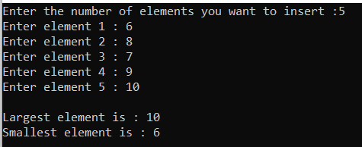

8.C-PROGRAM FOR EVEN SERIES

PROGRAM:

#include <stdio.h>

int main()

{

int a=1;

int num;

printf("\n Please Enter the Maximum num Value : ");

scanf("%d", &num);

printf("The even numbers in the list are");

while( a <= num)

{

printf("%d \t ",a);

a=a+2;

}

}

OUTPUT:



9.C-Program swapping of two numbers.

Program.

#include<stdio.h>

#include<conio.h>

int main()

{

int a, b;

clrscr();

printf("Enter value of a: ");

scanf("%d", &a);

printf("Enter value of b: ");

scanf("%d", &b);

printf("Before swapping: a = %d and b = %d\n", a, b);

a = a + b;

b = a - b;

a = a - b;

printf("After swapping: a = %d and b = %d", a, b);

getch();

**return**(0);

}

OUTPUT:

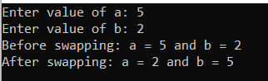

10.C-Program for linear search

PROGRAM

#include <stdio.h>

int main()  
{  
  int array[100], search, c, n;

  printf("Enter number of elements in array**\n**");  
  scanf("%d", &n);

  printf("Enter %d integer(s)**\n**", n);

  for (c = 0; c < n; c++)  
    scanf("%d", &array[c]);

  printf("Enter a number to search**\n**");  
  scanf("%d", &search);

  for (c = 0; c < n; c++)  
  {  
    if (array[c] == search)    */* If required element is found */*  
    {  
      printf("%d is present at location %d.**\n**", search, c+1);  
      **break**;  
    }  
  }  
  if (c == n)  
    printf("%d isn't present in the array.**\n**", search);

  return 0;  
}

OUTPUT:

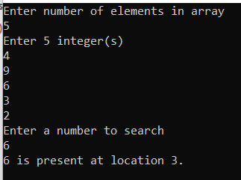

11.c- Program for summing of numbers

Program:

#include<stdio.h>

int main()

{

int n,i,sum=0;

printf("Enter the value of n:");

scanf("%d",&n);

printf(" The generation of n numbers are: \n");

for(i=1;i<=n;i++)

{

printf("\t %d",i);

sum+=i;

}

printf("\n\nSum of first n natural numbers is:%d",sum);

return 0;

}

OUTPUT:

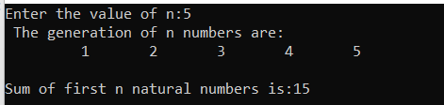

12.C-PROGRAM FOR SUMMING OF EVEN SERIES

Program

#include <stdio.h>

int main()

{

int a=2;

int sum=0;

int num;

printf("\n Please Enter the Maximum num Value : ");

scanf("%d", &num);

printf("The even numbers in the list are");

while( a <= num)

{

printf("%d \t ",a);

sum = sum + a;

a=a+2;

}

printf("Sum of all even numbers = %d \n", sum);

}

OUTPUT:

