Time Series

Alan Arnholt

8/30/2016

Read in the data:

library(readr)  
ages <- read_csv("Ch4Eg.csv")  
ages

# A tibble: 58 × 3  
 Year Women Men  
 <int> <dbl> <dbl>  
1 1998 25.0 26.7  
2 1997 25.0 26.8  
3 1996 24.8 27.1  
4 1995 24.5 26.9  
5 1994 24.5 26.7  
6 1993 24.5 26.5  
7 1992 24.4 26.5  
8 1991 24.1 26.3  
9 1990 23.9 26.1  
10 1989 23.8 26.2  
# ... with 48 more rows

Create side-by-side boxplots:

library(tidyr)  
NDF <- gather(ages, Gender, Age, -Year)  
NDF

# A tibble: 116 × 3  
 Year Gender Age  
 <int> <chr> <dbl>  
1 1998 Women 25.0  
2 1997 Women 25.0  
3 1996 Women 24.8  
4 1995 Women 24.5  
5 1994 Women 24.5  
6 1993 Women 24.5  
7 1992 Women 24.4  
8 1991 Women 24.1  
9 1990 Women 23.9  
10 1989 Women 23.8  
# ... with 106 more rows

library(ggplot2)  
ggplot(data = NDF, aes(x = Gender, y = Age, fill = Gender)) + geom_boxplot() +   
 theme_bw()

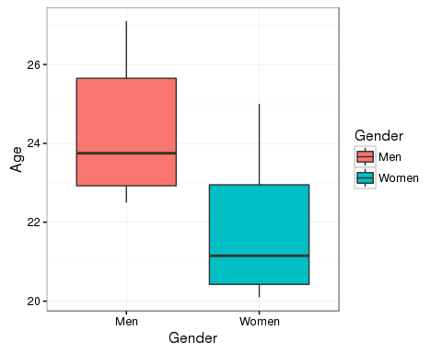

Density plots:

ggplot(data = NDF, aes(x = Age, fill = Gender)) +   
 geom_density(alpha = 0.35) +   
 theme_bw()

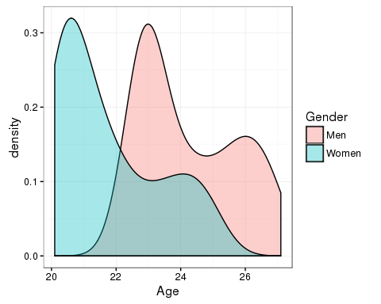

Summary information:

library(dplyr)  
SI <- NDF %>%  
 group_by(Gender) %>%  
 summarise(av_age = mean(Age), md_age = median(Age), sd_age = sd(Age))  
SI

# A tibble: 2 × 4  
 Gender av_age md_age sd_age  
 <chr> <dbl> <dbl> <dbl>  
1 Men 24.25000 23.75 1.490820  
2 Women 21.75172 21.15 1.554421

Create a time-series plot:

ggplot(data = ages, aes(x = Year, y = Women)) +   
 geom_line(color = "purple") +   
 geom_point(color = "purple") +   
 geom_smooth(color = "pink") +   
 geom_line(aes(x = Year, y = Men), color = "blue") +   
 geom_point(aes(x = Year, y = Men), color = "blue") +   
 geom_smooth(aes(x = Year, y = Men), color = "lightblue") +  
 labs(y = "Age") +  
 theme_bw()

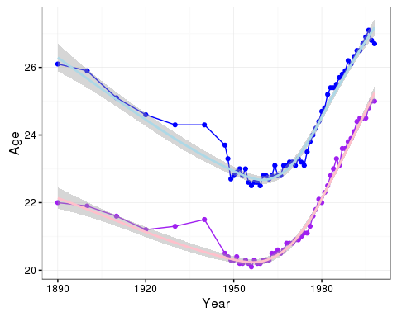

Time Series Plot

Another one using NDF:

ggplot(data = NDF, aes(x = Year, y = Age, color = Gender)) +   
 geom_point() +   
 geom_line() +  
 geom_smooth() +  
 theme_bw()

