Fake Logo Detection

In this project we have used CNN (convolution neural network) algorithm to classify logo as fake or original. To Train this algorithm we have used below logo images



In above screen we have to folders and each contains its own images like below screen

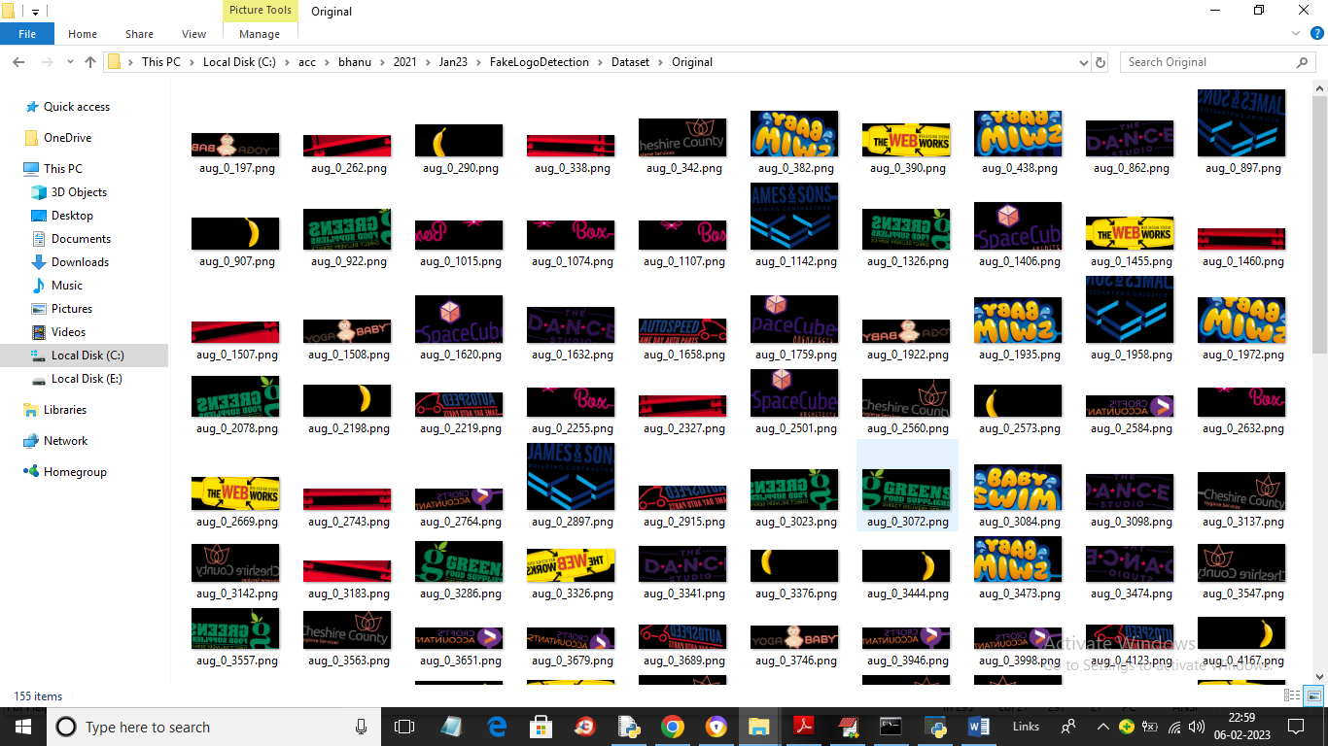

So by using above images will train CNN algorithm for logo classification. To implement this project we have designed following modules

1. Upload Logo Dataset: using this module we will upload dataset to application
2. Preprocess Dataset: using this module we will read each image and then resize all images to equal size and then normalize pixel values and then shuffle dataset. After processing we will split dataset into train and test where application using 80% dataset images for training and 20% for testing
3. Train CNN Algorithm: using this module we will input 80% training images to CNN algorithm to train a model and this model will be applied on 20% test images to calculate prediction accuracy.
4. CNN Training Graph: using this module we will plot CNN training accuracy and loss graph
5. Logo Classification: using this module we will upload test image and then CNN will classify those images as Fake or original

SCREEN SHOTS

To run project double click on ‘run.bat’ file to get below screen

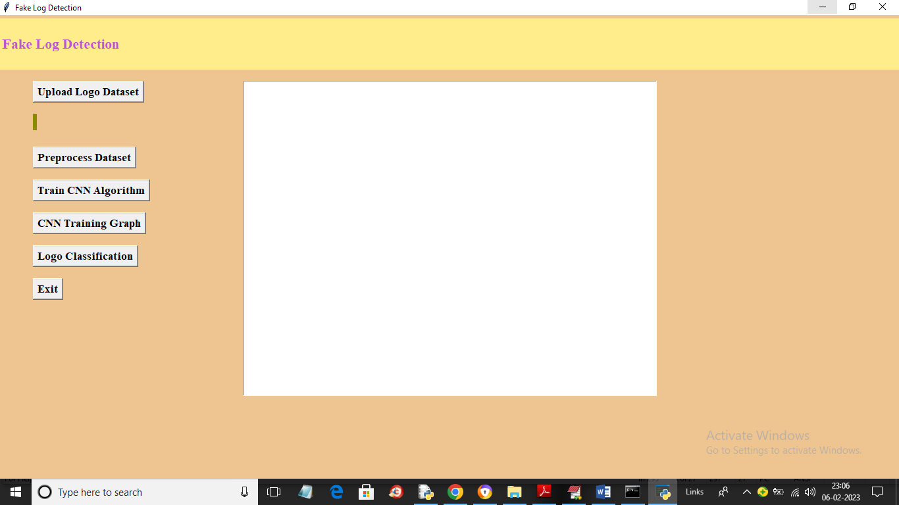

In above screen click on ‘Upload Logo Dataset’ button to upload dataset and get below output

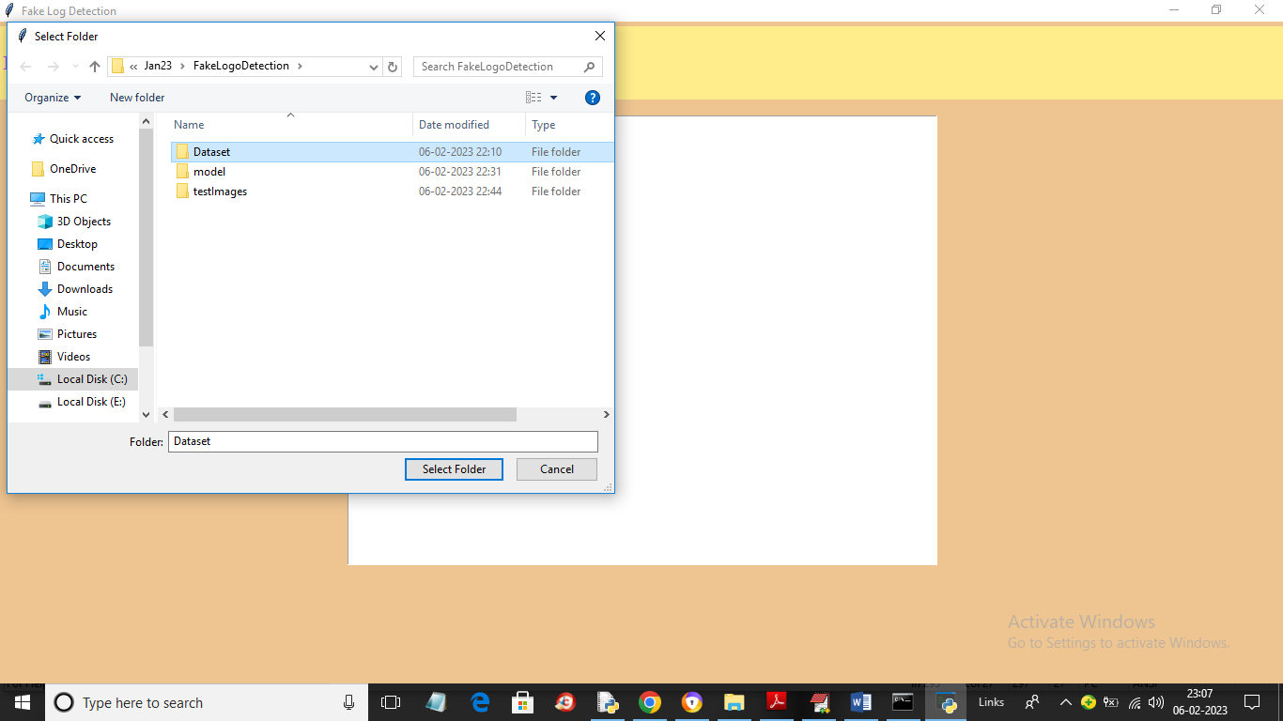

In above screen selecting and uploading entire “Dataset” folder and then click on ‘Select Folder’ button to load dataset and get below output

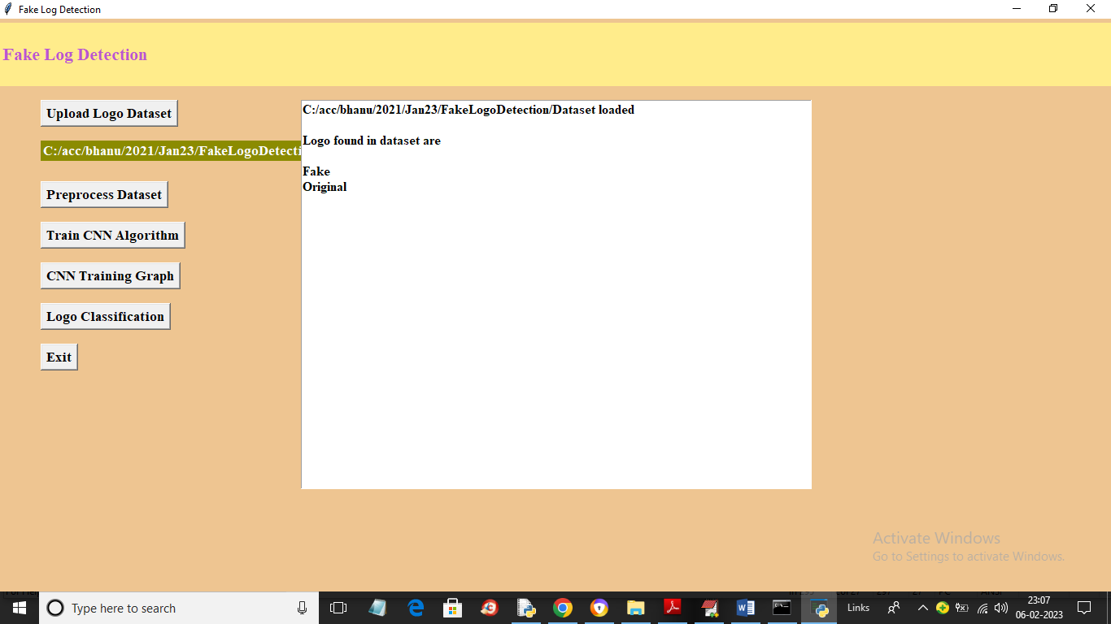

In above screen dataset images loaded as Fake and original and now click on ‘Preprocess Dataset’ button to process images and get below output

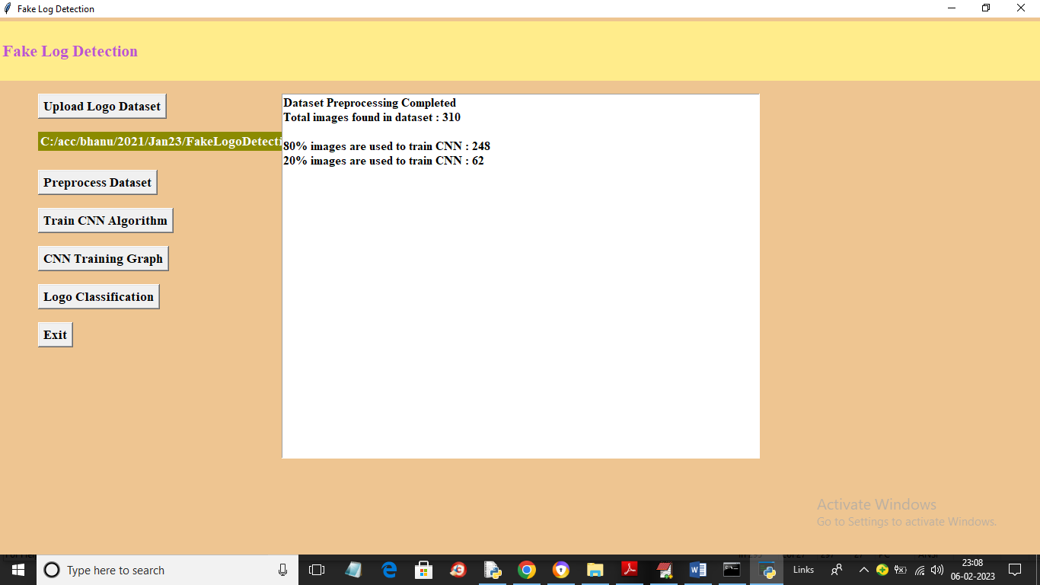

In above screen dataset processing completed and we can see dataset contains 310 images and application using 80% (248) images for training and 20% (62) images for testing and now click on ‘Train CNN Algorithm’ button train CNN with training images and get below output

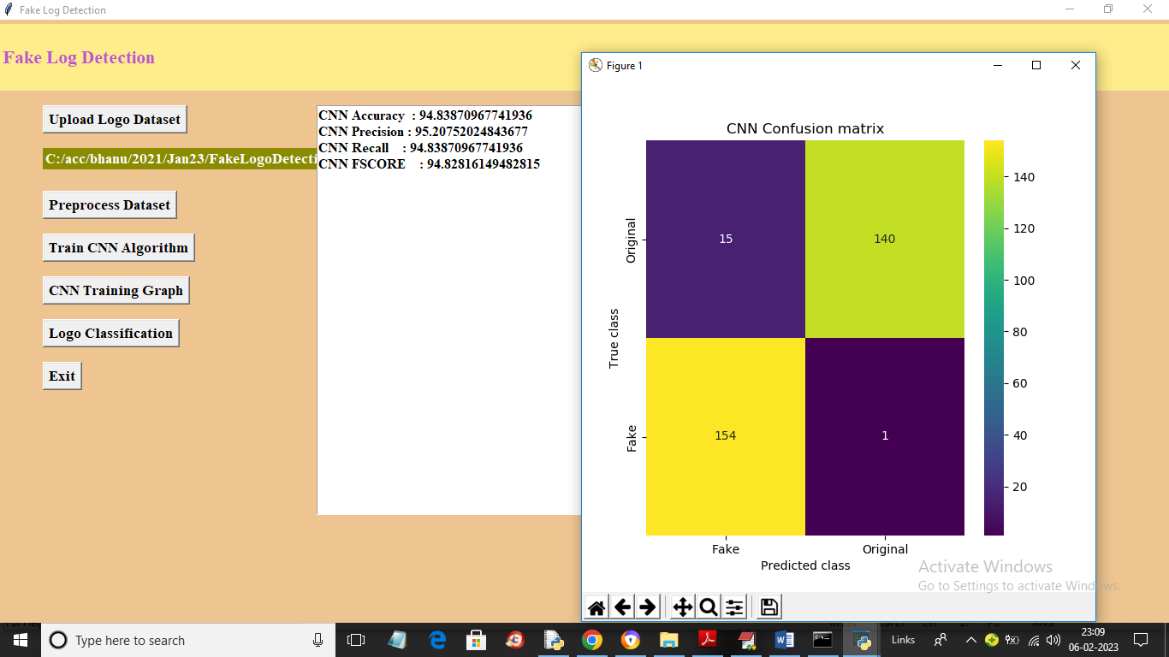

In above screen CNN training completed and we got its prediction accuracy as 94% and we can see other metric like precision, recall and FSCORE. In confusion matrix graph x-axis represents Predicted Labels and y-axis represents True Labels and blue colour boxes contains incorrect prediction count and different colour boxes contains correct prediction count and in above graph we can see wrong prediction counts are very few so we can say CNN predictions are more than 90% correct. Now click on ‘CNN Training Graph´ button to get below graph

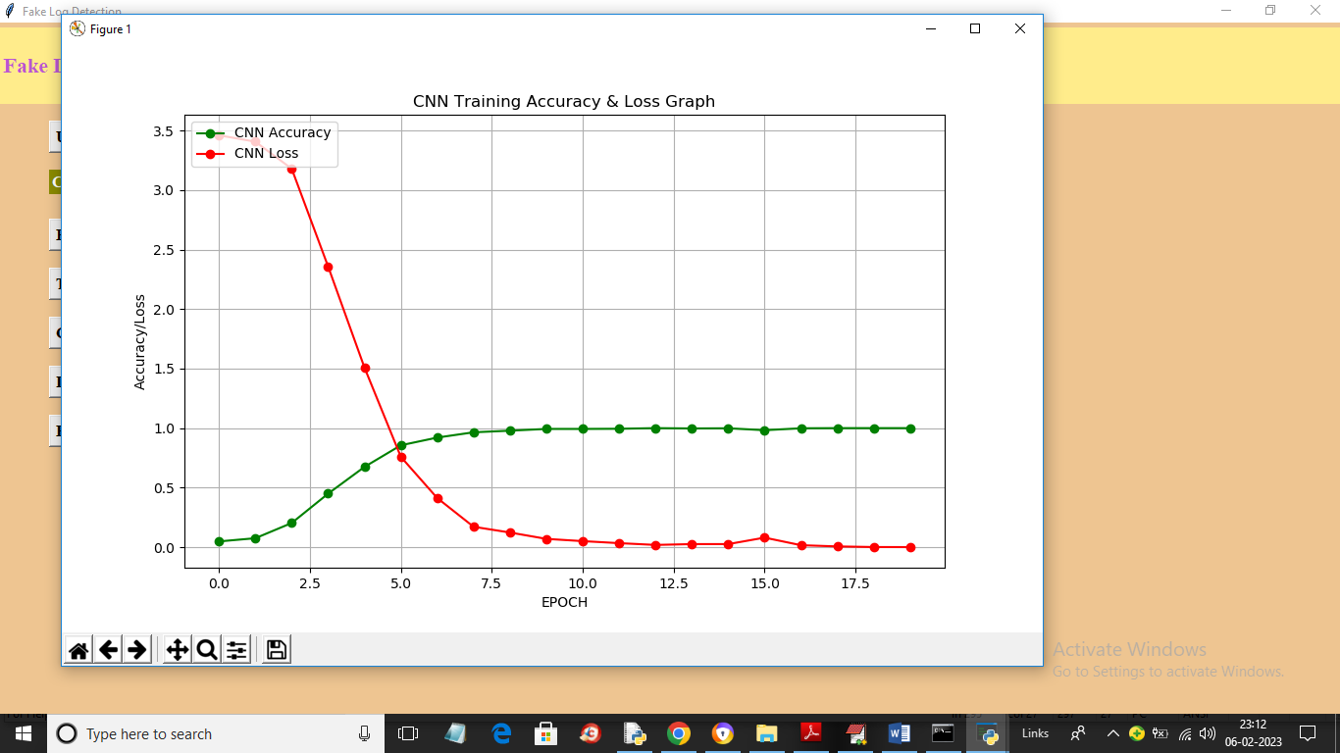

In above graph x-axis represents training epoch and y-axis represents Accuracy and Loss values and green line represents accuracy and red line represents loss and in above graph we can see with each increasing epoch accuracy got increase and loss got decrease. Now close above graph and then click on ‘Logo Classification’ button to get below output

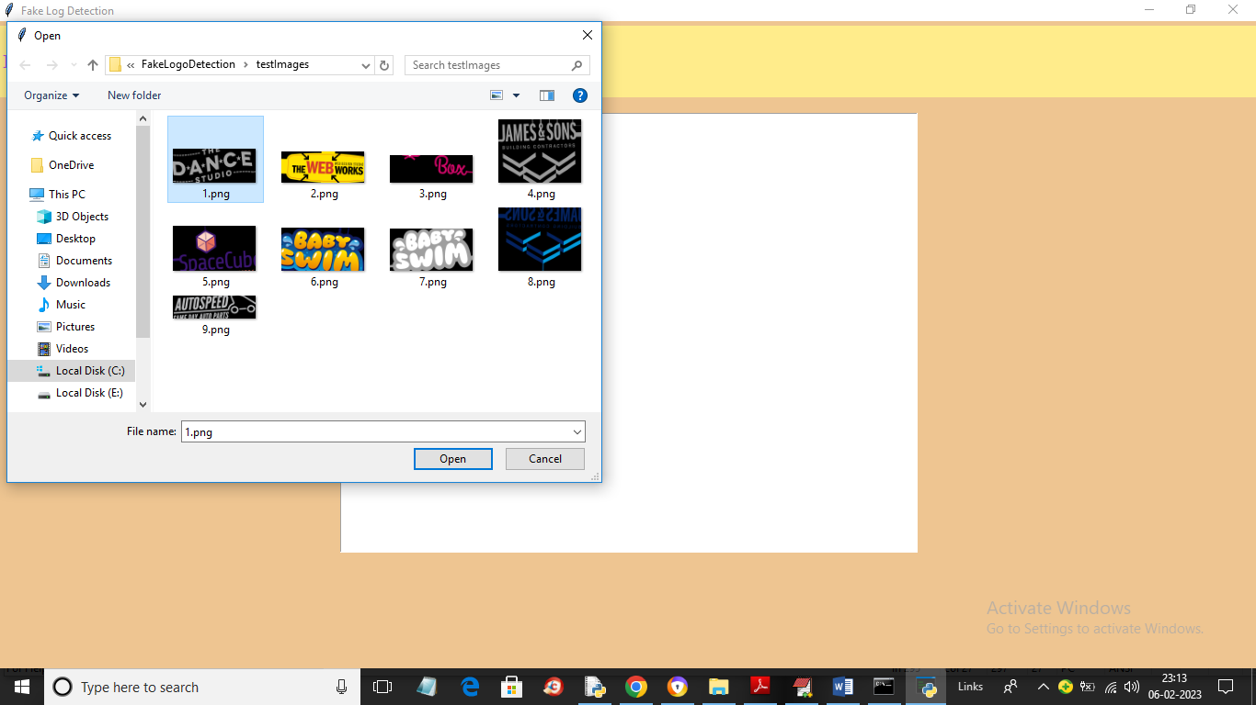

In above screen selecting and uploading logo image and then click on ‘Open’ button to get below output

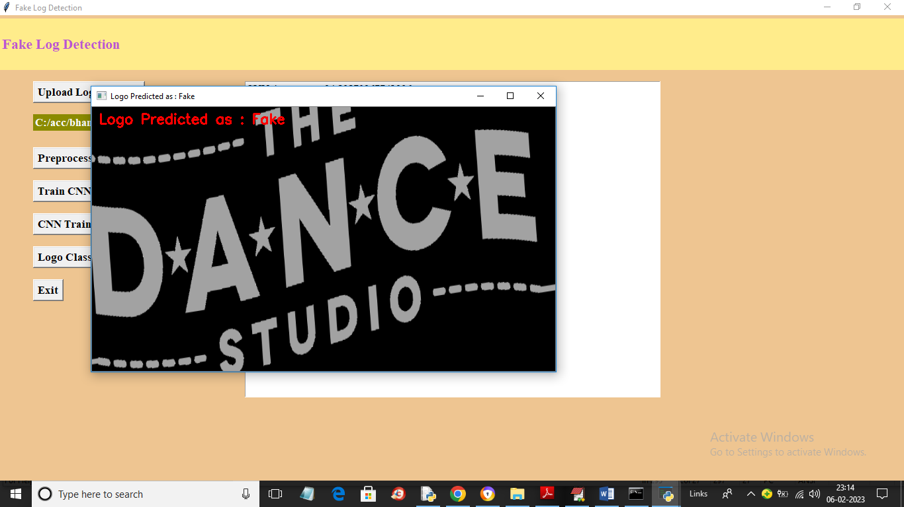

In above screen in red colour text we can see image logo classified as Fake and similarly you can upload and test other images

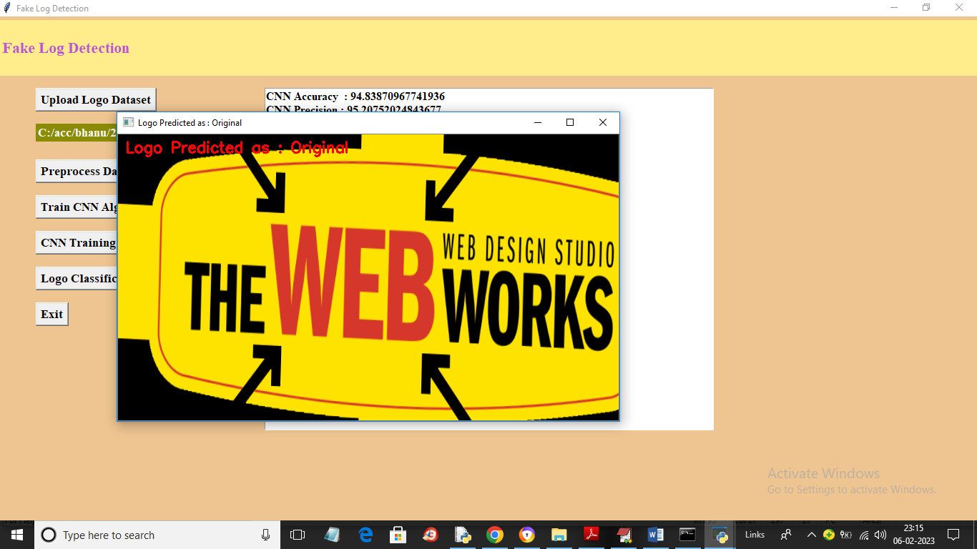

Above logo classify as original

