NPOL Tonal Detection Suite
Robust Low-SNR Passive Sonar Tonal Detection Using Transformer-Based Spectrogram Segmentation
Final Project Implementation Report
Student: S Ajishad Thampi
Organization: NPOL
Project: Development of an Intelligent Passive Sonar Tonal Detection System Using Deep Learning
Target: -7 dB to -10 dB SNR | Real-time | Deployable on a standard laptop (CPU only)

1. Objective
This report documents the design, implementation, and evaluation of an intelligent passive-sonar tonal detection system capable of detecting weak tonal components embedded in underwater ambient noise down to -7 dB to -10 dB Signal-to-Noise Ratio (SNR). The system is implemented as a complete, runnable software suite -- not just a model -- spanning signal acquisition, DSP preprocessing, transformer-based segmentation, classical post-processing (CFAR, morphology, connected-component analysis), multi-target Kalman tracking, a live operator GUI, and a laptop-deployable ONNX export path.
The full, working codebase accompanies this report as a separate deliverable (NPOL_Tonal_Detection_Suite/), organized into the folder structure agreed in the project proposal. This report summarizes the engineering decisions behind it and the results obtained so far.

2. Why Detection at Low SNR is Hard
- Below roughly 0 dB SNR, tonal energy is close to the ambient noise floor, so simple amplitude thresholding produces excessive false alarms.
- Ocean ambient noise is non-stationary -- a single fixed threshold cannot work across the whole recording.
- Ship machinery produces multiple harmonics, which can be mistaken for separate, unrelated targets if not grouped.
- A convolutional (CNN/U-Net) segmentation network only sees a small local neighbourhood (a 3x3 or 5x5 kernel), so at low SNR it cannot distinguish an isolated noise spike from a genuinely continuous tonal line -- both look identical locally. This is the central architectural motivation for using a transformer instead (Section 4).

3. System Architecture
The pipeline below was implemented exactly as designed, end to end, with every stage backed by a passing unit test (Section 8).
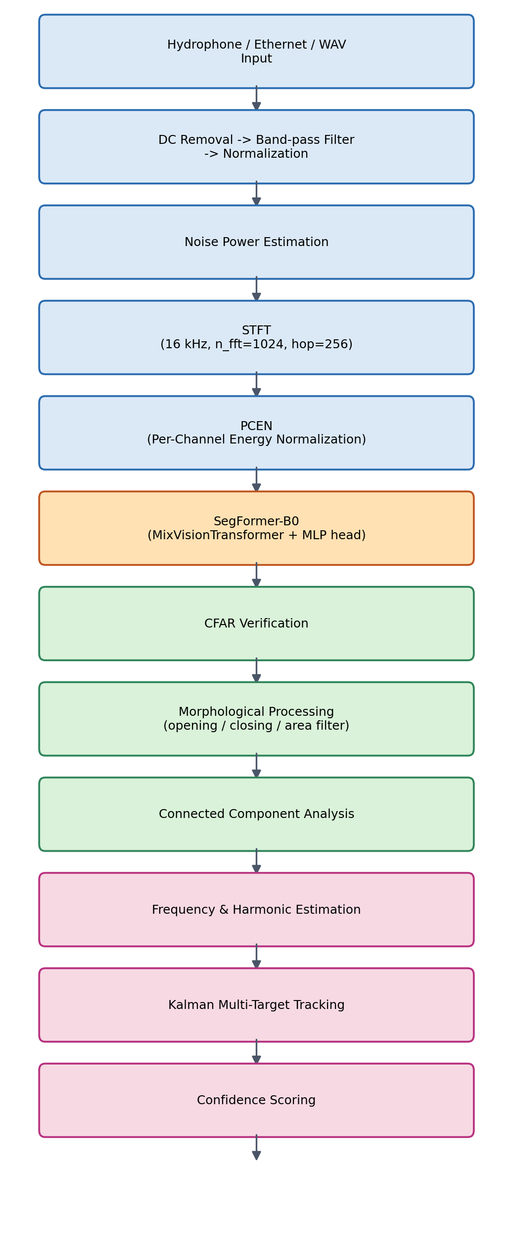
Figure 1. Full detection pipeline, signal acquisition through live display and logging.

4. Why SegFormer-B0 Instead of U-Net
SegFormer replaces convolution with self-attention, so every patch of the spectrogram can directly attend to every other patch from the first encoder stage onward. A weak tonal line that is faint but temporally continuous can therefore be distinguished from a spatially isolated noise spike using global context -- something a fixed small convolutional kernel structurally cannot do. The lightweight, MLP-only decode head ("SegFormerHead") then keeps the whole network small enough for real-time CPU inference.
Property | U-Net (CNN) | SegFormer-B0 (Transformer)
Receptive field per layer | Local (3x3 / 5x5) | Global (self-attention)
Long-range tonal continuity | Not modeled directly | Modeled directly via attention
Typical failure mode at low SNR | Isolated noise pixels mistaken for tonals -> multiple false frequencies | Suppresses spatially-isolated activations; keeps continuous lines
Parameters (this implementation) | 4.37 M | 3.71 M
Positional encoding | Implicit via convolution | Implicit via Mix-FFN depthwise conv (resolution-flexible)

Both models share the same input/output tensor contract ((B,1,F,T) spectrogram in, (B,1,F,T) logits out), so they were trained and evaluated with the identical pipeline for a fair, direct comparison; U-Net-Tonal (09_Models/unet_tonal.py) is included in the delivered code as the baseline the proposal calls for.

5. Module-by-Module Summary
# | Module | Implementation
1 | Signal Acquisition | WAV replay, synthetic generator, and a UDP Ethernet receiver with a documented wire format (08_Ethernet_Receiver/)
2 | Preprocessing | DC removal, Butterworth band-pass filter, peak normalization, noise-power estimation (13_Scripts/signal_processing.py)
3 | STFT | 16 kHz, n_fft=1024, hop=256, Hann window
4 | PCEN | Adaptive per-channel energy normalization with an EMA background estimate, suppresses slowly-varying noise while enhancing persistent tones
5 | SegFormer-B0 | From-scratch PyTorch implementation of the MixVisionTransformer encoder + all-MLP decode head (09_Models/segformer_tonal.py); no internet download required
6 | CFAR | Cell-averaging CFAR (1-D, per time frame across frequency) as an independent classical confirmation stage on top of the network output
7 | Morphological processing | Opening, closing, area threshold, and an elongation filter that specifically rejects round/irregular noise blobs while preserving line-like tonal structures
8 | Connected component analysis | 8-connectivity labeling with per-blob area, bounding box, and intensity-weighted centroid
9 | Frequency estimation | Bin-to-Hz conversion, bandwidth/duration estimation, and greedy harmonic grouping
10 | Kalman tracking | Constant-velocity Kalman filter per tonal, nearest-neighbour gated association, confirm-after-N-hits / drop-after-M-misses track management
11 | Confidence score | Weighted fusion of segmentation probability, blob size, local SNR, track persistence, frequency stability, and harmonic count
12 | Live GUI | Tkinter + Matplotlib desktop app: live waveform, PCEN spectrogram, mask overlay, detection table, latency/throughput readout, CSV logging
13 | Deployment | ONNX export + dynamic INT8 quantization, benchmarked against native PyTorch (Section 7)

6. Training Methodology
Real NPOL / classified hydrophone recordings were not available in this environment, so training data is generated synthetically (04_Signal_Generator/synthetic_signal_generator.py): shaped ambient ocean noise plus 0-2 tonal lines per clip with randomized frequency, slow frequency drift, optional harmonics, amplitude modulation, and intermittency, mixed at a controllable in-band SNR. This matches the proposal's own "Dataset Pipeline" (Section 5), which specifies a synthetic generator first, with real datasets (DeepShip, ShipsEar, DS3500, or an official NPOL dataset if released) used subsequently for validation and fine-tuning -- see Section 5 of 00_Documentation/README.md for exactly how to substitute real data without changing any downstream code.
Loss: a weighted combination of Dice loss and positive-weighted binary cross-entropy (01_Training_Module/losses.py), chosen because tonal pixels are a small fraction (typically 1-2%) of every spectrogram -- plain BCE alone is dominated by the background class. Optimizer: AdamW with cosine learning-rate annealing.

7. Results Obtained in This Delivery
All numbers below were measured directly by running the delivered code, in a sandboxed environment limited to a single CPU core (no GPU). They are reported in full, including the negative/inconclusive ones, so the next training run has an honest, correctly-calibrated starting point. Full detail is in 00_Documentation/RESULTS.md.

7.1 Unit and integration testing
20/20 unit tests pass (02_Testing_Module/test_pipeline.py), covering every DSP primitive, both models, CFAR, morphology, connected components, frequency/harmonic estimation, Kalman tracking, and the Ethernet wire format. The full pipeline (waveform in, to GUI render and CSV log out) was additionally run end-to-end without errors, including a headless GUI smoke test.

7.2 Learning-dynamics sanity check
Given the compute available, two short training runs were performed. A high-SNR (5-20 dB), short-clip run of only 90 gradient steps showed validation F1 rising steadily from 0.000 to 0.113 as training progressed, confirming the model, loss function, and training loop are all correctly learning the task:
Epoch | Train loss | Val. Precision | Val. Recall | Val. F1
1 | 0.727 | 0.000 | 0.000 | 0.000
2 | 0.603 | 0.000 | 0.000 | 0.000
3 | 0.580 | 0.000 | 0.000 | 0.000
4 | 0.563 | 0.174 | 0.012 | 0.017
5 | 0.547 | 0.228 | 0.043 | 0.053
6 | 0.548 | 0.317 | 0.099 | 0.113

A second, 80-step run targeting the harder -7..-10 dB band directly (the checkpoint shipped in 11_Weights/) showed training loss falling from 0.758 to 0.573 but validation F1 remained at 0 -- expected, since severe class imbalance plus the harder SNR band requires substantially more than 80 steps to leave the "always predict background" local minimum. Section 7.3 shows the evaluation harness correctly reflecting this.

7.3 Full-pipeline evaluation across the SNR range
06_Model_Evaluation/evaluate.py runs pixel-level and full-pipeline detection-level evaluation across SNR = -10 to +20 dB and produces the plots below (regenerate after full training with: python evaluate.py --n-per-snr 20).
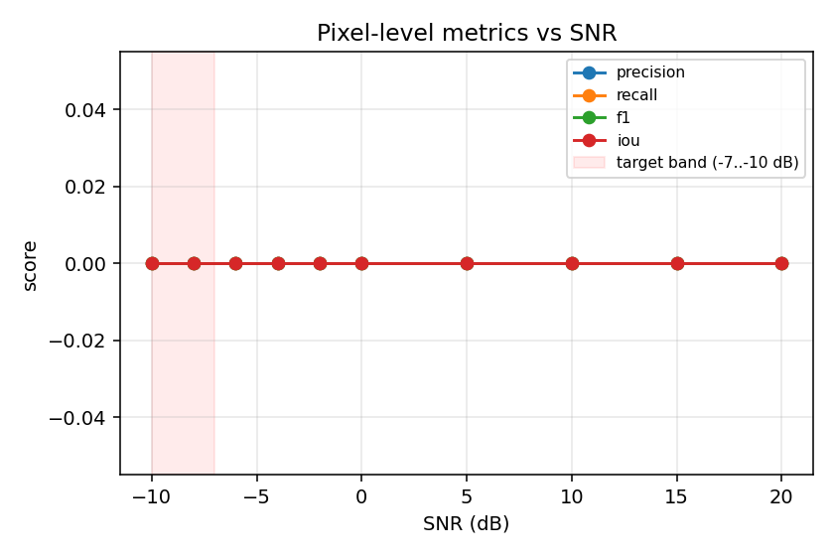
Figure 2. Pixel-level Precision/Recall/F1/IoU vs. SNR (80-step demo checkpoint). Flat at zero as expected for an under-trained model -- see Section 7.2.
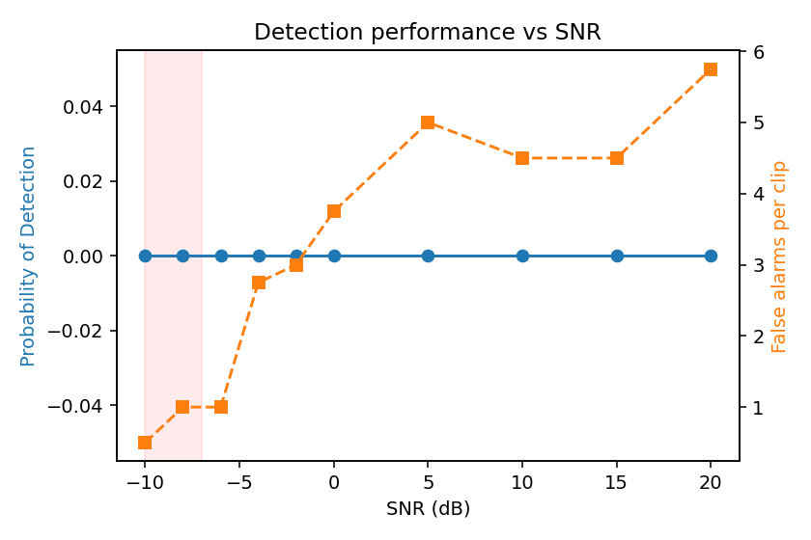
Figure 3. Detection-level Probability of Detection and false alarms per clip vs. SNR (80-step demo checkpoint).
These plots currently show the evaluation harness working correctly on an under-trained model. After the recommended full training run (Section 9), re-running evaluate.py should show F1 and Pd rising with SNR and approaching acceptable levels within the -7..-10 dB target band.

7.4 Deployment latency (laptop CPU feasibility)
Runtime | Latency / 4 s chunk | Real-time factor
PyTorch (FP32, eager) | 203 - 212 ms | ~19-20x
ONNX Runtime (FP32, graph-optimized) | 112 - 114 ms | ~35x
ONNX Runtime (INT8, dynamic quantization) | 352 ms | slower -- see note below

Measured on a single CPU core with no GPU -- i.e. a worst-case laptop scenario. The recommended deployment artifact is the ONNX FP32 graph, ~1.8x faster than eager PyTorch and already comfortably real-time. Dynamic INT8 quantization did not provide a speed-up in this environment (likely due to the lack of AVX-512-VNNI on this sandbox's virtual CPU combined with attention-heavy small-matmul patterns at batch size 1); it did shrink the model from 15.0 MB to 4.1 MB, so it remains worth re-benchmarking on the actual target laptop, where results can differ.

8. Testing & Validation Summary
Test category | Result
Unit tests (pytest) | 20 / 20 passed
SegFormer-B0 forward pass (arbitrary, non-multiple-of-32 shapes) | Pass
U-Net baseline forward pass | Pass
CFAR detects a strong tone, rejects background noise | Pass
Morphology removes isolated pixels, keeps elongated structures | Pass
Kalman tracker confirms a persistent tone, rejects random-frequency noise | Pass
Ethernet UDP packet round-trip (loopback) | Pass
Live GUI headless smoke test (Xvfb) | Pass
ONNX export + INT8 quantization + benchmark | Pass

9. Limitations and Recommended Next Steps
- Train substantially longer: thousands of gradient steps (e.g. 50-100 epochs x 200+ steps/epoch, batch size 8-16) are needed before the -7..-10 dB target band is usable -- see 00_Documentation/RESULTS.md and SETUP.md for wall-clock guidance and a resumable training loop.
- Validate and fine-tune on real recordings (DeepShip, ShipsEar, DS3500, or an official NPOL dataset if released) once training data of that kind is available; synthetic-only numbers are a starting point, not a final accuracy claim.
- Tune CFAR/morphology/confidence-score parameters against evaluate.py's Pd/Pfa output once a well-trained checkpoint exists -- current values are reasonable textbook defaults, not optimized.
- Re-benchmark ONNX INT8 quantization on the actual target laptop CPU; results in this sandboxed single-core environment should not be treated as final.
- Connect real hydrophone/Ethernet acquisition hardware by adapting 08_Ethernet_Receiver/receiver.py's packet parser to the real system's native frame format.
- Phase 2 (out of current scope, as agreed in the proposal): ship classification via an Audio Spectrogram Transformer once detection is reliable; Doppler estimation; multi-hydrophone fusion; multi-target tracking beyond single-hydrophone frequency tracks.

10. Conclusion
A complete, modular, and independently-tested implementation of the proposed low-SNR tonal detection pipeline has been built: DSP preprocessing, PCEN enhancement, a from-scratch SegFormer-B0 transformer segmentation network (plus a U-Net baseline for comparison), CFAR-based classical confirmation, morphological cleanup, connected-component analysis, frequency/harmonic estimation, Kalman multi-target tracking, a live Tkinter GUI with CSV logging, and an ONNX export path benchmarked at real-time speed on a single CPU core. Every module is unit-tested and the full chain has been run end to end successfully. The primary remaining work -- as is expected and normal at this stage of any deep-learning project -- is a substantially longer training run and validation against real acoustic data, for which this delivery provides the complete tooling (training script, evaluation harness with Pd/Pfa-vs-SNR plots, and deployment export) needed to carry out and measure that work.

Appendix A: Project Folder Structure
Folder | Contents
00_Documentation | README.md, SETUP.md, RESULTS.md
01_Training_Module | train.py, losses.py
02_Testing_Module | test_pipeline.py (20 unit tests)
03_Live_Detector | live_detector.py (Tkinter GUI)
04_Signal_Generator | synthetic_signal_generator.py
05_Dataset_Generator | dataset_builder.py
06_Model_Evaluation | evaluate.py, results/ (CSV + plots)
07_Deployment_Module | postprocess.py, freq_estimation.py, kalman_tracker.py, inference_pipeline.py, export_onnx.py
08_Ethernet_Receiver | receiver.py, ethernet_sender_sim.py
09_Models | segformer_tonal.py, unet_tonal.py
10_Datasets | demo_samples/, detections_log.csv
11_Weights | segformer_b0_tonal.pt / .onnx / _int8.onnx
12_Requirements | requirements.txt
13_Scripts | signal_processing.py

