Cr_GLM_pluie.demain

MDR

2024-06-26

## R Markdown

Définition du problème : Développer un modèle qui permet de prédire SI il va pleuvoir demain ou pas.

1- Chargement des données

library(readr)

## Warning: le package 'readr' a été compilé avec la version R 4.3.3

meteo_train <- read_csv("C:/Users/Driouich/Desktop/Modèles linéaires généralisés - R. RYDER-20240611/Projet/meteo.train.csv")

View(meteo_train)

2- Explorer et analyser les données :

summary(meteo_train)

## ...1 Year Month Day Hour   
## Min. : 2.0 Min. :2010 Min. : 1.000 Min. : 1.0 Min. :0   
## 1st Qu.: 721.5 1st Qu.:2012 1st Qu.: 3.000 1st Qu.: 8.0 1st Qu.:0   
## Median :1451.0 Median :2014 Median : 6.000 Median :16.0 Median :0   
## Mean :1459.8 Mean :2014 Mean : 6.436 Mean :15.8 Mean :0   
## 3rd Qu.:2189.0 3rd Qu.:2016 3rd Qu.: 9.000 3rd Qu.:23.0 3rd Qu.:0   
## Max. :2940.0 Max. :2018 Max. :12.000 Max. :31.0 Max. :0   
## Minute Temperature.daily.mean..2.m.above.gnd.  
## Min. :0 Min. :-7.63   
## 1st Qu.:0 1st Qu.: 6.71   
## Median :0 Median :12.08   
## Mean :0 Mean :12.23   
## 3rd Qu.:0 3rd Qu.:17.54   
## Max. :0 Max. :29.45   
## Relative.Humidity.daily.mean..2.m.above.gnd.  
## Min. :38.33   
## 1st Qu.:64.82   
## Median :72.21   
## Mean :71.40   
## 3rd Qu.:78.63   
## Max. :95.54   
## Mean.Sea.Level.Pressure.daily.mean..MSL. Total.Precipitation.daily.sum..sfc.  
## Min. : 978.9 Min. : 0.000   
## 1st Qu.:1012.4 1st Qu.: 0.000   
## Median :1017.0 Median : 0.100   
## Mean :1017.0 Mean : 2.085   
## 3rd Qu.:1022.0 3rd Qu.: 2.300   
## Max. :1042.4 Max. :31.500   
## Snowfall.amount.raw.daily.sum..sfc. Total.Cloud.Cover.daily.mean..sfc.  
## Min. :0.00000 Min. : 0.00   
## 1st Qu.:0.00000 1st Qu.: 23.80   
## Median :0.00000 Median : 51.67   
## Mean :0.04965 Mean : 50.76   
## 3rd Qu.:0.00000 3rd Qu.: 78.53   
## Max. :8.61000 Max. :100.00   
## High.Cloud.Cover.daily.mean..high.cld.lay.  
## Min. : 0.000   
## 1st Qu.: 1.657   
## Median : 11.880   
## Mean : 20.284   
## 3rd Qu.: 33.260   
## Max. :100.000   
## Medium.Cloud.Cover.daily.mean..mid.cld.lay.  
## Min. : 0.00   
## 1st Qu.: 1.83   
## Median : 24.98   
## Mean : 31.50   
## 3rd Qu.: 54.21   
## Max. :100.00   
## Low.Cloud.Cover.daily.mean..low.cld.lay. Sunshine.Duration.daily.sum..sfc.  
## Min. : 0.00 Min. : 0.0   
## 1st Qu.: 9.42 1st Qu.: 114.3   
## Median : 36.35 Median : 366.8   
## Mean : 39.34 Mean : 373.1   
## 3rd Qu.: 65.76 3rd Qu.: 587.7   
## Max. :100.00 Max. :1015.8   
## Shortwave.Radiation.daily.sum..sfc. Wind.Speed.daily.mean..10.m.above.gnd.  
## Min. : 265.2 Min. : 1.260   
## 1st Qu.:2096.2 1st Qu.: 6.428   
## Median :3675.3 Median : 9.195   
## Mean :3984.6 Mean :10.707   
## 3rd Qu.:5723.6 3rd Qu.:12.977   
## Max. :8363.3 Max. :42.210   
## Wind.Direction.daily.mean..10.m.above.gnd.  
## Min. : 11.19   
## 1st Qu.:152.40   
## Median :206.36   
## Mean :201.82   
## 3rd Qu.:254.19   
## Max. :331.67   
## Wind.Speed.daily.mean..80.m.above.gnd.  
## Min. : 1.34   
## 1st Qu.: 8.68   
## Median :12.41   
## Mean :14.28   
## 3rd Qu.:17.61   
## Max. :54.03   
## Wind.Direction.daily.mean..80.m.above.gnd. Wind.Speed.daily.mean..900.mb.  
## Min. : 12.18 Min. : 2.25   
## 1st Qu.:157.42 1st Qu.:13.02   
## Median :213.78 Median :19.57   
## Mean :206.23 Mean :24.57   
## 3rd Qu.:259.06 3rd Qu.:32.10   
## Max. :333.43 Max. :97.06   
## Wind.Direction.daily.mean..900.mb. Wind.Gust.daily.mean..sfc.  
## Min. : 17.37 Min. : 2.25   
## 1st Qu.:144.02 1st Qu.: 9.48   
## Median :233.47 Median :14.06   
## Mean :206.22 Mean :16.69   
## 3rd Qu.:265.93 3rd Qu.:21.15   
## Max. :344.82 Max. :79.38   
## Temperature.daily.max..2.m.above.gnd. Temperature.daily.min..2.m.above.gnd.  
## Min. :-3.84 Min. :-12.520   
## 1st Qu.:10.58 1st Qu.: 3.350   
## Median :16.54 Median : 8.005   
## Mean :16.54 Mean : 8.062   
## 3rd Qu.:22.36 3rd Qu.: 13.092   
## Max. :35.77 Max. : 23.940   
## Relative.Humidity.daily.max..2.m.above.gnd.  
## Min. : 59.00   
## 1st Qu.: 83.00   
## Median : 89.00   
## Mean : 87.69   
## 3rd Qu.: 94.00   
## Max. :100.00   
## Relative.Humidity.daily.min..2.m.above.gnd.  
## Min. :19.00   
## 1st Qu.:45.00   
## Median :54.00   
## Mean :54.04   
## 3rd Qu.:63.00   
## Max. :92.00   
## Mean.Sea.Level.Pressure.daily.max..MSL.  
## Min. : 981.9   
## 1st Qu.:1015.4   
## Median :1019.5   
## Mean :1019.9   
## 3rd Qu.:1024.7   
## Max. :1045.4   
## Mean.Sea.Level.Pressure.daily.min..MSL. Total.Cloud.Cover.daily.max..sfc.  
## Min. : 977 Min. : 0.00   
## 1st Qu.:1009 1st Qu.:100.00   
## Median :1015 Median :100.00   
## Mean :1014 Mean : 88.23   
## 3rd Qu.:1019 3rd Qu.:100.00   
## Max. :1039 Max. :100.00   
## Total.Cloud.Cover.daily.min..sfc. High.Cloud.Cover.daily.max..high.cld.lay.  
## Min. : 0.000 Min. : 0.00   
## 1st Qu.: 0.000 1st Qu.: 15.00   
## Median : 0.000 Median : 97.00   
## Mean : 8.692 Mean : 60.17   
## 3rd Qu.: 2.400 3rd Qu.:100.00   
## Max. :100.000 Max. :100.00   
## High.Cloud.Cover.daily.min..high.cld.lay.  
## Min. : 0.0000   
## 1st Qu.: 0.0000   
## Median : 0.0000   
## Mean : 0.9432   
## 3rd Qu.: 0.0000   
## Max. :100.0000   
## Medium.Cloud.Cover.daily.max..mid.cld.lay.  
## Min. : 0.00   
## 1st Qu.: 22.75   
## Median :100.00   
## Mean : 70.94   
## 3rd Qu.:100.00   
## Max. :100.00   
## Medium.Cloud.Cover.daily.min..mid.cld.lay.  
## Min. : 0.000   
## 1st Qu.: 0.000   
## Median : 0.000   
## Mean : 2.097   
## 3rd Qu.: 0.000   
## Max. :100.000   
## Low.Cloud.Cover.daily.max..low.cld.lay.  
## Min. : 0   
## 1st Qu.:100   
## Median :100   
## Mean : 80   
## 3rd Qu.:100   
## Max. :100   
## Low.Cloud.Cover.daily.min..low.cld.lay. Wind.Speed.daily.max..10.m.above.gnd.  
## Min. : 0.000 Min. : 2.52   
## 1st Qu.: 0.000 1st Qu.:12.32   
## Median : 0.000 Median :17.36   
## Mean : 3.879 Mean :19.06   
## 3rd Qu.: 0.000 3rd Qu.:23.44   
## Max. :100.000 Max. :79.99   
## Wind.Speed.daily.min..10.m.above.gnd. Wind.Speed.daily.max..80.m.above.gnd.  
## Min. : 0.00 Min. : 3.98   
## 1st Qu.: 1.14 1st Qu.:18.27   
## Median : 2.41 Median :23.85   
## Mean : 3.57 Mean :25.35   
## 3rd Qu.: 4.45 3rd Qu.:29.92   
## Max. :27.73 Max. :93.84   
## Wind.Speed.daily.min..80.m.above.gnd. Wind.Speed.daily.max..900.mb.  
## Min. : 0.000 Min. : 4.02   
## 1st Qu.: 1.140 1st Qu.: 24.54   
## Median : 2.600 Median : 37.12   
## Mean : 4.727 Mean : 41.82   
## 3rd Qu.: 5.830 3rd Qu.: 54.37   
## Max. :37.700 Max. :136.25   
## Wind.Speed.daily.min..900.mb. Wind.Gust.daily.max..sfc.  
## Min. : 0.00 Min. : 4.32   
## 1st Qu.: 3.05 1st Qu.:19.08   
## Median : 6.73 Median :26.10   
## Mean :11.09 Mean :29.31   
## 3rd Qu.:15.31 3rd Qu.:37.08   
## Max. :76.13 Max. :95.04   
## Wind.Gust.daily.min..sfc. pluie.demain   
## Min. : 0.000 Mode :logical   
## 1st Qu.: 2.160 FALSE:579   
## Median : 3.960 TRUE :601   
## Mean : 6.502   
## 3rd Qu.: 8.280   
## Max. :57.960

str(meteo_train)

## spc_tbl_ [1,180 × 47] (S3: spec_tbl_df/tbl_df/tbl/data.frame)  
## $ ...1 : num [1:1180] 2 4 6 8 10 12 14 16 18 20 ...  
## $ Year : num [1:1180] 2010 2010 2010 2010 2010 2010 2010 2010 2010 2010 ...  
## $ Month : num [1:1180] 6 6 6 6 6 6 6 6 6 6 ...  
## $ Day : num [1:1180] 2 4 6 8 10 12 14 16 18 20 ...  
## $ Hour : num [1:1180] 0 0 0 0 0 0 0 0 0 0 ...  
## $ Minute : num [1:1180] 0 0 0 0 0 0 0 0 0 0 ...  
## $ Temperature.daily.mean..2.m.above.gnd. : num [1:1180] 15 17.3 21.6 20.2 22.6 ...  
## $ Relative.Humidity.daily.mean..2.m.above.gnd.: num [1:1180] 76.5 77.6 69.5 75.1 73.5 ...  
## $ Mean.Sea.Level.Pressure.daily.mean..MSL. : num [1:1180] 1015 1017 1015 1008 1004 ...  
## $ Total.Precipitation.daily.sum..sfc. : num [1:1180] 1 0 3.7 0.2 0 2.2 1.8 1.8 17.5 1.2 ...  
## $ Snowfall.amount.raw.daily.sum..sfc. : num [1:1180] 0 0 0 0 0 0 0 0 0 0 ...  
## $ Total.Cloud.Cover.daily.mean..sfc. : num [1:1180] 79.8 4.7 42.1 67.5 56.3 ...  
## $ High.Cloud.Cover.daily.mean..high.cld.lay. : num [1:1180] 3 0.67 21.21 54.71 50.25 ...  
## $ Medium.Cloud.Cover.daily.mean..mid.cld.lay. : num [1:1180] 31.6 0 25.9 65.8 55.3 ...  
## $ Low.Cloud.Cover.daily.mean..low.cld.lay. : num [1:1180] 79.2 4.5 35.3 18.9 34.2 ...  
## $ Sunshine.Duration.daily.sum..sfc. : num [1:1180] 287.2 821.4 441.3 41.9 473.2 ...  
## $ Shortwave.Radiation.daily.sum..sfc. : num [1:1180] 6710 7974 4834 5390 7216 ...  
## $ Wind.Speed.daily.mean..10.m.above.gnd. : num [1:1180] 11.64 6.34 8.4 5.4 9.16 ...  
## $ Wind.Direction.daily.mean..10.m.above.gnd. : num [1:1180] 275 230 215 205 179 ...  
## $ Wind.Speed.daily.mean..80.m.above.gnd. : num [1:1180] 14.99 8.92 10.38 6.53 11.91 ...  
## $ Wind.Direction.daily.mean..80.m.above.gnd. : num [1:1180] 268 199 208 206 186 ...  
## $ Wind.Speed.daily.mean..900.mb. : num [1:1180] 20.6 27.9 18.9 10.4 21.9 ...  
## $ Wind.Direction.daily.mean..900.mb. : num [1:1180] 180.4 93.7 250.1 238.6 153 ...  
## $ Wind.Gust.daily.mean..sfc. : num [1:1180] 14.88 9.48 13.5 5.31 12.21 ...  
## $ Temperature.daily.max..2.m.above.gnd. : num [1:1180] 18.5 25 26.2 24.2 30.7 ...  
## $ Temperature.daily.min..2.m.above.gnd. : num [1:1180] 11.1 10.4 17.7 14.7 16.9 ...  
## $ Relative.Humidity.daily.max..2.m.above.gnd. : num [1:1180] 94 92 91 89 97 92 96 96 97 95 ...  
## $ Relative.Humidity.daily.min..2.m.above.gnd. : num [1:1180] 59 54 57 62 39 65 69 64 74 61 ...  
## $ Mean.Sea.Level.Pressure.daily.max..MSL. : num [1:1180] 1017 1019 1016 1010 1006 ...  
## $ Mean.Sea.Level.Pressure.daily.min..MSL. : num [1:1180] 1014 1016 1013 1006 1001 ...  
## $ Total.Cloud.Cover.daily.max..sfc. : num [1:1180] 100 28 100 100 100 100 100 100 100 100 ...  
## $ Total.Cloud.Cover.daily.min..sfc. : num [1:1180] 0 0 0 0 0 0 0 100 0 0 ...  
## $ High.Cloud.Cover.daily.max..high.cld.lay. : num [1:1180] 16 11 100 100 100 28 100 100 100 24 ...  
## $ High.Cloud.Cover.daily.min..high.cld.lay. : num [1:1180] 0 0 0 0 0 0 0 0 0 0 ...  
## $ Medium.Cloud.Cover.daily.max..mid.cld.lay. : num [1:1180] 100 0 100 100 100 100 100 100 100 41 ...  
## $ Medium.Cloud.Cover.daily.min..mid.cld.lay. : num [1:1180] 0 0 0 0 0 0 0 0 0 0 ...  
## $ Low.Cloud.Cover.daily.max..low.cld.lay. : num [1:1180] 100 28 100 100 100 100 100 100 100 100 ...  
## $ Low.Cloud.Cover.daily.min..low.cld.lay. : num [1:1180] 0 0 0 0 0 0 0 29 0 0 ...  
## $ Wind.Speed.daily.max..10.m.above.gnd. : num [1:1180] 22 15.5 22.7 10.7 20.5 ...  
## $ Wind.Speed.daily.min..10.m.above.gnd. : num [1:1180] 5.62 1.08 2.41 0 2.52 2.28 1.3 4.32 7.2 8.05 ...  
## $ Wind.Speed.daily.max..80.m.above.gnd. : num [1:1180] 23.8 18.7 32 10.2 23.4 ...  
## $ Wind.Speed.daily.min..80.m.above.gnd. : num [1:1180] 8.65 0 0.51 1.44 2.97 ...  
## $ Wind.Speed.daily.max..900.mb. : num [1:1180] 32.1 48.1 44 22.2 40.8 ...  
## $ Wind.Speed.daily.min..900.mb. : num [1:1180] 12.25 6.62 5.48 4.69 4.68 ...  
## $ Wind.Gust.daily.max..sfc. : num [1:1180] 25.2 20.2 41.8 11.2 24.1 ...  
## $ Wind.Gust.daily.min..sfc. : num [1:1180] 6.48 2.16 1.08 0.36 1.44 ...  
## $ pluie.demain : logi [1:1180] FALSE FALSE TRUE TRUE TRUE TRUE ...  
## - attr(*, "spec")=  
## .. cols(  
## .. ...1 = col_double(),  
## .. Year = col_double(),  
## .. Month = col_double(),  
## .. Day = col_double(),  
## .. Hour = col_double(),  
## .. Minute = col_double(),  
## .. Temperature.daily.mean..2.m.above.gnd. = col_double(),  
## .. Relative.Humidity.daily.mean..2.m.above.gnd. = col_double(),  
## .. Mean.Sea.Level.Pressure.daily.mean..MSL. = col_double(),  
## .. Total.Precipitation.daily.sum..sfc. = col_double(),  
## .. Snowfall.amount.raw.daily.sum..sfc. = col_double(),  
## .. Total.Cloud.Cover.daily.mean..sfc. = col_double(),  
## .. High.Cloud.Cover.daily.mean..high.cld.lay. = col_double(),  
## .. Medium.Cloud.Cover.daily.mean..mid.cld.lay. = col_double(),  
## .. Low.Cloud.Cover.daily.mean..low.cld.lay. = col_double(),  
## .. Sunshine.Duration.daily.sum..sfc. = col_double(),  
## .. Shortwave.Radiation.daily.sum..sfc. = col_double(),  
## .. Wind.Speed.daily.mean..10.m.above.gnd. = col_double(),  
## .. Wind.Direction.daily.mean..10.m.above.gnd. = col_double(),  
## .. Wind.Speed.daily.mean..80.m.above.gnd. = col_double(),  
## .. Wind.Direction.daily.mean..80.m.above.gnd. = col_double(),  
## .. Wind.Speed.daily.mean..900.mb. = col_double(),  
## .. Wind.Direction.daily.mean..900.mb. = col_double(),  
## .. Wind.Gust.daily.mean..sfc. = col_double(),  
## .. Temperature.daily.max..2.m.above.gnd. = col_double(),  
## .. Temperature.daily.min..2.m.above.gnd. = col_double(),  
## .. Relative.Humidity.daily.max..2.m.above.gnd. = col_double(),  
## .. Relative.Humidity.daily.min..2.m.above.gnd. = col_double(),  
## .. Mean.Sea.Level.Pressure.daily.max..MSL. = col_double(),  
## .. Mean.Sea.Level.Pressure.daily.min..MSL. = col_double(),  
## .. Total.Cloud.Cover.daily.max..sfc. = col_double(),  
## .. Total.Cloud.Cover.daily.min..sfc. = col_double(),  
## .. High.Cloud.Cover.daily.max..high.cld.lay. = col_double(),  
## .. High.Cloud.Cover.daily.min..high.cld.lay. = col_double(),  
## .. Medium.Cloud.Cover.daily.max..mid.cld.lay. = col_double(),  
## .. Medium.Cloud.Cover.daily.min..mid.cld.lay. = col_double(),  
## .. Low.Cloud.Cover.daily.max..low.cld.lay. = col_double(),  
## .. Low.Cloud.Cover.daily.min..low.cld.lay. = col_double(),  
## .. Wind.Speed.daily.max..10.m.above.gnd. = col_double(),  
## .. Wind.Speed.daily.min..10.m.above.gnd. = col_double(),  
## .. Wind.Speed.daily.max..80.m.above.gnd. = col_double(),  
## .. Wind.Speed.daily.min..80.m.above.gnd. = col_double(),  
## .. Wind.Speed.daily.max..900.mb. = col_double(),  
## .. Wind.Speed.daily.min..900.mb. = col_double(),  
## .. Wind.Gust.daily.max..sfc. = col_double(),  
## .. Wind.Gust.daily.min..sfc. = col_double(),  
## .. pluie.demain = col_logical()  
## .. )  
## - attr(*, "problems")=<externalptr>

any(is.na(meteo_train))

## [1] FALSE

Toutes les variables sont numeriques sauf la variable à expliquer : pluie.demain qui est logique. En outre, dans le jeu de données train, heuresement on a pas de valeurs manquantes ce qui signifie que le jeu de données est plus ou moins bon. Pour confirmer cela on va utiliser le code ci-dessous :

library(naniar)

## Warning: le package 'naniar' a été compilé avec la version R 4.3.3

dtn <- meteo_train  
vis_miss(dtn)

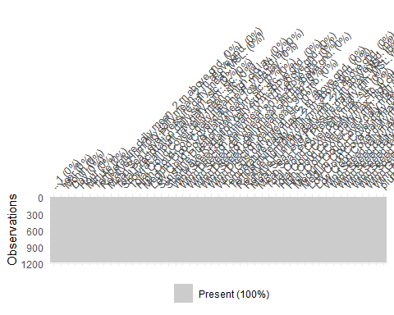 3- Conversion de la variable à expliquer : pluie.demain en factor et verification de la modification dans le code ci-dessous :

# convertir la variable en factor  
dtn$pluie.demain <- factor(dtn$pluie.demain)  
# vérifier la modification  
str(dtn$pluie.demain)

## Factor w/ 2 levels "FALSE","TRUE": 1 1 2 2 2 2 2 2 2 2 ...

4- Proportions pour ‘pluie.demain’

# Table et proportions pour 'pluie.demain'  
pluie.demainTable <- table(dtn$pluie.demain)  
proportionspluie.demain <- round(prop.table(pluie.demainTable) * 100, 1)  
labels <- paste(names(pluie.demainTable), "\n", proportionspluie.demain, "%", sep="")  
  
# Diagramme en camembert avec proportions  
pie(pluie.demainTable, labels = labels, main = "Répartition de la variable pluie.demain", col = c("red", "green"))

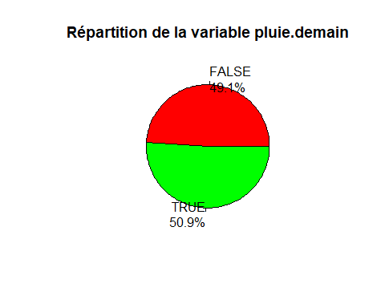 on a pratiquement la meme proportion de TRUE et FALSE ce qui est plustot pas mal et cela prouve encore que les données sont plus ou moins propres et surtout equilibrées.

5- box plot des variables vs la variable à expliquer : pluie.demain.

# Load necessary libraries  
library(ggplot2)

## Warning: le package 'ggplot2' a été compilé avec la version R 4.3.3

# Generate boxplots for each numeric variable in the dataset  
boxplot_plots <- lapply(names(dtn)[sapply(dtn, is.numeric)], function(variable){  
 ggplot(dtn, aes(x = factor(pluie.demain), y = .data[[variable]], fill = factor(pluie.demain))) +  
 geom_boxplot() +  
 labs(  
 title = paste("Boxplot of", variable, "vs. pluie de demain"),  
 x = "Pluie de demain",  
 y = variable  
 ) +  
 theme_minimal()  
})  
  
# To print all the plots  
lapply(boxplot_plots, print)

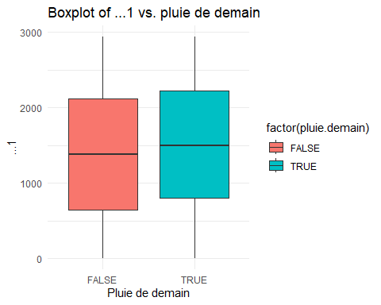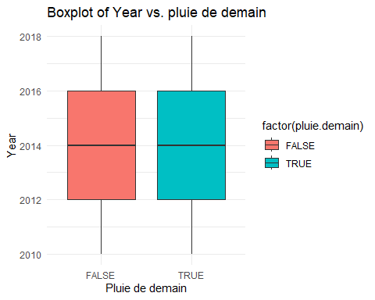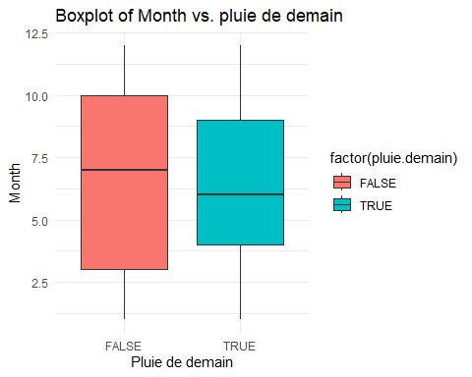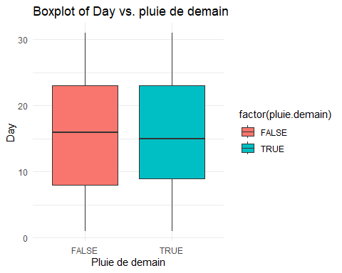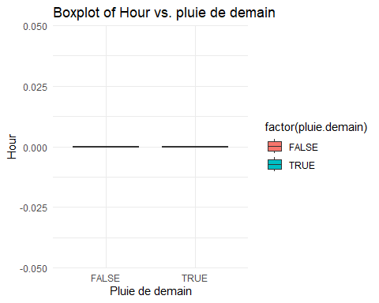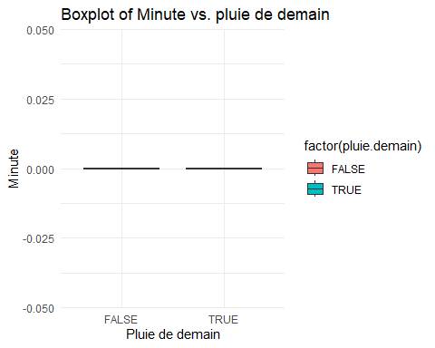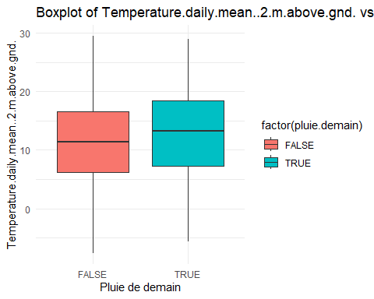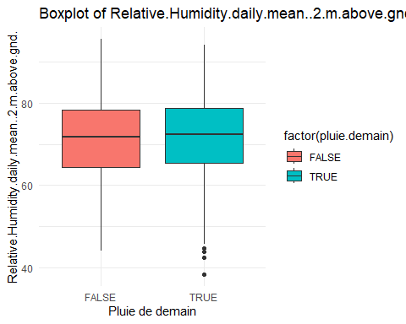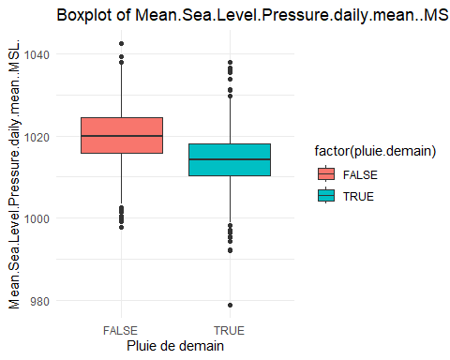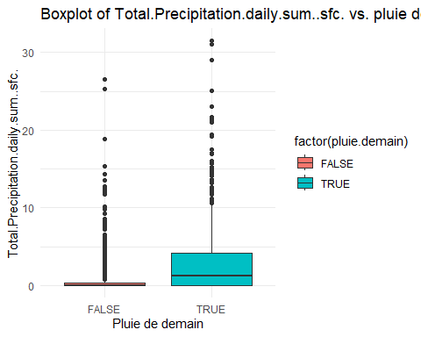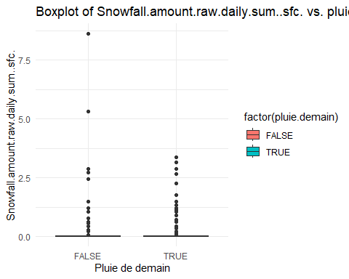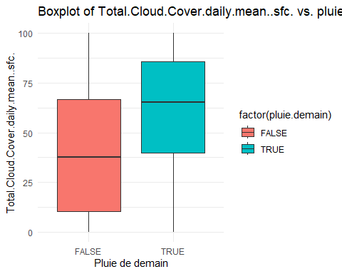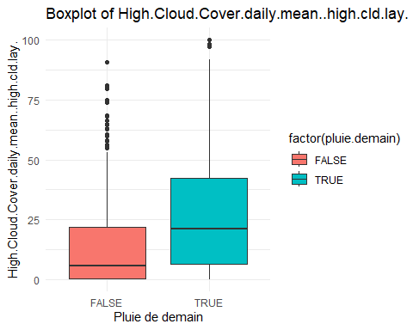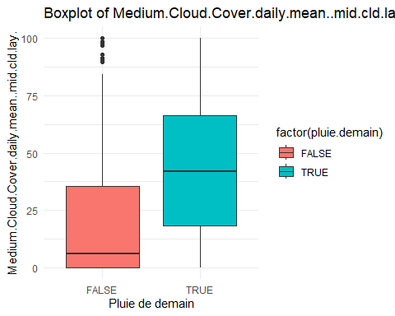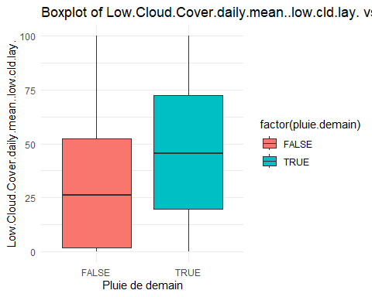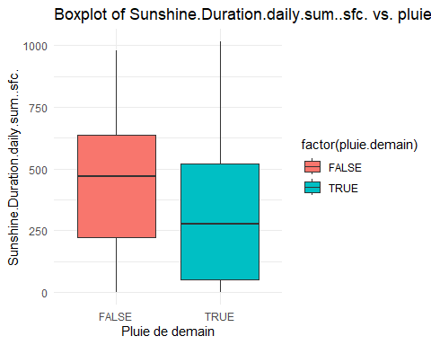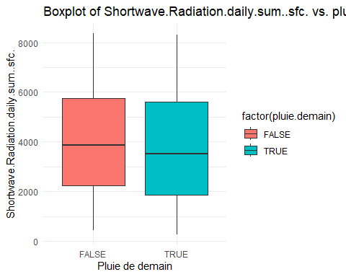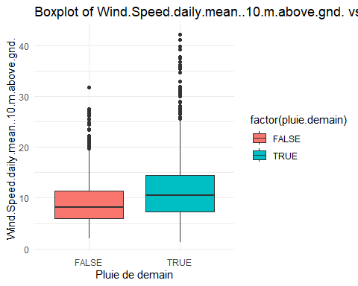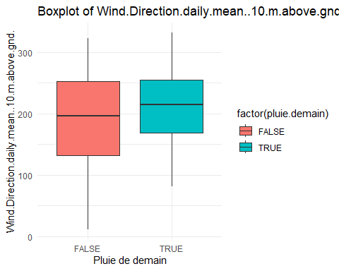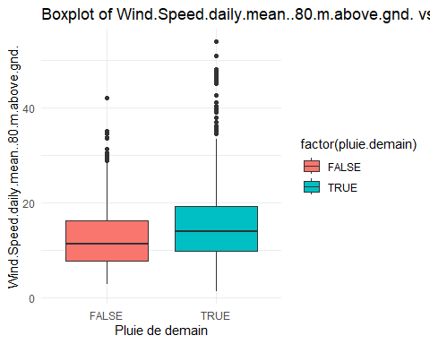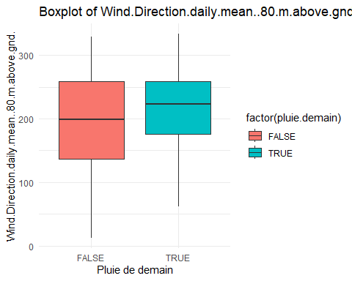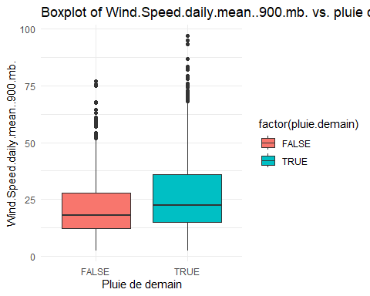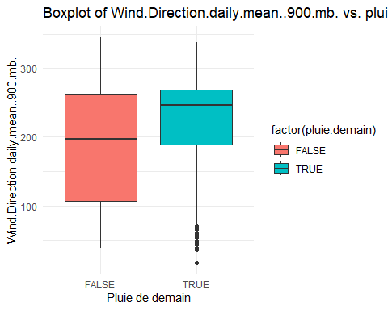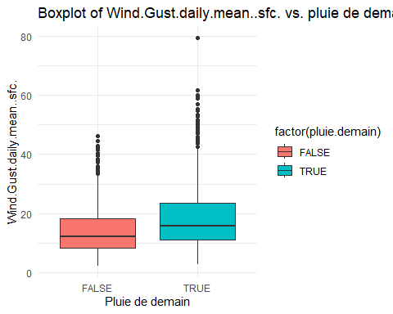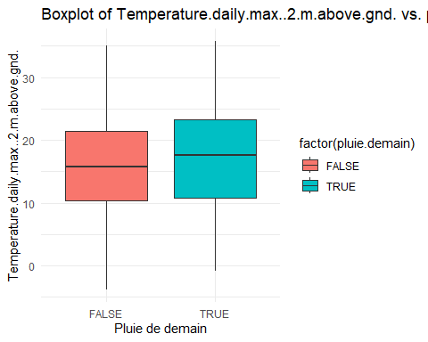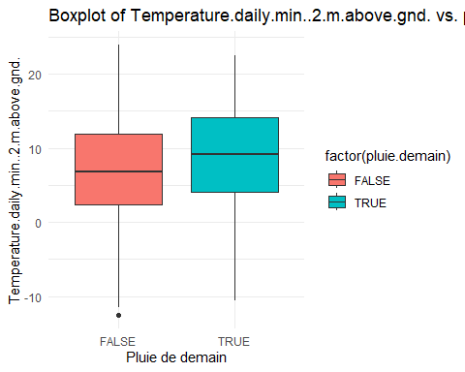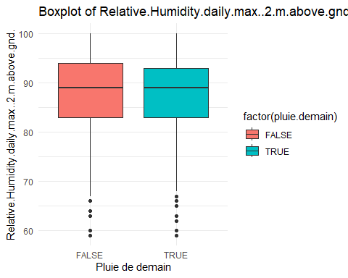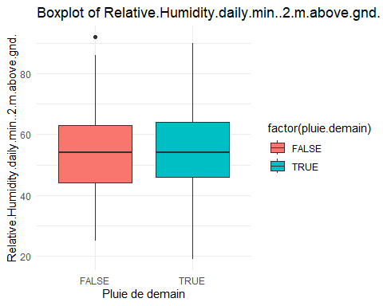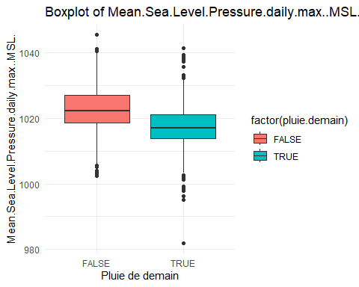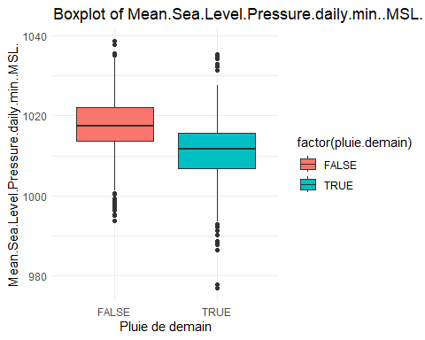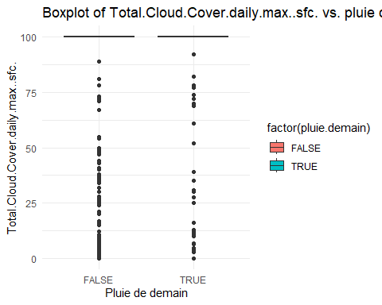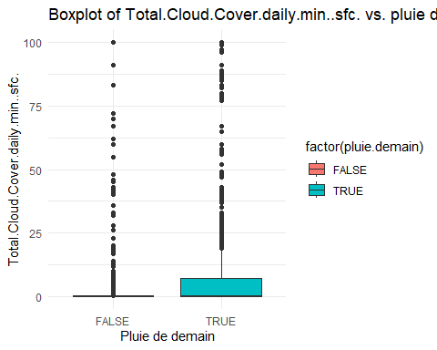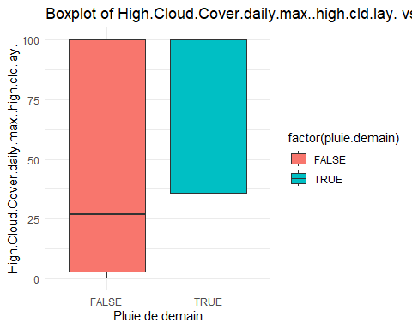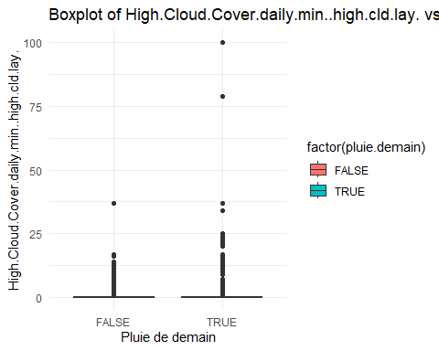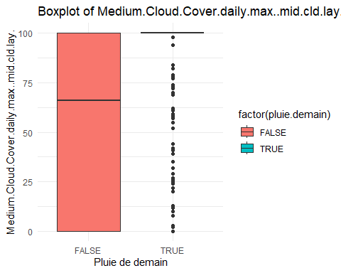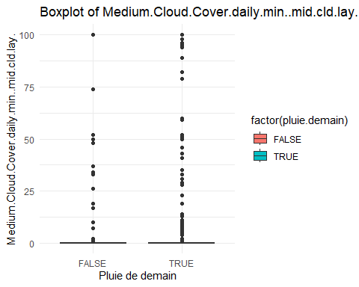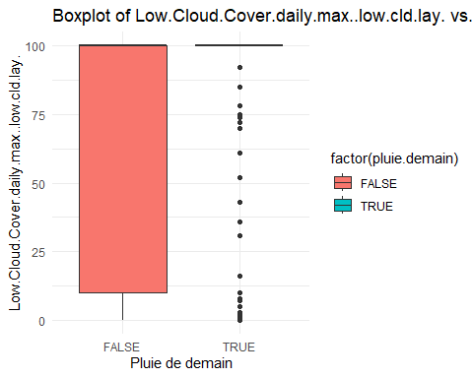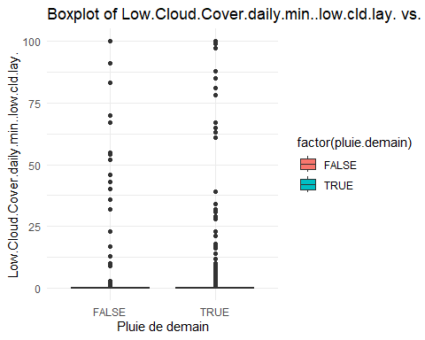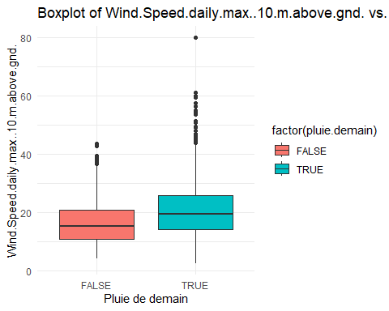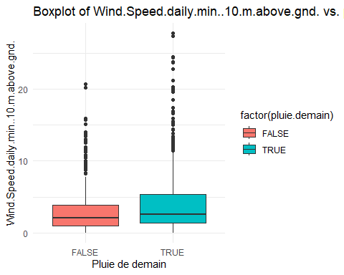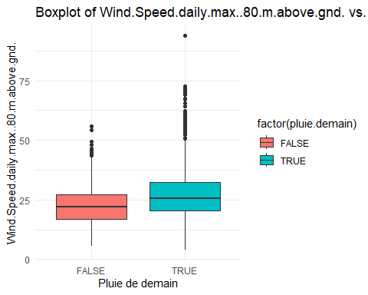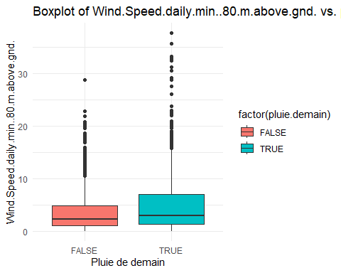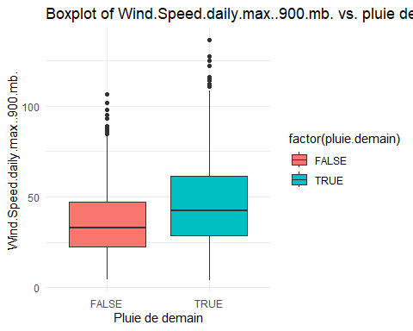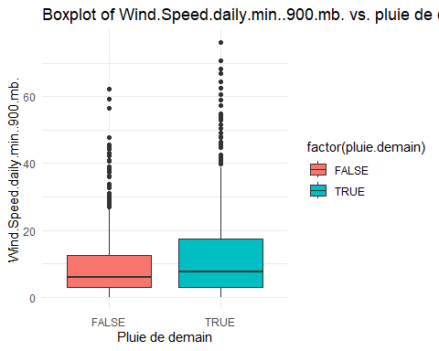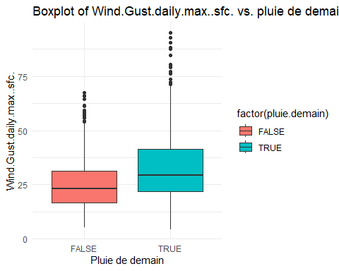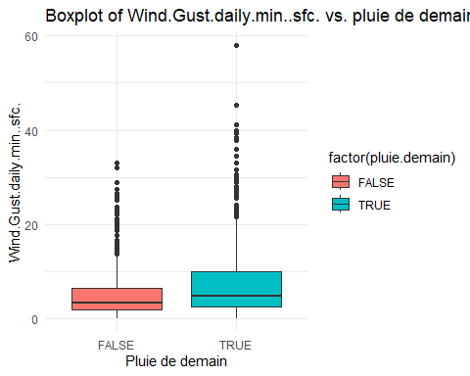

## [[1]]



##   
## [[2]]



##   
## [[3]]



##   
## [[4]]



##   
## [[5]]



##   
## [[6]]



##   
## [[7]]



##   
## [[8]]



##   
## [[9]]



##   
## [[10]]



##   
## [[11]]



##   
## [[12]]



##   
## [[13]]



##   
## [[14]]



##   
## [[15]]



##   
## [[16]]



##   
## [[17]]



##   
## [[18]]



##   
## [[19]]



##   
## [[20]]



##   
## [[21]]



##   
## [[22]]



##   
## [[23]]



##   
## [[24]]



##   
## [[25]]



##   
## [[26]]



##   
## [[27]]



##   
## [[28]]



##   
## [[29]]



##   
## [[30]]



##   
## [[31]]



##   
## [[32]]



##   
## [[33]]



##   
## [[34]]



##   
## [[35]]



##   
## [[36]]



##   
## [[37]]



##   
## [[38]]



##   
## [[39]]



##   
## [[40]]



##   
## [[41]]



##   
## [[42]]



##   
## [[43]]



##   
## [[44]]



##   
## [[45]]



##   
## [[46]]

 les box plot nous montrent qu’il n’y ait pas de valeurs aberrantes et que les données sont plus ou moins cohérentes 6- 1ere tentation GLM via la fonction : STEP ==> selecttion en automatique.

# Construction du modèle initial avec toutes les variables  
mdr2 <- glm(pluie.demain ~   
 . , data = dtn, family = binomial)  
summary(mdr2)

##   
## Call:  
## glm(formula = pluie.demain ~ ., family = binomial, data = dtn)  
##   
## Coefficients: (2 not defined because of singularities)  
## Estimate Std. Error z value  
## (Intercept) 5.031e+04 9.260e+04 0.543  
## ...1 6.862e-02 1.261e-01 0.544  
## Year -2.499e+01 4.606e+01 -0.543  
## Month -2.107e+00 3.837e+00 -0.549  
## Day -5.663e-02 1.260e-01 -0.449  
## Hour NA NA NA  
## Minute NA NA NA  
## Temperature.daily.mean..2.m.above.gnd. 1.859e-01 1.641e-01 1.133  
## Relative.Humidity.daily.mean..2.m.above.gnd. 2.011e-02 3.246e-02 0.620  
## Mean.Sea.Level.Pressure.daily.mean..MSL. 5.096e-01 1.394e-01 3.655  
## Total.Precipitation.daily.sum..sfc. 2.660e-02 2.811e-02 0.946  
## Snowfall.amount.raw.daily.sum..sfc. -2.973e-01 2.366e-01 -1.256  
## Total.Cloud.Cover.daily.mean..sfc. 1.192e-02 1.205e-02 0.989  
## High.Cloud.Cover.daily.mean..high.cld.lay. -3.216e-03 6.815e-03 -0.472  
## Medium.Cloud.Cover.daily.mean..mid.cld.lay. 5.727e-03 6.698e-03 0.855  
## Low.Cloud.Cover.daily.mean..low.cld.lay. -3.823e-03 8.162e-03 -0.468  
## Sunshine.Duration.daily.sum..sfc. 4.403e-04 8.880e-04 0.496  
## Shortwave.Radiation.daily.sum..sfc. 4.338e-05 1.021e-04 0.425  
## Wind.Speed.daily.mean..10.m.above.gnd. -4.846e-02 9.718e-02 -0.499  
## Wind.Direction.daily.mean..10.m.above.gnd. 5.797e-03 5.781e-03 1.003  
## Wind.Speed.daily.mean..80.m.above.gnd. -9.287e-02 6.956e-02 -1.335  
## Wind.Direction.daily.mean..80.m.above.gnd. -9.606e-03 5.970e-03 -1.609  
## Wind.Speed.daily.mean..900.mb. 1.883e-02 2.598e-02 0.725  
## Wind.Direction.daily.mean..900.mb. 5.409e-03 1.451e-03 3.727  
## Wind.Gust.daily.mean..sfc. 1.882e-02 3.697e-02 0.509  
## Temperature.daily.max..2.m.above.gnd. -1.067e-02 9.595e-02 -0.111  
## Temperature.daily.min..2.m.above.gnd. -1.335e-01 8.654e-02 -1.542  
## Relative.Humidity.daily.max..2.m.above.gnd. -2.289e-04 2.063e-02 -0.011  
## Relative.Humidity.daily.min..2.m.above.gnd. -7.114e-03 1.858e-02 -0.383  
## Mean.Sea.Level.Pressure.daily.max..MSL. -2.567e-01 7.518e-02 -3.414  
## Mean.Sea.Level.Pressure.daily.min..MSL. -3.196e-01 7.564e-02 -4.226  
## Total.Cloud.Cover.daily.max..sfc. 3.459e-03 4.869e-03 0.711  
## Total.Cloud.Cover.daily.min..sfc. 7.779e-03 6.263e-03 1.242  
## High.Cloud.Cover.daily.max..high.cld.lay. 3.460e-03 2.888e-03 1.198  
## High.Cloud.Cover.daily.min..high.cld.lay. 6.125e-03 2.087e-02 0.293  
## Medium.Cloud.Cover.daily.max..mid.cld.lay. 6.164e-03 3.165e-03 1.947  
## Medium.Cloud.Cover.daily.min..mid.cld.lay. -5.117e-03 9.483e-03 -0.540  
## Low.Cloud.Cover.daily.max..low.cld.lay. 2.962e-03 3.401e-03 0.871  
## Low.Cloud.Cover.daily.min..low.cld.lay. 2.872e-04 7.030e-03 0.041  
## Wind.Speed.daily.max..10.m.above.gnd. 5.599e-02 3.451e-02 1.622  
## Wind.Speed.daily.min..10.m.above.gnd. 1.699e-01 6.420e-02 2.646  
## Wind.Speed.daily.max..80.m.above.gnd. 4.034e-03 2.846e-02 0.142  
## Wind.Speed.daily.min..80.m.above.gnd. -5.365e-02 4.222e-02 -1.271  
## Wind.Speed.daily.max..900.mb. -1.346e-02 1.214e-02 -1.109  
## Wind.Speed.daily.min..900.mb. -4.779e-03 1.917e-02 -0.249  
## Wind.Gust.daily.max..sfc. 2.209e-02 1.736e-02 1.272  
## Wind.Gust.daily.min..sfc. 5.350e-03 2.804e-02 0.191  
## Pr(>|z|)   
## (Intercept) 0.586875   
## ...1 0.586307   
## Year 0.587341   
## Month 0.582985   
## Day 0.653079   
## Hour NA   
## Minute NA   
## Temperature.daily.mean..2.m.above.gnd. 0.257212   
## Relative.Humidity.daily.mean..2.m.above.gnd. 0.535569   
## Mean.Sea.Level.Pressure.daily.mean..MSL. 0.000257 ***  
## Total.Precipitation.daily.sum..sfc. 0.344021   
## Snowfall.amount.raw.daily.sum..sfc. 0.208975   
## Total.Cloud.Cover.daily.mean..sfc. 0.322842   
## High.Cloud.Cover.daily.mean..high.cld.lay. 0.637003   
## Medium.Cloud.Cover.daily.mean..mid.cld.lay. 0.392559   
## Low.Cloud.Cover.daily.mean..low.cld.lay. 0.639493   
## Sunshine.Duration.daily.sum..sfc. 0.620036   
## Shortwave.Radiation.daily.sum..sfc. 0.670887   
## Wind.Speed.daily.mean..10.m.above.gnd. 0.618033   
## Wind.Direction.daily.mean..10.m.above.gnd. 0.315988   
## Wind.Speed.daily.mean..80.m.above.gnd. 0.181842   
## Wind.Direction.daily.mean..80.m.above.gnd. 0.107638   
## Wind.Speed.daily.mean..900.mb. 0.468512   
## Wind.Direction.daily.mean..900.mb. 0.000194 ***  
## Wind.Gust.daily.mean..sfc. 0.610701   
## Temperature.daily.max..2.m.above.gnd. 0.911471   
## Temperature.daily.min..2.m.above.gnd. 0.122976   
## Relative.Humidity.daily.max..2.m.above.gnd. 0.991148   
## Relative.Humidity.daily.min..2.m.above.gnd. 0.701853   
## Mean.Sea.Level.Pressure.daily.max..MSL. 0.000640 ***  
## Mean.Sea.Level.Pressure.daily.min..MSL. 2.38e-05 ***  
## Total.Cloud.Cover.daily.max..sfc. 0.477369   
## Total.Cloud.Cover.daily.min..sfc. 0.214165   
## High.Cloud.Cover.daily.max..high.cld.lay. 0.230837   
## High.Cloud.Cover.daily.min..high.cld.lay. 0.769159   
## Medium.Cloud.Cover.daily.max..mid.cld.lay. 0.051483 .   
## Medium.Cloud.Cover.daily.min..mid.cld.lay. 0.589517   
## Low.Cloud.Cover.daily.max..low.cld.lay. 0.383830   
## Low.Cloud.Cover.daily.min..low.cld.lay. 0.967413   
## Wind.Speed.daily.max..10.m.above.gnd. 0.104752   
## Wind.Speed.daily.min..10.m.above.gnd. 0.008156 **   
## Wind.Speed.daily.max..80.m.above.gnd. 0.887292   
## Wind.Speed.daily.min..80.m.above.gnd. 0.203813   
## Wind.Speed.daily.max..900.mb. 0.267626   
## Wind.Speed.daily.min..900.mb. 0.803111   
## Wind.Gust.daily.max..sfc. 0.203229   
## Wind.Gust.daily.min..sfc. 0.848666   
## ---  
## Signif. codes: 0 '***' 0.001 '**' 0.01 '*' 0.05 '.' 0.1 ' ' 1  
##   
## (Dispersion parameter for binomial family taken to be 1)  
##   
## Null deviance: 1635.4 on 1179 degrees of freedom  
## Residual deviance: 1232.4 on 1135 degrees of freedom  
## AIC: 1322.4  
##   
## Number of Fisher Scoring iterations: 5

p4 = step(mdr2)

## Start: AIC=1322.4  
## pluie.demain ~ ...1 + Year + Month + Day + Hour + Minute + Temperature.daily.mean..2.m.above.gnd. +   
## Relative.Humidity.daily.mean..2.m.above.gnd. + Mean.Sea.Level.Pressure.daily.mean..MSL. +   
## Total.Precipitation.daily.sum..sfc. + Snowfall.amount.raw.daily.sum..sfc. +   
## Total.Cloud.Cover.daily.mean..sfc. + High.Cloud.Cover.daily.mean..high.cld.lay. +   
## Medium.Cloud.Cover.daily.mean..mid.cld.lay. + Low.Cloud.Cover.daily.mean..low.cld.lay. +   
## Sunshine.Duration.daily.sum..sfc. + Shortwave.Radiation.daily.sum..sfc. +   
## Wind.Speed.daily.mean..10.m.above.gnd. + Wind.Direction.daily.mean..10.m.above.gnd. +   
## Wind.Speed.daily.mean..80.m.above.gnd. + Wind.Direction.daily.mean..80.m.above.gnd. +   
## Wind.Speed.daily.mean..900.mb. + Wind.Direction.daily.mean..900.mb. +   
## Wind.Gust.daily.mean..sfc. + Temperature.daily.max..2.m.above.gnd. +   
## Temperature.daily.min..2.m.above.gnd. + Relative.Humidity.daily.max..2.m.above.gnd. +   
## Relative.Humidity.daily.min..2.m.above.gnd. + Mean.Sea.Level.Pressure.daily.max..MSL. +   
## Mean.Sea.Level.Pressure.daily.min..MSL. + Total.Cloud.Cover.daily.max..sfc. +   
## Total.Cloud.Cover.daily.min..sfc. + High.Cloud.Cover.daily.max..high.cld.lay. +   
## High.Cloud.Cover.daily.min..high.cld.lay. + Medium.Cloud.Cover.daily.max..mid.cld.lay. +   
## Medium.Cloud.Cover.daily.min..mid.cld.lay. + Low.Cloud.Cover.daily.max..low.cld.lay. +   
## Low.Cloud.Cover.daily.min..low.cld.lay. + Wind.Speed.daily.max..10.m.above.gnd. +   
## Wind.Speed.daily.min..10.m.above.gnd. + Wind.Speed.daily.max..80.m.above.gnd. +   
## Wind.Speed.daily.min..80.m.above.gnd. + Wind.Speed.daily.max..900.mb. +   
## Wind.Speed.daily.min..900.mb. + Wind.Gust.daily.max..sfc. +   
## Wind.Gust.daily.min..sfc.  
##   
##   
## Step: AIC=1322.4  
## pluie.demain ~ ...1 + Year + Month + Day + Hour + Temperature.daily.mean..2.m.above.gnd. +   
## Relative.Humidity.daily.mean..2.m.above.gnd. + Mean.Sea.Level.Pressure.daily.mean..MSL. +   
## Total.Precipitation.daily.sum..sfc. + Snowfall.amount.raw.daily.sum..sfc. +   
## Total.Cloud.Cover.daily.mean..sfc. + High.Cloud.Cover.daily.mean..high.cld.lay. +   
## Medium.Cloud.Cover.daily.mean..mid.cld.lay. + Low.Cloud.Cover.daily.mean..low.cld.lay. +   
## Sunshine.Duration.daily.sum..sfc. + Shortwave.Radiation.daily.sum..sfc. +   
## Wind.Speed.daily.mean..10.m.above.gnd. + Wind.Direction.daily.mean..10.m.above.gnd. +   
## Wind.Speed.daily.mean..80.m.above.gnd. + Wind.Direction.daily.mean..80.m.above.gnd. +   
## Wind.Speed.daily.mean..900.mb. + Wind.Direction.daily.mean..900.mb. +   
## Wind.Gust.daily.mean..sfc. + Temperature.daily.max..2.m.above.gnd. +   
## Temperature.daily.min..2.m.above.gnd. + Relative.Humidity.daily.max..2.m.above.gnd. +   
## Relative.Humidity.daily.min..2.m.above.gnd. + Mean.Sea.Level.Pressure.daily.max..MSL. +   
## Mean.Sea.Level.Pressure.daily.min..MSL. + Total.Cloud.Cover.daily.max..sfc. +   
## Total.Cloud.Cover.daily.min..sfc. + High.Cloud.Cover.daily.max..high.cld.lay. +   
## High.Cloud.Cover.daily.min..high.cld.lay. + Medium.Cloud.Cover.daily.max..mid.cld.lay. +   
## Medium.Cloud.Cover.daily.min..mid.cld.lay. + Low.Cloud.Cover.daily.max..low.cld.lay. +   
## Low.Cloud.Cover.daily.min..low.cld.lay. + Wind.Speed.daily.max..10.m.above.gnd. +   
## Wind.Speed.daily.min..10.m.above.gnd. + Wind.Speed.daily.max..80.m.above.gnd. +   
## Wind.Speed.daily.min..80.m.above.gnd. + Wind.Speed.daily.max..900.mb. +   
## Wind.Speed.daily.min..900.mb. + Wind.Gust.daily.max..sfc. +   
## Wind.Gust.daily.min..sfc.  
##   
##   
## Step: AIC=1322.4  
## pluie.demain ~ ...1 + Year + Month + Day + Temperature.daily.mean..2.m.above.gnd. +   
## Relative.Humidity.daily.mean..2.m.above.gnd. + Mean.Sea.Level.Pressure.daily.mean..MSL. +   
## Total.Precipitation.daily.sum..sfc. + Snowfall.amount.raw.daily.sum..sfc. +   
## Total.Cloud.Cover.daily.mean..sfc. + High.Cloud.Cover.daily.mean..high.cld.lay. +   
## Medium.Cloud.Cover.daily.mean..mid.cld.lay. + Low.Cloud.Cover.daily.mean..low.cld.lay. +   
## Sunshine.Duration.daily.sum..sfc. + Shortwave.Radiation.daily.sum..sfc. +   
## Wind.Speed.daily.mean..10.m.above.gnd. + Wind.Direction.daily.mean..10.m.above.gnd. +   
## Wind.Speed.daily.mean..80.m.above.gnd. + Wind.Direction.daily.mean..80.m.above.gnd. +   
## Wind.Speed.daily.mean..900.mb. + Wind.Direction.daily.mean..900.mb. +   
## Wind.Gust.daily.mean..sfc. + Temperature.daily.max..2.m.above.gnd. +   
## Temperature.daily.min..2.m.above.gnd. + Relative.Humidity.daily.max..2.m.above.gnd. +   
## Relative.Humidity.daily.min..2.m.above.gnd. + Mean.Sea.Level.Pressure.daily.max..MSL. +   
## Mean.Sea.Level.Pressure.daily.min..MSL. + Total.Cloud.Cover.daily.max..sfc. +   
## Total.Cloud.Cover.daily.min..sfc. + High.Cloud.Cover.daily.max..high.cld.lay. +   
## High.Cloud.Cover.daily.min..high.cld.lay. + Medium.Cloud.Cover.daily.max..mid.cld.lay. +   
## Medium.Cloud.Cover.daily.min..mid.cld.lay. + Low.Cloud.Cover.daily.max..low.cld.lay. +   
## Low.Cloud.Cover.daily.min..low.cld.lay. + Wind.Speed.daily.max..10.m.above.gnd. +   
## Wind.Speed.daily.min..10.m.above.gnd. + Wind.Speed.daily.max..80.m.above.gnd. +   
## Wind.Speed.daily.min..80.m.above.gnd. + Wind.Speed.daily.max..900.mb. +   
## Wind.Speed.daily.min..900.mb. + Wind.Gust.daily.max..sfc. +   
## Wind.Gust.daily.min..sfc.  
##   
## Df Deviance AIC  
## - Relative.Humidity.daily.max..2.m.above.gnd. 1 1232.4 1320.4  
## - Low.Cloud.Cover.daily.min..low.cld.lay. 1 1232.4 1320.4  
## - Temperature.daily.max..2.m.above.gnd. 1 1232.4 1320.4  
## - Wind.Speed.daily.max..80.m.above.gnd. 1 1232.4 1320.4  
## - Wind.Gust.daily.min..sfc. 1 1232.4 1320.4  
## - Wind.Speed.daily.min..900.mb. 1 1232.5 1320.5  
## - High.Cloud.Cover.daily.min..high.cld.lay. 1 1232.5 1320.5  
## - Relative.Humidity.daily.min..2.m.above.gnd. 1 1232.5 1320.5  
## - Shortwave.Radiation.daily.sum..sfc. 1 1232.6 1320.6  
## - Day 1 1232.6 1320.6  
## - Low.Cloud.Cover.daily.mean..low.cld.lay. 1 1232.6 1320.6  
## - High.Cloud.Cover.daily.mean..high.cld.lay. 1 1232.6 1320.6  
## - Sunshine.Duration.daily.sum..sfc. 1 1232.7 1320.7  
## - Wind.Speed.daily.mean..10.m.above.gnd. 1 1232.7 1320.7  
## - Wind.Gust.daily.mean..sfc. 1 1232.7 1320.7  
## - Medium.Cloud.Cover.daily.min..mid.cld.lay. 1 1232.7 1320.7  
## - Year 1 1232.7 1320.7  
## - ...1 1 1232.7 1320.7  
## - Month 1 1232.7 1320.7  
## - Relative.Humidity.daily.mean..2.m.above.gnd. 1 1232.8 1320.8  
## - Total.Cloud.Cover.daily.max..sfc. 1 1232.9 1320.9  
## - Wind.Speed.daily.mean..900.mb. 1 1232.9 1320.9  
## - Medium.Cloud.Cover.daily.mean..mid.cld.lay. 1 1233.1 1321.1  
## - Low.Cloud.Cover.daily.max..low.cld.lay. 1 1233.2 1321.2  
## - Total.Precipitation.daily.sum..sfc. 1 1233.3 1321.3  
## - Total.Cloud.Cover.daily.mean..sfc. 1 1233.4 1321.4  
## - Wind.Direction.daily.mean..10.m.above.gnd. 1 1233.4 1321.4  
## - Wind.Speed.daily.max..900.mb. 1 1233.6 1321.6  
## - Temperature.daily.mean..2.m.above.gnd. 1 1233.7 1321.7  
## - High.Cloud.Cover.daily.max..high.cld.lay. 1 1233.8 1321.8  
## - Wind.Speed.daily.min..80.m.above.gnd. 1 1234.0 1322.0  
## - Total.Cloud.Cover.daily.min..sfc. 1 1234.0 1322.0  
## - Wind.Gust.daily.max..sfc. 1 1234.0 1322.0  
## - Wind.Speed.daily.mean..80.m.above.gnd. 1 1234.2 1322.2  
## - Snowfall.amount.raw.daily.sum..sfc. 1 1234.3 1322.3  
## <none> 1232.4 1322.4  
## - Temperature.daily.min..2.m.above.gnd. 1 1234.8 1322.8  
## - Wind.Direction.daily.mean..80.m.above.gnd. 1 1235.0 1323.0  
## - Wind.Speed.daily.max..10.m.above.gnd. 1 1235.0 1323.0  
## - Medium.Cloud.Cover.daily.max..mid.cld.lay. 1 1236.2 1324.2  
## - Wind.Speed.daily.min..10.m.above.gnd. 1 1239.5 1327.5  
## - Mean.Sea.Level.Pressure.daily.max..MSL. 1 1244.7 1332.7  
## - Wind.Direction.daily.mean..900.mb. 1 1246.7 1334.7  
## - Mean.Sea.Level.Pressure.daily.mean..MSL. 1 1247.0 1335.0  
## - Mean.Sea.Level.Pressure.daily.min..MSL. 1 1252.9 1340.9  
##   
## Step: AIC=1320.4  
## pluie.demain ~ ...1 + Year + Month + Day + Temperature.daily.mean..2.m.above.gnd. +   
## Relative.Humidity.daily.mean..2.m.above.gnd. + Mean.Sea.Level.Pressure.daily.mean..MSL. +   
## Total.Precipitation.daily.sum..sfc. + Snowfall.amount.raw.daily.sum..sfc. +   
## Total.Cloud.Cover.daily.mean..sfc. + High.Cloud.Cover.daily.mean..high.cld.lay. +   
## Medium.Cloud.Cover.daily.mean..mid.cld.lay. + Low.Cloud.Cover.daily.mean..low.cld.lay. +   
## Sunshine.Duration.daily.sum..sfc. + Shortwave.Radiation.daily.sum..sfc. +   
## Wind.Speed.daily.mean..10.m.above.gnd. + Wind.Direction.daily.mean..10.m.above.gnd. +   
## Wind.Speed.daily.mean..80.m.above.gnd. + Wind.Direction.daily.mean..80.m.above.gnd. +   
## Wind.Speed.daily.mean..900.mb. + Wind.Direction.daily.mean..900.mb. +   
## Wind.Gust.daily.mean..sfc. + Temperature.daily.max..2.m.above.gnd. +   
## Temperature.daily.min..2.m.above.gnd. + Relative.Humidity.daily.min..2.m.above.gnd. +   
## Mean.Sea.Level.Pressure.daily.max..MSL. + Mean.Sea.Level.Pressure.daily.min..MSL. +   
## Total.Cloud.Cover.daily.max..sfc. + Total.Cloud.Cover.daily.min..sfc. +   
## High.Cloud.Cover.daily.max..high.cld.lay. + High.Cloud.Cover.daily.min..high.cld.lay. +   
## Medium.Cloud.Cover.daily.max..mid.cld.lay. + Medium.Cloud.Cover.daily.min..mid.cld.lay. +   
## Low.Cloud.Cover.daily.max..low.cld.lay. + Low.Cloud.Cover.daily.min..low.cld.lay. +   
## Wind.Speed.daily.max..10.m.above.gnd. + Wind.Speed.daily.min..10.m.above.gnd. +   
## Wind.Speed.daily.max..80.m.above.gnd. + Wind.Speed.daily.min..80.m.above.gnd. +   
## Wind.Speed.daily.max..900.mb. + Wind.Speed.daily.min..900.mb. +   
## Wind.Gust.daily.max..sfc. + Wind.Gust.daily.min..sfc.  
##   
## Df Deviance AIC  
## - Low.Cloud.Cover.daily.min..low.cld.lay. 1 1232.4 1318.4  
## - Temperature.daily.max..2.m.above.gnd. 1 1232.4 1318.4  
## - Wind.Speed.daily.max..80.m.above.gnd. 1 1232.4 1318.4  
## - Wind.Gust.daily.min..sfc. 1 1232.4 1318.4  
## - Wind.Speed.daily.min..900.mb. 1 1232.5 1318.5  
## - High.Cloud.Cover.daily.min..high.cld.lay. 1 1232.5 1318.5  
## - Shortwave.Radiation.daily.sum..sfc. 1 1232.6 1318.6  
## - Relative.Humidity.daily.min..2.m.above.gnd. 1 1232.6 1318.6  
## - Day 1 1232.6 1318.6  
## - Low.Cloud.Cover.daily.mean..low.cld.lay. 1 1232.6 1318.6  
## - High.Cloud.Cover.daily.mean..high.cld.lay. 1 1232.6 1318.6  
## - Sunshine.Duration.daily.sum..sfc. 1 1232.7 1318.7  
## - Wind.Speed.daily.mean..10.m.above.gnd. 1 1232.7 1318.7  
## - Wind.Gust.daily.mean..sfc. 1 1232.7 1318.7  
## - Medium.Cloud.Cover.daily.min..mid.cld.lay. 1 1232.7 1318.7  
## - Year 1 1232.7 1318.7  
## - ...1 1 1232.7 1318.7  
## - Month 1 1232.7 1318.7  
## - Total.Cloud.Cover.daily.max..sfc. 1 1232.9 1318.9  
## - Wind.Speed.daily.mean..900.mb. 1 1232.9 1318.9  
## - Medium.Cloud.Cover.daily.mean..mid.cld.lay. 1 1233.1 1319.1  
## - Low.Cloud.Cover.daily.max..low.cld.lay. 1 1233.2 1319.2  
## - Total.Precipitation.daily.sum..sfc. 1 1233.3 1319.3  
## - Total.Cloud.Cover.daily.mean..sfc. 1 1233.4 1319.4  
## - Relative.Humidity.daily.mean..2.m.above.gnd. 1 1233.4 1319.4  
## - Wind.Direction.daily.mean..10.m.above.gnd. 1 1233.4 1319.4  
## - Wind.Speed.daily.max..900.mb. 1 1233.6 1319.6  
## - Temperature.daily.mean..2.m.above.gnd. 1 1233.7 1319.7  
## - High.Cloud.Cover.daily.max..high.cld.lay. 1 1233.8 1319.8  
## - Wind.Speed.daily.min..80.m.above.gnd. 1 1234.0 1320.0  
## - Total.Cloud.Cover.daily.min..sfc. 1 1234.0 1320.0  
## - Wind.Gust.daily.max..sfc. 1 1234.0 1320.0  
## - Wind.Speed.daily.mean..80.m.above.gnd. 1 1234.2 1320.2  
## - Snowfall.amount.raw.daily.sum..sfc. 1 1234.3 1320.3  
## <none> 1232.4 1320.4  
## - Temperature.daily.min..2.m.above.gnd. 1 1235.0 1321.0  
## - Wind.Direction.daily.mean..80.m.above.gnd. 1 1235.0 1321.0  
## - Wind.Speed.daily.max..10.m.above.gnd. 1 1235.0 1321.0  
## - Medium.Cloud.Cover.daily.max..mid.cld.lay. 1 1236.2 1322.2  
## - Wind.Speed.daily.min..10.m.above.gnd. 1 1239.5 1325.5  
## - Mean.Sea.Level.Pressure.daily.max..MSL. 1 1244.7 1330.7  
## - Wind.Direction.daily.mean..900.mb. 1 1246.7 1332.7  
## - Mean.Sea.Level.Pressure.daily.mean..MSL. 1 1247.0 1333.0  
## - Mean.Sea.Level.Pressure.daily.min..MSL. 1 1252.9 1338.9  
##   
## Step: AIC=1318.4  
## pluie.demain ~ ...1 + Year + Month + Day + Temperature.daily.mean..2.m.above.gnd. +   
## Relative.Humidity.daily.mean..2.m.above.gnd. + Mean.Sea.Level.Pressure.daily.mean..MSL. +   
## Total.Precipitation.daily.sum..sfc. + Snowfall.amount.raw.daily.sum..sfc. +   
## Total.Cloud.Cover.daily.mean..sfc. + High.Cloud.Cover.daily.mean..high.cld.lay. +   
## Medium.Cloud.Cover.daily.mean..mid.cld.lay. + Low.Cloud.Cover.daily.mean..low.cld.lay. +   
## Sunshine.Duration.daily.sum..sfc. + Shortwave.Radiation.daily.sum..sfc. +   
## Wind.Speed.daily.mean..10.m.above.gnd. + Wind.Direction.daily.mean..10.m.above.gnd. +   
## Wind.Speed.daily.mean..80.m.above.gnd. + Wind.Direction.daily.mean..80.m.above.gnd. +   
## Wind.Speed.daily.mean..900.mb. + Wind.Direction.daily.mean..900.mb. +   
## Wind.Gust.daily.mean..sfc. + Temperature.daily.max..2.m.above.gnd. +   
## Temperature.daily.min..2.m.above.gnd. + Relative.Humidity.daily.min..2.m.above.gnd. +   
## Mean.Sea.Level.Pressure.daily.max..MSL. + Mean.Sea.Level.Pressure.daily.min..MSL. +   
## Total.Cloud.Cover.daily.max..sfc. + Total.Cloud.Cover.daily.min..sfc. +   
## High.Cloud.Cover.daily.max..high.cld.lay. + High.Cloud.Cover.daily.min..high.cld.lay. +   
## Medium.Cloud.Cover.daily.max..mid.cld.lay. + Medium.Cloud.Cover.daily.min..mid.cld.lay. +   
## Low.Cloud.Cover.daily.max..low.cld.lay. + Wind.Speed.daily.max..10.m.above.gnd. +   
## Wind.Speed.daily.min..10.m.above.gnd. + Wind.Speed.daily.max..80.m.above.gnd. +   
## Wind.Speed.daily.min..80.m.above.gnd. + Wind.Speed.daily.max..900.mb. +   
## Wind.Speed.daily.min..900.mb. + Wind.Gust.daily.max..sfc. +   
## Wind.Gust.daily.min..sfc.  
##   
## Df Deviance AIC  
## - Temperature.daily.max..2.m.above.gnd. 1 1232.4 1316.4  
## - Wind.Speed.daily.max..80.m.above.gnd. 1 1232.4 1316.4  
## - Wind.Gust.daily.min..sfc. 1 1232.4 1316.4  
## - Wind.Speed.daily.min..900.mb. 1 1232.5 1316.5  
## - High.Cloud.Cover.daily.min..high.cld.lay. 1 1232.5 1316.5  
## - Shortwave.Radiation.daily.sum..sfc. 1 1232.6 1316.6  
## - Relative.Humidity.daily.min..2.m.above.gnd. 1 1232.6 1316.6  
## - Day 1 1232.6 1316.6  
## - Low.Cloud.Cover.daily.mean..low.cld.lay. 1 1232.6 1316.6  
## - High.Cloud.Cover.daily.mean..high.cld.lay. 1 1232.6 1316.6  
## - Sunshine.Duration.daily.sum..sfc. 1 1232.7 1316.7  
## - Wind.Speed.daily.mean..10.m.above.gnd. 1 1232.7 1316.7  
## - Wind.Gust.daily.mean..sfc. 1 1232.7 1316.7  
## - Medium.Cloud.Cover.daily.min..mid.cld.lay. 1 1232.7 1316.7  
## - Year 1 1232.7 1316.7  
## - ...1 1 1232.7 1316.7  
## - Month 1 1232.7 1316.7  
## - Total.Cloud.Cover.daily.max..sfc. 1 1232.9 1316.9  
## - Wind.Speed.daily.mean..900.mb. 1 1232.9 1316.9  
## - Medium.Cloud.Cover.daily.mean..mid.cld.lay. 1 1233.2 1317.2  
## - Low.Cloud.Cover.daily.max..low.cld.lay. 1 1233.2 1317.2  
## - Total.Precipitation.daily.sum..sfc. 1 1233.4 1317.4  
## - Total.Cloud.Cover.daily.mean..sfc. 1 1233.4 1317.4  
## - Relative.Humidity.daily.mean..2.m.above.gnd. 1 1233.4 1317.4  
## - Wind.Direction.daily.mean..10.m.above.gnd. 1 1233.4 1317.4  
## - Wind.Speed.daily.max..900.mb. 1 1233.6 1317.6  
## - Temperature.daily.mean..2.m.above.gnd. 1 1233.7 1317.7  
## - High.Cloud.Cover.daily.max..high.cld.lay. 1 1233.8 1317.8  
## - Wind.Gust.daily.max..sfc. 1 1234.0 1318.0  
## - Wind.Speed.daily.min..80.m.above.gnd. 1 1234.0 1318.0  
## - Wind.Speed.daily.mean..80.m.above.gnd. 1 1234.2 1318.2  
## - Snowfall.amount.raw.daily.sum..sfc. 1 1234.3 1318.3  
## <none> 1232.4 1318.4  
## - Temperature.daily.min..2.m.above.gnd. 1 1235.0 1319.0  
## - Wind.Direction.daily.mean..80.m.above.gnd. 1 1235.0 1319.0  
## - Wind.Speed.daily.max..10.m.above.gnd. 1 1235.0 1319.0  
## - Total.Cloud.Cover.daily.min..sfc. 1 1235.4 1319.4  
## - Medium.Cloud.Cover.daily.max..mid.cld.lay. 1 1236.3 1320.3  
## - Wind.Speed.daily.min..10.m.above.gnd. 1 1239.5 1323.5  
## - Mean.Sea.Level.Pressure.daily.max..MSL. 1 1244.7 1328.7  
## - Wind.Direction.daily.mean..900.mb. 1 1246.7 1330.7  
## - Mean.Sea.Level.Pressure.daily.mean..MSL. 1 1247.0 1331.0  
## - Mean.Sea.Level.Pressure.daily.min..MSL. 1 1253.0 1337.0  
##   
## Step: AIC=1316.41  
## pluie.demain ~ ...1 + Year + Month + Day + Temperature.daily.mean..2.m.above.gnd. +   
## Relative.Humidity.daily.mean..2.m.above.gnd. + Mean.Sea.Level.Pressure.daily.mean..MSL. +   
## Total.Precipitation.daily.sum..sfc. + Snowfall.amount.raw.daily.sum..sfc. +   
## Total.Cloud.Cover.daily.mean..sfc. + High.Cloud.Cover.daily.mean..high.cld.lay. +   
## Medium.Cloud.Cover.daily.mean..mid.cld.lay. + Low.Cloud.Cover.daily.mean..low.cld.lay. +   
## Sunshine.Duration.daily.sum..sfc. + Shortwave.Radiation.daily.sum..sfc. +   
## Wind.Speed.daily.mean..10.m.above.gnd. + Wind.Direction.daily.mean..10.m.above.gnd. +   
## Wind.Speed.daily.mean..80.m.above.gnd. + Wind.Direction.daily.mean..80.m.above.gnd. +   
## Wind.Speed.daily.mean..900.mb. + Wind.Direction.daily.mean..900.mb. +   
## Wind.Gust.daily.mean..sfc. + Temperature.daily.min..2.m.above.gnd. +   
## Relative.Humidity.daily.min..2.m.above.gnd. + Mean.Sea.Level.Pressure.daily.max..MSL. +   
## Mean.Sea.Level.Pressure.daily.min..MSL. + Total.Cloud.Cover.daily.max..sfc. +   
## Total.Cloud.Cover.daily.min..sfc. + High.Cloud.Cover.daily.max..high.cld.lay. +   
## High.Cloud.Cover.daily.min..high.cld.lay. + Medium.Cloud.Cover.daily.max..mid.cld.lay. +   
## Medium.Cloud.Cover.daily.min..mid.cld.lay. + Low.Cloud.Cover.daily.max..low.cld.lay. +   
## Wind.Speed.daily.max..10.m.above.gnd. + Wind.Speed.daily.min..10.m.above.gnd. +   
## Wind.Speed.daily.max..80.m.above.gnd. + Wind.Speed.daily.min..80.m.above.gnd. +   
## Wind.Speed.daily.max..900.mb. + Wind.Speed.daily.min..900.mb. +   
## Wind.Gust.daily.max..sfc. + Wind.Gust.daily.min..sfc.  
##   
## Df Deviance AIC  
## - Wind.Speed.daily.max..80.m.above.gnd. 1 1232.4 1314.4  
## - Wind.Gust.daily.min..sfc. 1 1232.5 1314.5  
## - Wind.Speed.daily.min..900.mb. 1 1232.5 1314.5  
## - High.Cloud.Cover.daily.min..high.cld.lay. 1 1232.5 1314.5  
## - Relative.Humidity.daily.min..2.m.above.gnd. 1 1232.6 1314.6  
## - Shortwave.Radiation.daily.sum..sfc. 1 1232.6 1314.6  
## - Day 1 1232.6 1314.6  
## - Low.Cloud.Cover.daily.mean..low.cld.lay. 1 1232.6 1314.6  
## - High.Cloud.Cover.daily.mean..high.cld.lay. 1 1232.6 1314.6  
## - Wind.Speed.daily.mean..10.m.above.gnd. 1 1232.7 1314.7  
## - Sunshine.Duration.daily.sum..sfc. 1 1232.7 1314.7  
## - Wind.Gust.daily.mean..sfc. 1 1232.7 1314.7  
## - Medium.Cloud.Cover.daily.min..mid.cld.lay. 1 1232.7 1314.7  
## - Year 1 1232.7 1314.7  
## - ...1 1 1232.7 1314.7  
## - Month 1 1232.7 1314.7  
## - Total.Cloud.Cover.daily.max..sfc. 1 1232.9 1314.9  
## - Wind.Speed.daily.mean..900.mb. 1 1232.9 1314.9  
## - Medium.Cloud.Cover.daily.mean..mid.cld.lay. 1 1233.2 1315.2  
## - Low.Cloud.Cover.daily.max..low.cld.lay. 1 1233.2 1315.2  
## - Total.Precipitation.daily.sum..sfc. 1 1233.4 1315.4  
## - Total.Cloud.Cover.daily.mean..sfc. 1 1233.4 1315.4  
## - Relative.Humidity.daily.mean..2.m.above.gnd. 1 1233.4 1315.4  
## - Wind.Direction.daily.mean..10.m.above.gnd. 1 1233.4 1315.4  
## - Wind.Speed.daily.max..900.mb. 1 1233.6 1315.6  
## - High.Cloud.Cover.daily.max..high.cld.lay. 1 1233.8 1315.8  
## - Wind.Gust.daily.max..sfc. 1 1234.0 1316.0  
## - Wind.Speed.daily.min..80.m.above.gnd. 1 1234.0 1316.0  
## - Wind.Speed.daily.mean..80.m.above.gnd. 1 1234.2 1316.2  
## - Snowfall.amount.raw.daily.sum..sfc. 1 1234.3 1316.3  
## <none> 1232.4 1316.4  
## - Wind.Direction.daily.mean..80.m.above.gnd. 1 1235.0 1317.0  
## - Wind.Speed.daily.max..10.m.above.gnd. 1 1235.1 1317.1  
## - Total.Cloud.Cover.daily.min..sfc. 1 1235.4 1317.4  
## - Temperature.daily.min..2.m.above.gnd. 1 1235.9 1317.9  
## - Medium.Cloud.Cover.daily.max..mid.cld.lay. 1 1236.3 1318.3  
## - Temperature.daily.mean..2.m.above.gnd. 1 1238.0 1320.0  
## - Wind.Speed.daily.min..10.m.above.gnd. 1 1239.5 1321.5  
## - Mean.Sea.Level.Pressure.daily.max..MSL. 1 1244.9 1326.9  
## - Wind.Direction.daily.mean..900.mb. 1 1247.0 1329.0  
## - Mean.Sea.Level.Pressure.daily.mean..MSL. 1 1247.4 1329.4  
## - Mean.Sea.Level.Pressure.daily.min..MSL. 1 1253.4 1335.4  
##   
## Step: AIC=1314.43  
## pluie.demain ~ ...1 + Year + Month + Day + Temperature.daily.mean..2.m.above.gnd. +   
## Relative.Humidity.daily.mean..2.m.above.gnd. + Mean.Sea.Level.Pressure.daily.mean..MSL. +   
## Total.Precipitation.daily.sum..sfc. + Snowfall.amount.raw.daily.sum..sfc. +   
## Total.Cloud.Cover.daily.mean..sfc. + High.Cloud.Cover.daily.mean..high.cld.lay. +   
## Medium.Cloud.Cover.daily.mean..mid.cld.lay. + Low.Cloud.Cover.daily.mean..low.cld.lay. +   
## Sunshine.Duration.daily.sum..sfc. + Shortwave.Radiation.daily.sum..sfc. +   
## Wind.Speed.daily.mean..10.m.above.gnd. + Wind.Direction.daily.mean..10.m.above.gnd. +   
## Wind.Speed.daily.mean..80.m.above.gnd. + Wind.Direction.daily.mean..80.m.above.gnd. +   
## Wind.Speed.daily.mean..900.mb. + Wind.Direction.daily.mean..900.mb. +   
## Wind.Gust.daily.mean..sfc. + Temperature.daily.min..2.m.above.gnd. +   
## Relative.Humidity.daily.min..2.m.above.gnd. + Mean.Sea.Level.Pressure.daily.max..MSL. +   
## Mean.Sea.Level.Pressure.daily.min..MSL. + Total.Cloud.Cover.daily.max..sfc. +   
## Total.Cloud.Cover.daily.min..sfc. + High.Cloud.Cover.daily.max..high.cld.lay. +   
## High.Cloud.Cover.daily.min..high.cld.lay. + Medium.Cloud.Cover.daily.max..mid.cld.lay. +   
## Medium.Cloud.Cover.daily.min..mid.cld.lay. + Low.Cloud.Cover.daily.max..low.cld.lay. +   
## Wind.Speed.daily.max..10.m.above.gnd. + Wind.Speed.daily.min..10.m.above.gnd. +   
## Wind.Speed.daily.min..80.m.above.gnd. + Wind.Speed.daily.max..900.mb. +   
## Wind.Speed.daily.min..900.mb. + Wind.Gust.daily.max..sfc. +   
## Wind.Gust.daily.min..sfc.  
##   
## Df Deviance AIC  
## - Wind.Gust.daily.min..sfc. 1 1232.5 1312.5  
## - Wind.Speed.daily.min..900.mb. 1 1232.5 1312.5  
## - High.Cloud.Cover.daily.min..high.cld.lay. 1 1232.5 1312.5  
## - Relative.Humidity.daily.min..2.m.above.gnd. 1 1232.6 1312.6  
## - Shortwave.Radiation.daily.sum..sfc. 1 1232.6 1312.6  
## - Day 1 1232.6 1312.6  
## - Low.Cloud.Cover.daily.mean..low.cld.lay. 1 1232.7 1312.7  
## - High.Cloud.Cover.daily.mean..high.cld.lay. 1 1232.7 1312.7  
## - Sunshine.Duration.daily.sum..sfc. 1 1232.7 1312.7  
## - Wind.Gust.daily.mean..sfc. 1 1232.7 1312.7  
## - Medium.Cloud.Cover.daily.min..mid.cld.lay. 1 1232.7 1312.7  
## - Wind.Speed.daily.mean..10.m.above.gnd. 1 1232.7 1312.7  
## - Year 1 1232.7 1312.7  
## - ...1 1 1232.7 1312.7  
## - Month 1 1232.7 1312.7  
## - Total.Cloud.Cover.daily.max..sfc. 1 1232.9 1312.9  
## - Wind.Speed.daily.mean..900.mb. 1 1232.9 1312.9  
## - Medium.Cloud.Cover.daily.mean..mid.cld.lay. 1 1233.2 1313.2  
## - Low.Cloud.Cover.daily.max..low.cld.lay. 1 1233.2 1313.2  
## - Total.Precipitation.daily.sum..sfc. 1 1233.4 1313.4  
## - Total.Cloud.Cover.daily.mean..sfc. 1 1233.4 1313.4  
## - Relative.Humidity.daily.mean..2.m.above.gnd. 1 1233.5 1313.5  
## - Wind.Direction.daily.mean..10.m.above.gnd. 1 1233.5 1313.5  
## - Wind.Speed.daily.max..900.mb. 1 1233.6 1313.6  
## - High.Cloud.Cover.daily.max..high.cld.lay. 1 1233.9 1313.9  
## - Wind.Speed.daily.min..80.m.above.gnd. 1 1234.2 1314.2  
## - Snowfall.amount.raw.daily.sum..sfc. 1 1234.3 1314.3  
## - Wind.Gust.daily.max..sfc. 1 1234.4 1314.4  
## <none> 1232.4 1314.4  
## - Wind.Speed.daily.mean..80.m.above.gnd. 1 1234.6 1314.6  
## - Wind.Direction.daily.mean..80.m.above.gnd. 1 1235.1 1315.1  
## - Total.Cloud.Cover.daily.min..sfc. 1 1235.4 1315.4  
## - Temperature.daily.min..2.m.above.gnd. 1 1235.9 1315.9  
## - Medium.Cloud.Cover.daily.max..mid.cld.lay. 1 1236.4 1316.4  
## - Wind.Speed.daily.max..10.m.above.gnd. 1 1236.8 1316.8  
## - Temperature.daily.mean..2.m.above.gnd. 1 1238.1 1318.1  
## - Wind.Speed.daily.min..10.m.above.gnd. 1 1239.7 1319.7  
## - Mean.Sea.Level.Pressure.daily.max..MSL. 1 1244.9 1324.9  
## - Wind.Direction.daily.mean..900.mb. 1 1247.0 1327.0  
## - Mean.Sea.Level.Pressure.daily.mean..MSL. 1 1247.4 1327.4  
## - Mean.Sea.Level.Pressure.daily.min..MSL. 1 1253.5 1333.5  
##   
## Step: AIC=1312.47  
## pluie.demain ~ ...1 + Year + Month + Day + Temperature.daily.mean..2.m.above.gnd. +   
## Relative.Humidity.daily.mean..2.m.above.gnd. + Mean.Sea.Level.Pressure.daily.mean..MSL. +   
## Total.Precipitation.daily.sum..sfc. + Snowfall.amount.raw.daily.sum..sfc. +   
## Total.Cloud.Cover.daily.mean..sfc. + High.Cloud.Cover.daily.mean..high.cld.lay. +   
## Medium.Cloud.Cover.daily.mean..mid.cld.lay. + Low.Cloud.Cover.daily.mean..low.cld.lay. +   
## Sunshine.Duration.daily.sum..sfc. + Shortwave.Radiation.daily.sum..sfc. +   
## Wind.Speed.daily.mean..10.m.above.gnd. + Wind.Direction.daily.mean..10.m.above.gnd. +   
## Wind.Speed.daily.mean..80.m.above.gnd. + Wind.Direction.daily.mean..80.m.above.gnd. +   
## Wind.Speed.daily.mean..900.mb. + Wind.Direction.daily.mean..900.mb. +   
## Wind.Gust.daily.mean..sfc. + Temperature.daily.min..2.m.above.gnd. +   
## Relative.Humidity.daily.min..2.m.above.gnd. + Mean.Sea.Level.Pressure.daily.max..MSL. +   
## Mean.Sea.Level.Pressure.daily.min..MSL. + Total.Cloud.Cover.daily.max..sfc. +   
## Total.Cloud.Cover.daily.min..sfc. + High.Cloud.Cover.daily.max..high.cld.lay. +   
## High.Cloud.Cover.daily.min..high.cld.lay. + Medium.Cloud.Cover.daily.max..mid.cld.lay. +   
## Medium.Cloud.Cover.daily.min..mid.cld.lay. + Low.Cloud.Cover.daily.max..low.cld.lay. +   
## Wind.Speed.daily.max..10.m.above.gnd. + Wind.Speed.daily.min..10.m.above.gnd. +   
## Wind.Speed.daily.min..80.m.above.gnd. + Wind.Speed.daily.max..900.mb. +   
## Wind.Speed.daily.min..900.mb. + Wind.Gust.daily.max..sfc.  
##   
## Df Deviance AIC  
## - Wind.Speed.daily.min..900.mb. 1 1232.5 1310.5  
## - High.Cloud.Cover.daily.min..high.cld.lay. 1 1232.6 1310.6  
## - Relative.Humidity.daily.min..2.m.above.gnd. 1 1232.6 1310.6  
## - Shortwave.Radiation.daily.sum..sfc. 1 1232.7 1310.7  
## - Day 1 1232.7 1310.7  
## - Low.Cloud.Cover.daily.mean..low.cld.lay. 1 1232.7 1310.7  
## - High.Cloud.Cover.daily.mean..high.cld.lay. 1 1232.7 1310.7  
## - Sunshine.Duration.daily.sum..sfc. 1 1232.7 1310.7  
## - Medium.Cloud.Cover.daily.min..mid.cld.lay. 1 1232.8 1310.8  
## - Year 1 1232.8 1310.8  
## - ...1 1 1232.8 1310.8  
## - Month 1 1232.8 1310.8  
## - Wind.Speed.daily.mean..10.m.above.gnd. 1 1232.8 1310.8  
## - Wind.Gust.daily.mean..sfc. 1 1232.9 1310.9  
## - Wind.Speed.daily.mean..900.mb. 1 1233.0 1311.0  
## - Total.Cloud.Cover.daily.max..sfc. 1 1233.0 1311.0  
## - Medium.Cloud.Cover.daily.mean..mid.cld.lay. 1 1233.2 1311.2  
## - Low.Cloud.Cover.daily.max..low.cld.lay. 1 1233.2 1311.2  
## - Total.Precipitation.daily.sum..sfc. 1 1233.4 1311.4  
## - Total.Cloud.Cover.daily.mean..sfc. 1 1233.5 1311.5  
## - Relative.Humidity.daily.mean..2.m.above.gnd. 1 1233.5 1311.5  
## - Wind.Direction.daily.mean..10.m.above.gnd. 1 1233.5 1311.5  
## - Wind.Speed.daily.max..900.mb. 1 1233.6 1311.6  
## - High.Cloud.Cover.daily.max..high.cld.lay. 1 1234.0 1312.0  
## - Wind.Speed.daily.min..80.m.above.gnd. 1 1234.2 1312.2  
## - Snowfall.amount.raw.daily.sum..sfc. 1 1234.4 1312.4  
## - Wind.Gust.daily.max..sfc. 1 1234.4 1312.4  
## <none> 1232.5 1312.5  
## - Wind.Speed.daily.mean..80.m.above.gnd. 1 1234.7 1312.7  
## - Wind.Direction.daily.mean..80.m.above.gnd. 1 1235.1 1313.1  
## - Total.Cloud.Cover.daily.min..sfc. 1 1235.5 1313.5  
## - Temperature.daily.min..2.m.above.gnd. 1 1236.0 1314.0  
## - Medium.Cloud.Cover.daily.max..mid.cld.lay. 1 1236.4 1314.4  
## - Wind.Speed.daily.max..10.m.above.gnd. 1 1236.9 1314.9  
## - Temperature.daily.mean..2.m.above.gnd. 1 1238.2 1316.2  
## - Wind.Speed.daily.min..10.m.above.gnd. 1 1240.8 1318.8  
## - Mean.Sea.Level.Pressure.daily.max..MSL. 1 1244.9 1322.9  
## - Wind.Direction.daily.mean..900.mb. 1 1247.0 1325.0  
## - Mean.Sea.Level.Pressure.daily.mean..MSL. 1 1247.4 1325.4  
## - Mean.Sea.Level.Pressure.daily.min..MSL. 1 1253.5 1331.5  
##   
## Step: AIC=1310.51  
## pluie.demain ~ ...1 + Year + Month + Day + Temperature.daily.mean..2.m.above.gnd. +   
## Relative.Humidity.daily.mean..2.m.above.gnd. + Mean.Sea.Level.Pressure.daily.mean..MSL. +   
## Total.Precipitation.daily.sum..sfc. + Snowfall.amount.raw.daily.sum..sfc. +   
## Total.Cloud.Cover.daily.mean..sfc. + High.Cloud.Cover.daily.mean..high.cld.lay. +   
## Medium.Cloud.Cover.daily.mean..mid.cld.lay. + Low.Cloud.Cover.daily.mean..low.cld.lay. +   
## Sunshine.Duration.daily.sum..sfc. + Shortwave.Radiation.daily.sum..sfc. +   
## Wind.Speed.daily.mean..10.m.above.gnd. + Wind.Direction.daily.mean..10.m.above.gnd. +   
## Wind.Speed.daily.mean..80.m.above.gnd. + Wind.Direction.daily.mean..80.m.above.gnd. +   
## Wind.Speed.daily.mean..900.mb. + Wind.Direction.daily.mean..900.mb. +   
## Wind.Gust.daily.mean..sfc. + Temperature.daily.min..2.m.above.gnd. +   
## Relative.Humidity.daily.min..2.m.above.gnd. + Mean.Sea.Level.Pressure.daily.max..MSL. +   
## Mean.Sea.Level.Pressure.daily.min..MSL. + Total.Cloud.Cover.daily.max..sfc. +   
## Total.Cloud.Cover.daily.min..sfc. + High.Cloud.Cover.daily.max..high.cld.lay. +   
## High.Cloud.Cover.daily.min..high.cld.lay. + Medium.Cloud.Cover.daily.max..mid.cld.lay. +   
## Medium.Cloud.Cover.daily.min..mid.cld.lay. + Low.Cloud.Cover.daily.max..low.cld.lay. +   
## Wind.Speed.daily.max..10.m.above.gnd. + Wind.Speed.daily.min..10.m.above.gnd. +   
## Wind.Speed.daily.min..80.m.above.gnd. + Wind.Speed.daily.max..900.mb. +   
## Wind.Gust.daily.max..sfc.  
##   
## Df Deviance AIC  
## - High.Cloud.Cover.daily.min..high.cld.lay. 1 1232.6 1308.6  
## - Relative.Humidity.daily.min..2.m.above.gnd. 1 1232.7 1308.7  
## - Shortwave.Radiation.daily.sum..sfc. 1 1232.7 1308.7  
## - Day 1 1232.7 1308.7  
## - Low.Cloud.Cover.daily.mean..low.cld.lay. 1 1232.7 1308.7  
## - High.Cloud.Cover.daily.mean..high.cld.lay. 1 1232.7 1308.7  
## - Sunshine.Duration.daily.sum..sfc. 1 1232.8 1308.8  
## - Year 1 1232.8 1308.8  
## - ...1 1 1232.8 1308.8  
## - Month 1 1232.8 1308.8  
## - Medium.Cloud.Cover.daily.min..mid.cld.lay. 1 1232.8 1308.8  
## - Wind.Speed.daily.mean..10.m.above.gnd. 1 1232.8 1308.8  
## - Wind.Gust.daily.mean..sfc. 1 1232.9 1308.9  
## - Total.Cloud.Cover.daily.max..sfc. 1 1233.0 1309.0  
## - Wind.Speed.daily.mean..900.mb. 1 1233.2 1309.2  
## - Low.Cloud.Cover.daily.max..low.cld.lay. 1 1233.3 1309.3  
## - Medium.Cloud.Cover.daily.mean..mid.cld.lay. 1 1233.3 1309.3  
## - Total.Precipitation.daily.sum..sfc. 1 1233.5 1309.5  
## - Total.Cloud.Cover.daily.mean..sfc. 1 1233.5 1309.5  
## - Relative.Humidity.daily.mean..2.m.above.gnd. 1 1233.5 1309.5  
## - Wind.Direction.daily.mean..10.m.above.gnd. 1 1233.6 1309.6  
## - Wind.Speed.daily.max..900.mb. 1 1233.8 1309.8  
## - High.Cloud.Cover.daily.max..high.cld.lay. 1 1234.0 1310.0  
## - Wind.Speed.daily.min..80.m.above.gnd. 1 1234.3 1310.3  
## - Snowfall.amount.raw.daily.sum..sfc. 1 1234.4 1310.4  
## - Wind.Gust.daily.max..sfc. 1 1234.5 1310.5  
## <none> 1232.5 1310.5  
## - Wind.Speed.daily.mean..80.m.above.gnd. 1 1234.7 1310.7  
## - Wind.Direction.daily.mean..80.m.above.gnd. 1 1235.2 1311.2  
## - Total.Cloud.Cover.daily.min..sfc. 1 1235.6 1311.6  
## - Temperature.daily.min..2.m.above.gnd. 1 1236.1 1312.1  
## - Medium.Cloud.Cover.daily.max..mid.cld.lay. 1 1236.4 1312.4  
## - Wind.Speed.daily.max..10.m.above.gnd. 1 1237.0 1313.0  
## - Temperature.daily.mean..2.m.above.gnd. 1 1238.2 1314.2  
## - Wind.Speed.daily.min..10.m.above.gnd. 1 1240.8 1316.8  
## - Mean.Sea.Level.Pressure.daily.max..MSL. 1 1245.1 1321.1  
## - Wind.Direction.daily.mean..900.mb. 1 1247.1 1323.1  
## - Mean.Sea.Level.Pressure.daily.mean..MSL. 1 1247.5 1323.5  
## - Mean.Sea.Level.Pressure.daily.min..MSL. 1 1253.6 1329.6  
##   
## Step: AIC=1308.6  
## pluie.demain ~ ...1 + Year + Month + Day + Temperature.daily.mean..2.m.above.gnd. +   
## Relative.Humidity.daily.mean..2.m.above.gnd. + Mean.Sea.Level.Pressure.daily.mean..MSL. +   
## Total.Precipitation.daily.sum..sfc. + Snowfall.amount.raw.daily.sum..sfc. +   
## Total.Cloud.Cover.daily.mean..sfc. + High.Cloud.Cover.daily.mean..high.cld.lay. +   
## Medium.Cloud.Cover.daily.mean..mid.cld.lay. + Low.Cloud.Cover.daily.mean..low.cld.lay. +   
## Sunshine.Duration.daily.sum..sfc. + Shortwave.Radiation.daily.sum..sfc. +   
## Wind.Speed.daily.mean..10.m.above.gnd. + Wind.Direction.daily.mean..10.m.above.gnd. +   
## Wind.Speed.daily.mean..80.m.above.gnd. + Wind.Direction.daily.mean..80.m.above.gnd. +   
## Wind.Speed.daily.mean..900.mb. + Wind.Direction.daily.mean..900.mb. +   
## Wind.Gust.daily.mean..sfc. + Temperature.daily.min..2.m.above.gnd. +   
## Relative.Humidity.daily.min..2.m.above.gnd. + Mean.Sea.Level.Pressure.daily.max..MSL. +   
## Mean.Sea.Level.Pressure.daily.min..MSL. + Total.Cloud.Cover.daily.max..sfc. +   
## Total.Cloud.Cover.daily.min..sfc. + High.Cloud.Cover.daily.max..high.cld.lay. +   
## Medium.Cloud.Cover.daily.max..mid.cld.lay. + Medium.Cloud.Cover.daily.min..mid.cld.lay. +   
## Low.Cloud.Cover.daily.max..low.cld.lay. + Wind.Speed.daily.max..10.m.above.gnd. +   
## Wind.Speed.daily.min..10.m.above.gnd. + Wind.Speed.daily.min..80.m.above.gnd. +   
## Wind.Speed.daily.max..900.mb. + Wind.Gust.daily.max..sfc.  
##   
## Df Deviance AIC  
## - High.Cloud.Cover.daily.mean..high.cld.lay. 1 1232.8 1306.8  
## - Shortwave.Radiation.daily.sum..sfc. 1 1232.8 1306.8  
## - Relative.Humidity.daily.min..2.m.above.gnd. 1 1232.8 1306.8  
## - Day 1 1232.8 1306.8  
## - Low.Cloud.Cover.daily.mean..low.cld.lay. 1 1232.8 1306.8  
## - Medium.Cloud.Cover.daily.min..mid.cld.lay. 1 1232.8 1306.8  
## - Sunshine.Duration.daily.sum..sfc. 1 1232.9 1306.9  
## - Year 1 1232.9 1306.9  
## - ...1 1 1232.9 1306.9  
## - Month 1 1232.9 1306.9  
## - Wind.Speed.daily.mean..10.m.above.gnd. 1 1232.9 1306.9  
## - Wind.Gust.daily.mean..sfc. 1 1233.0 1307.0  
## - Total.Cloud.Cover.daily.max..sfc. 1 1233.1 1307.1  
## - Wind.Speed.daily.mean..900.mb. 1 1233.3 1307.3  
## - Low.Cloud.Cover.daily.max..low.cld.lay. 1 1233.3 1307.3  
## - Medium.Cloud.Cover.daily.mean..mid.cld.lay. 1 1233.3 1307.3  
## - Total.Precipitation.daily.sum..sfc. 1 1233.5 1307.5  
## - Total.Cloud.Cover.daily.mean..sfc. 1 1233.6 1307.6  
## - Relative.Humidity.daily.mean..2.m.above.gnd. 1 1233.6 1307.6  
## - Wind.Direction.daily.mean..10.m.above.gnd. 1 1233.7 1307.7  
## - Wind.Speed.daily.max..900.mb. 1 1233.8 1307.8  
## - High.Cloud.Cover.daily.max..high.cld.lay. 1 1234.0 1308.0  
## - Wind.Speed.daily.min..80.m.above.gnd. 1 1234.4 1308.4  
## - Snowfall.amount.raw.daily.sum..sfc. 1 1234.5 1308.5  
## - Wind.Gust.daily.max..sfc. 1 1234.6 1308.6  
## <none> 1232.6 1308.6  
## - Wind.Speed.daily.mean..80.m.above.gnd. 1 1234.8 1308.8  
## - Wind.Direction.daily.mean..80.m.above.gnd. 1 1235.3 1309.3  
## - Total.Cloud.Cover.daily.min..sfc. 1 1235.7 1309.7  
## - Temperature.daily.min..2.m.above.gnd. 1 1236.1 1310.1  
## - Medium.Cloud.Cover.daily.max..mid.cld.lay. 1 1236.6 1310.6  
## - Wind.Speed.daily.max..10.m.above.gnd. 1 1237.1 1311.1  
## - Temperature.daily.mean..2.m.above.gnd. 1 1238.3 1312.3  
## - Wind.Speed.daily.min..10.m.above.gnd. 1 1241.0 1315.0  
## - Mean.Sea.Level.Pressure.daily.max..MSL. 1 1245.2 1319.2  
## - Wind.Direction.daily.mean..900.mb. 1 1247.3 1321.3  
## - Mean.Sea.Level.Pressure.daily.mean..MSL. 1 1247.6 1321.6  
## - Mean.Sea.Level.Pressure.daily.min..MSL. 1 1253.7 1327.7  
##   
## Step: AIC=1306.75  
## pluie.demain ~ ...1 + Year + Month + Day + Temperature.daily.mean..2.m.above.gnd. +   
## Relative.Humidity.daily.mean..2.m.above.gnd. + Mean.Sea.Level.Pressure.daily.mean..MSL. +   
## Total.Precipitation.daily.sum..sfc. + Snowfall.amount.raw.daily.sum..sfc. +   
## Total.Cloud.Cover.daily.mean..sfc. + Medium.Cloud.Cover.daily.mean..mid.cld.lay. +   
## Low.Cloud.Cover.daily.mean..low.cld.lay. + Sunshine.Duration.daily.sum..sfc. +   
## Shortwave.Radiation.daily.sum..sfc. + Wind.Speed.daily.mean..10.m.above.gnd. +   
## Wind.Direction.daily.mean..10.m.above.gnd. + Wind.Speed.daily.mean..80.m.above.gnd. +   
## Wind.Direction.daily.mean..80.m.above.gnd. + Wind.Speed.daily.mean..900.mb. +   
## Wind.Direction.daily.mean..900.mb. + Wind.Gust.daily.mean..sfc. +   
## Temperature.daily.min..2.m.above.gnd. + Relative.Humidity.daily.min..2.m.above.gnd. +   
## Mean.Sea.Level.Pressure.daily.max..MSL. + Mean.Sea.Level.Pressure.daily.min..MSL. +   
## Total.Cloud.Cover.daily.max..sfc. + Total.Cloud.Cover.daily.min..sfc. +   
## High.Cloud.Cover.daily.max..high.cld.lay. + Medium.Cloud.Cover.daily.max..mid.cld.lay. +   
## Medium.Cloud.Cover.daily.min..mid.cld.lay. + Low.Cloud.Cover.daily.max..low.cld.lay. +   
## Wind.Speed.daily.max..10.m.above.gnd. + Wind.Speed.daily.min..10.m.above.gnd. +   
## Wind.Speed.daily.min..80.m.above.gnd. + Wind.Speed.daily.max..900.mb. +   
## Wind.Gust.daily.max..sfc.  
##   
## Df Deviance AIC  
## - Low.Cloud.Cover.daily.mean..low.cld.lay. 1 1232.9 1304.9  
## - Relative.Humidity.daily.min..2.m.above.gnd. 1 1232.9 1304.9  
## - Day 1 1232.9 1304.9  
## - Shortwave.Radiation.daily.sum..sfc. 1 1233.0 1305.0  
## - Medium.Cloud.Cover.daily.min..mid.cld.lay. 1 1233.0 1305.0  
## - Year 1 1233.0 1305.0  
## - ...1 1 1233.0 1305.0  
## - Sunshine.Duration.daily.sum..sfc. 1 1233.0 1305.0  
## - Month 1 1233.0 1305.0  
## - Wind.Speed.daily.mean..10.m.above.gnd. 1 1233.1 1305.1  
## - Wind.Gust.daily.mean..sfc. 1 1233.2 1305.2  
## - Total.Cloud.Cover.daily.max..sfc. 1 1233.2 1305.2  
## - Medium.Cloud.Cover.daily.mean..mid.cld.lay. 1 1233.4 1305.4  
## - Wind.Speed.daily.mean..900.mb. 1 1233.4 1305.4  
## - Low.Cloud.Cover.daily.max..low.cld.lay. 1 1233.5 1305.5  
## - Total.Cloud.Cover.daily.mean..sfc. 1 1233.6 1305.6  
## - Total.Precipitation.daily.sum..sfc. 1 1233.7 1305.7  
## - Relative.Humidity.daily.mean..2.m.above.gnd. 1 1233.7 1305.7  
## - Wind.Direction.daily.mean..10.m.above.gnd. 1 1233.8 1305.8  
## - Wind.Speed.daily.max..900.mb. 1 1234.0 1306.0  
## - High.Cloud.Cover.daily.max..high.cld.lay. 1 1234.1 1306.1  
## - Wind.Speed.daily.min..80.m.above.gnd. 1 1234.6 1306.6  
## - Snowfall.amount.raw.daily.sum..sfc. 1 1234.6 1306.6  
## - Wind.Gust.daily.max..sfc. 1 1234.7 1306.7  
## <none> 1232.8 1306.8  
## - Wind.Speed.daily.mean..80.m.above.gnd. 1 1234.9 1306.9  
## - Wind.Direction.daily.mean..80.m.above.gnd. 1 1235.4 1307.4  
## - Total.Cloud.Cover.daily.min..sfc. 1 1235.8 1307.8  
## - Temperature.daily.min..2.m.above.gnd. 1 1236.2 1308.2  
## - Wind.Speed.daily.max..10.m.above.gnd. 1 1237.3 1309.3  
## - Medium.Cloud.Cover.daily.max..mid.cld.lay. 1 1237.3 1309.3  
## - Temperature.daily.mean..2.m.above.gnd. 1 1238.3 1310.3  
## - Wind.Speed.daily.min..10.m.above.gnd. 1 1241.2 1313.2  
## - Mean.Sea.Level.Pressure.daily.max..MSL. 1 1245.4 1317.4  
## - Wind.Direction.daily.mean..900.mb. 1 1247.4 1319.4  
## - Mean.Sea.Level.Pressure.daily.mean..MSL. 1 1247.8 1319.8  
## - Mean.Sea.Level.Pressure.daily.min..MSL. 1 1253.8 1325.8  
##   
## Step: AIC=1304.89  
## pluie.demain ~ ...1 + Year + Month + Day + Temperature.daily.mean..2.m.above.gnd. +   
## Relative.Humidity.daily.mean..2.m.above.gnd. + Mean.Sea.Level.Pressure.daily.mean..MSL. +   
## Total.Precipitation.daily.sum..sfc. + Snowfall.amount.raw.daily.sum..sfc. +   
## Total.Cloud.Cover.daily.mean..sfc. + Medium.Cloud.Cover.daily.mean..mid.cld.lay. +   
## Sunshine.Duration.daily.sum..sfc. + Shortwave.Radiation.daily.sum..sfc. +   
## Wind.Speed.daily.mean..10.m.above.gnd. + Wind.Direction.daily.mean..10.m.above.gnd. +   
## Wind.Speed.daily.mean..80.m.above.gnd. + Wind.Direction.daily.mean..80.m.above.gnd. +   
## Wind.Speed.daily.mean..900.mb. + Wind.Direction.daily.mean..900.mb. +   
## Wind.Gust.daily.mean..sfc. + Temperature.daily.min..2.m.above.gnd. +   
## Relative.Humidity.daily.min..2.m.above.gnd. + Mean.Sea.Level.Pressure.daily.max..MSL. +   
## Mean.Sea.Level.Pressure.daily.min..MSL. + Total.Cloud.Cover.daily.max..sfc. +   
## Total.Cloud.Cover.daily.min..sfc. + High.Cloud.Cover.daily.max..high.cld.lay. +   
## Medium.Cloud.Cover.daily.max..mid.cld.lay. + Medium.Cloud.Cover.daily.min..mid.cld.lay. +   
## Low.Cloud.Cover.daily.max..low.cld.lay. + Wind.Speed.daily.max..10.m.above.gnd. +   
## Wind.Speed.daily.min..10.m.above.gnd. + Wind.Speed.daily.min..80.m.above.gnd. +   
## Wind.Speed.daily.max..900.mb. + Wind.Gust.daily.max..sfc.  
##   
## Df Deviance AIC  
## - Relative.Humidity.daily.min..2.m.above.gnd. 1 1233.0 1303.0  
## - Sunshine.Duration.daily.sum..sfc. 1 1233.1 1303.1  
## - Day 1 1233.1 1303.1  
## - Shortwave.Radiation.daily.sum..sfc. 1 1233.2 1303.2  
## - Medium.Cloud.Cover.daily.min..mid.cld.lay. 1 1233.2 1303.2  
## - Year 1 1233.2 1303.2  
## - ...1 1 1233.2 1303.2  
## - Month 1 1233.2 1303.2  
## - Wind.Speed.daily.mean..10.m.above.gnd. 1 1233.2 1303.2  
## - Wind.Gust.daily.mean..sfc. 1 1233.3 1303.3  
## - Total.Cloud.Cover.daily.max..sfc. 1 1233.5 1303.5  
## - Wind.Speed.daily.mean..900.mb. 1 1233.5 1303.5  
## - Low.Cloud.Cover.daily.max..low.cld.lay. 1 1233.5 1303.5  
## - Total.Precipitation.daily.sum..sfc. 1 1233.7 1303.7  
## - Relative.Humidity.daily.mean..2.m.above.gnd. 1 1233.8 1303.8  
## - Total.Cloud.Cover.daily.mean..sfc. 1 1233.9 1303.9  
## - Wind.Direction.daily.mean..10.m.above.gnd. 1 1233.9 1303.9  
## - Wind.Speed.daily.max..900.mb. 1 1234.1 1304.1  
## - Medium.Cloud.Cover.daily.mean..mid.cld.lay. 1 1234.1 1304.1  
## - High.Cloud.Cover.daily.max..high.cld.lay. 1 1234.5 1304.5  
## - Wind.Speed.daily.min..80.m.above.gnd. 1 1234.7 1304.7  
## - Wind.Gust.daily.max..sfc. 1 1234.8 1304.8  
## - Snowfall.amount.raw.daily.sum..sfc. 1 1234.8 1304.8  
## <none> 1232.9 1304.9  
## - Wind.Speed.daily.mean..80.m.above.gnd. 1 1235.0 1305.0  
## - Wind.Direction.daily.mean..80.m.above.gnd. 1 1235.5 1305.5  
## - Total.Cloud.Cover.daily.min..sfc. 1 1235.8 1305.8  
## - Temperature.daily.min..2.m.above.gnd. 1 1236.3 1306.3  
## - Wind.Speed.daily.max..10.m.above.gnd. 1 1237.4 1307.4  
## - Medium.Cloud.Cover.daily.max..mid.cld.lay. 1 1237.5 1307.5  
## - Temperature.daily.mean..2.m.above.gnd. 1 1238.4 1308.4  
## - Wind.Speed.daily.min..10.m.above.gnd. 1 1241.2 1311.2  
## - Mean.Sea.Level.Pressure.daily.max..MSL. 1 1245.6 1315.6  
## - Wind.Direction.daily.mean..900.mb. 1 1247.5 1317.5  
## - Mean.Sea.Level.Pressure.daily.mean..MSL. 1 1248.2 1318.2  
## - Mean.Sea.Level.Pressure.daily.min..MSL. 1 1254.5 1324.5  
##   
## Step: AIC=1303.04  
## pluie.demain ~ ...1 + Year + Month + Day + Temperature.daily.mean..2.m.above.gnd. +   
## Relative.Humidity.daily.mean..2.m.above.gnd. + Mean.Sea.Level.Pressure.daily.mean..MSL. +   
## Total.Precipitation.daily.sum..sfc. + Snowfall.amount.raw.daily.sum..sfc. +   
## Total.Cloud.Cover.daily.mean..sfc. + Medium.Cloud.Cover.daily.mean..mid.cld.lay. +   
## Sunshine.Duration.daily.sum..sfc. + Shortwave.Radiation.daily.sum..sfc. +   
## Wind.Speed.daily.mean..10.m.above.gnd. + Wind.Direction.daily.mean..10.m.above.gnd. +   
## Wind.Speed.daily.mean..80.m.above.gnd. + Wind.Direction.daily.mean..80.m.above.gnd. +   
## Wind.Speed.daily.mean..900.mb. + Wind.Direction.daily.mean..900.mb. +   
## Wind.Gust.daily.mean..sfc. + Temperature.daily.min..2.m.above.gnd. +   
## Mean.Sea.Level.Pressure.daily.max..MSL. + Mean.Sea.Level.Pressure.daily.min..MSL. +   
## Total.Cloud.Cover.daily.max..sfc. + Total.Cloud.Cover.daily.min..sfc. +   
## High.Cloud.Cover.daily.max..high.cld.lay. + Medium.Cloud.Cover.daily.max..mid.cld.lay. +   
## Medium.Cloud.Cover.daily.min..mid.cld.lay. + Low.Cloud.Cover.daily.max..low.cld.lay. +   
## Wind.Speed.daily.max..10.m.above.gnd. + Wind.Speed.daily.min..10.m.above.gnd. +   
## Wind.Speed.daily.min..80.m.above.gnd. + Wind.Speed.daily.max..900.mb. +   
## Wind.Gust.daily.max..sfc.  
##   
## Df Deviance AIC  
## - Day 1 1233.3 1301.3  
## - Sunshine.Duration.daily.sum..sfc. 1 1233.3 1301.3  
## - Medium.Cloud.Cover.daily.min..mid.cld.lay. 1 1233.3 1301.3  
## - Shortwave.Radiation.daily.sum..sfc. 1 1233.3 1301.3  
## - Year 1 1233.4 1301.4  
## - ...1 1 1233.4 1301.4  
## - Month 1 1233.4 1301.4  
## - Wind.Speed.daily.mean..10.m.above.gnd. 1 1233.4 1301.4  
## - Wind.Gust.daily.mean..sfc. 1 1233.5 1301.5  
## - Wind.Speed.daily.mean..900.mb. 1 1233.7 1301.7  
## - Total.Cloud.Cover.daily.max..sfc. 1 1233.7 1301.7  
## - Low.Cloud.Cover.daily.max..low.cld.lay. 1 1233.7 1301.7  
## - Total.Precipitation.daily.sum..sfc. 1 1233.8 1301.8  
## - Total.Cloud.Cover.daily.mean..sfc. 1 1234.0 1302.0  
## - Wind.Direction.daily.mean..10.m.above.gnd. 1 1234.1 1302.1  
## - Relative.Humidity.daily.mean..2.m.above.gnd. 1 1234.2 1302.2  
## - Wind.Speed.daily.max..900.mb. 1 1234.2 1302.2  
## - Medium.Cloud.Cover.daily.mean..mid.cld.lay. 1 1234.2 1302.2  
## - High.Cloud.Cover.daily.max..high.cld.lay. 1 1234.7 1302.7  
## - Wind.Gust.daily.max..sfc. 1 1234.9 1302.9  
## - Wind.Speed.daily.min..80.m.above.gnd. 1 1234.9 1302.9  
## - Snowfall.amount.raw.daily.sum..sfc. 1 1234.9 1302.9  
## <none> 1233.0 1303.0  
## - Wind.Speed.daily.mean..80.m.above.gnd. 1 1235.1 1303.1  
## - Wind.Direction.daily.mean..80.m.above.gnd. 1 1235.8 1303.8  
## - Total.Cloud.Cover.daily.min..sfc. 1 1235.9 1303.9  
## - Temperature.daily.min..2.m.above.gnd. 1 1236.9 1304.9  
## - Medium.Cloud.Cover.daily.max..mid.cld.lay. 1 1237.5 1305.5  
## - Wind.Speed.daily.max..10.m.above.gnd. 1 1237.8 1305.8  
## - Temperature.daily.mean..2.m.above.gnd. 1 1239.0 1307.0  
## - Wind.Speed.daily.min..10.m.above.gnd. 1 1241.6 1309.6  
## - Mean.Sea.Level.Pressure.daily.max..MSL. 1 1245.9 1313.9  
## - Wind.Direction.daily.mean..900.mb. 1 1247.6 1315.6  
## - Mean.Sea.Level.Pressure.daily.mean..MSL. 1 1248.7 1316.7  
## - Mean.Sea.Level.Pressure.daily.min..MSL. 1 1255.0 1323.0  
##   
## Step: AIC=1301.27  
## pluie.demain ~ ...1 + Year + Month + Temperature.daily.mean..2.m.above.gnd. +   
## Relative.Humidity.daily.mean..2.m.above.gnd. + Mean.Sea.Level.Pressure.daily.mean..MSL. +   
## Total.Precipitation.daily.sum..sfc. + Snowfall.amount.raw.daily.sum..sfc. +   
## Total.Cloud.Cover.daily.mean..sfc. + Medium.Cloud.Cover.daily.mean..mid.cld.lay. +   
## Sunshine.Duration.daily.sum..sfc. + Shortwave.Radiation.daily.sum..sfc. +   
## Wind.Speed.daily.mean..10.m.above.gnd. + Wind.Direction.daily.mean..10.m.above.gnd. +   
## Wind.Speed.daily.mean..80.m.above.gnd. + Wind.Direction.daily.mean..80.m.above.gnd. +   
## Wind.Speed.daily.mean..900.mb. + Wind.Direction.daily.mean..900.mb. +   
## Wind.Gust.daily.mean..sfc. + Temperature.daily.min..2.m.above.gnd. +   
## Mean.Sea.Level.Pressure.daily.max..MSL. + Mean.Sea.Level.Pressure.daily.min..MSL. +   
## Total.Cloud.Cover.daily.max..sfc. + Total.Cloud.Cover.daily.min..sfc. +   
## High.Cloud.Cover.daily.max..high.cld.lay. + Medium.Cloud.Cover.daily.max..mid.cld.lay. +   
## Medium.Cloud.Cover.daily.min..mid.cld.lay. + Low.Cloud.Cover.daily.max..low.cld.lay. +   
## Wind.Speed.daily.max..10.m.above.gnd. + Wind.Speed.daily.min..10.m.above.gnd. +   
## Wind.Speed.daily.min..80.m.above.gnd. + Wind.Speed.daily.max..900.mb. +   
## Wind.Gust.daily.max..sfc.  
##   
## Df Deviance AIC  
## - Shortwave.Radiation.daily.sum..sfc. 1 1233.5 1299.5  
## - Medium.Cloud.Cover.daily.min..mid.cld.lay. 1 1233.6 1299.6  
## - Sunshine.Duration.daily.sum..sfc. 1 1233.6 1299.6  
## - Wind.Speed.daily.mean..10.m.above.gnd. 1 1233.6 1299.6  
## - Wind.Gust.daily.mean..sfc. 1 1233.7 1299.7  
## - Total.Cloud.Cover.daily.max..sfc. 1 1233.9 1299.9  
## - Wind.Speed.daily.mean..900.mb. 1 1233.9 1299.9  
## - Low.Cloud.Cover.daily.max..low.cld.lay. 1 1233.9 1299.9  
## - Total.Precipitation.daily.sum..sfc. 1 1234.0 1300.0  
## - Total.Cloud.Cover.daily.mean..sfc. 1 1234.3 1300.3  
## - Wind.Direction.daily.mean..10.m.above.gnd. 1 1234.3 1300.3  
## - Relative.Humidity.daily.mean..2.m.above.gnd. 1 1234.5 1300.5  
## - Wind.Speed.daily.max..900.mb. 1 1234.5 1300.5  
## - Medium.Cloud.Cover.daily.mean..mid.cld.lay. 1 1234.5 1300.5  
## - High.Cloud.Cover.daily.max..high.cld.lay. 1 1234.9 1300.9  
## - Snowfall.amount.raw.daily.sum..sfc. 1 1235.1 1301.1  
## - Wind.Speed.daily.min..80.m.above.gnd. 1 1235.1 1301.1  
## - Wind.Gust.daily.max..sfc. 1 1235.2 1301.2  
## <none> 1233.3 1301.3  
## - Year 1 1235.4 1301.4  
## - Wind.Speed.daily.mean..80.m.above.gnd. 1 1235.4 1301.4  
## - ...1 1 1235.5 1301.5  
## - Month 1 1235.7 1301.7  
## - Wind.Direction.daily.mean..80.m.above.gnd. 1 1236.0 1302.0  
## - Total.Cloud.Cover.daily.min..sfc. 1 1236.0 1302.0  
## - Temperature.daily.min..2.m.above.gnd. 1 1237.0 1303.0  
## - Medium.Cloud.Cover.daily.max..mid.cld.lay. 1 1237.7 1303.7  
## - Wind.Speed.daily.max..10.m.above.gnd. 1 1238.0 1304.0  
## - Temperature.daily.mean..2.m.above.gnd. 1 1239.0 1305.0  
## - Wind.Speed.daily.min..10.m.above.gnd. 1 1241.7 1307.7  
## - Mean.Sea.Level.Pressure.daily.max..MSL. 1 1246.4 1312.4  
## - Wind.Direction.daily.mean..900.mb. 1 1247.8 1313.8  
## - Mean.Sea.Level.Pressure.daily.mean..MSL. 1 1249.1 1315.1  
## - Mean.Sea.Level.Pressure.daily.min..MSL. 1 1255.4 1321.4  
##   
## Step: AIC=1299.45  
## pluie.demain ~ ...1 + Year + Month + Temperature.daily.mean..2.m.above.gnd. +   
## Relative.Humidity.daily.mean..2.m.above.gnd. + Mean.Sea.Level.Pressure.daily.mean..MSL. +   
## Total.Precipitation.daily.sum..sfc. + Snowfall.amount.raw.daily.sum..sfc. +   
## Total.Cloud.Cover.daily.mean..sfc. + Medium.Cloud.Cover.daily.mean..mid.cld.lay. +   
## Sunshine.Duration.daily.sum..sfc. + Wind.Speed.daily.mean..10.m.above.gnd. +   
## Wind.Direction.daily.mean..10.m.above.gnd. + Wind.Speed.daily.mean..80.m.above.gnd. +   
## Wind.Direction.daily.mean..80.m.above.gnd. + Wind.Speed.daily.mean..900.mb. +   
## Wind.Direction.daily.mean..900.mb. + Wind.Gust.daily.mean..sfc. +   
## Temperature.daily.min..2.m.above.gnd. + Mean.Sea.Level.Pressure.daily.max..MSL. +   
## Mean.Sea.Level.Pressure.daily.min..MSL. + Total.Cloud.Cover.daily.max..sfc. +   
## Total.Cloud.Cover.daily.min..sfc. + High.Cloud.Cover.daily.max..high.cld.lay. +   
## Medium.Cloud.Cover.daily.max..mid.cld.lay. + Medium.Cloud.Cover.daily.min..mid.cld.lay. +   
## Low.Cloud.Cover.daily.max..low.cld.lay. + Wind.Speed.daily.max..10.m.above.gnd. +   
## Wind.Speed.daily.min..10.m.above.gnd. + Wind.Speed.daily.min..80.m.above.gnd. +   
## Wind.Speed.daily.max..900.mb. + Wind.Gust.daily.max..sfc.  
##   
## Df Deviance AIC  
## - Wind.Speed.daily.mean..10.m.above.gnd. 1 1233.7 1297.7  
## - Medium.Cloud.Cover.daily.min..mid.cld.lay. 1 1233.8 1297.8  
## - Wind.Gust.daily.mean..sfc. 1 1233.8 1297.8  
## - Wind.Speed.daily.mean..900.mb. 1 1234.0 1298.0  
## - Total.Precipitation.daily.sum..sfc. 1 1234.1 1298.1  
## - Low.Cloud.Cover.daily.max..low.cld.lay. 1 1234.1 1298.1  
## - Total.Cloud.Cover.daily.max..sfc. 1 1234.2 1298.2  
## - Sunshine.Duration.daily.sum..sfc. 1 1234.2 1298.2  
## - Relative.Humidity.daily.mean..2.m.above.gnd. 1 1234.5 1298.5  
## - Wind.Direction.daily.mean..10.m.above.gnd. 1 1234.6 1298.6  
## - Wind.Speed.daily.max..900.mb. 1 1234.7 1298.7  
## - Total.Cloud.Cover.daily.mean..sfc. 1 1234.7 1298.7  
## - Medium.Cloud.Cover.daily.mean..mid.cld.lay. 1 1234.7 1298.7  
## - High.Cloud.Cover.daily.max..high.cld.lay. 1 1235.0 1299.0  
## - Wind.Speed.daily.min..80.m.above.gnd. 1 1235.2 1299.2  
## - Snowfall.amount.raw.daily.sum..sfc. 1 1235.3 1299.3  
## <none> 1233.5 1299.5  
## - Wind.Gust.daily.max..sfc. 1 1235.5 1299.5  
## - Year 1 1235.5 1299.5  
## - ...1 1 1235.6 1299.6  
## - Month 1 1235.8 1299.8  
## - Wind.Speed.daily.mean..80.m.above.gnd. 1 1236.1 1300.1  
## - Total.Cloud.Cover.daily.min..sfc. 1 1236.1 1300.1  
## - Wind.Direction.daily.mean..80.m.above.gnd. 1 1236.2 1300.2  
## - Medium.Cloud.Cover.daily.max..mid.cld.lay. 1 1237.8 1301.8  
## - Wind.Speed.daily.max..10.m.above.gnd. 1 1238.2 1302.2  
## - Temperature.daily.min..2.m.above.gnd. 1 1238.7 1302.7  
## - Wind.Speed.daily.min..10.m.above.gnd. 1 1241.7 1305.7  
## - Temperature.daily.mean..2.m.above.gnd. 1 1243.1 1307.1  
## - Mean.Sea.Level.Pressure.daily.max..MSL. 1 1246.8 1310.8  
## - Wind.Direction.daily.mean..900.mb. 1 1247.9 1311.9  
## - Mean.Sea.Level.Pressure.daily.mean..MSL. 1 1249.4 1313.4  
## - Mean.Sea.Level.Pressure.daily.min..MSL. 1 1255.7 1319.7  
##   
## Step: AIC=1297.71  
## pluie.demain ~ ...1 + Year + Month + Temperature.daily.mean..2.m.above.gnd. +   
## Relative.Humidity.daily.mean..2.m.above.gnd. + Mean.Sea.Level.Pressure.daily.mean..MSL. +   
## Total.Precipitation.daily.sum..sfc. + Snowfall.amount.raw.daily.sum..sfc. +   
## Total.Cloud.Cover.daily.mean..sfc. + Medium.Cloud.Cover.daily.mean..mid.cld.lay. +   
## Sunshine.Duration.daily.sum..sfc. + Wind.Direction.daily.mean..10.m.above.gnd. +   
## Wind.Speed.daily.mean..80.m.above.gnd. + Wind.Direction.daily.mean..80.m.above.gnd. +   
## Wind.Speed.daily.mean..900.mb. + Wind.Direction.daily.mean..900.mb. +   
## Wind.Gust.daily.mean..sfc. + Temperature.daily.min..2.m.above.gnd. +   
## Mean.Sea.Level.Pressure.daily.max..MSL. + Mean.Sea.Level.Pressure.daily.min..MSL. +   
## Total.Cloud.Cover.daily.max..sfc. + Total.Cloud.Cover.daily.min..sfc. +   
## High.Cloud.Cover.daily.max..high.cld.lay. + Medium.Cloud.Cover.daily.max..mid.cld.lay. +   
## Medium.Cloud.Cover.daily.min..mid.cld.lay. + Low.Cloud.Cover.daily.max..low.cld.lay. +   
## Wind.Speed.daily.max..10.m.above.gnd. + Wind.Speed.daily.min..10.m.above.gnd. +   
## Wind.Speed.daily.min..80.m.above.gnd. + Wind.Speed.daily.max..900.mb. +   
## Wind.Gust.daily.max..sfc.  
##   
## Df Deviance AIC  
## - Medium.Cloud.Cover.daily.min..mid.cld.lay. 1 1234.0 1296.0  
## - Wind.Gust.daily.mean..sfc. 1 1234.0 1296.0  
## - Wind.Speed.daily.mean..900.mb. 1 1234.3 1296.3  
## - Total.Precipitation.daily.sum..sfc. 1 1234.3 1296.3  
## - Sunshine.Duration.daily.sum..sfc. 1 1234.3 1296.3  
## - Low.Cloud.Cover.daily.max..low.cld.lay. 1 1234.4 1296.4  
## - Total.Cloud.Cover.daily.max..sfc. 1 1234.5 1296.5  
## - Wind.Direction.daily.mean..10.m.above.gnd. 1 1234.8 1296.8  
## - Total.Cloud.Cover.daily.mean..sfc. 1 1234.8 1296.8  
## - Wind.Speed.daily.max..900.mb. 1 1234.9 1296.9  
## - Relative.Humidity.daily.mean..2.m.above.gnd. 1 1234.9 1296.9  
## - Medium.Cloud.Cover.daily.mean..mid.cld.lay. 1 1234.9 1296.9  
## - Wind.Speed.daily.min..80.m.above.gnd. 1 1235.2 1297.2  
## - High.Cloud.Cover.daily.max..high.cld.lay. 1 1235.4 1297.4  
## <none> 1233.7 1297.7  
## - Year 1 1235.8 1297.8  
## - ...1 1 1235.9 1297.9  
## - Snowfall.amount.raw.daily.sum..sfc. 1 1236.0 1298.0  
## - Wind.Gust.daily.max..sfc. 1 1236.1 1298.1  
## - Month 1 1236.2 1298.2  
## - Total.Cloud.Cover.daily.min..sfc. 1 1236.3 1298.3  
## - Wind.Direction.daily.mean..80.m.above.gnd. 1 1236.4 1298.4  
## - Medium.Cloud.Cover.daily.max..mid.cld.lay. 1 1238.1 1300.1  
## - Wind.Speed.daily.max..10.m.above.gnd. 1 1238.7 1300.7  
## - Temperature.daily.min..2.m.above.gnd. 1 1239.0 1301.0  
## - Wind.Speed.daily.min..10.m.above.gnd. 1 1242.2 1304.2  
## - Temperature.daily.mean..2.m.above.gnd. 1 1243.5 1305.5  
## - Wind.Speed.daily.mean..80.m.above.gnd. 1 1243.6 1305.6  
## - Mean.Sea.Level.Pressure.daily.max..MSL. 1 1246.8 1308.8  
## - Wind.Direction.daily.mean..900.mb. 1 1248.1 1310.1  
## - Mean.Sea.Level.Pressure.daily.mean..MSL. 1 1249.5 1311.5  
## - Mean.Sea.Level.Pressure.daily.min..MSL. 1 1255.7 1317.7  
##   
## Step: AIC=1295.97  
## pluie.demain ~ ...1 + Year + Month + Temperature.daily.mean..2.m.above.gnd. +   
## Relative.Humidity.daily.mean..2.m.above.gnd. + Mean.Sea.Level.Pressure.daily.mean..MSL. +   
## Total.Precipitation.daily.sum..sfc. + Snowfall.amount.raw.daily.sum..sfc. +   
## Total.Cloud.Cover.daily.mean..sfc. + Medium.Cloud.Cover.daily.mean..mid.cld.lay. +   
## Sunshine.Duration.daily.sum..sfc. + Wind.Direction.daily.mean..10.m.above.gnd. +   
## Wind.Speed.daily.mean..80.m.above.gnd. + Wind.Direction.daily.mean..80.m.above.gnd. +   
## Wind.Speed.daily.mean..900.mb. + Wind.Direction.daily.mean..900.mb. +   
## Wind.Gust.daily.mean..sfc. + Temperature.daily.min..2.m.above.gnd. +   
## Mean.Sea.Level.Pressure.daily.max..MSL. + Mean.Sea.Level.Pressure.daily.min..MSL. +   
## Total.Cloud.Cover.daily.max..sfc. + Total.Cloud.Cover.daily.min..sfc. +   
## High.Cloud.Cover.daily.max..high.cld.lay. + Medium.Cloud.Cover.daily.max..mid.cld.lay. +   
## Low.Cloud.Cover.daily.max..low.cld.lay. + Wind.Speed.daily.max..10.m.above.gnd. +   
## Wind.Speed.daily.min..10.m.above.gnd. + Wind.Speed.daily.min..80.m.above.gnd. +   
## Wind.Speed.daily.max..900.mb. + Wind.Gust.daily.max..sfc.  
##   
## Df Deviance AIC  
## - Wind.Gust.daily.mean..sfc. 1 1234.2 1294.2  
## - Wind.Speed.daily.mean..900.mb. 1 1234.5 1294.5  
## - Total.Precipitation.daily.sum..sfc. 1 1234.6 1294.6  
## - Low.Cloud.Cover.daily.max..low.cld.lay. 1 1234.6 1294.6  
## - Sunshine.Duration.daily.sum..sfc. 1 1234.6 1294.6  
## - Total.Cloud.Cover.daily.max..sfc. 1 1234.7 1294.7  
## - Medium.Cloud.Cover.daily.mean..mid.cld.lay. 1 1235.0 1295.0  
## - Wind.Direction.daily.mean..10.m.above.gnd. 1 1235.0 1295.0  
## - Wind.Speed.daily.max..900.mb. 1 1235.2 1295.2  
## - Relative.Humidity.daily.mean..2.m.above.gnd. 1 1235.2 1295.2  
## - Total.Cloud.Cover.daily.mean..sfc. 1 1235.2 1295.2  
## - Wind.Speed.daily.min..80.m.above.gnd. 1 1235.5 1295.5  
## - High.Cloud.Cover.daily.max..high.cld.lay. 1 1235.7 1295.7  
## <none> 1234.0 1296.0  
## - Year 1 1236.1 1296.1  
## - ...1 1 1236.2 1296.2  
## - Total.Cloud.Cover.daily.min..sfc. 1 1236.3 1296.3  
## - Wind.Gust.daily.max..sfc. 1 1236.4 1296.4  
## - Month 1 1236.4 1296.4  
## - Wind.Direction.daily.mean..80.m.above.gnd. 1 1236.6 1296.6  
## - Snowfall.amount.raw.daily.sum..sfc. 1 1236.7 1296.7  
## - Medium.Cloud.Cover.daily.max..mid.cld.lay. 1 1238.6 1298.6  
## - Wind.Speed.daily.max..10.m.above.gnd. 1 1239.1 1299.1  
## - Temperature.daily.min..2.m.above.gnd. 1 1239.3 1299.3  
## - Wind.Speed.daily.min..10.m.above.gnd. 1 1242.5 1302.5  
## - Wind.Speed.daily.mean..80.m.above.gnd. 1 1243.8 1303.8  
## - Temperature.daily.mean..2.m.above.gnd. 1 1243.9 1303.9  
## - Mean.Sea.Level.Pressure.daily.max..MSL. 1 1247.0 1307.0  
## - Wind.Direction.daily.mean..900.mb. 1 1248.4 1308.4  
## - Mean.Sea.Level.Pressure.daily.mean..MSL. 1 1249.5 1309.5  
## - Mean.Sea.Level.Pressure.daily.min..MSL. 1 1255.8 1315.8  
##   
## Step: AIC=1294.2  
## pluie.demain ~ ...1 + Year + Month + Temperature.daily.mean..2.m.above.gnd. +   
## Relative.Humidity.daily.mean..2.m.above.gnd. + Mean.Sea.Level.Pressure.daily.mean..MSL. +   
## Total.Precipitation.daily.sum..sfc. + Snowfall.amount.raw.daily.sum..sfc. +   
## Total.Cloud.Cover.daily.mean..sfc. + Medium.Cloud.Cover.daily.mean..mid.cld.lay. +   
## Sunshine.Duration.daily.sum..sfc. + Wind.Direction.daily.mean..10.m.above.gnd. +   
## Wind.Speed.daily.mean..80.m.above.gnd. + Wind.Direction.daily.mean..80.m.above.gnd. +   
## Wind.Speed.daily.mean..900.mb. + Wind.Direction.daily.mean..900.mb. +   
## Temperature.daily.min..2.m.above.gnd. + Mean.Sea.Level.Pressure.daily.max..MSL. +   
## Mean.Sea.Level.Pressure.daily.min..MSL. + Total.Cloud.Cover.daily.max..sfc. +   
## Total.Cloud.Cover.daily.min..sfc. + High.Cloud.Cover.daily.max..high.cld.lay. +   
## Medium.Cloud.Cover.daily.max..mid.cld.lay. + Low.Cloud.Cover.daily.max..low.cld.lay. +   
## Wind.Speed.daily.max..10.m.above.gnd. + Wind.Speed.daily.min..10.m.above.gnd. +   
## Wind.Speed.daily.min..80.m.above.gnd. + Wind.Speed.daily.max..900.mb. +   
## Wind.Gust.daily.max..sfc.  
##   
## Df Deviance AIC  
## - Low.Cloud.Cover.daily.max..low.cld.lay. 1 1234.8 1292.8  
## - Sunshine.Duration.daily.sum..sfc. 1 1234.9 1292.9  
## - Total.Precipitation.daily.sum..sfc. 1 1234.9 1292.9  
## - Total.Cloud.Cover.daily.max..sfc. 1 1234.9 1292.9  
## - Medium.Cloud.Cover.daily.mean..mid.cld.lay. 1 1235.2 1293.2  
## - Relative.Humidity.daily.mean..2.m.above.gnd. 1 1235.3 1293.3  
## - Wind.Direction.daily.mean..10.m.above.gnd. 1 1235.3 1293.3  
## - Total.Cloud.Cover.daily.mean..sfc. 1 1235.5 1293.5  
## - Wind.Speed.daily.min..80.m.above.gnd. 1 1235.6 1293.6  
## - Wind.Speed.daily.mean..900.mb. 1 1235.7 1293.7  
## - Wind.Speed.daily.max..900.mb. 1 1235.8 1293.8  
## - High.Cloud.Cover.daily.max..high.cld.lay. 1 1235.9 1293.9  
## <none> 1234.2 1294.2  
## - Year 1 1236.3 1294.3  
## - ...1 1 1236.4 1294.4  
## - Total.Cloud.Cover.daily.min..sfc. 1 1236.5 1294.5  
## - Month 1 1236.6 1294.6  
## - Snowfall.amount.raw.daily.sum..sfc. 1 1236.8 1294.8  
## - Wind.Direction.daily.mean..80.m.above.gnd. 1 1236.8 1294.8  
## - Medium.Cloud.Cover.daily.max..mid.cld.lay. 1 1238.8 1296.8  
## - Wind.Gust.daily.max..sfc. 1 1239.0 1297.0  
## - Wind.Speed.daily.max..10.m.above.gnd. 1 1239.2 1297.2  
## - Temperature.daily.min..2.m.above.gnd. 1 1239.5 1297.5  
## - Wind.Speed.daily.min..10.m.above.gnd. 1 1242.7 1300.7  
## - Temperature.daily.mean..2.m.above.gnd. 1 1244.1 1302.1  
## - Wind.Speed.daily.mean..80.m.above.gnd. 1 1244.4 1302.4  
## - Mean.Sea.Level.Pressure.daily.max..MSL. 1 1247.2 1305.2  
## - Wind.Direction.daily.mean..900.mb. 1 1248.6 1306.6  
## - Mean.Sea.Level.Pressure.daily.mean..MSL. 1 1249.7 1307.7  
## - Mean.Sea.Level.Pressure.daily.min..MSL. 1 1256.0 1314.0  
##   
## Step: AIC=1292.84  
## pluie.demain ~ ...1 + Year + Month + Temperature.daily.mean..2.m.above.gnd. +   
## Relative.Humidity.daily.mean..2.m.above.gnd. + Mean.Sea.Level.Pressure.daily.mean..MSL. +   
## Total.Precipitation.daily.sum..sfc. + Snowfall.amount.raw.daily.sum..sfc. +   
## Total.Cloud.Cover.daily.mean..sfc. + Medium.Cloud.Cover.daily.mean..mid.cld.lay. +   
## Sunshine.Duration.daily.sum..sfc. + Wind.Direction.daily.mean..10.m.above.gnd. +   
## Wind.Speed.daily.mean..80.m.above.gnd. + Wind.Direction.daily.mean..80.m.above.gnd. +   
## Wind.Speed.daily.mean..900.mb. + Wind.Direction.daily.mean..900.mb. +   
## Temperature.daily.min..2.m.above.gnd. + Mean.Sea.Level.Pressure.daily.max..MSL. +   
## Mean.Sea.Level.Pressure.daily.min..MSL. + Total.Cloud.Cover.daily.max..sfc. +   
## Total.Cloud.Cover.daily.min..sfc. + High.Cloud.Cover.daily.max..high.cld.lay. +   
## Medium.Cloud.Cover.daily.max..mid.cld.lay. + Wind.Speed.daily.max..10.m.above.gnd. +   
## Wind.Speed.daily.min..10.m.above.gnd. + Wind.Speed.daily.min..80.m.above.gnd. +   
## Wind.Speed.daily.max..900.mb. + Wind.Gust.daily.max..sfc.  
##   
## Df Deviance AIC  
## - Total.Precipitation.daily.sum..sfc. 1 1235.5 1291.5  
## - Sunshine.Duration.daily.sum..sfc. 1 1235.7 1291.7  
## - Wind.Direction.daily.mean..10.m.above.gnd. 1 1235.9 1291.9  
## - Medium.Cloud.Cover.daily.mean..mid.cld.lay. 1 1236.0 1292.0  
## - Relative.Humidity.daily.mean..2.m.above.gnd. 1 1236.0 1292.0  
## - Wind.Speed.daily.min..80.m.above.gnd. 1 1236.2 1292.2  
## - High.Cloud.Cover.daily.max..high.cld.lay. 1 1236.3 1292.3  
## - Wind.Speed.daily.mean..900.mb. 1 1236.4 1292.4  
## - Wind.Speed.daily.max..900.mb. 1 1236.4 1292.4  
## - Total.Cloud.Cover.daily.min..sfc. 1 1236.8 1292.8  
## <none> 1234.8 1292.8  
## - Year 1 1236.9 1292.9  
## - Total.Cloud.Cover.daily.mean..sfc. 1 1236.9 1292.9  
## - ...1 1 1236.9 1292.9  
## - Month 1 1237.2 1293.2  
## - Wind.Direction.daily.mean..80.m.above.gnd. 1 1237.4 1293.4  
## - Total.Cloud.Cover.daily.max..sfc. 1 1237.4 1293.4  
## - Snowfall.amount.raw.daily.sum..sfc. 1 1237.5 1293.5  
## - Medium.Cloud.Cover.daily.max..mid.cld.lay. 1 1238.9 1294.9  
## - Wind.Gust.daily.max..sfc. 1 1239.6 1295.6  
## - Temperature.daily.min..2.m.above.gnd. 1 1239.8 1295.8  
## - Wind.Speed.daily.max..10.m.above.gnd. 1 1240.3 1296.3  
## - Wind.Speed.daily.min..10.m.above.gnd. 1 1243.3 1299.3  
## - Temperature.daily.mean..2.m.above.gnd. 1 1244.3 1300.3  
## - Wind.Speed.daily.mean..80.m.above.gnd. 1 1245.6 1301.6  
## - Mean.Sea.Level.Pressure.daily.max..MSL. 1 1247.7 1303.7  
## - Wind.Direction.daily.mean..900.mb. 1 1249.2 1305.2  
## - Mean.Sea.Level.Pressure.daily.mean..MSL. 1 1250.2 1306.2  
## - Mean.Sea.Level.Pressure.daily.min..MSL. 1 1256.4 1312.4  
##   
## Step: AIC=1291.48  
## pluie.demain ~ ...1 + Year + Month + Temperature.daily.mean..2.m.above.gnd. +   
## Relative.Humidity.daily.mean..2.m.above.gnd. + Mean.Sea.Level.Pressure.daily.mean..MSL. +   
## Snowfall.amount.raw.daily.sum..sfc. + Total.Cloud.Cover.daily.mean..sfc. +   
## Medium.Cloud.Cover.daily.mean..mid.cld.lay. + Sunshine.Duration.daily.sum..sfc. +   
## Wind.Direction.daily.mean..10.m.above.gnd. + Wind.Speed.daily.mean..80.m.above.gnd. +   
## Wind.Direction.daily.mean..80.m.above.gnd. + Wind.Speed.daily.mean..900.mb. +   
## Wind.Direction.daily.mean..900.mb. + Temperature.daily.min..2.m.above.gnd. +   
## Mean.Sea.Level.Pressure.daily.max..MSL. + Mean.Sea.Level.Pressure.daily.min..MSL. +   
## Total.Cloud.Cover.daily.max..sfc. + Total.Cloud.Cover.daily.min..sfc. +   
## High.Cloud.Cover.daily.max..high.cld.lay. + Medium.Cloud.Cover.daily.max..mid.cld.lay. +   
## Wind.Speed.daily.max..10.m.above.gnd. + Wind.Speed.daily.min..10.m.above.gnd. +   
## Wind.Speed.daily.min..80.m.above.gnd. + Wind.Speed.daily.max..900.mb. +   
## Wind.Gust.daily.max..sfc.  
##   
## Df Deviance AIC  
## - Sunshine.Duration.daily.sum..sfc. 1 1236.4 1290.4  
## - Wind.Direction.daily.mean..10.m.above.gnd. 1 1236.7 1290.7  
## - Wind.Speed.daily.min..80.m.above.gnd. 1 1236.8 1290.8  
## - Wind.Speed.daily.mean..900.mb. 1 1236.9 1290.9  
## - Wind.Speed.daily.max..900.mb. 1 1236.9 1290.9  
## - High.Cloud.Cover.daily.max..high.cld.lay. 1 1236.9 1290.9  
## - Medium.Cloud.Cover.daily.mean..mid.cld.lay. 1 1237.0 1291.0  
## - Relative.Humidity.daily.mean..2.m.above.gnd. 1 1237.3 1291.3  
## <none> 1235.5 1291.5  
## - Year 1 1237.5 1291.5  
## - ...1 1 1237.6 1291.6  
## - Total.Cloud.Cover.daily.mean..sfc. 1 1237.6 1291.6  
## - Total.Cloud.Cover.daily.min..sfc. 1 1237.7 1291.7  
## - Month 1 1237.8 1291.8  
## - Snowfall.amount.raw.daily.sum..sfc. 1 1237.9 1291.9  
## - Total.Cloud.Cover.daily.max..sfc. 1 1237.9 1291.9  
## - Wind.Direction.daily.mean..80.m.above.gnd. 1 1238.1 1292.1  
## - Medium.Cloud.Cover.daily.max..mid.cld.lay. 1 1239.4 1293.4  
## - Temperature.daily.min..2.m.above.gnd. 1 1240.2 1294.2  
## - Wind.Gust.daily.max..sfc. 1 1240.6 1294.6  
## - Wind.Speed.daily.max..10.m.above.gnd. 1 1240.8 1294.8  
## - Wind.Speed.daily.min..10.m.above.gnd. 1 1243.9 1297.9  
## - Temperature.daily.mean..2.m.above.gnd. 1 1244.9 1298.9  
## - Wind.Speed.daily.mean..80.m.above.gnd. 1 1246.1 1300.1  
## - Mean.Sea.Level.Pressure.daily.max..MSL. 1 1247.8 1301.8  
## - Mean.Sea.Level.Pressure.daily.mean..MSL. 1 1250.3 1304.3  
## - Wind.Direction.daily.mean..900.mb. 1 1250.5 1304.5  
## - Mean.Sea.Level.Pressure.daily.min..MSL. 1 1256.6 1310.6  
##   
## Step: AIC=1290.41  
## pluie.demain ~ ...1 + Year + Month + Temperature.daily.mean..2.m.above.gnd. +   
## Relative.Humidity.daily.mean..2.m.above.gnd. + Mean.Sea.Level.Pressure.daily.mean..MSL. +   
## Snowfall.amount.raw.daily.sum..sfc. + Total.Cloud.Cover.daily.mean..sfc. +   
## Medium.Cloud.Cover.daily.mean..mid.cld.lay. + Wind.Direction.daily.mean..10.m.above.gnd. +   
## Wind.Speed.daily.mean..80.m.above.gnd. + Wind.Direction.daily.mean..80.m.above.gnd. +   
## Wind.Speed.daily.mean..900.mb. + Wind.Direction.daily.mean..900.mb. +   
## Temperature.daily.min..2.m.above.gnd. + Mean.Sea.Level.Pressure.daily.max..MSL. +   
## Mean.Sea.Level.Pressure.daily.min..MSL. + Total.Cloud.Cover.daily.max..sfc. +   
## Total.Cloud.Cover.daily.min..sfc. + High.Cloud.Cover.daily.max..high.cld.lay. +   
## Medium.Cloud.Cover.daily.max..mid.cld.lay. + Wind.Speed.daily.max..10.m.above.gnd. +   
## Wind.Speed.daily.min..10.m.above.gnd. + Wind.Speed.daily.min..80.m.above.gnd. +   
## Wind.Speed.daily.max..900.mb. + Wind.Gust.daily.max..sfc.  
##   
## Df Deviance AIC  
## - Wind.Direction.daily.mean..10.m.above.gnd. 1 1237.6 1289.6  
## - Total.Cloud.Cover.daily.mean..sfc. 1 1237.6 1289.6  
## - Wind.Speed.daily.mean..900.mb. 1 1237.7 1289.7  
## - High.Cloud.Cover.daily.max..high.cld.lay. 1 1237.7 1289.7  
## - Medium.Cloud.Cover.daily.mean..mid.cld.lay. 1 1237.7 1289.7  
## - Wind.Speed.daily.min..80.m.above.gnd. 1 1237.8 1289.8  
## - Wind.Speed.daily.max..900.mb. 1 1237.8 1289.8  
## - Relative.Humidity.daily.mean..2.m.above.gnd. 1 1237.9 1289.9  
## <none> 1236.4 1290.4  
## - Year 1 1238.5 1290.5  
## - ...1 1 1238.5 1290.5  
## - Snowfall.amount.raw.daily.sum..sfc. 1 1238.7 1290.7  
## - Month 1 1238.8 1290.8  
## - Total.Cloud.Cover.daily.min..sfc. 1 1238.9 1290.9  
## - Total.Cloud.Cover.daily.max..sfc. 1 1238.9 1290.9  
## - Wind.Direction.daily.mean..80.m.above.gnd. 1 1238.9 1290.9  
## - Medium.Cloud.Cover.daily.max..mid.cld.lay. 1 1240.3 1292.3  
## - Temperature.daily.min..2.m.above.gnd. 1 1241.3 1293.3  
## - Wind.Gust.daily.max..sfc. 1 1241.5 1293.5  
## - Wind.Speed.daily.max..10.m.above.gnd. 1 1241.9 1293.9  
## - Wind.Speed.daily.min..10.m.above.gnd. 1 1244.9 1296.9  
## - Temperature.daily.mean..2.m.above.gnd. 1 1246.8 1298.8  
## - Wind.Speed.daily.mean..80.m.above.gnd. 1 1246.9 1298.9  
## - Mean.Sea.Level.Pressure.daily.max..MSL. 1 1249.0 1301.0  
## - Wind.Direction.daily.mean..900.mb. 1 1250.9 1302.9  
## - Mean.Sea.Level.Pressure.daily.mean..MSL. 1 1251.7 1303.7  
## - Mean.Sea.Level.Pressure.daily.min..MSL. 1 1258.2 1310.2  
##   
## Step: AIC=1289.57  
## pluie.demain ~ ...1 + Year + Month + Temperature.daily.mean..2.m.above.gnd. +   
## Relative.Humidity.daily.mean..2.m.above.gnd. + Mean.Sea.Level.Pressure.daily.mean..MSL. +   
## Snowfall.amount.raw.daily.sum..sfc. + Total.Cloud.Cover.daily.mean..sfc. +   
## Medium.Cloud.Cover.daily.mean..mid.cld.lay. + Wind.Speed.daily.mean..80.m.above.gnd. +   
## Wind.Direction.daily.mean..80.m.above.gnd. + Wind.Speed.daily.mean..900.mb. +   
## Wind.Direction.daily.mean..900.mb. + Temperature.daily.min..2.m.above.gnd. +   
## Mean.Sea.Level.Pressure.daily.max..MSL. + Mean.Sea.Level.Pressure.daily.min..MSL. +   
## Total.Cloud.Cover.daily.max..sfc. + Total.Cloud.Cover.daily.min..sfc. +   
## High.Cloud.Cover.daily.max..high.cld.lay. + Medium.Cloud.Cover.daily.max..mid.cld.lay. +   
## Wind.Speed.daily.max..10.m.above.gnd. + Wind.Speed.daily.min..10.m.above.gnd. +   
## Wind.Speed.daily.min..80.m.above.gnd. + Wind.Speed.daily.max..900.mb. +   
## Wind.Gust.daily.max..sfc.  
##   
## Df Deviance AIC  
## - Wind.Speed.daily.mean..900.mb. 1 1238.6 1288.6  
## - Medium.Cloud.Cover.daily.mean..mid.cld.lay. 1 1238.7 1288.7  
## - High.Cloud.Cover.daily.max..high.cld.lay. 1 1238.8 1288.8  
## - Wind.Speed.daily.min..80.m.above.gnd. 1 1238.8 1288.8  
## - Total.Cloud.Cover.daily.mean..sfc. 1 1239.0 1289.0  
## - Wind.Speed.daily.max..900.mb. 1 1239.0 1289.0  
## - Relative.Humidity.daily.mean..2.m.above.gnd. 1 1239.3 1289.3  
## - Year 1 1239.6 1289.6  
## <none> 1237.6 1289.6  
## - ...1 1 1239.6 1289.6  
## - Month 1 1239.9 1289.9  
## - Total.Cloud.Cover.daily.min..sfc. 1 1240.0 1290.0  
## - Total.Cloud.Cover.daily.max..sfc. 1 1240.0 1290.0  
## - Snowfall.amount.raw.daily.sum..sfc. 1 1240.1 1290.1  
## - Medium.Cloud.Cover.daily.max..mid.cld.lay. 1 1241.6 1291.6  
## - Wind.Direction.daily.mean..80.m.above.gnd. 1 1241.7 1291.7  
## - Temperature.daily.min..2.m.above.gnd. 1 1242.2 1292.2  
## - Wind.Gust.daily.max..sfc. 1 1242.8 1292.8  
## - Wind.Speed.daily.max..10.m.above.gnd. 1 1243.3 1293.3  
## - Wind.Speed.daily.min..10.m.above.gnd. 1 1245.8 1295.8  
## - Wind.Speed.daily.mean..80.m.above.gnd. 1 1247.7 1297.7  
## - Temperature.daily.mean..2.m.above.gnd. 1 1247.7 1297.7  
## - Mean.Sea.Level.Pressure.daily.max..MSL. 1 1250.3 1300.3  
## - Wind.Direction.daily.mean..900.mb. 1 1251.0 1301.0  
## - Mean.Sea.Level.Pressure.daily.mean..MSL. 1 1253.2 1303.2  
## - Mean.Sea.Level.Pressure.daily.min..MSL. 1 1259.8 1309.8  
##   
## Step: AIC=1288.63  
## pluie.demain ~ ...1 + Year + Month + Temperature.daily.mean..2.m.above.gnd. +   
## Relative.Humidity.daily.mean..2.m.above.gnd. + Mean.Sea.Level.Pressure.daily.mean..MSL. +   
## Snowfall.amount.raw.daily.sum..sfc. + Total.Cloud.Cover.daily.mean..sfc. +   
## Medium.Cloud.Cover.daily.mean..mid.cld.lay. + Wind.Speed.daily.mean..80.m.above.gnd. +   
## Wind.Direction.daily.mean..80.m.above.gnd. + Wind.Direction.daily.mean..900.mb. +   
## Temperature.daily.min..2.m.above.gnd. + Mean.Sea.Level.Pressure.daily.max..MSL. +   
## Mean.Sea.Level.Pressure.daily.min..MSL. + Total.Cloud.Cover.daily.max..sfc. +   
## Total.Cloud.Cover.daily.min..sfc. + High.Cloud.Cover.daily.max..high.cld.lay. +   
## Medium.Cloud.Cover.daily.max..mid.cld.lay. + Wind.Speed.daily.max..10.m.above.gnd. +   
## Wind.Speed.daily.min..10.m.above.gnd. + Wind.Speed.daily.min..80.m.above.gnd. +   
## Wind.Speed.daily.max..900.mb. + Wind.Gust.daily.max..sfc.  
##   
## Df Deviance AIC  
## - Wind.Speed.daily.max..900.mb. 1 1239.0 1287.0  
## - Wind.Speed.daily.min..80.m.above.gnd. 1 1239.7 1287.7  
## - Total.Cloud.Cover.daily.mean..sfc. 1 1239.8 1287.8  
## - High.Cloud.Cover.daily.max..high.cld.lay. 1 1239.8 1287.8  
## - Medium.Cloud.Cover.daily.mean..mid.cld.lay. 1 1239.9 1287.9  
## - Relative.Humidity.daily.mean..2.m.above.gnd. 1 1240.2 1288.2  
## - Year 1 1240.5 1288.5  
## - ...1 1 1240.6 1288.6  
## <none> 1238.6 1288.6  
## - Month 1 1240.8 1288.8  
## - Total.Cloud.Cover.daily.min..sfc. 1 1241.0 1289.0  
## - Total.Cloud.Cover.daily.max..sfc. 1 1241.2 1289.2  
## - Snowfall.amount.raw.daily.sum..sfc. 1 1241.6 1289.6  
## - Medium.Cloud.Cover.daily.max..mid.cld.lay. 1 1242.4 1290.4  
## - Wind.Direction.daily.mean..80.m.above.gnd. 1 1242.5 1290.5  
## - Temperature.daily.min..2.m.above.gnd. 1 1243.0 1291.0  
## - Wind.Gust.daily.max..sfc. 1 1243.7 1291.7  
## - Wind.Speed.daily.max..10.m.above.gnd. 1 1244.1 1292.1  
## - Wind.Speed.daily.min..10.m.above.gnd. 1 1246.7 1294.7  
## - Wind.Speed.daily.mean..80.m.above.gnd. 1 1247.7 1295.7  
## - Temperature.daily.mean..2.m.above.gnd. 1 1248.3 1296.3  
## - Mean.Sea.Level.Pressure.daily.max..MSL. 1 1250.7 1298.7  
## - Wind.Direction.daily.mean..900.mb. 1 1251.9 1299.9  
## - Mean.Sea.Level.Pressure.daily.mean..MSL. 1 1253.3 1301.3  
## - Mean.Sea.Level.Pressure.daily.min..MSL. 1 1259.8 1307.8  
##   
## Step: AIC=1287.03  
## pluie.demain ~ ...1 + Year + Month + Temperature.daily.mean..2.m.above.gnd. +   
## Relative.Humidity.daily.mean..2.m.above.gnd. + Mean.Sea.Level.Pressure.daily.mean..MSL. +   
## Snowfall.amount.raw.daily.sum..sfc. + Total.Cloud.Cover.daily.mean..sfc. +   
## Medium.Cloud.Cover.daily.mean..mid.cld.lay. + Wind.Speed.daily.mean..80.m.above.gnd. +   
## Wind.Direction.daily.mean..80.m.above.gnd. + Wind.Direction.daily.mean..900.mb. +   
## Temperature.daily.min..2.m.above.gnd. + Mean.Sea.Level.Pressure.daily.max..MSL. +   
## Mean.Sea.Level.Pressure.daily.min..MSL. + Total.Cloud.Cover.daily.max..sfc. +   
## Total.Cloud.Cover.daily.min..sfc. + High.Cloud.Cover.daily.max..high.cld.lay. +   
## Medium.Cloud.Cover.daily.max..mid.cld.lay. + Wind.Speed.daily.max..10.m.above.gnd. +   
## Wind.Speed.daily.min..10.m.above.gnd. + Wind.Speed.daily.min..80.m.above.gnd. +   
## Wind.Gust.daily.max..sfc.  
##   
## Df Deviance AIC  
## - Wind.Speed.daily.min..80.m.above.gnd. 1 1240.0 1286.0  
## - High.Cloud.Cover.daily.max..high.cld.lay. 1 1240.1 1286.1  
## - Medium.Cloud.Cover.daily.mean..mid.cld.lay. 1 1240.2 1286.2  
## - Total.Cloud.Cover.daily.mean..sfc. 1 1240.2 1286.2  
## - Relative.Humidity.daily.mean..2.m.above.gnd. 1 1240.5 1286.5  
## - Year 1 1240.9 1286.9  
## - ...1 1 1240.9 1286.9  
## <none> 1239.0 1287.0  
## - Month 1 1241.2 1287.2  
## - Total.Cloud.Cover.daily.min..sfc. 1 1241.5 1287.5  
## - Total.Cloud.Cover.daily.max..sfc. 1 1241.6 1287.6  
## - Snowfall.amount.raw.daily.sum..sfc. 1 1241.8 1287.8  
## - Wind.Direction.daily.mean..80.m.above.gnd. 1 1242.7 1288.7  
## - Medium.Cloud.Cover.daily.max..mid.cld.lay. 1 1243.0 1289.0  
## - Temperature.daily.min..2.m.above.gnd. 1 1243.4 1289.4  
## - Wind.Gust.daily.max..sfc. 1 1244.1 1290.1  
## - Wind.Speed.daily.max..10.m.above.gnd. 1 1244.3 1290.3  
## - Wind.Speed.daily.min..10.m.above.gnd. 1 1247.0 1293.0  
## - Wind.Speed.daily.mean..80.m.above.gnd. 1 1248.2 1294.2  
## - Temperature.daily.mean..2.m.above.gnd. 1 1248.8 1294.8  
## - Mean.Sea.Level.Pressure.daily.max..MSL. 1 1251.2 1297.2  
## - Wind.Direction.daily.mean..900.mb. 1 1251.9 1297.9  
## - Mean.Sea.Level.Pressure.daily.mean..MSL. 1 1253.6 1299.6  
## - Mean.Sea.Level.Pressure.daily.min..MSL. 1 1260.0 1306.0  
##   
## Step: AIC=1286.05  
## pluie.demain ~ ...1 + Year + Month + Temperature.daily.mean..2.m.above.gnd. +   
## Relative.Humidity.daily.mean..2.m.above.gnd. + Mean.Sea.Level.Pressure.daily.mean..MSL. +   
## Snowfall.amount.raw.daily.sum..sfc. + Total.Cloud.Cover.daily.mean..sfc. +   
## Medium.Cloud.Cover.daily.mean..mid.cld.lay. + Wind.Speed.daily.mean..80.m.above.gnd. +   
## Wind.Direction.daily.mean..80.m.above.gnd. + Wind.Direction.daily.mean..900.mb. +   
## Temperature.daily.min..2.m.above.gnd. + Mean.Sea.Level.Pressure.daily.max..MSL. +   
## Mean.Sea.Level.Pressure.daily.min..MSL. + Total.Cloud.Cover.daily.max..sfc. +   
## Total.Cloud.Cover.daily.min..sfc. + High.Cloud.Cover.daily.max..high.cld.lay. +   
## Medium.Cloud.Cover.daily.max..mid.cld.lay. + Wind.Speed.daily.max..10.m.above.gnd. +   
## Wind.Speed.daily.min..10.m.above.gnd. + Wind.Gust.daily.max..sfc.  
##   
## Df Deviance AIC  
## - Total.Cloud.Cover.daily.mean..sfc. 1 1241.0 1285.0  
## - High.Cloud.Cover.daily.max..high.cld.lay. 1 1241.2 1285.2  
## - Medium.Cloud.Cover.daily.mean..mid.cld.lay. 1 1241.3 1285.3  
## - Relative.Humidity.daily.mean..2.m.above.gnd. 1 1241.6 1285.6  
## - Year 1 1241.9 1285.9  
## - ...1 1 1241.9 1285.9  
## <none> 1240.0 1286.0  
## - Month 1 1242.2 1286.2  
## - Total.Cloud.Cover.daily.min..sfc. 1 1242.5 1286.5  
## - Snowfall.amount.raw.daily.sum..sfc. 1 1242.5 1286.5  
## - Total.Cloud.Cover.daily.max..sfc. 1 1242.7 1286.7  
## - Medium.Cloud.Cover.daily.max..mid.cld.lay. 1 1244.0 1288.0  
## - Wind.Direction.daily.mean..80.m.above.gnd. 1 1244.3 1288.3  
## - Temperature.daily.min..2.m.above.gnd. 1 1244.5 1288.5  
## - Wind.Gust.daily.max..sfc. 1 1245.2 1289.2  
## - Wind.Speed.daily.max..10.m.above.gnd. 1 1246.9 1290.9  
## - Wind.Speed.daily.min..10.m.above.gnd. 1 1249.7 1293.7  
## - Temperature.daily.mean..2.m.above.gnd. 1 1249.9 1293.9  
## - Mean.Sea.Level.Pressure.daily.max..MSL. 1 1252.4 1296.4  
## - Wind.Direction.daily.mean..900.mb. 1 1253.3 1297.3  
## - Wind.Speed.daily.mean..80.m.above.gnd. 1 1254.4 1298.4  
## - Mean.Sea.Level.Pressure.daily.mean..MSL. 1 1254.8 1298.8  
## - Mean.Sea.Level.Pressure.daily.min..MSL. 1 1261.2 1305.2  
##   
## Step: AIC=1285.05  
## pluie.demain ~ ...1 + Year + Month + Temperature.daily.mean..2.m.above.gnd. +   
## Relative.Humidity.daily.mean..2.m.above.gnd. + Mean.Sea.Level.Pressure.daily.mean..MSL. +   
## Snowfall.amount.raw.daily.sum..sfc. + Medium.Cloud.Cover.daily.mean..mid.cld.lay. +   
## Wind.Speed.daily.mean..80.m.above.gnd. + Wind.Direction.daily.mean..80.m.above.gnd. +   
## Wind.Direction.daily.mean..900.mb. + Temperature.daily.min..2.m.above.gnd. +   
## Mean.Sea.Level.Pressure.daily.max..MSL. + Mean.Sea.Level.Pressure.daily.min..MSL. +   
## Total.Cloud.Cover.daily.max..sfc. + Total.Cloud.Cover.daily.min..sfc. +   
## High.Cloud.Cover.daily.max..high.cld.lay. + Medium.Cloud.Cover.daily.max..mid.cld.lay. +   
## Wind.Speed.daily.max..10.m.above.gnd. + Wind.Speed.daily.min..10.m.above.gnd. +   
## Wind.Gust.daily.max..sfc.  
##   
## Df Deviance AIC  
## - High.Cloud.Cover.daily.max..high.cld.lay. 1 1242.1 1284.1  
## - Year 1 1242.8 1284.8  
## - ...1 1 1242.9 1284.9  
## <none> 1241.0 1285.0  
## - Month 1 1243.2 1285.2  
## - Relative.Humidity.daily.mean..2.m.above.gnd. 1 1243.3 1285.3  
## - Snowfall.amount.raw.daily.sum..sfc. 1 1243.7 1285.7  
## - Wind.Direction.daily.mean..80.m.above.gnd. 1 1244.7 1286.7  
## - Total.Cloud.Cover.daily.min..sfc. 1 1244.7 1286.7  
## - Medium.Cloud.Cover.daily.max..mid.cld.lay. 1 1244.8 1286.8  
## - Temperature.daily.min..2.m.above.gnd. 1 1244.9 1286.9  
## - Medium.Cloud.Cover.daily.mean..mid.cld.lay. 1 1245.2 1287.2  
## - Total.Cloud.Cover.daily.max..sfc. 1 1245.9 1287.9  
## - Wind.Gust.daily.max..sfc. 1 1246.4 1288.4  
## - Wind.Speed.daily.max..10.m.above.gnd. 1 1248.0 1290.0  
## - Temperature.daily.mean..2.m.above.gnd. 1 1250.0 1292.0  
## - Wind.Speed.daily.min..10.m.above.gnd. 1 1251.4 1293.4  
## - Mean.Sea.Level.Pressure.daily.max..MSL. 1 1253.3 1295.3  
## - Wind.Direction.daily.mean..900.mb. 1 1254.4 1296.4  
## - Mean.Sea.Level.Pressure.daily.mean..MSL. 1 1255.7 1297.7  
## - Wind.Speed.daily.mean..80.m.above.gnd. 1 1256.0 1298.0  
## - Mean.Sea.Level.Pressure.daily.min..MSL. 1 1262.1 1304.1  
##   
## Step: AIC=1284.06  
## pluie.demain ~ ...1 + Year + Month + Temperature.daily.mean..2.m.above.gnd. +   
## Relative.Humidity.daily.mean..2.m.above.gnd. + Mean.Sea.Level.Pressure.daily.mean..MSL. +   
## Snowfall.amount.raw.daily.sum..sfc. + Medium.Cloud.Cover.daily.mean..mid.cld.lay. +   
## Wind.Speed.daily.mean..80.m.above.gnd. + Wind.Direction.daily.mean..80.m.above.gnd. +   
## Wind.Direction.daily.mean..900.mb. + Temperature.daily.min..2.m.above.gnd. +   
## Mean.Sea.Level.Pressure.daily.max..MSL. + Mean.Sea.Level.Pressure.daily.min..MSL. +   
## Total.Cloud.Cover.daily.max..sfc. + Total.Cloud.Cover.daily.min..sfc. +   
## Medium.Cloud.Cover.daily.max..mid.cld.lay. + Wind.Speed.daily.max..10.m.above.gnd. +   
## Wind.Speed.daily.min..10.m.above.gnd. + Wind.Gust.daily.max..sfc.  
##   
## Df Deviance AIC  
## - Year 1 1243.8 1283.8  
## - ...1 1 1243.9 1283.9  
## <none> 1242.1 1284.1  
## - Month 1 1244.2 1284.2  
## - Relative.Humidity.daily.mean..2.m.above.gnd. 1 1244.4 1284.4  
## - Snowfall.amount.raw.daily.sum..sfc. 1 1244.9 1284.9  
## - Total.Cloud.Cover.daily.min..sfc. 1 1245.6 1285.6  
## - Wind.Direction.daily.mean..80.m.above.gnd. 1 1245.9 1285.9  
## - Temperature.daily.min..2.m.above.gnd. 1 1246.3 1286.3  
## - Total.Cloud.Cover.daily.max..sfc. 1 1247.1 1287.1  
## - Wind.Gust.daily.max..sfc. 1 1247.7 1287.7  
## - Medium.Cloud.Cover.daily.mean..mid.cld.lay. 1 1247.9 1287.9  
## - Medium.Cloud.Cover.daily.max..mid.cld.lay. 1 1248.2 1288.2  
## - Wind.Speed.daily.max..10.m.above.gnd. 1 1248.8 1288.8  
## - Temperature.daily.mean..2.m.above.gnd. 1 1252.0 1292.0  
## - Wind.Speed.daily.min..10.m.above.gnd. 1 1252.1 1292.1  
## - Mean.Sea.Level.Pressure.daily.max..MSL. 1 1254.4 1294.4  
## - Wind.Direction.daily.mean..900.mb. 1 1255.6 1295.6  
## - Wind.Speed.daily.mean..80.m.above.gnd. 1 1256.9 1296.9  
## - Mean.Sea.Level.Pressure.daily.mean..MSL. 1 1257.1 1297.1  
## - Mean.Sea.Level.Pressure.daily.min..MSL. 1 1263.5 1303.5  
##   
## Step: AIC=1283.83  
## pluie.demain ~ ...1 + Month + Temperature.daily.mean..2.m.above.gnd. +   
## Relative.Humidity.daily.mean..2.m.above.gnd. + Mean.Sea.Level.Pressure.daily.mean..MSL. +   
## Snowfall.amount.raw.daily.sum..sfc. + Medium.Cloud.Cover.daily.mean..mid.cld.lay. +   
## Wind.Speed.daily.mean..80.m.above.gnd. + Wind.Direction.daily.mean..80.m.above.gnd. +   
## Wind.Direction.daily.mean..900.mb. + Temperature.daily.min..2.m.above.gnd. +   
## Mean.Sea.Level.Pressure.daily.max..MSL. + Mean.Sea.Level.Pressure.daily.min..MSL. +   
## Total.Cloud.Cover.daily.max..sfc. + Total.Cloud.Cover.daily.min..sfc. +   
## Medium.Cloud.Cover.daily.max..mid.cld.lay. + Wind.Speed.daily.max..10.m.above.gnd. +   
## Wind.Speed.daily.min..10.m.above.gnd. + Wind.Gust.daily.max..sfc.  
##   
## Df Deviance AIC  
## - Month 1 1245.8 1283.8  
## <none> 1243.8 1283.8  
## - Relative.Humidity.daily.mean..2.m.above.gnd. 1 1245.9 1283.9  
## - Snowfall.amount.raw.daily.sum..sfc. 1 1246.5 1284.5  
## - Total.Cloud.Cover.daily.min..sfc. 1 1247.6 1285.6  
## - Wind.Direction.daily.mean..80.m.above.gnd. 1 1247.8 1285.8  
## - Temperature.daily.min..2.m.above.gnd. 1 1248.0 1286.0  
## - ...1 1 1248.8 1286.8  
## - Total.Cloud.Cover.daily.max..sfc. 1 1249.0 1287.0  
## - Wind.Gust.daily.max..sfc. 1 1249.1 1287.1  
## - Medium.Cloud.Cover.daily.mean..mid.cld.lay. 1 1249.7 1287.7  
## - Medium.Cloud.Cover.daily.max..mid.cld.lay. 1 1250.0 1288.0  
## - Wind.Speed.daily.max..10.m.above.gnd. 1 1250.6 1288.6  
## - Temperature.daily.mean..2.m.above.gnd. 1 1253.6 1291.6  
## - Wind.Speed.daily.min..10.m.above.gnd. 1 1253.9 1291.9  
## - Mean.Sea.Level.Pressure.daily.max..MSL. 1 1255.9 1293.9  
## - Wind.Direction.daily.mean..900.mb. 1 1257.7 1295.7  
## - Mean.Sea.Level.Pressure.daily.mean..MSL. 1 1258.5 1296.5  
## - Wind.Speed.daily.mean..80.m.above.gnd. 1 1258.7 1296.7  
## - Mean.Sea.Level.Pressure.daily.min..MSL. 1 1264.9 1302.9  
##   
## Step: AIC=1283.77  
## pluie.demain ~ ...1 + Temperature.daily.mean..2.m.above.gnd. +   
## Relative.Humidity.daily.mean..2.m.above.gnd. + Mean.Sea.Level.Pressure.daily.mean..MSL. +   
## Snowfall.amount.raw.daily.sum..sfc. + Medium.Cloud.Cover.daily.mean..mid.cld.lay. +   
## Wind.Speed.daily.mean..80.m.above.gnd. + Wind.Direction.daily.mean..80.m.above.gnd. +   
## Wind.Direction.daily.mean..900.mb. + Temperature.daily.min..2.m.above.gnd. +   
## Mean.Sea.Level.Pressure.daily.max..MSL. + Mean.Sea.Level.Pressure.daily.min..MSL. +   
## Total.Cloud.Cover.daily.max..sfc. + Total.Cloud.Cover.daily.min..sfc. +   
## Medium.Cloud.Cover.daily.max..mid.cld.lay. + Wind.Speed.daily.max..10.m.above.gnd. +   
## Wind.Speed.daily.min..10.m.above.gnd. + Wind.Gust.daily.max..sfc.  
##   
## Df Deviance AIC  
## - Relative.Humidity.daily.mean..2.m.above.gnd. 1 1247.3 1283.3  
## <none> 1245.8 1283.8  
## - Snowfall.amount.raw.daily.sum..sfc. 1 1248.8 1284.8  
## - Wind.Direction.daily.mean..80.m.above.gnd. 1 1249.0 1285.0  
## - Total.Cloud.Cover.daily.min..sfc. 1 1249.6 1285.6  
## - Wind.Gust.daily.max..sfc. 1 1250.7 1286.7  
## - ...1 1 1250.9 1286.9  
## - Temperature.daily.min..2.m.above.gnd. 1 1251.0 1287.0  
## - Total.Cloud.Cover.daily.max..sfc. 1 1251.1 1287.1  
## - Medium.Cloud.Cover.daily.max..mid.cld.lay. 1 1251.6 1287.6  
## - Medium.Cloud.Cover.daily.mean..mid.cld.lay. 1 1252.1 1288.1  
## - Wind.Speed.daily.max..10.m.above.gnd. 1 1253.3 1289.3  
## - Wind.Speed.daily.min..10.m.above.gnd. 1 1256.3 1292.3  
## - Temperature.daily.mean..2.m.above.gnd. 1 1256.3 1292.3  
## - Mean.Sea.Level.Pressure.daily.max..MSL. 1 1258.0 1294.0  
## - Wind.Direction.daily.mean..900.mb. 1 1259.0 1295.0  
## - Mean.Sea.Level.Pressure.daily.mean..MSL. 1 1260.4 1296.4  
## - Wind.Speed.daily.mean..80.m.above.gnd. 1 1261.5 1297.5  
## - Mean.Sea.Level.Pressure.daily.min..MSL. 1 1266.8 1302.8  
##   
## Step: AIC=1283.29  
## pluie.demain ~ ...1 + Temperature.daily.mean..2.m.above.gnd. +   
## Mean.Sea.Level.Pressure.daily.mean..MSL. + Snowfall.amount.raw.daily.sum..sfc. +   
## Medium.Cloud.Cover.daily.mean..mid.cld.lay. + Wind.Speed.daily.mean..80.m.above.gnd. +   
## Wind.Direction.daily.mean..80.m.above.gnd. + Wind.Direction.daily.mean..900.mb. +   
## Temperature.daily.min..2.m.above.gnd. + Mean.Sea.Level.Pressure.daily.max..MSL. +   
## Mean.Sea.Level.Pressure.daily.min..MSL. + Total.Cloud.Cover.daily.max..sfc. +   
## Total.Cloud.Cover.daily.min..sfc. + Medium.Cloud.Cover.daily.max..mid.cld.lay. +   
## Wind.Speed.daily.max..10.m.above.gnd. + Wind.Speed.daily.min..10.m.above.gnd. +   
## Wind.Gust.daily.max..sfc.  
##   
## Df Deviance AIC  
## <none> 1247.3 1283.3  
## - Snowfall.amount.raw.daily.sum..sfc. 1 1250.1 1284.1  
## - Wind.Direction.daily.mean..80.m.above.gnd. 1 1250.3 1284.3  
## - Temperature.daily.min..2.m.above.gnd. 1 1251.2 1285.2  
## - ...1 1 1251.4 1285.4  
## - Total.Cloud.Cover.daily.min..sfc. 1 1251.5 1285.5  
## - Wind.Gust.daily.max..sfc. 1 1252.0 1286.0  
## - Medium.Cloud.Cover.daily.max..mid.cld.lay. 1 1252.8 1286.8  
## - Total.Cloud.Cover.daily.max..sfc. 1 1253.1 1287.1  
## - Wind.Speed.daily.max..10.m.above.gnd. 1 1254.5 1288.5  
## - Medium.Cloud.Cover.daily.mean..mid.cld.lay. 1 1254.6 1288.6  
## - Temperature.daily.mean..2.m.above.gnd. 1 1256.4 1290.4  
## - Wind.Speed.daily.min..10.m.above.gnd. 1 1257.1 1291.1  
## - Mean.Sea.Level.Pressure.daily.max..MSL. 1 1259.5 1293.5  
## - Wind.Direction.daily.mean..900.mb. 1 1260.1 1294.1  
## - Mean.Sea.Level.Pressure.daily.mean..MSL. 1 1262.1 1296.1  
## - Wind.Speed.daily.mean..80.m.above.gnd. 1 1262.5 1296.5  
## - Mean.Sea.Level.Pressure.daily.min..MSL. 1 1268.6 1302.6

summary(p4) # AIC=1393.27

##   
## Call:  
## glm(formula = pluie.demain ~ ...1 + Temperature.daily.mean..2.m.above.gnd. +   
## Mean.Sea.Level.Pressure.daily.mean..MSL. + Snowfall.amount.raw.daily.sum..sfc. +   
## Medium.Cloud.Cover.daily.mean..mid.cld.lay. + Wind.Speed.daily.mean..80.m.above.gnd. +   
## Wind.Direction.daily.mean..80.m.above.gnd. + Wind.Direction.daily.mean..900.mb. +   
## Temperature.daily.min..2.m.above.gnd. + Mean.Sea.Level.Pressure.daily.max..MSL. +   
## Mean.Sea.Level.Pressure.daily.min..MSL. + Total.Cloud.Cover.daily.max..sfc. +   
## Total.Cloud.Cover.daily.min..sfc. + Medium.Cloud.Cover.daily.max..mid.cld.lay. +   
## Wind.Speed.daily.max..10.m.above.gnd. + Wind.Speed.daily.min..10.m.above.gnd. +   
## Wind.Gust.daily.max..sfc., family = binomial, data = dtn)  
##   
## Coefficients:  
## Estimate Std. Error z value  
## (Intercept) 6.382e+01 1.182e+01 5.397  
## ...1 1.736e-04 8.558e-05 2.029  
## Temperature.daily.mean..2.m.above.gnd. 1.489e-01 4.984e-02 2.988  
## Mean.Sea.Level.Pressure.daily.mean..MSL. 4.822e-01 1.313e-01 3.672  
## Snowfall.amount.raw.daily.sum..sfc. -3.221e-01 2.155e-01 -1.494  
## Medium.Cloud.Cover.daily.mean..mid.cld.lay. 1.086e-02 4.059e-03 2.674  
## Wind.Speed.daily.mean..80.m.above.gnd. -1.150e-01 2.996e-02 -3.839  
## Wind.Direction.daily.mean..80.m.above.gnd. -2.628e-03 1.523e-03 -1.726  
## Wind.Direction.daily.mean..900.mb. 4.565e-03 1.289e-03 3.543  
## Temperature.daily.min..2.m.above.gnd. -1.059e-01 5.417e-02 -1.955  
## Mean.Sea.Level.Pressure.daily.max..MSL. -2.423e-01 7.062e-02 -3.432  
## Mean.Sea.Level.Pressure.daily.min..MSL. -3.064e-01 7.168e-02 -4.275  
## Total.Cloud.Cover.daily.max..sfc. 8.335e-03 3.505e-03 2.378  
## Total.Cloud.Cover.daily.min..sfc. 7.812e-03 3.863e-03 2.023  
## Medium.Cloud.Cover.daily.max..mid.cld.lay. 6.215e-03 2.671e-03 2.327  
## Wind.Speed.daily.max..10.m.above.gnd. 6.051e-02 2.274e-02 2.661  
## Wind.Speed.daily.min..10.m.above.gnd. 1.119e-01 3.610e-02 3.099  
## Wind.Gust.daily.max..sfc. 2.331e-02 1.085e-02 2.149  
## Pr(>|z|)   
## (Intercept) 6.78e-08 ***  
## ...1 0.042464 *   
## Temperature.daily.mean..2.m.above.gnd. 0.002808 **   
## Mean.Sea.Level.Pressure.daily.mean..MSL. 0.000240 ***  
## Snowfall.amount.raw.daily.sum..sfc. 0.135057   
## Medium.Cloud.Cover.daily.mean..mid.cld.lay. 0.007492 **   
## Wind.Speed.daily.mean..80.m.above.gnd. 0.000124 ***  
## Wind.Direction.daily.mean..80.m.above.gnd. 0.084346 .   
## Wind.Direction.daily.mean..900.mb. 0.000396 ***  
## Temperature.daily.min..2.m.above.gnd. 0.050642 .   
## Mean.Sea.Level.Pressure.daily.max..MSL. 0.000600 ***  
## Mean.Sea.Level.Pressure.daily.min..MSL. 1.91e-05 ***  
## Total.Cloud.Cover.daily.max..sfc. 0.017387 *   
## Total.Cloud.Cover.daily.min..sfc. 0.043122 *   
## Medium.Cloud.Cover.daily.max..mid.cld.lay. 0.019960 *   
## Wind.Speed.daily.max..10.m.above.gnd. 0.007799 **   
## Wind.Speed.daily.min..10.m.above.gnd. 0.001942 **   
## Wind.Gust.daily.max..sfc. 0.031673 *   
## ---  
## Signif. codes: 0 '***' 0.001 '**' 0.01 '*' 0.05 '.' 0.1 ' ' 1  
##   
## (Dispersion parameter for binomial family taken to be 1)  
##   
## Null deviance: 1635.4 on 1179 degrees of freedom  
## Residual deviance: 1247.3 on 1162 degrees of freedom  
## AIC: 1283.3  
##   
## Number of Fisher Scoring iterations: 4

plot(p4$residuals)

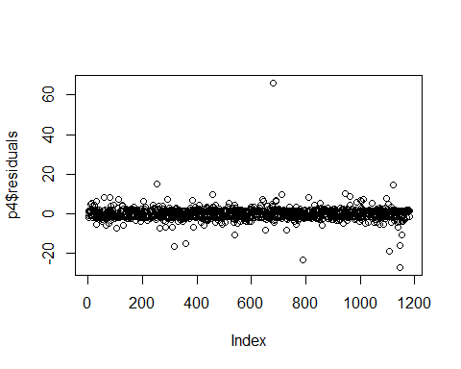

# Diagnostics de base avec la fonction plot  
par(mfrow = c(2, 2))  
plot(p4)

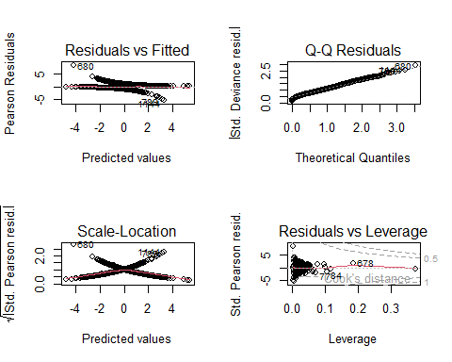

# p4  
# Diagnostics supplémentaires avec le package car  
library(car)

## Warning: le package 'car' a été compilé avec la version R 4.3.3

## Le chargement a nécessité le package : carData

## Warning: le package 'carData' a été compilé avec la version R 4.3.3

residualPlots(p4)

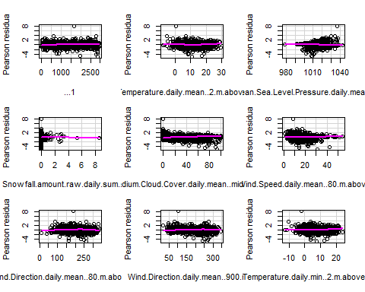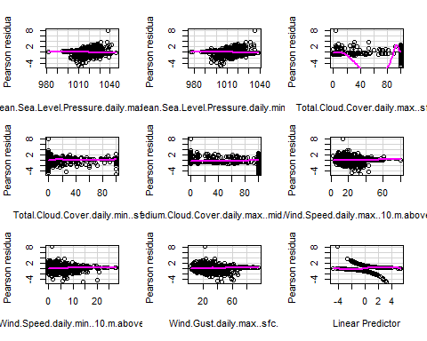

## Test stat Pr(>|Test stat|)   
## ...1 0.1560 0.6928398   
## Temperature.daily.mean..2.m.above.gnd. 15.8080 7.01e-05 ***  
## Mean.Sea.Level.Pressure.daily.mean..MSL. 0.0314 0.8593133   
## Snowfall.amount.raw.daily.sum..sfc. 1.3408 0.2468901   
## Medium.Cloud.Cover.daily.mean..mid.cld.lay. 0.3174 0.5731789   
## Wind.Speed.daily.mean..80.m.above.gnd. 1.5166 0.2181321   
## Wind.Direction.daily.mean..80.m.above.gnd. 7.7568 0.0053510 **   
## Wind.Direction.daily.mean..900.mb. 0.1831 0.6687317   
## Temperature.daily.min..2.m.above.gnd. 14.8991 0.0001134 ***  
## Mean.Sea.Level.Pressure.daily.max..MSL. 0.0015 0.9693391   
## Mean.Sea.Level.Pressure.daily.min..MSL. 0.0693 0.7923519   
## Total.Cloud.Cover.daily.max..sfc. 2.0713 0.1500955   
## Total.Cloud.Cover.daily.min..sfc. 0.1628 0.6866012   
## Medium.Cloud.Cover.daily.max..mid.cld.lay. 0.5777 0.4472046   
## Wind.Speed.daily.max..10.m.above.gnd. 2.2595 0.1328000   
## Wind.Speed.daily.min..10.m.above.gnd. 0.2621 0.6086829   
## Wind.Gust.daily.max..sfc. 0.0020 0.9641060   
## ---  
## Signif. codes: 0 '***' 0.001 '**' 0.01 '*' 0.05 '.' 0.1 ' ' 1

influencePlot(p4, main = "Influence Plot", sub = "Circle size is proportional to Cook's Distance")

## StudRes Hat CookD  
## 77 -1.8760298 0.072068208 0.018501751  
## 363 -0.6165307 0.374327555 0.008215328  
## 678 1.7129218 0.186730042 0.036416269  
## 680 2.9225646 0.002456940 0.008924333  
## 1144 -2.6015287 0.006461682 0.009487801

# Vérifications avec le package performance  
if (!require(performance)) {  
 install.packages("performance")  
 library(performance)  
}

## Le chargement a nécessité le package : performance

## Warning: le package 'performance' a été compilé avec la version R 4.3.3

check_collinearity(p4)

## # Check for Multicollinearity  
##   
## Low Correlation  
##   
## Term VIF VIF 95% CI Increased SE  
## ...1 1.09 [ 1.05, 1.19] 1.05  
## Snowfall.amount.raw.daily.sum..sfc. 1.16 [ 1.10, 1.25] 1.08  
## Medium.Cloud.Cover.daily.mean..mid.cld.lay. 2.67 [ 2.45, 2.94] 1.64  
## Wind.Direction.daily.mean..80.m.above.gnd. 1.89 [ 1.75, 2.06] 1.37  
## Wind.Direction.daily.mean..900.mb. 1.85 [ 1.71, 2.01] 1.36  
## Total.Cloud.Cover.daily.max..sfc. 1.62 [ 1.50, 1.75] 1.27  
## Total.Cloud.Cover.daily.min..sfc. 1.41 [ 1.32, 1.53] 1.19  
## Medium.Cloud.Cover.daily.max..mid.cld.lay. 2.40 [ 2.20, 2.63] 1.55  
## Wind.Speed.daily.min..10.m.above.gnd. 3.15 [ 2.87, 3.47] 1.77  
## Wind.Gust.daily.max..sfc. 4.31 [ 3.91, 4.77] 2.08  
## Tolerance Tolerance 95% CI  
## 0.91 [0.84, 0.96]  
## 0.86 [0.80, 0.91]  
## 0.37 [0.34, 0.41]  
## 0.53 [0.49, 0.57]  
## 0.54 [0.50, 0.59]  
## 0.62 [0.57, 0.67]  
## 0.71 [0.65, 0.76]  
## 0.42 [0.38, 0.45]  
## 0.32 [0.29, 0.35]  
## 0.23 [0.21, 0.26]  
##   
## Moderate Correlation  
##   
## Term VIF VIF 95% CI Increased SE  
## Wind.Speed.daily.mean..80.m.above.gnd. 9.78 [ 8.79, 10.88] 3.13  
## Wind.Speed.daily.max..10.m.above.gnd. 7.48 [ 6.74, 8.31] 2.73  
## Tolerance Tolerance 95% CI  
## 0.10 [0.09, 0.11]  
## 0.13 [0.12, 0.15]  
##   
## High Correlation  
##   
## Term VIF VIF 95% CI Increased SE  
## Temperature.daily.mean..2.m.above.gnd. 23.97 [ 21.48, 26.76] 4.90  
## Mean.Sea.Level.Pressure.daily.mean..MSL. 170.12 [152.13, 190.25] 13.04  
## Temperature.daily.min..2.m.above.gnd. 23.25 [ 20.84, 25.95] 4.82  
## Mean.Sea.Level.Pressure.daily.max..MSL. 46.74 [ 41.84, 52.23] 6.84  
## Mean.Sea.Level.Pressure.daily.min..MSL. 55.47 [ 49.64, 62.00] 7.45  
## Tolerance Tolerance 95% CI  
## 0.04 [0.04, 0.05]  
## 5.88e-03 [0.01, 0.01]  
## 0.04 [0.04, 0.05]  
## 0.02 [0.02, 0.02]  
## 0.02 [0.02, 0.02]

model_performance(p4)

## # Indices of model performance  
##   
## AIC | AICc | BIC | Tjur's R2 | RMSE | Sigma | Log_loss | Score_log | Score_spherical | PCP  
## -----------------------------------------------------------------------------------------------------------  
## 1283.294 | 1283.883 | 1374.613 | 0.296 | 0.418 | 1.000 | 0.529 | -Inf | 0.001 | 0.648

#install.packages("lmtest")  
library(lmtest)

## Warning: le package 'lmtest' a été compilé avec la version R 4.3.3

## Le chargement a nécessité le package : zoo

## Warning: le package 'zoo' a été compilé avec la version R 4.3.3

##   
## Attachement du package : 'zoo'

## Les objets suivants sont masqués depuis 'package:base':  
##   
## as.Date, as.Date.numeric

# Effectuer le test du rapport de vraisemblance (Likelihood Ratio Test)  
test_lrmdr2 <- lrtest(mdr2)  
  
# Afficher les résultats du test  
print(test_lrmdr2) # 2.2e-16 ***

## Likelihood ratio test  
##   
## Model 1: pluie.demain ~ ...1 + Year + Month + Day + Hour + Minute + Temperature.daily.mean..2.m.above.gnd. +   
## Relative.Humidity.daily.mean..2.m.above.gnd. + Mean.Sea.Level.Pressure.daily.mean..MSL. +   
## Total.Precipitation.daily.sum..sfc. + Snowfall.amount.raw.daily.sum..sfc. +   
## Total.Cloud.Cover.daily.mean..sfc. + High.Cloud.Cover.daily.mean..high.cld.lay. +   
## Medium.Cloud.Cover.daily.mean..mid.cld.lay. + Low.Cloud.Cover.daily.mean..low.cld.lay. +   
## Sunshine.Duration.daily.sum..sfc. + Shortwave.Radiation.daily.sum..sfc. +   
## Wind.Speed.daily.mean..10.m.above.gnd. + Wind.Direction.daily.mean..10.m.above.gnd. +   
## Wind.Speed.daily.mean..80.m.above.gnd. + Wind.Direction.daily.mean..80.m.above.gnd. +   
## Wind.Speed.daily.mean..900.mb. + Wind.Direction.daily.mean..900.mb. +   
## Wind.Gust.daily.mean..sfc. + Temperature.daily.max..2.m.above.gnd. +   
## Temperature.daily.min..2.m.above.gnd. + Relative.Humidity.daily.max..2.m.above.gnd. +   
## Relative.Humidity.daily.min..2.m.above.gnd. + Mean.Sea.Level.Pressure.daily.max..MSL. +   
## Mean.Sea.Level.Pressure.daily.min..MSL. + Total.Cloud.Cover.daily.max..sfc. +   
## Total.Cloud.Cover.daily.min..sfc. + High.Cloud.Cover.daily.max..high.cld.lay. +   
## High.Cloud.Cover.daily.min..high.cld.lay. + Medium.Cloud.Cover.daily.max..mid.cld.lay. +   
## Medium.Cloud.Cover.daily.min..mid.cld.lay. + Low.Cloud.Cover.daily.max..low.cld.lay. +   
## Low.Cloud.Cover.daily.min..low.cld.lay. + Wind.Speed.daily.max..10.m.above.gnd. +   
## Wind.Speed.daily.min..10.m.above.gnd. + Wind.Speed.daily.max..80.m.above.gnd. +   
## Wind.Speed.daily.min..80.m.above.gnd. + Wind.Speed.daily.max..900.mb. +   
## Wind.Speed.daily.min..900.mb. + Wind.Gust.daily.max..sfc. +   
## Wind.Gust.daily.min..sfc.  
## Model 2: pluie.demain ~ 1  
## #Df LogLik Df Chisq Pr(>Chisq)   
## 1 45 -616.20   
## 2 1 -817.71 -44 403.02 < 2.2e-16 ***  
## ---  
## Signif. codes: 0 '***' 0.001 '**' 0.01 '*' 0.05 '.' 0.1 ' ' 1

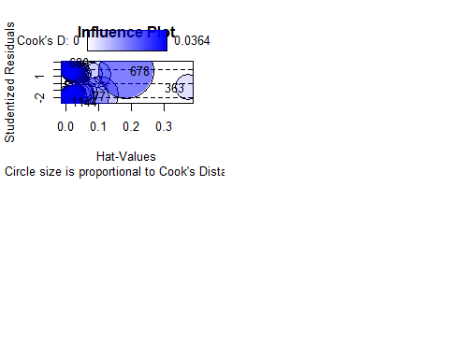

6-1 le model retenu via la fonction step : le mdr5 est le model retenu via STEP, avec un AIC=1283.3 et un Likelihood Ratio Test 2.2e-16 *** (rapport vraisemblance)

# Charger les bibliothèques nécessaires  
if (!require(car)) {  
 install.packages("car")  
 library(car)  
}  
if (!require(performance)) {  
 install.packages("performance")  
 library(performance)  
}  
  
# Construire le modèle initial avec toutes les variables  
mdr5 <- glm(formula = pluie.demain ~ ...1 + Temperature.daily.mean..2.m.above.gnd. +   
 Mean.Sea.Level.Pressure.daily.mean..MSL. + Snowfall.amount.raw.daily.sum..sfc. +   
 Medium.Cloud.Cover.daily.mean..mid.cld.lay. + Wind.Speed.daily.mean..80.m.above.gnd. +   
 Wind.Direction.daily.mean..80.m.above.gnd. + Wind.Direction.daily.mean..900.mb. +   
 Temperature.daily.min..2.m.above.gnd. + Mean.Sea.Level.Pressure.daily.max..MSL. +   
 Mean.Sea.Level.Pressure.daily.min..MSL. + Total.Cloud.Cover.daily.max..sfc. +   
 Total.Cloud.Cover.daily.min..sfc. + Medium.Cloud.Cover.daily.max..mid.cld.lay. +   
 Wind.Speed.daily.max..10.m.above.gnd. + Wind.Speed.daily.min..10.m.above.gnd. +   
 Wind.Gust.daily.max..sfc., family = binomial, data = dtn)  
  
# Afficher le résumé du modèle initial  
summary(mdr5)

##   
## Call:  
## glm(formula = pluie.demain ~ ...1 + Temperature.daily.mean..2.m.above.gnd. +   
## Mean.Sea.Level.Pressure.daily.mean..MSL. + Snowfall.amount.raw.daily.sum..sfc. +   
## Medium.Cloud.Cover.daily.mean..mid.cld.lay. + Wind.Speed.daily.mean..80.m.above.gnd. +   
## Wind.Direction.daily.mean..80.m.above.gnd. + Wind.Direction.daily.mean..900.mb. +   
## Temperature.daily.min..2.m.above.gnd. + Mean.Sea.Level.Pressure.daily.max..MSL. +   
## Mean.Sea.Level.Pressure.daily.min..MSL. + Total.Cloud.Cover.daily.max..sfc. +   
## Total.Cloud.Cover.daily.min..sfc. + Medium.Cloud.Cover.daily.max..mid.cld.lay. +   
## Wind.Speed.daily.max..10.m.above.gnd. + Wind.Speed.daily.min..10.m.above.gnd. +   
## Wind.Gust.daily.max..sfc., family = binomial, data = dtn)  
##   
## Coefficients:  
## Estimate Std. Error z value  
## (Intercept) 6.382e+01 1.182e+01 5.397  
## ...1 1.736e-04 8.558e-05 2.029  
## Temperature.daily.mean..2.m.above.gnd. 1.489e-01 4.984e-02 2.988  
## Mean.Sea.Level.Pressure.daily.mean..MSL. 4.822e-01 1.313e-01 3.672  
## Snowfall.amount.raw.daily.sum..sfc. -3.221e-01 2.155e-01 -1.494  
## Medium.Cloud.Cover.daily.mean..mid.cld.lay. 1.086e-02 4.059e-03 2.674  
## Wind.Speed.daily.mean..80.m.above.gnd. -1.150e-01 2.996e-02 -3.839  
## Wind.Direction.daily.mean..80.m.above.gnd. -2.628e-03 1.523e-03 -1.726  
## Wind.Direction.daily.mean..900.mb. 4.565e-03 1.289e-03 3.543  
## Temperature.daily.min..2.m.above.gnd. -1.059e-01 5.417e-02 -1.955  
## Mean.Sea.Level.Pressure.daily.max..MSL. -2.423e-01 7.062e-02 -3.432  
## Mean.Sea.Level.Pressure.daily.min..MSL. -3.064e-01 7.168e-02 -4.275  
## Total.Cloud.Cover.daily.max..sfc. 8.335e-03 3.505e-03 2.378  
## Total.Cloud.Cover.daily.min..sfc. 7.812e-03 3.863e-03 2.023  
## Medium.Cloud.Cover.daily.max..mid.cld.lay. 6.215e-03 2.671e-03 2.327  
## Wind.Speed.daily.max..10.m.above.gnd. 6.051e-02 2.274e-02 2.661  
## Wind.Speed.daily.min..10.m.above.gnd. 1.119e-01 3.610e-02 3.099  
## Wind.Gust.daily.max..sfc. 2.331e-02 1.085e-02 2.149  
## Pr(>|z|)   
## (Intercept) 6.78e-08 ***  
## ...1 0.042464 *   
## Temperature.daily.mean..2.m.above.gnd. 0.002808 **   
## Mean.Sea.Level.Pressure.daily.mean..MSL. 0.000240 ***  
## Snowfall.amount.raw.daily.sum..sfc. 0.135057   
## Medium.Cloud.Cover.daily.mean..mid.cld.lay. 0.007492 **   
## Wind.Speed.daily.mean..80.m.above.gnd. 0.000124 ***  
## Wind.Direction.daily.mean..80.m.above.gnd. 0.084346 .   
## Wind.Direction.daily.mean..900.mb. 0.000396 ***  
## Temperature.daily.min..2.m.above.gnd. 0.050642 .   
## Mean.Sea.Level.Pressure.daily.max..MSL. 0.000600 ***  
## Mean.Sea.Level.Pressure.daily.min..MSL. 1.91e-05 ***  
## Total.Cloud.Cover.daily.max..sfc. 0.017387 *   
## Total.Cloud.Cover.daily.min..sfc. 0.043122 *   
## Medium.Cloud.Cover.daily.max..mid.cld.lay. 0.019960 *   
## Wind.Speed.daily.max..10.m.above.gnd. 0.007799 **   
## Wind.Speed.daily.min..10.m.above.gnd. 0.001942 **   
## Wind.Gust.daily.max..sfc. 0.031673 *   
## ---  
## Signif. codes: 0 '***' 0.001 '**' 0.01 '*' 0.05 '.' 0.1 ' ' 1  
##   
## (Dispersion parameter for binomial family taken to be 1)  
##   
## Null deviance: 1635.4 on 1179 degrees of freedom  
## Residual deviance: 1247.3 on 1162 degrees of freedom  
## AIC: 1283.3  
##   
## Number of Fisher Scoring iterations: 4

# Sélection de variables avec la fonction step  
p7 <- step(mdr5)

## Start: AIC=1283.29  
## pluie.demain ~ ...1 + Temperature.daily.mean..2.m.above.gnd. +   
## Mean.Sea.Level.Pressure.daily.mean..MSL. + Snowfall.amount.raw.daily.sum..sfc. +   
## Medium.Cloud.Cover.daily.mean..mid.cld.lay. + Wind.Speed.daily.mean..80.m.above.gnd. +   
## Wind.Direction.daily.mean..80.m.above.gnd. + Wind.Direction.daily.mean..900.mb. +   
## Temperature.daily.min..2.m.above.gnd. + Mean.Sea.Level.Pressure.daily.max..MSL. +   
## Mean.Sea.Level.Pressure.daily.min..MSL. + Total.Cloud.Cover.daily.max..sfc. +   
## Total.Cloud.Cover.daily.min..sfc. + Medium.Cloud.Cover.daily.max..mid.cld.lay. +   
## Wind.Speed.daily.max..10.m.above.gnd. + Wind.Speed.daily.min..10.m.above.gnd. +   
## Wind.Gust.daily.max..sfc.  
##   
## Df Deviance AIC  
## <none> 1247.3 1283.3  
## - Snowfall.amount.raw.daily.sum..sfc. 1 1250.1 1284.1  
## - Wind.Direction.daily.mean..80.m.above.gnd. 1 1250.3 1284.3  
## - Temperature.daily.min..2.m.above.gnd. 1 1251.2 1285.2  
## - ...1 1 1251.4 1285.4  
## - Total.Cloud.Cover.daily.min..sfc. 1 1251.5 1285.5  
## - Wind.Gust.daily.max..sfc. 1 1252.0 1286.0  
## - Medium.Cloud.Cover.daily.max..mid.cld.lay. 1 1252.8 1286.8  
## - Total.Cloud.Cover.daily.max..sfc. 1 1253.1 1287.1  
## - Wind.Speed.daily.max..10.m.above.gnd. 1 1254.5 1288.5  
## - Medium.Cloud.Cover.daily.mean..mid.cld.lay. 1 1254.6 1288.6  
## - Temperature.daily.mean..2.m.above.gnd. 1 1256.4 1290.4  
## - Wind.Speed.daily.min..10.m.above.gnd. 1 1257.1 1291.1  
## - Mean.Sea.Level.Pressure.daily.max..MSL. 1 1259.5 1293.5  
## - Wind.Direction.daily.mean..900.mb. 1 1260.1 1294.1  
## - Mean.Sea.Level.Pressure.daily.mean..MSL. 1 1262.1 1296.1  
## - Wind.Speed.daily.mean..80.m.above.gnd. 1 1262.5 1296.5  
## - Mean.Sea.Level.Pressure.daily.min..MSL. 1 1268.6 1302.6

# Afficher le résumé du modèle après sélection de variables  
summary(p7) # AIC=1283.3

##   
## Call:  
## glm(formula = pluie.demain ~ ...1 + Temperature.daily.mean..2.m.above.gnd. +   
## Mean.Sea.Level.Pressure.daily.mean..MSL. + Snowfall.amount.raw.daily.sum..sfc. +   
## Medium.Cloud.Cover.daily.mean..mid.cld.lay. + Wind.Speed.daily.mean..80.m.above.gnd. +   
## Wind.Direction.daily.mean..80.m.above.gnd. + Wind.Direction.daily.mean..900.mb. +   
## Temperature.daily.min..2.m.above.gnd. + Mean.Sea.Level.Pressure.daily.max..MSL. +   
## Mean.Sea.Level.Pressure.daily.min..MSL. + Total.Cloud.Cover.daily.max..sfc. +   
## Total.Cloud.Cover.daily.min..sfc. + Medium.Cloud.Cover.daily.max..mid.cld.lay. +   
## Wind.Speed.daily.max..10.m.above.gnd. + Wind.Speed.daily.min..10.m.above.gnd. +   
## Wind.Gust.daily.max..sfc., family = binomial, data = dtn)  
##   
## Coefficients:  
## Estimate Std. Error z value  
## (Intercept) 6.382e+01 1.182e+01 5.397  
## ...1 1.736e-04 8.558e-05 2.029  
## Temperature.daily.mean..2.m.above.gnd. 1.489e-01 4.984e-02 2.988  
## Mean.Sea.Level.Pressure.daily.mean..MSL. 4.822e-01 1.313e-01 3.672  
## Snowfall.amount.raw.daily.sum..sfc. -3.221e-01 2.155e-01 -1.494  
## Medium.Cloud.Cover.daily.mean..mid.cld.lay. 1.086e-02 4.059e-03 2.674  
## Wind.Speed.daily.mean..80.m.above.gnd. -1.150e-01 2.996e-02 -3.839  
## Wind.Direction.daily.mean..80.m.above.gnd. -2.628e-03 1.523e-03 -1.726  
## Wind.Direction.daily.mean..900.mb. 4.565e-03 1.289e-03 3.543  
## Temperature.daily.min..2.m.above.gnd. -1.059e-01 5.417e-02 -1.955  
## Mean.Sea.Level.Pressure.daily.max..MSL. -2.423e-01 7.062e-02 -3.432  
## Mean.Sea.Level.Pressure.daily.min..MSL. -3.064e-01 7.168e-02 -4.275  
## Total.Cloud.Cover.daily.max..sfc. 8.335e-03 3.505e-03 2.378  
## Total.Cloud.Cover.daily.min..sfc. 7.812e-03 3.863e-03 2.023  
## Medium.Cloud.Cover.daily.max..mid.cld.lay. 6.215e-03 2.671e-03 2.327  
## Wind.Speed.daily.max..10.m.above.gnd. 6.051e-02 2.274e-02 2.661  
## Wind.Speed.daily.min..10.m.above.gnd. 1.119e-01 3.610e-02 3.099  
## Wind.Gust.daily.max..sfc. 2.331e-02 1.085e-02 2.149  
## Pr(>|z|)   
## (Intercept) 6.78e-08 ***  
## ...1 0.042464 *   
## Temperature.daily.mean..2.m.above.gnd. 0.002808 **   
## Mean.Sea.Level.Pressure.daily.mean..MSL. 0.000240 ***  
## Snowfall.amount.raw.daily.sum..sfc. 0.135057   
## Medium.Cloud.Cover.daily.mean..mid.cld.lay. 0.007492 **   
## Wind.Speed.daily.mean..80.m.above.gnd. 0.000124 ***  
## Wind.Direction.daily.mean..80.m.above.gnd. 0.084346 .   
## Wind.Direction.daily.mean..900.mb. 0.000396 ***  
## Temperature.daily.min..2.m.above.gnd. 0.050642 .   
## Mean.Sea.Level.Pressure.daily.max..MSL. 0.000600 ***  
## Mean.Sea.Level.Pressure.daily.min..MSL. 1.91e-05 ***  
## Total.Cloud.Cover.daily.max..sfc. 0.017387 *   
## Total.Cloud.Cover.daily.min..sfc. 0.043122 *   
## Medium.Cloud.Cover.daily.max..mid.cld.lay. 0.019960 *   
## Wind.Speed.daily.max..10.m.above.gnd. 0.007799 **   
## Wind.Speed.daily.min..10.m.above.gnd. 0.001942 **   
## Wind.Gust.daily.max..sfc. 0.031673 *   
## ---  
## Signif. codes: 0 '***' 0.001 '**' 0.01 '*' 0.05 '.' 0.1 ' ' 1  
##   
## (Dispersion parameter for binomial family taken to be 1)  
##   
## Null deviance: 1635.4 on 1179 degrees of freedom  
## Residual deviance: 1247.3 on 1162 degrees of freedom  
## AIC: 1283.3  
##   
## Number of Fisher Scoring iterations: 4

# Plot des résidus  
plot(p7$residuals)

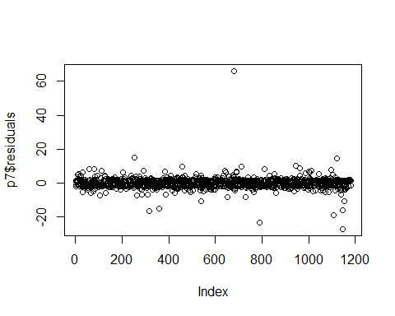

# Diagnostics de base avec la fonction plot  
par(mfrow = c(2, 2))  
plot(p7)



# Diagnostics supplémentaires avec le package car  
library(car)  
residualPlots(p7)



## Test stat Pr(>|Test stat|)   
## ...1 0.1560 0.6928398   
## Temperature.daily.mean..2.m.above.gnd. 15.8080 7.01e-05 ***  
## Mean.Sea.Level.Pressure.daily.mean..MSL. 0.0314 0.8593133   
## Snowfall.amount.raw.daily.sum..sfc. 1.3408 0.2468901   
## Medium.Cloud.Cover.daily.mean..mid.cld.lay. 0.3174 0.5731789   
## Wind.Speed.daily.mean..80.m.above.gnd. 1.5166 0.2181321   
## Wind.Direction.daily.mean..80.m.above.gnd. 7.7568 0.0053510 **   
## Wind.Direction.daily.mean..900.mb. 0.1831 0.6687317   
## Temperature.daily.min..2.m.above.gnd. 14.8991 0.0001134 ***  
## Mean.Sea.Level.Pressure.daily.max..MSL. 0.0015 0.9693391   
## Mean.Sea.Level.Pressure.daily.min..MSL. 0.0693 0.7923519   
## Total.Cloud.Cover.daily.max..sfc. 2.0713 0.1500955   
## Total.Cloud.Cover.daily.min..sfc. 0.1628 0.6866012   
## Medium.Cloud.Cover.daily.max..mid.cld.lay. 0.5777 0.4472046   
## Wind.Speed.daily.max..10.m.above.gnd. 2.2595 0.1328000   
## Wind.Speed.daily.min..10.m.above.gnd. 0.2621 0.6086829   
## Wind.Gust.daily.max..sfc. 0.0020 0.9641060   
## ---  
## Signif. codes: 0 '***' 0.001 '**' 0.01 '*' 0.05 '.' 0.1 ' ' 1

influencePlot(p7, main = "Influence Plot", sub = "Circle size is proportional to Cook's Distance")

## StudRes Hat CookD  
## 77 -1.8760298 0.072068208 0.018501751  
## 363 -0.6165307 0.374327555 0.008215328  
## 678 1.7129218 0.186730042 0.036416269  
## 680 2.9225646 0.002456940 0.008924333  
## 1144 -2.6015287 0.006461682 0.009487801

# Vérifications avec le package performance  
library(performance)  
vif_values <- vif(p7)  
print(vif_values)

## ...1   
## 1.093753   
## Temperature.daily.mean..2.m.above.gnd.   
## 23.968568   
## Mean.Sea.Level.Pressure.daily.mean..MSL.   
## 170.116474   
## Snowfall.amount.raw.daily.sum..sfc.   
## 1.157846   
## Medium.Cloud.Cover.daily.mean..mid.cld.lay.   
## 2.673327   
## Wind.Speed.daily.mean..80.m.above.gnd.   
## 9.775636   
## Wind.Direction.daily.mean..80.m.above.gnd.   
## 1.890155   
## Wind.Direction.daily.mean..900.mb.   
## 1.846207   
## Temperature.daily.min..2.m.above.gnd.   
## 23.251483   
## Mean.Sea.Level.Pressure.daily.max..MSL.   
## 46.738829   
## Mean.Sea.Level.Pressure.daily.min..MSL.   
## 55.472612   
## Total.Cloud.Cover.daily.max..sfc.   
## 1.616130   
## Total.Cloud.Cover.daily.min..sfc.   
## 1.413710   
## Medium.Cloud.Cover.daily.max..mid.cld.lay.   
## 2.395774   
## Wind.Speed.daily.max..10.m.above.gnd.   
## 7.478934   
## Wind.Speed.daily.min..10.m.above.gnd.   
## 3.148395   
## Wind.Gust.daily.max..sfc.   
## 4.312613

model_perf <- model_performance(p7)  
print(model_perf)

## # Indices of model performance  
##   
## AIC | AICc | BIC | Tjur's R2 | RMSE | Sigma | Log_loss | Score_log | Score_spherical | PCP  
## -----------------------------------------------------------------------------------------------------------  
## 1283.294 | 1283.883 | 1374.613 | 0.296 | 0.418 | 1.000 | 0.529 | -Inf | 0.001 | 0.648

#install.packages("lmtest")  
library(lmtest)  
  
# Effectuer le test du rapport de vraisemblance (Likelihood Ratio Test)  
test_lrmdr5 <- lrtest(mdr5)  
  
# Afficher les résultats du test  
print(test_lrmdr5) # 2.2e-16 ***

## Likelihood ratio test  
##   
## Model 1: pluie.demain ~ ...1 + Temperature.daily.mean..2.m.above.gnd. +   
## Mean.Sea.Level.Pressure.daily.mean..MSL. + Snowfall.amount.raw.daily.sum..sfc. +   
## Medium.Cloud.Cover.daily.mean..mid.cld.lay. + Wind.Speed.daily.mean..80.m.above.gnd. +   
## Wind.Direction.daily.mean..80.m.above.gnd. + Wind.Direction.daily.mean..900.mb. +   
## Temperature.daily.min..2.m.above.gnd. + Mean.Sea.Level.Pressure.daily.max..MSL. +   
## Mean.Sea.Level.Pressure.daily.min..MSL. + Total.Cloud.Cover.daily.max..sfc. +   
## Total.Cloud.Cover.daily.min..sfc. + Medium.Cloud.Cover.daily.max..mid.cld.lay. +   
## Wind.Speed.daily.max..10.m.above.gnd. + Wind.Speed.daily.min..10.m.above.gnd. +   
## Wind.Gust.daily.max..sfc.  
## Model 2: pluie.demain ~ 1  
## #Df LogLik Df Chisq Pr(>Chisq)   
## 1 18 -623.65   
## 2 1 -817.71 -17 388.12 < 2.2e-16 ***  
## ---  
## Signif. codes: 0 '***' 0.001 '**' 0.01 '*' 0.05 '.' 0.1 ' ' 1

 7- Sélection des caractéristiques numérique manuellement sans la fonction STEP Partie 1 : Charger les bibliothèques

# Charger la bibliothèque ggplot2 si ce n'est pas déjà fait  
if (!require(ggplot2)) {  
 install.packages("ggplot2")  
 library(ggplot2)  
}  
  
# Charger la bibliothèque gridExtra si ce n'est pas déjà fait  
if (!require(gridExtra)) {  
 install.packages("gridExtra")  
 library(gridExtra)  
}

## Le chargement a nécessité le package : gridExtra

## Warning: le package 'gridExtra' a été compilé avec la version R 4.3.3

Partie 2 : Définir la fonction pour générer des boxplots bivariés

# Créer une fonction pour générer des boxplots bivariés  
boxplot_bivarie <- function(dtn, variable_x, variable_y) {  
 ggplot(dtn, aes_string(x = variable_x, y = variable_y)) +  
 geom_boxplot(aes(fill = as.factor(get(variable_x)))) +  
 labs(title = paste("Boxplot de", variable_y, "par", variable_x),  
 x = variable_x, y = variable_y) +  
 theme_minimal() +  
 theme(axis.text.x = element_text(angle = 45, hjust = 1))  
}

Partie 3 : Générer les boxplots pour les variables quantitatives

# Variables quantitatives à explorer  
variables_quantitatives <- names(dtn)[sapply(dtn, is.numeric)]  
  
# Créer un boxplot bivarié pour chaque variable quantitative par rapport à pluie.demain  
boxplot_plots <- lapply(variables_quantitatives, function(variable) {  
 ggplot(dtn, aes(x = as.factor(pluie.demain), y = .data[[variable]], fill = as.factor(pluie.demain))) +  
 geom_boxplot() +  
 labs(title = paste("Boxplot de", variable, "par pluie.demain"),  
 x = "pluie.demain", y = variable) +  
 theme_minimal()  
})

Partie 4 : Afficher les boxplots en les divisant en quatre parties Cette partie est deja realisé ci dessus : 5- box plot des variables vs la variable à expliquer : pluie.demain. 7-1 test de kruskal_walis ce test ca nous permettre de classer les variable quantitatives :

# Charger les bibliothèques nécessaires  
if (!require(dplyr)) {  
 install.packages("dplyr")  
 library(dplyr)  
}

## Le chargement a nécessité le package : dplyr

## Warning: le package 'dplyr' a été compilé avec la version R 4.3.3

##   
## Attachement du package : 'dplyr'

## L'objet suivant est masqué depuis 'package:gridExtra':  
##   
## combine

## L'objet suivant est masqué depuis 'package:car':  
##   
## recode

## Les objets suivants sont masqués depuis 'package:stats':  
##   
## filter, lag

## Les objets suivants sont masqués depuis 'package:base':  
##   
## intersect, setdiff, setequal, union

# Sélectionner les variables numériques  
variables_numeriques <- names(dtn)[1:46]  
  
# Créer un tableau pour les résultats  
results <- data.frame(Variable = character(), Kruskal_Wallis = numeric(), P_value = numeric(), stringsAsFactors = FALSE)  
  
for (var in variables_numeriques) {  
 # Effectuer le test de Kruskal-Wallis  
 kruskal_test <- kruskal.test(dtn[[var]] ~ dtn$pluie.demain)  
   
 # Ajouter les résultats au tableau  
 results <- rbind(results, data.frame(Variable = var, Kruskal_Wallis = kruskal_test$statistic, P_value = kruskal_test$p.value, stringsAsFactors = FALSE))  
}  
  
# Trier les résultats par la statistique de test décroissant  
results <- results[order(results$Kruskal_Wallis, decreasing = TRUE), ]  
  
# Afficher les résultats  
print(results)

## Variable  
## Kruskal-Wallis chi-squared13 Medium.Cloud.Cover.daily.mean..mid.cld.lay.  
## Kruskal-Wallis chi-squared29 Mean.Sea.Level.Pressure.daily.min..MSL.  
## Kruskal-Wallis chi-squared34 Medium.Cloud.Cover.daily.max..mid.cld.lay.  
## Kruskal-Wallis chi-squared8 Mean.Sea.Level.Pressure.daily.mean..MSL.  
## Kruskal-Wallis chi-squared9 Total.Precipitation.daily.sum..sfc.  
## Kruskal-Wallis chi-squared28 Mean.Sea.Level.Pressure.daily.max..MSL.  
## Kruskal-Wallis chi-squared32 High.Cloud.Cover.daily.max..high.cld.lay.  
## Kruskal-Wallis chi-squared11 Total.Cloud.Cover.daily.mean..sfc.  
## Kruskal-Wallis chi-squared12 High.Cloud.Cover.daily.mean..high.cld.lay.  
## Kruskal-Wallis chi-squared44 Wind.Gust.daily.max..sfc.  
## Kruskal-Wallis chi-squared30 Total.Cloud.Cover.daily.max..sfc.  
## Kruskal-Wallis chi-squared15 Sunshine.Duration.daily.sum..sfc.  
## Kruskal-Wallis chi-squared38 Wind.Speed.daily.max..10.m.above.gnd.  
## Kruskal-Wallis chi-squared14 Low.Cloud.Cover.daily.mean..low.cld.lay.  
## Kruskal-Wallis chi-squared23 Wind.Gust.daily.mean..sfc.  
## Kruskal-Wallis chi-squared40 Wind.Speed.daily.max..80.m.above.gnd.  
## Kruskal-Wallis chi-squared42 Wind.Speed.daily.max..900.mb.  
## Kruskal-Wallis chi-squared36 Low.Cloud.Cover.daily.max..low.cld.lay.  
## Kruskal-Wallis chi-squared31 Total.Cloud.Cover.daily.min..sfc.  
## Kruskal-Wallis chi-squared17 Wind.Speed.daily.mean..10.m.above.gnd.  
## Kruskal-Wallis chi-squared22 Wind.Direction.daily.mean..900.mb.  
## Kruskal-Wallis chi-squared19 Wind.Speed.daily.mean..80.m.above.gnd.  
## Kruskal-Wallis chi-squared45 Wind.Gust.daily.min..sfc.  
## Kruskal-Wallis chi-squared21 Wind.Speed.daily.mean..900.mb.  
## Kruskal-Wallis chi-squared39 Wind.Speed.daily.min..10.m.above.gnd.  
## Kruskal-Wallis chi-squared25 Temperature.daily.min..2.m.above.gnd.  
## Kruskal-Wallis chi-squared37 Low.Cloud.Cover.daily.min..low.cld.lay.  
## Kruskal-Wallis chi-squared35 Medium.Cloud.Cover.daily.min..mid.cld.lay.  
## Kruskal-Wallis chi-squared41 Wind.Speed.daily.min..80.m.above.gnd.  
## Kruskal-Wallis chi-squared20 Wind.Direction.daily.mean..80.m.above.gnd.  
## Kruskal-Wallis chi-squared18 Wind.Direction.daily.mean..10.m.above.gnd.  
## Kruskal-Wallis chi-squared6 Temperature.daily.mean..2.m.above.gnd.  
## Kruskal-Wallis chi-squared24 Temperature.daily.max..2.m.above.gnd.  
## Kruskal-Wallis chi-squared33 High.Cloud.Cover.daily.min..high.cld.lay.  
## Kruskal-Wallis chi-squared43 Wind.Speed.daily.min..900.mb.  
## Kruskal-Wallis chi-squared1 Year  
## Kruskal-Wallis chi-squared16 Shortwave.Radiation.daily.sum..sfc.  
## Kruskal-Wallis chi-squared ...1  
## Kruskal-Wallis chi-squared10 Snowfall.amount.raw.daily.sum..sfc.  
## Kruskal-Wallis chi-squared2 Month  
## Kruskal-Wallis chi-squared27 Relative.Humidity.daily.min..2.m.above.gnd.  
## Kruskal-Wallis chi-squared7 Relative.Humidity.daily.mean..2.m.above.gnd.  
## Kruskal-Wallis chi-squared26 Relative.Humidity.daily.max..2.m.above.gnd.  
## Kruskal-Wallis chi-squared3 Day  
## Kruskal-Wallis chi-squared4 Hour  
## Kruskal-Wallis chi-squared5 Minute  
## Kruskal_Wallis P_value  
## Kruskal-Wallis chi-squared13 205.67452762 1.206722e-46  
## Kruskal-Wallis chi-squared29 203.56867158 3.476173e-46  
## Kruskal-Wallis chi-squared34 192.25747519 1.022322e-43  
## Kruskal-Wallis chi-squared8 186.80116963 1.587074e-42  
## Kruskal-Wallis chi-squared9 170.86250903 4.795000e-39  
## Kruskal-Wallis chi-squared28 164.17857568 1.382773e-37  
## Kruskal-Wallis chi-squared32 129.51351868 5.235864e-30  
## Kruskal-Wallis chi-squared11 122.46754913 1.823739e-28  
## Kruskal-Wallis chi-squared12 117.64243432 2.076403e-27  
## Kruskal-Wallis chi-squared44 88.04763852 6.389689e-21  
## Kruskal-Wallis chi-squared30 80.63417964 2.716204e-19  
## Kruskal-Wallis chi-squared15 73.80031510 8.643280e-18  
## Kruskal-Wallis chi-squared38 70.27332559 5.163115e-17  
## Kruskal-Wallis chi-squared14 66.18543586 4.104341e-16  
## Kruskal-Wallis chi-squared23 64.45556549 9.873407e-16  
## Kruskal-Wallis chi-squared40 62.46008902 2.718993e-15  
## Kruskal-Wallis chi-squared42 58.94298775 1.623072e-14  
## Kruskal-Wallis chi-squared36 58.20140654 2.366098e-14  
## Kruskal-Wallis chi-squared31 57.53854627 3.314202e-14  
## Kruskal-Wallis chi-squared17 54.06572657 1.938940e-13  
## Kruskal-Wallis chi-squared22 50.75193249 1.048093e-12  
## Kruskal-Wallis chi-squared19 41.01067420 1.514001e-10  
## Kruskal-Wallis chi-squared45 34.94562458 3.390424e-09  
## Kruskal-Wallis chi-squared21 34.29210291 4.743025e-09  
## Kruskal-Wallis chi-squared39 31.59161331 1.902495e-08  
## Kruskal-Wallis chi-squared25 23.13277207 1.511917e-06  
## Kruskal-Wallis chi-squared37 22.50681726 2.093991e-06  
## Kruskal-Wallis chi-squared35 21.83355460 2.973542e-06  
## Kruskal-Wallis chi-squared41 17.51981731 2.843286e-05  
## Kruskal-Wallis chi-squared20 15.91760529 6.616044e-05  
## Kruskal-Wallis chi-squared18 14.77774924 1.209543e-04  
## Kruskal-Wallis chi-squared6 14.75084255 1.226927e-04  
## Kruskal-Wallis chi-squared24 8.09822565 4.430861e-03  
## Kruskal-Wallis chi-squared33 8.08074796 4.473798e-03  
## Kruskal-Wallis chi-squared43 7.66631524 5.626123e-03  
## Kruskal-Wallis chi-squared1 5.18489213 2.278409e-02  
## Kruskal-Wallis chi-squared16 5.11593263 2.370712e-02  
## Kruskal-Wallis chi-squared 4.41582623 3.560703e-02  
## Kruskal-Wallis chi-squared10 3.61665250 5.720387e-02  
## Kruskal-Wallis chi-squared2 2.95143594 8.580129e-02  
## Kruskal-Wallis chi-squared27 1.41509767 2.342120e-01  
## Kruskal-Wallis chi-squared7 0.97383265 3.237262e-01  
## Kruskal-Wallis chi-squared26 0.41566257 5.191093e-01  
## Kruskal-Wallis chi-squared3 0.04744417 8.275718e-01  
## Kruskal-Wallis chi-squared4 NaN NaN  
## Kruskal-Wallis chi-squared5 NaN NaN

ici on que retenir que les résultats avec une valeur p inférieure à 0.05 :

# Charger les bibliothèques nécessaires  
if (!require(dplyr)) {  
 install.packages("dplyr")  
 library(dplyr)  
}  
  
# Sélectionner les variables numériques  
variables_numeriques <- names(dtn)[1:46]  
  
# Créer un tableau pour les résultats  
results <- data.frame(Variable = character(), Kruskal_Wallis = numeric(), P_value = numeric(), stringsAsFactors = FALSE)  
  
for (var in variables_numeriques) {  
 # Effectuer le test de Kruskal-Wallis  
 kruskal_test <- kruskal.test(dtn[[var]] ~ dtn$pluie.demain)  
   
 # Ajouter les résultats au tableau  
 results <- rbind(results, data.frame(Variable = var, Kruskal_Wallis = kruskal_test$statistic, P_value = kruskal_test$p.value, stringsAsFactors = FALSE))  
}  
  
# Filtrer les résultats avec une p-value < 0.05  
results_significatifs <- results %>% filter(P_value < 0.05)  
  
# Trier les résultats par la statistique de test décroissant  
results_significatifs <- results_significatifs[order(results_significatifs$Kruskal_Wallis, decreasing = TRUE), ]  
  
# Afficher les résultats significatifs  
print(results_significatifs)

## Variable  
## Kruskal-Wallis chi-squared13 Medium.Cloud.Cover.daily.mean..mid.cld.lay.  
## Kruskal-Wallis chi-squared29 Mean.Sea.Level.Pressure.daily.min..MSL.  
## Kruskal-Wallis chi-squared34 Medium.Cloud.Cover.daily.max..mid.cld.lay.  
## Kruskal-Wallis chi-squared8 Mean.Sea.Level.Pressure.daily.mean..MSL.  
## Kruskal-Wallis chi-squared9 Total.Precipitation.daily.sum..sfc.  
## Kruskal-Wallis chi-squared28 Mean.Sea.Level.Pressure.daily.max..MSL.  
## Kruskal-Wallis chi-squared32 High.Cloud.Cover.daily.max..high.cld.lay.  
## Kruskal-Wallis chi-squared11 Total.Cloud.Cover.daily.mean..sfc.  
## Kruskal-Wallis chi-squared12 High.Cloud.Cover.daily.mean..high.cld.lay.  
## Kruskal-Wallis chi-squared44 Wind.Gust.daily.max..sfc.  
## Kruskal-Wallis chi-squared30 Total.Cloud.Cover.daily.max..sfc.  
## Kruskal-Wallis chi-squared15 Sunshine.Duration.daily.sum..sfc.  
## Kruskal-Wallis chi-squared38 Wind.Speed.daily.max..10.m.above.gnd.  
## Kruskal-Wallis chi-squared14 Low.Cloud.Cover.daily.mean..low.cld.lay.  
## Kruskal-Wallis chi-squared23 Wind.Gust.daily.mean..sfc.  
## Kruskal-Wallis chi-squared40 Wind.Speed.daily.max..80.m.above.gnd.  
## Kruskal-Wallis chi-squared42 Wind.Speed.daily.max..900.mb.  
## Kruskal-Wallis chi-squared36 Low.Cloud.Cover.daily.max..low.cld.lay.  
## Kruskal-Wallis chi-squared31 Total.Cloud.Cover.daily.min..sfc.  
## Kruskal-Wallis chi-squared17 Wind.Speed.daily.mean..10.m.above.gnd.  
## Kruskal-Wallis chi-squared22 Wind.Direction.daily.mean..900.mb.  
## Kruskal-Wallis chi-squared19 Wind.Speed.daily.mean..80.m.above.gnd.  
## Kruskal-Wallis chi-squared45 Wind.Gust.daily.min..sfc.  
## Kruskal-Wallis chi-squared21 Wind.Speed.daily.mean..900.mb.  
## Kruskal-Wallis chi-squared39 Wind.Speed.daily.min..10.m.above.gnd.  
## Kruskal-Wallis chi-squared25 Temperature.daily.min..2.m.above.gnd.  
## Kruskal-Wallis chi-squared37 Low.Cloud.Cover.daily.min..low.cld.lay.  
## Kruskal-Wallis chi-squared35 Medium.Cloud.Cover.daily.min..mid.cld.lay.  
## Kruskal-Wallis chi-squared41 Wind.Speed.daily.min..80.m.above.gnd.  
## Kruskal-Wallis chi-squared20 Wind.Direction.daily.mean..80.m.above.gnd.  
## Kruskal-Wallis chi-squared18 Wind.Direction.daily.mean..10.m.above.gnd.  
## Kruskal-Wallis chi-squared6 Temperature.daily.mean..2.m.above.gnd.  
## Kruskal-Wallis chi-squared24 Temperature.daily.max..2.m.above.gnd.  
## Kruskal-Wallis chi-squared33 High.Cloud.Cover.daily.min..high.cld.lay.  
## Kruskal-Wallis chi-squared43 Wind.Speed.daily.min..900.mb.  
## Kruskal-Wallis chi-squared1 Year  
## Kruskal-Wallis chi-squared16 Shortwave.Radiation.daily.sum..sfc.  
## Kruskal-Wallis chi-squared ...1  
## Kruskal_Wallis P_value  
## Kruskal-Wallis chi-squared13 205.674528 1.206722e-46  
## Kruskal-Wallis chi-squared29 203.568672 3.476173e-46  
## Kruskal-Wallis chi-squared34 192.257475 1.022322e-43  
## Kruskal-Wallis chi-squared8 186.801170 1.587074e-42  
## Kruskal-Wallis chi-squared9 170.862509 4.795000e-39  
## Kruskal-Wallis chi-squared28 164.178576 1.382773e-37  
## Kruskal-Wallis chi-squared32 129.513519 5.235864e-30  
## Kruskal-Wallis chi-squared11 122.467549 1.823739e-28  
## Kruskal-Wallis chi-squared12 117.642434 2.076403e-27  
## Kruskal-Wallis chi-squared44 88.047639 6.389689e-21  
## Kruskal-Wallis chi-squared30 80.634180 2.716204e-19  
## Kruskal-Wallis chi-squared15 73.800315 8.643280e-18  
## Kruskal-Wallis chi-squared38 70.273326 5.163115e-17  
## Kruskal-Wallis chi-squared14 66.185436 4.104341e-16  
## Kruskal-Wallis chi-squared23 64.455565 9.873407e-16  
## Kruskal-Wallis chi-squared40 62.460089 2.718993e-15  
## Kruskal-Wallis chi-squared42 58.942988 1.623072e-14  
## Kruskal-Wallis chi-squared36 58.201407 2.366098e-14  
## Kruskal-Wallis chi-squared31 57.538546 3.314202e-14  
## Kruskal-Wallis chi-squared17 54.065727 1.938940e-13  
## Kruskal-Wallis chi-squared22 50.751932 1.048093e-12  
## Kruskal-Wallis chi-squared19 41.010674 1.514001e-10  
## Kruskal-Wallis chi-squared45 34.945625 3.390424e-09  
## Kruskal-Wallis chi-squared21 34.292103 4.743025e-09  
## Kruskal-Wallis chi-squared39 31.591613 1.902495e-08  
## Kruskal-Wallis chi-squared25 23.132772 1.511917e-06  
## Kruskal-Wallis chi-squared37 22.506817 2.093991e-06  
## Kruskal-Wallis chi-squared35 21.833555 2.973542e-06  
## Kruskal-Wallis chi-squared41 17.519817 2.843286e-05  
## Kruskal-Wallis chi-squared20 15.917605 6.616044e-05  
## Kruskal-Wallis chi-squared18 14.777749 1.209543e-04  
## Kruskal-Wallis chi-squared6 14.750843 1.226927e-04  
## Kruskal-Wallis chi-squared24 8.098226 4.430861e-03  
## Kruskal-Wallis chi-squared33 8.080748 4.473798e-03  
## Kruskal-Wallis chi-squared43 7.666315 5.626123e-03  
## Kruskal-Wallis chi-squared1 5.184892 2.278409e-02  
## Kruskal-Wallis chi-squared16 5.115933 2.370712e-02  
## Kruskal-Wallis chi-squared 4.415826 3.560703e-02

Suite a la selection manuelle en se basant sur la selection pure et dure des variable : - Des boxplots bivariés visuelle - Le test de kruskal_walis : classment des variable et filtrage sur les p-values En suite j’ai fait le choix de me limiter à 10 variables Maintenant je vais analyser la correlation entre ces 10 variables explicatives on va tester la correlation entre les 10 variables les plus significatives :

# Charger les bibliothèques nécessaires  
if (!require(corrplot)) {  
 install.packages("corrplot")  
 library(corrplot)  
}

## Le chargement a nécessité le package : corrplot

## Warning: le package 'corrplot' a été compilé avec la version R 4.3.3

## corrplot 0.92 loaded

# Sélectionner les variables spécifiques  
# Remplacer "var1", "var2", etc. par les noms réels des 10 variables que vous souhaitez analyser  
selected_variables <- dtn[, c("Medium.Cloud.Cover.daily.mean..mid.cld.lay.", "Mean.Sea.Level.Pressure.daily.min..MSL.",  
 "Medium.Cloud.Cover.daily.max..mid.cld.lay.", "Mean.Sea.Level.Pressure.daily.mean..MSL.", "Total.Precipitation.daily.sum..sfc.",   
 "Mean.Sea.Level.Pressure.daily.max..MSL.", "High.Cloud.Cover.daily.max..high.cld.lay.", "Total.Cloud.Cover.daily.mean..sfc.", "High.Cloud.Cover.daily.mean..high.cld.lay.",  
 "Wind.Gust.daily.max..sfc.")]  
  
# Calculer la matrice de corrélation  
correlation_matrix <- cor(selected_variables, use = "complete.obs", method = "pearson")  
  
# Afficher la matrice de corrélation  
corrplot(correlation_matrix, method = "color", type = "upper",   
 tl.col = "black", tl.srt = 45, addCoef.col = "black",   
 number.cex = 0.7)

## Warning in corrplot(correlation_matrix, method = "color", type = "upper", : Not  
## been able to calculate text margin, please try again with a clean new empty  
## window using {plot.new(); dev.off()} or reduce tl.cex

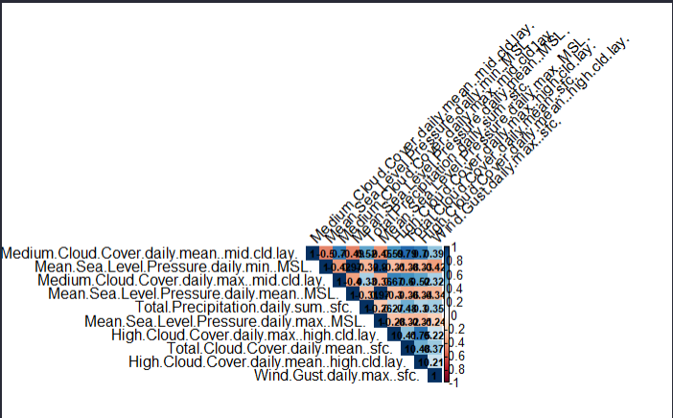

suite à un premiere selection ou enlevement des variable trop correlée on va effectuer un second test de correlation :

# Charger les bibliothèques nécessaires  
if (!require(corrplot)) {  
 install.packages("corrplot")  
 library(corrplot)  
}  
  
# Sélectionner les variables spécifiques  
# Remplacer "var1", "var2", etc. par les noms réels des 9 variables que vous souhaitez analyser  
selected_variables <- dtn[, c("Medium.Cloud.Cover.daily.max..mid.cld.lay." ,"Total.Precipitation.daily.sum..sfc.",   
 "Mean.Sea.Level.Pressure.daily.max..MSL.", "High.Cloud.Cover.daily.max..high.cld.lay.", "Total.Cloud.Cover.daily.mean..sfc.", "High.Cloud.Cover.daily.mean..high.cld.lay.",  
 "Wind.Gust.daily.max..sfc.")]  
  
# Calculer la matrice de corrélation  
correlation_matrix <- cor(selected_variables, use = "complete.obs", method = "pearson")  
  
# Afficher la matrice de corrélation  
corrplot(correlation_matrix, method = "color", type = "upper",   
 tl.col = "black", tl.srt = 45, addCoef.col = "black",   
 number.cex = 0.7)

## Warning in corrplot(correlation_matrix, method = "color", type = "upper", : Not  
## been able to calculate text margin, please try again with a clean new empty  
## window using {plot.new(); dev.off()} or reduce tl.cex

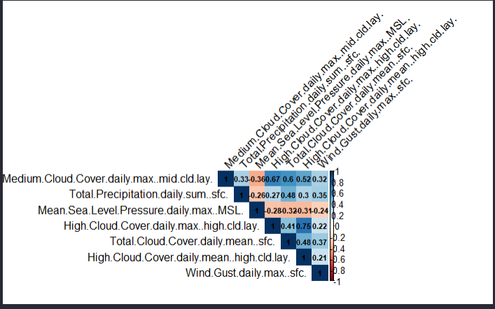

le model retenue apres analyse de la correlation est celui qui fera l’objet du glm ci dessous: mdr6

# Construction du modèle avec les variables choisis manuellement  
mdr6 <- glm(pluie.demain ~ Medium.Cloud.Cover.daily.max..mid.cld.lay.+ Total.Precipitation.daily.sum..sfc.+  
Mean.Sea.Level.Pressure.daily.max..MSL.+High.Cloud.Cover.daily.max..high.cld.lay.+Total.Cloud.Cover.daily.mean..sfc.  
+High.Cloud.Cover.daily.mean..high.cld.lay.+  
Wind.Gust.daily.max..sfc. , data = dtn, family = binomial)  
summary(mdr6)

##   
## Call:  
## glm(formula = pluie.demain ~ Medium.Cloud.Cover.daily.max..mid.cld.lay. +   
## Total.Precipitation.daily.sum..sfc. + Mean.Sea.Level.Pressure.daily.max..MSL. +   
## High.Cloud.Cover.daily.max..high.cld.lay. + Total.Cloud.Cover.daily.mean..sfc. +   
## High.Cloud.Cover.daily.mean..high.cld.lay. + Wind.Gust.daily.max..sfc.,   
## family = binomial, data = dtn)  
##   
## Coefficients:  
## Estimate Std. Error z value  
## (Intercept) 71.1435014 10.5802486 6.724  
## Medium.Cloud.Cover.daily.max..mid.cld.lay. 0.0094980 0.0023990 3.959  
## Total.Precipitation.daily.sum..sfc. 0.0268709 0.0216036 1.244  
## Mean.Sea.Level.Pressure.daily.max..MSL. -0.0715397 0.0103463 -6.915  
## High.Cloud.Cover.daily.max..high.cld.lay. 0.0054009 0.0026235 2.059  
## Total.Cloud.Cover.daily.mean..sfc. 0.0032343 0.0029492 1.097  
## High.Cloud.Cover.daily.mean..high.cld.lay. 0.0006122 0.0049143 0.125  
## Wind.Gust.daily.max..sfc. 0.0211968 0.0053070 3.994  
## Pr(>|z|)   
## (Intercept) 1.77e-11 ***  
## Medium.Cloud.Cover.daily.max..mid.cld.lay. 7.52e-05 ***  
## Total.Precipitation.daily.sum..sfc. 0.2136   
## Mean.Sea.Level.Pressure.daily.max..MSL. 4.69e-12 ***  
## High.Cloud.Cover.daily.max..high.cld.lay. 0.0395 *   
## Total.Cloud.Cover.daily.mean..sfc. 0.2728   
## High.Cloud.Cover.daily.mean..high.cld.lay. 0.9009   
## Wind.Gust.daily.max..sfc. 6.49e-05 ***  
## ---  
## Signif. codes: 0 '***' 0.001 '**' 0.01 '*' 0.05 '.' 0.1 ' ' 1  
##   
## (Dispersion parameter for binomial family taken to be 1)  
##   
## Null deviance: 1635.4 on 1179 degrees of freedom  
## Residual deviance: 1329.6 on 1172 degrees of freedom  
## AIC: 1345.6  
##   
## Number of Fisher Scoring iterations: 4

p6 = step(mdr6)

## Start: AIC=1345.64  
## pluie.demain ~ Medium.Cloud.Cover.daily.max..mid.cld.lay. + Total.Precipitation.daily.sum..sfc. +   
## Mean.Sea.Level.Pressure.daily.max..MSL. + High.Cloud.Cover.daily.max..high.cld.lay. +   
## Total.Cloud.Cover.daily.mean..sfc. + High.Cloud.Cover.daily.mean..high.cld.lay. +   
## Wind.Gust.daily.max..sfc.  
##   
## Df Deviance AIC  
## - High.Cloud.Cover.daily.mean..high.cld.lay. 1 1329.7 1343.7  
## - Total.Cloud.Cover.daily.mean..sfc. 1 1330.8 1344.8  
## - Total.Precipitation.daily.sum..sfc. 1 1331.3 1345.3  
## <none> 1329.6 1345.6  
## - High.Cloud.Cover.daily.max..high.cld.lay. 1 1333.9 1347.9  
## - Medium.Cloud.Cover.daily.max..mid.cld.lay. 1 1345.7 1359.7  
## - Wind.Gust.daily.max..sfc. 1 1346.4 1360.4  
## - Mean.Sea.Level.Pressure.daily.max..MSL. 1 1381.7 1395.7  
##   
## Step: AIC=1343.66  
## pluie.demain ~ Medium.Cloud.Cover.daily.max..mid.cld.lay. + Total.Precipitation.daily.sum..sfc. +   
## Mean.Sea.Level.Pressure.daily.max..MSL. + High.Cloud.Cover.daily.max..high.cld.lay. +   
## Total.Cloud.Cover.daily.mean..sfc. + Wind.Gust.daily.max..sfc.  
##   
## Df Deviance AIC  
## - Total.Cloud.Cover.daily.mean..sfc. 1 1331.0 1343.0  
## - Total.Precipitation.daily.sum..sfc. 1 1331.3 1343.3  
## <none> 1329.7 1343.7  
## - High.Cloud.Cover.daily.max..high.cld.lay. 1 1337.7 1349.7  
## - Medium.Cloud.Cover.daily.max..mid.cld.lay. 1 1345.7 1357.7  
## - Wind.Gust.daily.max..sfc. 1 1346.4 1358.4  
## - Mean.Sea.Level.Pressure.daily.max..MSL. 1 1382.8 1394.8  
##   
## Step: AIC=1343.04  
## pluie.demain ~ Medium.Cloud.Cover.daily.max..mid.cld.lay. + Total.Precipitation.daily.sum..sfc. +   
## Mean.Sea.Level.Pressure.daily.max..MSL. + High.Cloud.Cover.daily.max..high.cld.lay. +   
## Wind.Gust.daily.max..sfc.  
##   
## Df Deviance AIC  
## <none> 1331.0 1343.0  
## - Total.Precipitation.daily.sum..sfc. 1 1334.3 1344.3  
## - High.Cloud.Cover.daily.max..high.cld.lay. 1 1339.0 1349.0  
## - Wind.Gust.daily.max..sfc. 1 1349.5 1359.5  
## - Medium.Cloud.Cover.daily.max..mid.cld.lay. 1 1355.0 1365.0  
## - Mean.Sea.Level.Pressure.daily.max..MSL. 1 1385.0 1395.0

summary(p6) # AIC: 1347.5

##   
## Call:  
## glm(formula = pluie.demain ~ Medium.Cloud.Cover.daily.max..mid.cld.lay. +   
## Total.Precipitation.daily.sum..sfc. + Mean.Sea.Level.Pressure.daily.max..MSL. +   
## High.Cloud.Cover.daily.max..high.cld.lay. + Wind.Gust.daily.max..sfc.,   
## family = binomial, data = dtn)  
##   
## Coefficients:  
## Estimate Std. Error z value  
## (Intercept) 71.663031 10.484073 6.835  
## Medium.Cloud.Cover.daily.max..mid.cld.lay. 0.010588 0.002192 4.831  
## Total.Precipitation.daily.sum..sfc. 0.035636 0.020556 1.734  
## Mean.Sea.Level.Pressure.daily.max..MSL. -0.072004 0.010250 -7.025  
## High.Cloud.Cover.daily.max..high.cld.lay. 0.005565 0.001967 2.829  
## Wind.Gust.daily.max..sfc. 0.022031 0.005261 4.187  
## Pr(>|z|)   
## (Intercept) 8.18e-12 ***  
## Medium.Cloud.Cover.daily.max..mid.cld.lay. 1.36e-06 ***  
## Total.Precipitation.daily.sum..sfc. 0.08299 .   
## Mean.Sea.Level.Pressure.daily.max..MSL. 2.14e-12 ***  
## High.Cloud.Cover.daily.max..high.cld.lay. 0.00467 **   
## Wind.Gust.daily.max..sfc. 2.82e-05 ***  
## ---  
## Signif. codes: 0 '***' 0.001 '**' 0.01 '*' 0.05 '.' 0.1 ' ' 1  
##   
## (Dispersion parameter for binomial family taken to be 1)  
##   
## Null deviance: 1635.4 on 1179 degrees of freedom  
## Residual deviance: 1331.0 on 1174 degrees of freedom  
## AIC: 1343  
##   
## Number of Fisher Scoring iterations: 4

plot(p6$residuals)

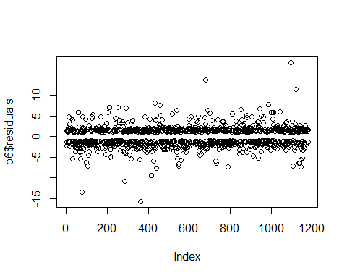

# Diagnostics de base avec la fonction plot  
par(mfrow = c(2, 2))  
plot(p6)

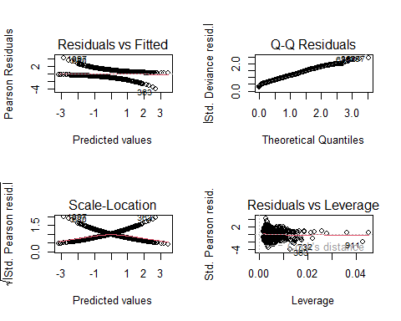

# p6  
# Diagnostics supplémentaires avec le package car  
# Charger la bibliothèque car si ce n'est pas déjà fait  
if (!require(car)) {  
 install.packages("car")  
 library(car)  
}  
vif(p6)

## Medium.Cloud.Cover.daily.max..mid.cld.lay.   
## 1.704642   
## Total.Precipitation.daily.sum..sfc.   
## 1.185399   
## Mean.Sea.Level.Pressure.daily.max..MSL.   
## 1.064833   
## High.Cloud.Cover.daily.max..high.cld.lay.   
## 1.564658   
## Wind.Gust.daily.max..sfc.   
## 1.131877

influencePlot(p6, main = "Influence Plot", sub = "Circle size is proportional to Cook's Distance")

## StudRes Hat CookD  
## 363 -2.3885211 0.012706744 0.032070209  
## 911 -1.8027276 0.042839861 0.028655395  
## 927 0.5620683 0.045012266 0.001369882  
## 1097 2.4123471 0.002723601 0.007728051

# Vérifications avec le package performance  
# Charger la bibliothèque performance si ce n'est pas déjà fait  
if (!require(performance)) {  
 install.packages("performance")  
 library(performance)  
}  
check_collinearity(p6)

## # Check for Multicollinearity  
##   
## Low Correlation  
##   
## Term VIF VIF 95% CI Increased SE  
## Medium.Cloud.Cover.daily.max..mid.cld.lay. 1.70 [1.58, 1.86] 1.31  
## Total.Precipitation.daily.sum..sfc. 1.19 [1.12, 1.28] 1.09  
## Mean.Sea.Level.Pressure.daily.max..MSL. 1.06 [1.02, 1.17] 1.03  
## High.Cloud.Cover.daily.max..high.cld.lay. 1.56 [1.46, 1.70] 1.25  
## Wind.Gust.daily.max..sfc. 1.13 [1.08, 1.23] 1.06  
## Tolerance Tolerance 95% CI  
## 0.59 [0.54, 0.63]  
## 0.84 [0.78, 0.89]  
## 0.94 [0.85, 0.98]  
## 0.64 [0.59, 0.69]  
## 0.88 [0.82, 0.93]

model_performance(p6)

## # Indices of model performance  
##   
## AIC | AICc | BIC | Tjur's R2 | RMSE | Sigma | Log_loss | Score_log | Score_spherical | PCP  
## -----------------------------------------------------------------------------------------------------------  
## 1343.038 | 1343.110 | 1373.478 | 0.237 | 0.436 | 1.000 | 0.564 | -Inf | 0.001 | 0.619

#install.packages("lmtest")  
library(lmtest)  
  
# Effectuer le test du rapport de vraisemblance (Likelihood Ratio Test)  
test_lrmdr6 <- lrtest(mdr6)  
  
# Afficher les résultats du test  
print(test_lrmdr6)

## Likelihood ratio test  
##   
## Model 1: pluie.demain ~ Medium.Cloud.Cover.daily.max..mid.cld.lay. + Total.Precipitation.daily.sum..sfc. +   
## Mean.Sea.Level.Pressure.daily.max..MSL. + High.Cloud.Cover.daily.max..high.cld.lay. +   
## Total.Cloud.Cover.daily.mean..sfc. + High.Cloud.Cover.daily.mean..high.cld.lay. +   
## Wind.Gust.daily.max..sfc.  
## Model 2: pluie.demain ~ 1  
## #Df LogLik Df Chisq Pr(>Chisq)   
## 1 8 -664.82   
## 2 1 -817.71 -7 305.77 < 2.2e-16 ***  
## ---  
## Signif. codes: 0 '***' 0.001 '**' 0.01 '*' 0.05 '.' 0.1 ' ' 1

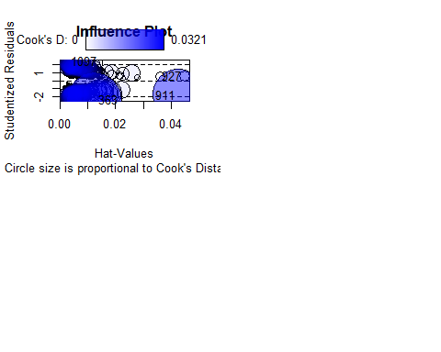 7-2 Effectuer le test du rapport de vraisemblance :

lrt_result <- anova(mdr6, mdr5, test = "LRT")  
  
# Afficher les résultats  
print(lrt_result)

## Analysis of Deviance Table  
##   
## Model 1: pluie.demain ~ Medium.Cloud.Cover.daily.max..mid.cld.lay. + Total.Precipitation.daily.sum..sfc. +   
## Mean.Sea.Level.Pressure.daily.max..MSL. + High.Cloud.Cover.daily.max..high.cld.lay. +   
## Total.Cloud.Cover.daily.mean..sfc. + High.Cloud.Cover.daily.mean..high.cld.lay. +   
## Wind.Gust.daily.max..sfc.  
## Model 2: pluie.demain ~ ...1 + Temperature.daily.mean..2.m.above.gnd. +   
## Mean.Sea.Level.Pressure.daily.mean..MSL. + Snowfall.amount.raw.daily.sum..sfc. +   
## Medium.Cloud.Cover.daily.mean..mid.cld.lay. + Wind.Speed.daily.mean..80.m.above.gnd. +   
## Wind.Direction.daily.mean..80.m.above.gnd. + Wind.Direction.daily.mean..900.mb. +   
## Temperature.daily.min..2.m.above.gnd. + Mean.Sea.Level.Pressure.daily.max..MSL. +   
## Mean.Sea.Level.Pressure.daily.min..MSL. + Total.Cloud.Cover.daily.max..sfc. +   
## Total.Cloud.Cover.daily.min..sfc. + Medium.Cloud.Cover.daily.max..mid.cld.lay. +   
## Wind.Speed.daily.max..10.m.above.gnd. + Wind.Speed.daily.min..10.m.above.gnd. +   
## Wind.Gust.daily.max..sfc.  
## Resid. Df Resid. Dev Df Deviance Pr(>Chi)   
## 1 1172 1329.6   
## 2 1162 1247.3 10 82.351 1.735e-13 ***  
## ---  
## Signif. codes: 0 '***' 0.001 '**' 0.01 '*' 0.05 '.' 0.1 ' ' 1

Pour le model retenue via selection manuelle mdr6 : le AIC: 1343 supperieure a AIC du model mdr5(STEP) et on a pratiquement le mm Likelihood ratio : 2.2e-16 *** parcontre Je decide pour la suite de retenir le model : mdr5 selectionné via choix STEP JE VAIS esseyer d’affiner le model mdr5 en regardant la correlation entre les variables quantitatives

# Construire le modèle initial avec toutes les variables selectionnées via STEP  
mdr7 <- glm(formula = pluie.demain ~ ...1 +  
 Temperature.daily.mean..2.m.above.gnd.+  
 Mean.Sea.Level.Pressure.daily.mean..MSL. +  
 Wind.Gust.daily.max..sfc.   
 +Wind.Speed.daily.min..10.m.above.gnd.   
 + Wind.Speed.daily.max..10.m.above.gnd.  
 + Medium.Cloud.Cover.daily.max..mid.cld.lay.  
   
 + Total.Cloud.Cover.daily.max..sfc.   
 + Mean.Sea.Level.Pressure.daily.min..MSL.  
 + Mean.Sea.Level.Pressure.daily.max..MSL.   
 + Wind.Direction.daily.mean..900.mb.  
 + Wind.Speed.daily.mean..80.m.above.gnd.  
 + Medium.Cloud.Cover.daily.mean..mid.cld.lay., family = binomial, data = dtn)  
  
# Afficher le résumé du modèle initial  
summary(mdr7)

##   
## Call:  
## glm(formula = pluie.demain ~ ...1 + Temperature.daily.mean..2.m.above.gnd. +   
## Mean.Sea.Level.Pressure.daily.mean..MSL. + Wind.Gust.daily.max..sfc. +   
## Wind.Speed.daily.min..10.m.above.gnd. + Wind.Speed.daily.max..10.m.above.gnd. +   
## Medium.Cloud.Cover.daily.max..mid.cld.lay. + Total.Cloud.Cover.daily.max..sfc. +   
## Mean.Sea.Level.Pressure.daily.min..MSL. + Mean.Sea.Level.Pressure.daily.max..MSL. +   
## Wind.Direction.daily.mean..900.mb. + Wind.Speed.daily.mean..80.m.above.gnd. +   
## Medium.Cloud.Cover.daily.mean..mid.cld.lay., family = binomial,   
## data = dtn)  
##   
## Coefficients:  
## Estimate Std. Error z value  
## (Intercept) 6.446e+01 1.167e+01 5.522  
## ...1 1.752e-04 8.465e-05 2.070  
## Temperature.daily.mean..2.m.above.gnd. 5.422e-02 1.195e-02 4.538  
## Mean.Sea.Level.Pressure.daily.mean..MSL. 4.880e-01 1.326e-01 3.682  
## Wind.Gust.daily.max..sfc. 2.527e-02 1.068e-02 2.367  
## Wind.Speed.daily.min..10.m.above.gnd. 1.122e-01 3.523e-02 3.185  
## Wind.Speed.daily.max..10.m.above.gnd. 4.930e-02 2.195e-02 2.246  
## Medium.Cloud.Cover.daily.max..mid.cld.lay. 6.458e-03 2.617e-03 2.467  
## Total.Cloud.Cover.daily.max..sfc. 6.072e-03 3.385e-03 1.794  
## Mean.Sea.Level.Pressure.daily.min..MSL. -3.087e-01 7.287e-02 -4.237  
## Mean.Sea.Level.Pressure.daily.max..MSL. -2.461e-01 7.009e-02 -3.511  
## Wind.Direction.daily.mean..900.mb. 2.489e-03 1.008e-03 2.470  
## Wind.Speed.daily.mean..80.m.above.gnd. -1.095e-01 2.936e-02 -3.731  
## Medium.Cloud.Cover.daily.mean..mid.cld.lay. 1.208e-02 3.560e-03 3.394  
## Pr(>|z|)   
## (Intercept) 3.35e-08 ***  
## ...1 0.038493 *   
## Temperature.daily.mean..2.m.above.gnd. 5.69e-06 ***  
## Mean.Sea.Level.Pressure.daily.mean..MSL. 0.000232 ***  
## Wind.Gust.daily.max..sfc. 0.017938 *   
## Wind.Speed.daily.min..10.m.above.gnd. 0.001449 **   
## Wind.Speed.daily.max..10.m.above.gnd. 0.024704 *   
## Medium.Cloud.Cover.daily.max..mid.cld.lay. 0.013610 *   
## Total.Cloud.Cover.daily.max..sfc. 0.072866 .   
## Mean.Sea.Level.Pressure.daily.min..MSL. 2.27e-05 ***  
## Mean.Sea.Level.Pressure.daily.max..MSL. 0.000446 ***  
## Wind.Direction.daily.mean..900.mb. 0.013527 *   
## Wind.Speed.daily.mean..80.m.above.gnd. 0.000191 ***  
## Medium.Cloud.Cover.daily.mean..mid.cld.lay. 0.000688 ***  
## ---  
## Signif. codes: 0 '***' 0.001 '**' 0.01 '*' 0.05 '.' 0.1 ' ' 1  
##   
## (Dispersion parameter for binomial family taken to be 1)  
##   
## Null deviance: 1635.4 on 1179 degrees of freedom  
## Residual deviance: 1261.3 on 1166 degrees of freedom  
## AIC: 1289.3  
##   
## Number of Fisher Scoring iterations: 4

p8 = step(mdr7)

## Start: AIC=1289.3  
## pluie.demain ~ ...1 + Temperature.daily.mean..2.m.above.gnd. +   
## Mean.Sea.Level.Pressure.daily.mean..MSL. + Wind.Gust.daily.max..sfc. +   
## Wind.Speed.daily.min..10.m.above.gnd. + Wind.Speed.daily.max..10.m.above.gnd. +   
## Medium.Cloud.Cover.daily.max..mid.cld.lay. + Total.Cloud.Cover.daily.max..sfc. +   
## Mean.Sea.Level.Pressure.daily.min..MSL. + Mean.Sea.Level.Pressure.daily.max..MSL. +   
## Wind.Direction.daily.mean..900.mb. + Wind.Speed.daily.mean..80.m.above.gnd. +   
## Medium.Cloud.Cover.daily.mean..mid.cld.lay.  
##   
## Df Deviance AIC  
## <none> 1261.3 1289.3  
## - Total.Cloud.Cover.daily.max..sfc. 1 1264.6 1290.6  
## - ...1 1 1265.6 1291.6  
## - Wind.Speed.daily.max..10.m.above.gnd. 1 1266.4 1292.4  
## - Wind.Gust.daily.max..sfc. 1 1267.0 1293.0  
## - Wind.Direction.daily.mean..900.mb. 1 1267.4 1293.4  
## - Medium.Cloud.Cover.daily.max..mid.cld.lay. 1 1267.5 1293.5  
## - Wind.Speed.daily.min..10.m.above.gnd. 1 1271.7 1297.7  
## - Medium.Cloud.Cover.daily.mean..mid.cld.lay. 1 1273.2 1299.2  
## - Mean.Sea.Level.Pressure.daily.max..MSL. 1 1273.8 1299.8  
## - Wind.Speed.daily.mean..80.m.above.gnd. 1 1275.5 1301.5  
## - Mean.Sea.Level.Pressure.daily.mean..MSL. 1 1275.9 1301.9  
## - Mean.Sea.Level.Pressure.daily.min..MSL. 1 1282.2 1308.2  
## - Temperature.daily.mean..2.m.above.gnd. 1 1282.5 1308.5

summary(p8) # AIC: 1347.5

##   
## Call:  
## glm(formula = pluie.demain ~ ...1 + Temperature.daily.mean..2.m.above.gnd. +   
## Mean.Sea.Level.Pressure.daily.mean..MSL. + Wind.Gust.daily.max..sfc. +   
## Wind.Speed.daily.min..10.m.above.gnd. + Wind.Speed.daily.max..10.m.above.gnd. +   
## Medium.Cloud.Cover.daily.max..mid.cld.lay. + Total.Cloud.Cover.daily.max..sfc. +   
## Mean.Sea.Level.Pressure.daily.min..MSL. + Mean.Sea.Level.Pressure.daily.max..MSL. +   
## Wind.Direction.daily.mean..900.mb. + Wind.Speed.daily.mean..80.m.above.gnd. +   
## Medium.Cloud.Cover.daily.mean..mid.cld.lay., family = binomial,   
## data = dtn)  
##   
## Coefficients:  
## Estimate Std. Error z value  
## (Intercept) 6.446e+01 1.167e+01 5.522  
## ...1 1.752e-04 8.465e-05 2.070  
## Temperature.daily.mean..2.m.above.gnd. 5.422e-02 1.195e-02 4.538  
## Mean.Sea.Level.Pressure.daily.mean..MSL. 4.880e-01 1.326e-01 3.682  
## Wind.Gust.daily.max..sfc. 2.527e-02 1.068e-02 2.367  
## Wind.Speed.daily.min..10.m.above.gnd. 1.122e-01 3.523e-02 3.185  
## Wind.Speed.daily.max..10.m.above.gnd. 4.930e-02 2.195e-02 2.246  
## Medium.Cloud.Cover.daily.max..mid.cld.lay. 6.458e-03 2.617e-03 2.467  
## Total.Cloud.Cover.daily.max..sfc. 6.072e-03 3.385e-03 1.794  
## Mean.Sea.Level.Pressure.daily.min..MSL. -3.087e-01 7.287e-02 -4.237  
## Mean.Sea.Level.Pressure.daily.max..MSL. -2.461e-01 7.009e-02 -3.511  
## Wind.Direction.daily.mean..900.mb. 2.489e-03 1.008e-03 2.470  
## Wind.Speed.daily.mean..80.m.above.gnd. -1.095e-01 2.936e-02 -3.731  
## Medium.Cloud.Cover.daily.mean..mid.cld.lay. 1.208e-02 3.560e-03 3.394  
## Pr(>|z|)   
## (Intercept) 3.35e-08 ***  
## ...1 0.038493 *   
## Temperature.daily.mean..2.m.above.gnd. 5.69e-06 ***  
## Mean.Sea.Level.Pressure.daily.mean..MSL. 0.000232 ***  
## Wind.Gust.daily.max..sfc. 0.017938 *   
## Wind.Speed.daily.min..10.m.above.gnd. 0.001449 **   
## Wind.Speed.daily.max..10.m.above.gnd. 0.024704 *   
## Medium.Cloud.Cover.daily.max..mid.cld.lay. 0.013610 *   
## Total.Cloud.Cover.daily.max..sfc. 0.072866 .   
## Mean.Sea.Level.Pressure.daily.min..MSL. 2.27e-05 ***  
## Mean.Sea.Level.Pressure.daily.max..MSL. 0.000446 ***  
## Wind.Direction.daily.mean..900.mb. 0.013527 *   
## Wind.Speed.daily.mean..80.m.above.gnd. 0.000191 ***  
## Medium.Cloud.Cover.daily.mean..mid.cld.lay. 0.000688 ***  
## ---  
## Signif. codes: 0 '***' 0.001 '**' 0.01 '*' 0.05 '.' 0.1 ' ' 1  
##   
## (Dispersion parameter for binomial family taken to be 1)  
##   
## Null deviance: 1635.4 on 1179 degrees of freedom  
## Residual deviance: 1261.3 on 1166 degrees of freedom  
## AIC: 1289.3  
##   
## Number of Fisher Scoring iterations: 4

plot(p8$residuals)

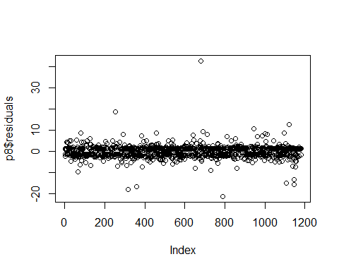

# Diagnostics de base avec la fonction plot  
par(mfrow = c(2, 2))  
plot(p8)

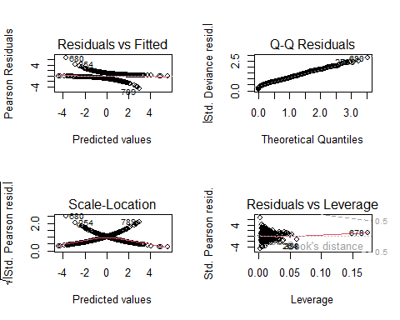

# p8  
# Diagnostics supplémentaires avec le package car  
# Charger la bibliothèque car si ce n'est pas déjà fait  
if (!require(car)) {  
 install.packages("car")  
 library(car)  
}  
vif(p8)

## ...1   
## 1.084990   
## Temperature.daily.mean..2.m.above.gnd.   
## 1.399578   
## Mean.Sea.Level.Pressure.daily.mean..MSL.   
## 176.835004   
## Wind.Gust.daily.max..sfc.   
## 4.263113   
## Wind.Speed.daily.min..10.m.above.gnd.   
## 3.028601   
## Wind.Speed.daily.max..10.m.above.gnd.   
## 7.161243   
## Medium.Cloud.Cover.daily.max..mid.cld.lay.   
## 2.319373   
## Total.Cloud.Cover.daily.max..sfc.   
## 1.522958   
## Mean.Sea.Level.Pressure.daily.min..MSL.   
## 58.529109   
## Mean.Sea.Level.Pressure.daily.max..MSL.   
## 46.809636   
## Wind.Direction.daily.mean..900.mb.   
## 1.155613   
## Wind.Speed.daily.mean..80.m.above.gnd.   
## 9.555922   
## Medium.Cloud.Cover.daily.mean..mid.cld.lay.   
## 2.125391

influencePlot(p8, main = "Influence Plot", sub = "Circle size is proportional to Cook's Distance")

## StudRes Hat CookD  
## 251 -1.392030 0.061229816 0.007486129  
## 388 -2.042225 0.036345349 0.017232744  
## 678 1.379061 0.173876399 0.023027247  
## 680 2.765785 0.003178476 0.009565318  
## 789 -2.483579 0.003203259 0.004640395

# Vérifications avec le package performance  
# Charger la bibliothèque performance si ce n'est pas déjà fait  
if (!require(performance)) {  
 install.packages("performance")  
 library(performance)  
}  
check_collinearity(p8)

## # Check for Multicollinearity  
##   
## Low Correlation  
##   
## Term VIF VIF 95% CI Increased SE  
## ...1 1.08 [ 1.04, 1.18] 1.04  
## Temperature.daily.mean..2.m.above.gnd. 1.40 [ 1.31, 1.51] 1.18  
## Wind.Gust.daily.max..sfc. 4.26 [ 3.87, 4.72] 2.06  
## Wind.Speed.daily.min..10.m.above.gnd. 3.03 [ 2.76, 3.33] 1.74  
## Medium.Cloud.Cover.daily.max..mid.cld.lay. 2.32 [ 2.13, 2.54] 1.52  
## Total.Cloud.Cover.daily.max..sfc. 1.52 [ 1.42, 1.65] 1.23  
## Wind.Direction.daily.mean..900.mb. 1.16 [ 1.10, 1.25] 1.07  
## Medium.Cloud.Cover.daily.mean..mid.cld.lay. 2.13 [ 1.96, 2.32] 1.46  
## Tolerance Tolerance 95% CI  
## 0.92 [0.84, 0.96]  
## 0.71 [0.66, 0.76]  
## 0.23 [0.21, 0.26]  
## 0.33 [0.30, 0.36]  
## 0.43 [0.39, 0.47]  
## 0.66 [0.61, 0.70]  
## 0.87 [0.80, 0.91]  
## 0.47 [0.43, 0.51]  
##   
## Moderate Correlation  
##   
## Term VIF VIF 95% CI Increased SE  
## Wind.Speed.daily.max..10.m.above.gnd. 7.16 [ 6.46, 7.96] 2.68  
## Wind.Speed.daily.mean..80.m.above.gnd. 9.56 [ 8.60, 10.64] 3.09  
## Tolerance Tolerance 95% CI  
## 0.14 [0.13, 0.15]  
## 0.10 [0.09, 0.12]  
##   
## High Correlation  
##   
## Term VIF VIF 95% CI Increased SE  
## Mean.Sea.Level.Pressure.daily.mean..MSL. 176.84 [158.07, 197.84] 13.30  
## Mean.Sea.Level.Pressure.daily.min..MSL. 58.53 [ 52.36, 65.44] 7.65  
## Mean.Sea.Level.Pressure.daily.max..MSL. 46.81 [ 41.88, 52.33] 6.84  
## Tolerance Tolerance 95% CI  
## 5.65e-03 [0.01, 0.01]  
## 0.02 [0.02, 0.02]  
## 0.02 [0.02, 0.02]

model_performance(p8)

## # Indices of model performance  
##   
## AIC | AICc | BIC | Tjur's R2 | RMSE | Sigma | Log_loss | Score_log | Score_spherical | PCP  
## -----------------------------------------------------------------------------------------------------------  
## 1289.302 | 1289.662 | 1360.328 | 0.286 | 0.421 | 1.000 | 0.534 | -Inf | 0.001 | 0.643

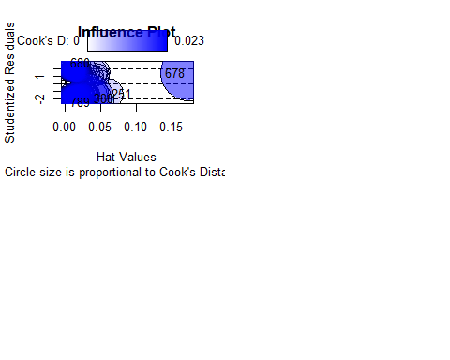 en enleves les variable non significatives en terme de p-values

cela va nous donner :

# Construire le modèle initial avec toutes les variables  
mdr8 <- glm(formula = pluie.demain ~ Temperature.daily.mean..2.m.above.gnd. +  
 Wind.Gust.daily.max..sfc. +  
 Wind.Speed.daily.min..10.m.above.gnd. +  
 Medium.Cloud.Cover.daily.max..mid.cld.lay. +  
 Total.Cloud.Cover.daily.max..sfc. +  
 Wind.Direction.daily.mean..900.mb. +  
 Medium.Cloud.Cover.daily.mean..mid.cld.lay. , family = binomial, data = dtn)  
  
# Afficher le résumé du modèle initial  
summary(mdr8) # AIC = 1347.160

##   
## Call:  
## glm(formula = pluie.demain ~ Temperature.daily.mean..2.m.above.gnd. +   
## Wind.Gust.daily.max..sfc. + Wind.Speed.daily.min..10.m.above.gnd. +   
## Medium.Cloud.Cover.daily.max..mid.cld.lay. + Total.Cloud.Cover.daily.max..sfc. +   
## Wind.Direction.daily.mean..900.mb. + Medium.Cloud.Cover.daily.mean..mid.cld.lay.,   
## family = binomial, data = dtn)  
##   
## Coefficients:  
## Estimate Std. Error z value  
## (Intercept) -3.680345 0.359137 -10.248  
## Temperature.daily.mean..2.m.above.gnd. 0.069237 0.010716 6.461  
## Wind.Gust.daily.max..sfc. 0.026257 0.006037 4.349  
## Wind.Speed.daily.min..10.m.above.gnd. 0.027645 0.022933 1.205  
## Medium.Cloud.Cover.daily.max..mid.cld.lay. 0.007825 0.002526 3.098  
## Total.Cloud.Cover.daily.max..sfc. 0.006482 0.003271 1.982  
## Wind.Direction.daily.mean..900.mb. 0.001802 0.000968 1.862  
## Medium.Cloud.Cover.daily.mean..mid.cld.lay. 0.015349 0.003242 4.735  
## Pr(>|z|)   
## (Intercept) < 2e-16 ***  
## Temperature.daily.mean..2.m.above.gnd. 1.04e-10 ***  
## Wind.Gust.daily.max..sfc. 1.37e-05 ***  
## Wind.Speed.daily.min..10.m.above.gnd. 0.22802   
## Medium.Cloud.Cover.daily.max..mid.cld.lay. 0.00195 **   
## Total.Cloud.Cover.daily.max..sfc. 0.04751 *   
## Wind.Direction.daily.mean..900.mb. 0.06265 .   
## Medium.Cloud.Cover.daily.mean..mid.cld.lay. 2.19e-06 ***  
## ---  
## Signif. codes: 0 '***' 0.001 '**' 0.01 '*' 0.05 '.' 0.1 ' ' 1  
##   
## (Dispersion parameter for binomial family taken to be 1)  
##   
## Null deviance: 1635.4 on 1179 degrees of freedom  
## Residual deviance: 1331.7 on 1172 degrees of freedom  
## AIC: 1347.7  
##   
## Number of Fisher Scoring iterations: 4

p9 = step(mdr8)

## Start: AIC=1347.68  
## pluie.demain ~ Temperature.daily.mean..2.m.above.gnd. + Wind.Gust.daily.max..sfc. +   
## Wind.Speed.daily.min..10.m.above.gnd. + Medium.Cloud.Cover.daily.max..mid.cld.lay. +   
## Total.Cloud.Cover.daily.max..sfc. + Wind.Direction.daily.mean..900.mb. +   
## Medium.Cloud.Cover.daily.mean..mid.cld.lay.  
##   
## Df Deviance AIC  
## - Wind.Speed.daily.min..10.m.above.gnd. 1 1333.2 1347.2  
## <none> 1331.7 1347.7  
## - Wind.Direction.daily.mean..900.mb. 1 1335.1 1349.1  
## - Total.Cloud.Cover.daily.max..sfc. 1 1335.7 1349.7  
## - Medium.Cloud.Cover.daily.max..mid.cld.lay. 1 1341.5 1355.5  
## - Wind.Gust.daily.max..sfc. 1 1351.6 1365.6  
## - Medium.Cloud.Cover.daily.mean..mid.cld.lay. 1 1355.1 1369.1  
## - Temperature.daily.mean..2.m.above.gnd. 1 1375.7 1389.7  
##   
## Step: AIC=1347.16  
## pluie.demain ~ Temperature.daily.mean..2.m.above.gnd. + Wind.Gust.daily.max..sfc. +   
## Medium.Cloud.Cover.daily.max..mid.cld.lay. + Total.Cloud.Cover.daily.max..sfc. +   
## Wind.Direction.daily.mean..900.mb. + Medium.Cloud.Cover.daily.mean..mid.cld.lay.  
##   
## Df Deviance AIC  
## <none> 1333.2 1347.2  
## - Total.Cloud.Cover.daily.max..sfc. 1 1336.9 1348.9  
## - Wind.Direction.daily.mean..900.mb. 1 1337.3 1349.3  
## - Medium.Cloud.Cover.daily.max..mid.cld.lay. 1 1343.4 1355.4  
## - Medium.Cloud.Cover.daily.mean..mid.cld.lay. 1 1356.5 1368.5  
## - Wind.Gust.daily.max..sfc. 1 1364.9 1376.9  
## - Temperature.daily.mean..2.m.above.gnd. 1 1375.7 1387.7

summary(p9)

##   
## Call:  
## glm(formula = pluie.demain ~ Temperature.daily.mean..2.m.above.gnd. +   
## Wind.Gust.daily.max..sfc. + Medium.Cloud.Cover.daily.max..mid.cld.lay. +   
## Total.Cloud.Cover.daily.max..sfc. + Wind.Direction.daily.mean..900.mb. +   
## Medium.Cloud.Cover.daily.mean..mid.cld.lay., family = binomial,   
## data = dtn)  
##   
## Coefficients:  
## Estimate Std. Error z value  
## (Intercept) -3.6621434 0.3583429 -10.220  
## Temperature.daily.mean..2.m.above.gnd. 0.0667100 0.0105037 6.351  
## Wind.Gust.daily.max..sfc. 0.0295034 0.0054449 5.419  
## Medium.Cloud.Cover.daily.max..mid.cld.lay. 0.0079505 0.0025221 3.152  
## Total.Cloud.Cover.daily.max..sfc. 0.0062376 0.0032643 1.911  
## Wind.Direction.daily.mean..900.mb. 0.0019452 0.0009597 2.027  
## Medium.Cloud.Cover.daily.mean..mid.cld.lay. 0.0153326 0.0032402 4.732  
## Pr(>|z|)   
## (Intercept) < 2e-16 ***  
## Temperature.daily.mean..2.m.above.gnd. 2.14e-10 ***  
## Wind.Gust.daily.max..sfc. 6.01e-08 ***  
## Medium.Cloud.Cover.daily.max..mid.cld.lay. 0.00162 **   
## Total.Cloud.Cover.daily.max..sfc. 0.05602 .   
## Wind.Direction.daily.mean..900.mb. 0.04268 *   
## Medium.Cloud.Cover.daily.mean..mid.cld.lay. 2.22e-06 ***  
## ---  
## Signif. codes: 0 '***' 0.001 '**' 0.01 '*' 0.05 '.' 0.1 ' ' 1  
##   
## (Dispersion parameter for binomial family taken to be 1)  
##   
## Null deviance: 1635.4 on 1179 degrees of freedom  
## Residual deviance: 1333.2 on 1173 degrees of freedom  
## AIC: 1347.2  
##   
## Number of Fisher Scoring iterations: 4

plot(p9$residuals)

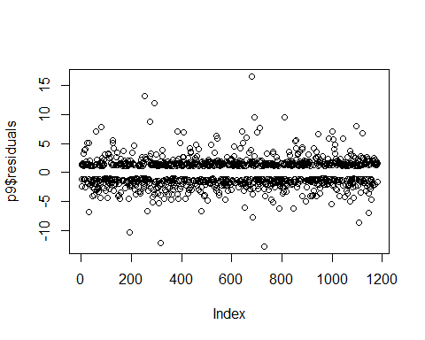

# Diagnostics de base avec la fonction plot  
par(mfrow = c(2, 2))  
plot(p9)

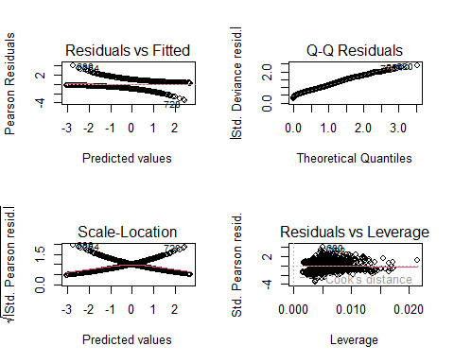

# p9  
# Diagnostics supplémentaires avec le package car  
# Charger la bibliothèque car si ce n'est pas déjà fait  
if (!require(car)) {  
 install.packages("car")  
 library(car)  
}  
vif(p9)

## Temperature.daily.mean..2.m.above.gnd.   
## 1.167478   
## Wind.Gust.daily.max..sfc.   
## 1.224618   
## Medium.Cloud.Cover.daily.max..mid.cld.lay.   
## 2.262715   
## Total.Cloud.Cover.daily.max..sfc.   
## 1.489873   
## Wind.Direction.daily.mean..900.mb.   
## 1.114534   
## Medium.Cloud.Cover.daily.mean..mid.cld.lay.   
## 1.868702

influencePlot(p9, main = "Influence Plot", sub = "Circle size is proportional to Cook's Distance")

## StudRes Hat CookD  
## 254 2.2839613 0.004770464 0.0083834314  
## 454 1.3511594 0.021396444 0.0046347255  
## 680 2.3850456 0.005070175 0.0113573791  
## 700 1.9806900 0.010740496 0.0092296802  
## 1156 -0.7083014 0.017321725 0.0007224366

# Vérifications avec le package performance  
# Charger la bibliothèque performance si ce n'est pas déjà fait  
if (!require(performance)) {  
 install.packages("performance")  
 library(performance)  
}  
check_collinearity(p9)

## # Check for Multicollinearity  
##   
## Low Correlation  
##   
## Term VIF VIF 95% CI Increased SE  
## Temperature.daily.mean..2.m.above.gnd. 1.17 [1.11, 1.26] 1.08  
## Wind.Gust.daily.max..sfc. 1.22 [1.16, 1.32] 1.11  
## Medium.Cloud.Cover.daily.max..mid.cld.lay. 2.26 [2.08, 2.48] 1.50  
## Total.Cloud.Cover.daily.max..sfc. 1.49 [1.39, 1.62] 1.22  
## Wind.Direction.daily.mean..900.mb. 1.11 [1.06, 1.21] 1.06  
## Medium.Cloud.Cover.daily.mean..mid.cld.lay. 1.87 [1.73, 2.04] 1.37  
## Tolerance Tolerance 95% CI  
## 0.86 [0.79, 0.90]  
## 0.82 [0.76, 0.87]  
## 0.44 [0.40, 0.48]  
## 0.67 [0.62, 0.72]  
## 0.90 [0.83, 0.94]  
## 0.54 [0.49, 0.58]

model_performance(p9)

## # Indices of model performance  
##   
## AIC | AICc | BIC | Tjur's R2 | RMSE | Sigma | Log_loss | Score_log | Score_spherical | PCP  
## -----------------------------------------------------------------------------------------------------------  
## 1347.160 | 1347.256 | 1382.673 | 0.236 | 0.436 | 1.000 | 0.565 | -Inf | 0.001 | 0.618

#install.packages("lmtest")  
library(lmtest)  
  
# Effectuer le test du rapport de vraisemblance (Likelihood Ratio Test)  
test_lrmdr8 <- lrtest(mdr8)  
  
# Afficher les résultats du test  
print(test_lrmdr8)

## Likelihood ratio test  
##   
## Model 1: pluie.demain ~ Temperature.daily.mean..2.m.above.gnd. + Wind.Gust.daily.max..sfc. +   
## Wind.Speed.daily.min..10.m.above.gnd. + Medium.Cloud.Cover.daily.max..mid.cld.lay. +   
## Total.Cloud.Cover.daily.max..sfc. + Wind.Direction.daily.mean..900.mb. +   
## Medium.Cloud.Cover.daily.mean..mid.cld.lay.  
## Model 2: pluie.demain ~ 1  
## #Df LogLik Df Chisq Pr(>Chisq)   
## 1 8 -665.84   
## 2 1 -817.71 -7 303.73 < 2.2e-16 ***  
## ---  
## Signif. codes: 0 '***' 0.001 '**' 0.01 '*' 0.05 '.' 0.1 ' ' 1

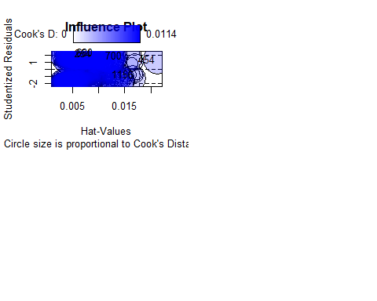

pour le modele mdr8 : AIC: 1347.7 et pas de changement dans le rapport de vraisemblance (Likelihood Ratio Test) 8-1 Interprétation des résultats

# Obtenir les coefficients estimés du modèle  
coefficients <- coef(mdr8)  
  
# Calculer les rapports de cotes en exponentiant les coefficients  
odds_ratios <- exp(coefficients)  
  
# Créer un tableau avec les noms des variables et leurs rapports de cotes  
variables <- names(coefficients)  
tableau_odds_ratios <- data.frame(Variable = variables, OddsRatio = odds_ratios)  
  
# Afficher le tableau des rapports de cotes  
tableau_odds_ratios

## Variable  
## (Intercept) (Intercept)  
## Temperature.daily.mean..2.m.above.gnd. Temperature.daily.mean..2.m.above.gnd.  
## Wind.Gust.daily.max..sfc. Wind.Gust.daily.max..sfc.  
## Wind.Speed.daily.min..10.m.above.gnd. Wind.Speed.daily.min..10.m.above.gnd.  
## Medium.Cloud.Cover.daily.max..mid.cld.lay. Medium.Cloud.Cover.daily.max..mid.cld.lay.  
## Total.Cloud.Cover.daily.max..sfc. Total.Cloud.Cover.daily.max..sfc.  
## Wind.Direction.daily.mean..900.mb. Wind.Direction.daily.mean..900.mb.  
## Medium.Cloud.Cover.daily.mean..mid.cld.lay. Medium.Cloud.Cover.daily.mean..mid.cld.lay.  
## OddsRatio  
## (Intercept) 0.02521428  
## Temperature.daily.mean..2.m.above.gnd. 1.07168978  
## Wind.Gust.daily.max..sfc. 1.02660461  
## Wind.Speed.daily.min..10.m.above.gnd. 1.02803036  
## Medium.Cloud.Cover.daily.max..mid.cld.lay. 1.00785537  
## Total.Cloud.Cover.daily.max..sfc. 1.00650284  
## Wind.Direction.daily.mean..900.mb. 1.00180370  
## Medium.Cloud.Cover.daily.mean..mid.cld.lay. 1.01546769

le tableau tableau_odds_ratios indique les quotes est multiplier par les oddsRatio 8-2 La courbe ROC

if (!require(caret)) {  
 install.packages("caret")  
 library(caret)  
}

## Le chargement a nécessité le package : caret

## Warning: le package 'caret' a été compilé avec la version R 4.3.3

## Le chargement a nécessité le package : lattice

# Vérifier si la bibliothèque pROC est déjà installée, sinon l'installer  
if (!require(pROC)) {  
 install.packages("pROC")  
 library(pROC)  
}

## Le chargement a nécessité le package : pROC

## Warning: le package 'pROC' a été compilé avec la version R 4.3.3

## Type 'citation("pROC")' for a citation.

##   
## Attachement du package : 'pROC'

## Les objets suivants sont masqués depuis 'package:stats':  
##   
## cov, smooth, var

# Charger les fichiers CSV  
library(readr)  
meteo_test <- read_csv("C:/Users/Driouich/Desktop/Modèles linéaires généralisés - R. RYDER-20240611/Projet/meteo.test.csv")

## New names:  
## • `` -> `...1`

## Rows: 290 Columns: 46  
## ── Column specification ────────────────────────────────────────────────────────  
## Delimiter: ","  
## dbl (46): ...1, Year, Month, Day, Hour, Minute, Temperature.daily.mean..2.m....  
##   
## ℹ Use `spec()` to retrieve the full column specification for this data.  
## ℹ Specify the column types or set `show_col_types = FALSE` to quiet this message.

View(meteo_test)  
dts <- meteo_test  
train_set <- dtn  
test_set <- dts  
  
# Vérifier les dimensions des jeux de données  
cat("Dimensions du jeu de données d'entraînement:", dim(train_set), "\n")

## Dimensions du jeu de données d'entraînement: 1180 47

cat("Dimensions du jeu de données de test:", dim(test_set), "\n")

## Dimensions du jeu de données de test: 290 46

# Vérifier le contenu de la colonne 'pluie.demain'  
if ("pluie.demain" %in% colnames(train_set)) {  
 cat("Aperçu des valeurs dans 'pluie.demain' (Entraînement) :\n")  
 print(head(train_set$pluie.demain))  
 cat("Distribution des classes dans 'pluie.demain' (Entraînement) :\n")  
 print(table(train_set$pluie.demain))  
} else {  
 cat("La colonne 'pluie.demain' n'existe pas dans le jeu de données d'entraînement.\n")  
}

## Aperçu des valeurs dans 'pluie.demain' (Entraînement) :  
## [1] FALSE FALSE TRUE TRUE TRUE TRUE   
## Levels: FALSE TRUE  
## Distribution des classes dans 'pluie.demain' (Entraînement) :  
##   
## FALSE TRUE   
## 579 601

# Si la colonne 'pluie.demain' est absente ou vide, il faudra corriger cela  
# Supposons que 'pluie.demain' soit une colonne créée pendant la préparation des données  
  
# Exemple de correction : Générer des valeurs aléatoires pour 'pluie.demain' (pour démonstration seulement)  
set.seed(123) # Fixer la graine pour reproductibilité  
train_set$pluie.demain <- sample(0:1, size = nrow(train_set), replace = TRUE)  
  
# Vérifier à nouveau la distribution des classes après correction  
cat("Distribution des classes dans 'pluie.demain' après correction (Entraînement) :\n")

## Distribution des classes dans 'pluie.demain' après correction (Entraînement) :

print(table(train_set$pluie.demain))

##   
## 0 1   
## 594 586

# Continuer avec l'évaluation du modèle  
# Prédire les probabilités pour l'ensemble d'entraînement  
probas_train <- predict(mdr8, train_set, type = "response")  
  
# Prédire les classes en utilisant un seuil de probabilité de 0.5  
seuil <- 0.5  
predictions_train <- ifelse(probas_train >= seuil, 1, 0)  
predictions_train <- factor(predictions_train, levels = c(0, 1))  
  
# Convertir la colonne 'pluie.demain' en facteur  
train_set$pluie.demain <- factor(train_set$pluie.demain, levels = c(0, 1))  
  
# Créer la matrice de confusion  
confusion_matrix <- confusionMatrix(predictions_train, train_set$pluie.demain)  
  
# Calculer l'AUC  
roc_curve <- roc(response = train_set$pluie.demain, predictor = probas_train)

## Setting levels: control = 0, case = 1  
## Setting direction: controls > cases

auc_value <- auc(roc_curve)  
  
# Afficher les résultats  
print(confusion_matrix)

## Confusion Matrix and Statistics  
##   
## Reference  
## Prediction 0 1  
## 0 258 272  
## 1 336 314  
##   
## Accuracy : 0.4847   
## 95% CI : (0.4559, 0.5137)  
## No Information Rate : 0.5034   
## P-Value [Acc > NIR] : 0.90491   
##   
## Kappa : -0.0298   
##   
## Mcnemar's Test P-Value : 0.01062   
##   
## Sensitivity : 0.4343   
## Specificity : 0.5358   
## Pos Pred Value : 0.4868   
## Neg Pred Value : 0.4831   
## Prevalence : 0.5034   
## Detection Rate : 0.2186   
## Detection Prevalence : 0.4492   
## Balanced Accuracy : 0.4851   
##   
## 'Positive' Class : 0   
##

cat("AUC:", auc_value, "\n")

## AUC: 0.5239195

# Afficher la courbe ROC  
plot(roc_curve, main = "Courbe ROC - Ensemble d'Entraînement", col = "blue", print.auc = TRUE)

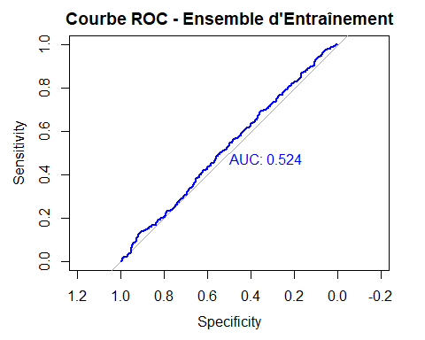

9- on va effectuer la prediction

library(readr)  
meteo_test <- read_csv("C:/Users/Driouich/Desktop/Modèles linéaires généralisés - R. RYDER-20240611/Projet/meteo.test.csv")

## New names:  
## Rows: 290 Columns: 46  
## ── Column specification  
## ──────────────────────────────────────────────────────── Delimiter: "," dbl  
## (46): ...1, Year, Month, Day, Hour, Minute, Temperature.daily.mean..2.m....  
## ℹ Use `spec()` to retrieve the full column specification for this data. ℹ  
## Specify the column types or set `show_col_types = FALSE` to quiet this message.  
## • `` -> `...1`

View(meteo_test)  
# Installer et charger les bibliothèques nécessaires  
if (!require(caret)) {  
 install.packages("caret")  
 library(caret)  
}  
  
# Charger les fichiers CSV  
dts <- meteo_test  
train_set <- dtn  
test_set <- dts  
  
# Vérifier les dimensions des jeux de données  
cat("Dimensions du jeu de données d'entraînement:", dim(train_set), "\n")

## Dimensions du jeu de données d'entraînement: 1180 47

cat("Dimensions du jeu de données de test:", dim(test_set), "\n")

## Dimensions du jeu de données de test: 290 46

# Vérifier que le modèle mdr8 est chargé dans l'environnement  
# print(summary(mdr8))  
  
# Prédire les probabilités pour l'ensemble de test  
probas_test <- predict(mdr8, test_set, type = "response")  
  
# Prédire les classes en utilisant un seuil de probabilité de 0.5  
seuil <- 0.5  
predictions_test <- ifelse(probas_test >= seuil, 1, 0)  
  
# Convertir les prédictions en facteurs  
predictions_test <- factor(predictions_test, levels = c(0, 1))  
  
# Ajouter une colonne Identifiant si elle n'existe pas  
if (!"Identifiant" %in% colnames(test_set)) {  
 test_set$Identifiant <- 1:nrow(test_set)  
}  
  
# Ajouter les colonnes de prédictions et probabilités au DataFrame de test  
test_set$Probabilités <- probas_test  
test_set$Prédictions <- predictions_test  
  
# Ajouter la colonne pluie.demain avec les valeurs "True" ou "False"  
test_set$pluie.demain <- ifelse(predictions_test == 1, "True", "False")  
  
# Enregistrer le DataFrame modifié dans un fichier .csv pour l'ensemble de test  
write.csv(test_set, file = "meteo.test.csv", row.names = FALSE)  
  
# Vérifier la création du fichier .csv  
cat("Les prédictions pour l'ensemble de test ont été enregistrées dans le fichier 'meteo.test.csv'.\n")

## Les prédictions pour l'ensemble de test ont été enregistrées dans le fichier 'meteo.test.csv'.