**SQL Challenge 6**

# Marketing Analysis

# image

# Intro

You are a Marketing Analyst. The 'Sustainable Clothing Co.' have been running several marketing campaigns and have asked you to provide your insight into whether they have been successful or not. Analyse the following data and answer the questions to form your answer.

# Tables

Here are the tables you will be using

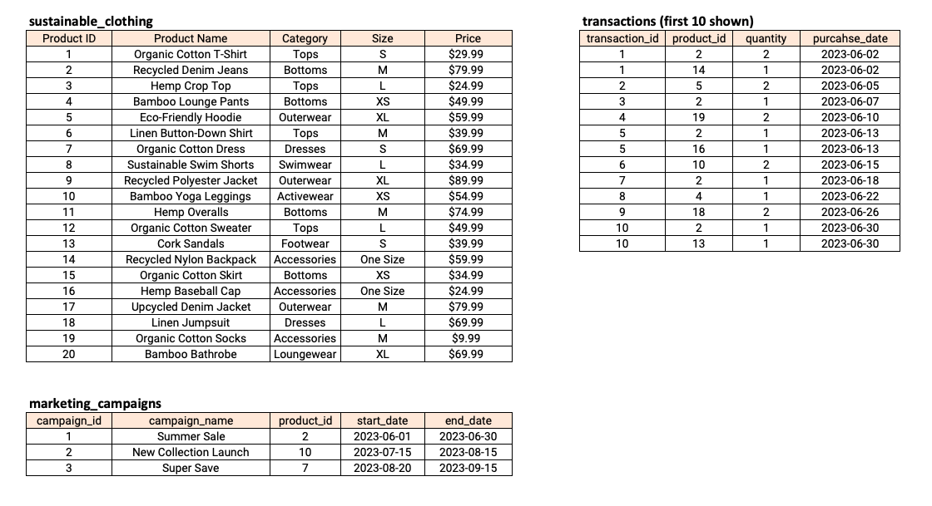

## Questions

1. How many transactions were completed during each marketing campaign?

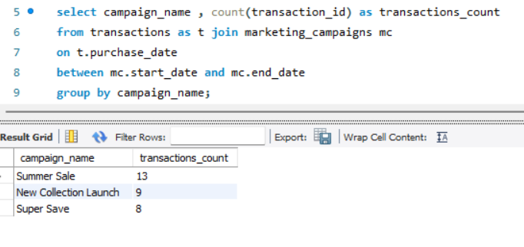

2. Which product had the highest sales quantity?

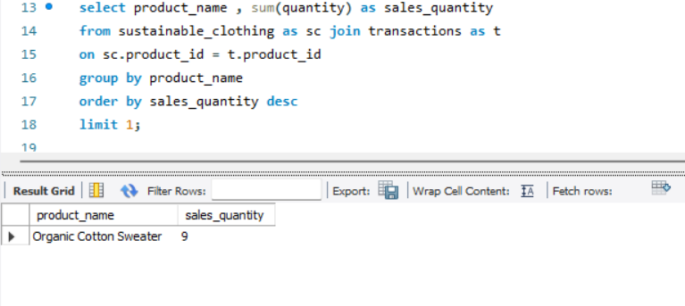

3. What is the total revenue generated from each marketing campaign?

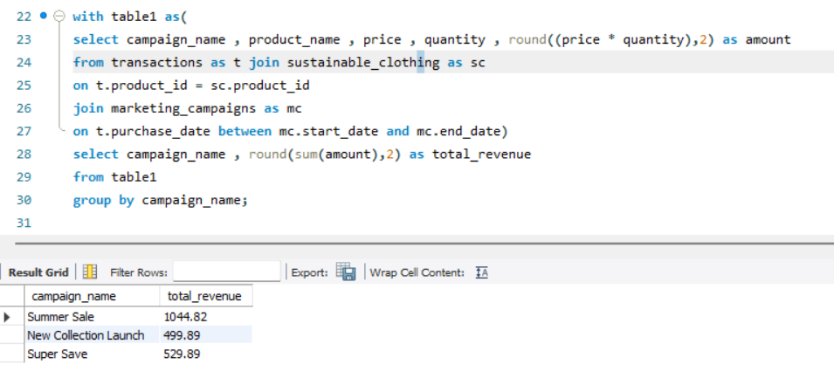

4. What is the top-selling product category based on the total revenue generated?

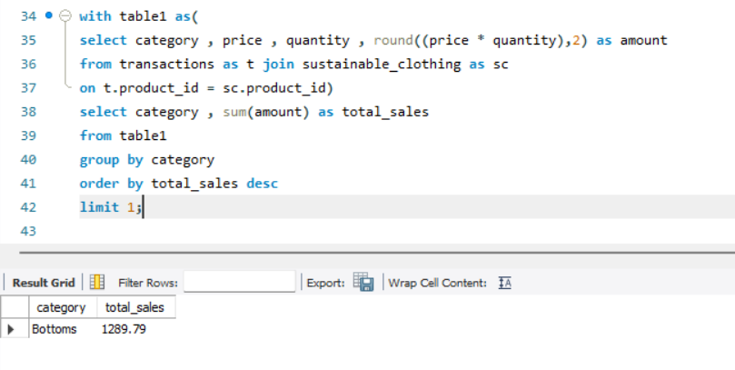

5. Which products had a higher quantity sold compared to the average quantity sold?

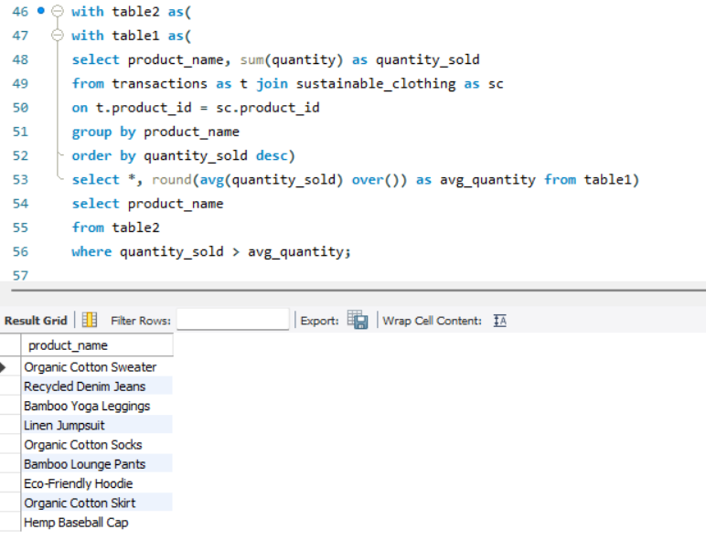

6. What is the average revenue generated per day during the marketing campaigns?

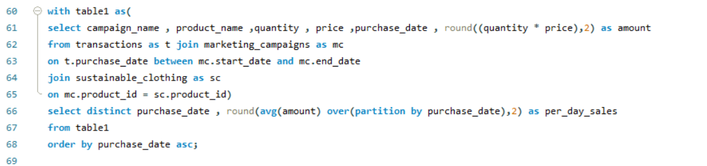

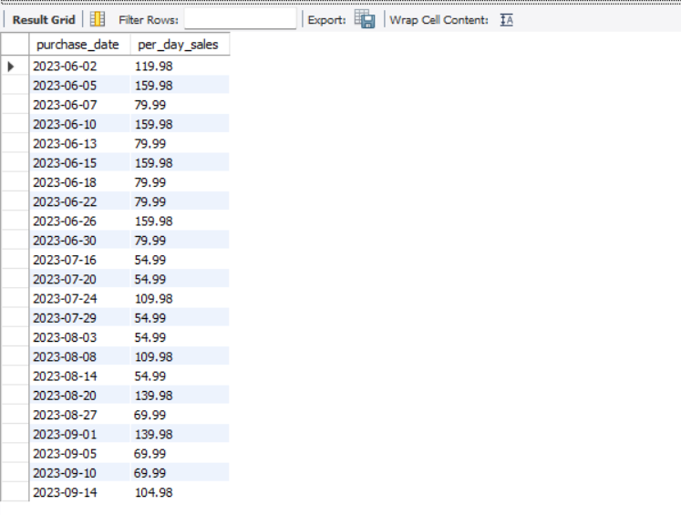

7. What is the percentage contribution of each product to the total revenue?

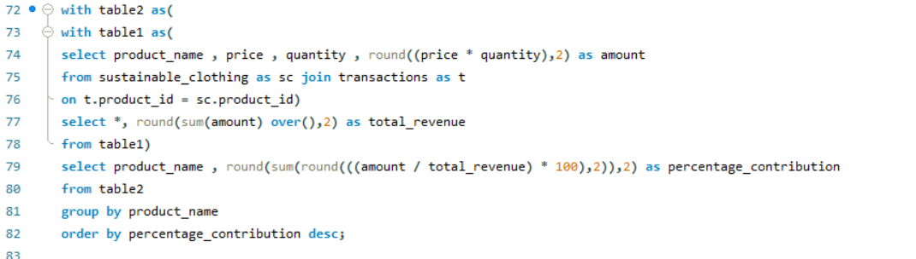

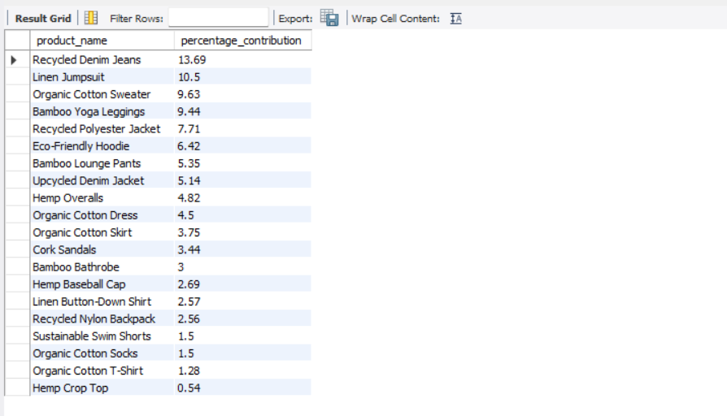

8. Compare the average quantity sold during marketing campaigns to outside the marketing campaigns

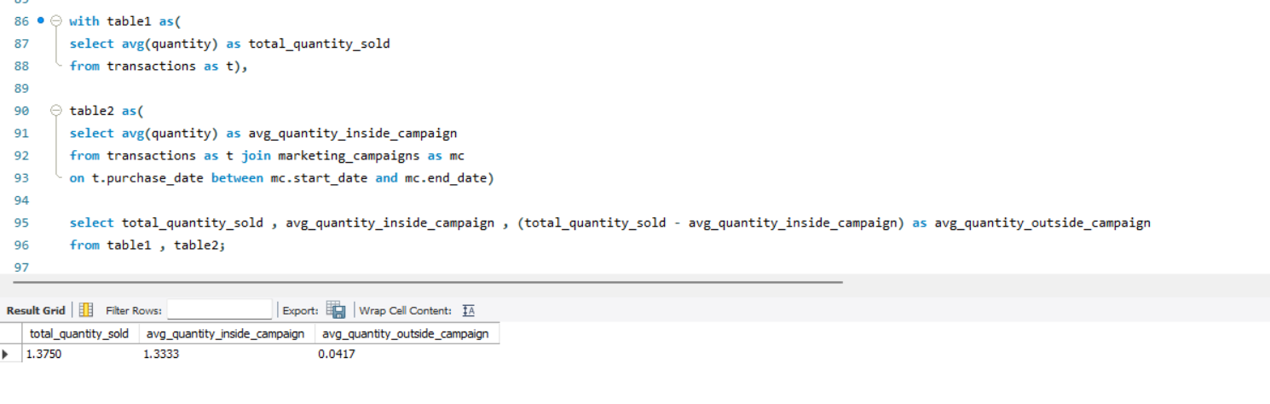

9. Compare the revenue generated by products inside the marketing campaigns to outside the campaigns

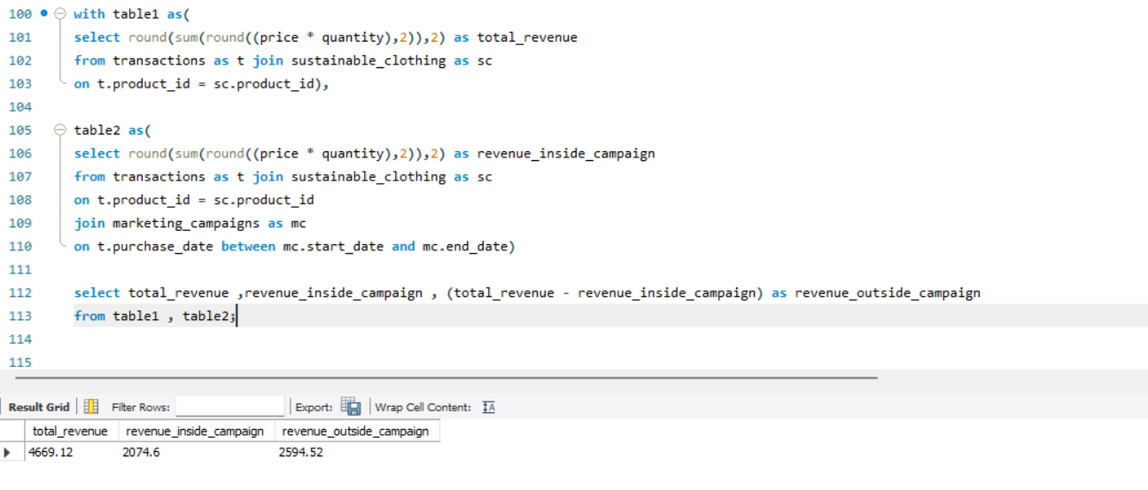

10. Rank the products by their average daily quantity sold

