SOCIAL MEDIA APPLICATION

Project Documentation
A Full-Stack Social Media Platform

Submitted By
Mohd Arshan
B.Tech — Computer Science and Engineering
KIET Deemed to be University

Project Type
Academic / Personal Software Project

Technology Domain
• Web Development
• Real-Time Communication

Technologies
• React
• NodeJs
• Express
• RestAPI
• MongoDB
• WebSockets

Project Documentation
2026

2. Abstract

The Social Media Application is a full-stack web application developed using the MERN stack, consisting of MongoDB, Express.js, React, and Node.js. The primary objective of the application is to provide users with a secure and interactive platform for connecting with other users, sharing content, and communicating in real time.

The application implements secure user authentication using JSON Web Tokens (JWT) with cookie-based authentication to protect user sessions and private resources. Users can perform common social media operations such as creating and managing posts, following and unfollowing other users, and liking posts. These features are implemented through RESTful APIs and basic CRUD operations.

The application also supports real-time communication using WebSockets, allowing users to exchange messages with low latency while maintaining authenticated communication between clients and the server. The backend is built using Node.js and Express.js, while MongoDB is used for storing application data. React is used to develop the client-side interface and provide an interactive user experience.

The project focuses on practical implementation of modern web development concepts, including REST API design, authentication and authorization, database management, CRUD operations, real-time communication, and secure client-server interaction. Overall, the application demonstrates how the MERN stack can be used to design and implement a modern social media platform with both conventional HTTP-based APIs and real-time WebSocket communication.

3. Introduction
Social media platforms have become an important part of modern digital communication, allowing users to connect with others, share content, and communicate instantly. Developing such an application provides an opportunity to implement and understand several important concepts in modern web development, including client-server architecture, RESTful APIs, authentication, database management, CRUD operations, and real-time communication.
The Social Media Application is a full-stack web application developed using the MERN stack, consisting of MongoDB, Express.js, React, and Node.js. The application provides users with core social networking functionality such as creating posts, liking posts, following and unfollowing users, and communicating through real-time messaging.
The system uses JWT-based authentication with cookies to provide secure access to protected resources. In addition to conventional HTTP-based communication through REST APIs, WebSockets are used to support real-time communication between users.

3.1 Problem Statement
Traditional web applications often handle user interactions through independent HTTP requests, which is not sufficient for features that require immediate communication between users. At the same time, a social platform must securely manage user identities, relationships, user-generated content, and access to private resources.
The objective of this project is to develop a social media application that provides essential social networking functionality while demonstrating secure authentication, CRUD-based operations, RESTful API communication, database management, and real-time communication.
The system aims to provide a structured platform where authenticated users can create and interact with content, connect with other users, and communicate with each other in real time.

3.2 Motivation
The motivation behind this project is to gain practical experience in developing a complete full-stack application rather than working with individual technologies in isolation.
A social media application provides a suitable environment for implementing multiple real-world software engineering concepts. It requires user authentication, authorization, database relationships, API development, frontend-backend communication, and real-time data exchange.
The project also provides practical experience with the MERN stack and helps demonstrate how REST APIs and WebSocket-based communication can work together within the same application.

3.3 Objectives
The primary objectives of the Social Media Application are:
- To develop a full-stack social media platform using the MERN stack.
- To implement secure user authentication using JWT and cookies.
- To provide authenticated users with protected application resources.
- To implement basic CRUD operations for user-generated content.
- To allow users to create, manage, and interact with posts.
- To implement social interactions such as following, unfollowing, and liking posts.
- To develop RESTful APIs for communication between the frontend and backend.
- To implement real-time communication using WebSockets.
- To store and manage application data using MongoDB.
- To provide an interactive and responsive user interface using React.
- To understand and apply practical concepts of full-stack web application architecture and secure client-server communication.

3.4 Scope
The scope of the project covers the development of the core functionality required for a social media platform.

Included in the Scope
- User registration and login
- JWT-based authentication using cookies
- Protected API resources
- User profile management
- Creating and managing posts
- Liking posts
- Following and unfollowing users
- Basic CRUD operations
- RESTful API communication
- MongoDB-based data storage
- Real-time communication using WebSockets
- React-based frontend interface
- Node.js and Express.js backend

Outside the Current Scope
The current version focuses on the fundamental functionality of a social media platform and does not attempt to implement every feature available in large-scale commercial social media platforms. Advanced features such as sophisticated recommendation algorithms, large-scale content moderation, advanced media processing, and large-scale distributed infrastructure are outside the current scope.
The application is primarily intended to demonstrate the practical implementation of a modern full-stack web application using the MERN stack, with particular emphasis on secure authentication, CRUD-based operations, and real-time communication.

4. Technology Stack
The Social Media Application is developed using the MERN stack along with additional technologies for secure authentication and real-time communication. Each technology is used for a specific role within the application architecture.

4.1 Frontend

React.js
React.js is used to develop the client-side interface of the application. It provides a component-based architecture that allows the user interface to be divided into reusable and maintainable components.
The frontend communicates with the backend through RESTful APIs and establishes WebSocket connections for real-time communication.

4.2 Backend

Node.js
Node.js provides the runtime environment for executing the server-side JavaScript code. Its asynchronous and event-driven architecture makes it suitable for handling API requests and real-time communication.

Express.js
Express.js is used as the backend web framework. It handles HTTP requests, routing, middleware, authentication-related processing, and communication between the frontend and database.
Express.js is also used to build the RESTful APIs required by the application.

4.3 Database

MongoDB
MongoDB is used as the primary database for storing application data. It is a NoSQL document-oriented database that stores data in flexible document structures.
The database stores information such as:
- User accounts
- User profiles
- Posts
- Likes
- Followers and following relationships
- Messages
- Other application-related data

4.4 Authentication

JSON Web Token (JWT)
JSON Web Tokens are used to implement authentication and authorization. After successful authentication, the server generates a JWT that is stored using cookies.
Protected resources require a valid authentication token, allowing the backend to verify the identity of the requesting user before processing protected operations.

Cookies
Cookies are used to securely transmit and maintain authentication information between the client and server. Cookie-based authentication helps prevent the application from exposing authentication tokens directly through normal client-side storage mechanisms.

4.5 Real-Time Communication

WebSockets
WebSockets are used to implement real-time communication between users. Unlike traditional request-response communication, WebSockets maintain a persistent connection between the client and server, allowing data to be transmitted with low latency.
The technology is primarily used for real-time messaging within the application.

4.6 API Communication

RESTful APIs
RESTful APIs provide communication between the React frontend and the Node.js/Express.js backend.
The APIs are used for operations such as:
- User authentication
- Creating and retrieving posts
- Updating and deleting resources
- Following and unfollowing users
- Liking posts
- Retrieving user-related data

4.7 Development Tools

Git
Git is used for version control and tracking changes throughout the development process.

GitHub
GitHub is used for storing and managing the project's source code repository.

Visual Studio Code
Visual Studio Code is used as the primary development environment for writing, debugging, and managing the project source code.

5. System Requirements
The following requirements are necessary for developing, running, and testing the Social Media Application.

5.1 Hardware Requirements
The application does not require specialized hardware for local development. A standard modern computer is sufficient.
Component | Minimum Requirement | Recommended
Processor | Dual-Core CPU | Quad-Core or better
RAM | 4 GB | 8 GB or more
Storage | 5 GB available space | 10 GB or more
Network | Internet connection | Stable broadband connection
Display | 1280 × 720 | 1920 × 1080

5.2 Software Requirements
Software | Requirement
Operating System | Windows / Linux / macOS
Node.js | LTS version
npm | Comes with Node.js
MongoDB | Local MongoDB or MongoDB Atlas
Git | Latest stable version
Code Editor | Visual Studio Code or equivalent
Web Browser | Chrome, Firefox, Edge, or equivalent

5.3 Runtime Requirements
The application requires the following services to be available during execution:
- Node.js runtime — required to run the backend server.
- MongoDB — required for persistent application data storage.
- Web Browser — required to access the React frontend.
- Network Connection — required when using a remote database or other external services.

5.4 Development Environment
The project can be developed and tested locally using a development environment containing Node.js, npm, MongoDB, Git, and a suitable code editor.
The frontend and backend can be executed as separate processes during development, with the frontend communicating with the Express.js backend through RESTful APIs and WebSocket connections.

6. System Architecture
The Social Media Application follows a client-server architecture based on the MERN stack. The system is divided into two primary applications: a React-based frontend and a Node.js/Express.js backend. MongoDB is used as the persistent data storage layer.
The application uses two major communication mechanisms. RESTful HTTP APIs are used for conventional operations such as authentication, user management, posts, likes, follows, and conversations. Socket.IO is used for real-time communication, particularly for exchanging messages between users.
The backend follows a modular structure consisting of routes, controllers, middleware, services, models, configuration modules, and socket handlers. This separation allows different responsibilities of the application to be maintained independently.

6.1 High-Level Architecture
The high-level architecture of the application consists of the following major components:
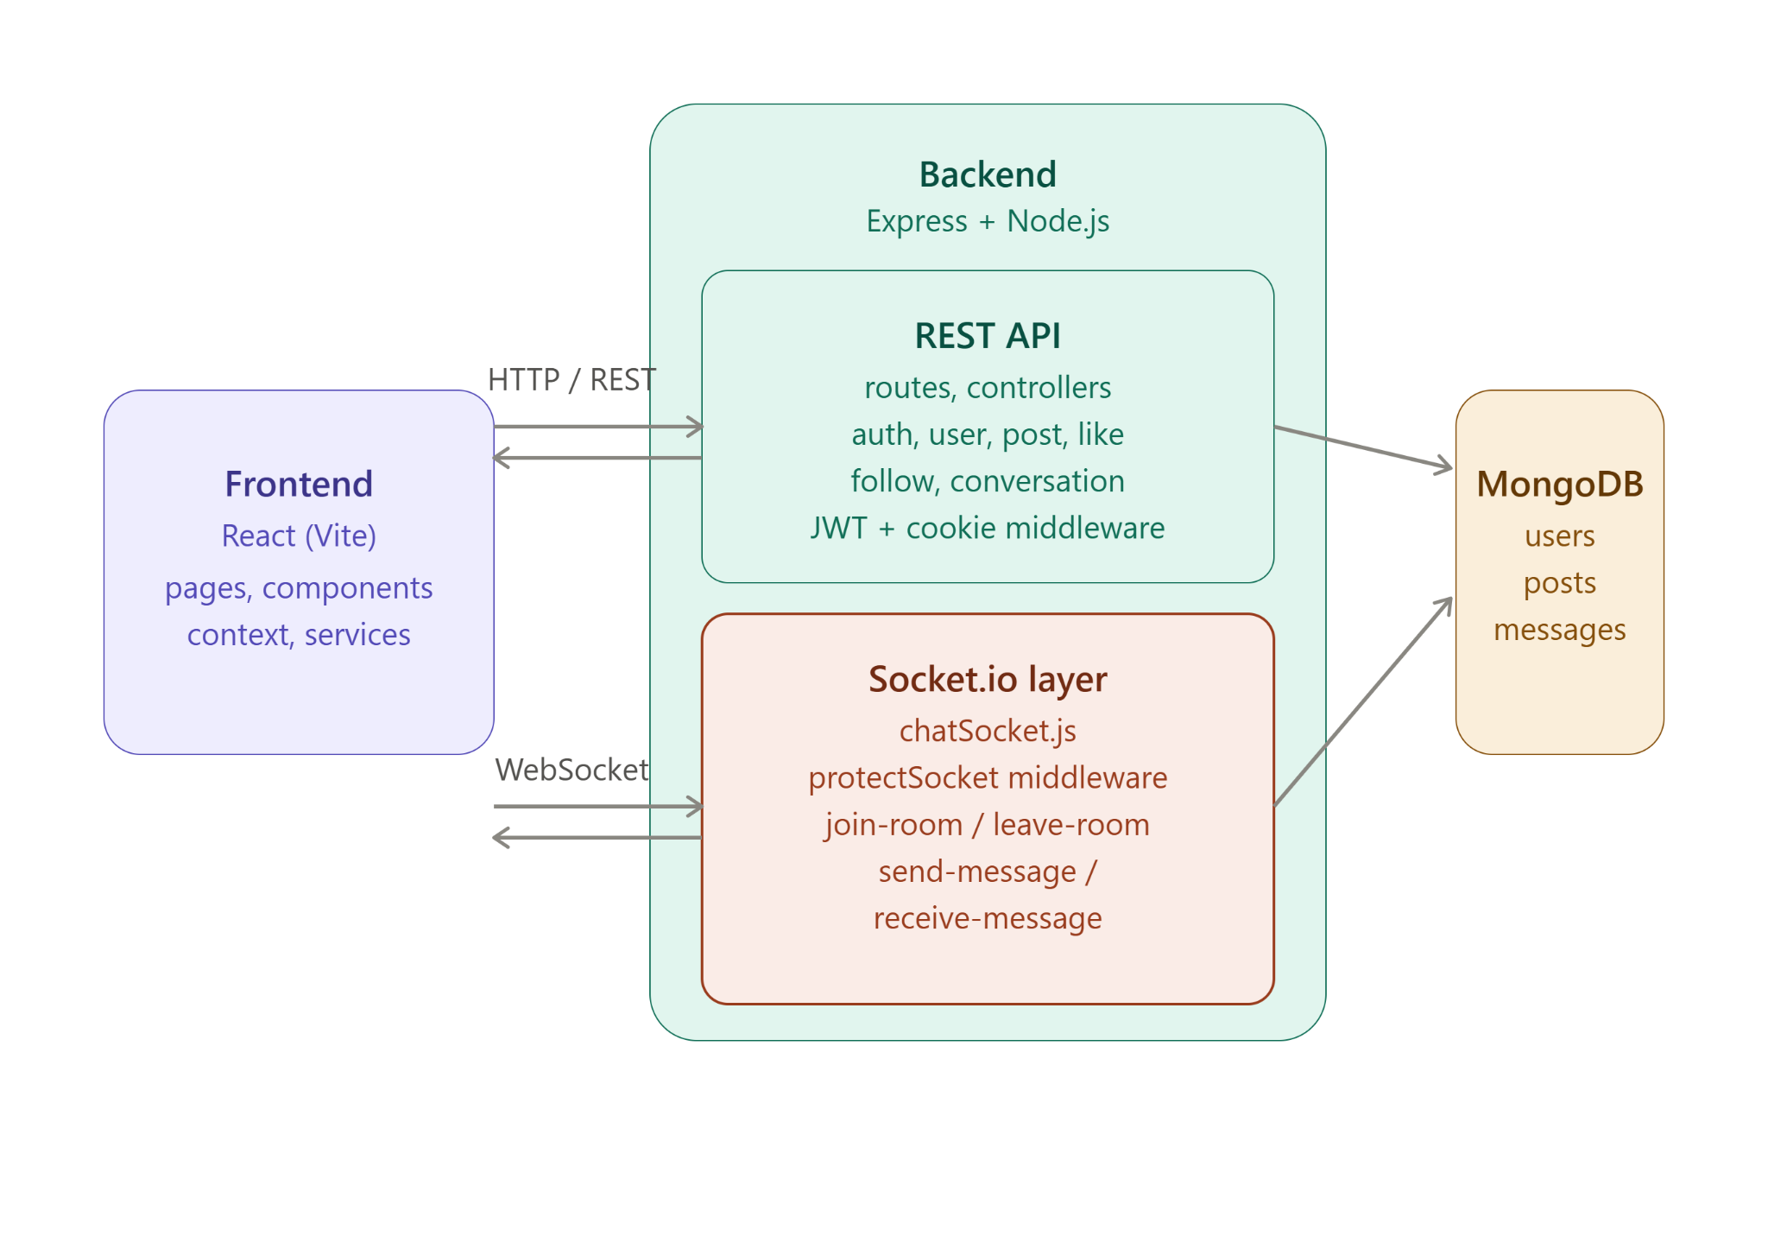

Frontend Layer
The frontend is developed using React and is organized into several modules:
- Components — reusable UI components.
- Pages — application-level screens.
- Context — shared application state and context management.
- Services — communication with backend APIs and related client-side services.
- Styles — styling and presentation.
- Assets — static frontend resources.
The frontend communicates with the backend using REST APIs for standard operations and Socket.IO for real-time communication.

Backend Layer
The backend is developed using Node.js and Express.js. The backend contains the following major modules:
- Routes — define API endpoints and connect requests to controllers.
- Controllers — handle application-specific request processing.
- Middleware — perform cross-cutting operations such as authentication and request processing.
- Services — contain reusable application logic where required.
- Models — define the structure and database interaction for MongoDB documents.
- Configs — contain application configuration and database connection logic.
- Sockets — contain Socket.IO-based real-time communication logic.

Database Layer
MongoDB serves as the persistent data storage layer. The backend interacts with MongoDB through the application's model layer.
The database stores application information such as users, posts, likes, follows, conversations, and messages.

Real-Time Communication Layer
Socket.IO is integrated with the Node.js HTTP server to provide real-time communication.
The socket layer contains:
- Socket authentication
- Connection handling
- Conversation room management
- Message sending
- Message broadcasting
- Room leaving
- Disconnection handling
This allows messages to be delivered to users without requiring repeated HTTP requests.

6.2 Request Flow
The application has two primary request flows: HTTP/REST API requests and real-time Socket.IO communication.
The documentation does not need to describe every API endpoint individually in this section. Instead, representative request flows are used to explain how requests move through the architecture. Individual endpoints are documented separately in the API Documentation section.

6.2.1 REST API Request Flow
A typical REST API request follows this flow:
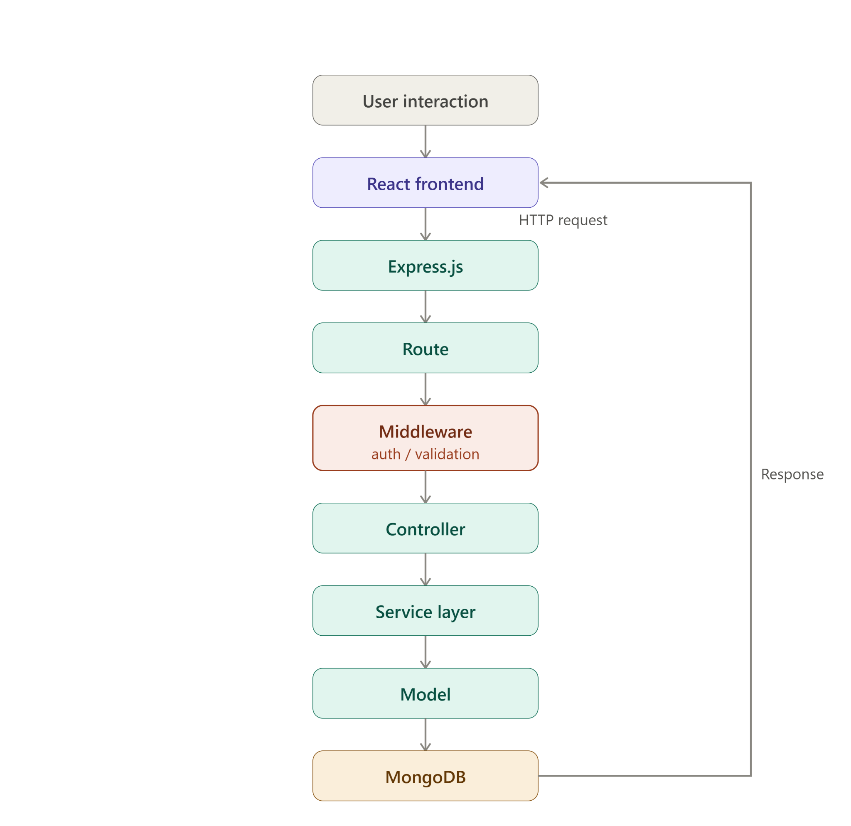
The authentication middleware verifies the user's authentication information before the protected operation is processed. The controller then handles the request and uses the appropriate application logic and model to interact with MongoDB.

6.2.2 Authentication Request Flow
Authentication follows a similar HTTP request flow:
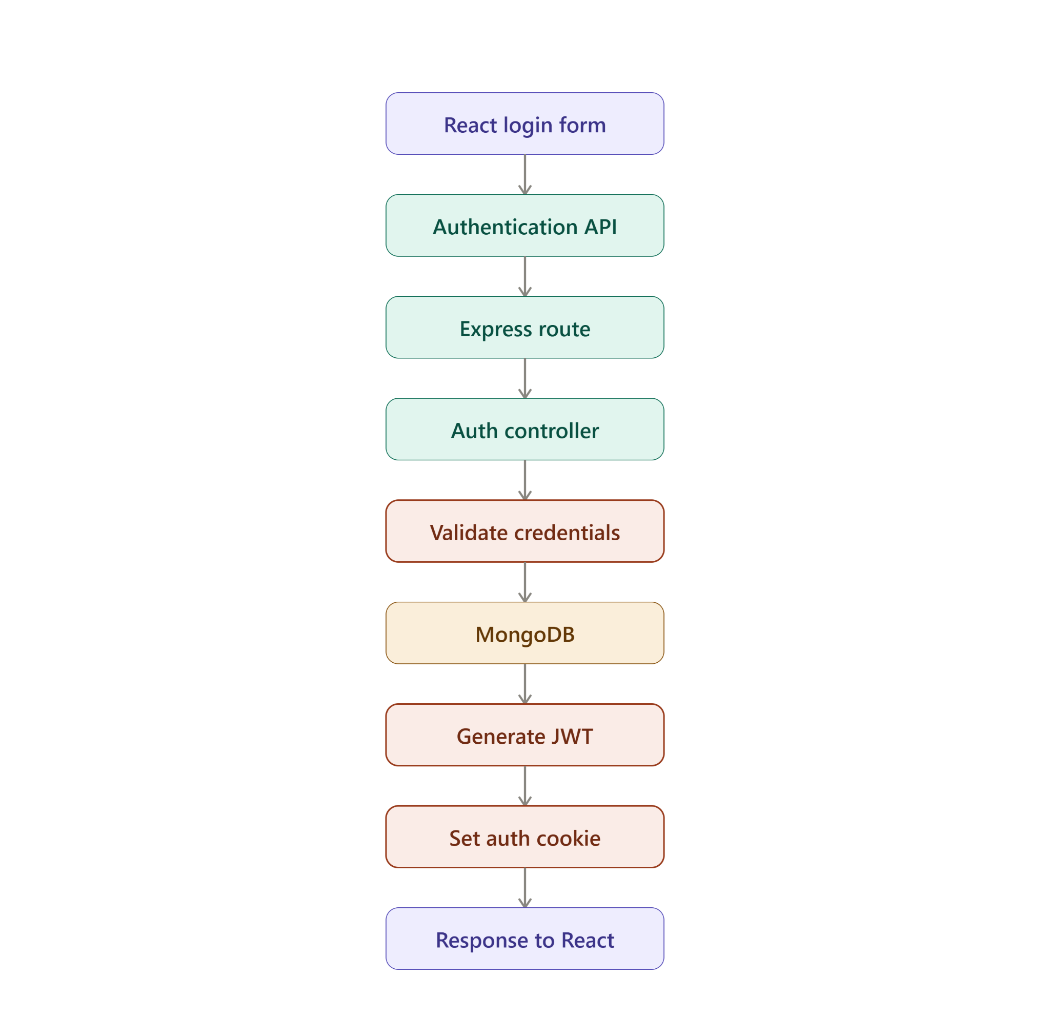

For subsequent protected requests, the authentication information stored in the cookie is sent with the request and verified by the backend authentication middleware.

6.2.3 Socket.IO Connection Flow

Real-time communication follows a different flow from REST APIs.
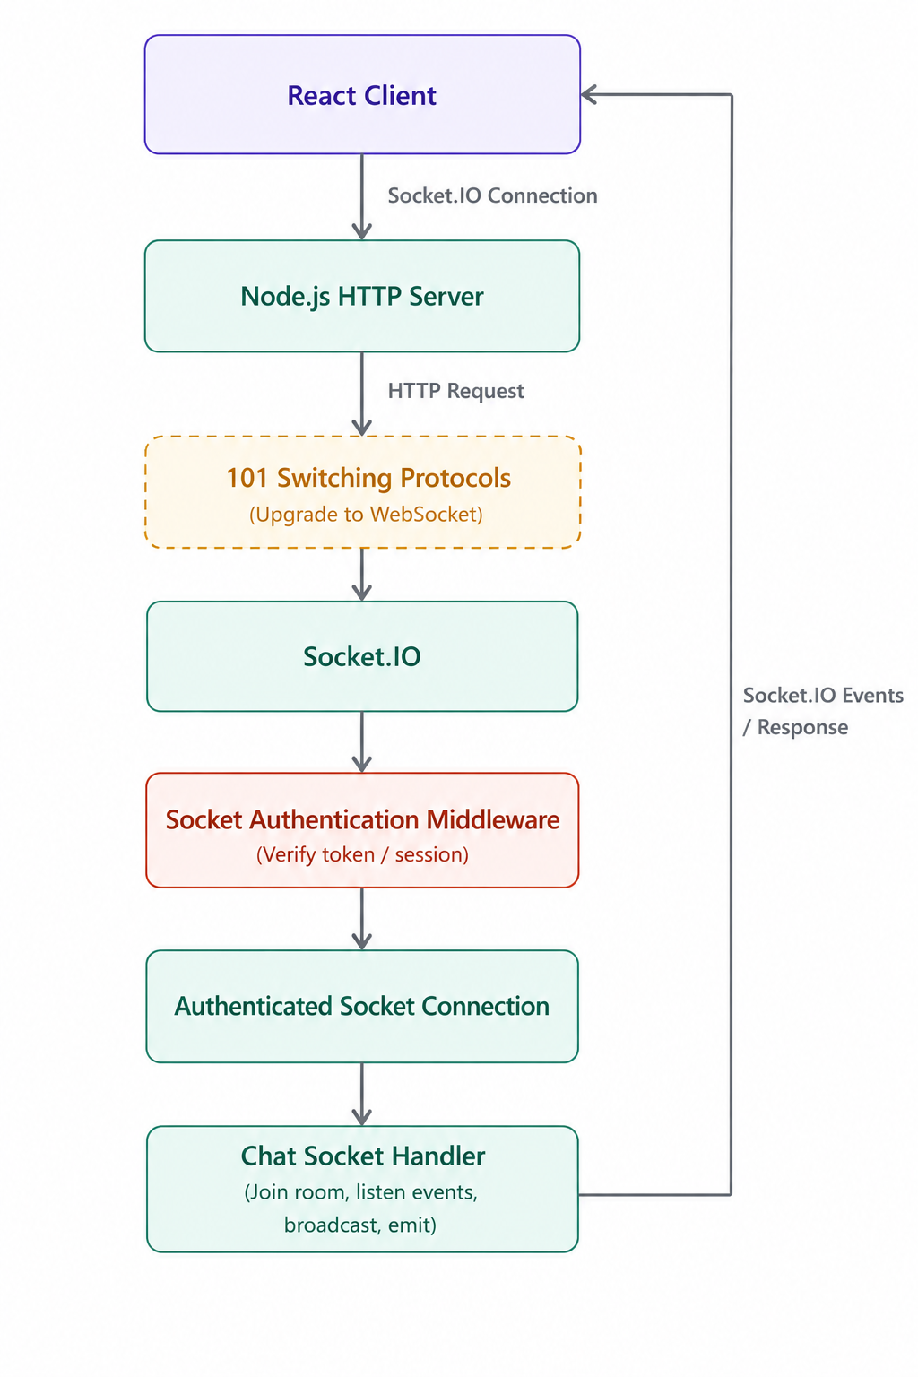

In the server implementation, Socket.IO is attached to the Node.js HTTP server. The socket authentication middleware executes before a client is allowed to establish an authenticated socket connection.

6.2.4 Joining a Conversation Room
When a user joins a conversation:
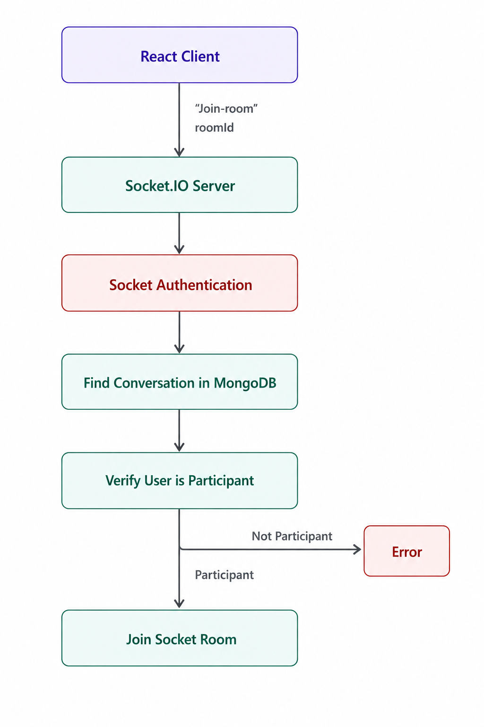
The server does not simply allow a user to join any room. It first searches for the conversation using the supplied room ID and verifies that the authenticated user is one of the conversation participants.
This provides an additional authorization check for real-time communication.

6.2.5 Sending a Real-Time Message
The message flow is:
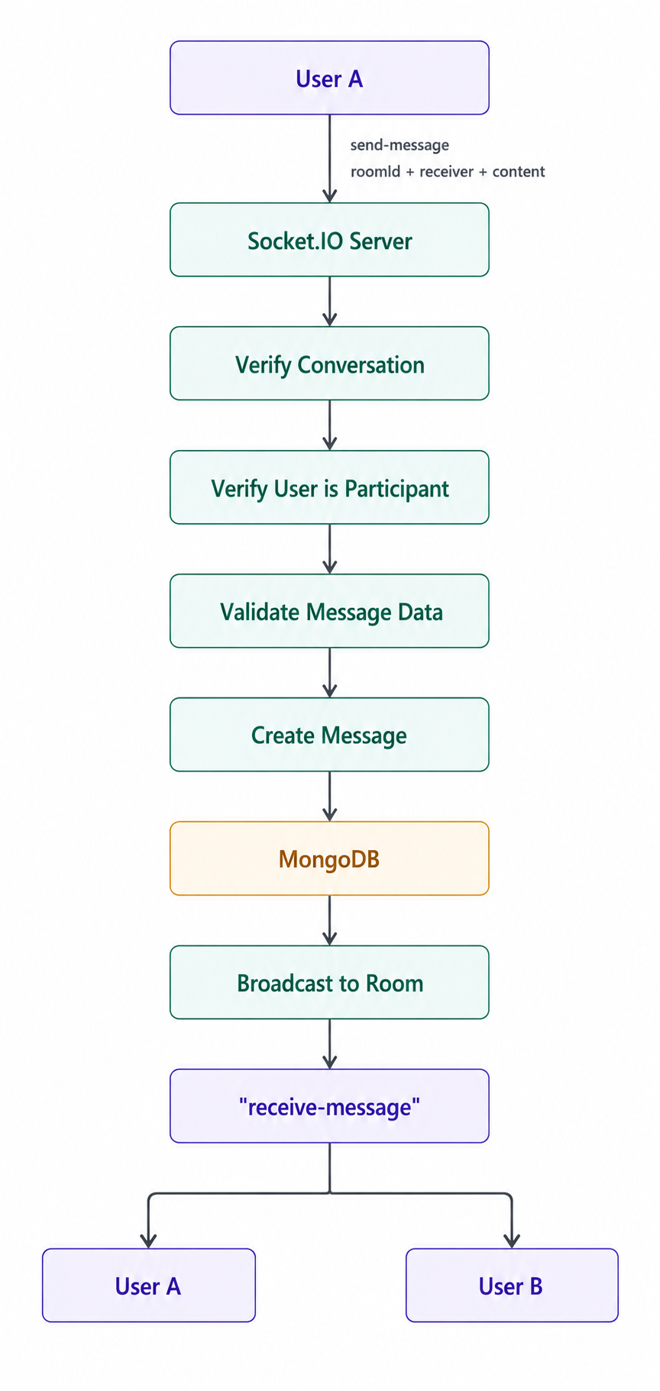

The message is first validated and stored in MongoDB. After successful persistence, the server broadcasts the message to the corresponding conversation room using Socket.IO.
This approach ensures that the message is stored before it is broadcast to connected clients.

6.2.6 Socket Disconnection Flow
When a client disconnects from the Socket.IO server:
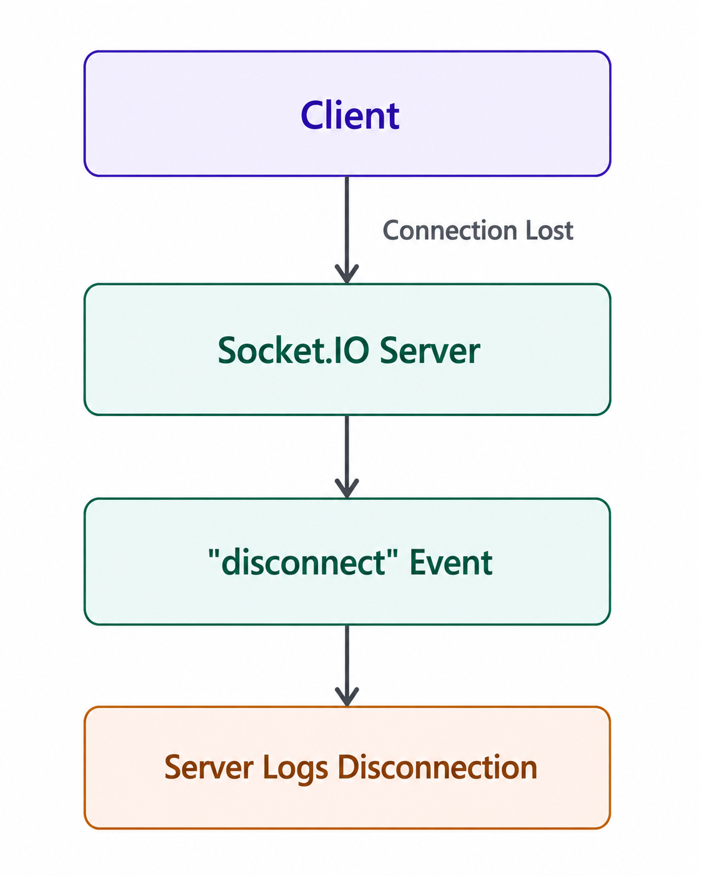

The current implementation handles the disconnect event and records the disconnected socket.

6.3 Component Architecture
The application is organized into separate frontend and backend components.

6.3.1 Backend Component Architecture
The backend follows a modular layered structure:
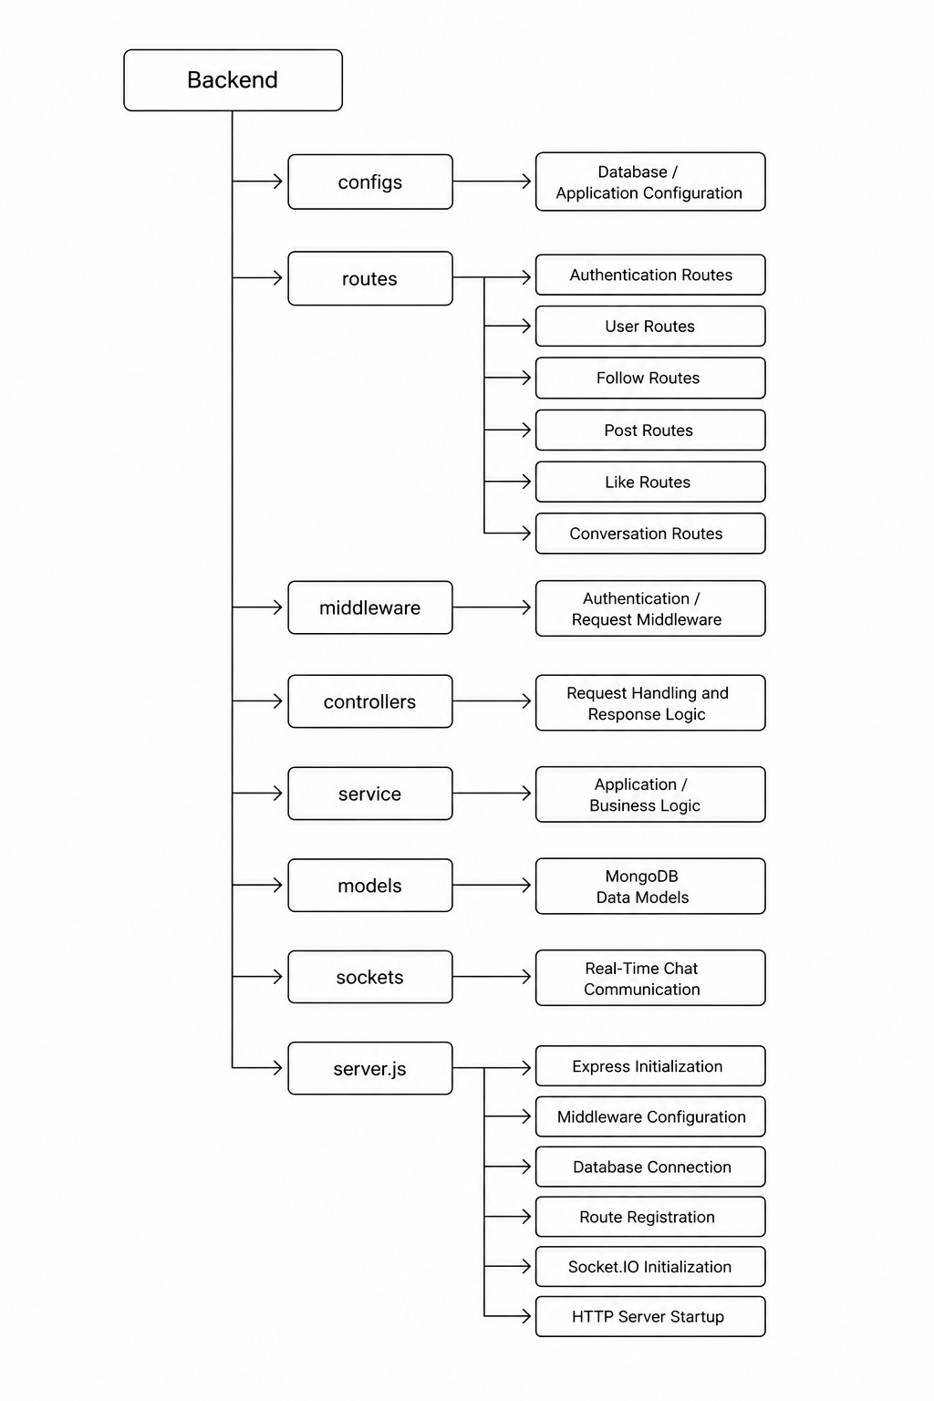
The server.js file acts as the main entry point of the backend. It initializes Express, creates the HTTP server, configures CORS and cookie handling, connects to MongoDB, registers REST API routes, and initializes Socket.IO.
The main REST API modules are registered under the following route prefixes:
/api/auth
/api/user
/api/follow
/api/post
/api/like
/api/conversation

6.3.2 Frontend Component Architecture
The React frontend is organized into the following major components:
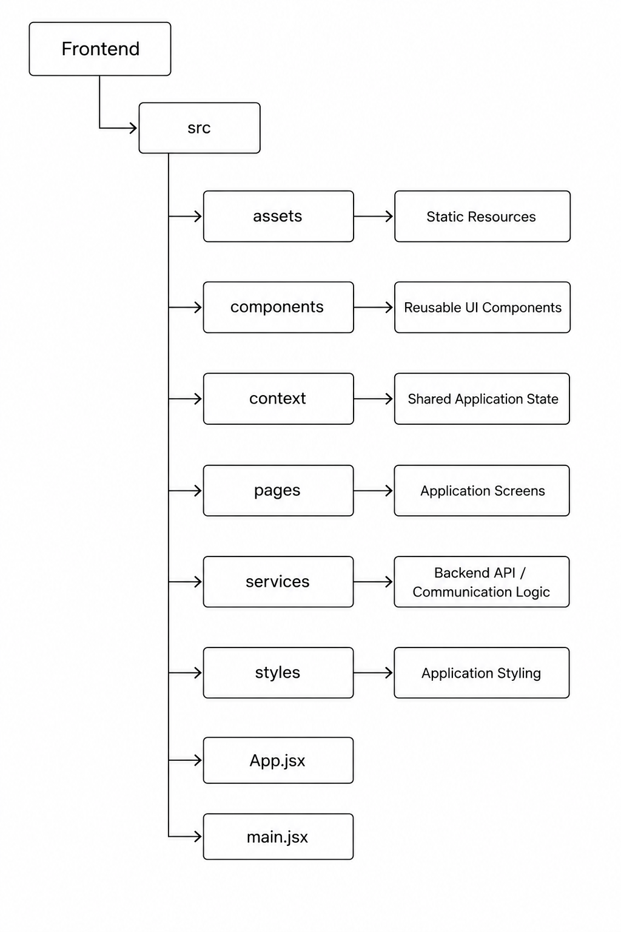

The main.jsx file serves as the frontend entry point, while App.jsx represents the main application component. The frontend services communicate with the backend APIs, while the Socket.IO client is used for real-time communication.

6.3.3 Real-Time Chat Component Architecture
The real-time communication subsystem is separated from the conventional REST API system.
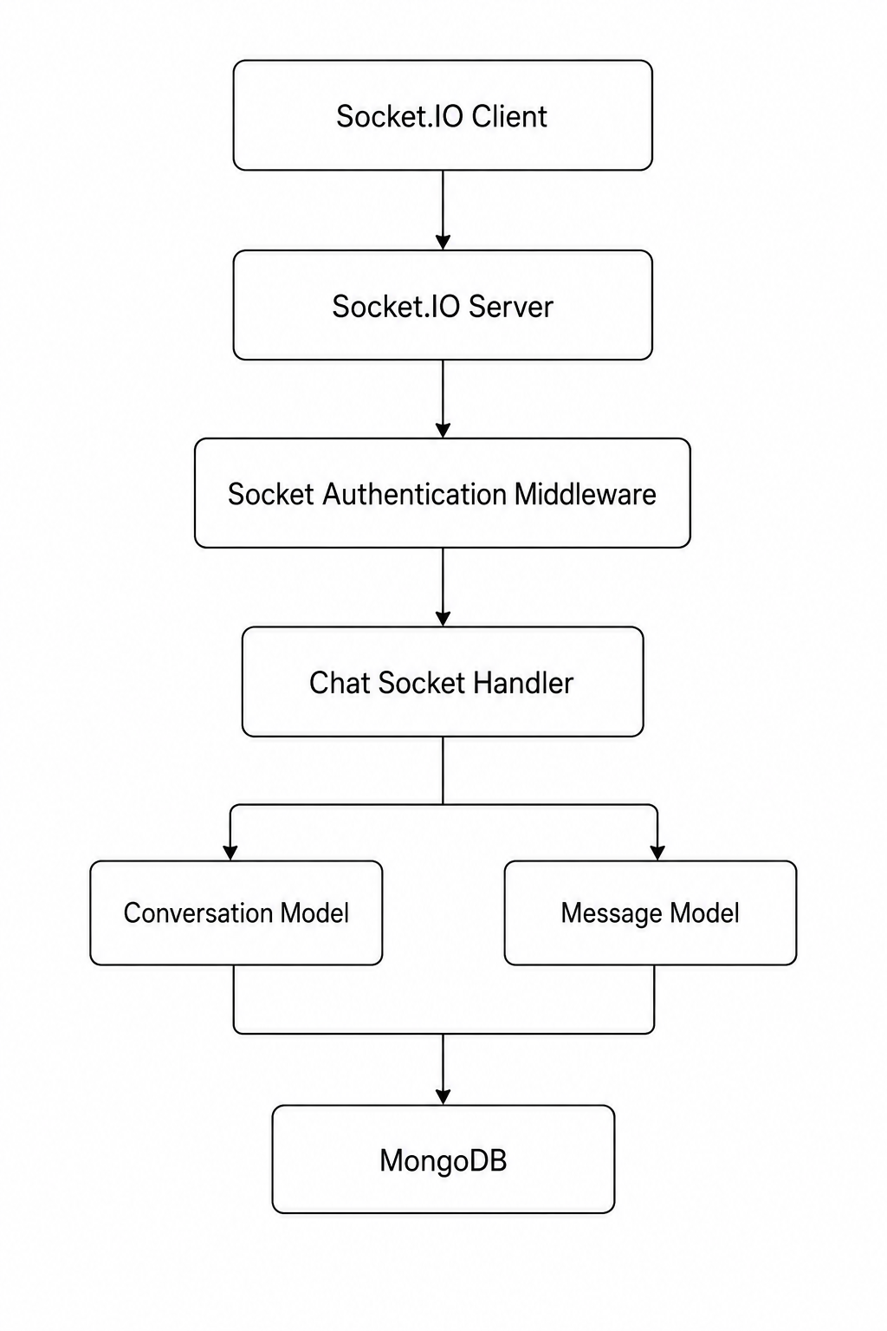
The chat socket handler manages socket connections, conversation room membership, message sending, message broadcasting, room leaving, and disconnection events.
Before joining a conversation room or sending a message, the server verifies that the authenticated user is a participant in the requested conversation. This prevents an authenticated user from accessing a conversation simply by knowing its room ID.

6.3.4 Overall Component Relationship
The overall relationship between the major components can be summarized as:
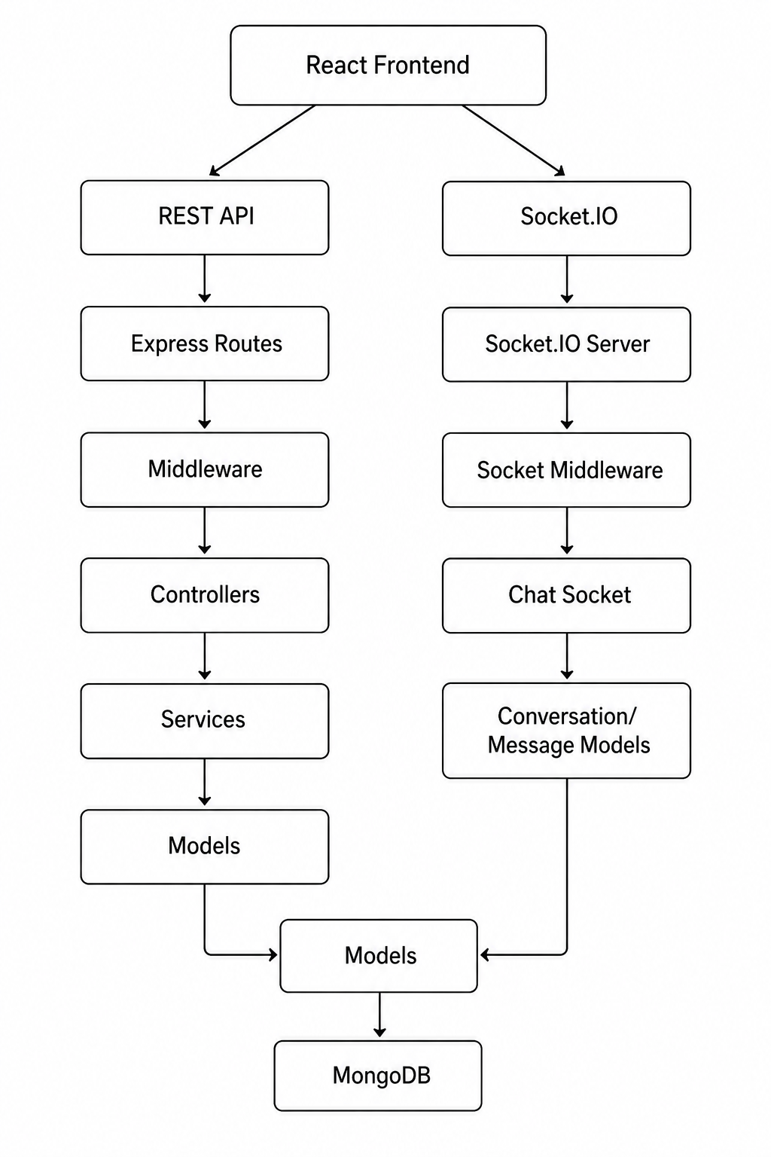
This architecture separates the responsibilities of the frontend, REST API layer, authentication middleware, application logic, database models, and real-time communication layer. Such separation improves maintainability and allows the REST and real-time communication mechanisms to operate alongside each other within the same application.

7. Features
The Social Media Application provides a set of core social networking features that allow authenticated users to create and interact with content, connect with other users, and communicate in real time. The major features of the application are described below.

7.1 User Authentication
The application provides secure user authentication using JSON Web Tokens (JWT) and cookies.
The authentication system allows users to:
- Register a new account.
- Log in using their credentials.
- Maintain an authenticated session using cookies.
- Access protected resources only after successful authentication.
- Log out from the application.
JWT-based authentication is used to verify the identity of users when accessing protected backend resources.

7.2 User Management
Authenticated users can interact with user profiles and manage their social connections.
The user management functionality includes:
- Viewing user information.
- Accessing user profiles.
- Managing relationships with other users.
- Following other users.
- Unfollowing users.
User-related operations are handled through dedicated REST API endpoints.

7.3 Post Management
The application provides basic CRUD functionality for user posts.
Authenticated users can:
- Create posts.
- View posts.
- Update their posts where permitted.
- Delete their posts where permitted.
Post-related operations are handled through RESTful APIs and stored in MongoDB.
The system also applies authentication and authorization checks to ensure that users can perform protected operations only on resources for which they have the required permissions.

7.4 Post Likes
Users can interact with posts by liking them.
The like functionality allows users to:
- Like a post.
- Manage their interaction with a post.
Like operations are connected to the corresponding user and post data stored in MongoDB.

7.5 Follow and Unfollow
The application provides a social relationship system through which users can follow other users.
Users can:
- Follow another user.
- Unfollow a user.
- Establish social connections with other users.
- Manage their existing follow relationships.
These relationships are maintained in the database and are associated with the corresponding users.

7.6 Real-Time Messaging
The application supports real-time communication using Socket.IO.
Unlike conventional REST API requests, real-time messaging maintains a persistent connection between the client and server, allowing messages to be delivered immediately to connected users.
The messaging system provides functionality for:
- Establishing an authenticated Socket.IO connection.
- Joining conversation rooms.
- Leaving conversation rooms.
- Sending messages.
- Receiving messages in real time.
- Broadcasting messages to users in a conversation.
- Handling socket disconnections.
Messages are persisted in MongoDB so that the communication data can be maintained beyond the lifetime of a socket connection.

7.7 Conversation Management
The application provides conversation-based communication for users.
A conversation represents a communication context between participating users. Before a user can join a conversation room or send a message, the backend verifies that the authenticated user is a participant of that conversation.
This provides an additional authorization layer for real-time communication and prevents unauthorized users from accessing conversation rooms.

7.8 Secure Real-Time Communication
Security is applied to the real-time communication layer in addition to the REST API layer.
Before establishing a Socket.IO connection, socket authentication middleware verifies the connecting user. Conversation-level authorization is also performed when users attempt to join rooms or send messages.
This prevents a user from accessing a conversation merely by knowing its room identifier.

7.9 RESTful API Communication
The application uses RESTful APIs for standard client-server operations.
The backend provides separate API route modules for major application functionality, including:
- Authentication
- Users
- Follow relationships
- Posts
- Likes
- Conversations
This modular API structure allows different application features to be managed independently.

7.10 Database Persistence
MongoDB is used to persist application data.
The database stores information related to:
- Users
- Posts
- Likes
- Follow relationships
- Conversations
- Messages
The backend interacts with MongoDB through the application's model layer, allowing data to be created, retrieved, updated, and deleted according to application requirements.

7.11 Summary of Features
Feature | Description
Authentication | Secure JWT-based authentication using cookies
User Management | User profiles and user-related operations
Posts | Create, view, update, and delete posts
Likes | Like and manage interactions with posts
Follow System | Follow and unfollow other users
Conversations | Manage conversation-based communication
Real-Time Messaging | Exchange messages using Socket.IO
Room Management | Join and leave authorized conversation rooms
Authorization | Protect user resources and conversations
REST APIs | HTTP-based communication for application operations
MongoDB | Persistent storage for application data

8. Database Design
The Social Media Application uses MongoDB as its primary database. MongoDB is a document-oriented NoSQL database in which application data is stored as documents within collections.
The application uses Mongoose to define schemas and interact with MongoDB. The database design consists of collections representing users, posts, comments, conversations, and messages. Relationships between documents are represented using referenced identifiers.
Unlike a traditional relational database, the application does not use tables and foreign keys. Instead, MongoDB documents use identifiers and Mongoose references to associate related data.

8.1 Database Relationship Diagram
Based on the implemented Mongoose models, the major relationships between the application's data entities can be represented as follows:
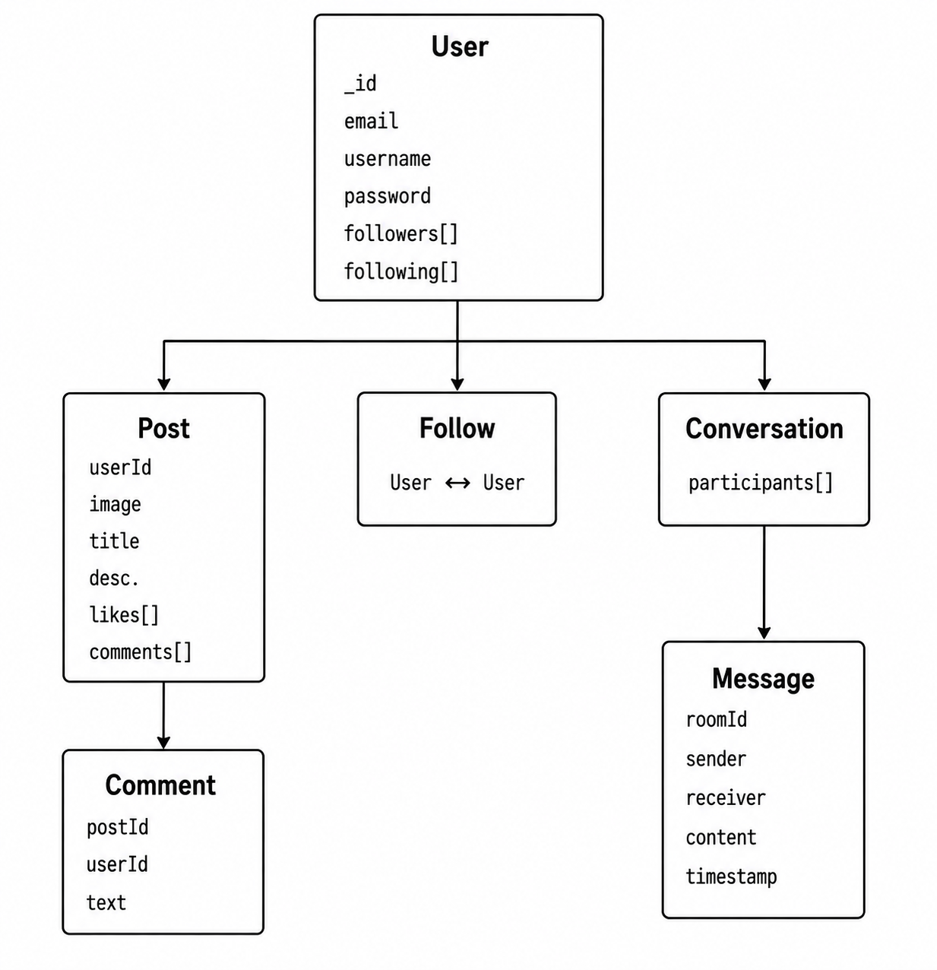

Main Data Relationships
The implemented models establish the following major relationships:
- A User can create multiple Posts.
- A Post contains a reference to its creating user.
- A User can have multiple followers and following users.
- A Post contains references to users who have liked it.
- A Post can contain references to multiple comments.
- A Comment references both its associated post and the user who created it.
- A Conversation contains multiple participating users.
- A Message belongs to a conversation through roomId.
- A Message references a sender and receiver.
The exact references are implemented using Mongoose schema references in the application models.

8.2 Database Models

8.2.1 User Model
The User model represents registered users of the application.
The schema contains account information, profile information, and social relationship data. The followers and following fields contain references to other User documents.
Field | Type | Required | Description
_id | String | Yes | Unique user identifier
email | String | Yes | User email address; must be unique
full_name | String | No | User's full name
username | String | Yes | Unique username
password | String | Yes | User password
bio | String | No | User biography
profile_picture | String | No | Profile picture reference
cover_picture | String | No | Cover picture reference
location | String | No | User location
followers | Array of String | No | References to users following this user
following | Array of String | No | References to users followed by this user
createdAt | Date | Auto | Document creation timestamp
updatedAt | Date | Auto | Document update timestamp
The schema also enables Mongoose timestamps, resulting in automatic createdAt and updatedAt fields.

8.2.2 Post Model
The Post model represents content created by users.
A post contains an author reference, optional image and text content, and arrays containing references to users who liked the post and comments associated with it.
Field | Type | Required | Description
_id | String | Yes | Unique post identifier
userId | String | Yes | Reference to the user who created the post
image | String | No | Image associated with the post
title | String | No | Post title
description | String | No | Post description/content
likes | Array of String | No | References to users who liked the post
comments | Array of String | No | References to comments associated with the post
createdAt | Date | Auto | Document creation timestamp
updatedAt | Date | Auto | Document update timestamp
The userId field references the User model, while the likes and comments arrays reference User and Comment documents respectively.

8.2.3 Comment Model
The Comment model represents comments made by users on posts.
Each comment contains its own identifier, text content, a reference to the associated post, and a reference to the user who created it.
Field | Type | Required | Description
_id | String | Yes | Unique comment identifier
text | String | Yes* | Text content of the comment
postId | String | Yes | Reference to the associated post
userId | String | Yes | Reference to the user who created the comment
createdAt | Date | Auto | Document creation timestamp
updatedAt | Date | Auto | Document update timestamp
*The schema declares the text field with require: true rather than required: true; the documentation describes the intended field requirement without modifying the implementation.

8.2.4 Conversation Model
The Conversation model represents a chat conversation between users.
A conversation contains a participants array. Each participant is represented using a MongoDB ObjectId referencing the User model. Timestamps are automatically maintained by Mongoose.
Field | Type | Required | Description
_id | ObjectId | Auto | Unique conversation identifier
participants | Array of ObjectId | Yes | References to users participating in the conversation
createdAt | Date | Auto | Conversation creation timestamp
updatedAt | Date | Auto | Conversation update timestamp
The participants field establishes the relationship between a conversation and its users.

8.2.5 Message Model
The Message model stores individual messages exchanged within a conversation.
Each message references the conversation through roomId and contains references to both the sender and receiver. The actual message content and timestamp are also stored.
Field | Type | Required | Description
_id | ObjectId | Auto | Unique message identifier
roomId | ObjectId | Yes | Reference to the associated Conversation
sender | ObjectId | Yes | Reference to the user sending the message
receiver | ObjectId | Yes | Reference to the user receiving the message
content | String | Yes | Message content
timestamp | Date | Auto | Time at which the message was created
The roomId references the Conversation model, while sender and receiver reference User documents.

8.3 Relationships Between Collections

8.3.1 User and Post
A user can create multiple posts. Each post stores the identifier of the user who created it through the userId field.
User
│
│ userId
▼
Post

The Post model defines userId as a reference to the User model.

8.3.2 User and Follow Relationships
The User model maintains two arrays:
- followers — users who follow the current user.
- following — users followed by the current user.
follows
User A ──────────────────► User B

User B.followers → User A
User A.following → User B

Both fields are arrays containing references to User documents.

8.3.3 User and Post Likes
The Post model maintains a likes array containing references to users who have liked the post.
User
│
│ reference
▼
Post.likes[]

This allows the application to associate multiple users with the likes of a particular post.

8.3.4 User, Post, and Comment
A comment connects a user and a post.
User
│
│ userId
▼
Comment
│
│ postId
▼
Post

The Comment model stores both userId and postId, while the Post model maintains a comments reference array.

8.3.5 User and Conversation
A conversation contains an array of participating users.
User A ─────┐
│
┼──► Conversation
│
User B ─────┘

The participants field stores User references using MongoDB ObjectIds.

8.3.6 Conversation and Message
A message belongs to a conversation through its roomId field.
Conversation
│
│ roomId
▼
Message

The Message model defines roomId as an ObjectId reference to the Conversation model.

8.3.7 User and Message
Each message contains two User references:
User A ──► sender
│
▼
Message
▲
│
User B ──► receiver

The sender and receiver fields reference User documents, allowing the application to identify the participants involved in each message.

Database Design Summary

The database design combines document-oriented MongoDB storage with referenced relationships managed through Mongoose. User-generated content such as posts and comments is associated with users through references, while the messaging system uses conversations and messages to represent real-time communication data.
The design therefore supports both the social networking functionality of the application and its real-time messaging subsystem while maintaining the data in separate, logically organized collections.

9. Authentication & Authorization
The Social Media Application implements authentication and authorization to protect user accounts, REST API resources, and real-time communication. The application uses JSON Web Tokens (JWT) together with cookies for user authentication.
Authentication is implemented for both the HTTP-based REST API layer and the Socket.IO real-time communication layer. In addition to verifying the user's identity, the application performs authorization checks before allowing access to protected resources such as conversation rooms.

9.1 User Authentication
Authentication is used to verify the identity of a user before providing access to protected functionality.
The general authentication process is as follows:
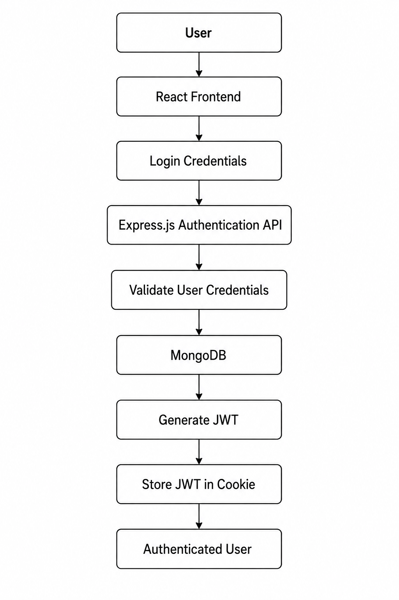
After successful authentication, the application uses the JWT to identify the authenticated user when accessing protected resources.

9.2 JWT-Based Authentication
JSON Web Token (JWT) is used as the authentication mechanism.
The JWT represents the authenticated user's identity and is used by the backend when processing protected requests.
The general flow is:
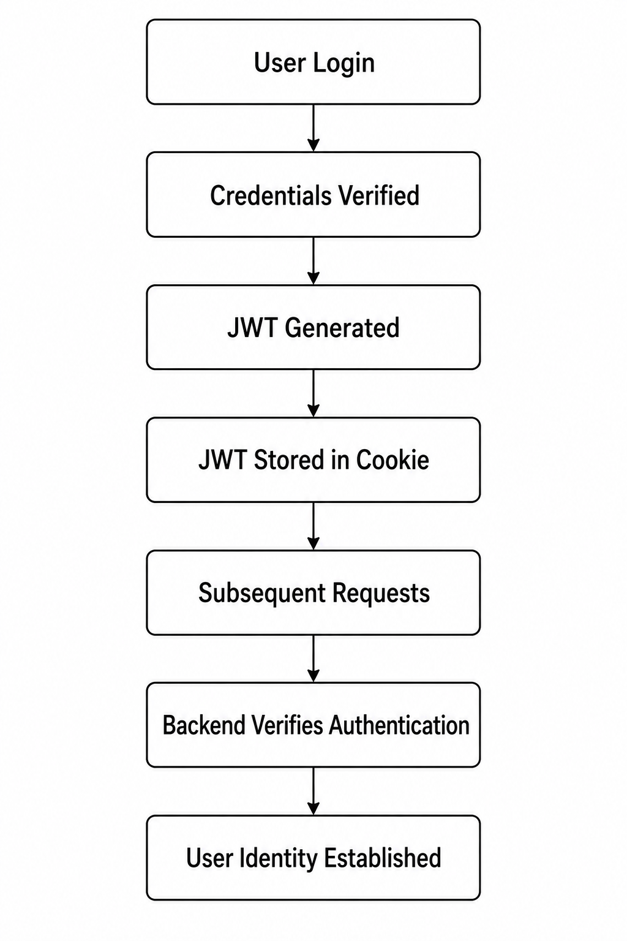
This authentication mechanism allows the backend to distinguish between authenticated and unauthenticated requests.

9.3 Cookie-Based Authentication
The application uses cookies to maintain authentication information between the client and server.
The Express server uses the cookie-parser middleware to process cookies received with requests.
App.use(cookieParser());
The application also enables credentials in its CORS configuration:
credentials: true
This allows authentication information stored in cookies to be included when the frontend communicates with the backend.

9.4 Authorization of REST API Requests
Authentication and authorization serve different purposes:
- Authentication determines who the user is.
- Authorization determines what the authenticated user is allowed to do.
After a user has been authenticated, protected operations can use the authenticated user's identity to determine whether the requested operation is permitted.
The REST API is organized into separate route modules:
/api/auth
/api/user
/api/follow
/api/post
/api/like
/api/conversation
A typical protected request follows this flow:
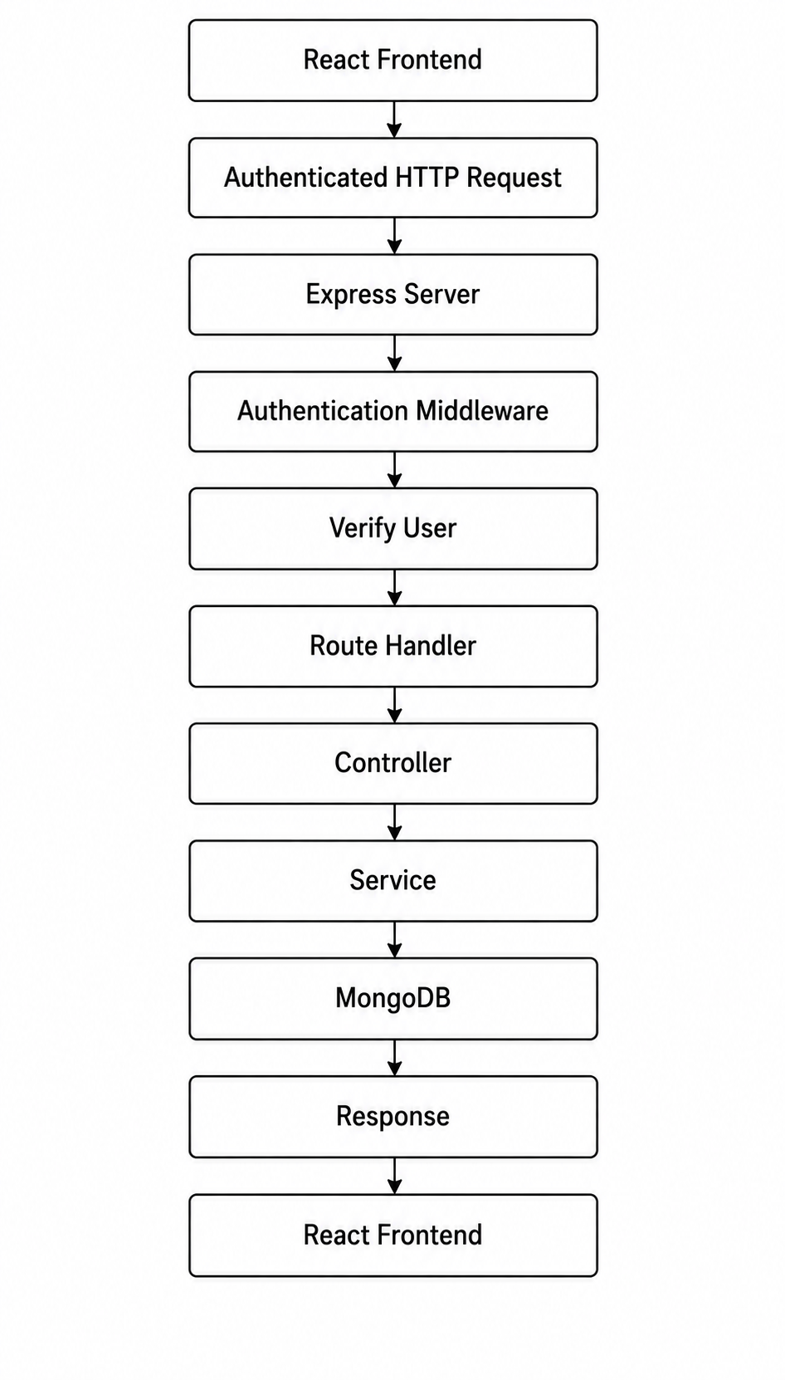
If authentication fails, the request is rejected and the protected operation is not executed.

9.5 Socket.IO Authentication
Authentication is also applied to the real-time communication layer.
The application initializes Socket.IO on the Node.js HTTP server and applies a dedicated socket authentication middleware:
io.use(protectSocket);
The socket authentication middleware is executed before the connection event handler processes the authenticated connection.
The flow can be represented as:
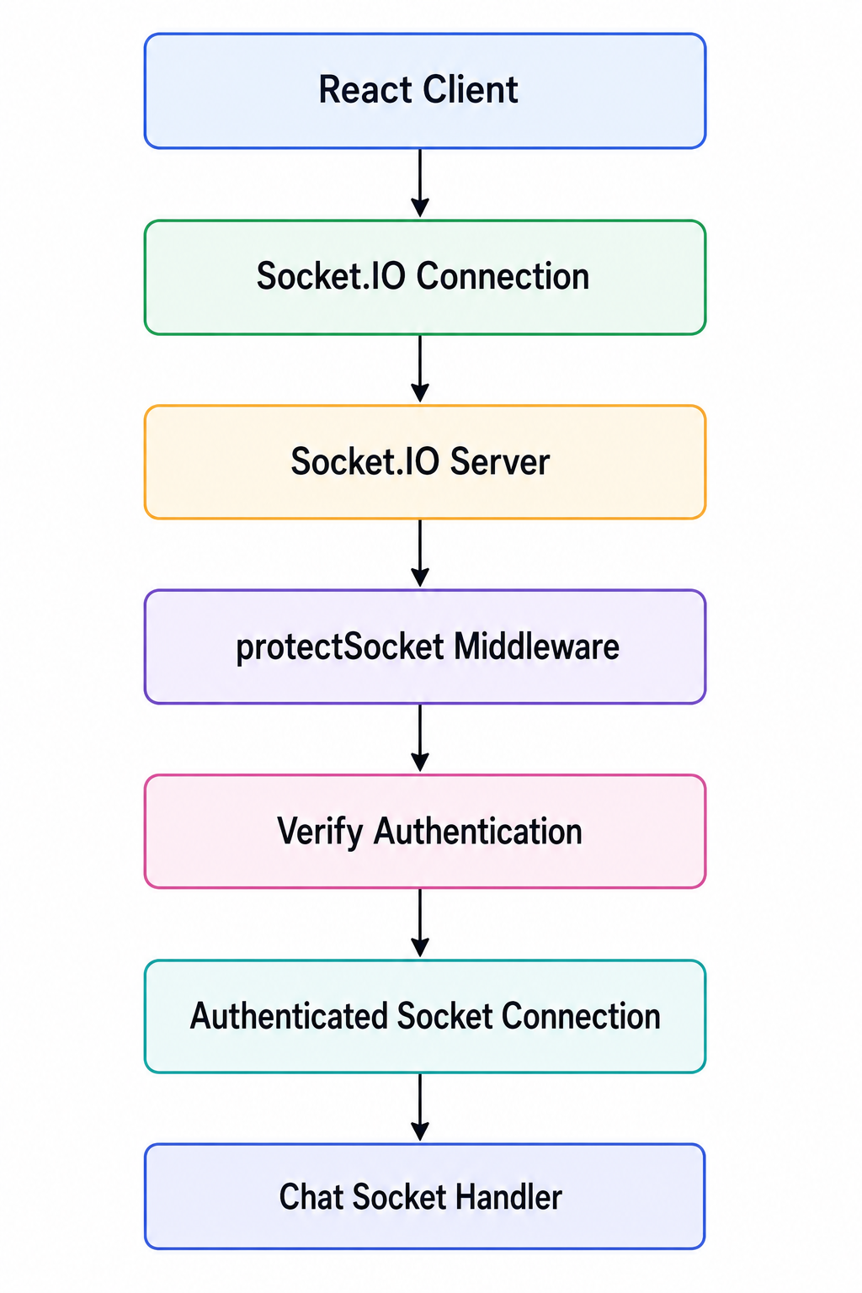
If authentication fails, the socket connection is not allowed to proceed.
Once authenticated, the socket connection has access to the authenticated user's identity.

9.6 Conversation-Level Authorization
The application performs an additional authorization check when a user attempts to access a conversation room.
When the client sends the Join-room event, the server searches for the requested conversation and verifies that the authenticated user is one of its participants.
The process is:
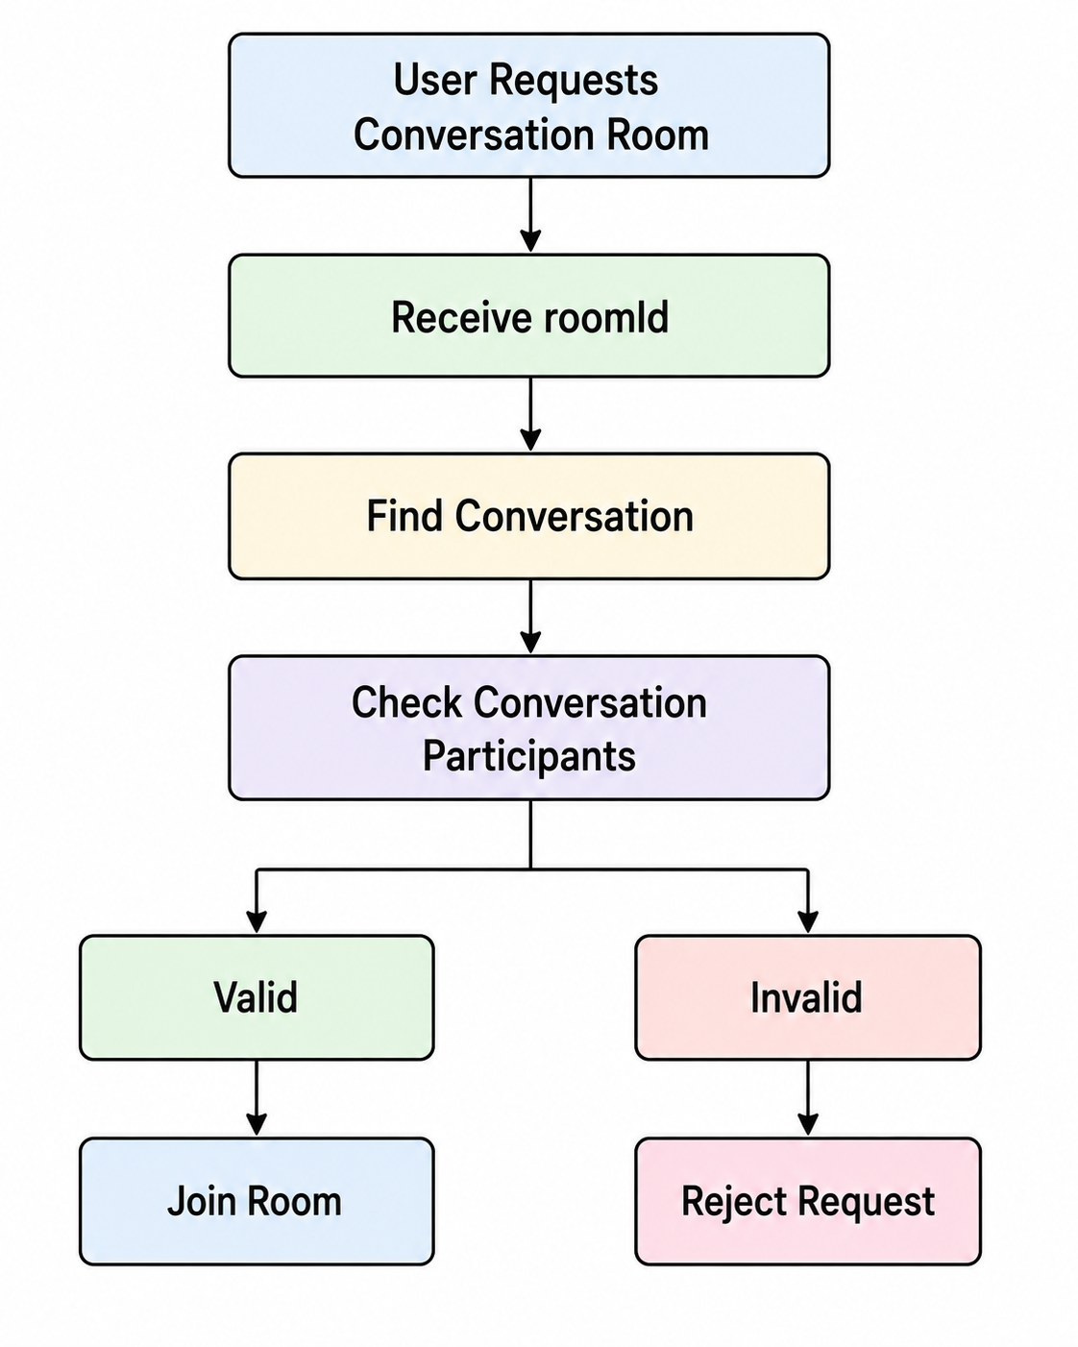
The server performs a database query to verify the user's participation:
Conversation.findOne({
_id: roomId,
participants: { $in: [socket.user.id || socket.user._id] }
});

If the authenticated user is not a participant, the server does not allow the socket to join the room and returns an authorization error.
This prevents a user from accessing a conversation simply by knowing its room ID.

9.7 Message Authorization
Authorization is also performed when sending a message.
Before processing a send-message event, the server checks whether the authenticated user is a participant in the requested conversation.
The process is:
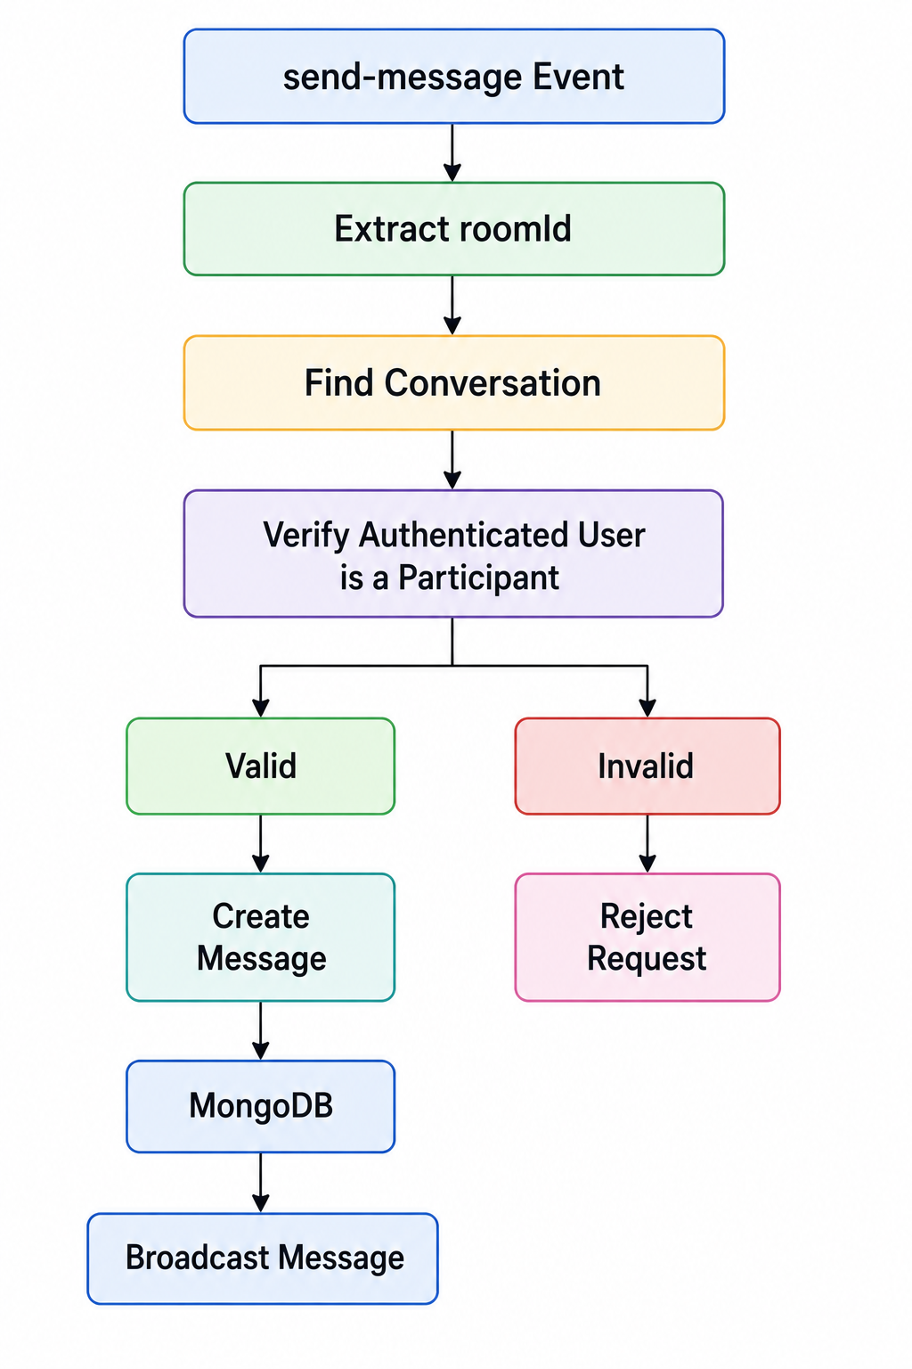
This prevents an authenticated user from sending messages to a conversation to which they do not belong.

9.8 Authentication and Authorization Summary
Security Layer | Mechanism | Purpose
User Authentication | JWT | Identify authenticated users
Session Transport | Cookies | Maintain authentication information
REST API Protection | Authentication Middleware | Protect API resources
Socket Authentication | protectSocket Middleware | Authenticate Socket.IO connections
Conversation Authorization | Participant Verification | Prevent unauthorized room access
Message Authorization | Participant Verification | Prevent unauthorized message sending
Overall, the application uses multiple layers of authentication and authorization. JWT and cookies are used for user authentication, while Socket.IO has a dedicated authentication middleware for real-time connections. For chat functionality, authentication is supplemented with conversation-level authorization by verifying that the authenticated user is a participant in the requested conversation.

10. API Documentation
The Social Media Application provides RESTful APIs for authentication, user management, posts, likes, follows, and conversation management. The APIs are implemented using Express.js and are protected using authentication middleware where required.
The backend organizes APIs into separate route modules according to their functionality.

10.1 API Base URL
During local development, the backend server runs on:
http://localhost:5000
The API routes are organized using the following base paths:
/api/auth
/api/user
/api/follow
/api/post
/api/like
/api/conversation

10.2 Authentication APIs
Authentication APIs are used to register users, authenticate users, log out users, and retrieve the currently authenticated user's information.

10.2.1 Register User
Endpoint:
POST /api/auth/register
Authentication: Not required
Description:
Creates a new user account.
Request Body:
{
"email": "user@example.com",
"username": "username",
"password": "password"
}
Response:
The server returns the result of the registration operation.

10.2.2 Login User
Endpoint:
POST /api/auth/login
Authentication: Not required
Description:
Authenticates an existing user and establishes the authenticated session.
Request Body:
{
"email": "user@example.com",
"password": "password"
}

10.2.3 Logout User
Endpoint:
POST /api/auth/logout
Authentication: Not required
Description:
Logs the user out of the application and clears the authentication state.

10.2.4 Get Current User
Endpoint:
GET /api/auth/me
Authentication: Required
Description:
Retrieves information about the currently authenticated user.

10.3 User APIs
The user API module provides functionality for retrieving profiles, getting recommended profiles, and updating user information. The recommend-profiles and update endpoints are protected by authentication middleware.

10.3.1 Get User Profile
Endpoint:
GET /api/user/profile/:id
Authentication: Not required
Description:
Retrieves the profile information of a user using the user's ID.
Path Parameter:
id
Example:
GET /api/user/profile/USER_ID

10.3.2 Get Recommended Profiles
Endpoint:
GET /api/user/recommend-profiles
Authentication: Required
Description:
Retrieves all the profiles to the authenticated user.

10.3.3 Update User Profile
Endpoint:
PATCH /api/user/update/:id
Authentication: Required
Description:
Updates the profile information associated with a user.
Path Parameter:
id

10.4 Post APIs
The post module provides APIs for creating, retrieving, updating, deleting, and recommending posts. All currently defined post endpoints use the authentication middleware.

10.4.1 Create Post
Endpoint:
POST /api/post/create
Authentication: Required
Description:
Creates a new post for the authenticated user.

10.4.2 Get All Posts
Endpoint:
GET /api/post/getAll
Authentication: Required
Description:
Retrieves posts available to the authenticated user.

10.4.3 Update Post
Endpoint:
PATCH /api/post/update/:postId
Authentication: Required
Description:
Updates an existing post.
Path Parameter:
postId

10.4.4 Delete Post
Endpoint:
DELETE /api/post/delete/:postId
Authentication: Required
Description:
Deletes an existing post.
Path Parameter:
postId

10.4.5 Get Posts by User
Endpoint:
GET /api/post/getPostsByUserId/:userId
Authentication: Required
Description:
Retrieves posts created by a specific user.
Path Parameter:
userId

10.4.6 Get Recommended Posts
Endpoint:
GET /api/post/recommend-posts
Authentication: Required
Description:
Retrieves recommended posts for the authenticated user.

10.5 Like APIs
The like API module provides operations for liking and unliking posts. Both endpoints require authentication.

10.5.1 Like Post
Endpoint:
POST /api/like/likeById
Authentication: Required
Description:
Adds a like to a post on behalf of the authenticated user.

10.5.2 Unlike Post
Endpoint:
POST /api/like/unlikeById
Authentication: Required
Description:
Removes the authenticated user's like from a post.

10.6 Follow APIs
The follow API module provides operations for following and unfollowing users. Both endpoints require authentication.

10.6.1 Follow User
Endpoint:
POST /api/follow/followById
Authentication: Required
Description:
Allows the authenticated user to follow another user.

10.6.2 Unfollow User
Endpoint:
POST /api/follow/unfollowById
Authentication: Required
Description:
Allows the authenticated user to stop following another user.

10.7 Conversation APIs
The conversation API module provides functionality for retrieving conversation room information, messages, and chat partners. All conversation endpoints require authentication.

10.7.1 Get Conversation Room ID
Endpoint:
GET /api/conversation/getRoomId/:id
Authentication: Required
Description:
Retrieves the conversation room associated with the specified user or conversation identifier.
Path Parameter:
id

10.7.2 Get Messages
Endpoint:
GET /api/conversation/getMessages/:roomId
Authentication: Required
Description:
Retrieves messages associated with a specific conversation room.
Path Parameter:
roomId

10.7.3 Get Chat Partners
Endpoint:
GET /api/conversation/getChatPartners
Authentication: Required
Description:
Retrieves the chat partners associated with the authenticated user.

10.8 API Summary
Module | Method | Endpoint | Authentication
Authentication | POST | /api/auth/register | No
Authentication | POST | /api/auth/login | No
Authentication | POST | /api/auth/logout | No
Authentication | GET | /api/auth/me | Yes
User | GET | /api/user/profile/:id | No
User | GET | /api/user/recommend-profiles | Yes
User | PATCH | /api/user/update/:id | Yes
Post | POST | /api/post/create | Yes
Post | GET | /api/post/getAll | Yes
Post | PATCH | /api/post/update/:postId | Yes
Post | DELETE | /api/post/delete/:postId | Yes
Post | GET | /api/post/getPostsByUserId/:userId | Yes
Post | GET | /api/post/recommend-posts | Yes
Like | POST | /api/like/likeById | Yes
Like | POST | /api/like/unlikeById | Yes
Follow | POST | /api/follow/followById | Yes
Follow | POST | /api/follow/unfollowById | Yes
Conversation | GET | /api/conversation/getRoomId/:id | Yes
Conversation | GET | /api/conversation/getMessages/:roomId | Yes
Conversation | GET | /api/conversation/getChatPartners | Yes
The API structure separates functionality into independent modules, making the backend easier to maintain and extend. Authentication middleware is applied to protected endpoints to ensure that only authenticated users can access restricted functionality.

11. Security
Security is an important part of the Social Media Application because the application handles user accounts, personal information, social interactions, and private conversations. The application implements authentication, authorization, protected API routes, cookie-based authentication, and conversation-level authorization for real-time communication.

11.1 Authentication Security
The application uses JSON Web Tokens (JWT) to authenticate users.
After successful login, the authenticated user's identity is maintained through the authentication mechanism. Protected API endpoints use authentication middleware to verify whether the request is associated with an authenticated user.
The authentication system is used to protect resources such as:
- User profile updates
- Post creation and modification
- Likes
- Follow operations
- Conversation data
- Other authenticated operations

11.2 Cookie-Based Authentication
Authentication information is handled using cookies.
The backend uses the cookie-parser middleware:
App.use(cookieParser());

The application also enables credentials in its CORS configuration:
credentials: true
This allows authentication cookies to be included when the frontend communicates with the backend.

11.3 Protected API Endpoints
Sensitive operations are protected using authentication middleware.
For example, the post routes use the protect middleware:
router.post('/create', protect, createPost);
router.patch('/update/:postId', protect, updatePost);
router.delete('/delete/:postId', protect, deletePost);

This ensures that authentication is checked before the requested operation is executed.
Similar protection is applied to user, follow, like, and conversation operations.

11.4 Authorization
Authentication verifies the identity of the user, while authorization determines whether the authenticated user is allowed to perform a particular operation.
The application applies authorization checks to protected resources.
For example, real-time conversation access is not granted simply because a user is authenticated. The server also checks whether the authenticated user is a participant of the requested conversation.

11.5 Socket.IO Security
The real-time communication layer is also protected.
The Socket.IO server uses a dedicated authentication middleware:
io.use(protectSocket);

This middleware runs before an authenticated socket connection is established.
This prevents unauthenticated clients from accessing the real-time chat functionality.

11.6 Conversation Room Authorization
The application performs an additional security check before allowing a user to join a conversation room.
When a user requests to join a room, the server checks the conversation and verifies that the authenticated user is included in the conversation's participants.
This prevents unauthorized users from accessing private conversations by simply obtaining or guessing a room ID.

11.7 Message Authorization
The same participant verification is performed when a user attempts to send a message.
This ensures that an authenticated user cannot send messages to a conversation in which they are not a participant.

11.8 CORS Configuration
Cross-Origin Resource Sharing (CORS) is configured on the backend to control communication between the frontend and backend.
The application specifies the frontend origin and enables credentials:
cors({
origin: 'http://localhost:5173',
methods: ['GET', 'POST', 'PUT', 'DELETE', 'PATCH'],
credentials: true
})
Socket.IO is also configured with CORS settings so that real-time communication follows the application's allowed frontend origin.

11.9 Input Validation
The application validates important request data before performing operations.
For example, the Socket.IO message handler checks whether required message fields are present:
if (!receiver || !content || !roomId || content.trim() === '') {
return;
}

This prevents incomplete message data from being stored in the database.

11.10 Database Security
MongoDB is accessed through the backend rather than directly from the frontend.
The application follows the architecture:
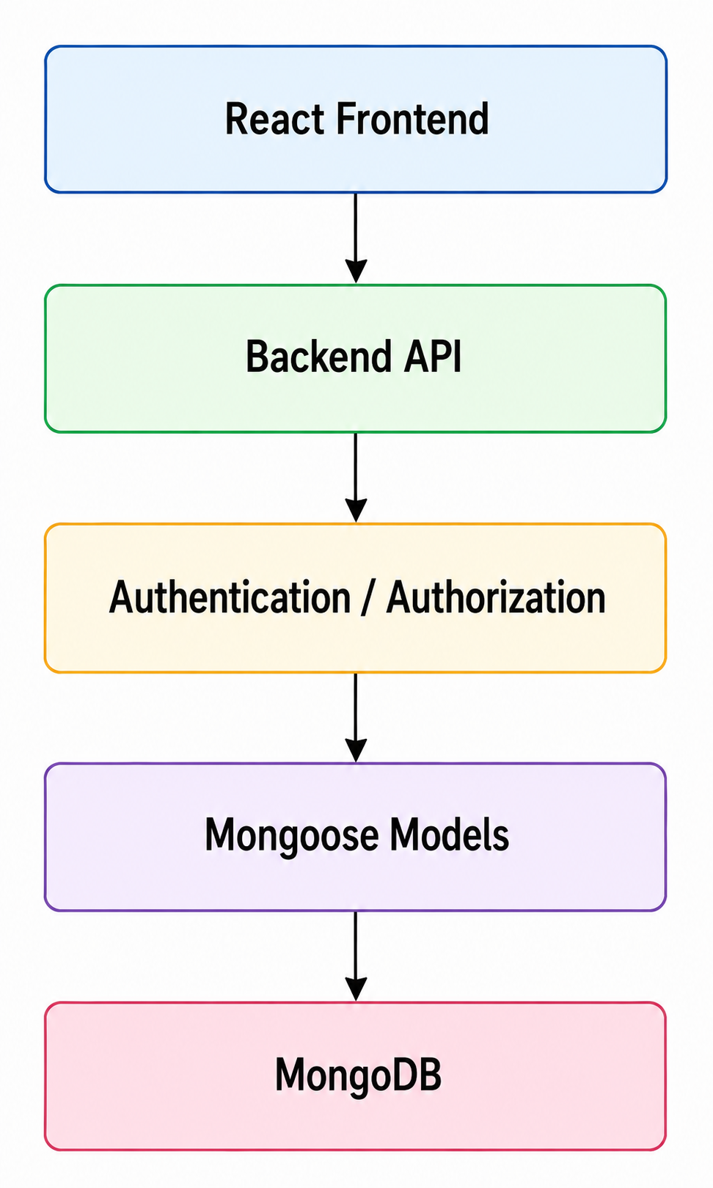
This prevents clients from directly accessing the database and allows the backend to control which operations can be performed.

11.11 Security Summary
The main security mechanisms implemented in the application are:
Security Mechanism | Purpose
JWT Authentication | Identifies authenticated users
Cookies | Maintains authentication information
Authentication Middleware | Protects REST API endpoints
Socket Authentication | Protects real-time connections
Conversation Authorization | Prevents unauthorized room access
Message Authorization | Prevents unauthorized message sending
CORS | Controls cross-origin communication
Input Validation | Prevents invalid request data
Backend Database Access | Prevents direct frontend database access
Overall, the application uses security controls at multiple layers, including HTTP authentication, API protection, Socket.IO authentication, conversation-level authorization, and database access through the backend. This layered approach helps protect both the social media functionality and the real-time messaging system.

12. Installation & Setup
This section describes the steps required to install, configure, and run the Social Media Application locally. The application consists of two main parts:
- Frontend — React application built using Vite.
- Backend — Node.js and Express.js application with MongoDB and Socket.IO.

12.1 Prerequisites
Before setting up the application, ensure that the following software is installed:
- Node.js
- npm
- MongoDB
- Git
The project uses Node.js and npm for dependency management and application execution.

12.2 Project Structure
The application is divided into separate frontend and backend directories:
Social Media Application/
│
├── frontend/
│ ├── package.json
│ ├── package-lock.json
│ └── ...
│
└── backend/
├── package.json
├── server.js
├── .env
└── ...

12.3 Frontend Setup
The frontend is developed using React and Vite.

Step 1: Navigate to the Frontend Directory
cd frontend

Step 2: Install Dependencies
Run the following command:
npm install
npm install react react-dom
npm install react-router-dom
npm install socket.io-client
npm install lucide-react

The major frontend dependencies include:
Package | Purpose
React | Building the user interface
React DOM | Rendering React components
React Router DOM | Client-side routing
Socket.IO Client | Real-time communication with the backend
Lucide React | Icons
Vite | Frontend development and build tool
The project also uses Vite-related development dependencies for React development and compilation.

Step 3: Start the Frontend Development Server
After installing the dependencies, start the frontend using:
npm run dev
The Vite development server will start the frontend application.

12.4 Backend Setup
The backend is developed using Node.js, Express.js, MongoDB, Mongoose, and Socket.IO.

Step 1: Navigate to the Backend Directory
From the project root:
cd backend

Step 2: Install Dependencies
Run:
npm install express
npm install mongoose
npm install socket.io
npm install jsonwebtoken
npm install bcrypt
npm install cookie-parser
npm install cors
npm install dotenv
npm install multer
npm install -D nodemon

This installs all dependencies specified in the backend package.json.
The major backend dependencies include:
Package | Purpose
Express | Backend web framework
Mongoose | MongoDB object modeling
Socket.IO | Real-time communication
JSON Web Token | User authentication
bcrypt | Password hashing
cookie-parser | Cookie handling
CORS | Cross-origin request handling
dotenv | Environment variable management
Multer | File upload handling
Nodemon | Automatic server restart during development

12.5 Environment Configuration
The backend requires environment variables for database connectivity and JWT authentication.
Create a .env file inside the backend directory:
backend/
├── .env
├── server.js
├── package.json
└── ...
The .env file should contain the following configuration:
MONGODB_USERNAME="your_username"
MONGODB_PASSWORD="your_password"
MONGODB_URL="your_cluster_url"
JWT_SECRET="your_jwt_secrete_key"

Environment Variables
Variable | Description
MONGODB_USERNAME | MongoDB username
MONGODB_PASSWORD | MongoDB password
MONGODB_URL | MongoDB connection URL
JWT_SECRET | Secret key used for JWT authentication
The actual credentials and secret values should be provided in the local environment and should not be committed to the Git repository.

12.6 Starting the Backend
The backend provides two npm scripts.

Development Mode
For development, run:
npm run server
This uses Nodemon, which automatically restarts the server when changes are detected.

Production/Normal Start
To start the server normally, run:
npm start
This executes:
node server.js
The backend server uses the port configured in the application or falls back to port 5000.
12.7 Running the Complete Application
The frontend and backend should be running simultaneously.

Terminal 1 — Backend
cd backend
npm install
npm run server

Terminal 2 — Frontend
cd frontend
npm install
npm run dev

12.8 Important Configuration Notes
The backend uses environment variables for sensitive configuration. Therefore, the .env file should remain local and should not be publicly exposed.
A typical project should include the following in .gitignore:
.env
node_modules/
This prevents sensitive credentials and installed dependencies from being committed to the source-code repository.

12.9 Installation Summary
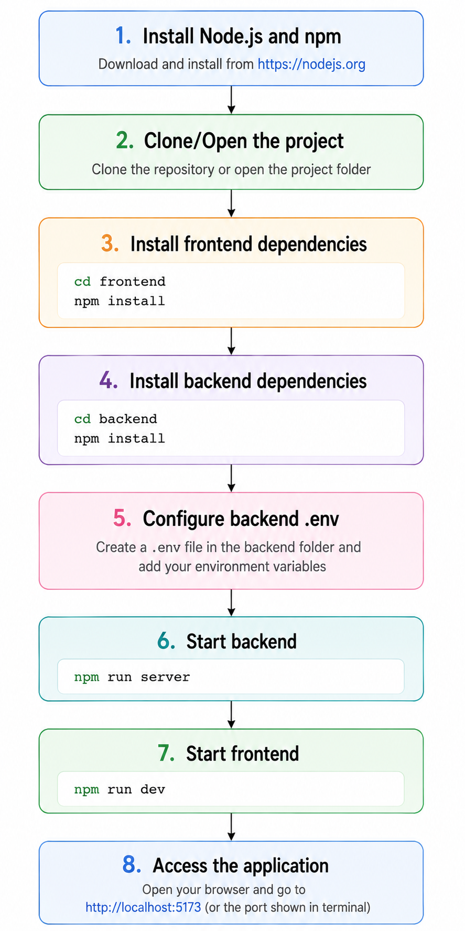
This completes the local installation and setup of the Social Media Application.

13. Testing
The Social Media Application was tested manually during development to verify the functionality of the implemented features. REST APIs were tested using Postman, while the real-time communication functionality was tested through the application using Socket.IO.
The testing process focused on authentication, CRUD operations, social interactions, conversation management, and real-time messaging.

13.1 Testing Approach
The application primarily uses manual functional testing.
The following approaches were used:
- REST API testing using Postman.
- Authentication and authorization testing.
- CRUD operation testing.
- Request and response validation.
- Invalid input testing.
- Protected endpoint testing.
- Real-time communication testing using Socket.IO.
- Conversation room authorization testing.

13.2 API Testing Using Postman
Postman was used to test the REST APIs provided by the backend.
For each API, the request method, endpoint, request body, authentication information, and server response were verified.
The following API modules were tested:
Module | Operations Tested | Testing Tool
Authentication | Register, Login, Logout, Current User | Postman
User | Profile, Update Profile, Recommended Profiles | Postman
Post | Create, Retrieve, Update, Delete | Postman
Like | Like, Unlike | Postman
Follow | Follow, Unfollow | Postman
Conversation | Get Room, Get Messages, Get Chat Partners | Postman

13.3 Authentication Testing
Authentication functionality was tested using valid and invalid authentication scenarios.
The following cases were tested:
1. User registration with valid information
2. User login with valid credentials
3. User login with invalid credentials
4. Accessing protected APIs without authentication
5. Accessing protected APIs with authentication
6. Logout functionality
The purpose of these tests was to verify that authenticated users can access protected functionality while unauthorized requests are appropriately rejected.

13.4 CRUD Operation Testing
The CRUD functionality of the application was tested through the Post APIs.
The following operations were verified:
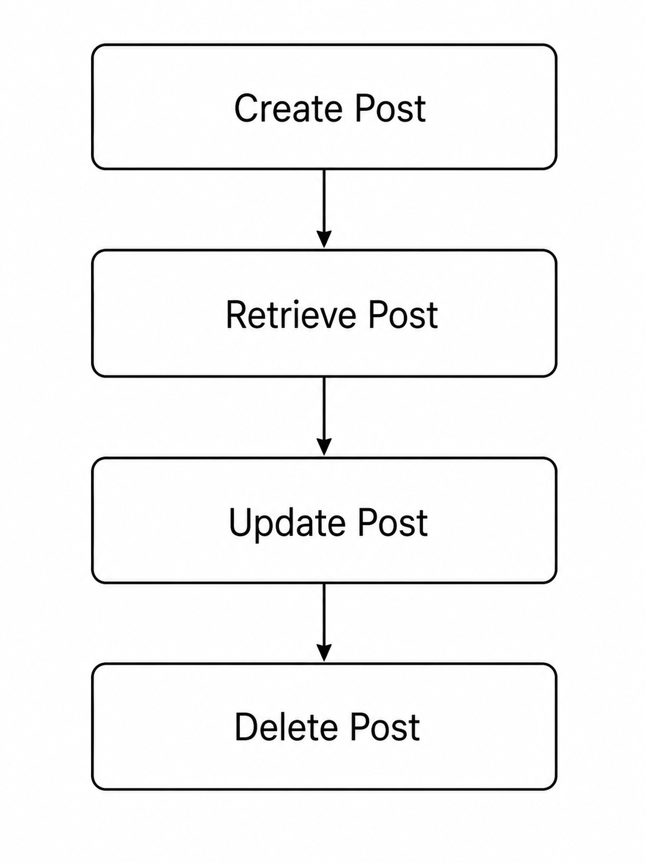
Each operation was tested by sending the appropriate HTTP request through Postman and verifying the response returned by the backend.

13.5 Social Interaction Testing
The application's social interaction functionality was tested through the Follow and Like APIs.

Follow Testing
The following operations were tested:
- Following another user.
- Unfollowing a user.
- Verifying the follow relationship.

Like Testing
The following operations were tested:
- Liking a post.
- Unliking a post.
- Verifying the like relationship.

13.6 Conversation API Testing
The conversation APIs were tested using Postman.
The following operations were verified:
- Retrieving a conversation room.
- Retrieving messages from a conversation.
- Retrieving chat partners.
- Accessing conversation APIs with authentication.
These tests were used to verify that conversation-related data was correctly retrieved from the backend.

13.7 Real-Time Communication Testing
The real-time messaging functionality was tested using Socket.IO.
The following functionality was verified:
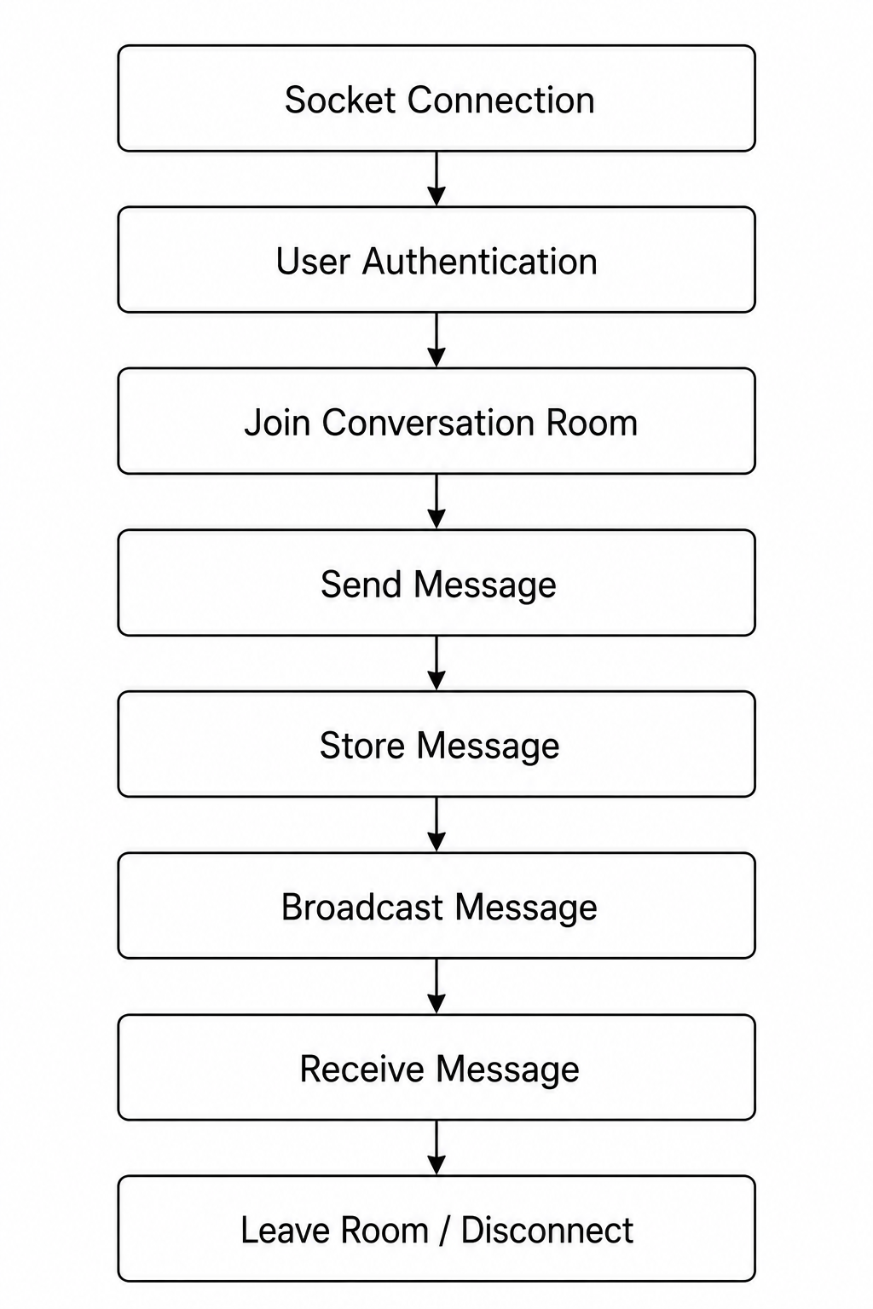
The testing focused on verifying that messages were transmitted between connected users and that conversation rooms were handled correctly.

13.8 Socket Authorization Testing
The application performs authorization checks before allowing users to access conversation rooms.
The following scenarios were tested:
Test Case | Expected Behavior
Authenticated user connects | Connection is established
User joins an authorized room | User joins the room
User attempts to join unauthorized room | Request is rejected
User sends message to authorized room | Message is processed
User sends message to unauthorized room | Request is rejected
User leaves a room | User leaves the room
Socket disconnects | Disconnect event is handled

13.9 Test Result
Manual testing using Postman and application-level testing of Socket.IO functionality were used to verify the major features of the application.
The testing process covered:
- User authentication
- Authorization
- User management
- Post CRUD operations
- Likes
- Follow and unfollow functionality
- Conversation APIs
- Real-time messaging
- Conversation room authorization
- Socket disconnection handling
The testing helped identify and verify functional issues during development and ensured that the major application features behaved as expected.

14. Challenges & Solutions
During the development of the Social Media Application, several technical challenges were encountered, particularly in implementing secure real-time communication. The major challenges and the solutions implemented to address them are described below.

14.1 Securing the Socket.IO Connection

Challenge
One of the major challenges was securing the real-time communication system implemented using Socket.IO.
Unlike normal REST API requests, Socket.IO maintains a persistent connection between the client and server. Therefore, it was necessary to verify the identity of the user before allowing the user to establish a socket connection and access chat functionality.
Another important concern was preventing an authenticated user from accessing a conversation room to which they did not belong.

Solution
JWT-based authentication was implemented for the Socket.IO connection.
A dedicated socket authentication middleware is used before establishing the connection:
io.use(protectSocket);
The middleware verifies the user's authentication information and associates the authenticated user with the socket connection.
After authentication, additional authorization is performed when a user attempts to join a conversation room.
The server verifies whether the authenticated user's ID exists in the conversation's participant list before allowing the user to join the room.
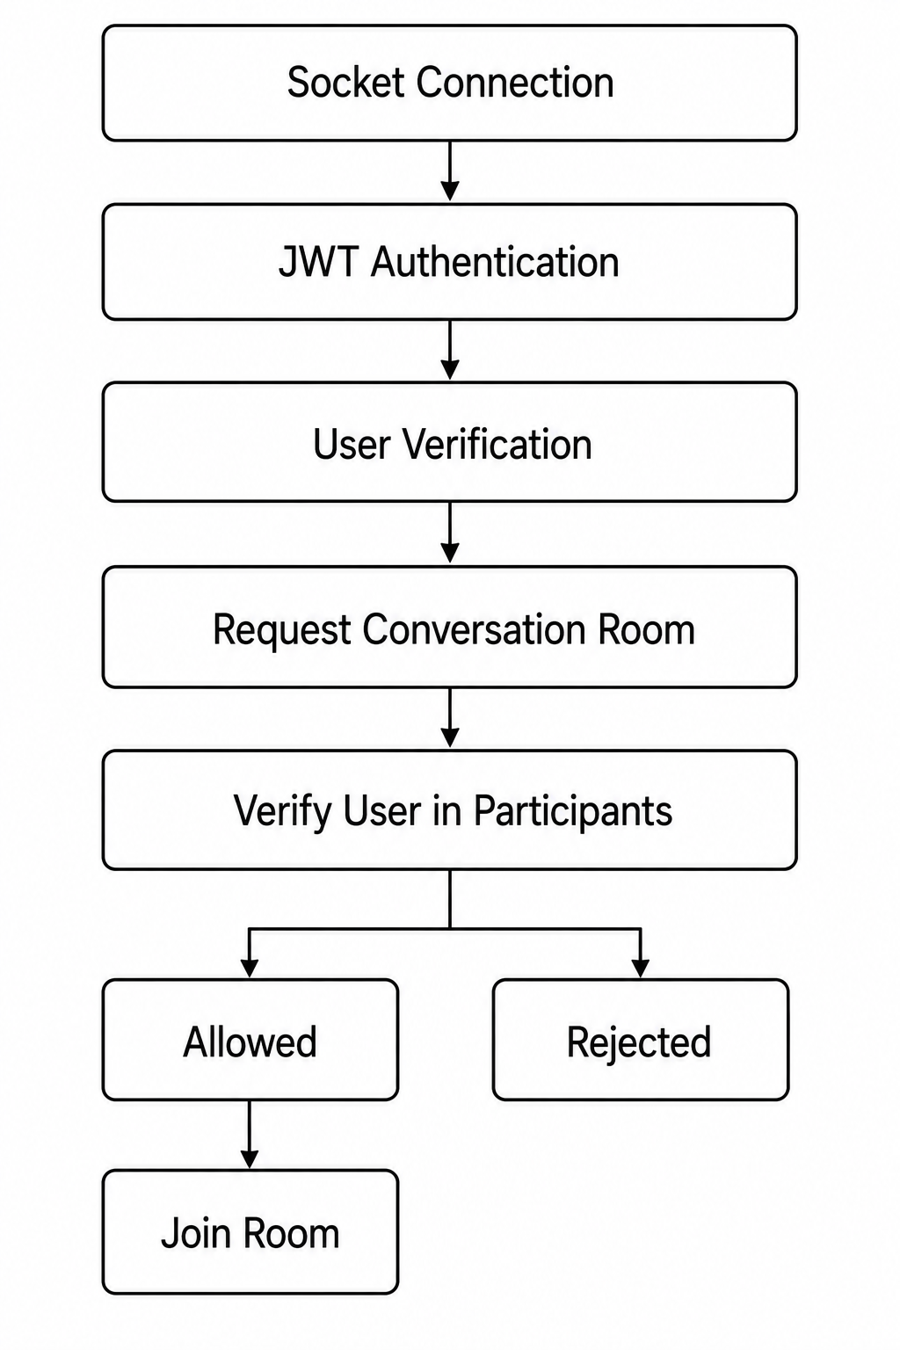
This two-level approach ensures that both the user identity and conversation access are verified.

14.2 Securing Message Transmission

Challenge
Another challenge was preventing authenticated users from sending messages to conversations that they were not authorized to access.

Solution
Before processing a send-message event, the backend verifies that the authenticated user is a participant in the requested conversation.
Only after successful verification is the message stored in MongoDB and broadcast to the conversation room.
This prevents users from sending messages to unauthorized conversation rooms even if they know the room identifier.

15. Limitations
Although the application provides core social networking and real-time messaging functionality, several features are currently not implemented.

15.1 No Recommendation System
The current application does not provide an advanced recommendation system for suggesting relevant posts or users to users.
A recommendation mechanism can be implemented in a future version based on user activity, interests, relationships, and engagement.

15.2 No Online Status System
The application currently does not provide an online/offline status indicator for users.
Users cannot currently determine whether another user is online or offline.

15.3 No Notification System
The application does not currently provide a notification system for events such as:
- New followers
- Likes
- Comments
- New messages
- Other social interactions

15.4 No Typing Indicator
The current messaging system does not provide a typing indicator.
Users cannot see whether another participant is currently typing a message.

15.5 No End-to-End Encryption
The messaging system currently does not implement end-to-end encryption.
Messages are transmitted through the application server and stored in the database. Therefore, the current implementation should not be considered an end-to-end encrypted messaging system.

15.6 Image Upload Limitation
Currently, users cannot directly upload images through a dedicated cloud storage system.
The application currently works with image URLs rather than providing a complete image-upload and storage workflow.
This limits the application's media management capabilities.

16. Future Enhancements
The application can be extended with several additional features to improve functionality, security, scalability, and user experience.

16.1 Recommendation System
A recommendation system can be implemented to provide personalized suggestions for:
- Posts
- Users to follow
- Relevant content
Recommendations could be generated based on user interactions, following relationships, likes, and other activity.

16.2 Online and Offline Status
An online presence system can be implemented using Socket.IO to show whether users are currently online or offline.
This can provide users with real-time presence information.

16.3 Notification System
A notification system can be added to notify users about important activities such as:
- New followers
- Likes
- Comments
- New messages
- Other social interactions
Real-time notifications can also be implemented using Socket.IO.

16.4 Typing Indicator
A typing indicator can be added to the messaging system.
For example:
User is typing...
This would improve the real-time messaging experience.

16.5 End-to-End Encryption
End-to-end encryption can be implemented for private messaging to provide stronger privacy and security.
With end-to-end encryption, messages can be encrypted on the sender's device and decrypted only by the intended recipient.

16.6 Cloud-Based Image Storage
The current image system can be enhanced by implementing cloud-based image uploads.
AWS S3 can be integrated to:
- Upload images directly from the application.
- Store images securely in cloud storage.
- Generate accessible image URLs.
- Reduce the need to store image data directly on the application server.
- Improve scalability for media storage.
The future image-upload flow could be:
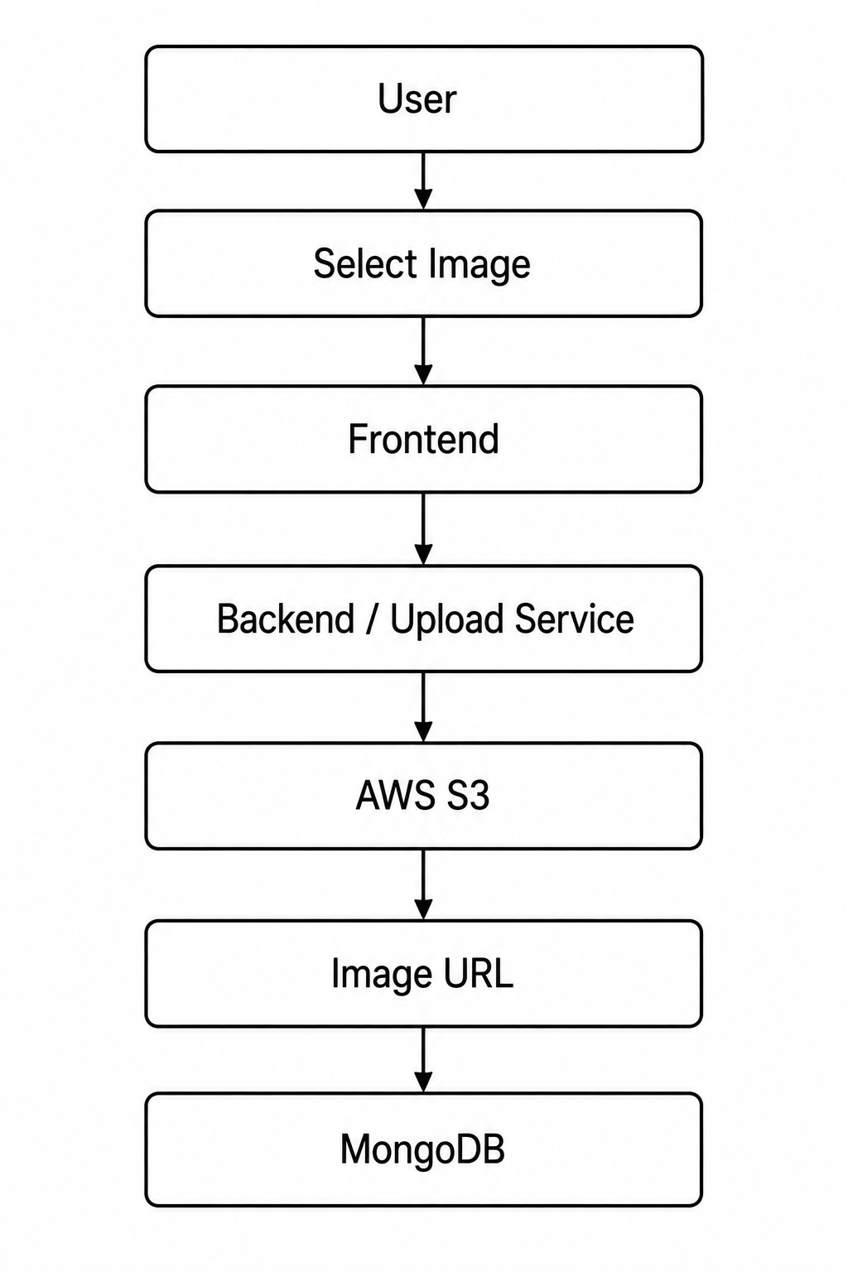
The database would store the image URL/reference rather than the actual image file.

16.7 Overall Future Scope
The future development of the application can focus on improving personalization, real-time interaction, privacy, notifications, and media management.
The planned enhancements include:
Future Enhancement | Purpose
Recommendation System | Personalized posts and user suggestions
Online/Offline Status | Display user presence
Notifications | Inform users about social activities
Typing Indicator | Improve real-time chat experience
End-to-End Encryption | Improve message privacy
AWS S3 Integration | Scalable image storage
Image Upload | Allow users to upload images directly
These enhancements can transform the current application from a basic social media and messaging platform into a more complete and scalable social networking system.

17. Conclusion
The Social Media Application was developed as a full-stack web application using the MERN stack, consisting of React, Node.js, Express.js, and MongoDB. The application provides core social media functionality such as user authentication, profile management, post creation and management, likes, following and unfollowing users, and real-time communication.
A major focus of the project was implementing secure real-time communication using Socket.IO. JWT-based socket authentication and participant verification were implemented to ensure that only authorized users can access conversation rooms and send messages.
The project also provided practical experience in designing RESTful APIs, implementing authentication and authorization, working with MongoDB and Mongoose, handling real-time communication, and testing backend functionality using Postman.
Although the current implementation has limitations such as the absence of advanced recommendation systems, notifications, online indicators, typing indicators, end-to-end encryption, and direct image uploading, these areas provide opportunities for future development. Integration with services such as AWS S3 can further improve the application's media storage and scalability.
Overall, the project demonstrates the development of a functional and secure social media platform while providing a foundation for adding more advanced features and improving scalability, security, and user experience in future versions.

18. References
The following resources were referred to during the development and documentation of the Social Media Application.

18.1 React Documentation
React was used for developing the frontend user interface and component-based application structure.
Reference:
React Official Documentation
https://react.dev/

18.2 Node.js Documentation
Node.js was used as the JavaScript runtime environment for the backend application.
Reference:
Node.js Official Documentation
https://nodejs.org/docs/

18.3 Express.js Documentation
Express.js was used to develop the REST API and backend server.
Reference:
Express.js Official Documentation
https://expressjs.com/

18.4 MongoDB Documentation
MongoDB was used as the primary database for storing application data.
Reference:
MongoDB Official Documentation
https://www.mongodb.com/docs/

18.5 Mongoose Documentation
Mongoose was used for defining MongoDB schemas and interacting with MongoDB from the Node.js backend.
Reference:
Mongoose Official Documentation
https://mongoosejs.com/docs/

18.6 Socket.IO Documentation
Socket.IO was used to implement real-time communication and chat functionality.
Reference:
Socket.IO Official Documentation
https://socket.io/docs/

18.7 JSON Web Token Documentation
JWT was used for implementing authentication and securing protected resources.
Reference:
JSON Web Token Official Website
https://jwt.io/

18.8 Postman Documentation
Postman was used for manually testing the application's REST APIs.
Reference:
Postman Official Documentation
https://learning.postman.com/docs/

18.9 Vite Documentation
Vite was used as the development and build tool for the React frontend.
Reference:
Vite Official Documentation
https://vite.dev/

