Creating an IAM User in AWS Console

Step 1 - Go to AWS Console
Open your web browser and navigate to the official AWS Console page. You can access it by typing 'aws.amazon.com/console' in your browser's address bar.
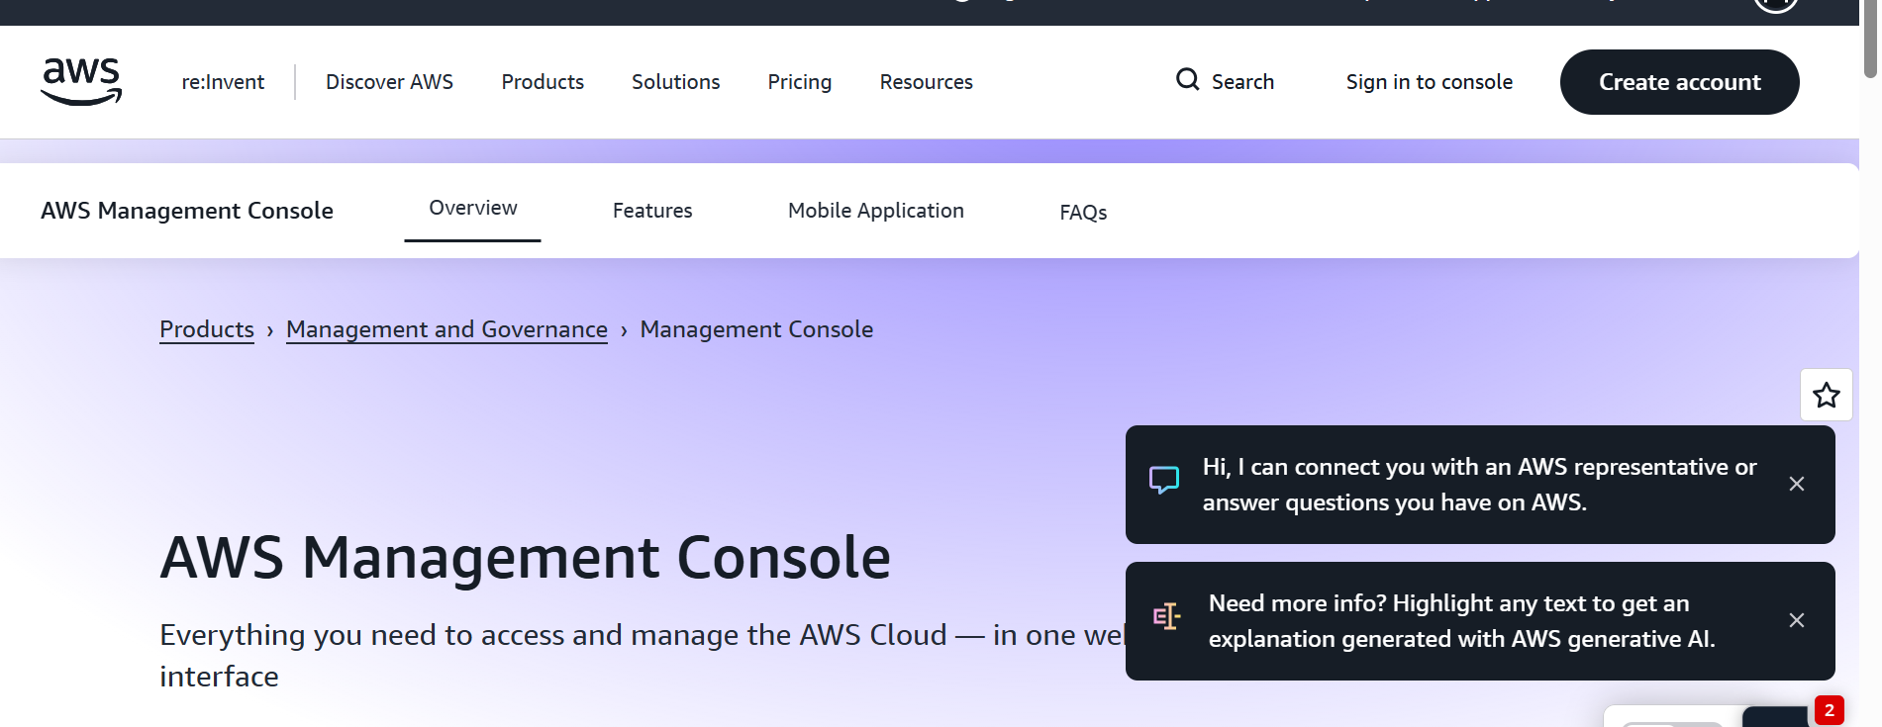

Step 2 - Sign in to AWS Console
Click on the 'Sign In' button. Enter your AWS account credentials (email/phone number and password).

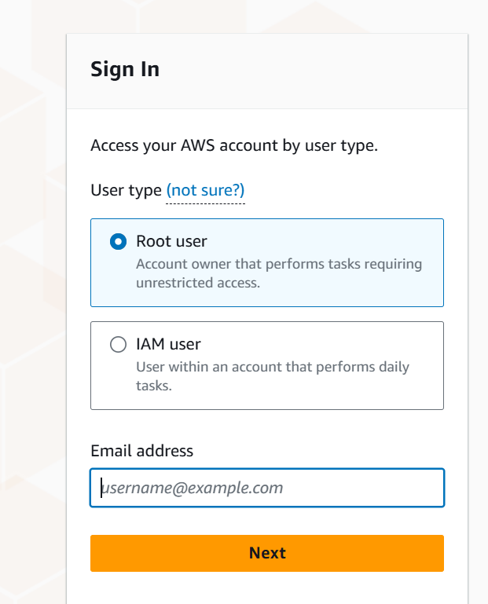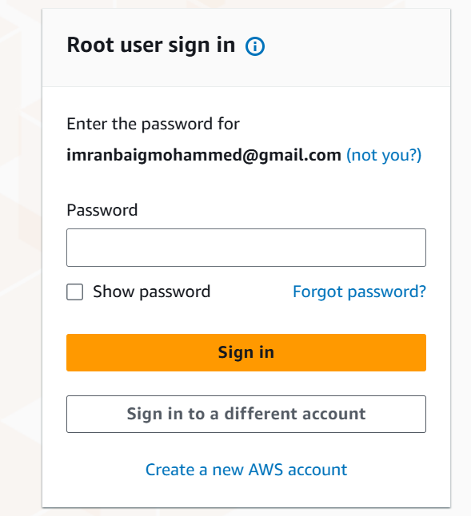
Step 3 - Go to IAM
Once logged in, go to the Services menu at the top of the page. From the list of services, search for or select 'IAM' (Identity and Access Management).
IAM is the service where you manage users, groups, roles, and permissions.
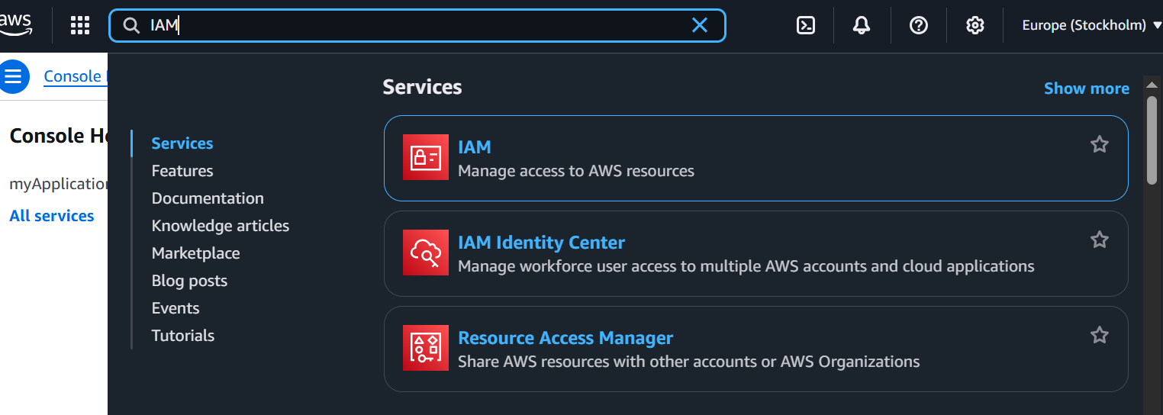

Step 4 - Go to Users
In the IAM dashboard, look at the left-hand navigation panel and click on the 'Users' option. This section displays all existing IAM users and provides options for adding new ones.
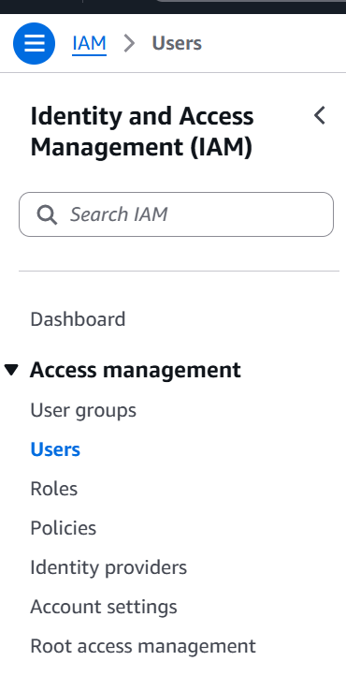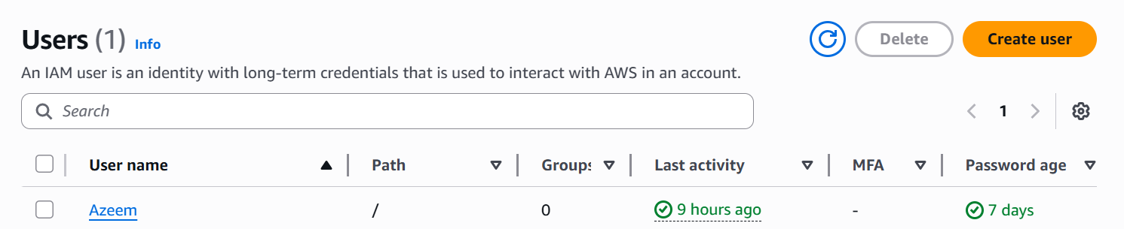

Step 5 - Select 'Create User'
Click the 'Create User' button to start the user creation process. This opens the user configuration wizard.
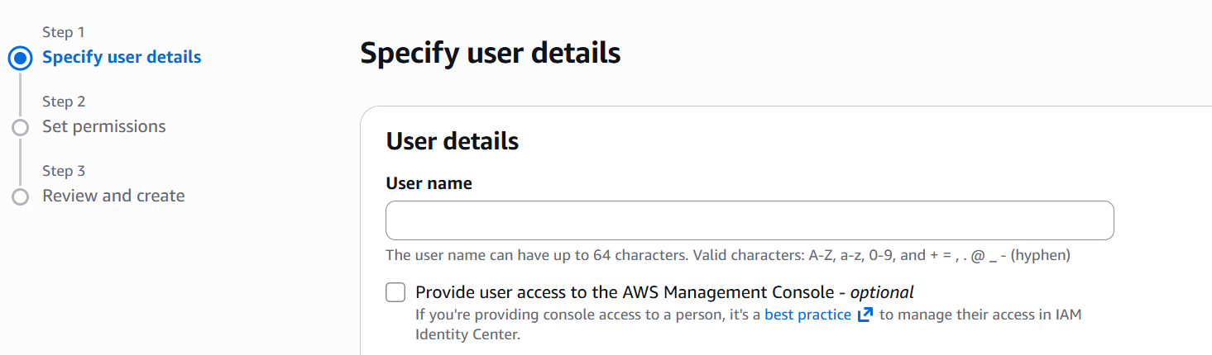
Step 6 - Provide Username
Enter a unique username for the new user. The username is used for identification and login. Use a descriptive name such as 'developer-user', 'admin-user', or per your organizational standards.
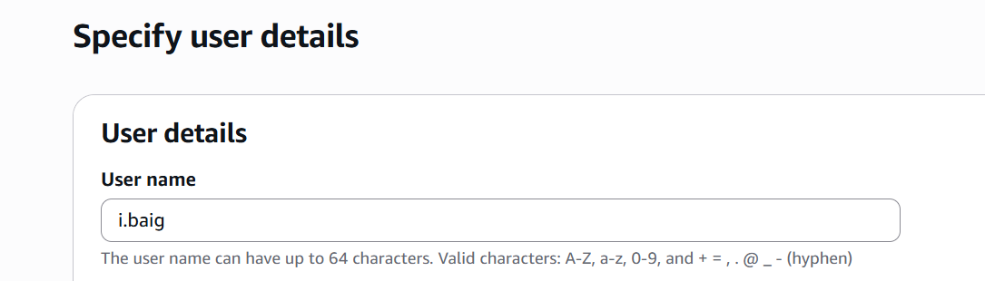
Step 7 - Provide Console Access
Choose whether the new user should have AWS Management Console access. If yes, enable 'Console Password' and either create a password manually or choose auto-generated. You can also require the user to reset the password on their first login.
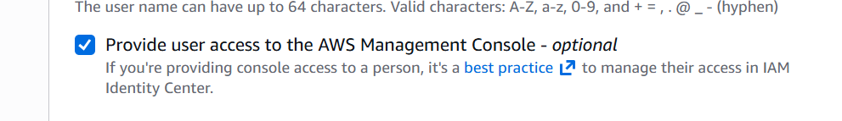
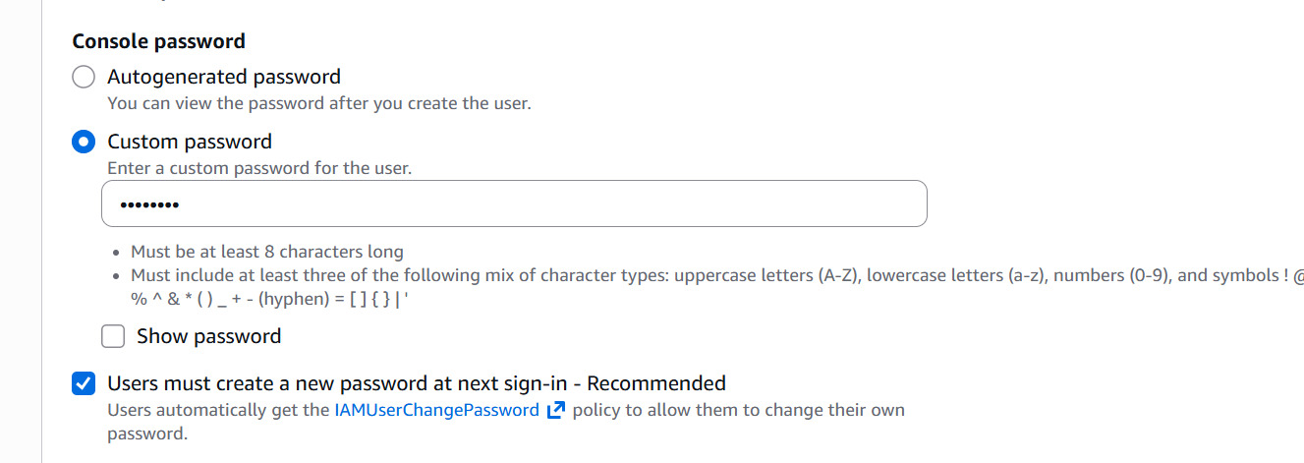
Step 8 – Permission Policy Access
We need to give Permission policy access to the IAM user to work on AWS. We give AdministorAccesss to IAM User.
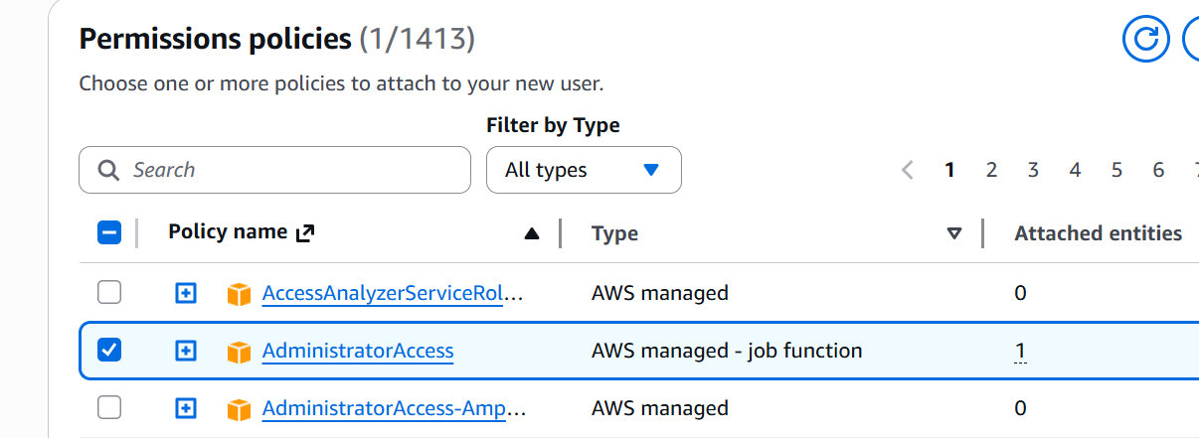
Step 9 – Review and Create
We should review the details and create user. If any changes are there we can edit.
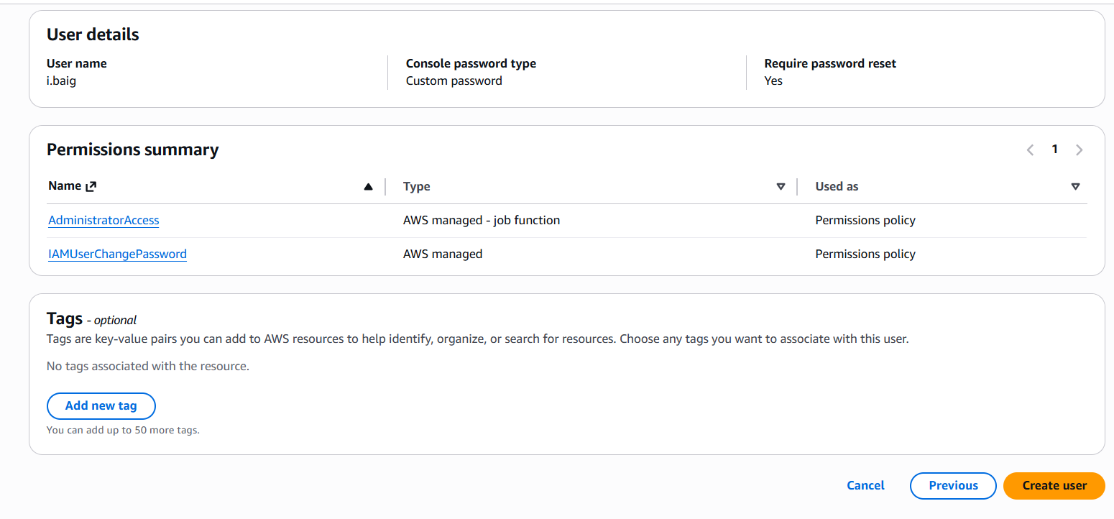
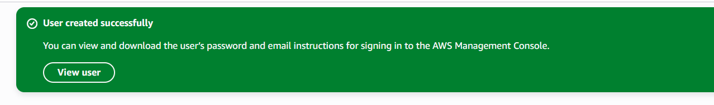
Step 10 – Sign In and Retrieve password
We should sign In to AWS console and retrieve the password for IAM user because we gave access to change the password. Sign In with Account ID and give IAM user name and password. Sign In and reset password as shown below.
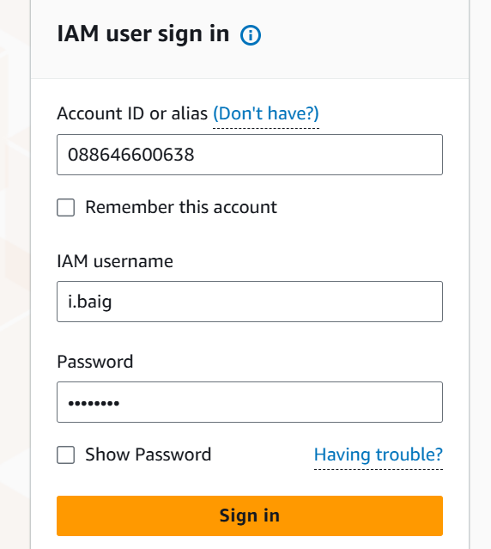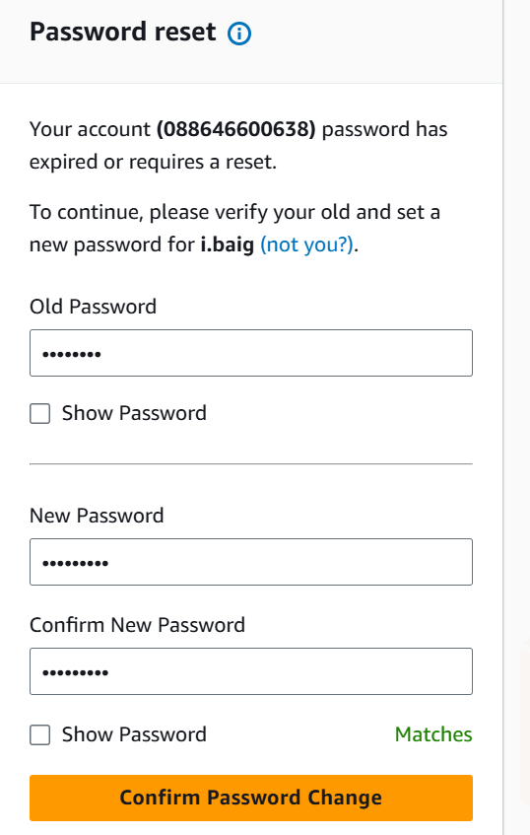
Step 11 – Sign In to AWS Console
After resetting the password, we sign In with IAM user and it open as shown below.
