Multi-Server Java Application Build, Store, and Deployment System

Objective
The objective of this task is to set up a multi-server environment for building, storing, and deploying a Java web application using a Build Server, Nexus Repository Server, and Deploy Server.

Servers Used
1. Build Server – Build Java application using Maven
2. Nexus Repository Server – Store WAR artifacts
3. Deploy Server – Deploy application on Apache Tomcat

1. Java Build Server Setup
Step 1: Connect to Build Server
ssh -i "devops.pem" ubuntu@ec2-3-91-216-228.compute-1.amazonaws.com
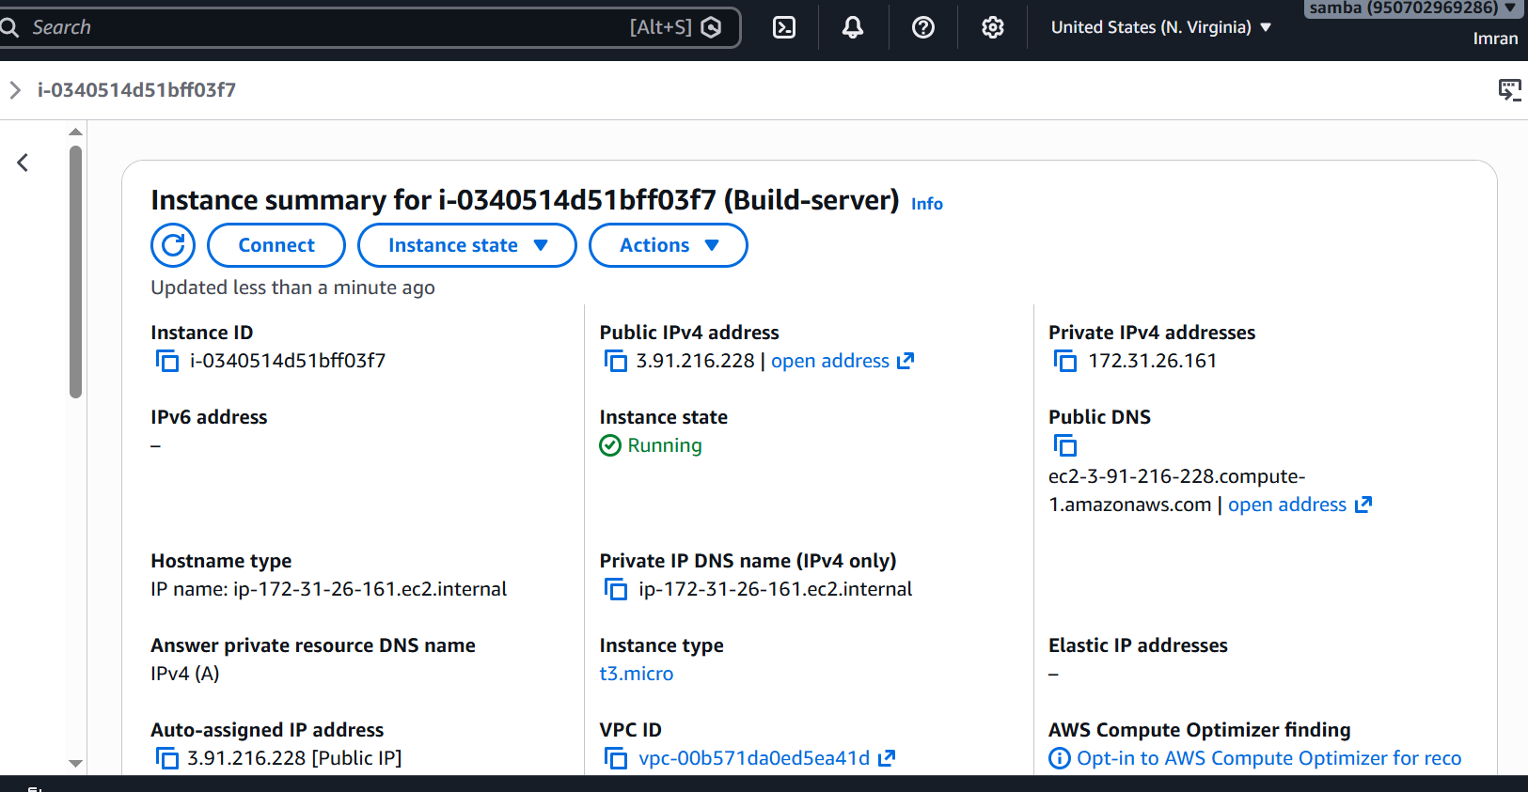
Step 2: Install Java and Maven
sudo apt update
sudo apt install openjdk-17-jdk -y
sudo apt install maven -y
java -version
mvn -version
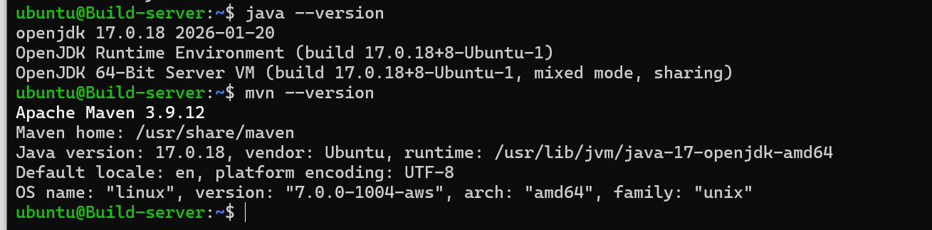
Step 3: Clone GitHub Repository
git clone https://github.com/mrtechreddy/Java-Web-Calculator-App.git
cd Java-Web-Calculator-App
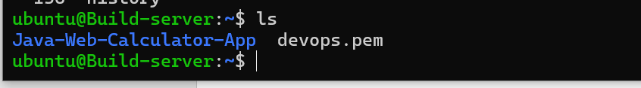
Step 4: Build Application
mvn clean package
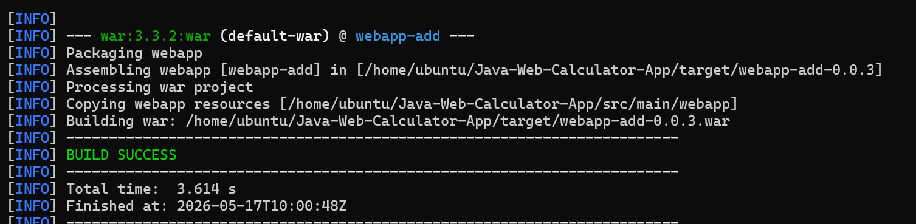
WAR file generated inside target/ directory.
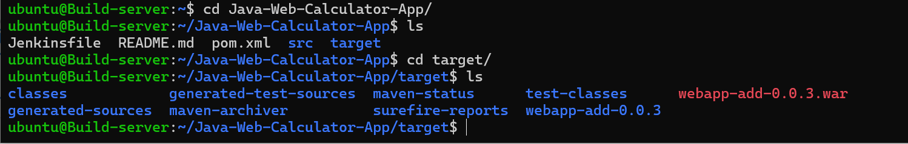
Step 5: Configure pom.xml
Add Nexus repository configuration under distributionManagement.
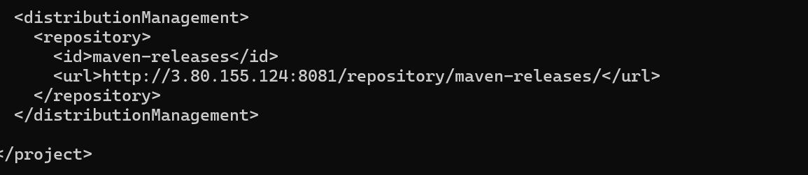
Step 6: Configure Maven settings.xml
Add Nexus credentials in /etc/maven/settings.xml.
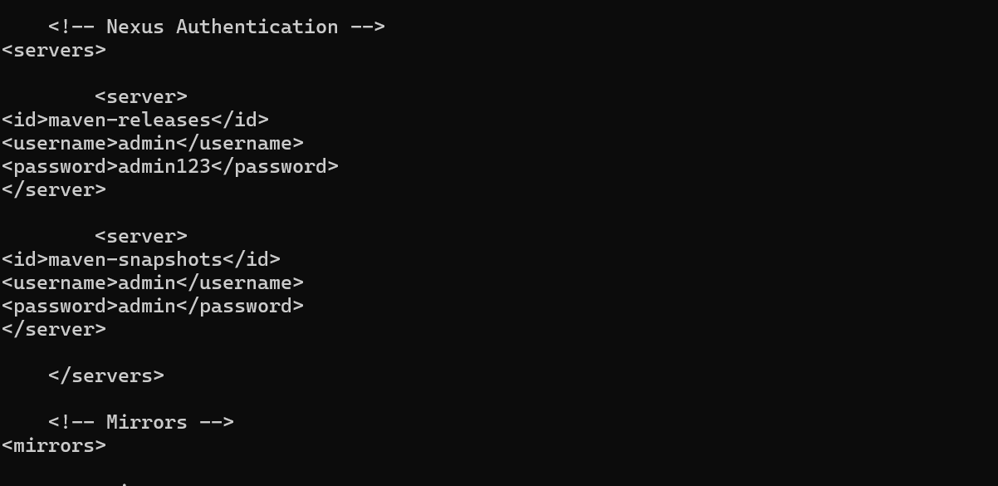
Step 7: Deploy Artifact to Nexus
mvn deploy

2. Nexus Repository Server Setup
Step 1: Install Java
sudo apt update
sudo apt install openjdk-17-jdk -y
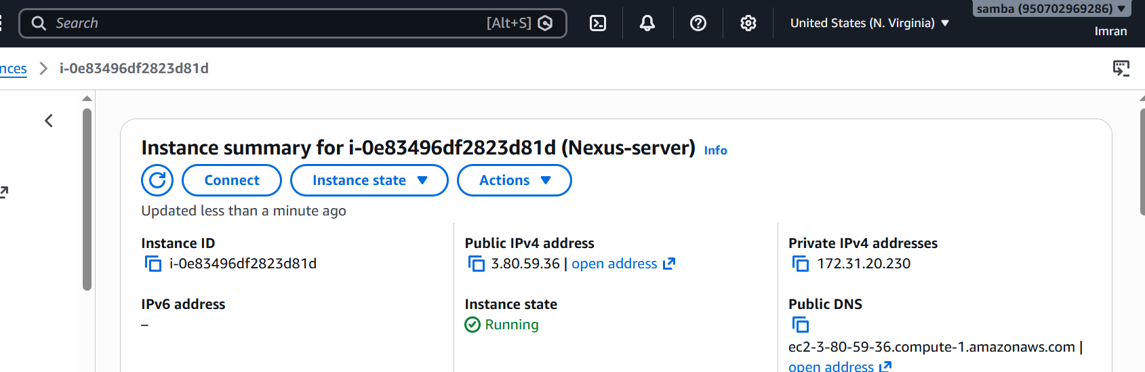
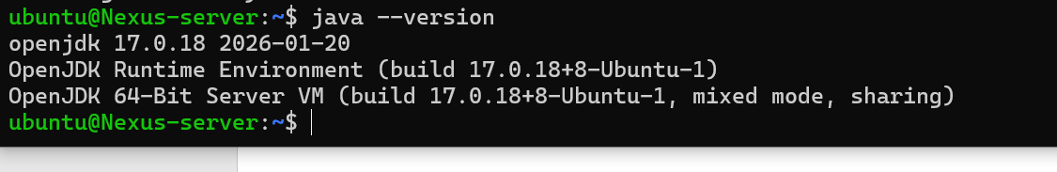
Step 2: Download Nexus
Step 3: Extract Nexus
tar -xvf latest-unix.tar.gz
Start Nexus
cd /opt/nexus/bin
./nexus start
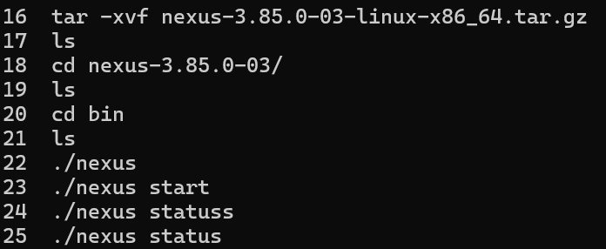

Step 5: Access Nexus Web Interface
http://3.80.59.36:8081
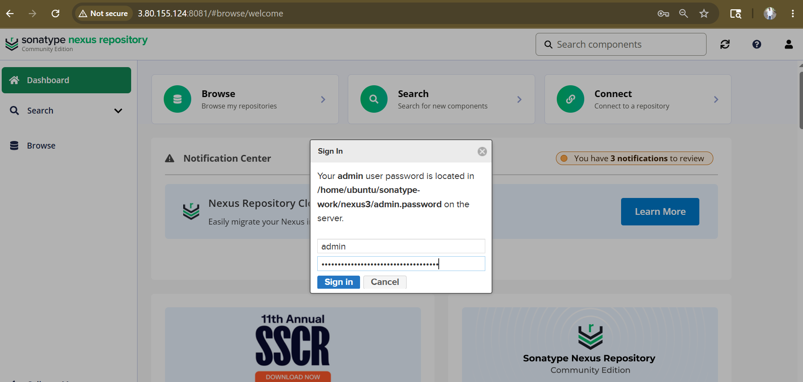
Step 6: Create Maven Hosted Repository
Create repository named maven-releases.
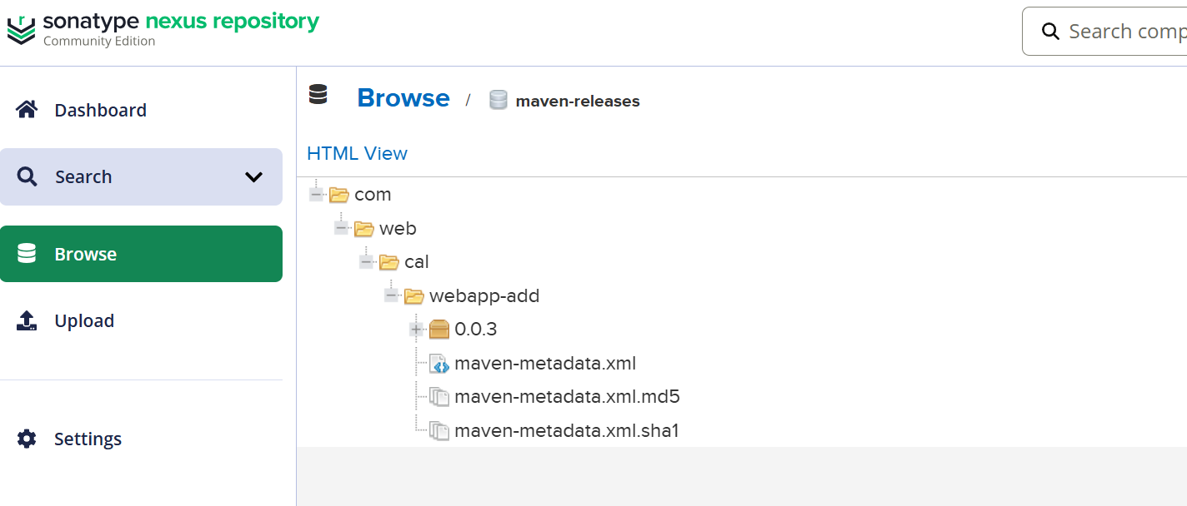

3. Deploy Server Setup
Step 1: Install Java and Apache Tomcat
sudo apt update
sudo apt install openjdk-17-jdk -y
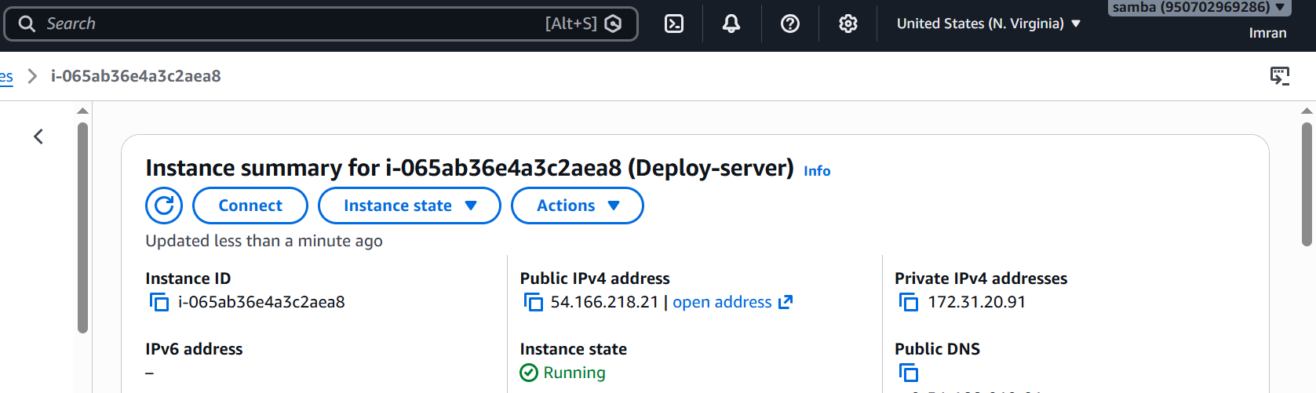

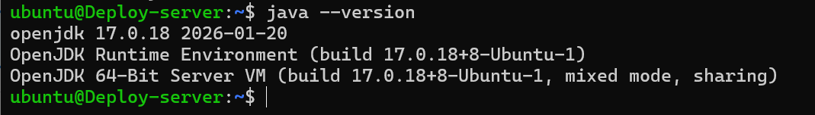
Download Tomcat:
wget https://downloads.apache.org/tomcat/tomcat-9/v9.0.118/bin/apache-tomcat-9.0.118.tar.gz
Extract Tomcat:
tar -xvf apache-tomcat-9.0.118.tar.gz

Step 2: Start Tomcat
cd /opt/tomcat/bin
./startup.sh
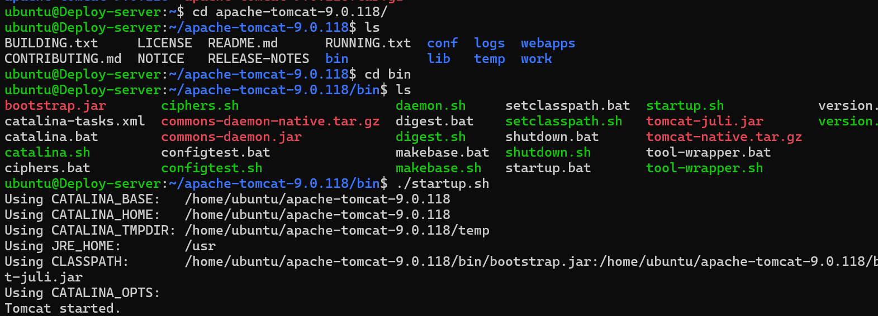
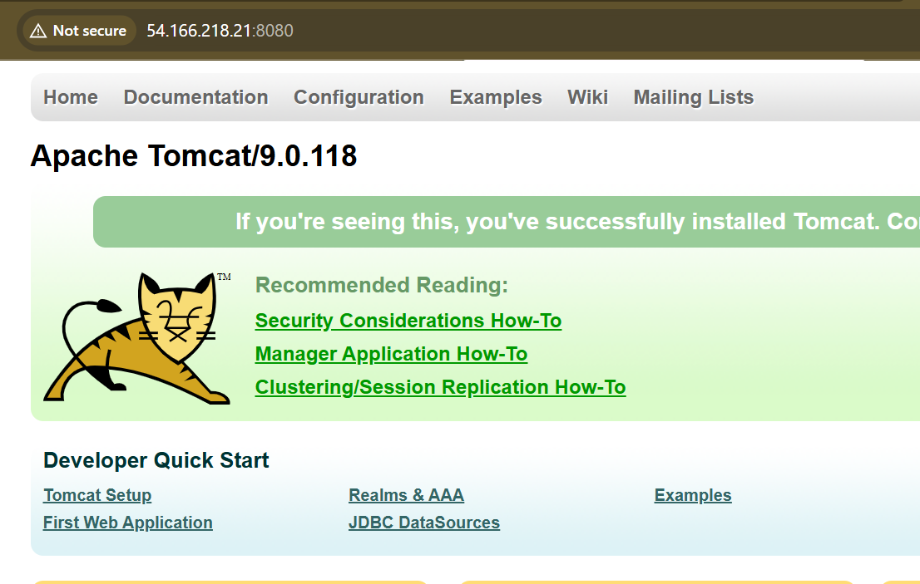
Step 3: Copy WAR File to Deploy Server

Step 4: Access Application
http://54.166.218.21:8080
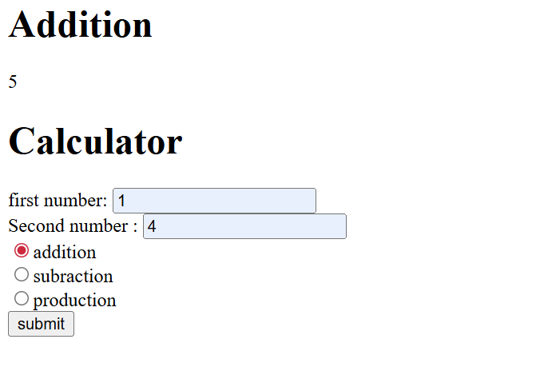

Issues Encountered and Fixes
1. Permission denied for PEM file → Fixed using chmod 400 devops.pem
2. Maven deployment failed → Corrected Nexus repository ID and credentials
3. Tomcat startup issue → Verified Java installation and Tomcat logs
4. SCP connection issue → Updated security groups and PEM permissions

Conclusion
Successfully implemented a complete multi-server Java application deployment pipeline using Apache Maven, Nexus Repository Manager, and Apache Tomcat.

