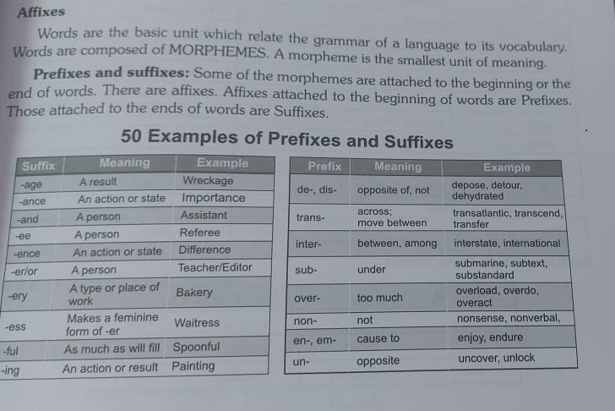

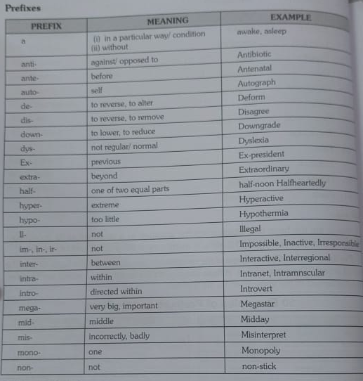

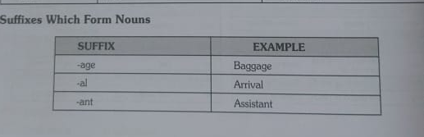

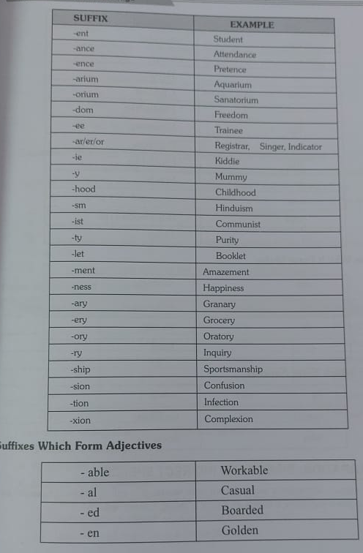

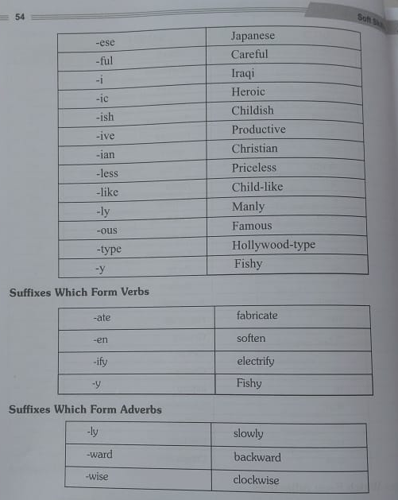

**Phrases with Meaning**

1) **A bird in the hand is worth two in the bush**- Having something that is certain is much better than taking a risk for more, because chances are you might losing everything.

2) **A blessing in disguise**- Something good that isn’t recognized by first

3) **Bull in china shop**- One who causes damage

4) **A chip on your shoulder**- Being upset for something that happened in the past

5) **A damp squib**- Complete failure

6) **A dime A dozen**- Anything that is common and easy to get

7) **A doubting Thomas**- A skeptic who needs physical or personal evidence in order to believe something

8) **A drop in the bucket**- A very small part of something big or whole

9) **A fool and his money are easily parted**- It’s easy for a foolish person to lose his/ her money

10) **A gentleman at large**- An unreliable person

11) **A green horn**- Inexperienced

12) **A house divided against itself cannot stand**- Everyone involved must unify and function together or it will not work out.

13) **A leopard can’t change his spots**- You cannot change who you are

14) **A lost cause**- A hopeless case, a person or situation having no hope of positive change.

15**) A man of straw**- A weak person

16) **A mare’s nest**- A false invention

17) **A penny saved is a penny earned**- By not spending money, you are saving money (little by little)

18) **A picture paints a thousand words**- A visual presentation is far more descriptive than words

19) **A piece of cake**- A task that can be accomplished very easily

20) **A slap on the wrist**- A very mild punishment

21) **A stalking horse**- Pretence

22) **A steal**- Very inexpensive, a bargain

23) **A taste of your own medicine**- When you are mistreated the same way you mistreat others

24) **A toss-up**- A result hat is still unclear and can go either way

25) **A wolf in sheep’s clothing**- A dangerous person pretending harmless

26) **ABC: Very common knowledge about to**- Ready to, just going to

27) **Above all**- Mainly, especially

28) **Above board**- Fair and honest

29) **According to**- In the order of; on the authority of

30) **Actions speak louder than words**- It’s better to actually do something than hust talk about it

31) **Add fuel to the fire**- Whenever something is done to make a bad situation even worse than it is

32) **Against the clock**- Rushed and short on time

33**) All (day, week, month, year) long**- The entire day, week, month, year

34) **All along**- All the time, from the beginning (without change)

35) **All and Sundry**- Without making any distinction

36) **All bark and no bite**- When someone is threatening and/ or aggressive but not willing to engage in a fight

37) **All greek to me**- Meaningless and incomprehensible like someone who cannot read, speak, or

38) **All in all**- Considering everything

39) **All in the same boat**- When everyone is facing the same challenges

40) **All of a sudden**- Suddenly, without warning (All at once)

41) **All right**- Acceptable, fine; yes, okay

42) **Alpha and omega**- First and last letter of Greek alphabet, means beginning and end

43) **An arm and a leg**- Very expensive, A large amount of money

44) **An axe to grind**- To have a dispute with someone

45) **An eye wash**- A pretence

46) **An iron hand**- By force

47) **Apple to my eye**- Someone who is cherished above all others

48) **As a matter of fact**- Really, actually (also: as to)

49) **As for-** Regarding, concerning (also: as to)

50) **As high as a kite**- Anything that is high up in the sky

51) **As soon as**- Just after, when

52) **As usual**- as is the general case, as is typical

53) **At all**- To any degree (also: in the least)

54) **At heart**- Basically, fundamentally

55) **At last**- Finally, after a long time

56) **At least**- A minimum of, no fewer (or less) than

57) **At odds**- In dispute

58) **At sixes and seven**- Persons who are having different opinions

59) **At the drop of a hat**- Willing to do something immediately

60) **Back and call**- At the service

61) **Back and forth**- In a backward and forward motion

62) **Back seat driver**- People who criticize from the sidelines, much like someone giving unwanted advice

63) **Back to square one**- Having to start all over again

64) **Back to the drawing board**- When an attempt fails and it’s time to start all over

65) **Bag and baggage**- with all goods

66) **Baker’s dozen**- Thirteen

67) **Bank on**- Depend on, count on

68) **Barking up the wrong tree**- A mistake made in something you are trying to achieve

69**) Bated breath**- In anxiety, expectancy

70) **Beat a dead horse**- To force an issue that has already ended

71) **Beating around** **the bash**- Avoiding the main topic, not speaking directly about the issue

72) **Bend over backwards**- Do whatever it takes to help. Willing to do anything

73) **Between a Rock and a Hard place**- Stuck between two very bad options

74) **Between Scylla and Charybdis**- Choice between two unpleasant alternatives

75) **Between the cup and the lips**- On the point of achievement

76) **Bite off more than you can chew**- To take on a task that is a way to big

77**) Bite your tongue**- To avoid talking

78) **Black and white**- In writing

79) **Blood is thicker than water**- The family bond is closer than anything else

80) **Blow hot and cold**- Having no stand, shows favour at one time and unfavour at another

81) **Blue moon**- A rare event or occurrence

82) **Body and soul**- Entirely

83) **Break a leg**- A superstitious way to say ‘Good Luck’ without saying ‘Good Luck’,

84) **Buy a lemon**- To purchase a vehicle that constantly gives problems or stops running after you drive it

85) **By & by**- Gradually

86) **By all means**- Certainly, definitely, naturally (also: of course); using any possible way or method

87) **By far**- By a great margin, clearly

88) **By fits and starts**- Irregularly

89) **By heart**- By memorizing

90) **By hook or by crook**- By any means

91) **By leaps and bound**- speedily

92) **By oneself**- Alone, without assistance

93) **By the way**- Incidentally

94) **Call a spade a spade**- Straight talks

95) **Can’t cut the mustard**- Someone who isn’t adequate enough to compete or participate

96) **Cast iron stomach**- Someone who has no problems, complications or ill effects with eating anything

97) **Cats and bull story**- Untrue story

98) **Cats and dogs**- Heavy rain

99) **Charley horse**- stiffness in the leg/ A leg cramp

100) **Chew someone out**- Verbally scold someone

101) **Chip on his shoulder**- Angry today about something that occurred in the past

102) **Chow down**- To eat

103) **Clear- cut**- Clearly stated, definite, apparent

104) **Close but no cigar**- To be near and almost accomplish a goal, but fall short

105) **Close call**- A situation involving a narrow escape from danger

106) **Cock and bull story**- An unbelievable tale, untrue story

107) **Come hell or high water**- Any difficult situation or obstacle

108) **Crack someone up**- To make someone laugh

109) **Cross your fingers**- To hope that something happens the way you want it to

110) **Cry wolf**- Intentionally raise a false alarm

111) **Cup of joe**- A cup of coffee

112) **Curtain lecture**- A reproof by wife to her husband

113) **Cut and dried**- Ready made form

114) **Cut to the chase**- Leave out all the unnecessary details and just get to the point

115) **Dark horse**- One who was previously unknown and is now prominent

116) **Day in and day out**- Continuously, constantly

117) **Dead Ringer**- 100 % identical, a duplicate

118**) Devil’s advocate**- Someone who takes a position for the sake of argument without believing in that

119) **Dog days of summer**- The hottest day of the summer season

120) **Don’t count your chickens before they hatch**- Don’t rely on it until you sure of it

121) **Don’t look a gift horse in the month**- When someone gives you a gift, don’t be ungrateful

122) **Don’t pull all your eggs in one basket**- Do not pull all your resources in one possibility

123) **Doozy**- Something outstanding

124) **Down to the wire**- Something that ends at the last minute or last few seconds

125) **Drastic times call for drastic measures**- When you are extremely desperate you need to take extremely desperate actions

126) **Drink like a fish**- To drink very heavily, drinking anything

127) **Dry run**- Rehearsal

128) **Egg on**- To urge somebody

129) **Eighty six**- A certain item is no longer available. Or this idiom can also mean, to throw away

130) **Elvis has left the building**- The show has come to an end. It’s all over

131) **Ethnic cleansing**- Killing of a certain ethnic or religious group on a massive scale

132) **Ever and anon**- Now and then

133) **Every cloud has a silver lining**- Be optimistic, even difficult times will lead to better days

134) **Every other (one)**- Every second (one), alternate (ones)

135) **Everything but the kitchen sink**- Almost everything and anything has been included

136) **Excuse my French**- Please forgive me for cussing

137) **Fabian policy**- Policy of delaying decisions

138) **Face-to-face**- Direct, personal; directly, personally (written without hyphens)

139) **Fair and wide**- Equal opportunity to all

140) **Far and wide**- Every where

141) **Few and far between**- Not frequent, unusual, rare

142) **Field day**- An enjoyable day or circumstance

143) **Fifty- fifty**- Divided into two equal parts

144) **Finding your feet**- To become more comfortable in whatever you are doing

145) **Finger licking good**- To become more comfortable in whatever you are doing

146) **Fire and brimstone**- A very tasty food or meal

147) **Fire and fury**- Fearful penalties

148) **First and foremost**- Extreme enthusiasm

149) **Fishy: doubtful**- Highest priority

150) **Fixed in your ways**- Not willing or wanting to change from your normal way of doing something

151) **Flash in the pan**- Something that shows potential or looks promising in the beginning but fails to deliver

152) **Flea market**- A swap meet. A place where people gather to buy and sell inexpensive goods

153) **Flesh and blood**- This idiom can mean living material of which people are made of, or it can refer to human nature

154) **Flip the bird**- To raise your middle finger at someone

155) **Foam at the mouth**- To be enraged and show it

156**) Fools’ Gold**- Iron pyrites, a worthless rock that resembles real gold

157) **Foot the bill**- Bear expenses

158) **For good**- Permanently, forever

159) **For once**- This one time, for only one time

160) **For sure**- Without doubt (also: for certain)

161) **For the** **time being**- Temporarily (also: for now)

162) **Free and easy**- Natural and simple

163) **French kiss**- An open mouth kiss where tongues touch

164) **From now on**- From this time into the future

165) **From rags to riches**- To go from very poor to being very wealthy

166) **Fuddy- duddy**- An old-fashioned and foolish type of person

167) **Full monty**- This idiom can mean either, “The whole thing” or “Completely nude”

168) **Funny farm**- A mental institutional facility

169) **Gall and wormwood**- Source of irritation

170) **Get down to brass tacks**- To become serious about something

171) **Get over it**- To move beyond something that is bothering you

172) **Get up on the wrong side of the bed**- Someone who is having a horrible day

173) **Get your walking papers**- Get fired from the job

174) **Gird up the loin**- To be ready

175) **Give and take**- Compromise, cooperation between people

176) **Give him the slip**- To get away from, to escape

177) **Give in-** Surrender

178) **Go down like a lead balloon**- To be received badly by an audience

179) **Go for broke**- To gamble everything you have

180) **Go out on a limb**- Put yourself in a tough position in order to support someone/ something

181) **Go the extra mile**- Going above and beyond whatever is required for the task at hand

182) **Good Samaritan**- Someone who helps others when they are in need, with no discussion for

183) **Graveyard shift**- Working hours from about 12:00 am to 8.00

184) **Great minds think alike**- Intelligent people think like each other

185) **Green room-** The waiting room, especially for those who are about to go on a TV or radio show

186) **Gut feeling**- A personal intuition you get, especially when feel something may not be right

187) **Had better**- Should, ought to, be advisable to

188) **Hand a gloves**- Very intimate friends

189) **Hard and fast**- Certain

190) **Hard of hearing**- Partially deaf, not able to hear well

191) **Haste makes waste**- Quickly doing things results in a poor ending

192) **Hat Trick**- When one player scores three goals in the same hockey game.

193) **Haughty and naughty**- Arrogant and naughty

194) **Have an axe to grind**- To have a dispute with someone

195) **Have got**- To have, to possess

196) **Have got to**- Must (also: have to)

197) **He lost his head**- Angry and overcome by emotions

198) **Head and shoulder**- Superior

199) **Head over heels**- Very excited and/ or joyful, especially when in love

200) **Heart and soul**- With full devotion

201) **Hell in a hand basket**- Deteriorating and headed for complete disaster

202) **Helter Shelter**-Here and there

203) **Herculean task**- A tedious job

204) **High five**- Slapping palms above each others heads as celebration gesture

205) **High on the Hog**- Living in luxury

206) **Hit** **below the belt**- Contrary the principles of fairness

207) **Hit the books**- To study, especially for a test or exam

208) **Hit the hay**- Go to bed or go to sleep

209) **Hit the nail on the head**- Do something exactly right or say something exactly right

210) **Hit the sack**- Go to bed or go to sleep

211) **Hither and thither**- Here and there

212) **Hocus Pocus**- In general, a term used in magic or trickery

213) **Hold your horses**- Be patient

214) **Hole and corner** **policy**- A secret policy for an evil purpose

215) **Hornet’s nest**- Raise controversy

216) **Hue and cry**- Great noise

217) **Hush money**- A bribe

218) **Icing on the cake**- When you already have it good and get something on top of what you already have

219) **Idle hands are the devil’s tools**- You are more likely to get in trouble if you have nothing to do

220) **If** **it’s not one thing, it’s another**- When one thing goes wrong, then another, and another…

221) **Ill at ease**- Uncomfortable or worried in a situation

222) **In a hurry**- Hurried, rushed (also: in a rush)

223) **In case-** In order to be prepared if the meaning is in order to be prepared if something happens

224) **In hand**- Under firm control, well managed

225) **In like Flynn**- To be easily successful, especially when sexual or romantic

226) **In no time**- Very quickly, rapidly

227) **In the bag**- To have something secured

228) **In the buff**- Nude

229) **In the heat of the moment**- Overwhelmed by what is happening in the moment

230) **In the long run**- Eventually, after a long period of time

231) **In the worst way**- Very much, greatly

232) **In** **time to**- Before the time necessary to do something

233) **In touch**- Having contact

234**) In vain**- Useless, without the desired result

235) **In your face**- An aggressive and bold confrontation

236) **Ins and outs**- Full detail

237) **Inside out**- With the inside facing the outside

238) **Intents and purposes**- Practically

239) **It figures**- It seems likely, reasonable, or typical

240) **It takes two to tango**- A two person conflict where both people are at fault

241) **It’s a small world**- You frequently see the same people in different places

242) **It** **anyone’s call-** A competition where the outcome is difficult to judge or predict

243) **Ivory tower**- Imaginary world

244) **Ivy league**- Since 1954 the Ivy league has been the following universities: Columbia, Brown, Cornell

245) **Jaywalk**- Crossing the street (from the middle) without using the crosswalk

246) **Joshing me**- Tricking me

247) **Keep an eye** **on him**- You should carefully watch him. Keep an eye on

248) **Keep body** and soul together- To earn a sufficient amount of money in order to keep yourself alive

249) **Keep your chin up- To remain joyful in a tough situation**

**250) Kick the** bucket- Die

251) **Kith and kin**- Blood relatives

252) **Kitty-corner**- Diagonally across. Sometimes called Catty- Corner as well

253) **Knock on Wood**- Knuckle tapping on wood in order to avoid some bad luck

254) **Know the ropes**- To understand the details

255) **Last but not least**- An introduction phrase to let the audience know that the last person mentioned is also very important

256) **Last straw**- The final event in a series of unacceptable actions

257) **Latin and Greek**- Unable to understand

258) **Leave no stone unturned**- Make all possible efforts

259) **Lend me your ear**- To politely ask for someone’s full attention

260) **Length and breadth**- All over

261) **Let along**- and certainly not (also: not to mention, to say nothing of)

262) **Let the cat out of the bag**- To share a secret that wasn’t suppose to be shared

263) **Level playing field**- A fair competition where no side has an advantage

264) **Life and soul**- Main support

265) **Like a** **chicken and its head cut off**- To act in a frenzied manner

266) **Liquor someone up**- To get someone drunk

267) **Little by little**- Gradually, slowly (also: step by step)

268) **Live-wire-** Energetic

269) **Loaves and fish**- Material interests

270) **Lock** **and key**- In safe place

271) **Long in the tooth**- Old people (or horses)

272) **Loose cannon**- Someone who is unpredictable and can cause damage if not kept in check

273) **Make no bones about**- To state a fact so there are no doubts or objections

274) **Method to my madness**- Strange or crazy actions that appear meaningless but in the end are done for a good reason

275) **Might and main**- With all enthusiasm

276) **Milk and water**- Weak

277) **More or less**- Approximately, almost, somewhat, to a certain degree

278) **Mumbo Jumbo**- Nonsense or meaningless speech

280) **Mum’s the word**- To keep quiet, To say nothing

280) **Narrow-minded**- Not willing to accept the ideas of others