**<https://www.techtarget.com/searchnetworking/reference/IEEE-802-Wireless-Standards-Fast-Reference#:~:text=IEEE%20802%20is%20a%20collection,metropolitan%20area%20networks%20(MAN)>.**

**https://www.scaler.com/topics/computer-network/ieee-standards-in-computer-networks/**

**IEEE standards**

IEEE 802 is a collection of networking standards that cover the physical and data-link layer specifications for technologies such as Ethernet and wireless. These specifications apply to local area networks ([LAN](https://www.techtarget.com/searchnetworking/definition/local-area-network-LAN#:~:text=A%20local%20area%20network%20(LAN,in%20a%20corporation's%20central%20office.)) and metropolitan area networks ([MAN](https://www.techtarget.com/searchnetworking/definition/metropolitan-area-network-MAN#:~:text=A%20metropolitan%20area%20network%20(MAN,wide%20area%20network%20(WAN).&text=A%20recent%20trend%20is%20the%20installation%20of%20wireless%20MANs.)). IEEE 802 also aids in ensuring multi-vendor interoperability by promoting standards for vendors to follow.

Essentially, the IEEE 802 standards help make sure internet services and technologies follow a set of recommended practices so network devices can all work together smoothly.

IEEE stands for Institute of Electrical and Electronics Engineers. The main AIM of IEEE is to foster technological innovation and excellence for the benefit of humanity. The IEEE standards in computer networks ensure communication between various devices; it also helps to make sure that the network service, i.e., the Internet and its related technologies, must follow a set of guidelines and practices so that all the networking devices can communicate and work smoothly. Since there are various types of computer system manufacturers, the IEEE's computer society started a project in 1985 called project 802 to enable standard communication between various devices. The standards that deal with computer networking are called the IEEE 802 wireless standards.

**What are IEEE Standards in Computer Networks?**

IEEE, or Institute of Electrical and Electronics Engineers, is an organization that develops standards for the electronics industry and computers. IEEE is composed of numerous scientists, engineers, and students from all over the globe. The main AIM of IEEE is to ensure foster technological innovation and excellence for the benefit of humanity.

The IEEE standards in computer networks ensure communication between various devices; it also helps to make sure that the network service, i.e., the Internet and its related technologies, must follow a set of guidelines and practices so that all the networking devices can communicate and work smoothly.

Since there are various types of computer system manufacturers, the IEEE's computer society started a project in 1985 called Project 802 to enable standard communication between various devices. Under this project, the IEEE divided the data link layer into two sub-parts, namely

* LLC or Logical Link Control and
* MAC or Media Access Control.

The standards that deal with computer networking (networking in general) are called the IEEE 802 wireless standards. The IEEE 802 is a collection of networking standards that deals with the data link layer and physical layer technologies like ethernet and wireless communications.

There are various IEEE standards in computer networks. We will be discussing all the IEEE standards in computer networks in the later section. Let us first learn about the three notable IEEE standards.

1. **IEEE 802**: The IEEE 802 deals with the standards of LAN and MAN, i.e., Local Area Network and Metropolitan Area Network.
2. **IEEE 802.1**: The IEEE 802.1 deals with the standards of LAN and MAN. Along with that, it also deals with the MAC (Media Access Control) bridging.
3. **IEEE 802.2**: The IEEE 802.2 deals with the LLC (Logical Link Control).
4. **List of IEEE standards in computer networks**
5. Let us look at the various IEEE standards in computer networks and their usage (or function):

| **IEEE standards in computer networks** | **Description** |
| --- | --- |
| IEEE 802 | It is used for the overview and architecture of LAN/MAN. |
| IEEE 802.1 | It is used for bridging and management of LAN/MAN. |
| IEEE 802.1s | It is used in multiple spanning trees. |
| IEEE 802.1 w | It is used for rapid reconfiguration of spanning trees. |
| IEEE 802.1x | It is used for network access control of ports. |
| IEEE 802.2 | It is used in Logical Link Control (LLC). |
| IEEE 802.3 | It is used in Ethernet (CSMA/CD access method). |
| IEEE 802.3ae | It is used for 10 Gigabit Ethernet. |
| IEEE 802.4 | It is used for token passing bus access methods and the physical layer specifications. |
| IEEE 802.5 | It is used for token ring access methods and the physical layer specifications. |
| IEEE 802.6 | It is used in distributed Queue Dual Bus (DQDB) access method and for the physical layer specifications (MAN). |
| IEEE 802.7 | It is used in broadband LAN. |
| IEEE 802.8 | It is used in fiber optics. |
| IEEE 802.9 | It is used in isochronous LANs. |
| IEEE 802.10 | It is used in interoperable LAN/MAN security. |
| IEEE 802.11 | It is used in wireless LAN, MAC, and Physical layer specifications. |
| IEEE 802.12 | It is used in the demand-priority access method, in the physical layer, and in repeater specifications. |
| IEEE 802.13 | It is not used. |
| IEEE 802.14 | It is used in cable modems (not used now). |
| IEEE 802.15 | It is used in WPAN (Wireless Personal Area Network). |
| IEEE 802.16 | It is used in Wireless MAN (Wireless Metropolitan Area Network). |
| IEEE 802.17 | It is used in RPR access (Resilient Packet Ring). |

**https://www.tutorialspoint.com/data_communication_computer_network/error_detection_and_correction.htm**

**Error Detection & Correction**

**Error**  
A condition when the receiver’s information does not match with the sender’s information. During transmission, digital signals suffer from noise that can introduce errors in the binary bits travelling from sender to receiver. That means a 0 bit may change to 1 or a 1 bit may change to 0.

**Error Detecting Codes (Implemented either at Data link layer or Transport Layer of OSI Model)**

Whenever a message is transmitted, it may get scrambled by noise or data may get corrupted. To avoid this, we use error-detecting codes which are additional data added to a given digital message to help us detect if any error has occurred during transmission of the message.

There are many reasons such as noise, cross-talk etc., which may help data to get corrupted during transmission. The upper layers work on some generalized view of network architecture and are not aware of actual hardware data processing.Hence, the upper layers expect error-free transmission between the systems. Most of the applications would not function expectedly if they receive erroneous data. Applications such as voice and video may not be that affected and with some errors they may still function well.

Data-link layer uses some error control mechanism to ensure that frames (data bit streams) are transmitted with certain level of accuracy. But to understand how errors is controlled, it is essential to know what types of errors may occur.

## Types of Errors

There may be three types of errors:

* **Single bit error**

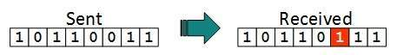

In a frame, there is only one bit, anywhere though, which is corrupt.

* **Multiple bits error**

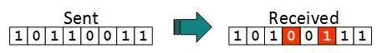

Frame is received with more than one bits in corrupted state.

* **Burst error**

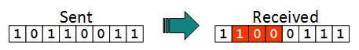

Frame contains more than1 consecutive bits corrupted.

Error control mechanism may involve two possible ways:

* Error detection
* Error correction

## Error Detection

Errors in the received frames are detected by means of Parity Check and Cyclic Redundancy Check (CRC). In both cases, few extra bits are sent along with actual data to confirm that bits received at other end are same as they were sent. If the counter-check at receiver’ end fails, the bits are considered corrupted.

### **Parity Check**

One extra bit is sent along with the original bits to make number of 1s either even in case of even parity, or odd in case of odd parity.

The sender while creating a frame counts the number of 1s in it. For example, if even parity is used and number of 1s is even then one bit with value 0 is added. This way number of 1s remains even.If the number of 1s is odd, to make it even a bit with value 1 is added.

Even Parity

The receiver simply counts the number of 1s in a frame. If the count of 1s is even and even parity is used, the frame is considered to be not-corrupted and is accepted. If the count of 1s is odd and odd parity is used, the frame is still not corrupted.

If a single bit flips in transit, the receiver can detect it by counting the number of 1s. But when more than one bits are erro neous, then it is very hard for the receiver to detect the error.

### **Cyclic Redundancy Check (CRC)**

CRC is a different approach to detect if the received frame contains valid data. This technique involves binary division of the data bits being sent. The divisor is generated using polynomials. The sender performs a division operation on the bits being sent and calculates the remainder. Before sending the actual bits, the sender adds the remainder at the end of the actual bits. Actual data bits plus the remainder is called a codeword. The sender transmits data bits as codewords.

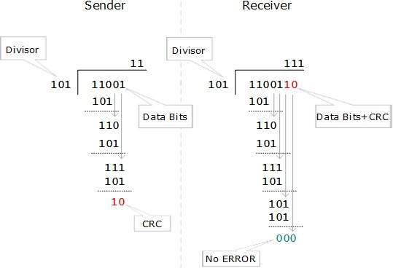

At the other end, the receiver performs division operation on codewords using the same CRC divisor. If the remainder contains all zeros the data bits are accepted, otherwise it is considered as there some data corruption occurred in transit.

## Error Correction

In the digital world, error correction can be done in two ways:

* **Backward Error Correction** When the receiver detects an error in the data received, it requests back the sender to retransmit the data unit.
* **Forward Error Correction** When the receiver detects some error in the data received, it executes error-correcting code, which helps it to auto-recover and to correct some kinds of errors.

The first one, Backward Error Correction, is simple and can only be efficiently used where retransmitting is not expensive. For example, fiber optics. But in case of wireless transmission retransmitting may cost too much. In the latter case, Forward Error Correction is used.

To correct the error in data frame, the receiver must know exactly which bit in the frame is corrupted. To locate the bit in error, redundant bits are used as parity bits for error detection.For example, we take ASCII words (7 bits data), then there could be 8 kind of information we need: first seven bits to tell us which bit is error and one more bit to tell that there is no error.

For m data bits, r redundant bits are used. r bits can provide 2r combinations of information. In m+r bit codeword, there is possibility that the r bits themselves may get corrupted. So the number of r bits used must inform about m+r bit locations plus no-error information, i.e. m+r+1.