**Test Result for below business Requirement**

|  |
| --- |
| **- Please don't input words from standard input, no one like to type long list of names manually.**  **Count Words Coding Assignment**  **Write a program called Count Words that processes a List of Strings and applies the following business rules:**  **- Counts and returns the NUMBER of words (i.e., Strings) that start with "M" or "m"**  **- Returns all the words longer than 5 characters** |
| **Hints**  **- Make sure you implement this test like you would all your production code (Documentation, unit tests, build/packaging, etc.).**  **- Business rules change, and new ones pop up all the time; how will your account for this?**  **Please don’t input words from standard input, no one likes to type long list of name manually** |

**Test Case**

1. **Verify that** properties.txt and businessRule.txt **file is present in the file folder**.
2. **Verify that after running the code, Code is giving the proper output that is**

* **Output should contain string starting with M/m**
* **Output should contain string having length greater than 5.**

1. **Verify that after changing the values in** businessRule.txt **proper result is coming**

* **If you change the** INPUTCHAR in businessRule.txt **then you will get String starting with the provided char.**
* **If you change** STRINGLENGTH in businessRule.txt **then you will get String having length greater than the provided length.**

1. **Verify that if in** businessRule.txt, properties.txt **file path is not correct we will get proper error message**

**Test case 1**

1. **Verify that** properties.txt and businessRule.txt **file is present in the file folder**.

* **Select the AssessmentCountWords Project**
* **Under with select file folder and open it**
* **Check the details and close the txt file**

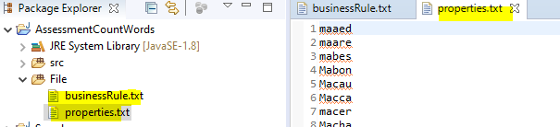

* **Both Files are present in AssessmentCountWords Project**

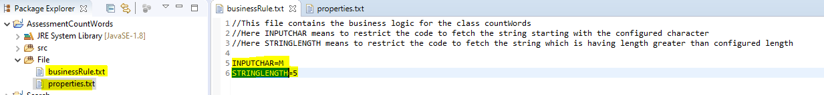

* **Verify the** businessRule.txt **file.**

**Test Case 2nd**

1. **Verify that after running the code, Code is giving the proper output that is**

* **Output should contain string starting with M/m**
* **Output should contain string having length greater than 5.**

**When character M and Length 5 is configured in** businessRule.txt **file.**

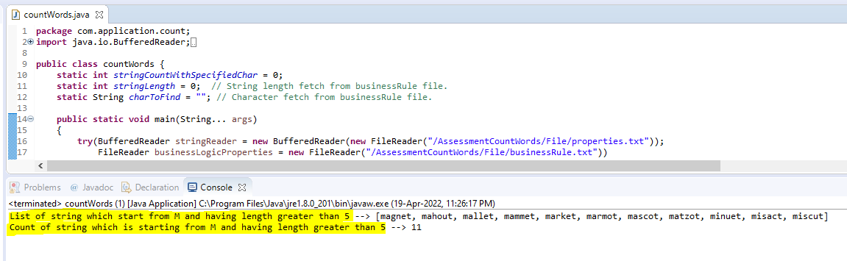

**Test Case 3rd**

1. **Verify that after changing the values in** businessRule.txt **proper result is coming**

* **If you change the** INPUTCHAR in businessRule.txt **then you will get String starting with the provided char.**
* **If you change** STRINGLENGTH in businessRule.txt **then you will get String having length greater than the provided length.**

**Change the** INPUTCHAR to K and STRINGLENGTH to 3 in businessRule.txt.

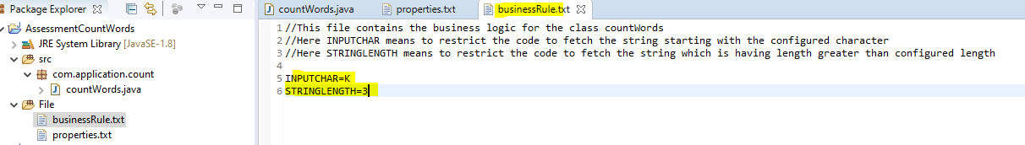

**Run the code again to verify the changes**

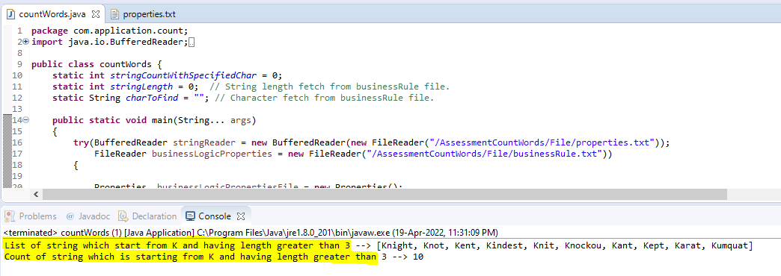

**Test Case 4th**

1. **Verify that if in** businessRule.txt, properties.txt **file path is not correct we will get proper error message**

