Grocery Pricing & Inventory Dashboard

Project Overview
This project performs Exploratory Data Analysis (EDA) on a grocery inventory dataset to analyze pricing, discount patterns, and inventory status. Using Python, SQL, and Power BI, the project uncovers key insights, identifies best-value products, and presents findings through an interactive dashboard to support data-driven retail decisions.
Dataset Summary

The dataset consists of product-level grocery inventory data representing items commonly sold on online quick-commerce platforms. Each record corresponds to an individual product and captures detailed information related to pricing, discounts, quantity, and stock availability.

The dataset includes categorical attributes such as product category and product name, along with numerical features like MRP (Maximum Retail Price), discount percentage, discounted selling price, product weight (in grams), and quantity available or ordered.

Additionally, a boolean field indicates whether a product is currently out of stock, allowing inventory health analysis.

This dataset enables comprehensive exploratory analysis of:
- Pricing structure and discount strategies
- Product value comparison using price-per-gram metrics
- Bulk versus single-unit purchase patterns
- Inventory availability and stock distribution

Exploratory Data Analysis using Python
We began with data preparation and cleaning in Python:

- Data Loading: Imported the dataset using pandas.

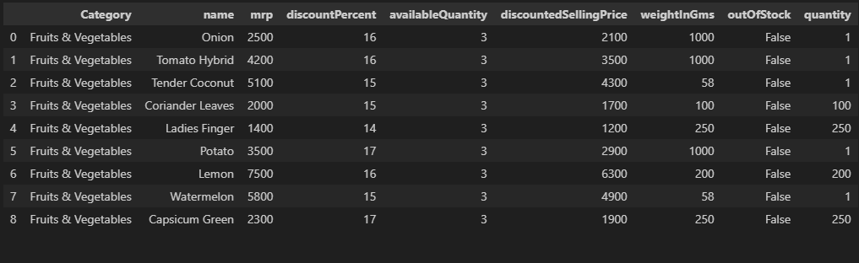
- Initial Exploration: Used df.info() to check structure and .describe() for summary statistics.
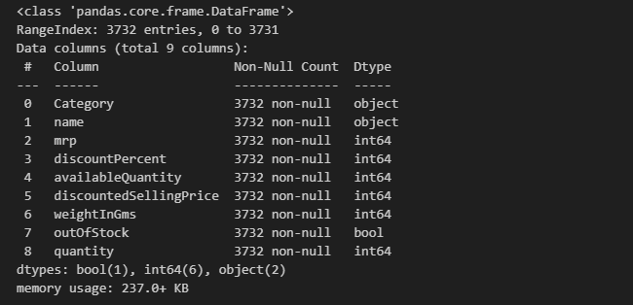

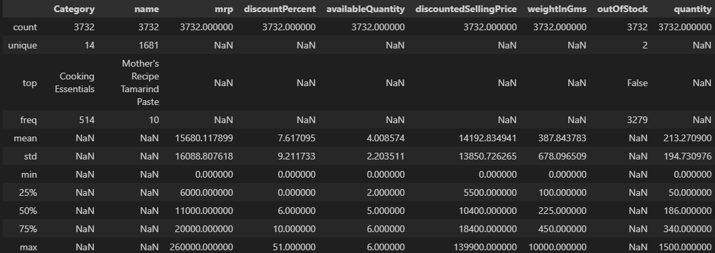

- Missing Data Handling: Checked for null values and imputed missing values in the dataset .

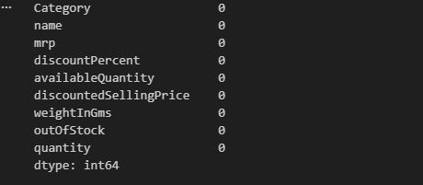

- Data type correction: Correct the 3 columns data types .

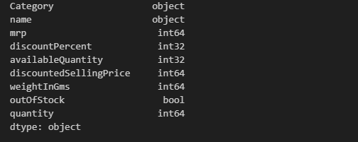

- Column Standardization: Renamed columns to snake case for better readability and documentation.

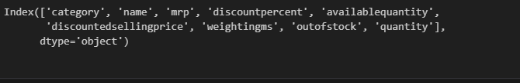

- Feature Engineering:

  - Create Column Calculate discount amount .

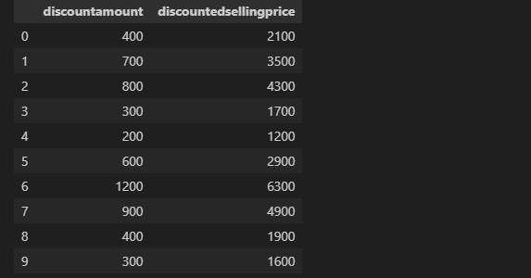

  - Create Column Price per gram .

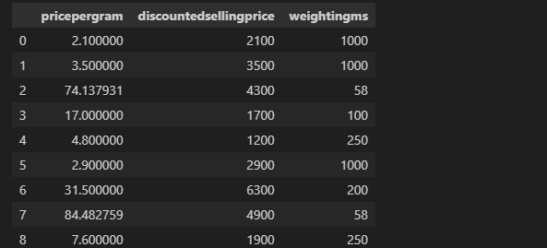

  - Create Column Total stock value .

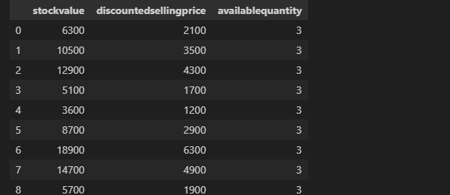

  - Category level analysis .

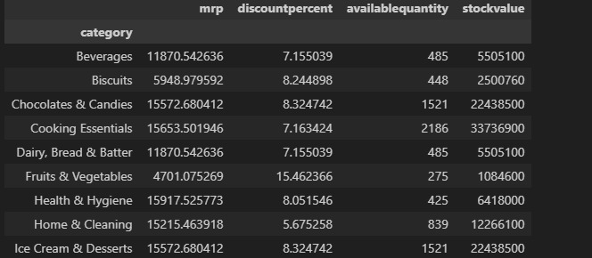

  - Average Selling Price by Category .

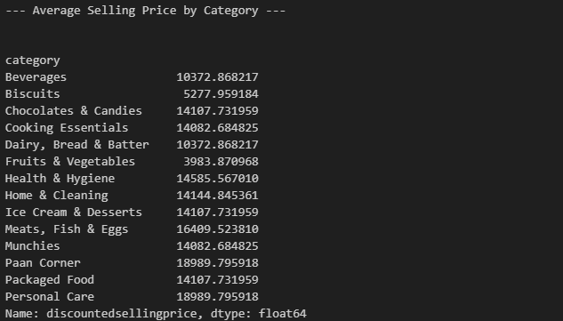

  - Total Quality Sold by Category .

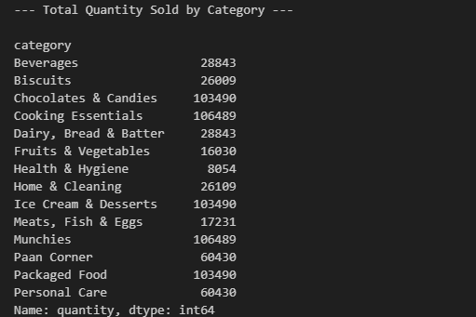

  - Highest Discount Product .

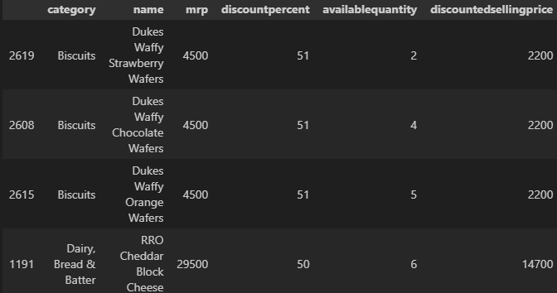

  - Top Expensive Product .

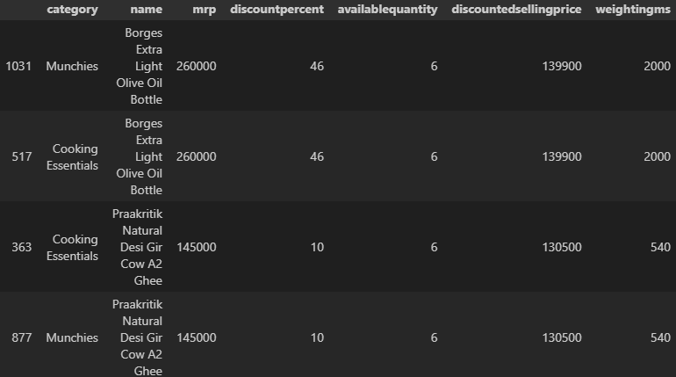

  - Out of Stock Product .

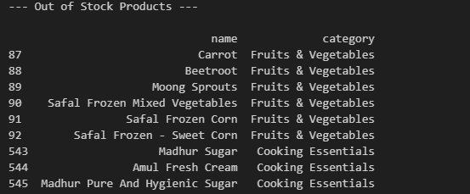

- Database Integration: Connected Python script to MySQL Database and loaded the cleaned DataFrame into the database for SQL analysis.

Data Analysis Using MySQL
We performed structured analysis in PostgreSQL to answer key business questions:

1. Find the top 10 best-value products based on the discount percentage.

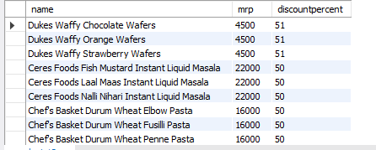
2. What are the Products with High MRP but Out of Stock
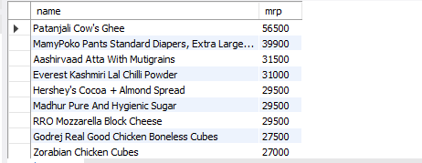

3. Calculate Estimated Revenue for each category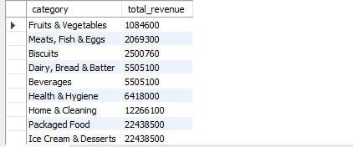

4. Find all products where MRP is greater than ₹500 and discount is less than 10%.
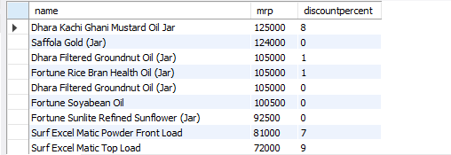
5. Identify the top 5 categories offering the highest average discount percentage.
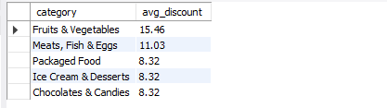
6. Find the price per gram for products above 100g and sort by best value.
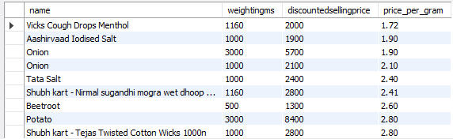

7. Group the products into categories like Low, Medium, Bulk.
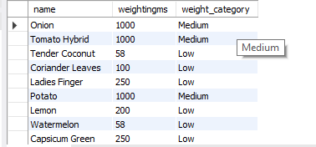
8. What is the Total Inventory Weight Per Category
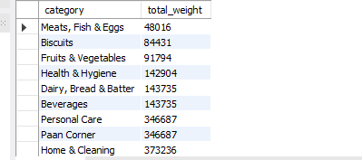

Dashboard in Power BI

Finally, we built an interactive dashboard in Power BI to present insights visually.

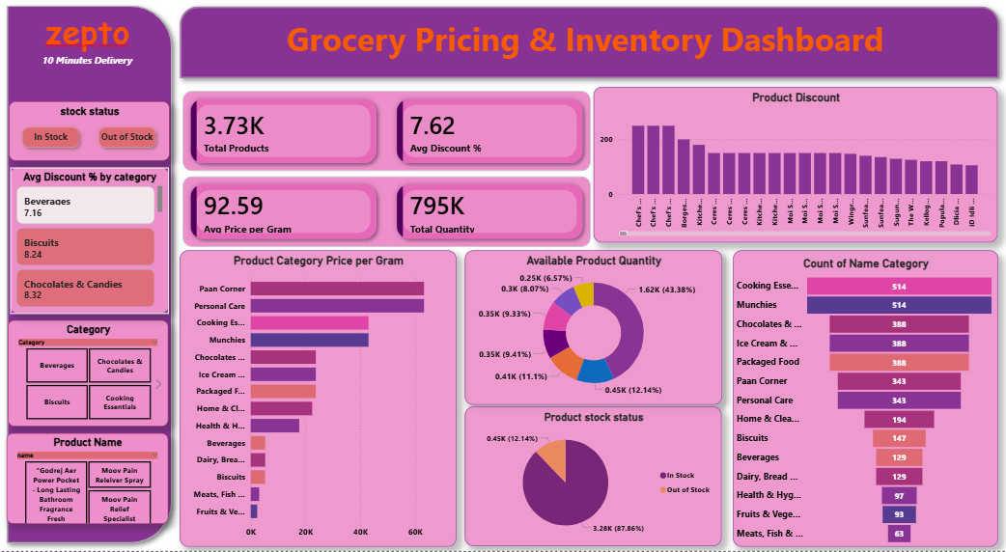

Business Recommendations

- Promote bulk products as cost-effective options
- Use price per gram as a key metric for pricing decisions
- Maintain controlled discount strategies to protect margins
- Monitor quantity trends for inventory planning
- Leverage dashboards for real-time pricing and stock monitoring

