## **Summer Training Report**

## **On**

**Student’s Details Management System**

## **Submitted**

## **In The Partial Fulfillment Of**

## **Bachelor of Technology**

## **(Computer Science Engineering)**

## **Submitted by:**

## **Mohd Afzal**

## **Roll No.-00220907217**

# C:\Users\Shehzad\Downloads\download.jpg

DEPT. OF COMPUTER SCIENCE

GOVIND BALLABH PANT ENGINEERING COLLEGE

NEW DELHI-110020

2016-2020

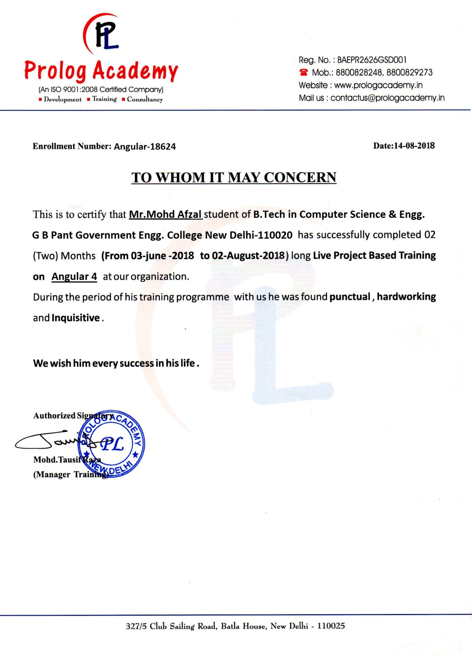

**ACKNOWLEDGEMENT**

It is my pleasure to be indebted to various people, who directly or indirectly contributed in the development of this work and who influenced my thinking, behavior, and acts during the course of study.

I am thankful to **Mrs. Sunita Kumari** for his support, cooperation, and motivation provided to me during the training for constant inspiration, presence and blessings.

Furthermore, I would also like to acknowledge with much appreciation the crucial role of our college faculty members of CSE Department for their encouragement & guidance.

Lastly, I would like to thank the almighty and my parents for their moral support and my friends with whom I shared my day-to-day experience and received lots of suggestions that improved my quality of work.

**CANDIDATE DECLARATION**

I, **MOHD AFZAL**, Roll No. 00220907217, B.Tech(Semester-5th) of Govind Ballabh Pant Engineering College, New Delhi hereby declare that the Training Report entitled “**Online Student Management System**” is an original work and data provided in the study is authentic to the best of my knowledge. This report has not been submitted to any other institute for the award of any other degree.

Place: New Delhi **Mohd Afzal**

Date: 12.11.2018 (Roll No: 00220907217)

CONTENTS

1. **INTRODUCTION 7**
   1. Introduction to Organisation
   2. Introduction to Project
   3. Technology

1.3.1 Front End

1.3.1.1 Angular 4

1.3.2 Back End

1.3.2.1 Spring

1.3.3 Database

1.3.3.1 PostgreSQL

1. **REQUIREMENT ANALYSIS AND SYSTEM SPECIFICATION 17** Software Requirement Specification (SRS)
   1. Data Requirement
   2. Functional Requirement

2.2.1 Admin’s Functional Requirement

2.2.1.1 Dashboard

2.2.1.2 Add New Student

2.2.1.3 View Student’s Details

2.2.1.4 Update Student’s Details

2.2.1.5 Delete Student

2.2.1.6 Search Student

2.2.1.7 Download List of Students

2.2.2 User’s Functional Requirement

2.2.2.1 Dashboard

2.2.2.2 View Student’s Details

2.2.2.3 Filter

2.2.2.4 Download List of Students

2.3 Performance Requirement

1. **PROJECT DESIGN 20**
   1. Use Case Diagram
   2. ER Diagram
2. **RESULT 22** 
   1. Snapshots of Application
3. **REFRENCE 29**

**CHAPTER 1**

**INTRODUCTION**

**1.1 Introduction to Organisation**

I had my two months training at Prolog Academy which is one of the best training academy of Delhi with a unique focus on quality training on innovative technologies, leadership and design, started by an Jamia Millia Islamia alumni in 2010.

Today, Prolog Academy is one of the pioneers in providing innovative training. Their ideology is to be a consultant to their students rather than making more customers. They have developed many applications in Education sector. 

Good thing about Prolog Academy is that it is driven by ethical values, energy to build great trainees and determination to deliver the best. They are keen to provide out of box tricks to the students keeping the cost to academy aside. Prolog academy faculty are trained to work under various technologies such as Java, Web designing, Android, PHP, Java Script, Angular etc.

**1.2 Introduction to Project**

The purpose of the student’s details management system application is to provide a platform to share student’s details with recruiters, using this application recruits can view the student’s details, filter students by their aggregate percentage and can generate pdf file of filtered student’s details in a tabular form.

It is a platform that can be used during the recruitment process in the colleges, and can help the recruiters to shortlist students for interview process by using its filter.

It is an application that is designed for the storing and managing student’s details. In this application there are two types of users-

1. Admin
2. User

**Admin** can add the students in the record, view their details. Admin can also edit the details of students as well as he can delete the record of student, and he can generate a pdf file of students and can further print that. Admin can be TPO department of the college that creates a database of students record and want to share with the recruiters for shortlisting process to interview.

**User** can be the recruiter who wants a database of students and he has to shortlist students for the interview process. This application provides a convenient way to share the database as well as to shortlist the students by using filter as per the recruiter’s percentage criteria. Recruiter can easily filter the students by their aggregate percentage and generate the pdf file of shortlisted students.

It will save time, efforts and complexity, and also provide a very convenient and user-friendly environment to shortlist the students as per given percentage criteria.

Role of the user will depend on the login credential, as both admin as well as user have their separate login credentials. Here the role of user plays an important role as user could not update details of the student, and could not be able to delete a student from the database. User Can only view the details filter on their aggregate percentage and can generate pdf file of filtered students.

But if application is logged-in by admin’s login credentials then admin have authority to add, update, delete students.

This basic idea to develop this application is, Admin crates a database of students, and then share the user’s login credentials with the recruiters, by using this login credential recruiters can view the database and can filter according to the desired percentage criteria to shortlist the students for interview process.

**1.3 Technology**

**1.3.1 Front End**

**1.3.1.1 Angular 4**

**Angular 4**

Angular 4 is a JavaScript framework for building web applications and apps in JavaScript, html, and TypeScript, which is a superset of JavaScript. Angular provides built-in features for animation, http service, and materials which in turn has features such as auto-complete, navigation, toolbar, menus, etc. The code is written in TypeScript, which compiles to JavaScript and displays the same in the browser.

There are three major releases of Angular. The first version that was released is Angular1, which is also called AngularJS. Angular1 was followed by Angular2, which came in with a lot of changes when compared to Angular1.

The structure of Angular is based on the components/services architecture. AngularJS was based on the model view controller. **Angular 4** released in March 2017 proves to be a major breakthrough and is the latest release from the Angular team after Angular2.

Angular is an open source web application framework. It was originally developed in 2009 by Misko Hevery and Adam Abrons. It is now maintained by Google.

## **Features**

* Angular is a powerful JavaScript based development framework to create RICH Internet Application(RIA).
* Angular provides developers options to write client side application (using JavaScript) in a clean MVC(Model View Controller) way.
* Application written in Angular is cross-browser compliant. Angular automatically handles JavaScript code suitable for each browser.
* Angular is open source, completely free, and used by thousands of developers around the world. It is licensed under the Apache License version 2.0.

Overall, Angular is a framework to build large scale and high performance web application while keeping them as easy-to-maintain.

## **Core Features**

Following are most important core features of Angular −

* **Data-binding** − It is the automatic synchronization of data between model and view components.
* **Scope** − These are objects that refer to the model. They act as a glue between controller and view.
* **Controller** − These are JavaScript functions that are bound to a particular scope.
* **Services** − Angular come with several built-in services for example $https: to make a XMLHttpRequests. These are singleton objects which are instantiated only once in app.
* **Filters** − These select a subset of items from an array and returns a new array.
* **Directives** − Directives are markers on DOM elements (such as elements, attributes, css, and more). These can be used to create custom HTML tags that serve as new, custom widgets. Angular has built-in directives (ngBind, ngModel...)
* **Templates** − These are the rendered view with information from the controller and model. These can be a single file (like index.html) or multiple views in one page using "partials".
* **Routing** − It is concept of switching views.
* **Model View Whatever** − MVC is a design pattern for dividing an application into different parts (called Model, View and Controller), each with distinct responsibilities. AngularJS does not implement MVC in the traditional sense, but rather something closer to MVVM (Model-View-ViewModel). The Angular JS team refers it humorously as Model View Whatever.

## **Concepts**

Following diagram depicts some important parts of Angular :

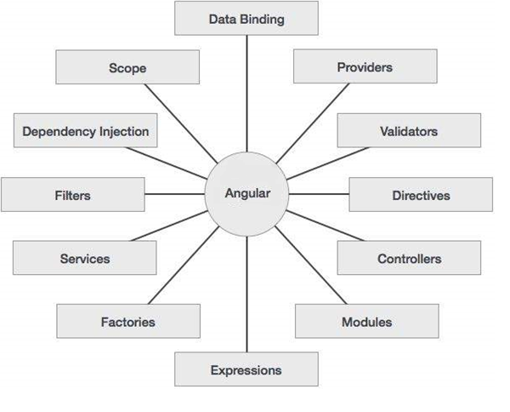

Figure 1.1: Features of Angular

## **Angular Components**

The Angular framework can be divided into following three major parts −

* **ng-app** − This directive defines and links an Angular application to HTML.
* **ng-model** − This directive binds the values of Angular application data to HTML input controls.
* **ng-bind** − This directive binds the AngularJS Application data to HTML tags.

**1.3.2 Back end**

**1.3.2.1 Spring**

**Spring**

Spring framework is an open source Java platform that provides comprehensive infrastructure support for developing robust Java applications very easily and very rapidly. Spring framework was initially written by Rod Johnson and was first released under the Apache 2.0 license in June 2003.

Spring is the most popular application development framework for enterprise Java. Millions of developers around the world use Spring Framework to create high performing, easily testable, and reusable code.

Spring framework is an open source Java platform. It was initially written by Rod Johnson and was first released under the Apache 2.0 license in June 2003.

Spring is lightweight when it comes to size and transparency. The basic version of Spring framework is around 2MB.

The core features of the Spring Framework can be used in developing any Java application, but there are extensions for building web applications on top of the Java EE platform. Spring framework targets to make J2EE development easier to use and promotes good programming practices by enabling a POJO-based programming model.

## **Benefits of Using the Spring Framework**

Following is the list of few of the great benefits of using Spring Framework −

* Spring enables developers to develop enterprise-class applications using POJOs. The benefit of using only POJOs is that you do not need an EJB container product such as an application server but you have the option of using only a robust servlet container such as Tomcat or some commercial product.
* Spring is organized in a modular fashion. Even though the number of packages and classes are substantial, you have to worry only about the ones you need and ignore the rest.
* Spring does not reinvent the wheel, instead it truly makes use of some of the existing technologies like several ORM frameworks, logging frameworks, JEE, Quartz and JDK timers, and other view technologies.
* Testing an application written with Spring is simple because environment-dependent code is moved into this framework. Furthermore, by using JavaBeanstyle POJOs, it becomes easier to use dependency injection for injecting test data.
* Spring's web framework is a well-designed web MVC framework, which provides a great alternative to web frameworks such as Struts or other over-engineered or less popular web frameworks.
* Spring provides a convenient API to translate technology-specific exceptions (thrown by JDBC, Hibernate, or JDO, for example) into consistent, unchecked exceptions.
* Lightweight IoC containers tend to be lightweight, especially when compared to EJB containers, for example. This is beneficial for developing and deploying applications on computers with limited memory and CPU resources.
* Spring provides a consistent transaction management interface that can scale down to a local transaction (using a single database, for example) and scale up to global transactions (using JTA, for example).

# **Spring Modules**

The Spring framework comprises of many modules such as core, beans, context, expression language, AOP, Aspects, Instrumentation, JDBC, ORM, OXM, JMS, Transaction, Web, Servlet, Struts etc. These modules are grouped into Test, Core Container, AOP, Aspects, Instrumentation, Data Access / Integration, Web (MVC / Remoting) as displayed in the following diagram.

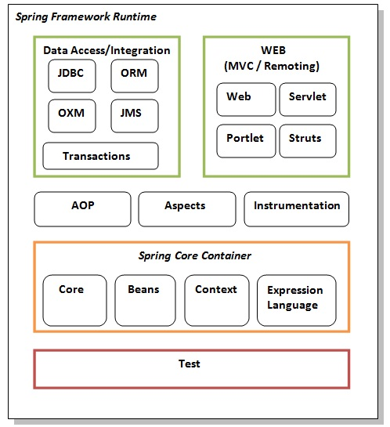

Figure 1.2: Spring Modules

**Spring Modules:**

Spring Modules can be divided into following three major parts −

* **Test -** This layer provides support of testing with JUnit and TestNG.
* **Spring Core Container -** The Spring Core container contains core, beans, context and expression language (EL) modules.
* **Core and Beans -** These modules provide IOC and Dependency Injection features.
* **Context *-*** This module supports internationalization (I18N), EJB, JMS, Basic Remoting.

#### **Expression Language -** It is an extension to the EL defined in JSP. It provides support to setting and getting property values, method invocation, accessing collections and indexers, named variables, logical and arithmetic operators, retrieval of objects by name etc.

#### **AOP, Aspects and Instrumentation -** These modules support aspect oriented programming implementation where you can use Advices, Pointcuts etc. to decouple the code.The aspects module provides support to integration with AspectJ.The instrumentation module provides support to class instrumentation and classloader implementations.

#### **Data Access / Integration -** This group comprises of JDBC, ORM, OXM, JMS and Transaction modules. These modules basically provide support to interact with the database.

#### **Web -** This group comprises of Web, Web-Servlet, Web-Struts and Web-Portlet. These modules provide support to create web application.

**1.3.1 Database**

**1.3.3.1 PostgreSQL**

**PostgreSQL**

PostgreSQL is a powerful, open source object-relational database system. It has more than 15 years of active development and a proven architecture that has earned it a strong reputation for reliability, data integrity, and correctness. PostgreSQL runs on all major operating systems, including Linux, UNIX (AIX, BSD, HP-UX, SGI IRIX, Mac OS X, Solaris, Tru64), and Windows.Node.js was written and introduced by Ryan Dahl in 2009.

PostgreSQL (pronounced as **post-gress-Q-L**) is an open source relational database management system (DBMS) developed by a worldwide team of volunteers. PostgreSQL is not controlled by any corporation or other private entity and the source code is available free of charge.

PostgreSQL, originally called Postgres, was created at UCB by a computer science professor named Michael Stonebraker. Stonebraker started Postgres in 1986 as a follow-up project to its predecessor, Ingres, now owned by Computer Associates.

## **Key Features of PostgreSQL**

PostgreSQL runs on all major operating systems, including Linux, UNIX (AIX, BSD, HP-UX, SGI IRIX, Mac OS X, Solaris, Tru64), and Windows. It supports text, images, sounds, and video, and includes programming interfaces for C / C++, Java, Perl, Python, Ruby, Tcl and Open Database Connectivity (ODBC).

PostgreSQL supports a large part of the SQL standard and offers many modern features including the following −

* Complex SQL queries
* SQL Sub-selects
* Foreign keys
* Trigger
* Views
* Transactions
* Multiversion concurrency control (MVCC)
* Streaming Replication (as of 9.0)
* Hot Standby (as of 9.0)

Also, PostgreSQL can be extended by the user in many ways, for example by adding new

* Data types
* Functions
* Operators
* Aggregate functions
* Index methods
* Procedural languages

And because of the liberal license, PostgreSQL can be used, modified, and distributed by anyone free of charge for any purpose, be it private, commercial, or academic.

**CHAPTER 2**

**REQUIREMENT ANALYSIS AND SYSTEM SPECIFICATION**

Software Requirement Specification (SRS)

* 1. **Data Requirement**

Data Requirements is meant to be the data that will be used in our application. Data required in their project in all details of students that need to be conveyed to the user. This application also require the username and passwords of persons to login as admin as well as user. So the main requirements is student’s Details

* 1. **Functional Requirement**

In order to make the application functional, we require the functional requirements. There are two types of functionalities in this application separate for admin and user. Both of the parties can login into the application by their separate login credentials.

1. **Admin’s Functional Requirements**

In order to make application functional as the role of admin, we require the following-

**2.2.1.1 Dashboard**

Given that admin is logged in, then first page that is shown should be the dashboard page.

**2.2.1.2 Add New Student**

Admin should be able to add new students into records and store his/her all the relevant details into database.

**2.2.1.3 View Student’s Details**

Admin should be able to view all the details of particular student only who has already added into the application.

**2.2.1.4 Update Student’s Details**

Admin should be able to update the details of particular student who has already added into records.

* + - 1. **Delete Student**

Admin should be able to delete student from the record, that particular student should be permanently deleted from the database.

* + - 1. **Search Student**

Admin should be able to search student by his first name in order to view, update or delete the details of that particular student.

* + - 1. **Download List of Students**

Admin should be able to download document file or pdf file containing the list of student’s details in order to print the student’s record.

1. **User’s Functional Requirements**

**2.2.2.1 Dashboard**

Given that user is logged in, then first page that is shown should be the dashboard page, containing a table of student’s details.

**2.2.2.2 View Student’s Details**

User should be able to view all the details of particular student only who has already added into the application.

**2.2.2.3 Filter**

User should be able to filter the students by their aggregate percentage. When user enters a percentage in the search box, all the students having aggregate percentage more than or equal to that percentage should only be visible to user.

**2.2.2.4 Download List of Students**

User should be able to download pdf file containing the list of filtered student’s details in order to print the selected student’s record.

* 1. **Performance Requirement**

The requirements in this section provide a detailed specification of the admin and user interaction with the software:

* Prominent search feature
* Response time should be less
* Fault tolerance should be good

**CHAPTER 3**

**PROJECT DESIGN**

**3.1 Use Case Diagram**

**Use case diagram** are usually referred to as behavior diagrams used to describe a set of actors (use cases) that some system or systems (subject) should or can perform in collaboration with one or more external users of the system(actors).

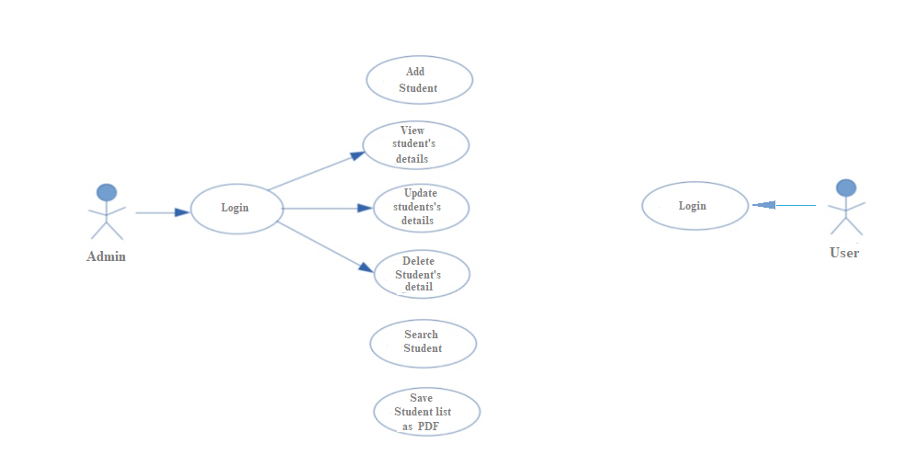

Figure 3.1 Use Case Diagram

**3.2 ER Diagram**

**Entity-relationship diagram (ERD)** is a data modeling technique that graphically illustrates an information system’s entities and the relationships between those entities. An ERD is a conceptual and representational model of data used to represent the entity framework infrastructure.

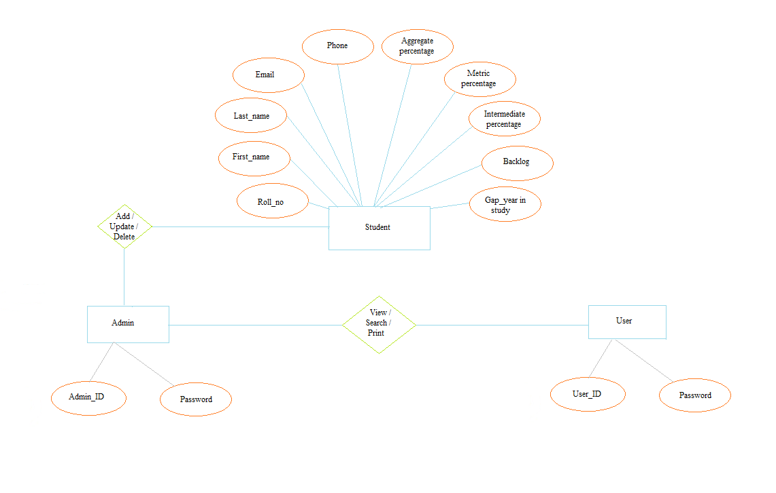

Figure 3.2 ER Diagram

**CHAPTER 4**

**RESULT**

**4.1 Snapshots**

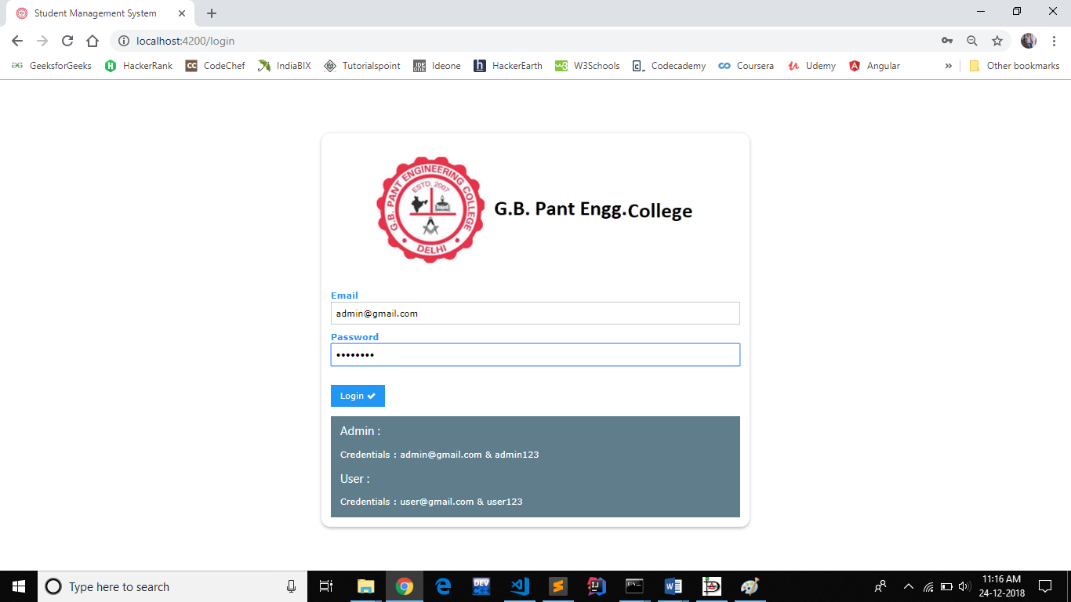

**Figure 4.1 : Login Page**

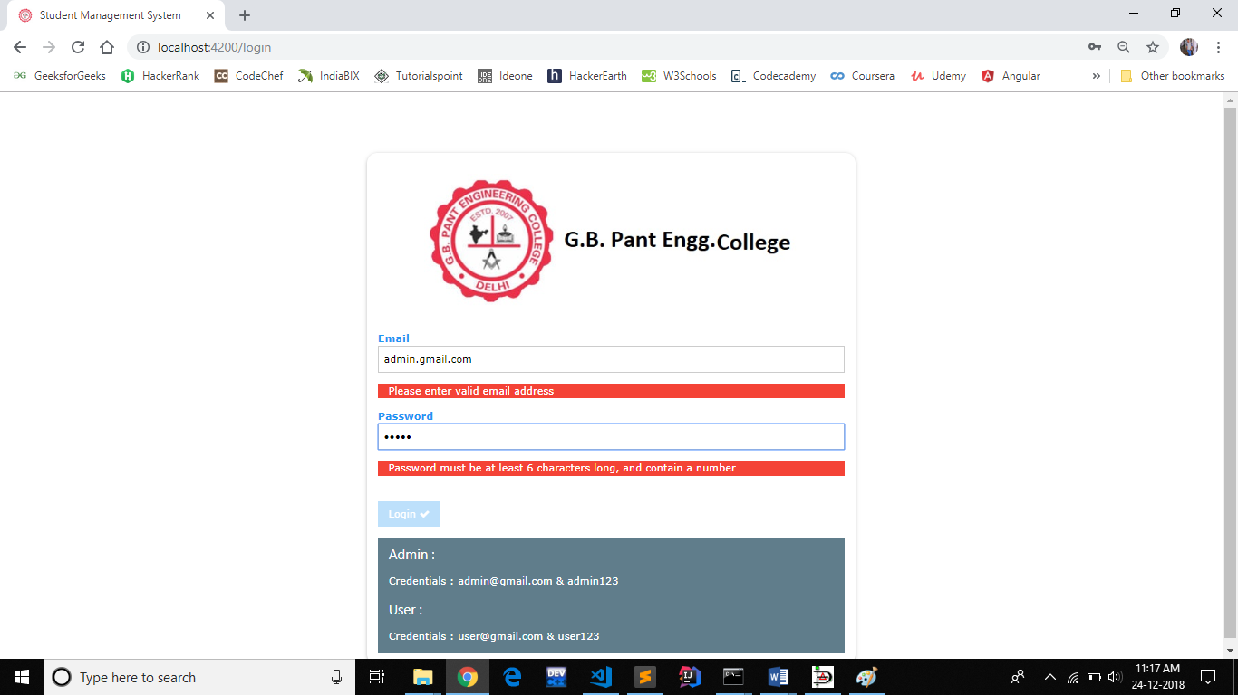

**Figure 4.2 : Validation on Login credentials**

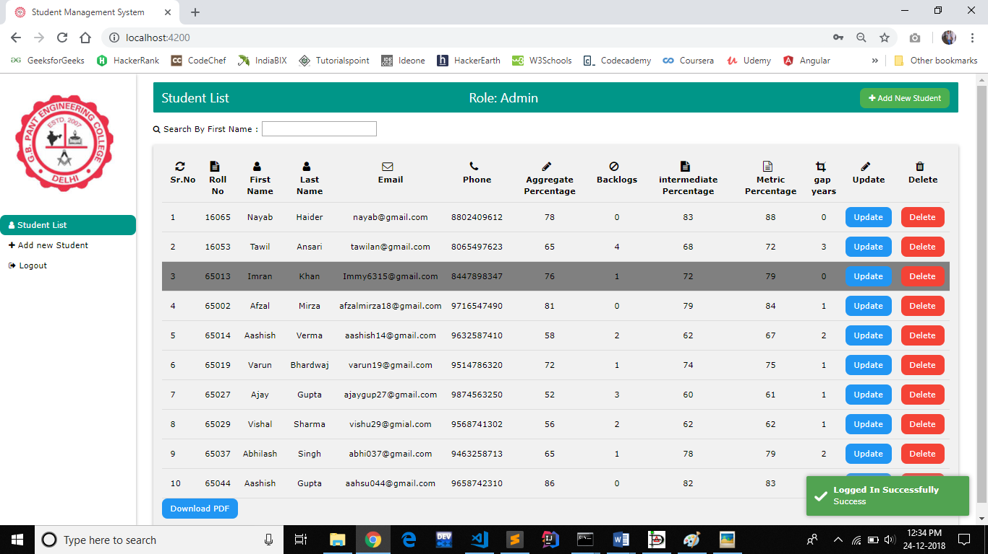

**Figure 4.3 : Dashboard**

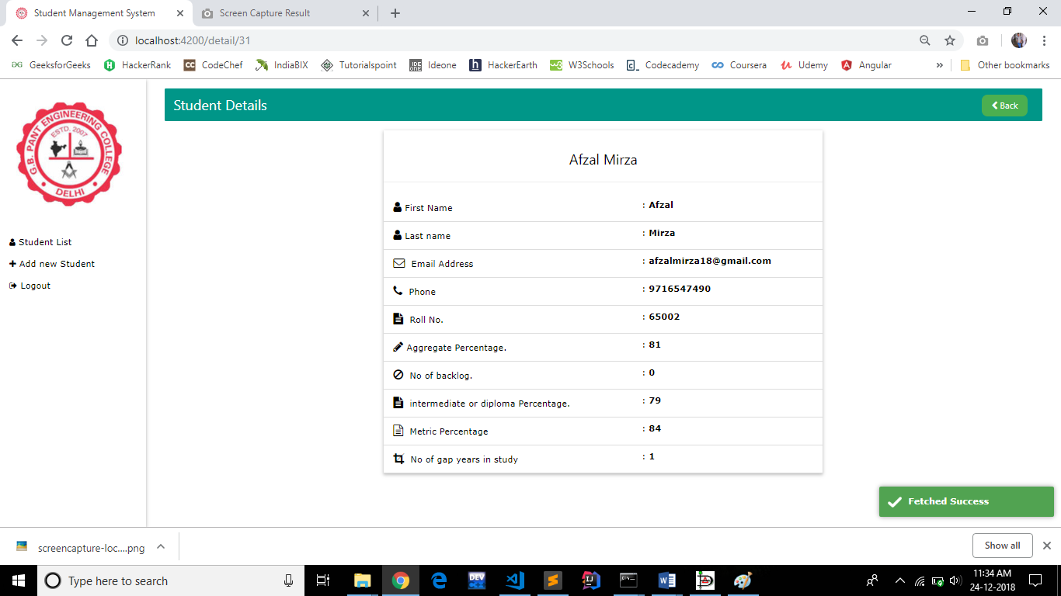

**Figure 4.4: View Details of a perticular student**

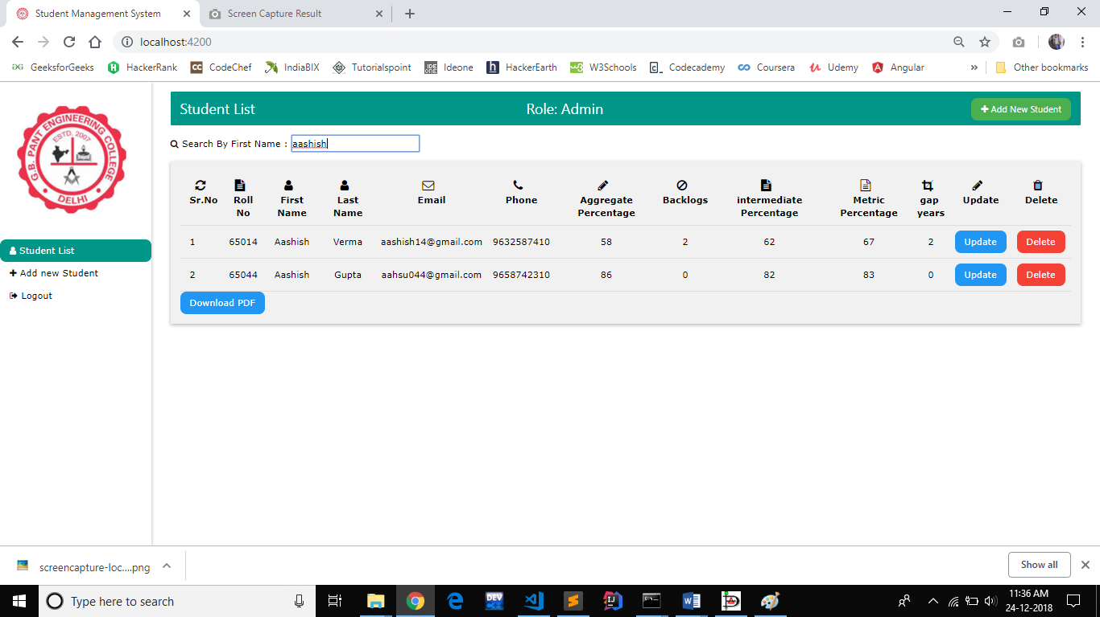

**Figure 4.5 : Search**

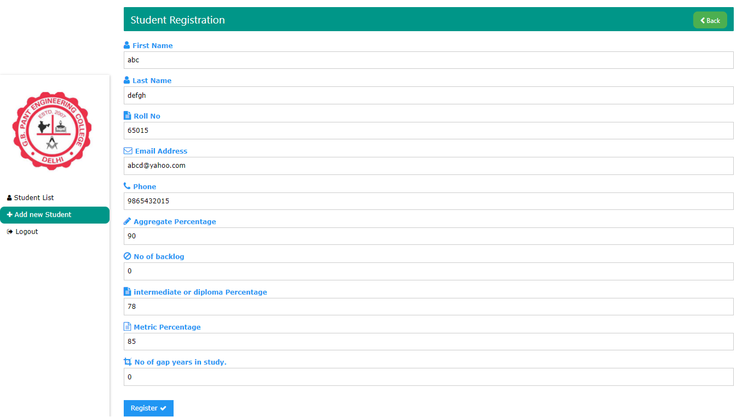

**Figure 4.6: Student Registration**

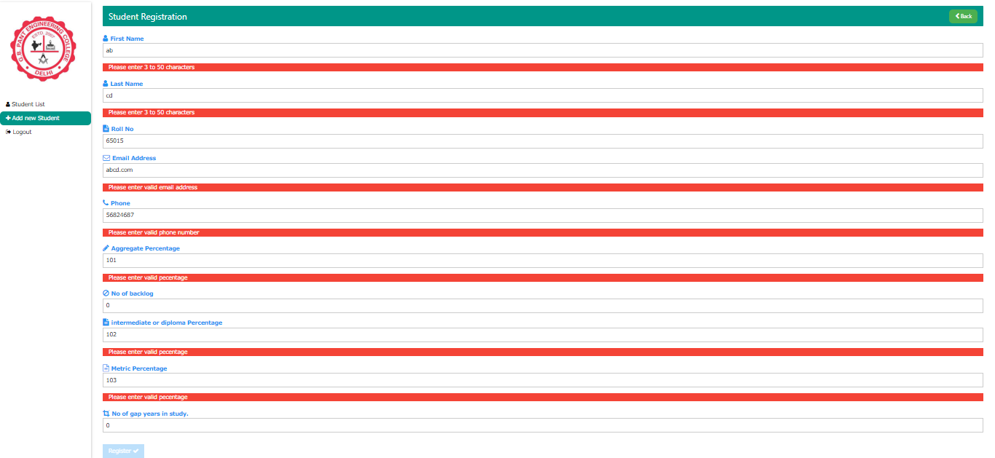

**Figure 4.7 : Validation on Student Registration**

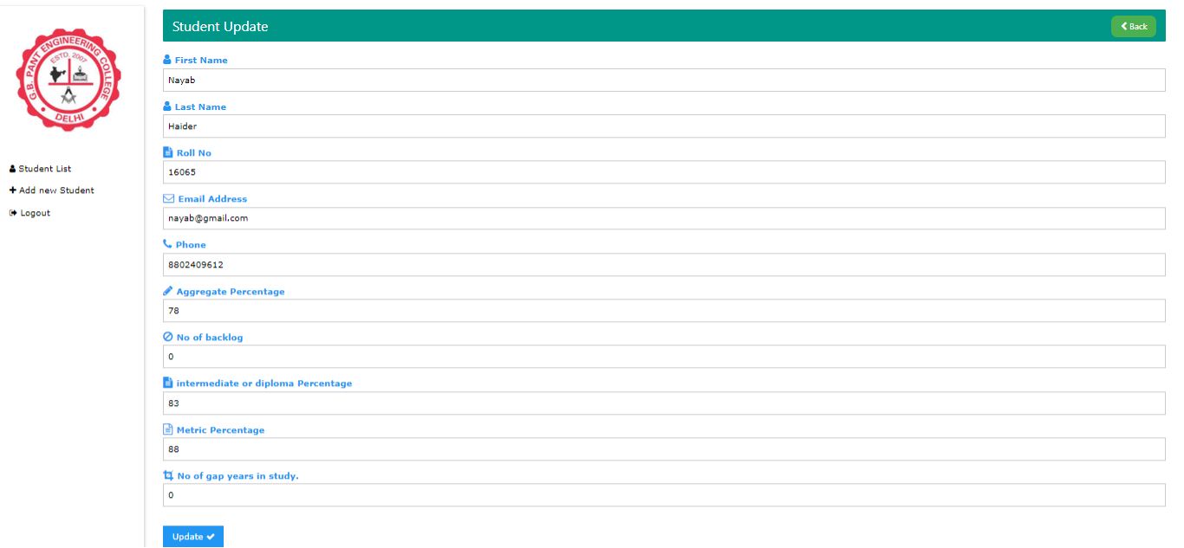

**Figure 4.8: Update Student Details**

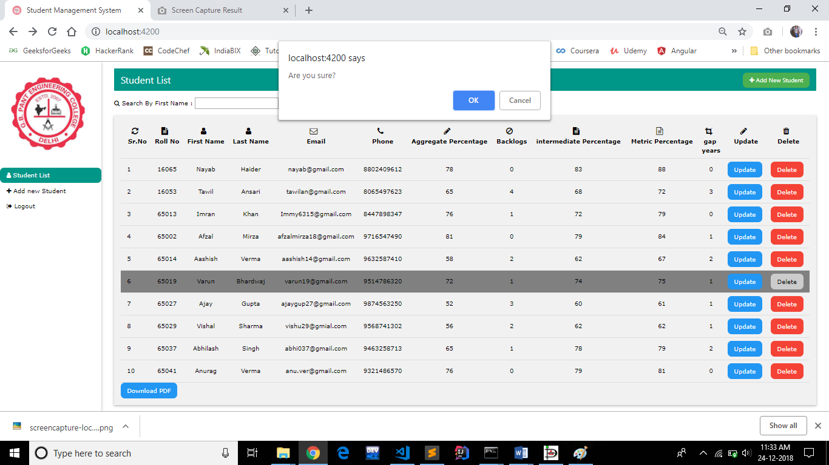

**Figure 4.9 : Deleting the Student’s Record**

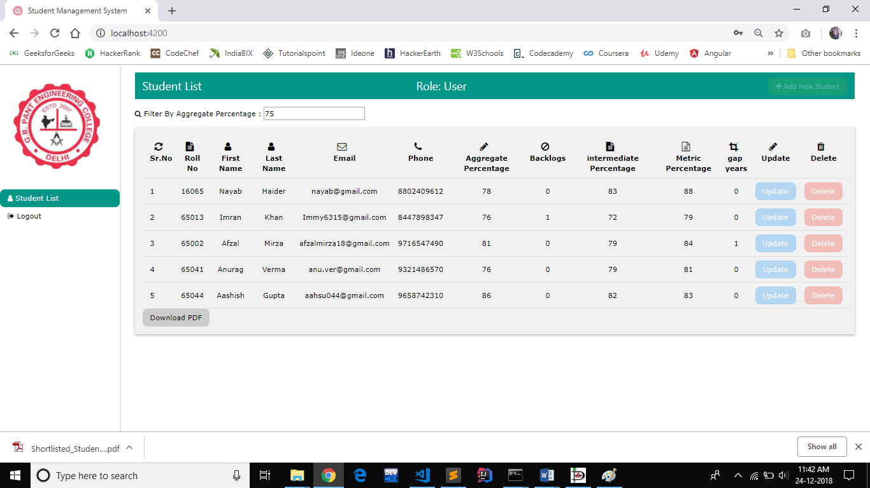

**Figure 4.10: Filter Students by Aggregate percentage**

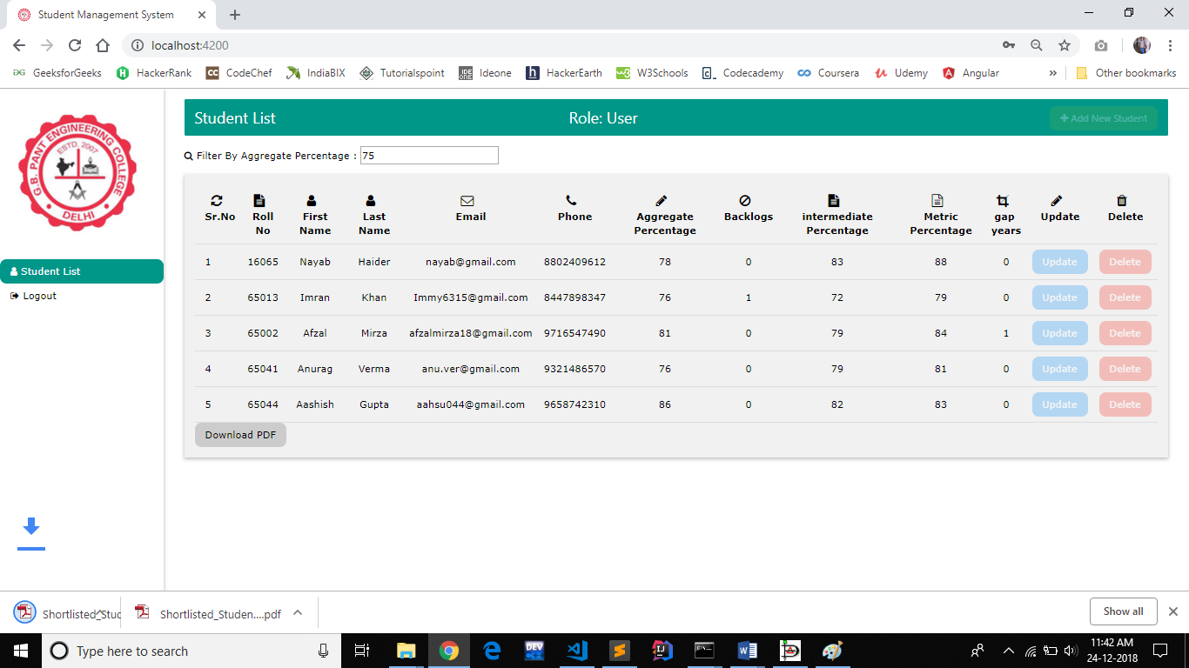

**Figure 4.11 : Generating pdf of Filtered Students**

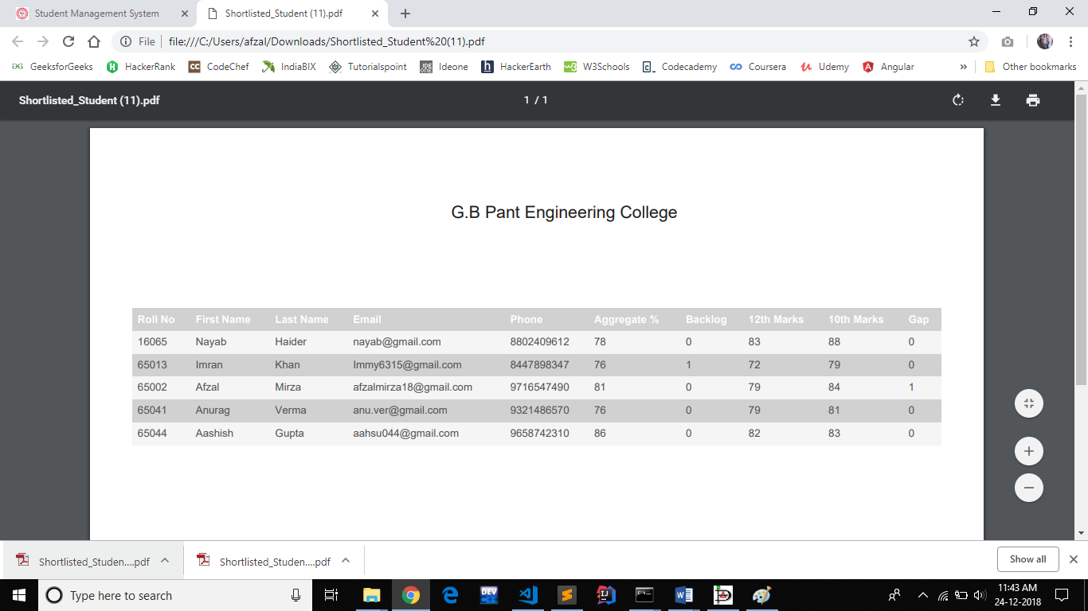

**Figure 4.12: Generated pdf**

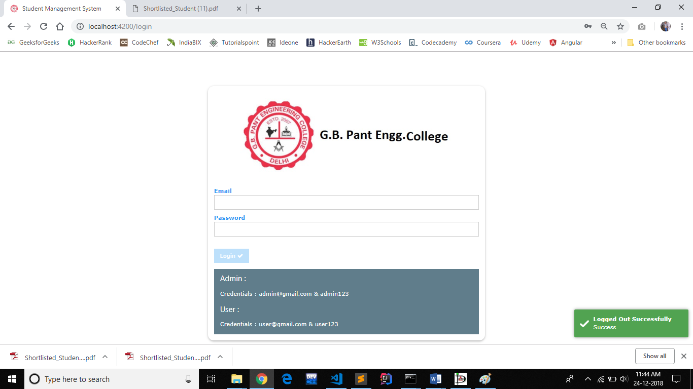

**Figure 4.13 : Logout User**

**CHAPTER 5**

**REFERENCE**

* [**https://angular.io/guide/quickstart#the-src-folder**](https://angular.io/guide/quickstart#the-src-folder)
* [**https://spring.io/docs**](https://spring.io/docs)
* [**https://www.postgresql.org/docs/**](https://www.postgresql.org/docs/)