NEWS WEBSITE

## A PROJECT REPORT

**for**

**Mini Project (KCA353) Session (2023-24)**

**Submitted by MOHD. ARKAN**

**2200290140093**

### Submitted in partial fulfilment of the Requirements for the Degree of

MASTER OF COMPUTER APPLICATION

**Under the Supervision of DR. AMIT KUMAR GOYA****L**

**ASSOCIATE PROFESSOR**



# Submitted to

**Department Of Computer Applications**

**KIET Group of Institutions, Ghaziabad Uttar Pradesh-201206**

**2023-24**

## CERTIFICATE

It is to Certified that **MOHD. ARKAN** has/ have carried out the project work having **“NEWS WEBSITE” (Mini Project-KCA353)** for **Master of Computer Application** from Dr. A.P.J. Abdul Kalam Technical University (AKTU) (formerly UPTU), Lucknow under my supervision. The project report embodies original work, and studies are carried out by the student himself/herself and the contents of the project report do not form the basis for the award of any other degree to the candidate or to anybody else from this or any other University/Institution.

**Date:**

**Mohd. Arkan 2200290140093**

This is to certify that the above statement made by the candidate is correct to the best of my knowledge.

Date:

**Dr. Amit Kumar Goyal Dr. Arun Kumar Tripathi**

**Associate Professor Head of Department**

**Department Of Computer Department of Computer**

**Applications, KIET Group of Applications, KIET Group**

**Institutions, Ghaziabad of Institutions, Ghaziabad**

## ABSTRACT

In today's world, technology is like the air we breathe – we rely on it all the time. Computers and the internet have changed everything. Think about your day; chances are, you use technology from morning till night. This is a special time for computers; they're doing so much for us, especially through websites and apps. These websites help us find information super easily, and they don't cost much to use.

Information is gold today. But in a big and diverse country like India, sometimes news doesn't reach everyone who needs it. That's where our news website steps in. We want to make sure news gets to everyone quickly and easily. Our plan is to use technology to build a website where everyone can find out what's happening. By doing this, we hope to help people make better decisions based on the news.

Our main goal is to ensure everyone gets the news they need. This will make our society more connected and informed, and that's what this project is all about.

## ACKNOWLEDGEMENT

Success in life is never attained single-handedly. My deepest gratitude goes to my project supervisor, Mr. Amit Kumar Goyal for his/ her guidance, help, and encouragement throughout my project work. Their enlightening ideas, comments, and suggestions. Words are not enough to express my gratitude to Dr. Arun Kumar Tripathi, Professor and Head, Department of Computer Applications, for his insightful comments and administrative help on various occasions. Fortunately, I have many understanding friends, who have helped me a lot on many critical conditions.

Finally, my sincere thanks go to my family members and all those who have directly and indirectly provided me with moral support and other kind of help. Without their support, completion of this work would not have been possible in time. They keep my life filled with enjoyment and happiness.

**Mohd. Arkan 2200290140093**

## TABLE OF CONTENTS

|  |  |
| --- | --- |
| **Contents** | **Page No.** |
| Certificate | i |
| Abstract | ii |
| Acknowledgement | iii |
| List of Contents | iv-vi |
| List of Figures | vii |
| **Chapter 1: Introduction** | **1-2** |
| 1.1 Project Objective | 1 |
| 1.2 Literature Review | 1 |
| 1.3 Project Organization | 2 |
| 1.4 Project Modules | 2 |
| 1.4.1 User Module | 2 |
| 1.4.2 Admin Module | 2 |
| 1.4.2.1 Admin Dashboard | 2 |
| 1.4.2.2 Sub-Admin | 2 |
| 1.4.2.3 Category | 2 |
| 1.4.2.4 Sub-Category | 3 |
| 1.4.2.5 Post | 3 |
| 1.4.2.6 Pages | 3 |
| 1.4.3 Sub-Admin Module | 3 |
| **Chapter 2: Programming Languages** | **4-5** |
| 2.1 PHP | 4 |
| 2.2 My-SQL | 4 |
| 2.3 CSS | 4 |
| 2.4 JavaScript | 5 |
| **Chapter 3: Development Models** | **6-9** |
| 3.1 Waterfall Model | 6 |
| 3.1.1 Advantages | 7 |
| 3.1.2 Disadvantages | 7 |
| 3.2 Prototype Model | 8 |
| 3.2.1 Advantages | 8 |
| 3.2.2 Disadvantages | 9 |
| 3.3 When to Use Prototype Model | 9 |
| **Chapter 4: Data Gathering** | **10-16** |
| 4.1 Documentation | 10 |

|  |  |
| --- | --- |
| 4.1.1 Data Flow Diagram | 10 |
| 4.1.1.1 Circle | 10 |
| 4.1.1.2 Arrow | 11 |
| 4.1.1.3 Square | 11 |
| 4.1.1.4 Open Rectangle | 11 |
| 4.2 Use Case Diagrams | 13 |
| 4.3 E-R Diagram | 15 |
| 4.3.1 E-R Notations | 15 |
| **Chapter 5: System Design** | **17-20** |
| 5.1 Before Start Design | 17 |
| 5.1.1 Hardware Requirement | 17 |
| 5.1.2 Software Requirement | 17 |
| 5.1.2.1 XAMPP | 17 |
| 5.1.2.2 XAMPP for Windows | 17 |
| 5.1.2.3 Programming Language | 18 |
| 5.2 Files and Database | 18 |
| **Chapter 6: Activities of System** | **21-31** |
| 6.1 User Specification | 21 |
| 6.1.1 Home Page | 21 |
| 6.1.2 About Us | 22 |
| 6.1.3 Contact Us | 22 |
| 6.1.4 News | 23 |
| 6.1.5 Admin Login | 23 |
| 6.1.6 Dashboard | 24 |
| 6.1.7 Change Password | 24 |
| 6.1.8 Add Sub-Admin | 25 |

|  |  |
| --- | --- |
| 6.1.9 Manage Sub-Admin | 25 |
| 6.1.10 Update Sub-Admin | 26 |
| 6.1.11 Add Category | 26 |
| 6.1.12 Manage Category | 27 |
| 6.1.13 Update Category | 27 |
| 6.1.14 Add Sub-Category | 28 |
| 6.1.15 Manage Sub-Category | 28 |
| 6.1.16 Add Post | 29 |
| 6.1.17 Manage Post | 29 |
| 6.1.18 Update Post | 30 |
| 6.1.19 About Us Page | 30 |
| 6.1.20 Contact Us Page | 31 |
| 6.1.21 Comments | 31 |
| **Chapter 7: Testing** | **32** |
| 7.1 Unit Testing | 32 |
| 7.2 Module Testing | 32 |
| 7.3 Sub-System Testing | 32 |
| 7.4 System Testing | 32 |
| 7.5 Acceptance Testing | 32 |
| **Chapter 8: Observation** | **33** |
| 8.1 System Performance | 33 |
| 8.1.1 Success | 33 |
| 8.1.2 Failure | 33 |
| 8.2 Limitations | 34 |
| 8.3 Future Scope | 34 |
| **Conclusion** | **35** |
| **Bibliography** | **36** |

**LIST OF FIGURES**

|  |  |  |
| --- | --- | --- |
| **Figure No.** | **Name of Figure** | **Page No.** |
| 3.1 | Waterfall Model | 7 |
| 3.2 | Prototype Model | 8 |
| 4.1 | Circle | 10 |
| 4.2 | Arrow | 11 |
| 4.3 | Square | 11 |
| 4.4 | Open Rectangle | 12 |
| 4.5 | Data Flow Diagram for User | 12 |
| 4.6 | Data Flow Diagram for Admin | 12 |
| 4.7 | Use Case Diagram for User | 13 |
| 4.8 | Use Case Diagram for Admin | 14 |
| 4.9 | E-R Diagram | 16 |

### Chapter 1 Introduction

Now-a-days we live in age of Information Communication and Technology. We can’t think a single moment without technology. From morning to night, we need help of the technology. This is the revolutionary time of computer technology. Most of the works depends on web application. For this reason, anytime, anywhere, anyone can access a website by internet at low cost and we can find our expectable and most update information from website. At present information is one the most valuable resource of the current world. We have developed our project so that we can aware the people.

* 1. **Project Objective**
* The objective of this project is to develop a web application for Online News Paper website that can aware the people
* The objective of this project is to provide the daily news.
* The objective of this project is to provide the breaking news.
* It makes use of various technologies to get required crime-oriented information more quickly, easily, colorfully and attractively.
* To do this for more widely coverage of distribution and faster dissemination of information in a timelier manner.
* Anytime, anywhere, anyone can know about the news or information by internet at low cost.
* Dynamically provides facility.
* To add any new information without any complexity.
  1. **Literature Review**

A lot of project work has carried on Online News Portal System. At the present time, Online News Portal websites are available. But most of this website is static and traditional. There is no feature that can make people awareness. This is why we have done this project. Our project has many features that can aware the people. By using this website one can get more and more information that helps the people in their daily life.

* 1. **Project Organization**

In this project we have develop an Online News Portal website. It is a dynamic system. It can be maintained and changed easily because it is based on database. It’s contained web pages that are generated in real-time. These pages include Web scripting code, such as PHP. It is fully secured from unauthorized access. In a word it can say that our Online News Portal website is a completely dynamic website.

To create the software, we have worked on all possible types of basic codes used for principal design based on mainly on PHP, CSS and HTML. Here we have used incremental model to create the software. We have collected all kinds of information related to this software from the customer. Actually, it is one kind of Customized software products.

The project background model specially designed on the basis of certain web programming language like PHP, MYSQL, JAVASCRIPT, CSS etc. In following section here, we are going to give a brief description about this language in this project.

* 1. **Project Modules**

News having three modules i.e. user, admin, sub-admins.

* + 1. **User module**

Anyone can read the news and also search for particular news. The reader can leave comments on the particular news.

* + 1. **Admin Module**

The Admin Module for a news website serves as the backbone for managing various aspects of the platform, ensuring smooth operations, content management, and user administration. This module provides secure login functionality for administrators, facilitates the management of sub-administrators, enables the posting and management of news articles, and allows for the organization of content through categories and subcategories.

**1.4.2.1 Admin Dashboard**

In this section admin can view, listed categories & sub categories, total published news & trashed news.

* + - 1. **Sub-admin Management**

In this section, admin can add/edit/delete sub-admin. Admin have the authority to manage sub-administrators, including adding, removing, or modifying their accounts.

* + - 1. **Category**

In this section admin can add/update/delete the category. Admin can also restore deleted category. Each news article is assigned to one or more categories/subcategories, allowing users to easily navigate through related topics.

* + - 1. **Sub- Category**

In this section admin can add/update/delete the Subcategory. Admin can also restore deleted Subcategory.

* + - 1. **Post**

Admin can add /update / delete news posts. admin can also view deleted news post in trash post section and restore deleted posts.

* + - 1. **Pages**

Admin can manage the contact of about us and contact us page. Comments – Admin can approve/ unapproved / delete reader comments.

* + 1. **Sub-Admin Module**

Sub-Admin and Admin features are the same except Sub-Admin creation. Sub- Admin can’t create the Sub-Admins. The Sub-Admin Module for news website serves as an extension of the admin module, allowing designated sub-administrators to manage certain aspects of the platform under the supervision of the main administrator. This module provides secure login functionality for sub-administrators, facilitates the posting and management of news articles, and allows for the organization of content through categories and subcategories.

### Chapter 2 Programming Languages

* 1. **PHP**
     + PHP stands for PHP: Hypertext Preprocessor.
     + PHP is a server-side scripting language, like ASP.
     + PHP scripts are executed on the server.
     + PHP supports many databases (MYSQL, Informix, Oracle, Sybase, Solid, Generic ODBC, etc.).
     + PHP is an open-source software.
     + PHP is free to download and use.
  2. **MYSQL**
     + MYSQL is a database server.
     + MYSQL is ideal for both small and large applications.
     + MYSQL supports standard SQL.
     + MYSQL compiles on a number of platforms.
     + MYSQL is free to download and use.
  3. **CSS**
* Cascading Style Sheets (CSS).
* Simple mechanism.
* Easy for adding style (e.g., fonts, colours, spacing) to Web documents
* CSS properties are attributes that define the visual characteristics of elements, such as color, font size, width, height, margin, padding, and border.
* Each property is associated with a value that specifies how the property should be applied. Values can be keywords, numerical values, colors, URLs, or other specific data types.
* Properties and values are combined to create CSS rules that determine the styling of selected elements.
* The CSS box model describes the layout of elements on a web page as rectangular boxes with content, padding, borders, and margins.
* The content area contains the actual content of the element, while padding creates space between the content and the border.
* Borders surround the padding and content areas, and margins create space between the element and adjacent elements.
  1. **JavaScript**
* JavaScript is a high-level, interpreted programming language.
* It is primarily used for creating dynamic and interactive content on websites.
* JavaScript is mainly a client-side scripting language, meaning it runs on the user's web browser.
* JavaScript is an object-oriented language, allowing developers to create and manipulate objects easily.
* JavaScript is often used for event-driven programming, responding to user interactions like clicks and keypresses.

### Chapter 3 Development Models

**There are some Software Process Models these are listed below—**

* + - Waterfall model
    - Prototype model
  1. **Water fall Model**

The waterfall model is probably the oldest and the best-known model as far as software development process models is concerned. The role of the waterfall model in software engineering is as important as its role in software testing. Of course, over the years, there are a number of other software process models which have been designed and implemented, but what is true is that a lot of them are based (in some way or the other) on the fundamental principle of the waterfall model.

**On that note, let us examine the waterfall model in detail.**

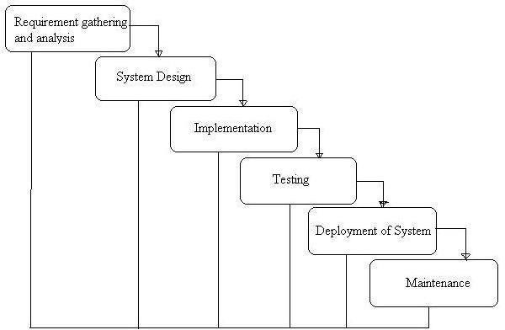

**Fig. 3.1: Waterfall Model**

* + 1. **Advantages of waterfall model:**
       - Simple and easy to understand and use.
       - Easy to manage due to the rigidity of the model – each phase has specific deliverables and a review process.
       - Phases are processed and completed one at a time.
       - Works well for smaller projects where requirements are very well understood.
    2. **Disadvantages of waterfall model:**
       - Once an application is in the testing stage, it is very difficult to go back and change something that was not well-thought out in the concept stage.
       - No working software is produced until late during the life cycle.
       - High amounts of risk and uncertainty.
       - Not a good model for complex and object-oriented projects.
       - Poor model for long and ongoing projects.
       - Not suitable for the projects where requirements are at a moderate to high risk of

changing.

* + - * The project is short.
  1. **Prototype Model**

The basic idea here is that instead of freezing the requirements before a design or coding can proceed, a throwaway prototype is built to understand the requirements. This prototype is developed based on the currently known requirements. By using this prototype, the client can get an “actual feel” of the system, since the interactions with prototype can enable the client to better understand the requirements of the desired system. Prototyping is an attractive idea for complicated and large systems for which there is no manual process or existing system to help determining the requirements. The prototypes are usually not complete systems and many of the details are not built in the prototype. The goal is to provide a system with overall functionality.

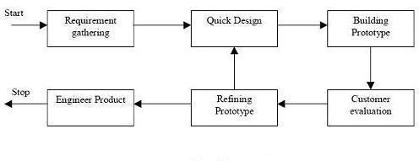

**Fig. 3.2: Prototype Model.**

* + 1. **Advantages of Prototype model:**
       - Users are actively involved in the development
       - Since in this methodology a working model of the system is provided, the users get a better understanding of the system being developed.
       - Errors can be detected much earlier.
       - Quicker user feedback is available leading to better solutions. Missing functionality can be identified easily
       - Confusing or difficult functions can be identified Requirements validation,

Quick implementation of, incomplete, but functional, application.

* + 1. **Disadvantages of Prototype model:**
       - Leads to implementing and then repairing way of building systems.
       - Practically, this methodology may increase the complexity of the system as scope of the system may expand beyond original plans.
       - Incomplete application may cause application not to be used as the full system was designed Incomplete or inadequate problem analysis.
  1. **When to use Prototype model:**
* Prototype model should be used when the desired system needs to have a lot of interaction with the end users.
* Typically, online systems, web interfaces have a very high amount of interaction with end users, are best suited for Prototype model. It might take a while for a system to be built that allows ease of use and needs minimal training for the end user.
* Prototyping ensures that the end users constantly work with the system and provide feedback which is incorporated in the prototype to result in a useable system. They are excellent for designing good human computer interface systems.

### Chapter 4 Data gathering

To complete this project first we have gathered necessary data or information from our supervisor, our respective teachers, friends, junior students of our department, and internet. It was complex because our system is unique and needed data are not available. It was expensive too and required a lot of work and time. To gather information, we have used certain sources:

* **Documentation**
* **Onsite observations**

# Documentation

During data gathering we searched related information in Google. We found various procedures, manual, reports, create account forms, loan request form, and many other materials but all information was difficult to assess. We spend lot of time by reading manual or reports.

* + 1. **Data Flow Diagram**

A data flow diagram is a short road map for that graphically represents how the data moves through the existing system. we have used data flow diagram in design process. The data flow diagram provides facilitating communication between us and user. DFD shows what kinds of information will be input to and output from the system, where the data will come from and go to, and where the data will be stored. It does not show information about the timing of processes, or information about whether processes will operate in sequence or in parallel.

* + - 1. **Circle**

The processes are represented by circle shows what the action take on the data- checking. A process accepts input data needed for the process to be carried out and produces data that it passes on to another part of the DFD.

### Arrow

**Fig. 4.1: circle.**

Arrow defines direction of the data flow. It shows the direction between a data store to another data store, source to processes.

### Square

**Fig. 4.2: Arrow.**

Square indicate the source and destination of the system.

11

**Fig. 4.3: Square.**

### Open Rectangle

A database is a repository of data here it represented by open-ended box. This information may be stored either temporarily or permanently by admin. Data may be changed or updated.

**Fig. 4.4: Open Rectangle.**

### Data flow diagram of Online News Portal for the USER:

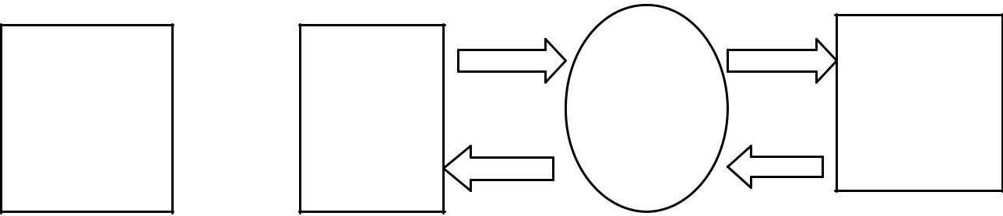

**Process**

**Database**

**User Or**

**Visitor**

**Result**

**Fig. 4.5: A data flow diagram for the USER.**

### Data flow diagram of Online News Portal for the Admin:

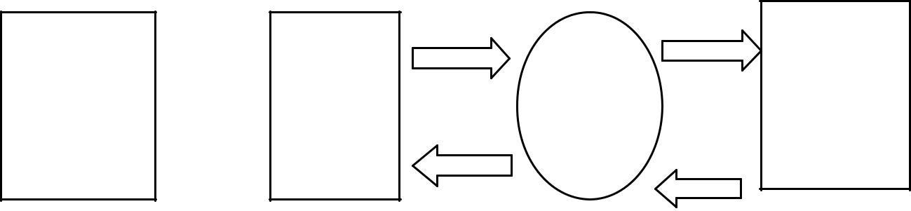

**Admin**

**Process**

**Input Data**

**Data Stored**

**In Database**

**Fig. 4.6: A data flow diagram for the Admin.**

**Result**

### Use Case Diagrams:

* + 1. **User Case Diagram:**

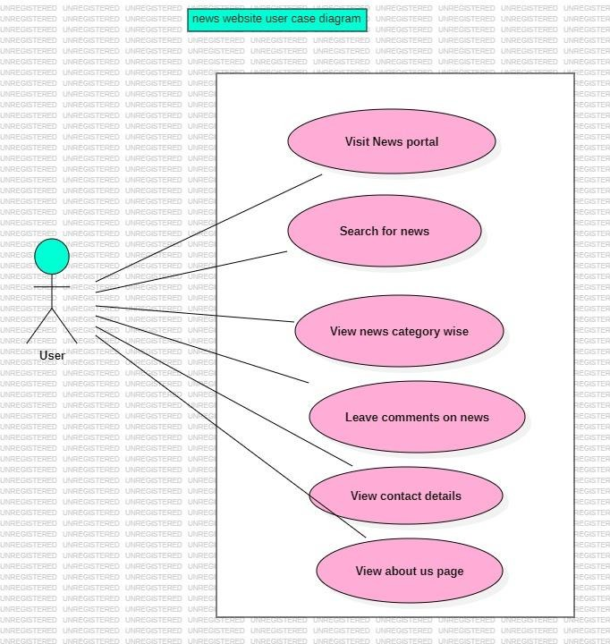

**Fig. 4.7: Use Case Diagram for user.**

* + 1. **Admin Case Diagram:**

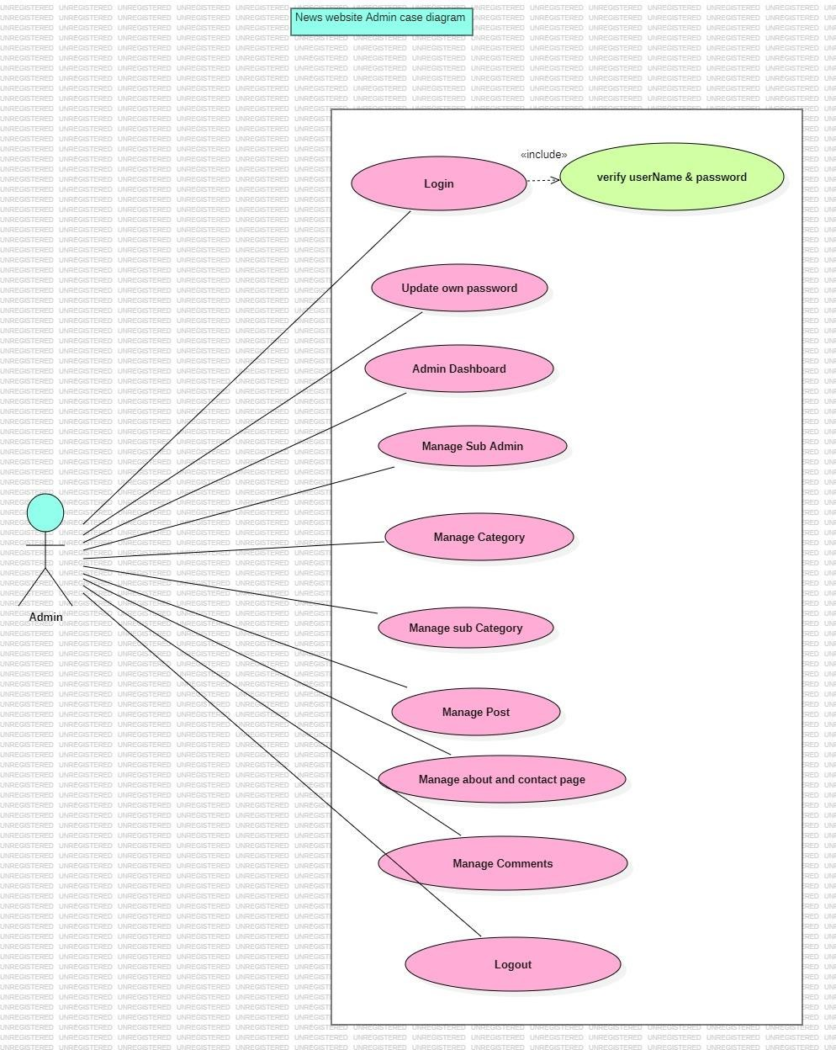

**Fig. 4.8: Use Case Diagram for Admin.**

### ER Diagram:

The Entity-Relationship (ER) model was originally proposed by Peter in 1976 [Chen76] as a way to unify the network and relational database views. Simply stated the ER model is a conceptual data model that views the real world as entities and relationships. A basic component of the model is the Entity-Relationship diagram which is used to visually represent data objects. Since Chen wrote his paper the model has been extended and today it is commonly used for database design for the database designer, the utility of the ER model is:

* It maps well to the relational model. The constructs used in the ER model can easily be transformed into relational tables.
* It is simple and easy to understand with a minimum of training. Therefore, the model can be used by the database designer to communicate the design to the end user.
* In addition, the model can be used as a design plan by the database developer to implement a data model in specific database management software.
  + 1. **ER Notations:**

There is no standard for representing data objects in ER diagrams. Each modeling methodology uses its own notation. The original notation used by Chen is widely used in academics texts and journals but rarely seen in either CASE tools or publications by non-academics. Today, there are a number of notations used; among the more common are Bachman, crow's foot, and IDEFIX.

All notational styles represent entities as rectangular boxes and relationships as lines connecting boxes. Each style uses a special set of symbols to represent the cardinality of a connection. The notation used in this document is from Martin. The symbols used for the basic ER constructs are:

* **Entities** are represented by labelled rectangles. The label is the name of the entity. Entity names should be singular nouns.
* **Relationships** are represented by a solid line connecting two entities. The name of the relationship is written above the line. Relationship names should be verbs
* **Attributes,** when included, are listed inside the entity rectangle. Attributes which are identifiers are underlined. Attribute names should be singular nouns.
* **Cardinalit**y of many is represented by a line ending in a crow's foot. If the crow's foot is omitted, the cardinality is one.
* **Existence** is represented by placing a circle or a perpendicular bar on the line. Mandatory existence is shown by the bar (looks like a 1) next to the entity for an instance is required. Optional existence is shown by placing a circle next to the entity that is optional.

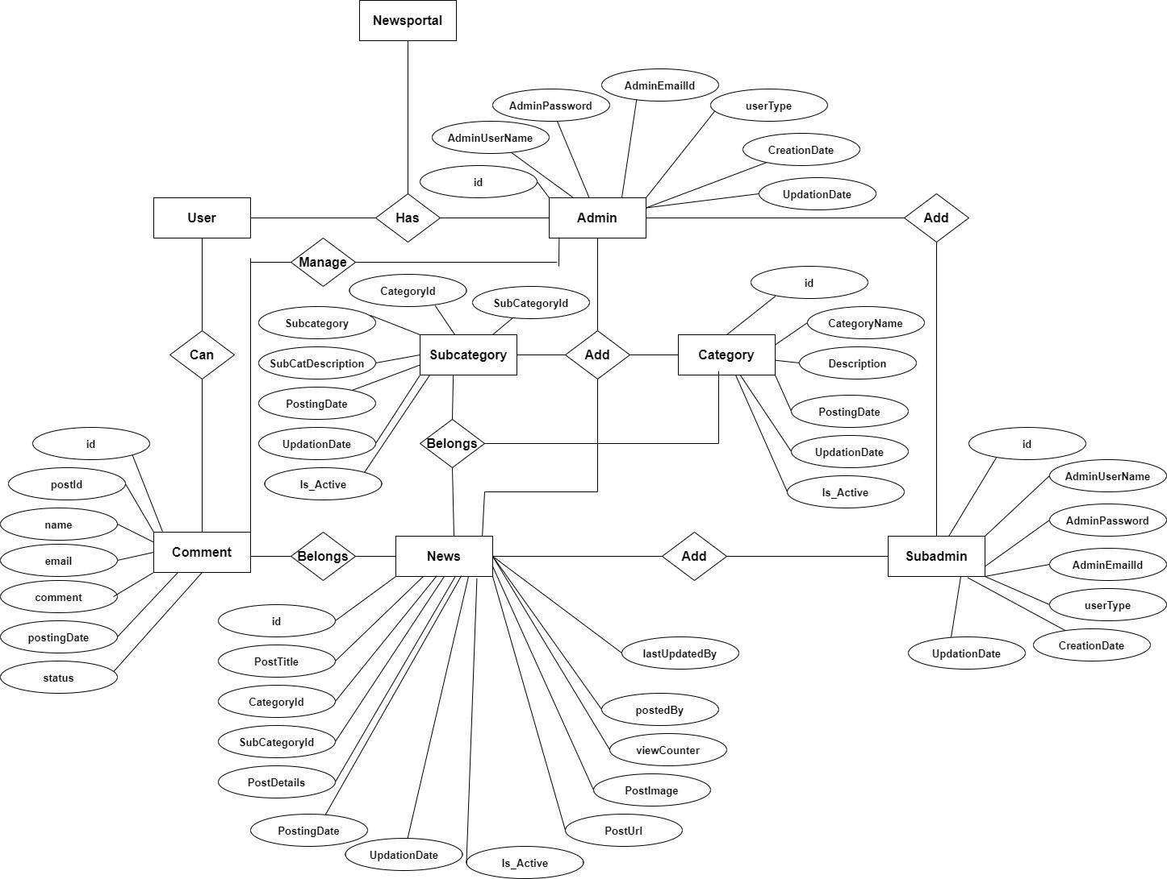

**Fig. 4.9: E-R Diagram**

### Chapter 5 System Design

System design is the most creative and challenging. The System Design Document describes the system requirements, operating environment, system and subsystem architecture, files and database design, input formats, output layouts, human- machine interfaces, detailed design, processing logic, and external interfaces.

### Before Start Deign:

To make web application for Online News Paper website it is need to select a standard PC that can support XAMPP.

* + 1. **Hardware Requirements:**

XAMPP Software installs on a standard PC system. Minimum Hardware requirements are as follows:

* Processor –Celeron (R) Dual –Core CPU [T3100@1.90GHz](mailto:T3100@1.90GHz) 1.90 GHz;
* Installed Memory (RAM) – at least 350 MB;
* System type-32-bit Operating System;
* Model-Presario CQ42 Notebook PC; Resolution-1366/768;
  + 1. **Software requirements:**
       1. **XAMPP:**
          - XAMPP is an easy to install Apache distribution containing MySQL, PHP and Perl.
          - XAMPP is really very easy to install and to use - just download, extract and start.
       2. **XAMPP for Windows:**

The distribution for Windows 2000, 2003, XP, Vista, 7 and 8. This version contains: Apache, MySQL, PHP + PEAR, Perl, mod_php, mod_perl, mod_ssl, OpenSSL, phpMyAdmin,

Nebulizer, Mercury Mail Transport System for Win32 and NetWare Systems v3.32, Ming, FileZilla FTP Server, mcrypt, eAccelerator, SQLite, and WEB-DAV + mod_auth_mysql.

* + - * + Apache 2.4.9
        + MySQL10.1.31Maria DB
        + PHP 7.2.3
        + phpMyAdmin 4.7.9
      1. **Programming Languages:**
         * HTML
         * CSS
         * jQuery
         * PHP
         * MySQL

### Files and Database:

We have organized one database news portal for system design. It can be accessed directly or sequentially by registered. The database determines files, record, fields, and characters. It can be easily controlled and updated. This database and its table and component are described by using flow diagram that is given in the below……….

**News portal Database has 6 tables**

* tbladmin
* tblcategory
* tblcomments
* tblpages
* tblposts
* tblsubcategory
* **tbladmin:**

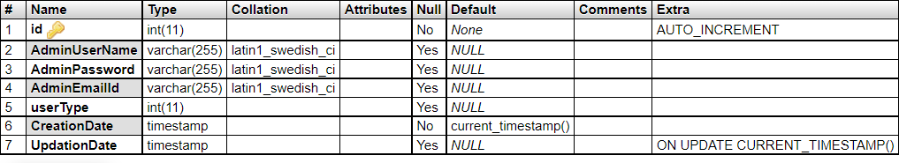

* **tblcategory:**

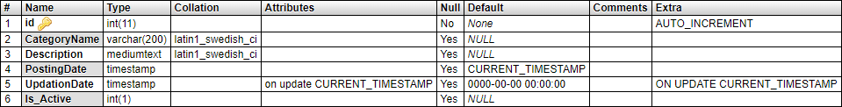

* **tblcomments:**

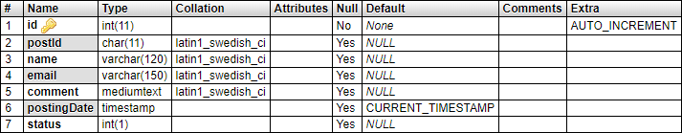

* **tblpages:**

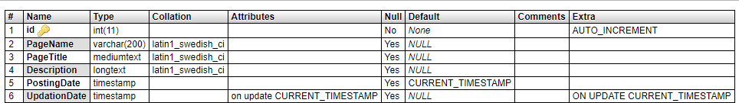

* **tblposts:**

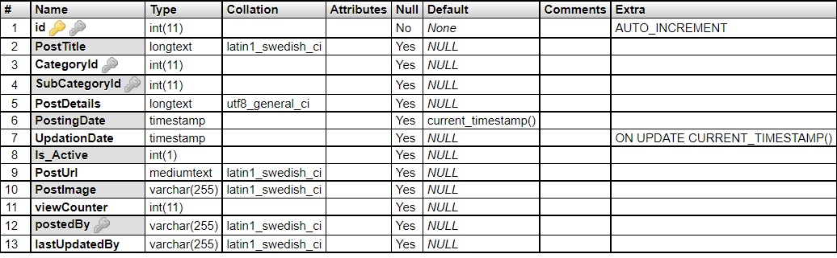

* **tblsubcategory:**

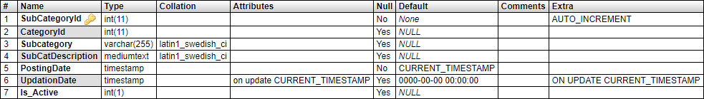

* **Relationship between tables (Class Diagram):**

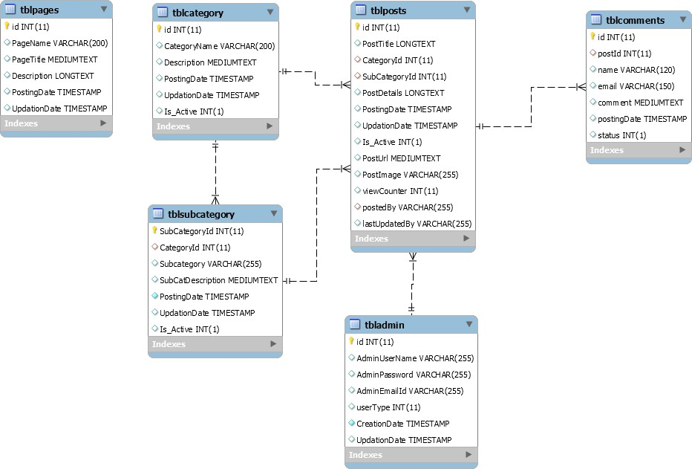

### Chapter 6

**Activities of the System Development**

We divided system development phase’s activities into three categories. These provide components of the development phase that can construct the program and including a list of the programs needed to meet the systems objectives and complete documentation

To complete our system development, we three types of specification. These are……

* User specification.
* Admin specification.
* Files and database.
  1. **User Specification:**

The proposed systems are physically developed in this stage. User specification or output specification provides the proposed system goals. User specification stage fulfilled the user need by preparing building blocks of the system. User specification is developed by based on output design. It provides total outlook of the system and offer various features for user.

**After going to** [**http://localhost/newsportal/index.php**](http://localhost/newsportal/index.php) **a user can see the view.**

* + 1. **Homepage:**

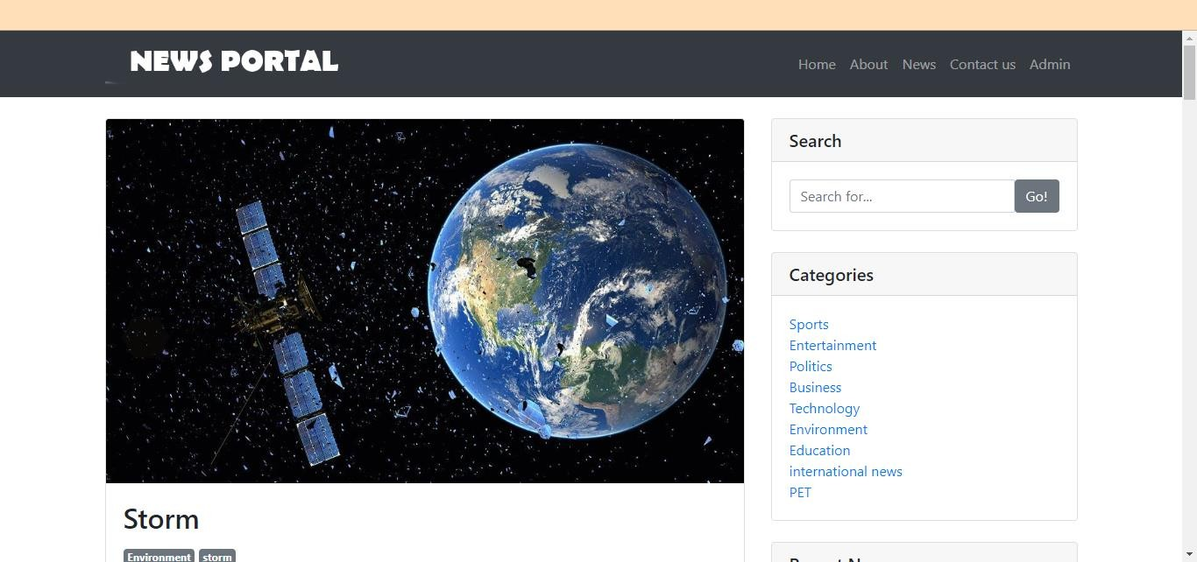

* + 1. **About Us:**

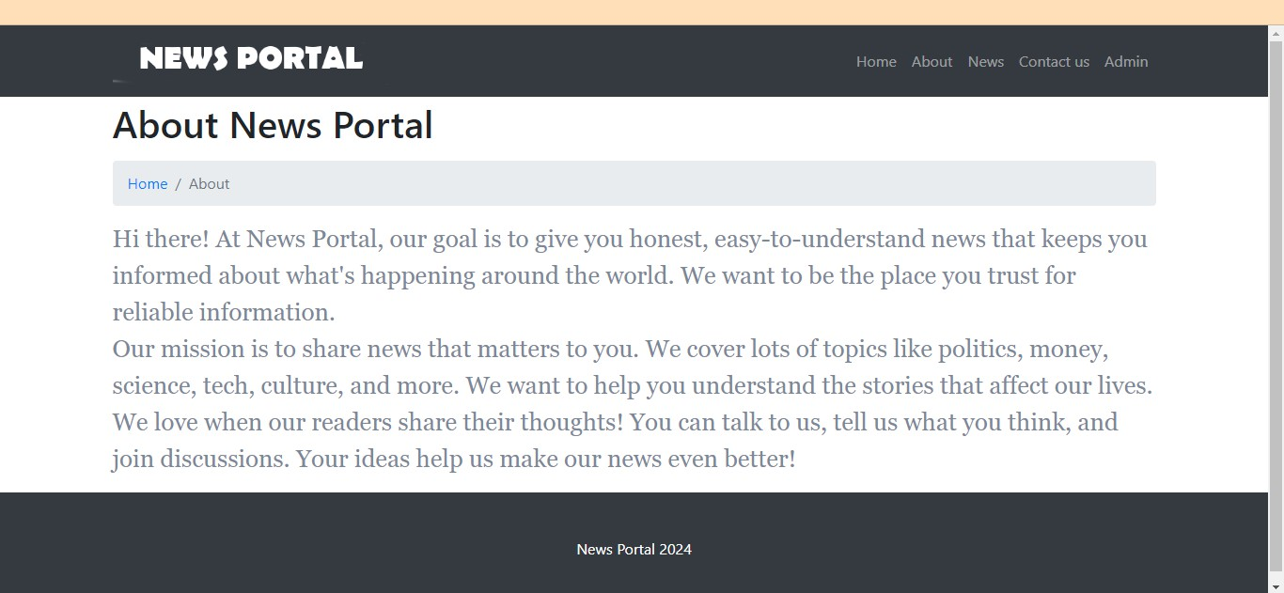

* + 1. **Contact Us:**

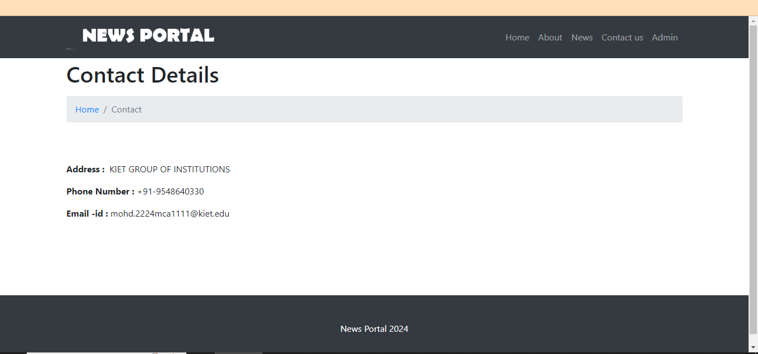

* + 1. **News:**

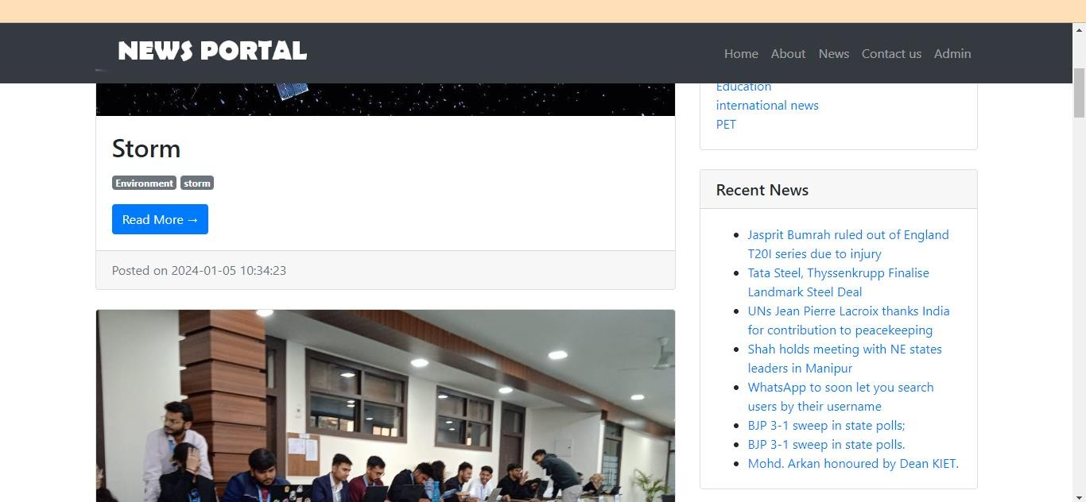

* + 1. **Admin Login:**

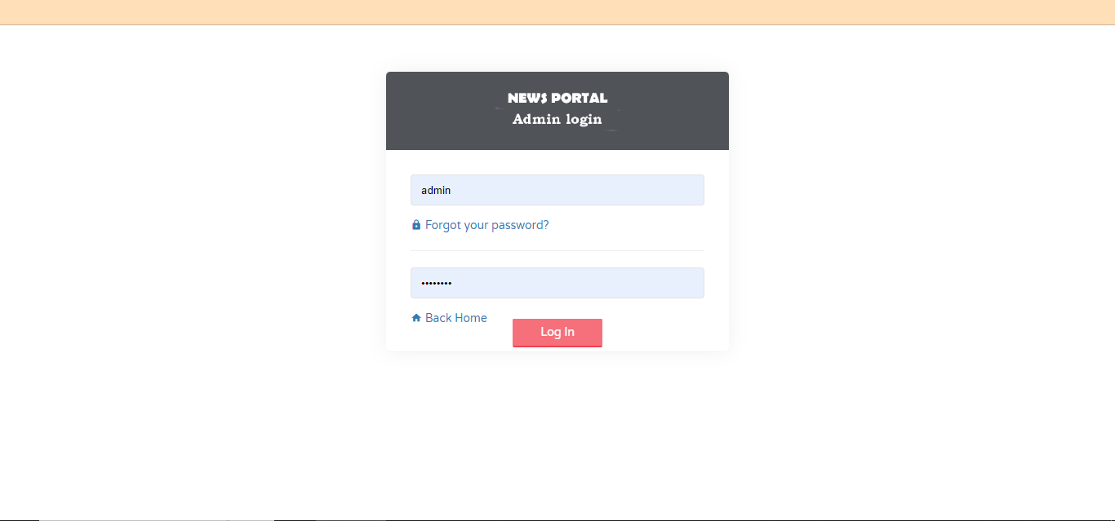

* + 1. **Dashboard:**

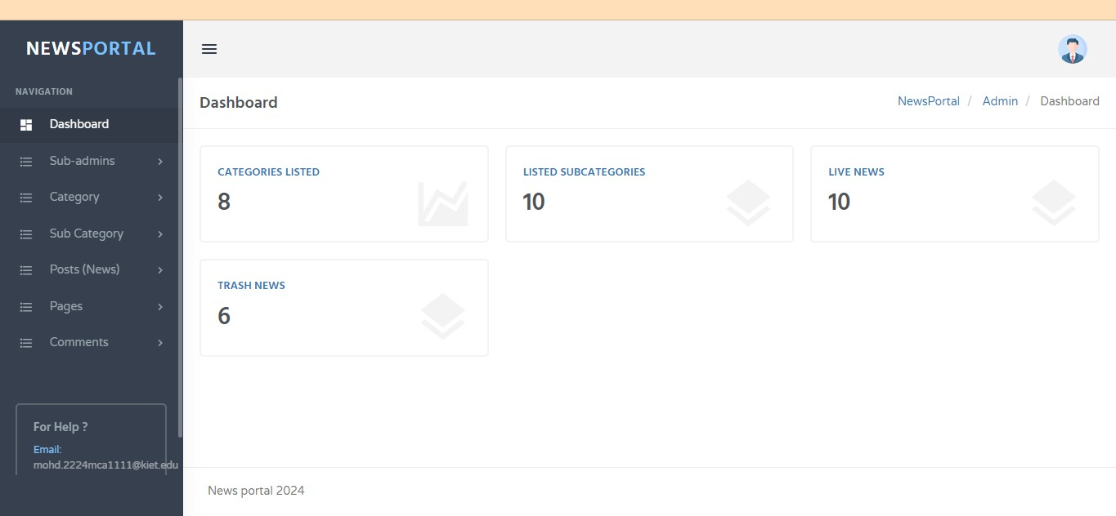

* + 1. **Change Password:**

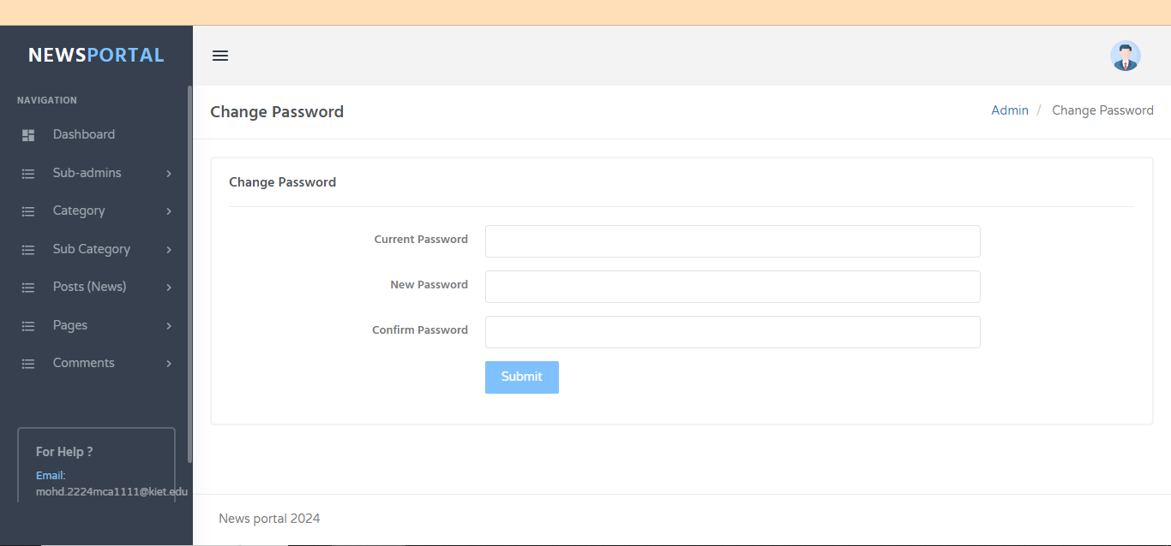

* + 1. **Add Sub Admin:**

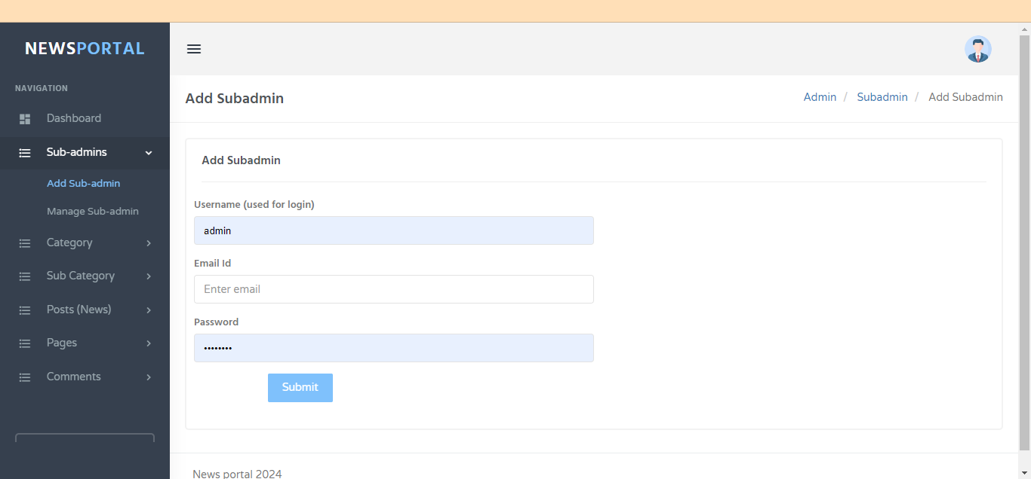

* + 1. **Manage Sub Admin:**

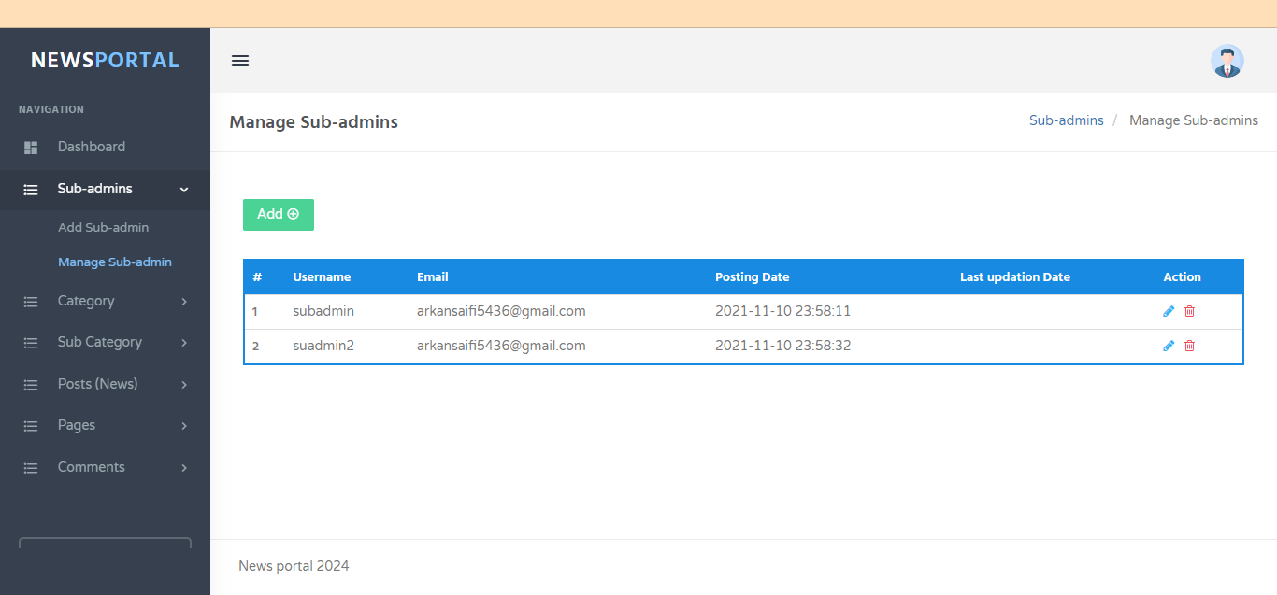

* + 1. **Update Sub Admin:**

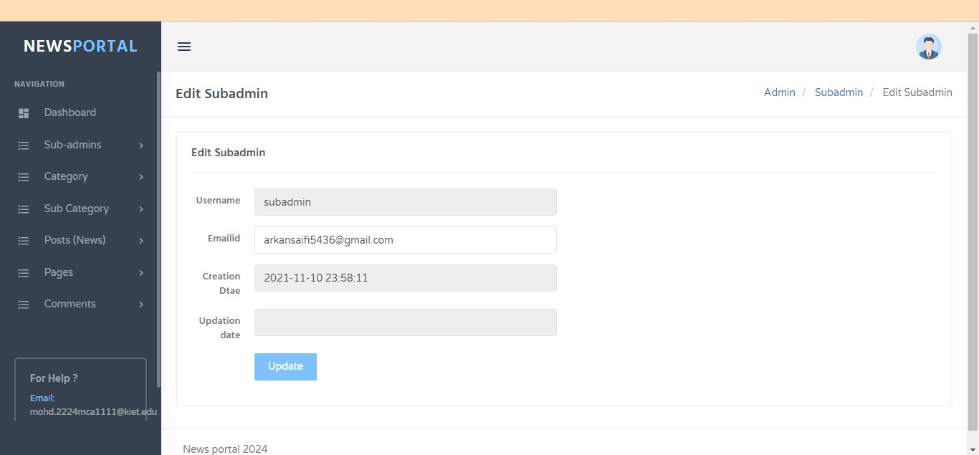

* + 1. **Add Category:**

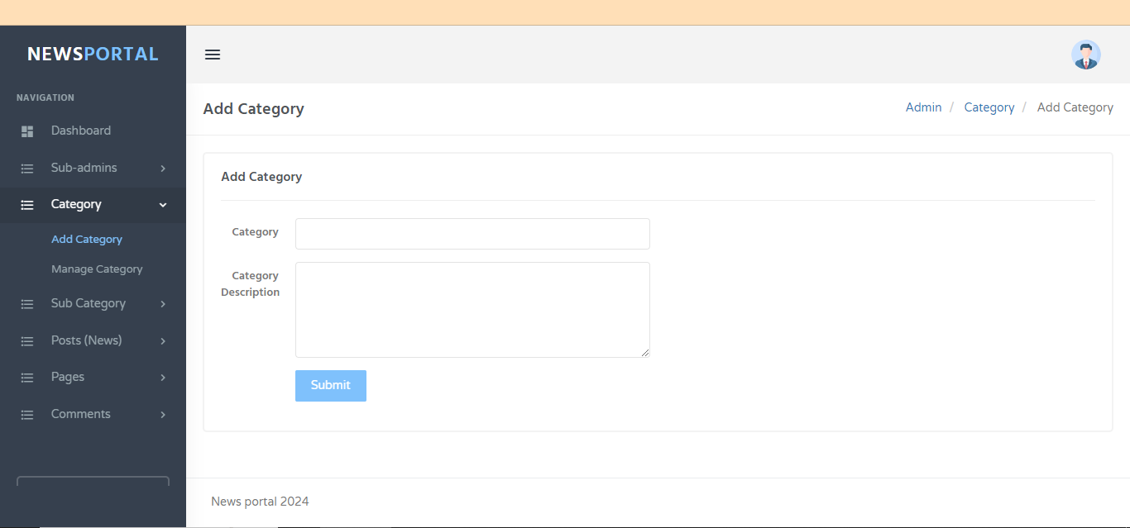

* + 1. **Manage Category:**

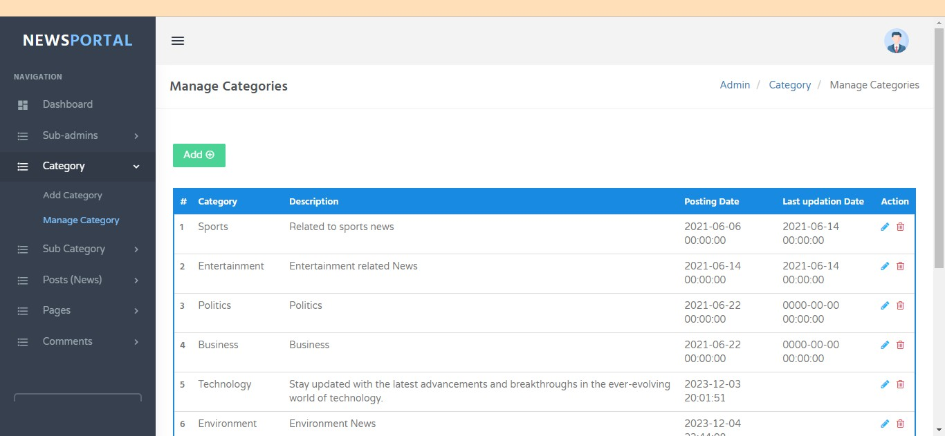

* + 1. **Update Category:**

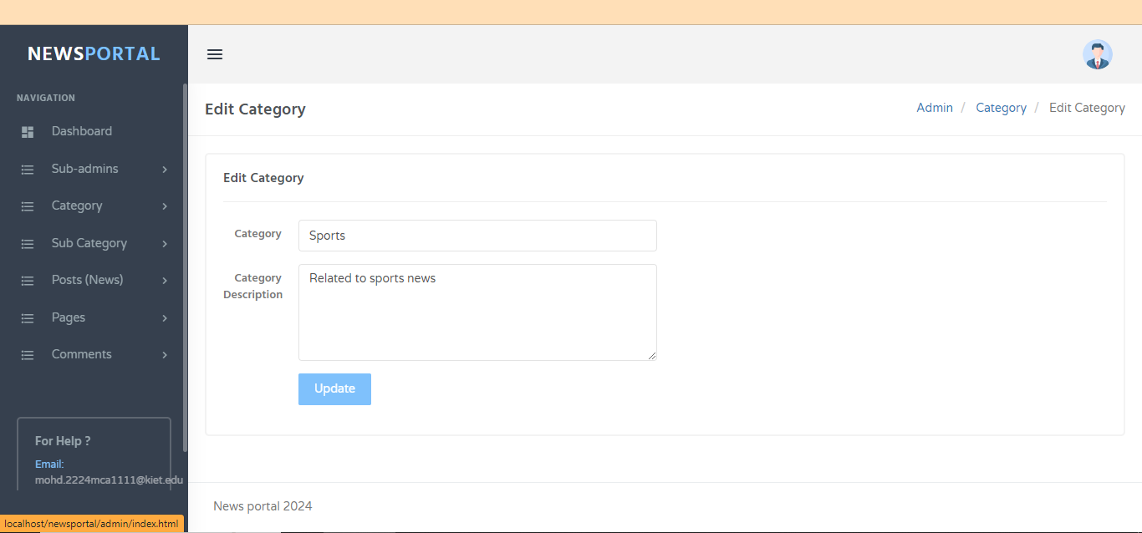

* + 1. **Add Sub Category:**

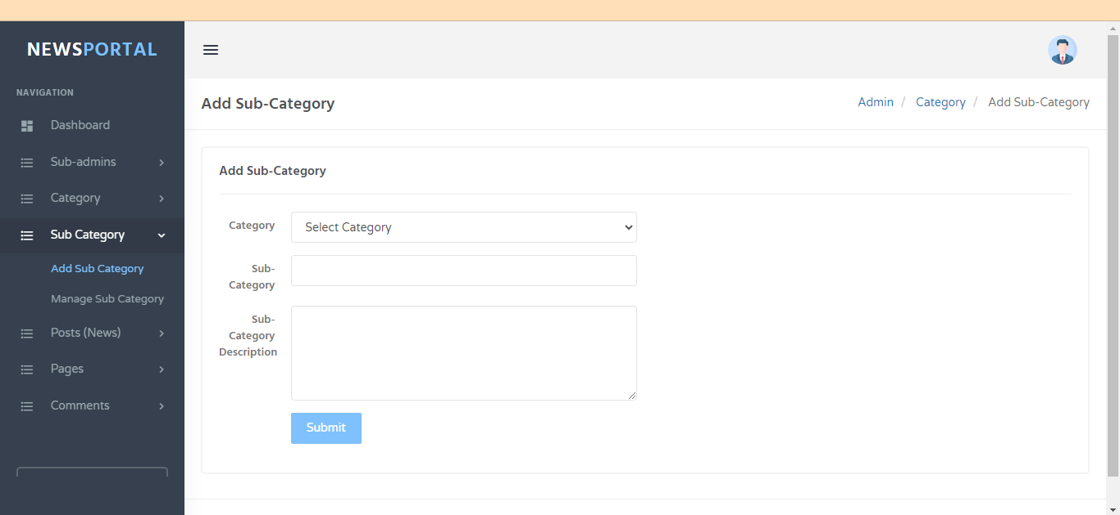

* + 1. **Manage Sub Category:**

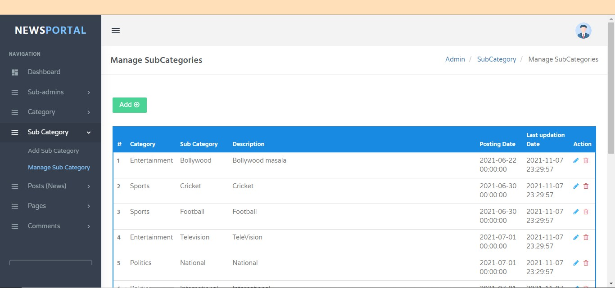

* + 1. **Add Post:**

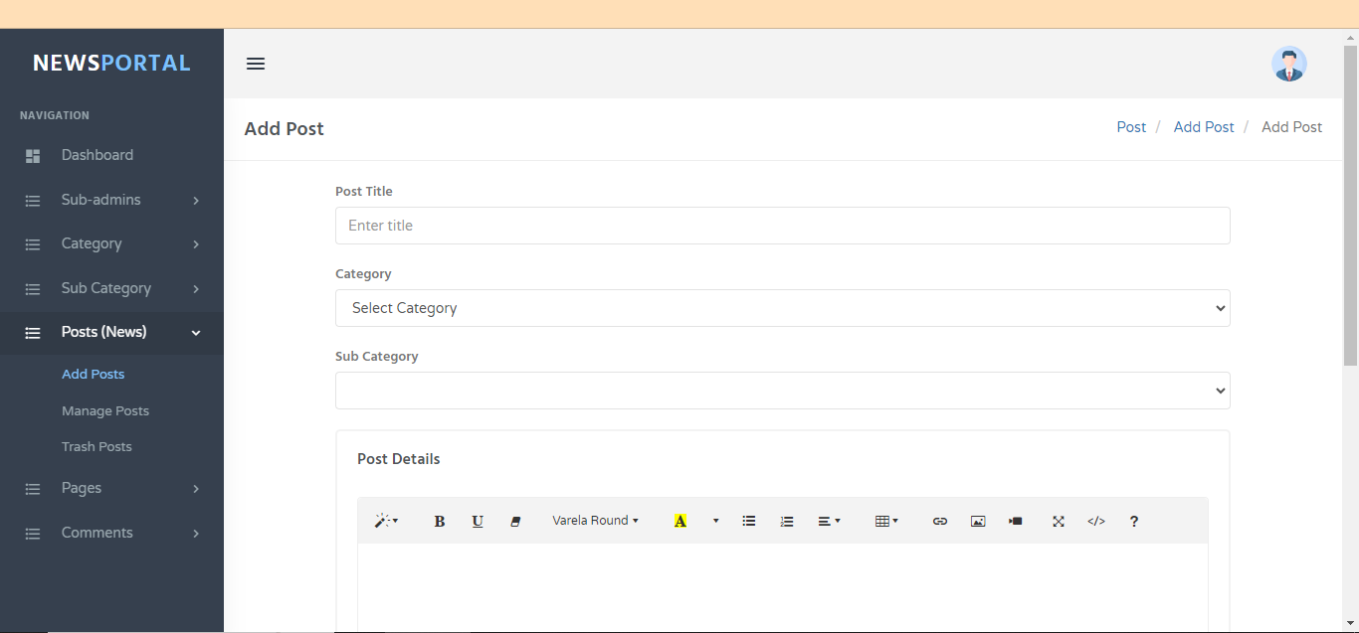

* + 1. **Manage Post:**

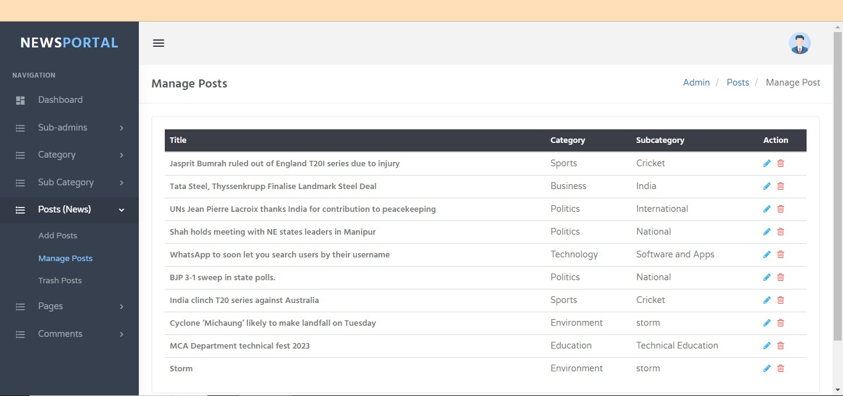

* + 1. **Update Post:**

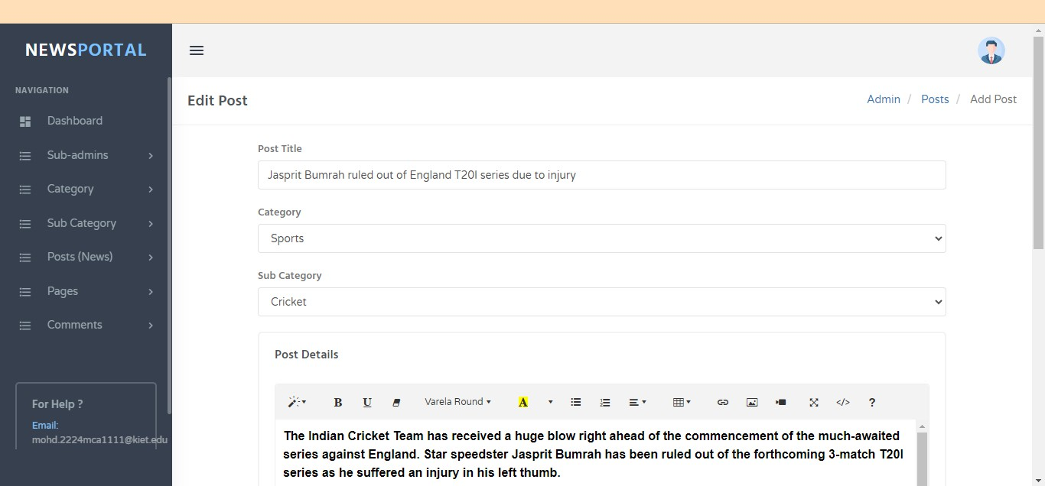

* + 1. **About Us Page:**

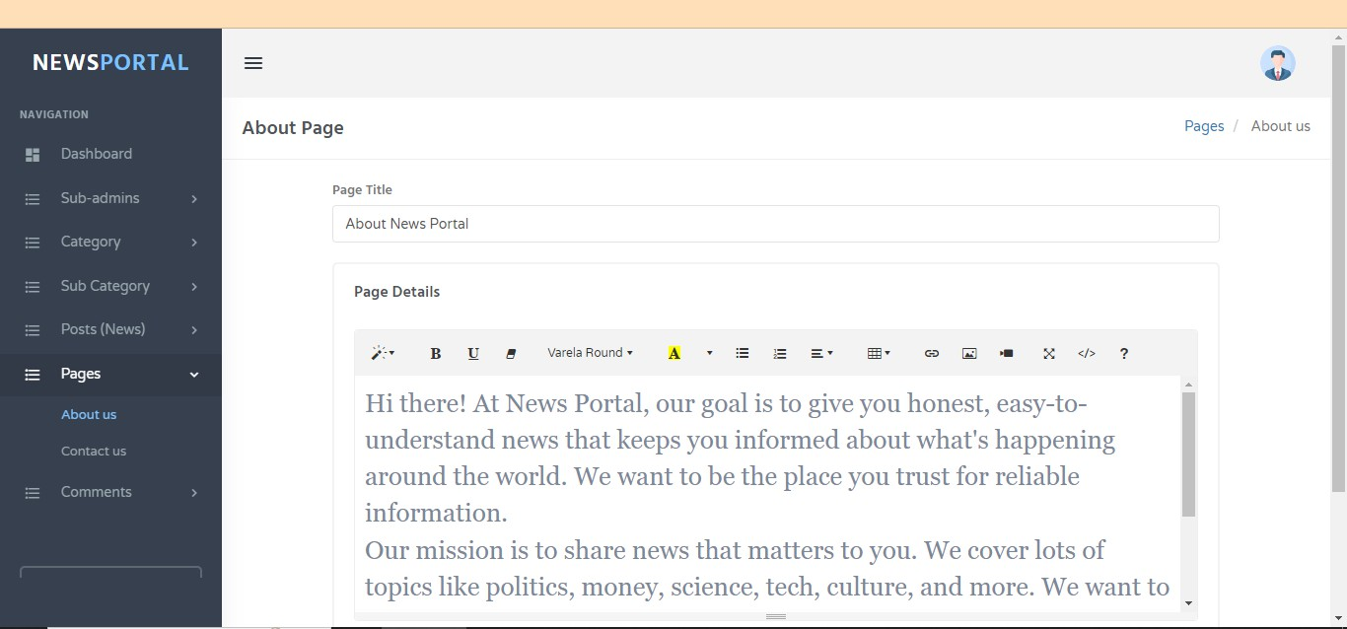

* + 1. **Contact Us Page:**

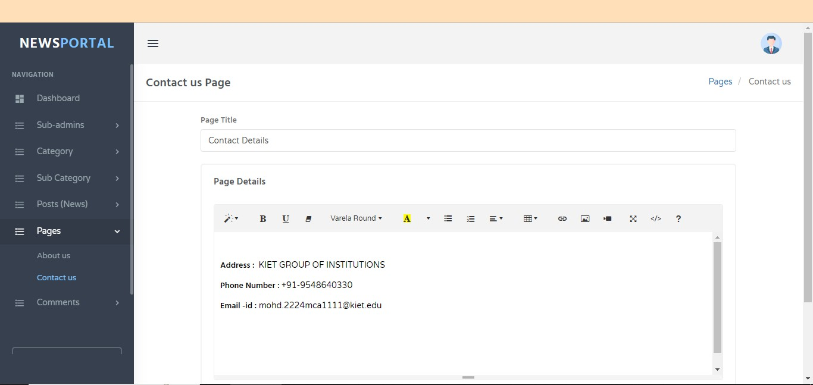

* + 1. **Comments:**

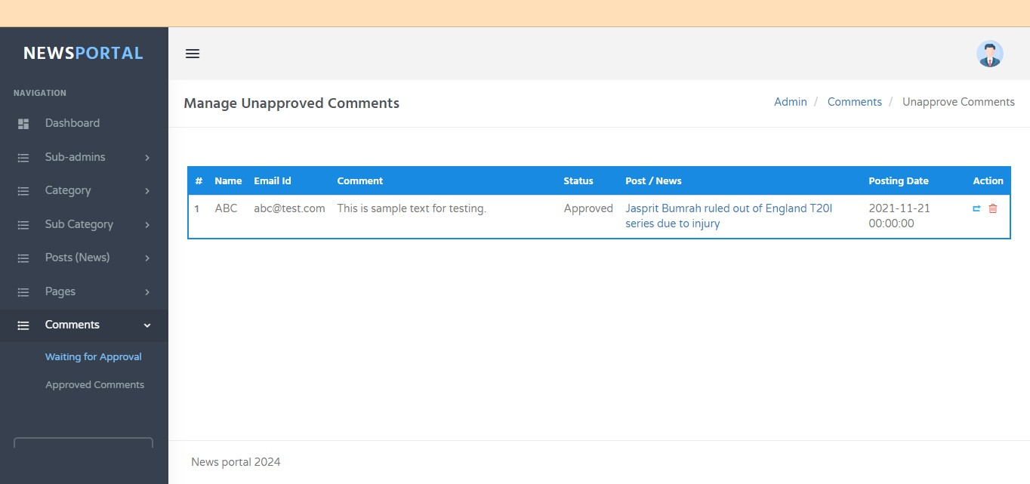

### Chapter 7 Testing

Build up Our project We Use Software Testing Process for executing a program with the intent of finding errors that is uncovering errors in a program makes it a feasible task and also trying to find the errors (whose presence is assumed) in a program. As it is a destructive process.

Here we just mentioned that how the testing is related to this software and in which way we have test the software? In our project we have used 5 types of testing these are listed below-

* 1. **Unit Testing:** Unit testing where individual program units or object classes are tested. Here by using this testing we have focused on testing the functionality of methods.
  2. **Module Testing:** Where this is the combination of unit program is called module. Here we tested the unit program (5-6 programs) is where the module programs have dependency.
  3. **Sub-system Testing:** Then we combined some module for the Preliminary System Testing in our Project.
  4. **System Testing:** Where it is the combination of two or more sub-system and then it is tested. Here we tested the Entire system as per the requirements.
  5. **Acceptance Testing:** Normally this type of testing is done to verify if system meets the customer specified requirements. After submitting this project to User then they tested it and to determine whether to accept application. It is the system testing performed by the customer(s) to determine whether they should accept the delivery of the system.

In our project work, an attempt has been made to develop a News or information- based web site. We develop this project that helps the people and make them aware so that they can know any news. To establish this website, we use various methodologies. To develop this project, we have faced many problems but we hardly tried to develop this project. Our supervisor helps us by giving his valuable opinion, decision and time.

### Chapter 8 Observation

**The above experiment leads us to the following observations:**

* + - It makes online news-oriented information easier to its user.
    - It provides a wonderful user interface that attracts more and more user.
    - To provides a flexible way of real time communication that safe user’s time and effort.
    - To provides a safe and secure communication system.
    - It makes use of various technologies and updated news about various crime and rules and crime-oriented information that is more effective and useful for conscious people.
    - It can offer the faster and informative information system about crime news and rules of the country.
    - To do this for more widely coverage of distribution and faster dissemination of information in a timelier manner.
    - To introduce the people about the system.
    - To get information about current world all ages anytime, anywhere, anyone can access by internet at low cost.
  1. **System Performance:**

System performance totally depends on the output of the system. The percentage of success rate and failure rate has been calculated using the following equations: Success:

* + 1. **Success:**

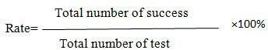

* + 1. **Failure:**



The performance is related to success rate and failure rate. If the success is high then the performance of the system is good. Success rate and Failure rate are contradiction of each other. So, when success rate is high then failure rate is low. In the two terms the performance of the system is depended.

* 1. **Limitations:**

There are some limitations for the current system to which solutions can be provided as a future development:

* We don’t manage news reporting system.
* Sensibility level could not add.
  1. **Future Scope:**

The future scope of our project is valuable. Our project time duration was only one years. In this time interval we developed our project. It was very difficult to complete project within this time duration. In future if we get chance, we will develop this website for large volume.

**As for other future developments, the following can be done:**

* We will manage news reporting system.
* We can make video conferencing system.
* We update our database.
* Sensibility level could add be added.

### Conclusion

In our project work, an attempt has been made to develop News or information-based web site. We develop this project that helps the people and make them aware so that they can know any news. To establish this website, we use various methodologies. To develop this project, we have faced many problems but we hardly tried to develop this project. Our supervisor helps us by giving his valuable opinion, decision and time.

**For PHP**

### Bibliography

* <https://www.w3schools.com/php/default.asp>
* <https://www.sitepoint.com/php/>
* <https://www.php.net/>

**For MySQL**

* <https://www.mysql.com/>
* [http://www.mysqltutorial.org](http://www.mysqltutorial.org/)

**For XAMPP**

* <https://www.apachefriends.org/download.html>