Creation of WAR and build in server

Step 1-: Clone wms-redesign new patch from GIT. Test or do sanity of the new Patch. If new there is any changes in package.json the install node module in local and upload the file in PPT folder. Zip all the code required to create war or build.
Step 2:- All the file will be uploaded in client PC. Copy all the file and upload it in 65 Box.
Step 3:- Copy node_module file inside Web. 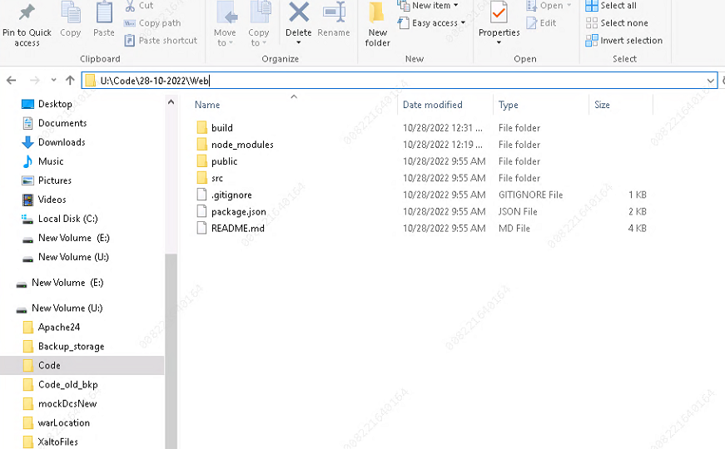
Step 4:- Make changes in file properties.js file. Comment localhost port and uncomment ../wms-application/
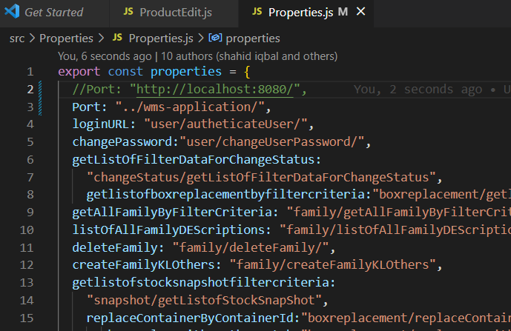
Step 5:-Open cmd after going inside web folder.
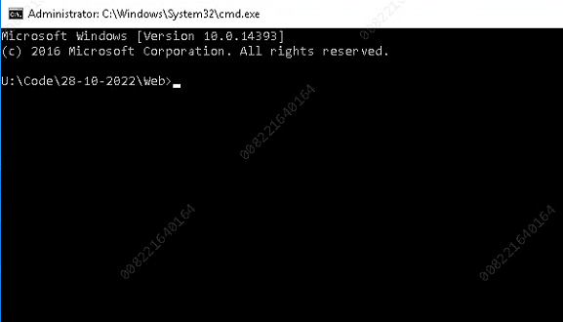
Step 5:- Run command “npm run build” and wait for some time after the build created. You will find new folder inside web called “Build”.

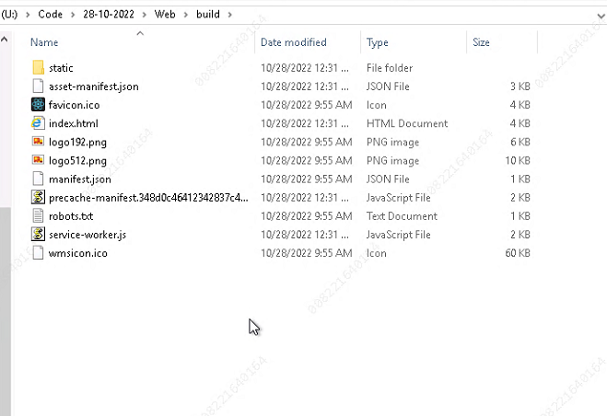

Step 6:- Import API in STS . Open Application.properties file . Change datasource.url to this name jdbc:sqlserver://192.168.140.69;databaseName=Migrated_db_for_prod_04-10-22
Note:- database name can vary
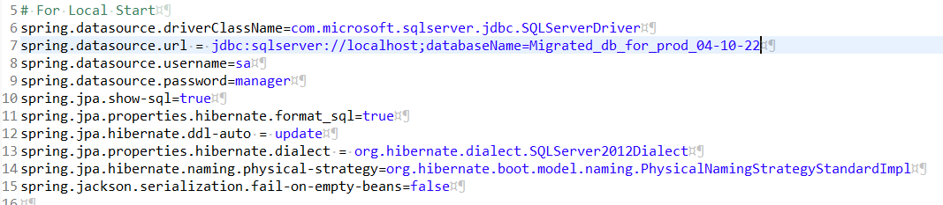
Step 7:- Change jms.connection.url from https-remoting://127.0.0.1 to https-remoting://192.168.140.65:8180 for test and to https-remoting://192.168.140.21:8180 for production server
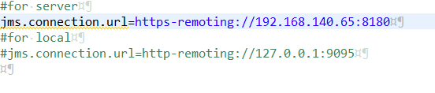
Step 8:- After that create war file of api. Name of the war will be “wms-application”
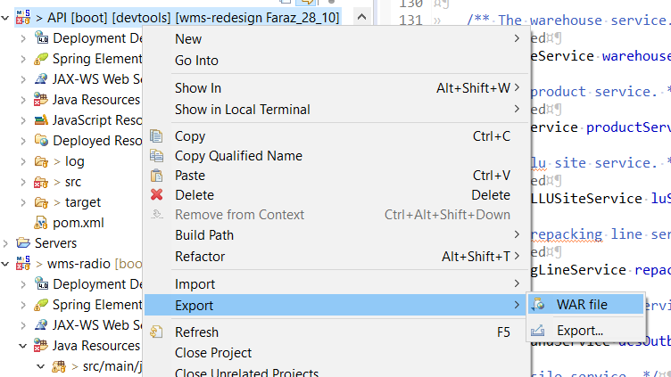

Step 9:- Go to the location where you exported war file. Right click on war and open the archive of the war file.
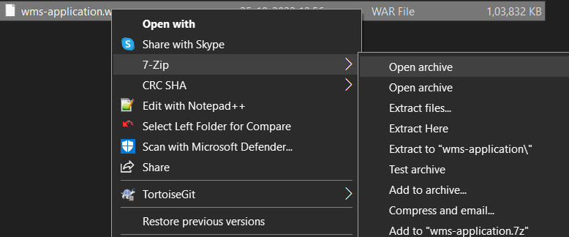
Step 10:- Open build file and select all file , then scroll all the build files inside the war file
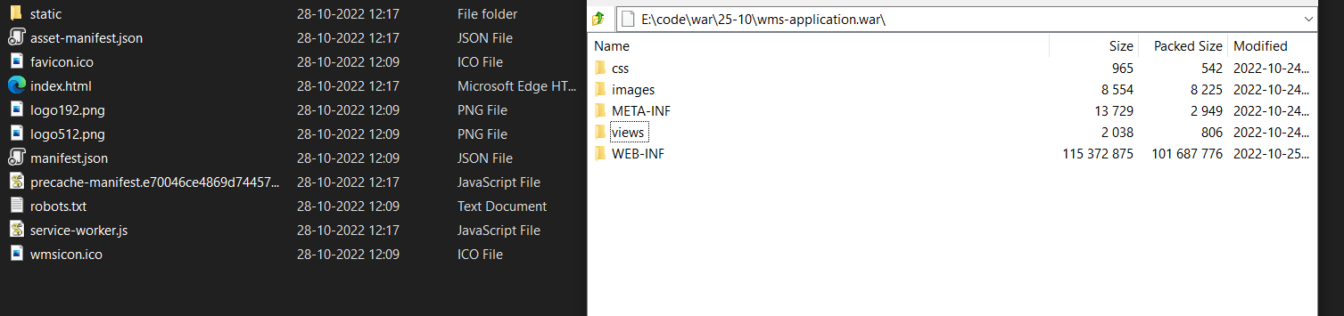

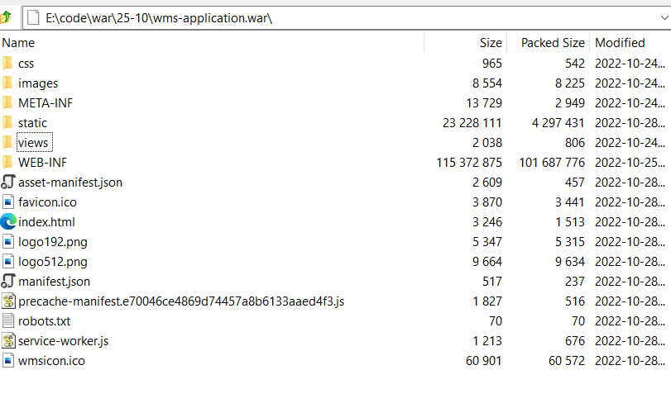
This is how the war file look now.
Step 11:- Now take the backup of wms-application.war file which is deployed in war. After taking the backup, stop the JBossEAP7 from the roles of Fail over cluster manager. If it shows pending for more then 10 second go to task manager and end task of Java(TM) Platform SE Binary.
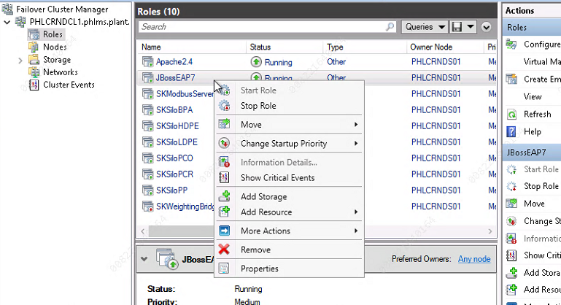
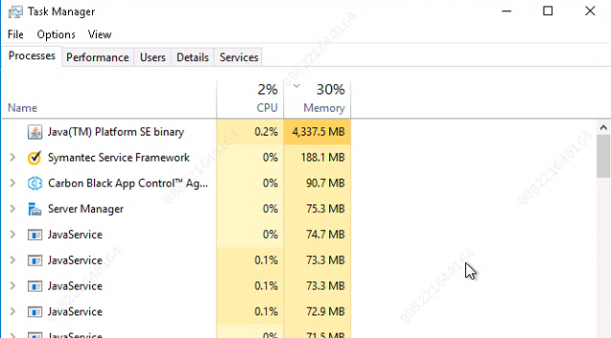
Step 12:- Copy your new war which you created and paste it to C:\java\jbosseap-7.1.0-ms-sql\standalone\deployments. After pasting it start JBossEAP7 from the failover cluster manager.


