CAREER CATALYST
AI-Powered Resume & Career Acceleration Platform
Project Documentation
REACT FASTAPI SUPABASE REDIS GEMINI / GROQ STRIPE
Full-stack SaaS • AI Prompt Engineering • LaTeX PDF Generation • Token Economy

1. Project Overview
Modern recruiters and companies rely on ATS (Applicant Tracking System) software to filter resumes before a human ever sees them. Career Catalyst is built to give candidates an unfair advantage inside that system — not by stuffing keywords, but by combining Large Language Models (LLMs) with mathematical fuzzy matching (RapidFuzz) to rewrite resume bullet points using the STAR / XYZ formula. The goal is to shape a resume into exactly what senior recruiters want to read, so candidates get shortlisted more easily.
In short: Career Catalyst is not just a resume builder — it is a complete career acceleration ecosystem combining a 3D UI, secure authentication, complex AI prompt engineering, Redis rate-limiting, LaTeX PDF generation, and a SaaS token economy.

2. Tech Stack

2.1 Frontend — /frontend (User Interface & Experience)
Layer | Technology | Purpose
Core | React.js (React 19) + TypeScript | Application framework
Routing | React Router v7 | Client-side navigation
Styling / UI | Tailwind CSS + Glassmorphism | Custom, modern visual design
3D & Animation | @react-three/fiber, @react-three/drei, tsparticles | Interactive 3D elements, premium animations
Data Visualization | Recharts | Visualizing ATS scores and analytics
Auth | Supabase Auth (Magic Links, OAuth) | Direct frontend authentication

2.2 Backend — /resume-engine (Core Logic & AI)
Layer | Technology | Purpose
Framework | FastAPI (Python 3.10+) | High-speed, modern API layer
Data Validation | Pydantic | Strict JSON schema validation
AI / LLMs | Google Gemini Flash + Groq SDK | Orchestrated AI generation
Algorithm | RapidFuzz | Mathematical string matching & keyword detection
PDF Compiler | Tectonic | Converts LLM JSON → LaTeX → PDF
PDF Parser | PyMuPDF | Parses and reads uploaded resumes

2.3 Database, Caching & Infrastructure
Layer | Technology | Purpose
Database | Supabase (PostgreSQL) | Users, tokens, logs, referrals
Caching / Rate Limiting | Redis | Fast data access & request throttling
Payments | Stripe | Token purchases

3. Core Features & Product Tools
The product is intelligently split into two parts: a Premium (SaaS) toolkit that consumes tokens, and a Free (lead-generation) toolkit that drives organic and viral growth.

3.1 Premium SaaS Toolkit (Token-Based)
Tool | What It Does
AI Resume Tailor | Analyzes the JD vs. resume, finds missing technical skills, rewrites bullets in STAR format, and outputs a perfect PDF via Tectonic.
ATS Evaluator | Produces a real-time, mathematical score predicting ATS pass/fail.
Cover Letter Generator | Generates a highly targeted, markdown-stripped cover letter matched to the JD.
Mock Interview Simulator | Generates AI interview questions tailored to the job profile for practice.
LinkedIn Profile Optimizer | SEO-optimizes Headline, About, and Experience sections per the LinkedIn algorithm.
Cold Outreach Drafter | Drafts high-converting cold emails/DMs to hiring managers.
Career Roadmap | Compares the current resume to the user's dream job and builds a week-by-week upskilling plan.

3.2 Free SEO & Viral Tools (User Acquisition)
Tool | What It Does
Bullet Rewriter (/bullet-rewriter) | Instantly turns a boring sentence into a metric-driven achievement.
Job Fit Calculator (/job-fit) | Client-side tool that instantly checks JD-to-resume match.
Resignation Letter Generator | Quick tool to produce professional resignation letters.
Resume Diff Checker (/resume-diff) | Line-by-line comparison of changes between an old and new resume.

4. System Architecture
The execution workflow is enterprise-grade, with clear separation between the frontend, access control, AI orchestration, and PDF compilation layers.
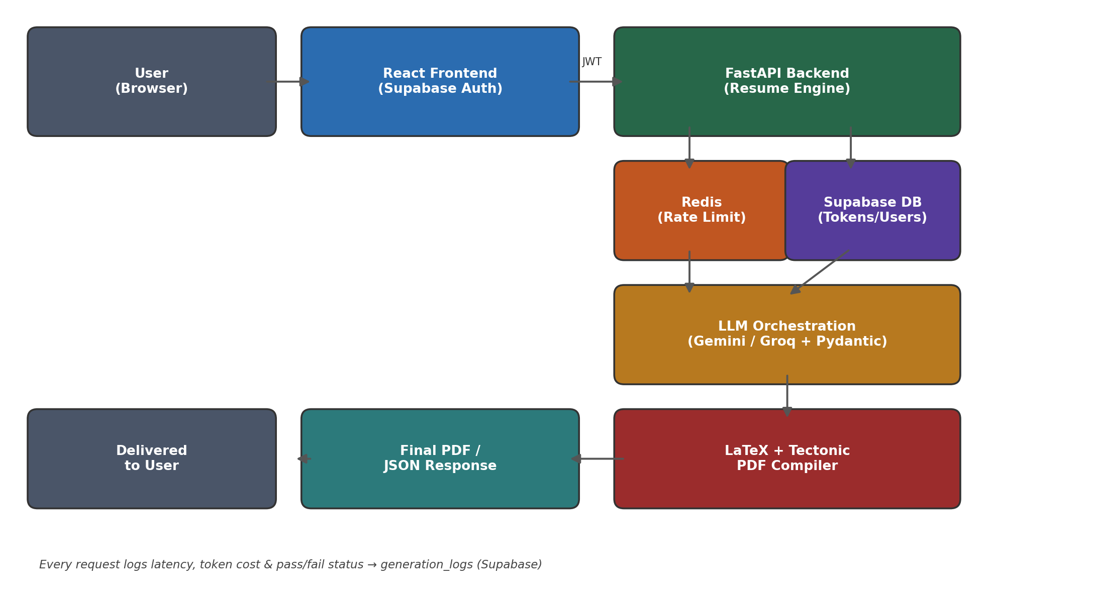
Figure 1: Request flow from user login to final PDF delivery

4.1 User Flow & Authentication
The user logs in through Supabase on the frontend. This generates a JWT token, which is sent with every API request to the FastAPI backend.

4.2 Access Control
- Free APIs: protected by Redis-based IP rate limiting (e.g., 10 requests/hour).
- Premium APIs: FastAPI checks the Supabase DB, verifies token balance, and deducts a token only on successful task completion.

4.3 LLM Orchestration ("The Brain")
On each request, FastAPI loads a specific AI prompt (e.g., /app/prompts/evaluate/prompt_evaluate.txt), sends the relevant data to the LLM, and expects a strict JSON response back.

4.4 Strict Validation
Pydantic performs strict data validation on every LLM response to prevent hallucinated or malformed output. If the format is incorrect, the system throws an error or retries.

4.5 Resume Compilation Engine
The JSON returned by the AI is sanitized (special characters like % and # are escaped), fed into a Jinja2/LaTeX template, and compiled instantly into a polished PDF by Tectonic.

4.6 Logging
Every request's latency, LLM token cost, and pass/fail status is saved to the generation_logs table in Supabase for admin analytics.

5. Growth & Business Infrastructure (Monetization)
Career Catalyst isn't just a tech product — it is a complete SaaS business model.
Mechanism | How It Works
Token Economy | New users get 15 free tokens on sign-up. Each AI feature use deducts 1 token. Additional tokens are purchased via Stripe.
Referral Loop | Sharing a personal link (/signup?ref=CODE) rewards both the referrer and the new user with 5 bonus tokens each — built for organic virality.
Admin Dashboard | Backend view showing daily API hits, revenue generated, and where users drop off in the funnel.

6. Conclusion
Career Catalyst brings together a 3D-enhanced UI, secure authentication, complex AI prompt engineering, Redis rate-limiting, LaTeX-based PDF generation, and a full SaaS token economy into one cohesive, enterprise-grade career acceleration platform.

