Laboratory Procedure

Data collection

Feature Extraction

Feature Selection

Multiple Linear Regression Model

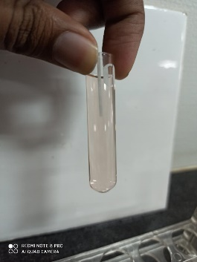 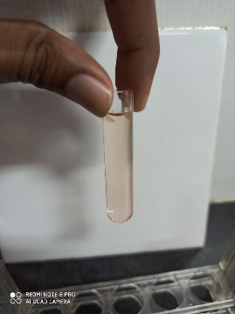 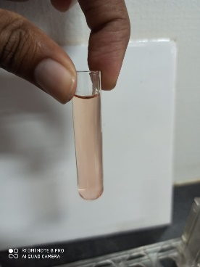 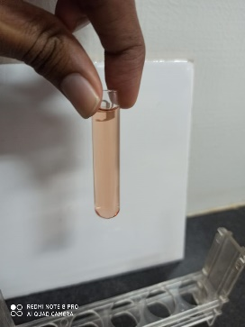 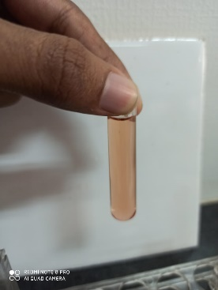

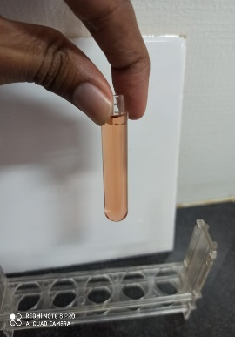 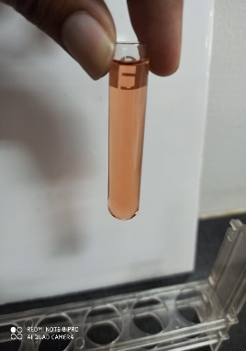 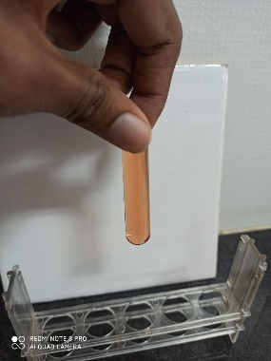 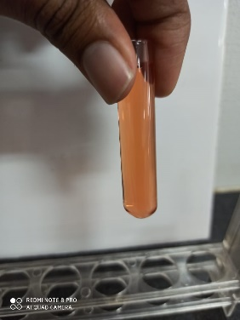 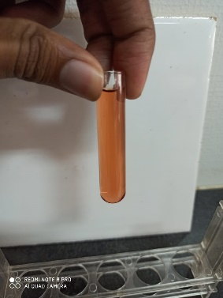

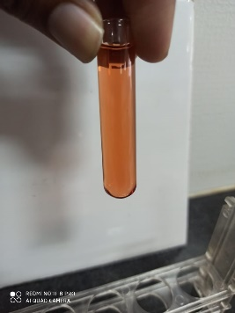 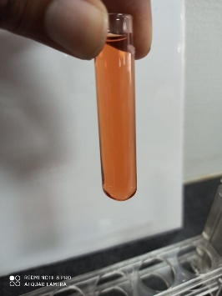 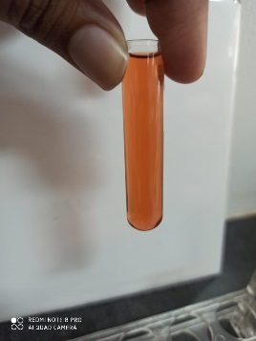 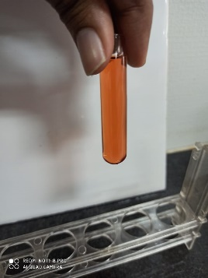 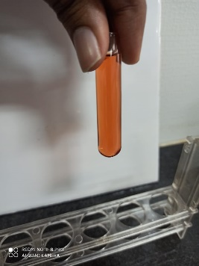

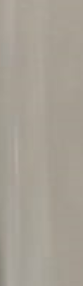 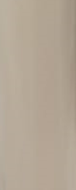 C:\Users\mosa0816\Project Urine\Project colorimeter\Images cuvette\cropped Images\1.5.PNG 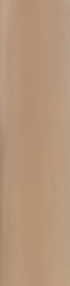 C:\Users\mosa0816\Project Urine\Project colorimeter\Images cuvette\cropped Images\2.5.PNG 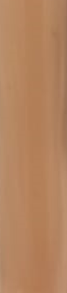 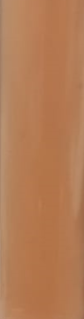 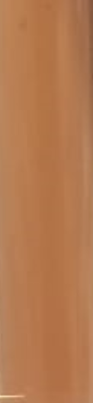 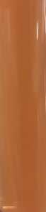 C:\Users\mosa0816\Project Urine\Project colorimeter\Images cuvette\cropped Images\5.PNG C:\Users\mosa0816\Project Urine\Project colorimeter\Images cuvette\cropped Images\5.5.PNG 