# Assignment #01

MAD (Mobile App Development)

-MOHAMMAD

-L1F22BSCS0521

-E2

-SIR MUNEEB ALI MUZAFFAR

Q1: UI DEVELOPMENT IN .XML FILE

SOL:

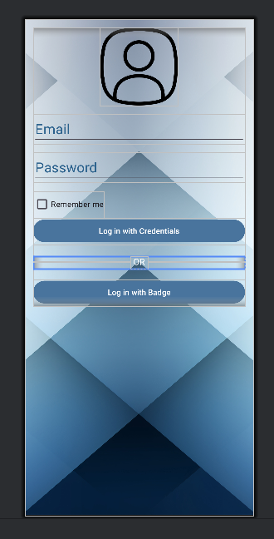

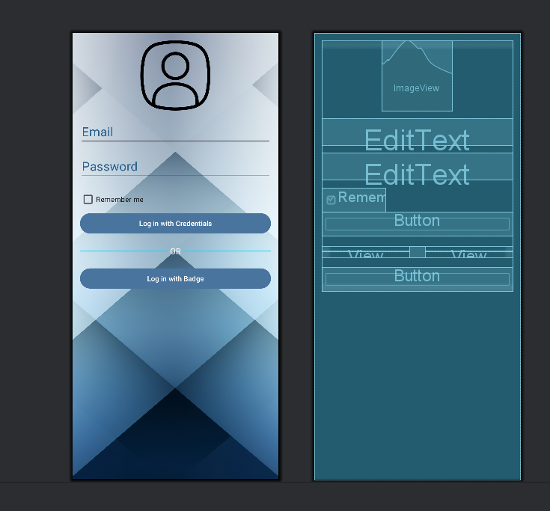

CODE: (XML FILE ALSO ATTACHED FOR REF.)

<?xml version="1.0" encoding="utf-8"?>  
<RelativeLayout xmlns:android="http://schemas.android.com/apk/res/android"  
 xmlns:app="http://schemas.android.com/apk/res-auto"  
 xmlns:tools="http://schemas.android.com/tools"  
 android:id="@+id/main"  
 android:layout_width="match_parent"  
 android:layout_height="match_parent"  
 tools:context=".MainActivity"  
 android:gravity="top"  
 android:padding="15dp"  
 android:background="@drawable/bg">  
  
 <LinearLayout  
 android:layout_width="match_parent"  
 android:layout_height="wrap_content"  
 android:gravity="center"  
 android:orientation="vertical">  
 <ImageView  
 android:layout_width="140dp"  
 android:layout_height="140dp"  
 android:src="@drawable/user"/>  
 <EditText  
 android:layout_width="match_parent"  
 android:layout_height="wrap_content"  
 android:hint="Email"  
 android:textColorHint="#2C628D"  
 android:textSize="25sp"  
 android:layout_marginTop="15dp"  
 android:inputType="textEmailAddress"/>  
 <EditText  
 android:layout_width="match_parent"  
 android:layout_height="wrap_content"  
 android:hint="Password"  
 android:textColorHint="#2C628D"  
 android:textSize="25sp"  
 android:layout_marginTop="15dp"  
 android:inputType="textPassword"/>  
 <CheckBox  
 android:layout_width="wrap_content"  
 android:layout_height="wrap_content"  
 android:layout_gravity="start"  
 android:text="Remember me"  
 android:layout_marginTop="15dp"  
 />  
  
  
 <Button  
 android:layout_width="match_parent"  
 android:layout_height="match_parent"  
 android:text="Log in with Credentials"  
 android:backgroundTint="#49749D"/>  
 <!-- Divider with OR -->  
 <LinearLayout  
 android:layout_width="match_parent"  
 android:layout_height="wrap_content"  
 android:orientation="horizontal"  
 android:gravity="center"  
 android:layout_marginTop="20dp"  
 android:layout_marginBottom="20dp">  
  
 <!-- Left Line -->  
 <View  
 android:layout_width="0dp"  
 android:layout_height="1dp"  
 android:layout_weight="1"  
 android:background="@android:color/holo_blue_bright" />  
  
 <!-- OR Text -->  
 <TextView  
 android:layout_width="wrap_content"  
 android:layout_height="wrap_content"  
 android:text="OR"  
 android:textColor="@android:color/white"  
 android:paddingStart="5dp"  
 android:paddingEnd="5dp"  
 android:textSize="16sp"  
 />  
  
 <!-- Right Line -->  
 <View  
 android:layout_width="0dp"  
 android:layout_height="1dp"  
 android:layout_weight="1"  
 android:background="@android:color/holo_blue_bright" />  
 </LinearLayout>  
 <Button  
 android:layout_width="match_parent"  
 android:layout_height="match_parent"  
 android:text="Log in with Badge"  
 android:backgroundTint="#49749D"/>  
 </LinearLayout>  
  
</RelativeLayout>