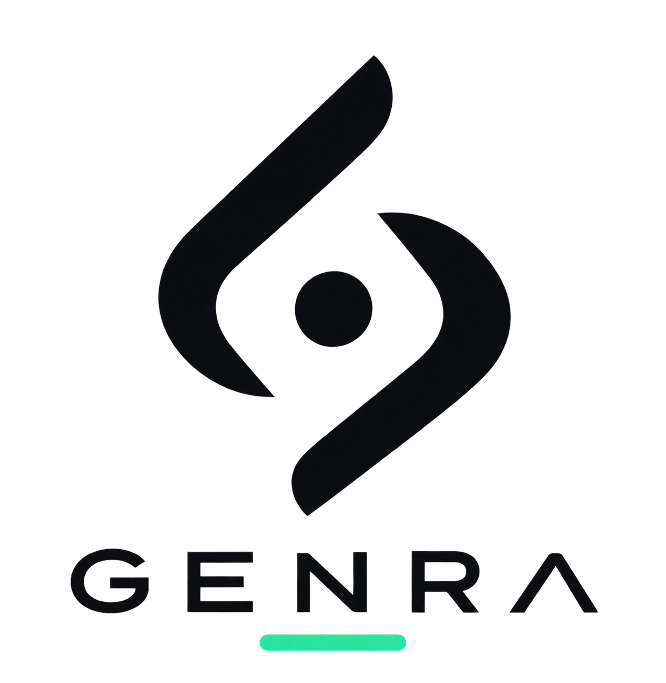
GENRA
BRAND IDENTITY & VISUAL SYSTEM
A practical foundation for GENRA's digital, product, and communication identity.
Build. Automate. Advance.
You bring the idea. We make it happen

1. Brand Foundation
GENRA is positioned as a modern technology company focused on turning ideas and opportunities into practical outcomes through software, AI, automation, and intelligent execution.

Brand personality
Intelligent • Capable • Modern • Confident • Approachable • Fast • Curious
GENRA should feel technologically advanced without becoming cold, robotic, or overly futuristic. The identity is deliberately restrained: the logo stays simple while the wider brand environment can introduce subtle depth, motion, light, and gradients.

2. Logo System
The GENRA symbol is an abstract, symmetrical mark built from opposing curved forms and a central dot. It is intentionally non-literal: it does not need to look like a letter G or an obvious AI symbol. Its role is to become a distinctive visual signature associated with GENRA.

Approved logo variants
- Primary logo — dark emblem + GENRA wordmark on Ivory/light backgrounds.
- Dark logo — Ivory emblem + wordmark on Obsidian backgrounds.
- Accent logo — Mint/teal gradient emblem with restrained accent treatment for hero and marketing applications.
- Monochrome logo — 100% black or 100% white for print, embossing, stamps, and constrained applications.
- Icon-only mark — emblem without the wordmark for favicon, app icon, social avatar, and compact UI.

Logo usage principles
- Preserve generous clear space around the mark.
- Do not stretch, skew, rotate, outline, or add decorative effects to the logo.
- Do not place the gradient treatment on every application; it is an accent, not the default.
- At very small sizes, prioritize the icon-only mark and simplify only if legibility requires it.

3. Color System
GENRA uses a dark-first palette built around Obsidian and Ivory, with Mint as a restrained signature accent. The overall effect should be premium and contemporary rather than neon or overly colorful.
Color | HEX | Role | Recommended use
Obsidian | #080B0B | Primary | Dark backgrounds, navigation, hero sections, dark logo applications
Ivory | #F5F4EF | Primary light | Light backgrounds, documents, cards, light logo applications
GENRA Mint | #34D399 | Signature accent | Buttons, links, logo underline, active states, highlights
Deep Mint | #10B981 | Accent depth | Hover states, gradient depth, secondary accent
Graphite | #374151 | Secondary | Secondary text, UI, icons, borders
Silver | #D1D5DB | Neutral | Fine borders, disabled states, metadata

Primary gradient
GENRA Mint → Deep Mint: #34D399 → #10B981
Optional marketing gradient: #34D399 → #5EEAD4 → #60A5FA. Use sparingly for atmospheric or premium digital treatments.

Color balance
Approximate visual ratio: 50% Obsidian • 35% Ivory • 10% Graphite/Silver • 5% Mint.
The mint should behave like a signal: noticeable and recognizable, but never overwhelming.

4. Typography
The recommended pairing is Sora for display typography and the GENRA wordmark, with Inter for body copy and interface elements.
Purpose | Font | Weight | Guidance
Logo / display | Sora | SemiBold 600 | Wide spacing; clean geometric character
H1 / H2 | Sora | SemiBold 600 | Strong, confident headlines
H3 | Sora | SemiBold 600 | Section and card headings
Body | Inter | Regular 400 | 16–18 px digital body copy
UI / navigation | Inter | Medium 500 | 14–16 px
Buttons | Inter | SemiBold 600 | 14–16 px
Captions | Inter | Medium 500 | 12–14 px, slightly increased tracking

Recommended digital hierarchy
- H1: Sora 600, approximately 48–72 px desktop.
- H2: Sora 600, approximately 32–44 px.
- H3: Sora 600, approximately 24–30 px.
- Body: Inter 400, approximately 16–18 px with 1.5–1.65 line height.
- Navigation/UI: Inter 500.
- Buttons: Inter 600.

5. Digital & UI Language
GENRA interfaces should feel spacious, precise, and quiet. Depth comes from layering and subtle contrast, not from excessive shadows, glow, or decorative effects.
Element | Value
Dark background | #080B0B
Light background | #F5F4EF
Dark card | #111615
Light card | #FFFFFF
Dark border | #1F2926
Light border | #E5E7E5
Primary button | #34D399
Button text | #080B0B
Hover accent | #10B981

6. Imagery & Graphic Direction
- Prefer dark environments, architectural geometry, subtle light, real work, and sophisticated technology imagery.
- Use abstract geometry and layered surfaces for AI/automation themes.
- Human imagery should feel authentic and purposeful rather than generic corporate stock photography.
- Avoid robots, glowing brains, circuit-board clichés, excessive blue neon, and stereotypical 'AI' visuals.
- Use subtle mint light, reflections, gradients, or depth as supporting brand atmosphere.

7. Logo & Favicon Specifications
Maintain separate master assets for the full logo, icon-only mark, monochrome versions, and accent version.
- Favicon: 16×16 and 32×32 px.
- App / PWA icon: 180×180, 192×192, and 512×512 px.
- Social/avatar: square icon-only mark.
- Use the icon-only mark whenever the wordmark would become too small to read.

8. Brand Voice
GENRA should communicate with clarity and confidence. Prefer short, direct statements over corporate jargon.
Avoid | Prefer
We leverage cutting-edge AI technologies... | We build systems that do the work.
AI-powered recruitment solutions... | You find the opportunity. GENRA handles the work.
Customized AI automation solutions... | If it can be done, it can probably be automated.

9. Tagline & Messaging Directions
Primary working line:
Build. Automate. Advance.
You bring the idea. We make it happen.
Additional directions:
- Build. Automate. Advance.
- You Name It. We Build It.
- Same intelligence. More possibilities.
- Technology that moves people forward.
- Intelligence, put to work.
- From intent to execution.

10. Brand Asset Checklist
- Primary full logo — light background
- Dark-mode full logo
- Accent/gradient full logo
- Black monochrome logo
- White monochrome logo
- Icon-only mark
- Icon-only dark version
- Icon-only accent version
- Favicon set
- App/PWA icon set
- Typography files / usage specification
- Color palette specification
- Social profile/avatar assets
- Website header and footer logo assets
- Business card and letterhead templates
- Email signature
- Presentation / pitch-deck template
- LinkedIn/social banner system

GENRA — Build. Automate. Advance.

