**Reading CSV Data using Pandas**

Method #1: Using read_csv() method: read_csv() is an important pandas function to read csv files and do operations on it.

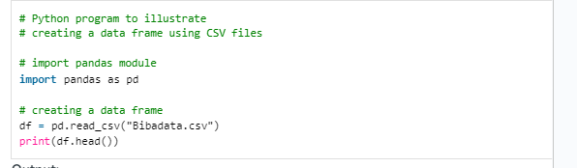

Method #2: Using read_table() method: read_table() is another important pandas function to read csv files and create data frame from it.



Method #3: Using the csv module: One can directly import the csv files using the csv module and then create a data frame using that csv file.

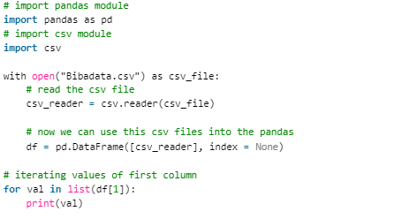

**Count Values in Pandas Dataframe**

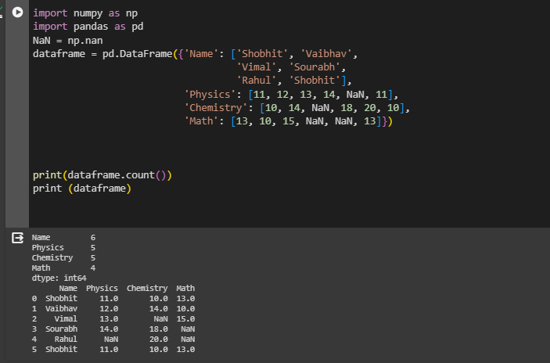

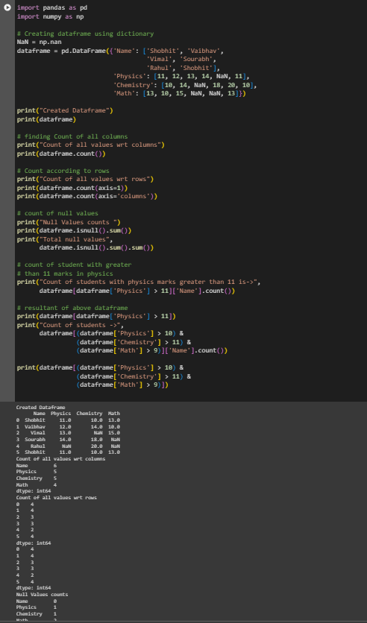

**Types of Joins in Pandas**

Pandas Inner Join

Inner join is the most common type of join you’ll be working with. It returns a Dataframe with only those rows that have common characteristics. This is similar to the intersection of two sets.

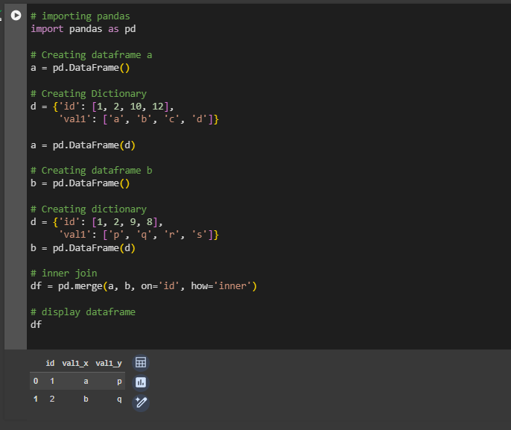

Pandas Left Join

With a left outer join, all the records from the first Dataframe will be displayed, irrespective of whether the keys in the first Dataframe can be found in the second Dataframe. Whereas, for the second Dataframe, only the records with the keys in the second Dataframe that can be found in the first Dataframe will be displayed.

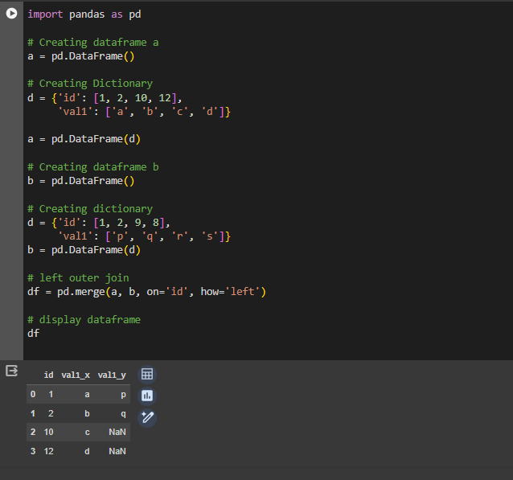

Pandas Right Outer Join

For a right join, all the records from the second Dataframe will be displayed. However, only the records with the keys in the first Dataframe that can be found in the second Dataframe will be displayed.

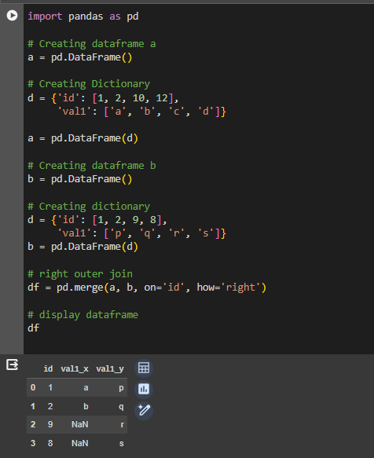

Pandas Full Outer Join

A full outer join returns all the rows from the left Dataframe, and all the rows from the right Dataframe, and matches up rows where possible, with NaNs elsewhere. But if the Dataframe is complete, then we get the same output.

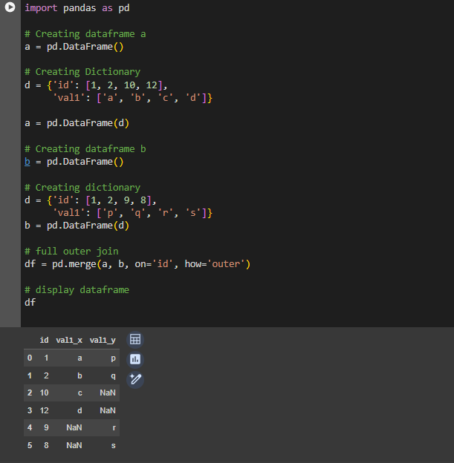

Pandas Index Join

To merge the Dataframe on indices pass the left_index and right_index arguments as True i.e. both the Dataframes are merged on an index using default Inner Join.

