1. File I/O using Python: Read Data from CSV File into Python List

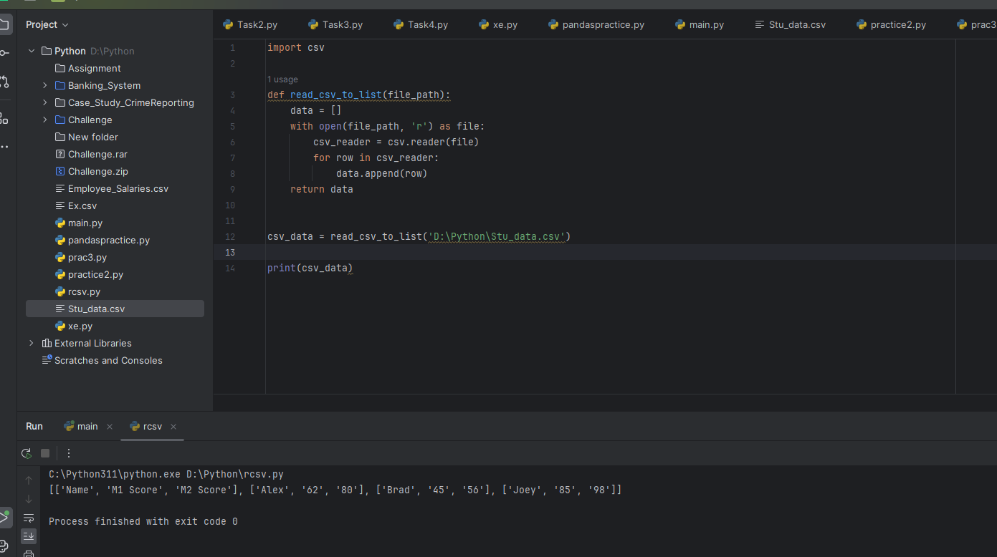

a. Use of Lambda Functions in Python:

Lambda functions are small, anonymous functions that can have any number of arguments but can only have one expression. They are useful for writing short, throwaway functions without the need to define a separate function using the def keyword.

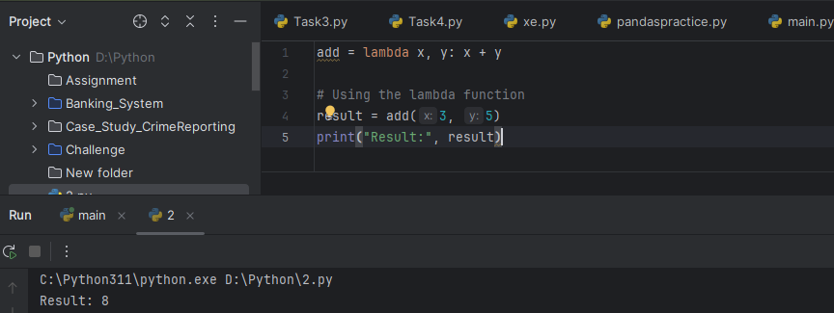

b. Practical Uses of Python Lambda Functions:

Lambda functions are commonly used in situations where a small anonymous function is needed for a short period of time. Some practical use cases include:

1. Sorting: Lambda functions can be used as key functions in sorting operations.
2. Filtering: Lambda functions are useful in filtering data using functions like filter().
3. Mapping: Lambda functions can be used with map() to apply a function to each element of an iterable.
4. Reducing: Lambda functions can be applied to reduce() to perform cumulative operations on a sequence.

c. Using Lambda Functions with map(), filter(), reduce():

Lambda functions are often used in conjunction with higher-order functions like map(), filter(), and reduce() for concise and expressive code.

1. map():

The map() function in Python applies a given function to each item of an iterable (such as a list) and returns a new iterator with the results.

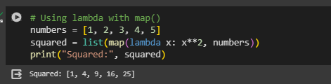

2. filter():

The filter() function in Python filters elements from an iterable based on a given function (predicate) and returns an iterator with the elements for which the function returns True.

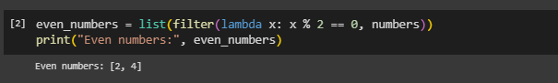

3. reduce():

The reduce() function in Python applies a rolling computation to sequential pairs of values in an iterable and returns a single value.

