**Get Unique Values from a List Using Set Method**

**1.** **Using set() :**

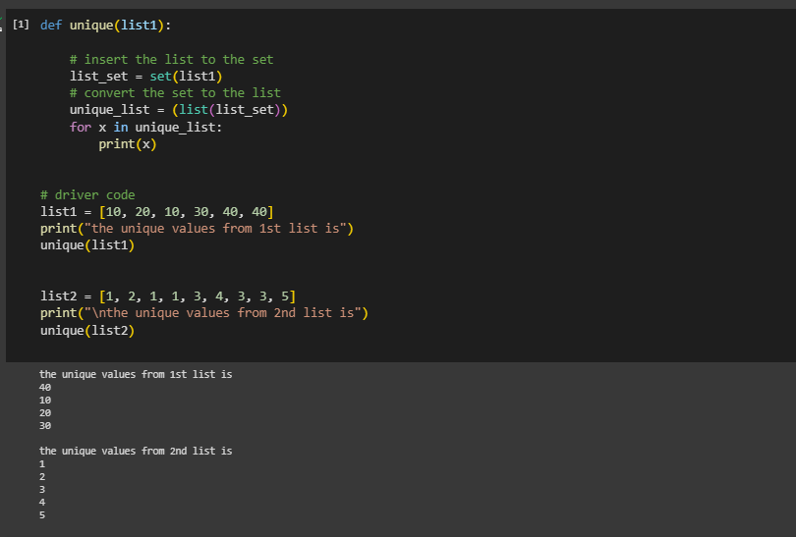

**2. Using Python import reduce() from functools and iterate over all element and checks if the element is a duplicate or unique value.**

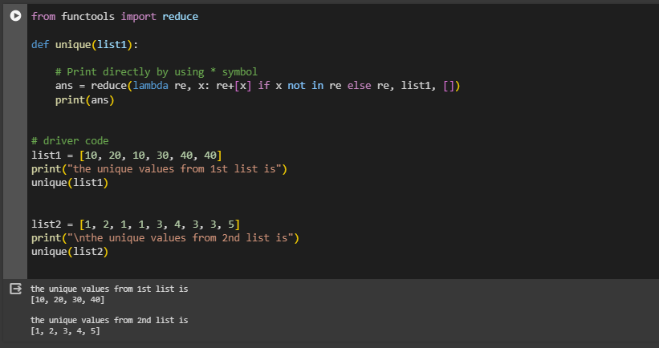

**3. Get Unique Values From a List in Python Using Operator.countOf() method :**

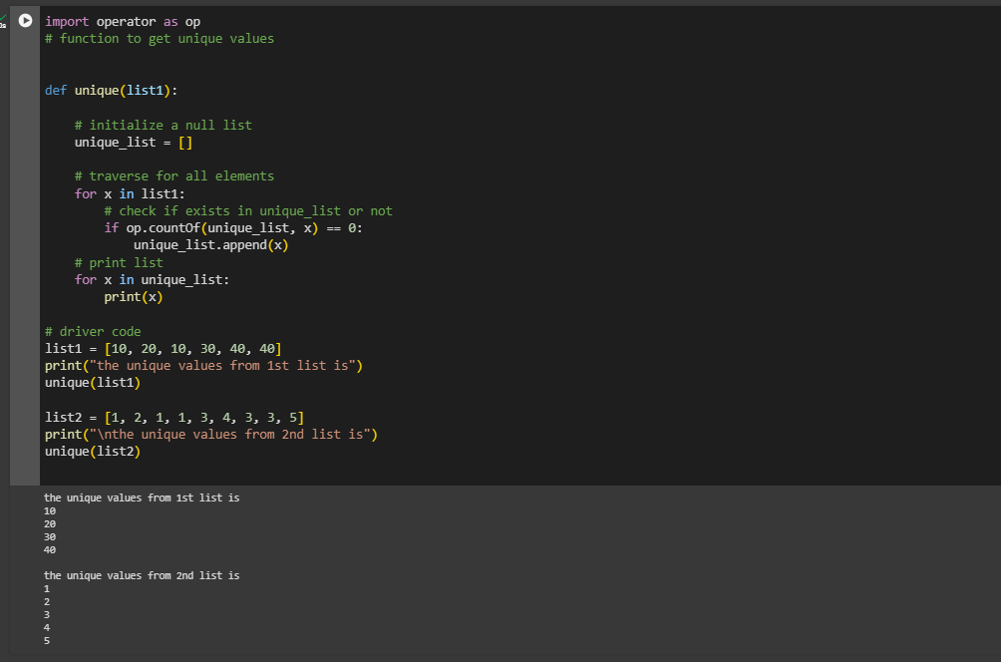

**4. Get Unique Values From a List in Python Using pandas module :**

The ‘unique’ function utilizes Pandas to create a Series from ‘list1’, then employs ‘drop_duplicates()’ to eliminate duplicates and obtain a list of unique values. Subsequently, it iterates through the unique list and prints each element. The driver code demonstrates the process for two lists, ‘list1’ and ‘list2’, providing distinct values for each list.

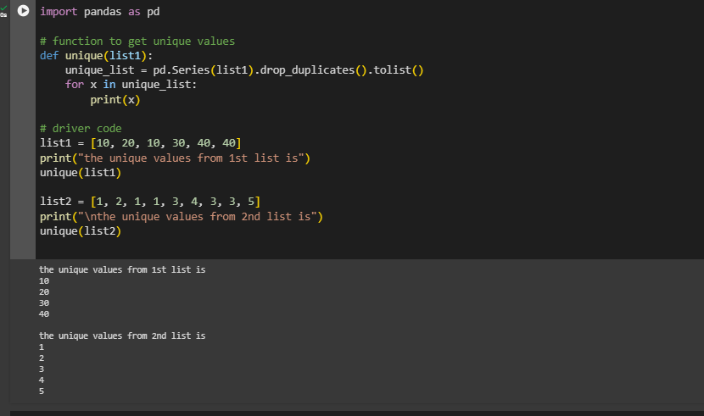

**5.** **Get Unique Values From a List Using numpy.unique :**

Using Python’s import numpy, the unique elements in the array are also obtained. In the first step convert the list to x=numpy.array(list) and then use numpy.unique(x) function to get the unique values from the list. numpy.unique() returns only the unique values in the list.

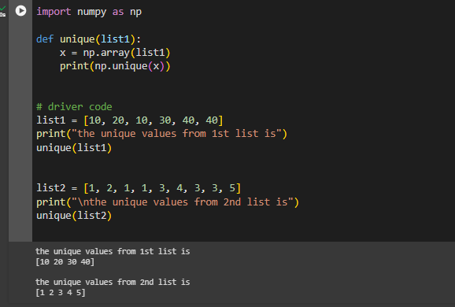

**6. Get Unique Values From a List in Python Using collections.Counter() :**

Using Python to import Counter() from collections print all the keys of Counter elements or we print directly by using the “*” symbol. Below is the implementation of the above approach.

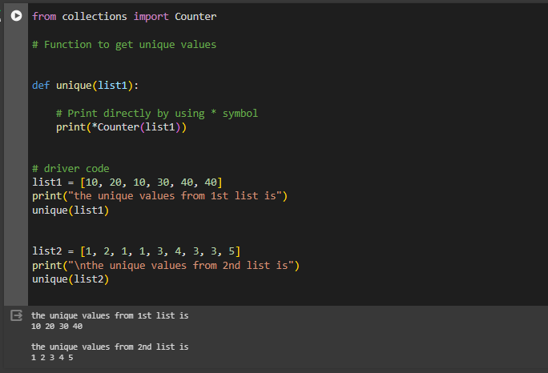

**7. Get Unique Values From a List Using dict.fromkeys():**

Using the fromkeys() method of dictionary data structure we can fetch the unique elements.Firstly we need to define a list that consists of duplicate elements.Then we need to use a variable in which we will store the result after using the fromkeys() method.We need to convert that result into a list, as the fromkeys() method is part of the dictionary so by default it returns a dictionary with all the unique keys and None as their values.

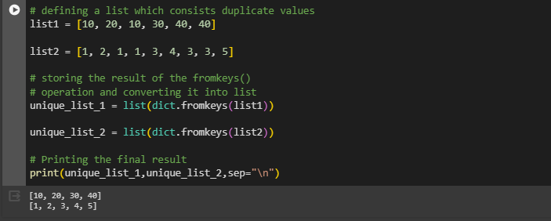

**JSON**

**JSON** stands for **J**ava**S**cript **O**bject **N**otation. It is a format for structuring data. This format is used by different web applications to communicate with each other. JSON is the replacement of the XML data exchange format in JSON. It is easy to structure the data compare to XML. It supports data structures like arrays and objects and the JSON documents that are rapidly executed on the server.

Convert JSON String to Dictionary Python

In this example, we are going to convert a JSON string to Python Dictionary using json.loads() method of JSON module in Python. Firstly, we import json module and then define JSON string after that converting JSON string to Python dictionary by passing it to json.loads() in parameter.

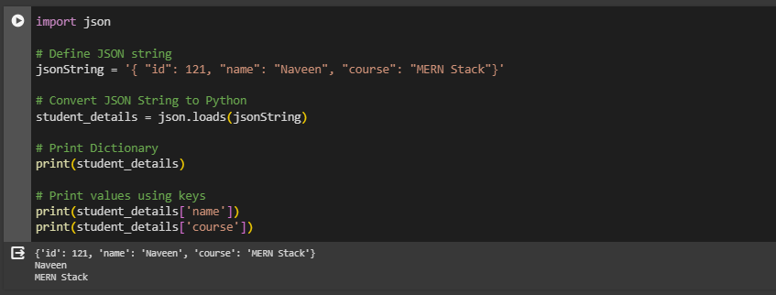

**Convert JSON File to Python Object**

Below is the JSON file that we will convert to Python dictionary using json.load() mehtod.

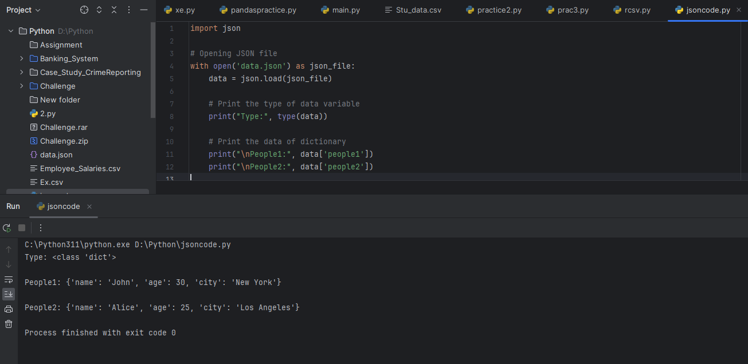

**Convert Nested JSON Object to Dictionary**

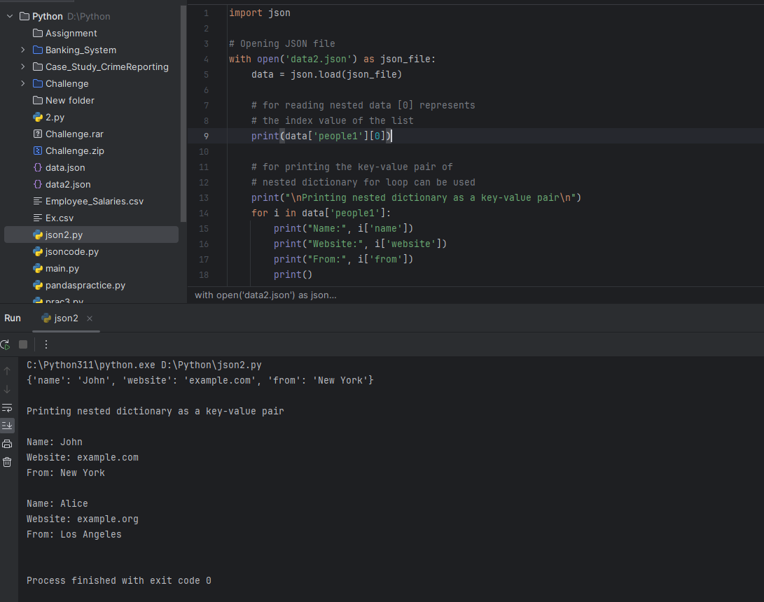

**Convert Python Dict to JSON**

In the below code, we are converting a Python dictionary to a JSON object using json.dumps() method of JSON module in Python. We first import the JSON module and then make a small dictionary with some key-value pairs and then passed it into json.dumps() method with ‘indent=4’ to convert this Python dictionary into a JSON object .

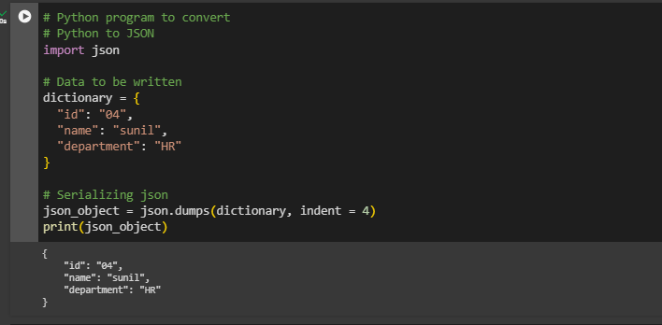

**Writing JSON to a file in Python**

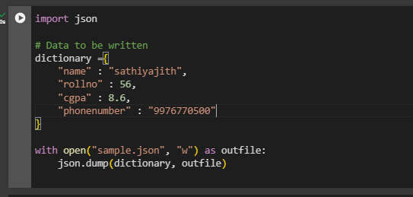

**Python Pretty Print JSON**

When we convert a string to JSON the data is in a less readable format. To make it more readable we can use pretty printing by passing additional arguments in json.dumps() function such as indent and sort_keys as used in the below code.

