1.DDL commands

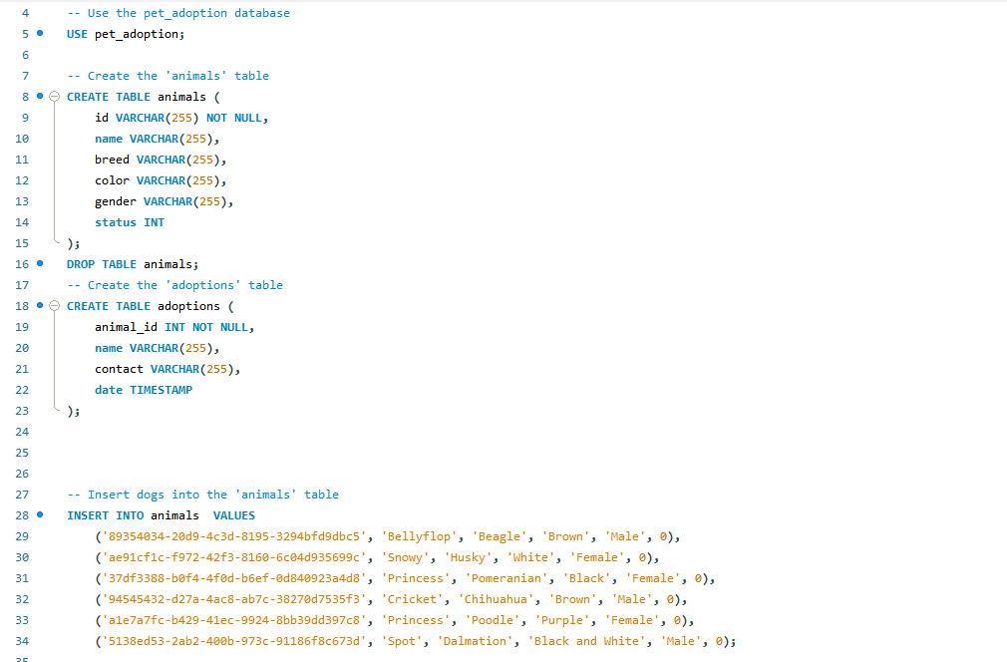

2 .Updating the table

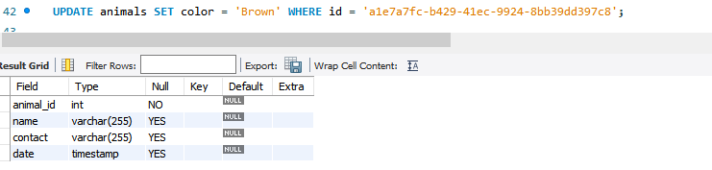

3. Deleting data from table



4.Retrieving Specific attributes

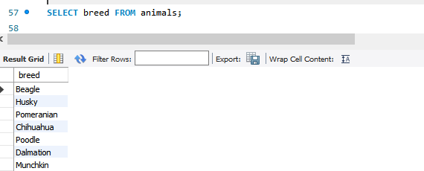

5. Retrieving Selected rows

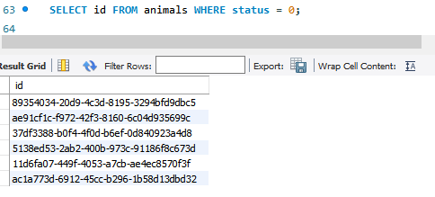

Filtering data

6. Using IN

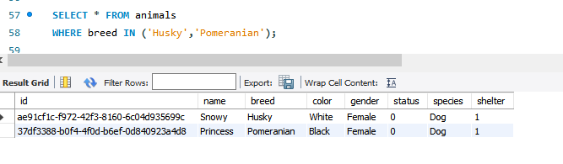

7. Using Distinct

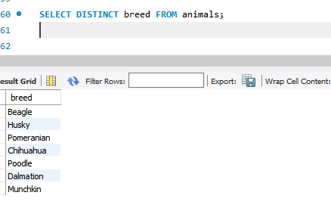

8. Using And OR

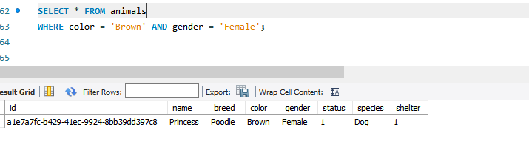

9. Using Between

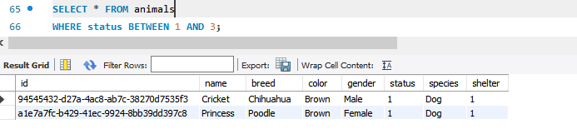

10. Using Like

