Three models, one recognition task
TRAFFIC SIGN RECOGNITION | MODEL COMPARISON & EXPERIMENT RESULTS
This report compares the implemented Baseline CNN, CNN + Adaptive Batch Normalization (AdaBN), and CNN + Ant Colony Optimization (ACO). It uses the current local source code, nine saved robustness-result CSVs, and nine original clean-test confusion-matrix PDFs.

Main result
CNN + AdaBN has the highest saved mean corruption accuracy: 89.02%, followed by CNN + ACO at 73.56% and Baseline CNN at 70.41%. These averages weight the three datasets equally.

Datasets are evaluated independently
Dataset | Region | Output classes
GTSRB | Germany | 43
BTSD | Belgium | 62
CTSD | China | 58

Each model is trained and evaluated separately for each dataset. Class IDs belong to their own dataset; the datasets are not merged into a common label space.

What is included
Pages 2-3 explain architecture and model differences. Page 4 compares numerical metrics. Page 5 explains interpretation and limitations. Pages 6-14 reproduce one clean-test confusion matrix for every model-dataset pair.

Important distinction
Numerical tables summarize corrupted-image testing. The embedded matrices show clean-image testing. They describe different conditions and must not be treated as the same evaluation. No clean-test numerical accuracy is inferred from image colors.

Shared CNN architecture and differences
All models take RGB images resized to 49 x 49 pixels and produce one raw score (logit) per class. Pixel values are scaled to [0, 1]. The current activation is ReLU, not GELU.
Stage | Operation | Output per image
Input | RGB image | 3 x 49 x 49
Block 1 | 3 x 3 convolution: 3 to 32; ReLU; 2 x 2 max pooling | 32 x 24 x 24
Block 2 | 3 x 3 convolution: 32 to 64; ReLU; Dropout2d (0.2); max pooling | 64 x 12 x 12
Block 3 | 3 x 3 convolution: 64 to 128; ReLU; max pooling | 128 x 6 x 6
Classifier | Flatten; Linear 4608 to 512; ReLU; Dropout (0.5); Linear 512 to K | K logits

All convolutions use stride 1 and padding 1. Pooling halves spatial size with rounding down. K is 43, 62, or 58 depending on the dataset. Prediction is the class with the largest logit; softmax is not needed to select that class.

What changes between the models?
Property | Baseline | AdaBN | ACO
BatchNorm layers | None | After each convolution and first linear layer | None
Feature gate | None | None | 128-channel pheromone gate after third pooling
Extra procedure | None | Update BN statistics on unlabeled target images | Offline ant-colony search during training
Test-time changes | None | Running mean and variance only | None; gate is fixed

ReLU keeps positive activations and sets negative ones to zero. Pooling reduces spatial resolution. Dropout randomly suppresses activations during training and is disabled during inference. These mechanisms are shared rather than unique contributions.

How each model learns and predicts

1. Baseline CNN
Convolutions learn image features and the dense classifier maps them to sign classes. Training updates the network weights using labeled images. Testing uses the saved weights without normalization adaptation or feature-search steps. This is the reference model.

2. CNN + AdaBN
BatchNorm normalizes activations using a mean and variance, then applies learned scale and offset parameters. AdaBN recalibrates the running statistics using unlabeled target images; it does not retrain the convolution or classifier weights.
For each corruption condition, the evaluator restores the source checkpoint, resets BN statistics, and passes the whole corrupted test set through the model without gradients. BN layers collect statistics while dropout stays disabled. The model is then evaluated on that condition. Clean testing occurs without this adaptation step.
Example: brightness changes may shift feature statistics. AdaBN attempts to account for the new distribution rather than using only the original training statistics.

3. CNN + ACO
The network first trains for one warm-up epoch. Before epoch 2, ACO evaluates candidate binary masks of the final 128 feature channels. The configured defaults are 15 ants, 5 search iterations, and pheromone evaporation of 0.15.
Search fitness is classification accuracy on one sampled training batch. The heuristic is normalized channel-activation variance. Pheromones are converted into a continuous gate of approximately 0.5 to 1.5, then the network continues training with the fixed gate. The gate is applied before the dense classifier and is saved with the checkpoint.
This is channel reweighting, not actual channel removal or a smaller CNN. ACO is not the optimizer used for the convolution weights, and the existing search does not explicitly optimize corruption robustness.

Shared training configuration
Source-code defaults: Adam optimizer, learning rate 0.001, cross-entropy loss, batch size 64, and 5 epochs. Defaults are not a complete audit trail of every saved run. All models use Adam for trainable weights; ACO adds its separate channel-search step.

Evaluation metrics and measured results
Every model-dataset CSV contains 14 corruption types x 5 severity levels = 70 conditions. The values below are arithmetic means of the saved per-condition metrics, not clean-test scores and not metrics pooled over one combined prediction list.
Model | Dataset | Acc. % | P micro % | R micro % | F1 macro
Baseline CNN | GTSRB | 70.65 | 70.65 | 70.65 | 0.6702
Baseline CNN | BTSD | 73.75 | 73.75 | 73.75 | 0.5273
Baseline CNN | CTSD | 66.83 | 66.83 | 66.83 | 0.5045
CNN + AdaBN | GTSRB | 78.79 | 78.79 | 78.79 | 0.7661
CNN + AdaBN | BTSD | 92.30 | 92.30 | 92.30 | 0.8323
CNN + AdaBN | CTSD | 95.98 | 95.98 | 95.98 | 0.9488
CNN + ACO | GTSRB | 71.70 | 71.70 | 71.70 | 0.6891
CNN + ACO | BTSD | 74.29 | 74.29 | 74.29 | 0.5220
CNN + ACO | CTSD | 74.71 | 74.71 | 74.71 | 0.6301

Equal-weight average across the three datasets
Model | Acc. % | P micro % | R micro % | F1 macro
Baseline CNN | 70.41 | 70.41 | 70.41 | 0.5673
CNN + AdaBN | 89.02 | 89.02 | 89.02 | 0.8491
CNN + ACO | 73.56 | 73.56 | 73.56 | 0.6137

Definitions and availability
Accuracy = correct predictions / all predictions. Precision = true positives / (true positives + false positives). Recall = true positives / (true positives + false negatives). F1 balances precision and recall through their harmonic mean.
Micro averaging aggregates class counts before calculating the metric. In this single-label, full-class classification setting, micro-precision and micro-recall both equal accuracy. Their entries are mathematically derived from saved accuracy, not independently recorded precision/recall measurements.
Macro-F1 averages per-class F1 scores and is saved on the 0-1 scale. Macro-precision and macro-recall were not saved and cannot be recovered from accuracy and macro-F1. They require another inference pass, not retraining. The evaluator uses sklearn's default class set for macro-F1, rather than explicitly fixing all dataset class IDs.

Interpretation, matrix guide and evidence

What the saved results support
AdaBN leads on mean corruption accuracy for each of the three datasets. Its equal-dataset average exceeds baseline by 18.61 percentage points and ACO by 15.46 points. ACO improves mean accuracy over baseline on all three datasets, but its BTSD macro-F1 is lower. Higher accuracy does not necessarily mean better performance across classes.

How to read the confusion matrices
Rows are true classes and columns are predicted classes. Diagonal cells represent correct classifications. Off-diagonal cells represent mistakes: a cell at row 3, column 5 means true class 3 was predicted as class 5. The following nine figures reproduce the saved clean-test matrices; they are not generated or estimated illustrations.
The matrices display raw counts through color, without cell-number annotations or a colorbar. Plot colors are independently scaled, so do not compare darkness across different matrices as a shared numerical scale. Class numbers are dataset-specific.

Limits of this comparison
The baseline has no BN, whereas the AdaBN architecture includes BN and adaptation. An additional evaluation of the same BN-equipped checkpoint with adaptation disabled is needed to isolate the adaptation benefit. These are saved single-run results, not multi-seed estimates. Historical files do not prove that all runs used identical random corruptions; shared caching was added during this experiment period.

Result provenance
Root: D:/python/ML-Project. Numeric sources: output/<model>/<dataset>/robustness_results_<dataset>.csv. SHA-256 prefixes below identify the exact CSV snapshots.
Model | Dataset | CSV SHA-256 prefix
Baseline CNN | GTSRB | d6b0b500d422
Baseline CNN | BTSD | 9db1189e7729
Baseline CNN | CTSD | fcf60b8d16d2
CNN + AdaBN | GTSRB | 201d404edf94
CNN + AdaBN | BTSD | 2dcb4b7f250b
CNN + AdaBN | CTSD | 8cc2b3379519
CNN + ACO | GTSRB | e3bc62e0da86
CNN + ACO | BTSD | c9a8aa58a88d
CNN + ACO | CTSD | 2c7141bb4d1e

Baseline CNN | GTSRB confusion matrix
CLEAN TEST DATA | 43 CLASSES | 49 x 49 RGB INPUT
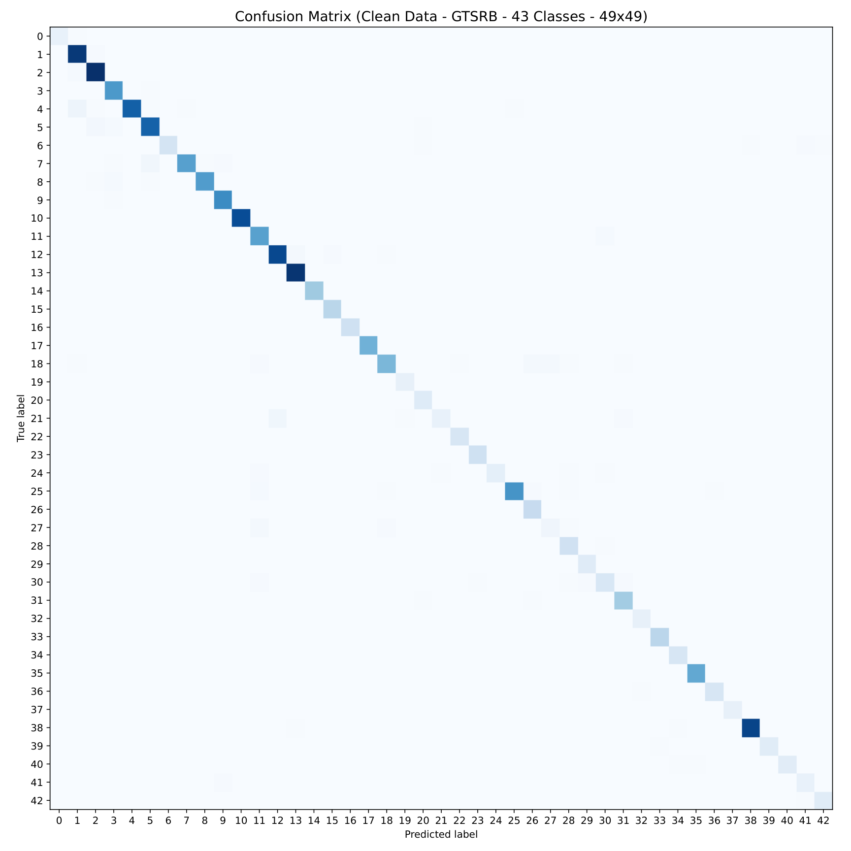
True class: vertical axis. Predicted class: horizontal axis. Diagonal = correct; off-diagonal = misclassified. Colors encode raw counts.
This figure is from clean testing. It does not represent the 70-condition corruption average shown in the numerical tables.
Source: output/baseline/gtsrb/test_without_noise_gtsrb.pdf | SHA-256 prefix: ef6701890b4a
Additional corruption matrices are saved separately in output/baseline/gtsrb/noise/ (14 severity-5 PDFs).

Baseline CNN | BTSD confusion matrix
CLEAN TEST DATA | 62 CLASSES | 49 x 49 RGB INPUT
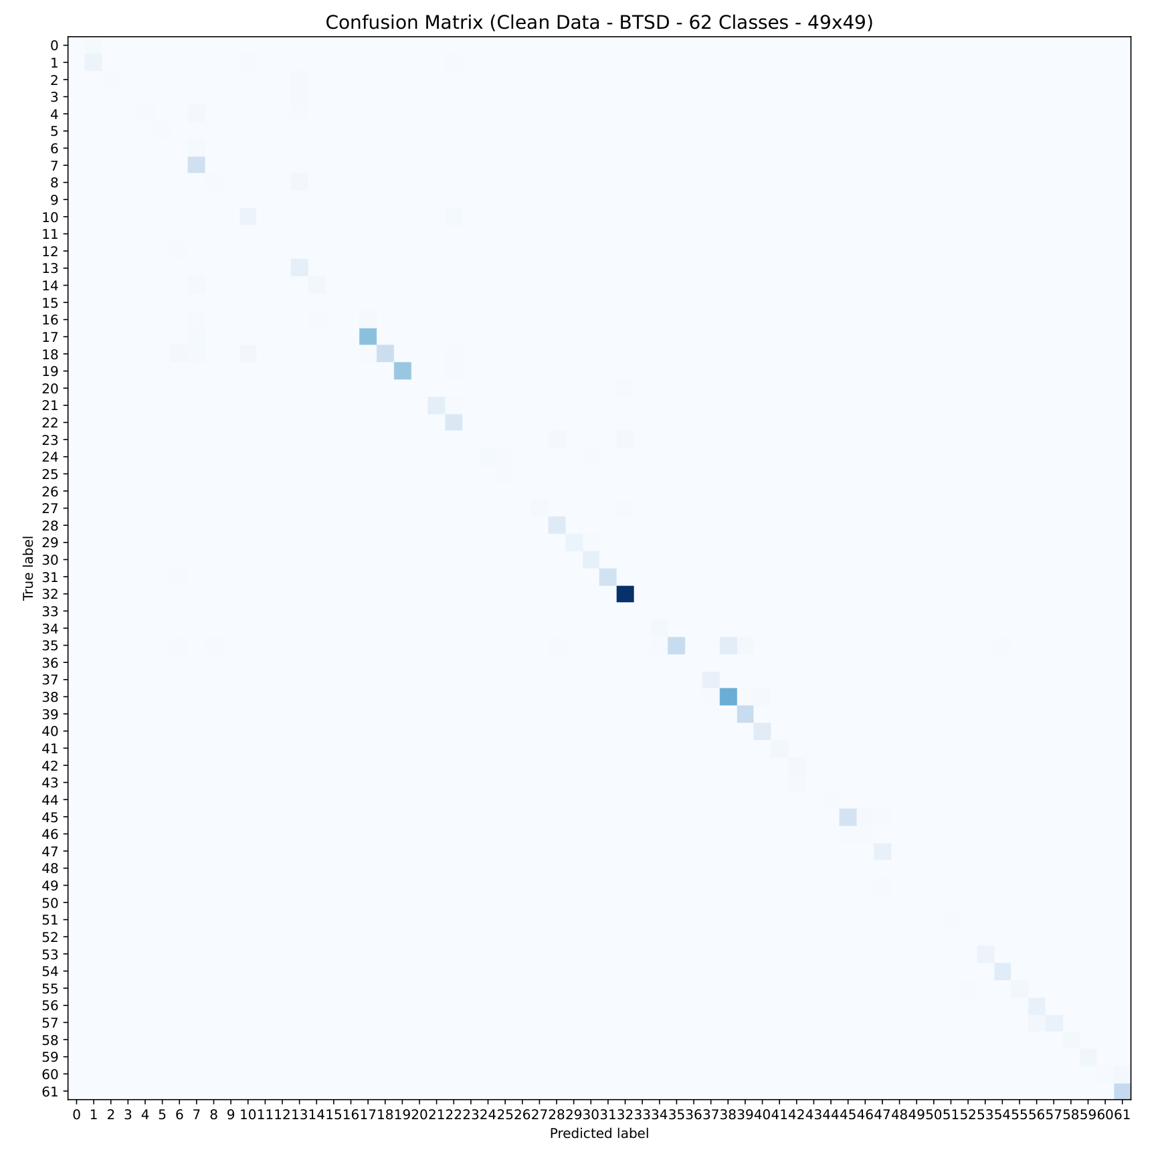
True class: vertical axis. Predicted class: horizontal axis. Diagonal = correct; off-diagonal = misclassified. Colors encode raw counts.
This figure is from clean testing. It does not represent the 70-condition corruption average shown in the numerical tables.
Source: output/baseline/btsd/test_without_noise_btsd.pdf | SHA-256 prefix: 92149395b674
Additional corruption matrices are saved separately in output/baseline/btsd/noise/ (14 severity-5 PDFs).

Baseline CNN | CTSD confusion matrix
CLEAN TEST DATA | 58 CLASSES | 49 x 49 RGB INPUT
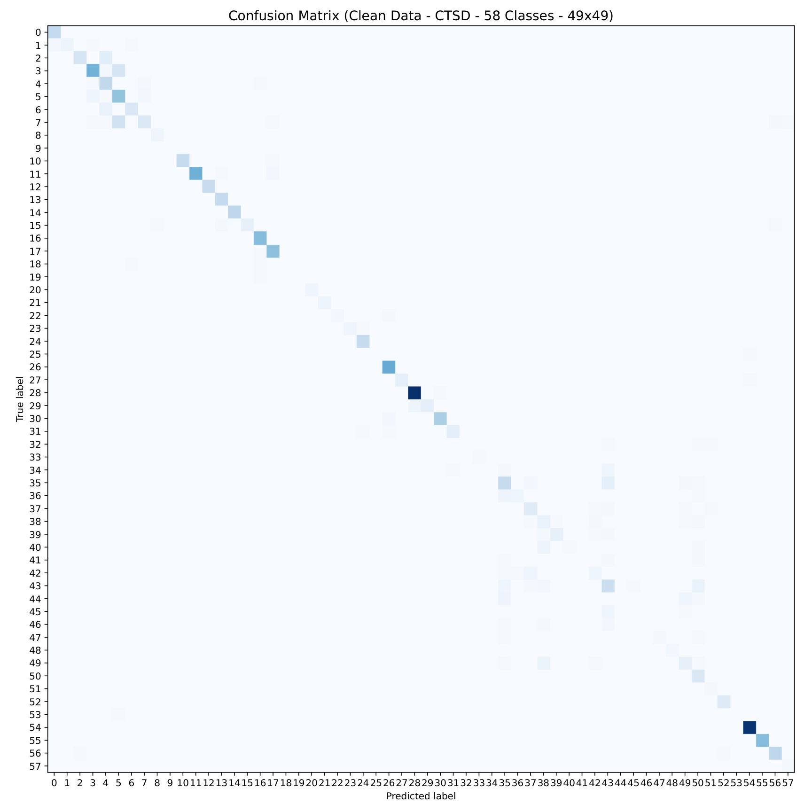
True class: vertical axis. Predicted class: horizontal axis. Diagonal = correct; off-diagonal = misclassified. Colors encode raw counts.
This figure is from clean testing. It does not represent the 70-condition corruption average shown in the numerical tables.
Source: output/baseline/ctsd/test_without_noise_ctsd.pdf | SHA-256 prefix: 058f03ac895f
Additional corruption matrices are saved separately in output/baseline/ctsd/noise/ (14 severity-5 PDFs).

CNN + AdaBN | GTSRB confusion matrix
CLEAN TEST DATA | 43 CLASSES | 49 x 49 RGB INPUT
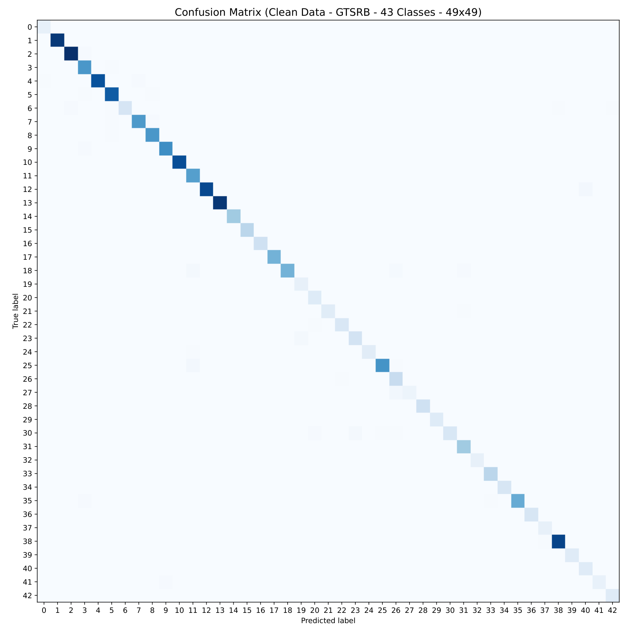
True class: vertical axis. Predicted class: horizontal axis. Diagonal = correct; off-diagonal = misclassified. Colors encode raw counts.
This figure is from clean testing. It does not represent the 70-condition corruption average shown in the numerical tables.
Source: output/adabn/gtsrb/test_without_noise_gtsrb.pdf | SHA-256 prefix: d7631ad7e9f1
Additional corruption matrices are saved separately in output/adabn/gtsrb/noise/ (14 severity-5 PDFs).

CNN + AdaBN | BTSD confusion matrix
CLEAN TEST DATA | 62 CLASSES | 49 x 49 RGB INPUT
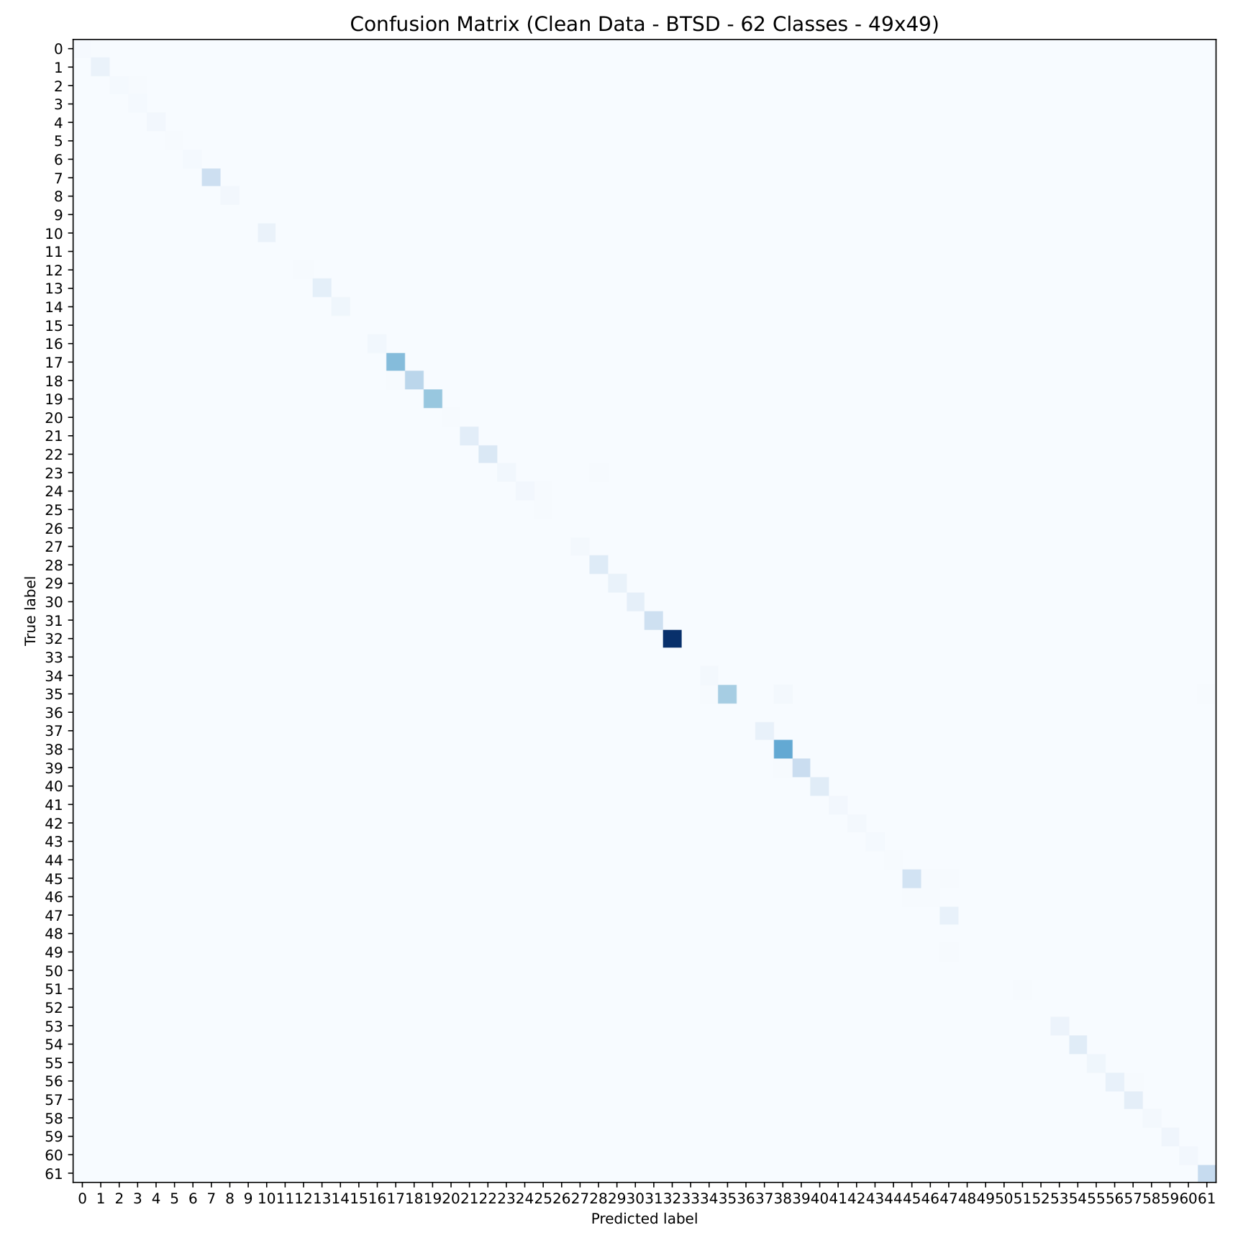
True class: vertical axis. Predicted class: horizontal axis. Diagonal = correct; off-diagonal = misclassified. Colors encode raw counts.
This figure is from clean testing. It does not represent the 70-condition corruption average shown in the numerical tables.
Source: output/adabn/btsd/test_without_noise_btsd.pdf | SHA-256 prefix: 12e43c20a1d7
Additional corruption matrices are saved separately in output/adabn/btsd/noise/ (14 severity-5 PDFs).

CNN + AdaBN | CTSD confusion matrix
CLEAN TEST DATA | 58 CLASSES | 49 x 49 RGB INPUT
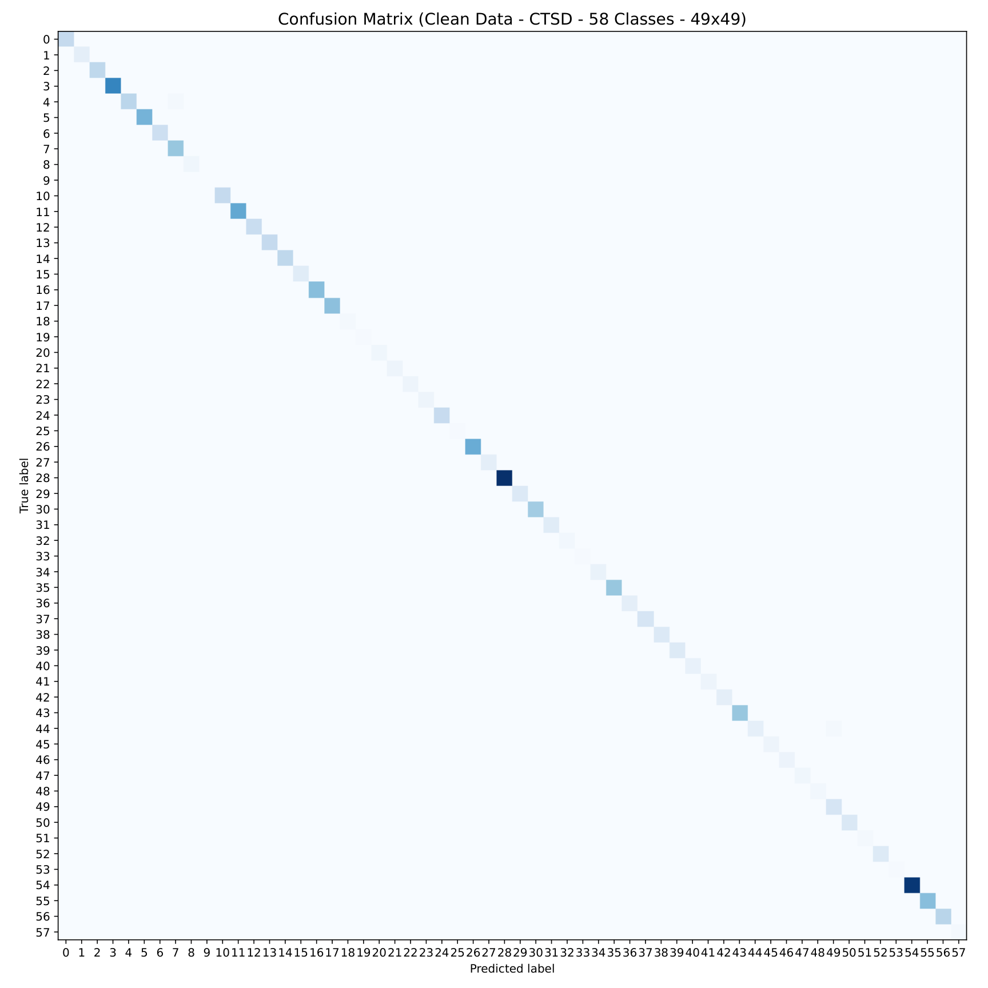
True class: vertical axis. Predicted class: horizontal axis. Diagonal = correct; off-diagonal = misclassified. Colors encode raw counts.
This figure is from clean testing. It does not represent the 70-condition corruption average shown in the numerical tables.
Source: output/adabn/ctsd/test_without_noise_ctsd.pdf | SHA-256 prefix: f23235fb82bc
Additional corruption matrices are saved separately in output/adabn/ctsd/noise/ (14 severity-5 PDFs).

CNN + ACO | GTSRB confusion matrix
CLEAN TEST DATA | 43 CLASSES | 49 x 49 RGB INPUT
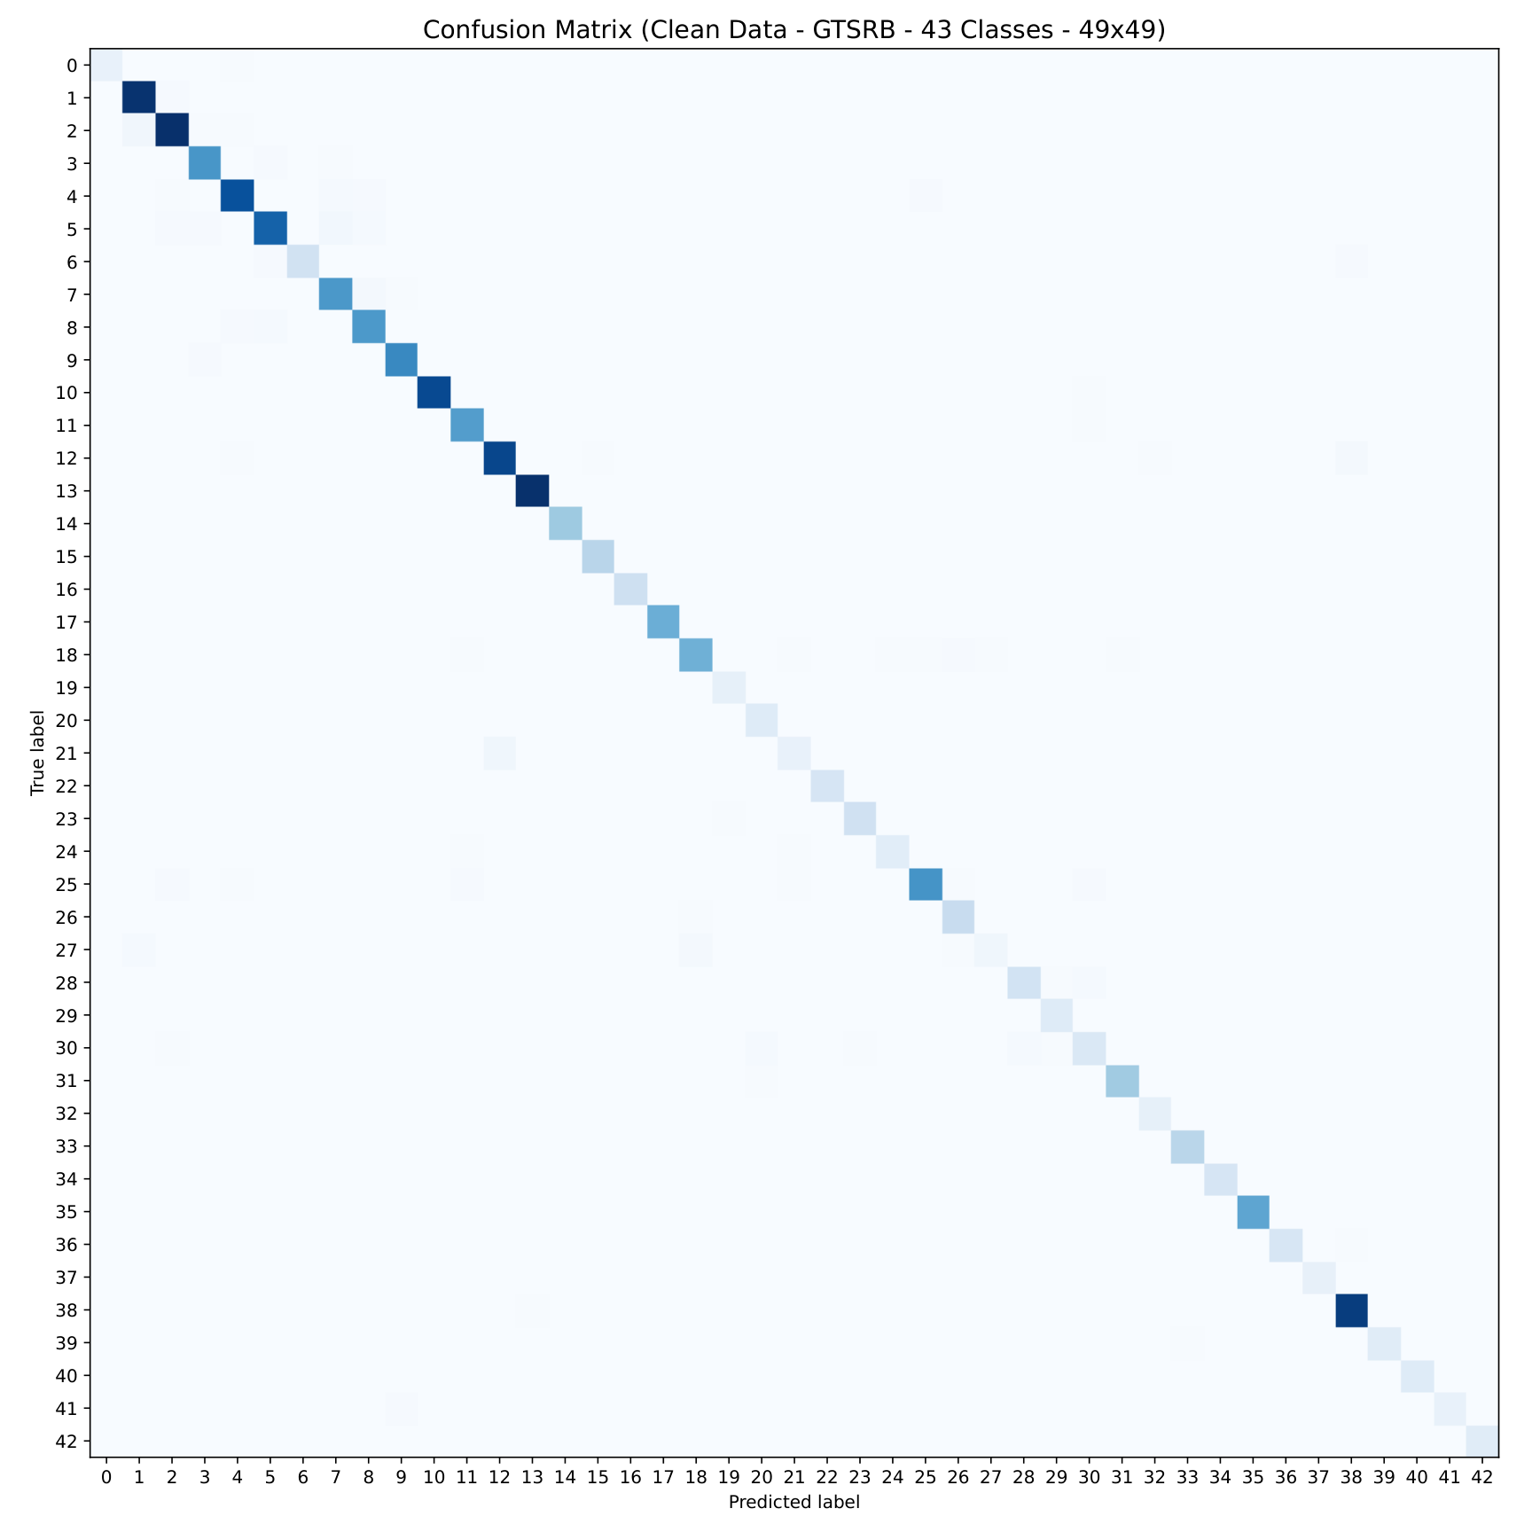
True class: vertical axis. Predicted class: horizontal axis. Diagonal = correct; off-diagonal = misclassified. Colors encode raw counts.
This figure is from clean testing. It does not represent the 70-condition corruption average shown in the numerical tables.
Source: output/aco/gtsrb/test_without_noise_gtsrb.pdf | SHA-256 prefix: cb32d783b92f
Additional corruption matrices are saved separately in output/aco/gtsrb/noise/ (14 severity-5 PDFs).

CNN + ACO | BTSD confusion matrix
CLEAN TEST DATA | 62 CLASSES | 49 x 49 RGB INPUT
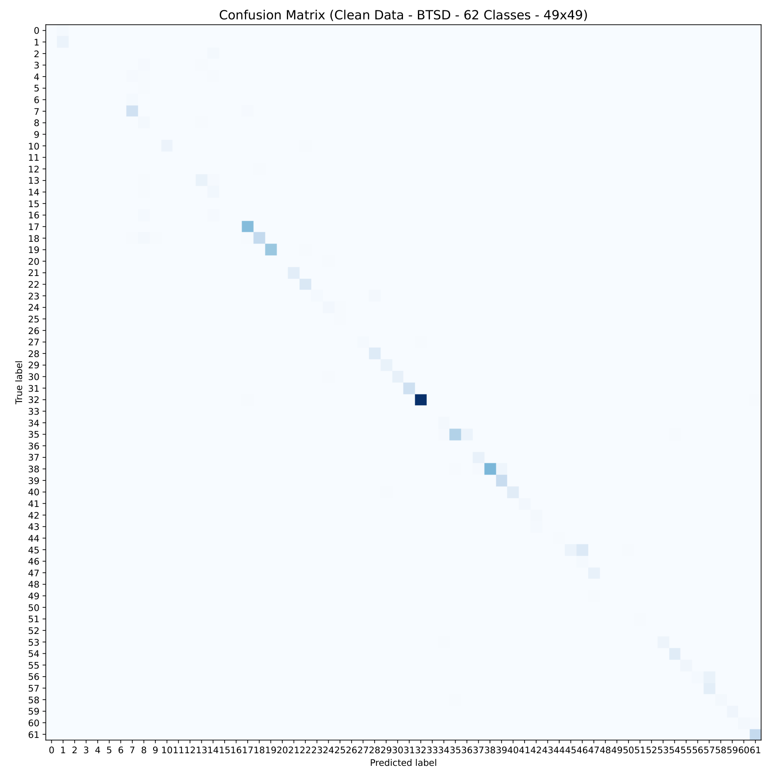
True class: vertical axis. Predicted class: horizontal axis. Diagonal = correct; off-diagonal = misclassified. Colors encode raw counts.
This figure is from clean testing. It does not represent the 70-condition corruption average shown in the numerical tables.
Source: output/aco/btsd/test_without_noise_btsd.pdf | SHA-256 prefix: d63d4896a20d
Additional corruption matrices are saved separately in output/aco/btsd/noise/ (14 severity-5 PDFs).

CNN + ACO | CTSD confusion matrix
CLEAN TEST DATA | 58 CLASSES | 49 x 49 RGB INPUT
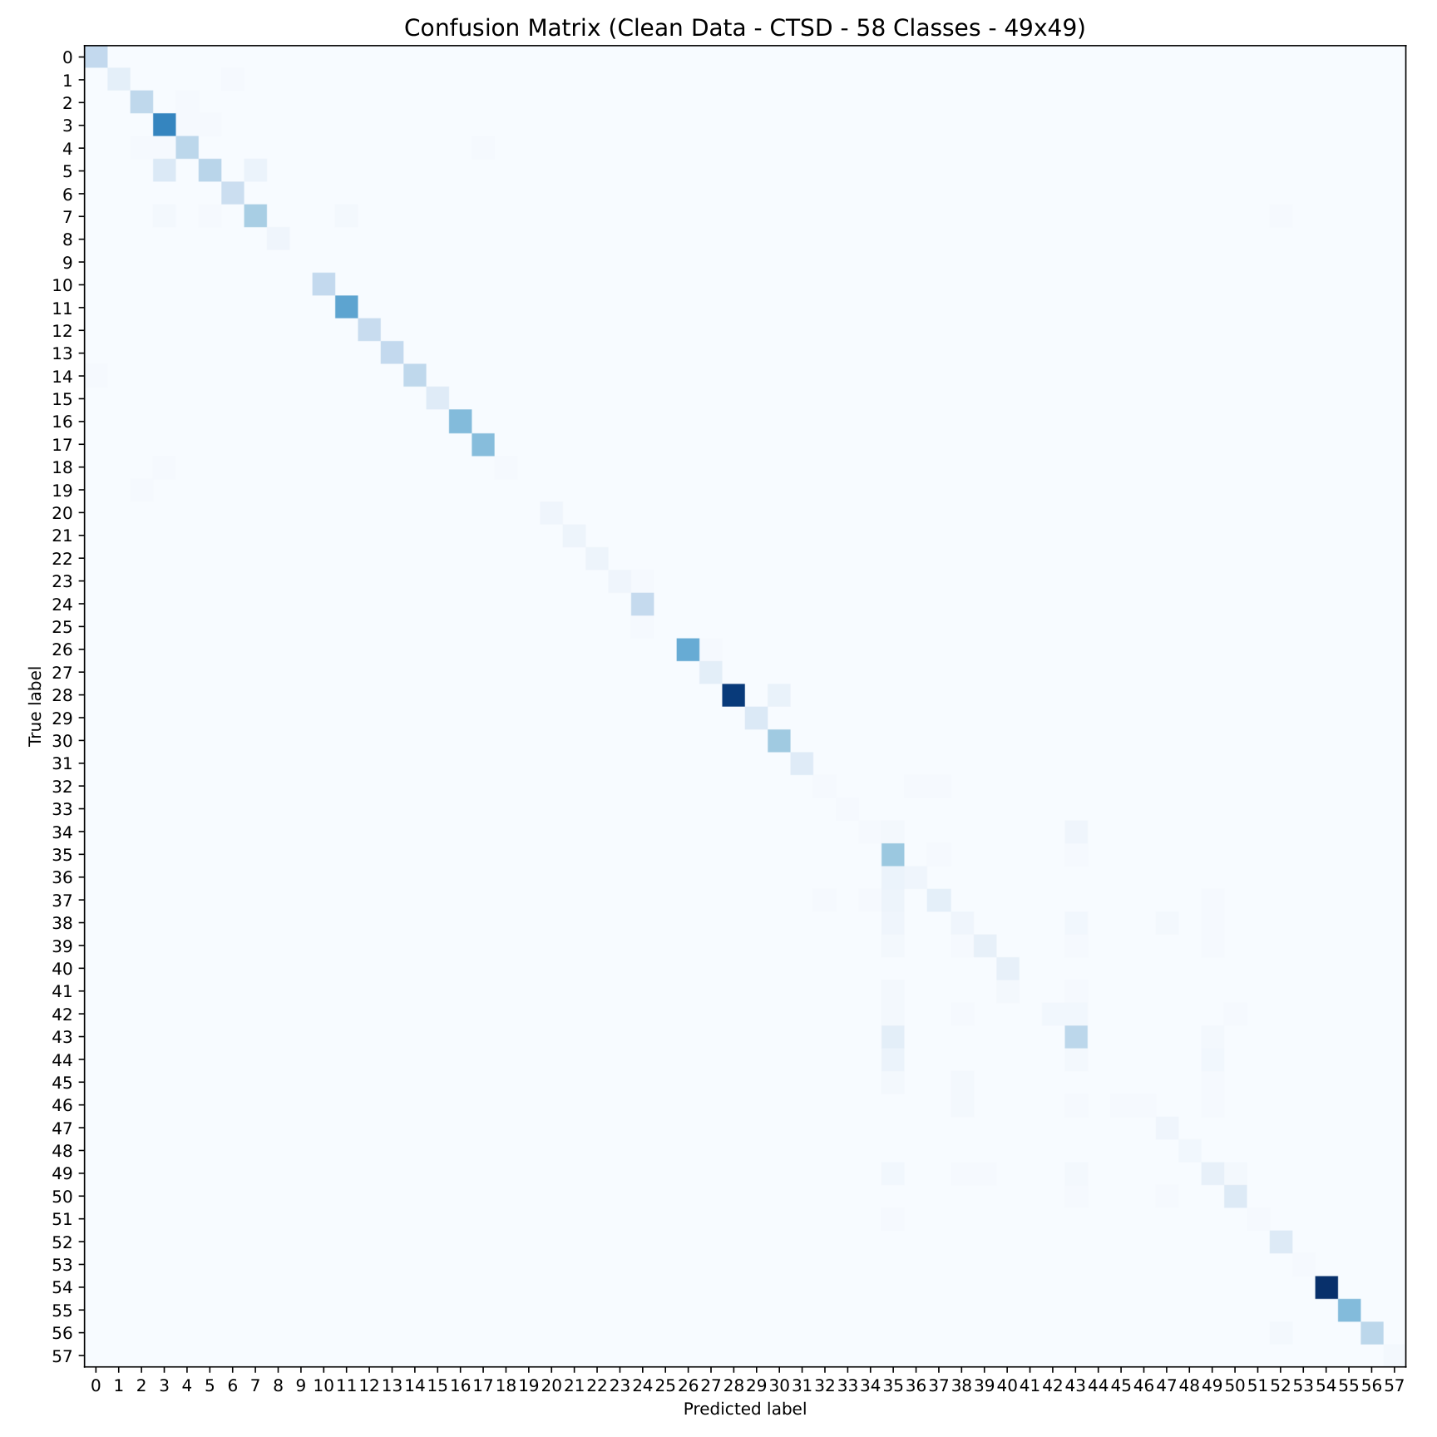
True class: vertical axis. Predicted class: horizontal axis. Diagonal = correct; off-diagonal = misclassified. Colors encode raw counts.
This figure is from clean testing. It does not represent the 70-condition corruption average shown in the numerical tables.
Source: output/aco/ctsd/test_without_noise_ctsd.pdf | SHA-256 prefix: a1763ce392bf
Additional corruption matrices are saved separately in output/aco/ctsd/noise/ (14 severity-5 PDFs).

