Industrial Internship Report on
”Machine Learning Applications in Precision Agriculture: Crop Production Prediction and Crop–Weed Detection”
Prepared by
Mohd Huzaif (25SCS1003000875)

Executive Summary
This report provides details of the Industrial Internship provided by upskill Campus and The IoT Academy in collaboration with Industrial Partner UniConverge Technologies Pvt Ltd (UCT).
This internship was focused on a project/problem statement provided by UCT, in the domain of Machine Learning. The internship, including the report, was completed over 4 weeks.
My project involved two parallel Machine Learning initiatives in precision agriculture: (1) predicting agricultural crop production in India using climatic, soil and satellite (NDVI) data, and (2) detecting crops and weeds in field imagery using deep learning-based segmentation, to support precision-farming decisions.
This internship gave me a very good opportunity to get exposure to Industrial problems and design/implement solution for that. It was an overall great experience to have this internship.

TABLE OF CONTENTS
1 Preface 3
2 Introduction 4
2.1 About UniConverge Technologies Pvt Ltd 4
2.2 About upskill Campus 8
2.3 Objective 9
2.4 Reference 9
2.5 Glossary 10
3 Problem Statement 11
4 Existing and Proposed solution 12
5 Proposed Design/ Model 13
5.1 High Level Diagram (if applicable) 13
5.2 Low Level Diagram (if applicable) 13
5.3 Interfaces (if applicable) 13
6 Performance Test 14
6.1 Test Plan/ Test Cases 14
6.2 Test Procedure 14
6.3 Performance Outcome 14
7 My learnings 15
8 Future work scope 16

Preface
Over four weeks, I worked on two Machine Learning projects in precision agriculture: predicting crop production in India from climatic, soil, and satellite (NDVI) data, and detecting crops and weeds in field imagery using deep learning-based image segmentation. The work progressed from dataset collection and baseline models in Week 1, to advanced models (XGBoost, LSTM, U-Net) and hyperparameter tuning in Weeks 2–3, to ensemble methods, Mask R-CNN, final evaluation, and reporting in Week 4.
An industry internship bridges the gap between classroom learning and real-world problem solving. It gave me hands-on exposure to the full Machine Learning workflow — from messy real-world data to a validated, evaluated model — and to the kind of iterative, metric-driven decision-making that industry projects demand.
My problem statement had two parts. The first was to predict agricultural crop production in India using climatic, soil, and vegetation-index data. The second was to detect and segment crops versus weeds in field images to support precision-farming and automated field-monitoring applications.
I am grateful to upskill Campus (USC), The IoT Academy, and Industrial Partner UniConverge Technologies Pvt Ltd (UCT) for the opportunity to work on real, industry-relevant problem statements and to be mentored through the process.
How Program was planned
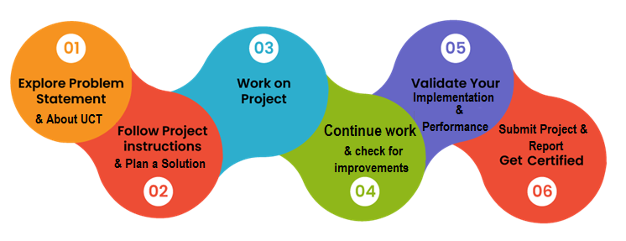
This internship strengthened my practical command of the Machine Learning pipeline — data cleaning, feature engineering, model selection, hyperparameter tuning, and rigorous evaluation using metrics such as RMSE, MAE, R², precision, recall, F1-score, and IoU. I also learned to communicate technical progress clearly through visualizations and structured weekly reporting, and to work through real data-quality and computational challenges rather than idealized textbook datasets.
I would like to thank my mentors at UCT and upskill Campus, and my faculty guide at IILM University, [Mentor Name], for their continuous guidance and feedback throughout this internship. I also thank my peers for their support and collaboration during the project.
To juniors taking on this internship: start with the data before the models — most of the real learning happens in cleaning, understanding, and questioning your dataset. Track your experiments and metrics from Week 1, and don't be afraid of models failing; the debugging is where the actual skill is built.

Introduction

About UniConverge Technologies Pvt Ltd
A company established in 2013 and working in Digital Transformation domain and providing Industrial solutions with prime focus on sustainability and RoI.
For developing its products and solutions it is leveraging various Cutting Edge Technologies e.g. Internet of Things (IoT), Cyber Security, Cloud computing (AWS, Azure), Machine Learning, Communication Technologies (4G/5G/LoRaWAN), Java Full Stack, Python, Front end etc.

- UCT IoT Platform ()
UCT Insight is an IOT platform designed for quick deployment of IOT applications on the same time providing valuable “insight” for your process/business. It has been built in Java for backend and ReactJS for Front end. It has support for MySQL and various NoSql Databases.
- It enables device connectivity via industry standard IoT protocols - MQTT, CoAP, HTTP, Modbus TCP, OPC UA
- It supports both cloud and on-premises deployments.
It has features to
• Build Your own dashboard
• Analytics and Reporting
• Alert and Notification
• Integration with third party application(Power BI, SAP, ERP)
• Rule Engine

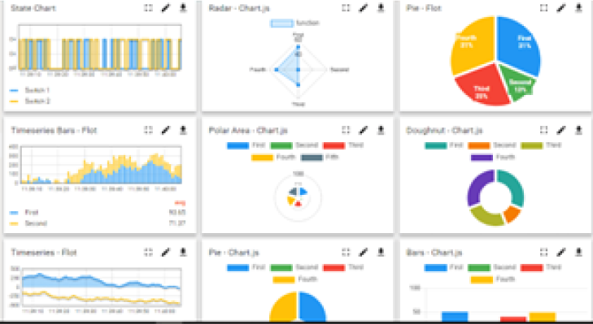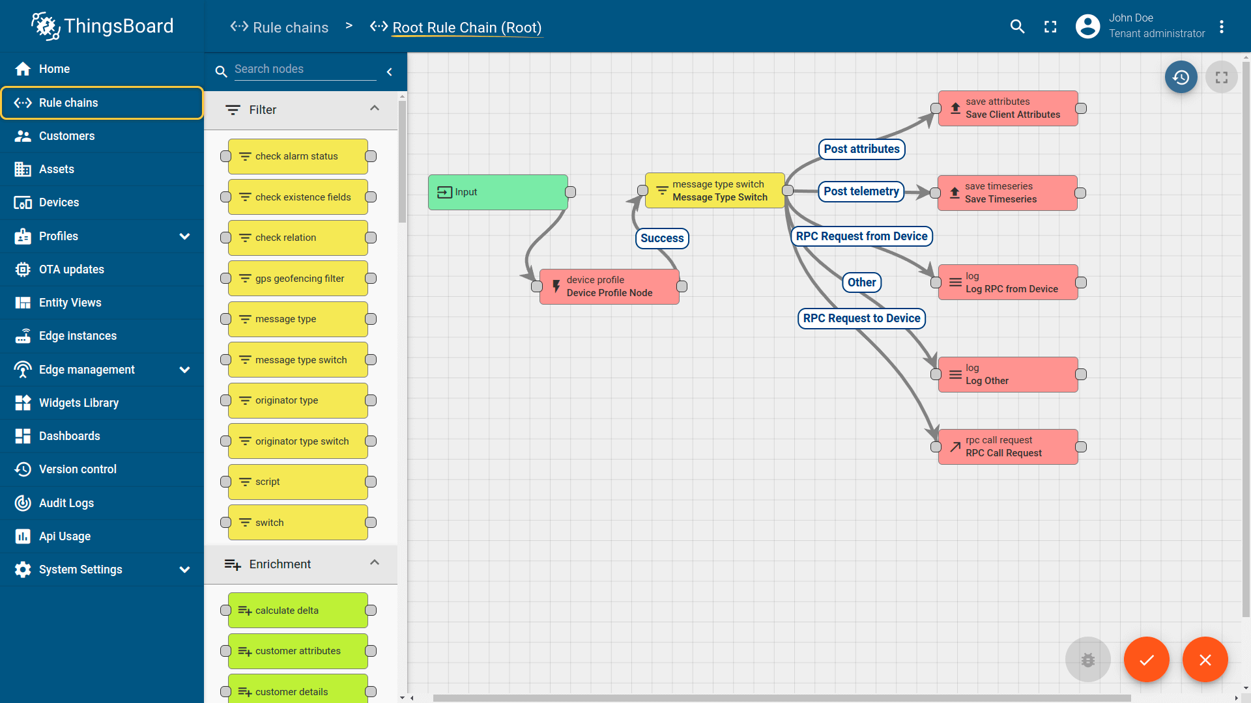

- Smart Factory Platform ()
Factory watch is a platform for smart factory needs.
It provides Users/ Factory
- with a scalable solution for their Production and asset monitoring
- OEE and predictive maintenance solution scaling up to digital twin for your assets.
- to unleased the true potential of the data that their machines are generating and helps to identify the KPIs and also improve them.
- A modular architecture that allows users to choose the service that they what to start and then can scale to more complex solutions as per their demands.
Its unique SaaS model helps users to save time, cost and money.
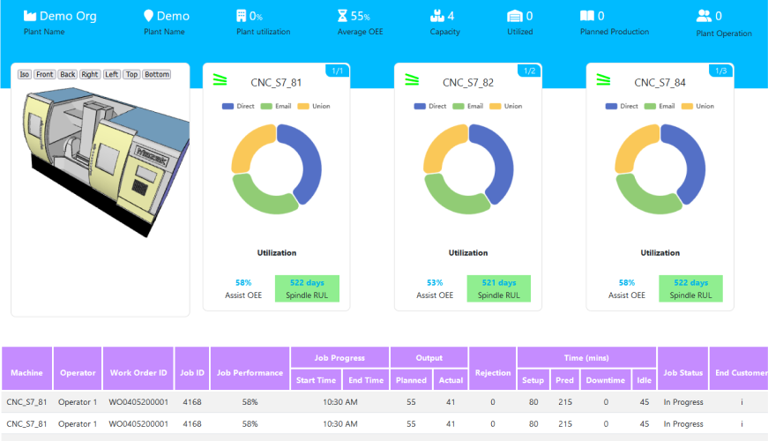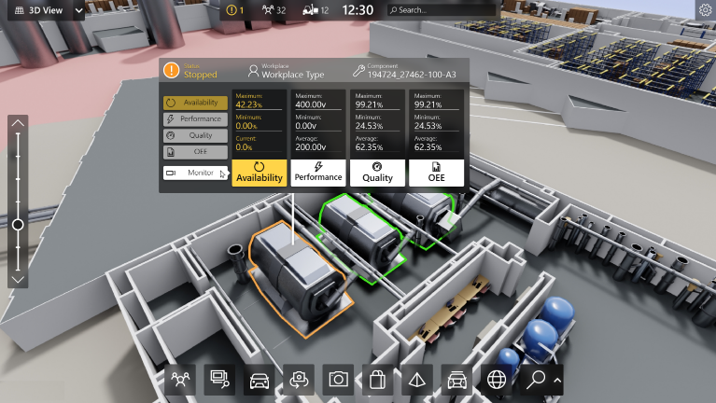

- 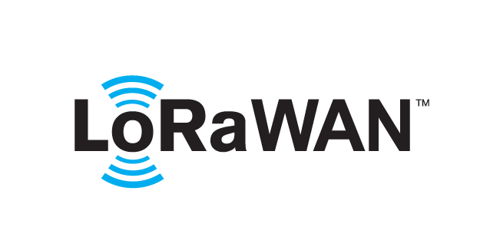 based Solution
UCT is one of the early adopters of LoRAWAN teschnology and providing solution in Agritech, Smart cities, Industrial Monitoring, Smart Street Light, Smart Water/ Gas/ Electricity metering solutions etc.
- Predictive Maintenance
UCT is providing Industrial Machine health monitoring and Predictive maintenance solution leveraging Embedded system, Industrial IoT and Machine Learning Technologies by finding Remaining useful life time of various Machines used in production process.
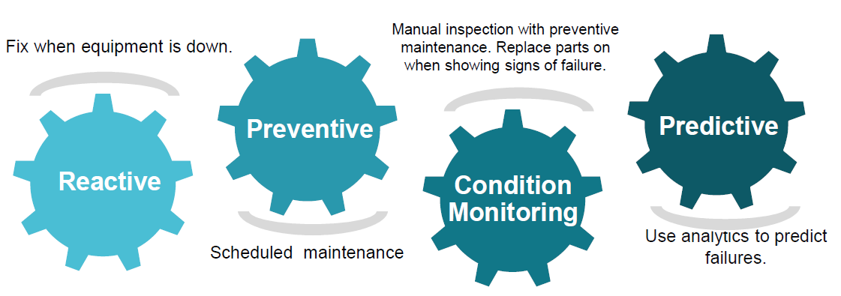

About upskill Campus (USC)
upskill Campus along with The IoT Academy and in association with Uniconverge technologies has facilitated the smooth execution of the complete internship process.
USC is a career development platform that delivers personalized executive coaching in a more affordable, scalable and measurable way.




Seeing need of upskilling in self paced manner along-with additional support services e.g. Internship, projects, interaction with Industry experts, Career growth Services
https://www.upskillcampus.com/
upSkill Campus aiming to upskill 1 million learners in next 5 year

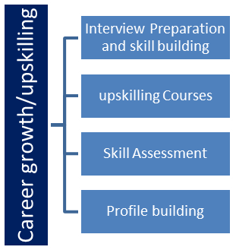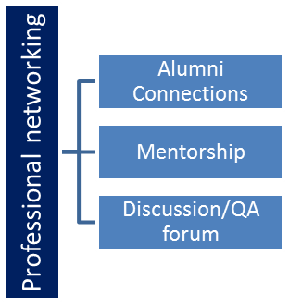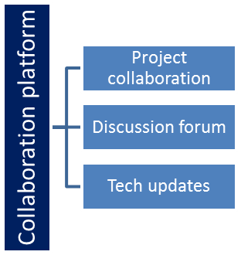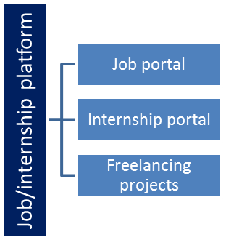

The IoT Academy
The IoT academy is EdTech Division of UCT that is running long executive certification programs in collaboration with EICT Academy, IITK, IITR and IITG in multiple domains.

Objectives of this Internship program
The objective for this internship program was to
☛ get practical experience of working in the industry.
☛ to solve real world problems.
☛ to have improved job prospects.
☛ to have Improved understanding of our field and its applications.
☛ to have Personal growth like better communication and problem solving.

Reference
[1] Government of India open agricultural datasets (rainfall, soil, and crop yield records).
[2] MODIS/Sentinel satellite NDVI (Normalized Difference Vegetation Index) data sources.
[3] PlantVillage and DeepWeeds public crop–weed image datasets; Kaggle notebooks on plant disease and weed detection.

Glossary
Terms | Acronym
NDVI | Normalized Difference Vegetation Index
RMSE | Root Mean Squared Error
MAE | Mean Absolute Error
R² | Coefficient of Determination
IoU | Intersection over Union

Problem Statement
In the assigned problem statement
Two problem statements were addressed. (1) Agriculture Crop Production Prediction: build a Machine Learning model that predicts crop production/yield across regions in India using historical rainfall, temperature, soil, and satellite vegetation-index (NDVI) data, to help forecast supply and support agricultural planning. (2) Crop and Weed Detection: build a computer-vision model that can distinguish crops from weeds in field images, including overlapping and dense-vegetation regions, to support automated, targeted weed management in precision farming.

Existing and Proposed solution

Existing crop-yield forecasting approaches largely rely on classical statistical and regression models using limited climatic variables, which struggle to capture non-linear, time-dependent relationships and rarely integrate remote-sensing data such as NDVI. Existing crop–weed detection approaches are often based on simple CNN classifiers, which perform reasonably on clean, well-separated images but degrade sharply on overlapping crop–weed regions and imbalanced datasets, and rarely provide pixel-level (segmentation) output needed for precise, targeted intervention.
For crop production prediction, I proposed an ensemble approach combining XGBoost and LSTM networks, trained on an enriched dataset that integrates satellite NDVI data alongside rainfall, temperature, and soil features, with hyperparameter tuning via grid/random search. For crop–weed detection, I proposed moving from CNN-based classification to semantic segmentation using U-Net, and subsequently to Mask R-CNN for instance-level segmentation, combined with a unified preprocessing, augmentation, and automated dataset-balancing pipeline.
The ensemble (XGBoost + LSTM) model improves generalization and prediction accuracy over single baseline models by capturing both structured tabular relationships and temporal/sequential patterns in the data. The move from classification to segmentation (U-Net, then Mask R-CNN) adds pixel-level precision, improving detection in overlapping vegetation and reducing false positives, which makes the pipeline realistic for field deployment rather than a purely academic exercise.

Code submission : https://github.com/MohdHuzaif-coder/upskillcampus/blob/9f2c0ae2c037d0b42310dc3e75fd8810e3df0dbb/crop_production_prediction.py
https://github.com/MohdHuzaif-coder/upskillcampus/blob/9f2c0ae2c037d0b42310dc3e75fd8810e3df0dbb/crop_weed_detection.py

Report submission (Github link) : https://github.com/MohdHuzaif-coder/upskillcampus.git

Proposed Design/ Model

Both pipelines follow a similar high-level flow: raw data collection, cleaning and preprocessing, feature engineering/augmentation, model training with hyperparameter tuning, evaluation against metrics, and final ensembling/selection of the best model. Project 1 (crop production) moves from Linear Regression and Decision Tree baselines through Random Forest, XGBoost and LSTM, to a final XGBoost + LSTM ensemble. Project 2 (crop–weed detection) moves from CNN-based classification through U-Net semantic segmentation, to Mask R-CNN instance segmentation for the final pipeline.

High Level Diagram (if applicable)
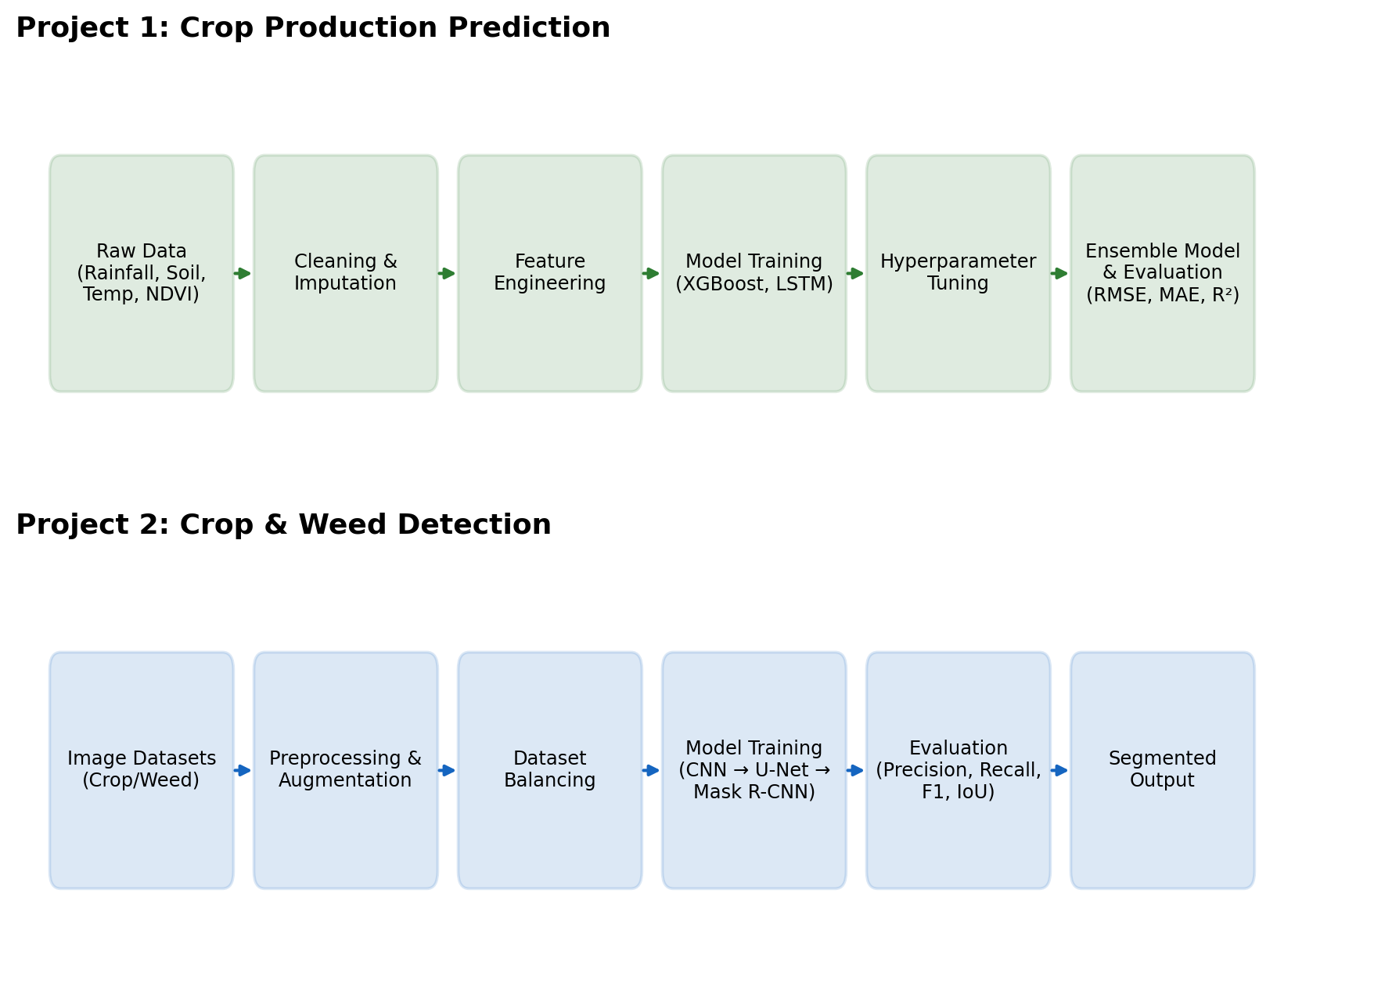

Figure 1: HIGH LEVEL DIAGRAM OF THE SYSTEM

Low Level Diagram (if applicable)

Interfaces (if applicable)
Project 1 data flow: Raw agricultural datasets (rainfall, temperature, soil, satellite NDVI) → Cleaning & Imputation → Feature Engineering → Model Training (XGBoost, LSTM) → Hyperparameter Tuning → Ensemble Model → Evaluation (RMSE, MAE, R²). Project 2 data flow: Crop–weed image datasets → Preprocessing & Augmentation → Dataset Balancing → Model Training (CNN → U-Net → Mask R-CNN) → Evaluation (Precision, Recall, F1-score, IoU) → Segmented Output.

Performance Test

Rigorous, metric-driven evaluation was central to both projects, distinguishing them from purely academic exercises: models were compared systematically and the best-performing configuration was chosen for deployment readiness, not just for reporting accuracy.
For Project 1, the key constraints were prediction accuracy (RMSE, MAE, R²) and generalization to unseen regions/seasons. For Project 2, the key constraints were segmentation accuracy (IoU, F1-score), false-positive rate in dense/overlapping vegetation, and GPU/compute cost of training Mask R-CNN.
For Project 1, constraints were addressed through feature enrichment (adding NDVI), cross-validation, dropout regularization in LSTM, and ensembling XGBoost with LSTM to balance bias and variance. For Project 2, constraints were addressed through data augmentation, automated dataset balancing, early stopping, and progressing from CNN to U-Net to Mask R-CNN for finer-grained, more accurate segmentation.
Project 1: the Decision Tree baseline reached roughly 70% accuracy; the final XGBoost + LSTM ensemble achieved the lowest RMSE and MAE and the highest R² among all models tested, confirming stronger generalization than any single model. Project 2: U-Net outperformed ResNet/MobileNet classification baselines on segmentation accuracy, and the final Mask R-CNN model achieved higher IoU than U-Net (especially in overlapping crop–weed regions) along with fewer false positives, at the cost of higher GPU memory and training time.
Constraints tracked here: prediction accuracy (RMSE, MAE, R² for Project 1; Precision, Recall, F1-score, IoU for Project 2) and computational cost (GPU memory and training time, particularly for LSTM and Mask R-CNN).
For real-world/field deployment, the computational cost of Mask R-CNN and LSTM would need to be addressed — for example via model compression, quantization, or using lighter architectures (e.g. MobileNet) for time- or resource-constrained deployments such as edge devices in the field.

Test Plan/ Test Cases
Project 1 was tested by holding out a validation split of the enriched dataset (rainfall, temperature, soil, and NDVI features) and comparing Linear Regression, Decision Tree, Random Forest, XGBoost, LSTM, and the final XGBoost + LSTM ensemble against it. Project 2 was tested by holding out a validation split of the crop–weed image dataset and comparing CNN, ResNet, MobileNet, U-Net, and Mask R-CNN on their ability to correctly classify/segment crop versus weed regions, including deliberately difficult overlapping-vegetation cases.

Test Procedure
For Project 1, each model was trained on the training split and evaluated on the held-out validation split using RMSE, MAE, and R²; hyperparameters were tuned via grid search and random search, and dropout/regularization was applied to the LSTM to reduce overfitting before final ensembling. For Project 2, each model was trained with augmented and balanced data, then evaluated on the validation split using precision, recall, F1-score, and IoU, with particular attention to performance on overlapping and dense-vegetation regions where segmentation is hardest.

Performance Outcome
Project 1: baseline Linear Regression and Decision Tree models established feasibility, with Decision Tree reaching roughly 70% accuracy in Week 1. Progressively adding NDVI/satellite features, then XGBoost and LSTM, then hyperparameter tuning and dropout regularization, steadily improved generalization; the final XGBoost + LSTM ensemble achieved the lowest RMSE and MAE and the highest R² of all models tested, confirming it as the best-performing and most robust configuration. Project 2: CNN-based classification baselines were limited by dataset imbalance and could not localize weeds precisely. Moving to U-Net semantic segmentation improved precision and recall over the CNN baselines, and the final Mask R-CNN model achieved the highest IoU overall — especially in overlapping crop-weed regions — while also reducing false positives compared to U-Net, at the cost of higher GPU memory and training time.

My learnings

This internship gave me end-to-end, hands-on experience of the Machine Learning lifecycle: sourcing and cleaning real-world data, engineering meaningful features (including satellite NDVI), building and comparing multiple model families (Linear Regression, Decision Tree, Random Forest, XGBoost, LSTM, CNN, U-Net, Mask R-CNN), tuning hyperparameters, and evaluating models rigorously with the right metrics for each task (RMSE, MAE, R² for regression; precision, recall, F1-score, IoU for segmentation). I also learned the value of ensembling to improve robustness, and of systematic, metrics-driven comparison rather than relying on a single model. Beyond the technical skills, I learned to manage a multi-week project with weekly milestones, document my work clearly, and communicate results through visualizations and structured reports — skills I expect to directly support my career growth in applied Machine Learning and data science, particularly in domains like precision agriculture and computer vision where real-world data is messy and rigorous evaluation matters.

Future work scope

Given more time, I would like to: (1) deploy the crop production ensemble model as a live prediction service integrated with real-time satellite/NDVI feeds; (2) extend the crop-weed detection pipeline with lighter-weight architectures (e.g. MobileNet-based segmentation) for real-time inference on edge devices such as drones or field cameras; (3) explore additional data sources such as soil-sensor IoT data and multi-year weather patterns to further improve crop production forecasts; and (4) run larger-scale field trials of the Mask R-CNN weed-detection pipeline to validate its performance under varied lighting, crop types, and growth stages before real-world deployment.

