15. Count the number of vowels in a string

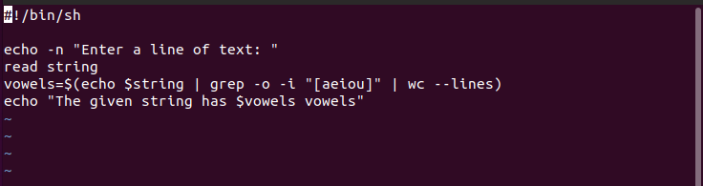
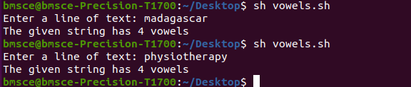
16. Check Number of lines, words, characters in a file

