1. Find a given number if it is equal to 0, positive or negative
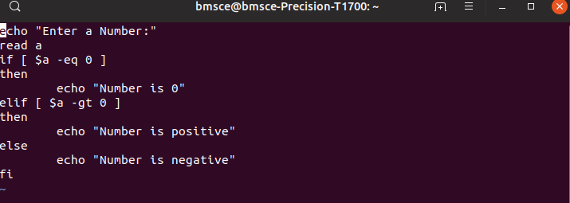
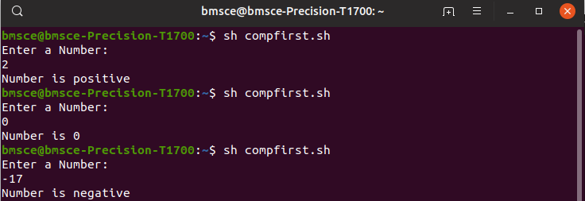

2. Find the greatest of threee numbers

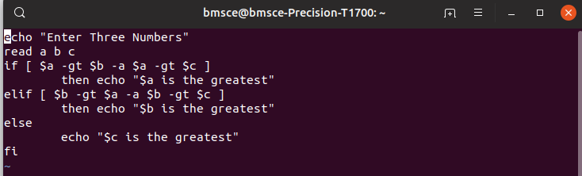
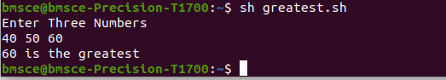
3. Leap year or not




4.Find the area of circle
