LINUX LAB- 1 ASSIGNMENT

- Find the present Directory
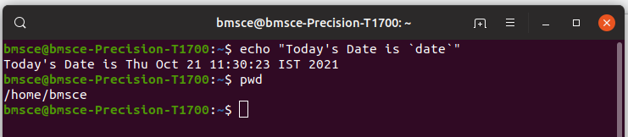

- Write the / directory structure

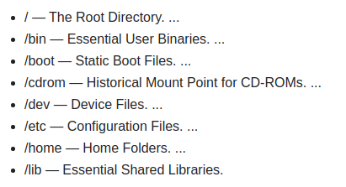

- Write a few commands available in /bin and /sbin directory
/bin – ls, co, cat, ps, date , pwd
/sbin – fastboot, fasthalt, fdisk, halt

- Create a new Directory test

- Write the permissions of test directory
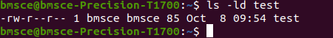

- Copy the file /etc/resolv.conf in test directory

- Rename the test directory to testing

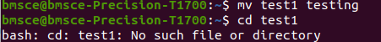

- Change the permissions of testing directory to 775

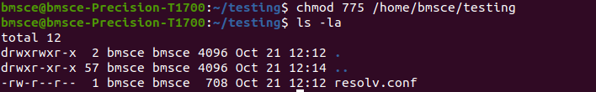

- Change the permissions of /tmp directory to 700

- Change the permissions of guest directory to 700
- Delete the testing directory

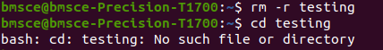

- The location of kernel files in Unix File System is /boot and by looking at the kernel file, write the kernel version you are using in your system.

- Change directory to /
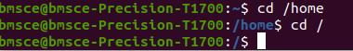

- List the contents of /home directory
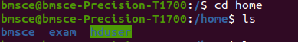

- Create a file sidbi in the home directory
- Find the permissions of the file sidbi
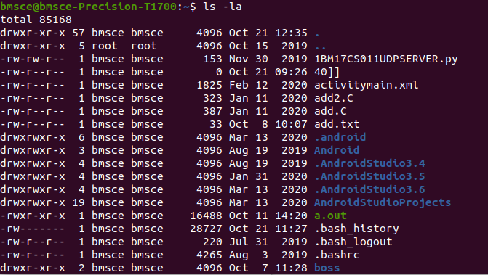

- Find the inode number of file sidbi (hint: ls –li)
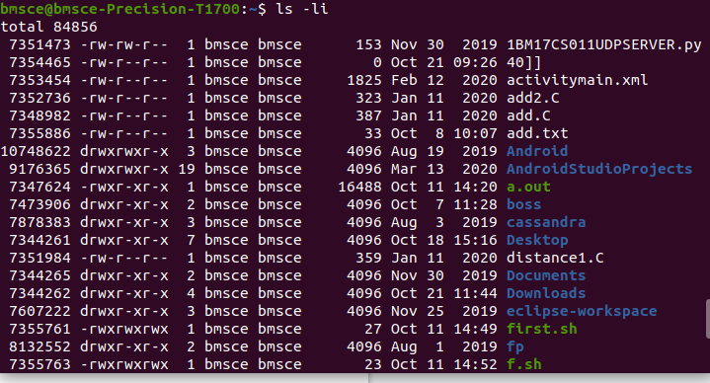
- Copy the file sidbi to sidbi1

- Find the inode number of file sidbi1 (hint: ls –li)
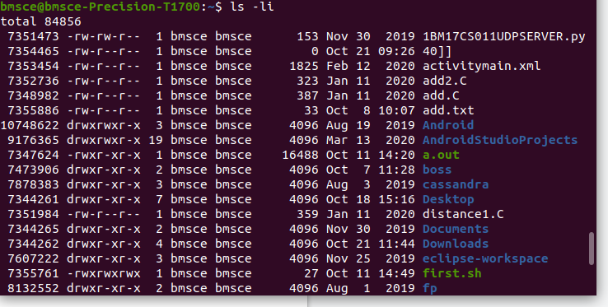

- Move the file sidbi to sidbi2

- Find the inode number of file sidbi2 (hint: ls –li)
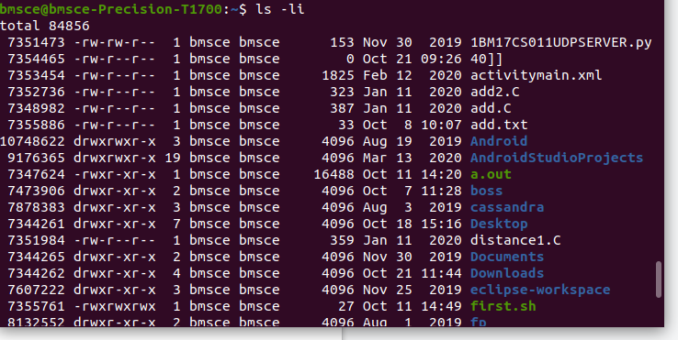

- Move sidbi2 to sidbi

