## 

## 

## Project – 1

## RIDING OF A BIKE

## Name – Mohd Jubair Khan

## Date- 22-01-20224

## Abstract:

“In this study, in this project we read Dataset_1 and found out about its types. After that we found out about the shape of the dataset_1. When we found out about the types of dataset_1, we came to know that in the column dteday object, we have to convert it into integer.

And then read dataset_2 and find out about its types and shape. And found out about the columns of dataset_2. Then dataset_2 instant values turn up.

Then after that dataset_1 and dataset_2 were merged. And found out about the columns and shape of the merged data. And extract the unique values of the merged data. All the useless columns were thrown out integer merged data.

After that we read dataset_3 and found out about its types and shapes. After that the merged data and dataset_3 were concatenated. Or then find out skewness or correlation of final data.

Find the mean, median or mode of the final data or find outliers of the data or even make a boxplot of the final data. we analyzed the data or after that convert the final data into exel file.”

## Content:

## Introduction

## Objectives

## Methods

## Results

## Conclusions

## Chapter-1:

## Introduction:

“ In this project of ride of bike, we got data to use data wrangling. There are many ambiguities in the data. In this data there are many columns (date of ride, season, holiday, working day, weather, windspeed, humidity etc).

To read the data, we imported two important libraries pandas and numpy. The first task in this project was data acquisition and data wrangling. On which we applied all the methods or data wrangling.”

## Chapter-2:

## Objectives:

1. Data Acquisition :- data acquisition involves organizing information in a clear and visually engaging manner. Below is an outline that you can use to structure your presentation. Make sure to customize it according to your specific needs and audience.

## Slide 1: Introduction

1. Brief overview of data acquisition
2. Importance of using Python for data acquisition
3. Outline of the presentation.

## Slide 2: Why Python for Data Acquisition?

## Python's popularity in data science and engineering

## Rich ecosystem: libraries and frameworks (NumPy, Pandas, Matplotlib)

## Community support and documentation.

## 2. Data Cleaning:-

The data will need to be cleaned and removed missing values for better prediction.

## Chapter – 3:

## Methods:-

## Data import and Conversion

We have dataset_1 and dataset_2 using this data set we have first imported this data set from external drive to jupyter notebook using pandas Dataframe coding.

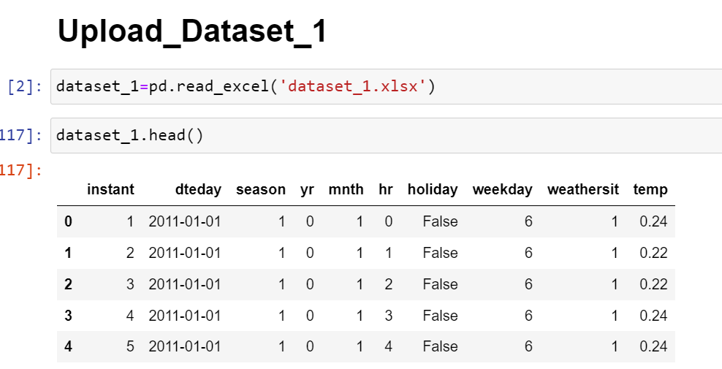

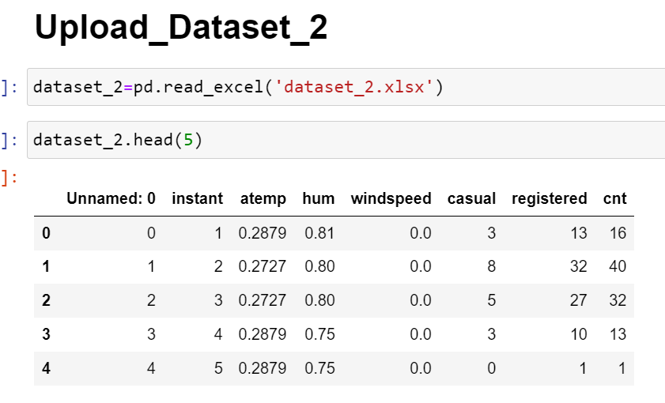

Then we have evaluated the data set such as null values or unique values and its data summary and also data cleaning so we can clearly understand the whole dataset.

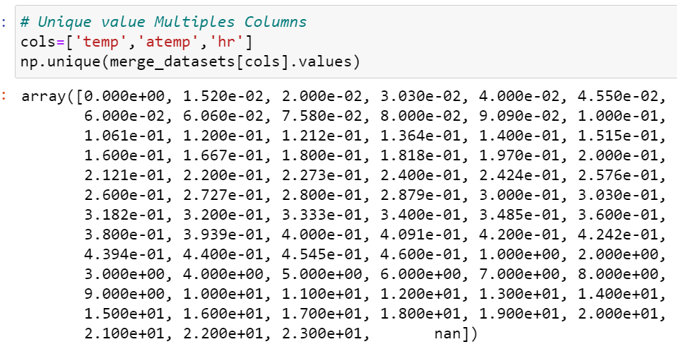

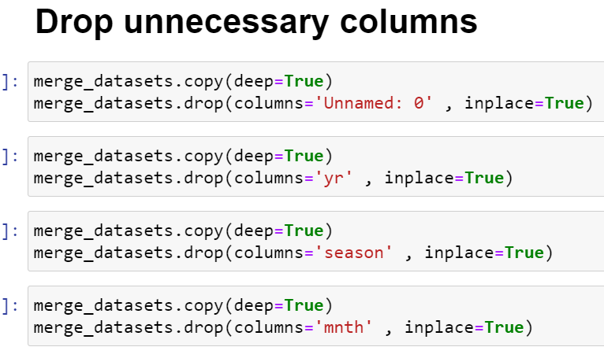

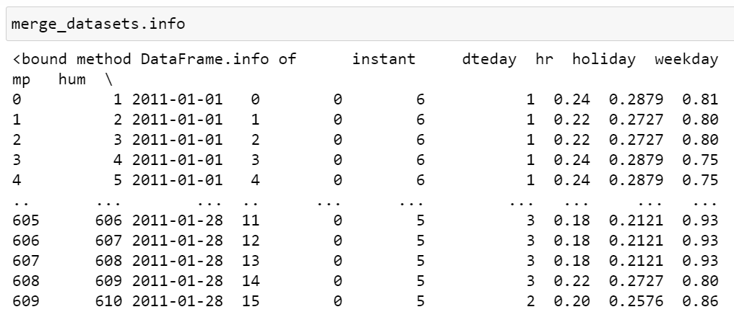

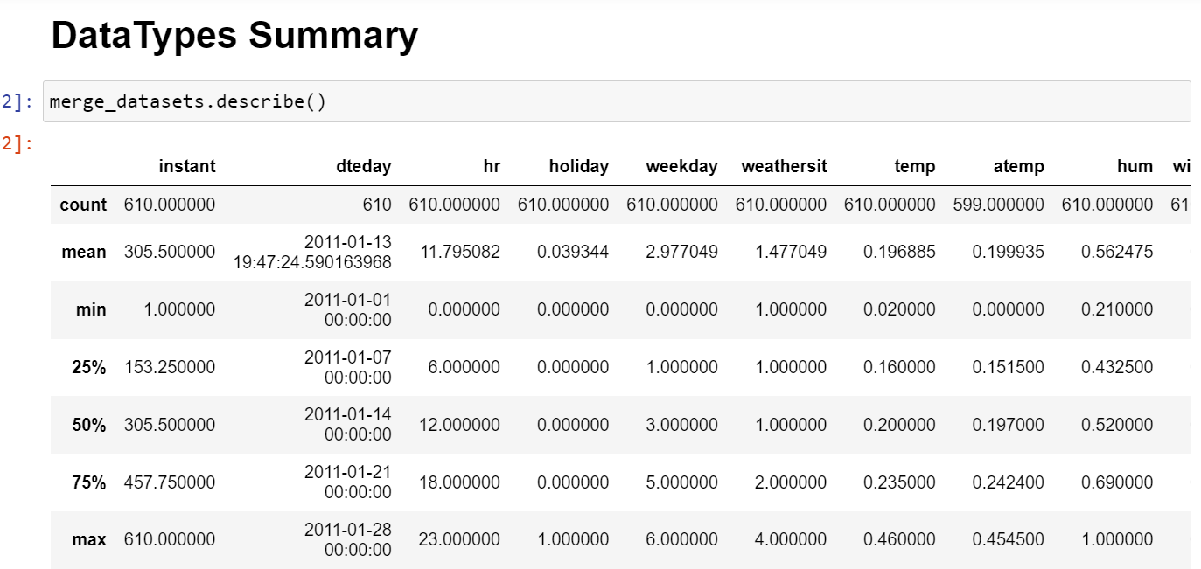

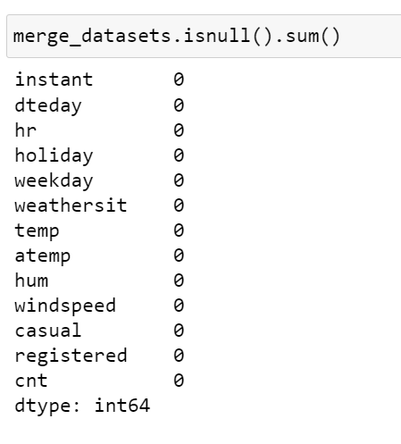

## Concatenate combine datasets:

Then we have Concatenate combines datasets and find out skewness and correlation and also find mean and median final dataset.

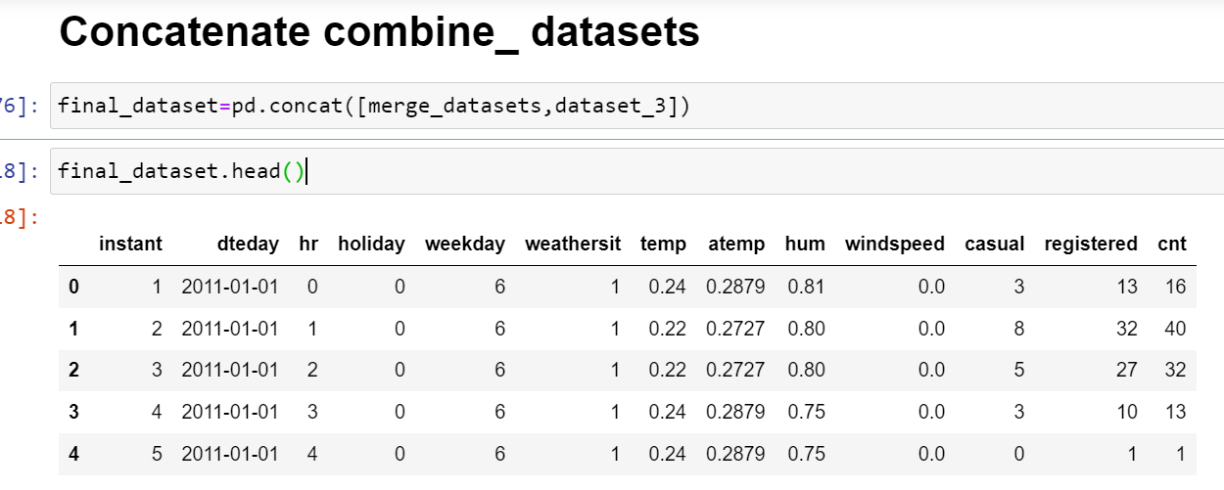

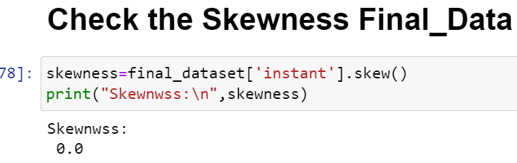

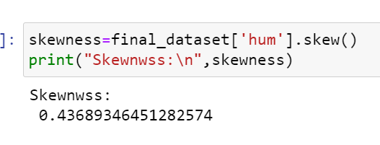

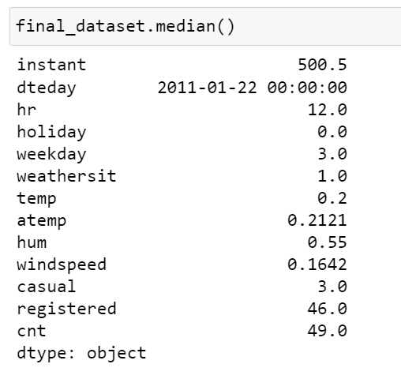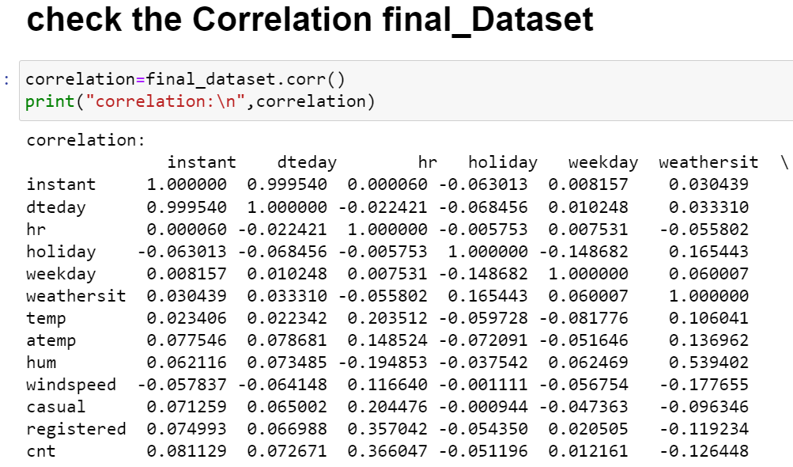

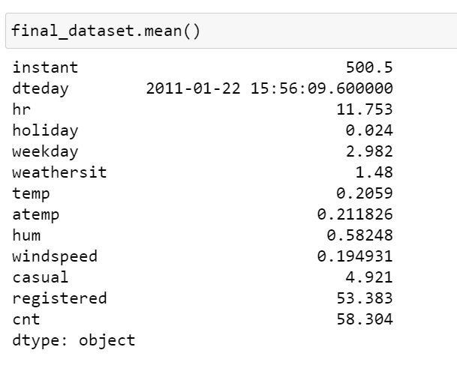

## Boxplot of final dataset:-

Then we have making a boxplot of final dataset and also find outliers in final dataset .

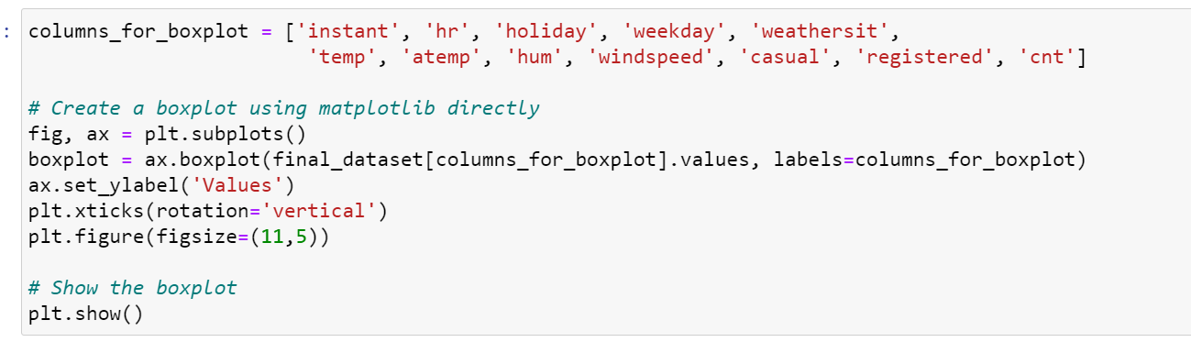

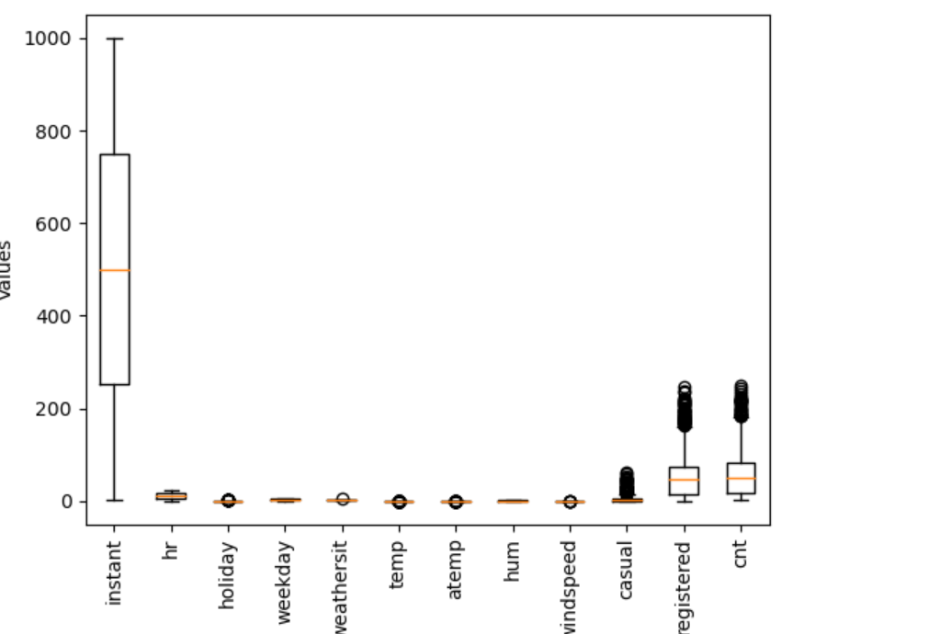

## C:\Users\Hp\Pictures\Screenshots\Screenshot 2024-02-02 203949.png

## C:\Users\Hp\Pictures\Screenshots\Screenshot 2024-02-02 203942.png

## Chapter – 4:-

## Results:-

After data cleaning, we apply all the methods so we can easily read the data or can easily work on the data. Then we have got the result from the data and remove all the missing values and find also outliers in the data. And we our project convert into excel file.

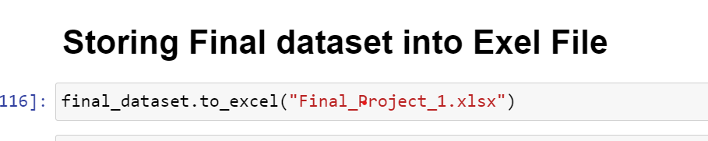

## Chapter – 5:

## Conclusion:-

The main objective of this project is bike riding while we are talking about the speed of the bike or the speed of the wind or the humidity. And then our investigation we will find out that is the project which has missing values or unwanted columns which we have removed. And now we can easily follow about this project.