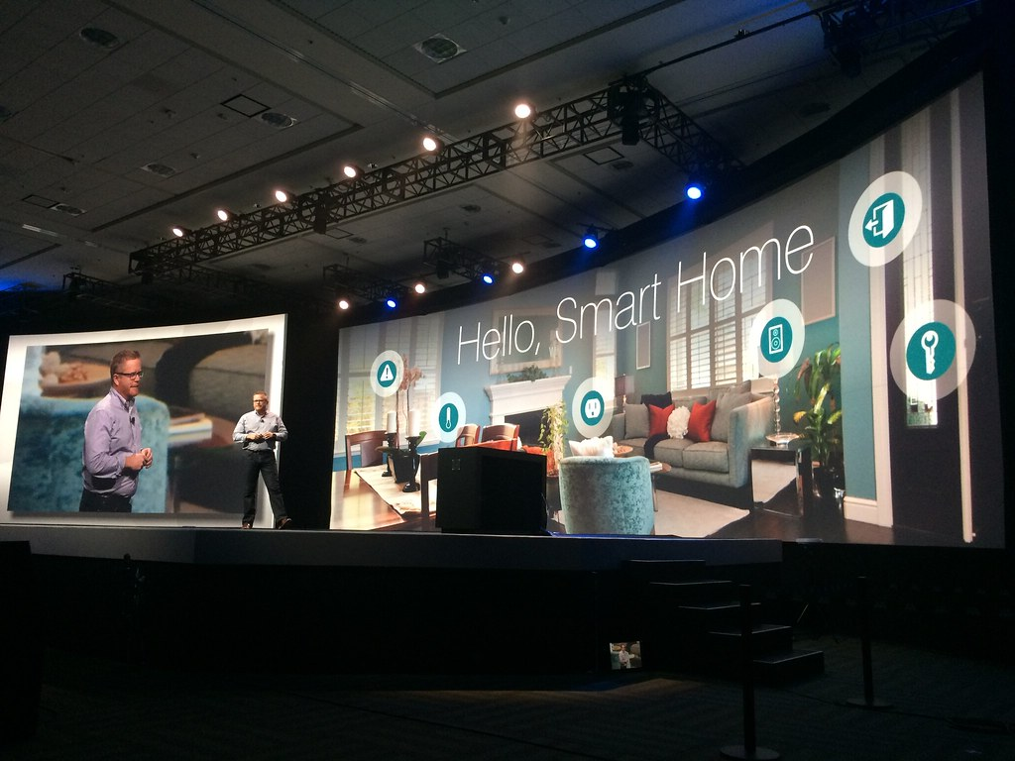

Project Name:

Sentinel: Smart Home Security and Monitoring System

  - Prepared By:
  - Mohammad Murra

Project Idea:
The Smart Home Security and Monitoring System project enhances home security and automation using RFID technology, sensors, and servo motors. The system unlocks the door with a correct RFID card, sounds alarms and lights LEDs for security breaches, and operates the garage door with a push button. Additionally, it provides safety alerts for gas leaks and fires, making your home smarter and safer.

How Projects works:
Welcome to the Smart Home Security and Monitoring System project! This system enhances the security of your home using modern technology. Here’s how it works:
- Welcome Message: When the system is powered on, the LCD screen displays "Welcome! Put your card."

- RFID Card for Home Door:
- Scanning: When you place your RFID card on the reader, the screen shows "Scanning."
- Correct Card: If the card is correct, the screen displays "Unlocked." The servo motor turns the door from angle 0 to 90, a piezo buzzer beeps briefly, and a green LED light up for a few seconds before turning off.
- Incorrect Card: If the card is incorrect, the screen shows "Wrong card!" The door remains locked, and a red LED turns on while the piezo buzzer sounds an alert.
- Locking the Door: To lock the door, use the designated card, and the screen will display "Locked" as the servo motor closes the door and returns to angle 0.

- Smart Garage Door:
- Open/Close Button: Press the button once to open the garage door (servo motor moves from angle 90 to 0). Press it again to close the door (servo motor moves back from angle 0 to 90).

- Safety Sensors:
- Gas Sensor: If gas is detected, the piezo buzzer sounds an alarm, and a blue LED lights up.
- Flame Sensor: If a fire is detected, the piezo buzzer sounds an alarm, and a red LED lights up.

