**Software Testing Report: AI-Based Automated Legal Assistant**

**Prepared by:** Muskan Vishwakarma

**1. Introduction**

The AI-Based Automated Legal Assistant is designed to streamline legal research, document analysis, and case predictions using AI. This report evaluates its performance, security, functionality, and reliability through rigorous testing methodologies to ensure compliance with quality standards.

**2. Testing Methodology**

The system underwent various testing stages, including:

* **Unit Testing:** Verified individual components for expected behavior.
* **Integration Testing:** Checked interactions between AI models, databases, and APIs.
* **Performance Testing:** Assessed response time and efficiency in handling large datasets.
* **Security Testing:** Identified vulnerabilities in data privacy and access control.
* **User Acceptance Testing (UAT):** Ensured usability and accuracy through legal expert feedback.

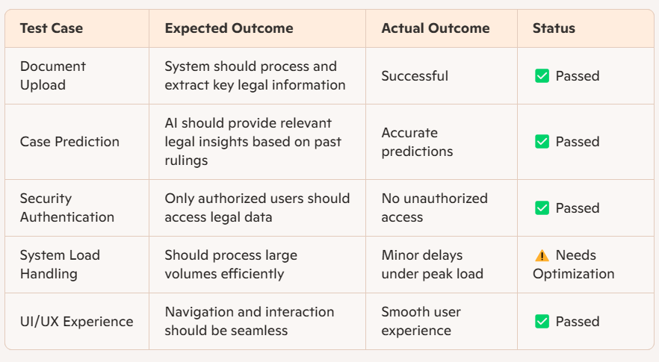**3. Test Cases & Results**

**4. Key Findings & Issues Identified**

* **Strengths:** The AI system efficiently analyzes legal texts, predicts case outcomes, and provides accurate summaries.
* **Weaknesses:** Performance slows under heavy legal document processing; optimization required for scalability.
* **Security Observations:** Strong encryption is implemented, but regular updates are needed to prevent evolving threats.

**5. Recommendations**

* Enhance AI model optimization for large-scale document processing.
* Improve caching mechanisms for faster data retrieval.
* Implement periodic security audits to maintain compliance.
* Gather ongoing feedback from legal professionals to refine AI accuracy.

**6. Conclusion**

The AI-Based Automated Legal Assistant demonstrates strong potential in automating legal research and case assessments. While security and accuracy are well-established, minor performance improvements will enhance efficiency. Continuous monitoring and refinements will ensure long-term reliability and user satisfaction.