***Cement concrete compressive strength predictor***

***Wireframe Documentation***

|  |  |
| --- | --- |
| Name | Mohd Shadab |
| Email | Mohd.shadabaziz999@gmail.com |

**Homepage**

The Compressive strength predictor is composed an interactive page where the user has to fill the input values as asked through the use of number box.

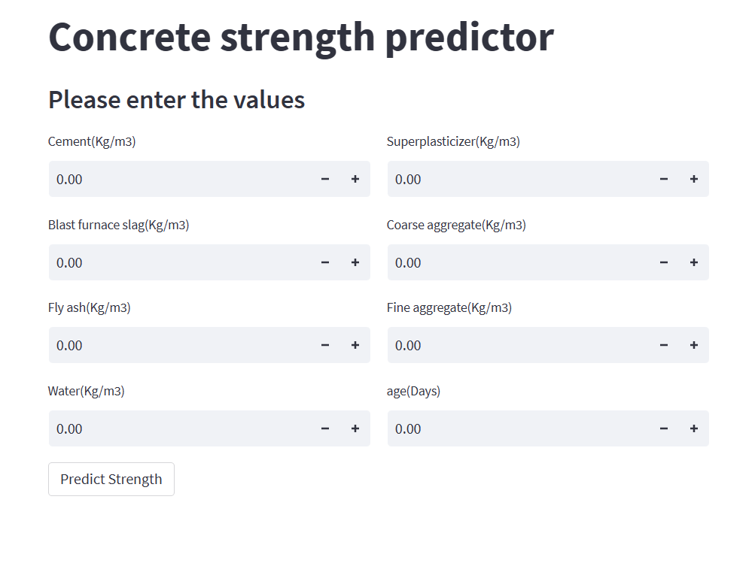

**User input fields**

There are a total of 8 fields that the user should input before proceeding to the predict button

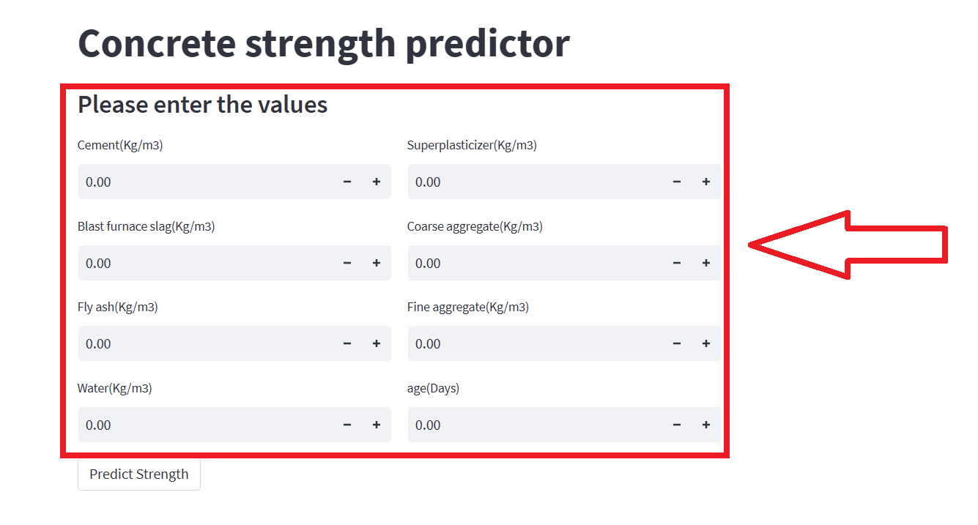

**Prediction**

After filling the desired input by the user, the prediction can be made by simply clicking the ‘Predict Strength’ button

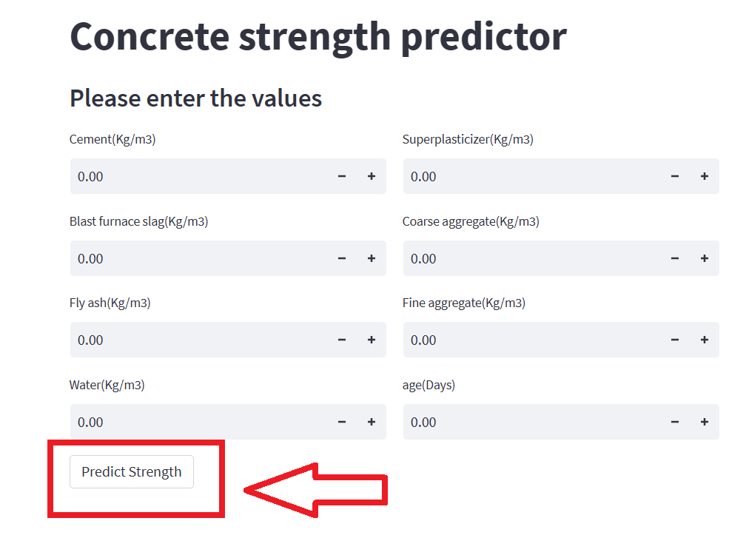

**Display of output**

