Bayan
User Manual
Features, screens and permissions

A dynamic database query platform: authored SQL, controlled access,
audited execution, and scheduled exports.

Generated 13 August 2026

Contents

Right-click the table above and choose “Update Field” to populate or refresh it (Word builds the entry list when the document is opened).

1. About this manual
This manual describes every screen in Bayan, what each control does, and exactly which role is allowed to use it. It is written for four audiences, and each chapter says at the top which of them it is for:
- Users — people who run queries that have been assigned to them and read their own results.
- Administrators — people who author queries, organise them, grant access, schedule exports and manage accounts.
- Auditors — people who review what was run and what was changed, without being able to run or change anything themselves.
- Access Managers — people who decide who may reach which queries, without being able to see the SQL or run it.
Chapters 2 to 4 apply to everyone. Chapter 5 is the day-to-day guide for Users. Chapters 6 to 11 are administration. Chapter 12 covers the two audit trails.
Note. Every screenshot in this manual was taken from a live installation, in the dark theme. If a screen in front of you differs, your account may hold a different set of roles — Chapter 4 explains what each role can see.

2. What the system does
Bayan lets a small number of people write SQL queries once, and lets a much larger number of people run those queries safely, without database access and without being able to change the SQL. Around that idea sit access control, a full audit trail, and a scheduler that runs the same queries unattended and writes the results to files.

2.1 The core idea
- An administrator writes a query and declares its parameters — for example a start date, an end date and a branch.
- The administrator decides who may run it: by role, by user group, by named user, or by putting it in a query group and granting the group.
- A user opens the query, fills in a generated form, and runs it. They never see or edit the SQL.
- The result is paged, sorted and filtered on the server and can be exported to Excel, CSV, PDF, Word or JSON.
- Every run is written to the execution log; every administrative change is written to the system audit trail.

2.2 Key terms
Term | Meaning
Dynamic query | A stored, named SQL statement with declared parameters. It may read (SELECT) or write (INSERT / UPDATE / DELETE).
Parameter | A declared input on a query. Five types: String, Number, Date, Boolean and Dropdown.
Query group | A folder of queries. Granting access to the group grants all the queries inside it.
User group | A named list of people, kept inside this application. Granting a query to a user group grants it to every member. Not an Active Directory group, and not the same thing as a query group.
Database connection | A named set of database credentials (“DB User”) that a query runs through. Passwords are encrypted at rest.
Execution | One run of one query by one person, recorded in the execution log.
Scheduled task | One or more queries run unattended on a timetable, with the results written to files on the server.
Role | A named permission set held by an account. An account may hold more than one; permissions add up.

2.3 How a query is kept safe
- Values are never pasted into SQL. Every parameter is bound through the database driver, so a value cannot change the meaning of the statement.
- Write queries are previewed first. An INSERT, UPDATE or DELETE runs inside a transaction that is rolled back, so you see how many rows would change — and for UPDATE and DELETE, which rows — before anything is committed.
- Before-change values are captured. For UPDATE and DELETE, the rows as they were before the change are stored with the execution log.
- Timeouts are enforced. Each query carries its own timeout; slow queries can be marked long-running so they are not cut off by a network gateway.
- Credentials are encrypted. Database passwords are stored with AES-256 encryption and are never included in an export file.

3. Getting started

3.1 Signing in
Open the application address in a browser and sign in with your username and password. Accounts are either local to the application or imported from Active Directory — in both cases you sign in on the same form.
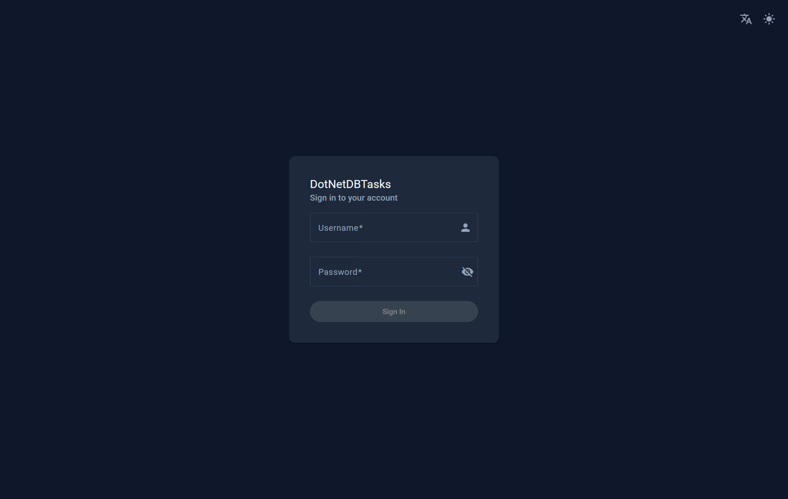
Figure 1. The sign-in page. The two buttons in the top corner switch the language and the colour theme before you sign in.
- Show / hide password — the eye icon inside the password box.
- Language — the translate icon in the top corner switches between English and Arabic. It is available before sign-in so that the form itself can be read in either language.
- Theme — the sun/moon icon switches between the light and dark themes.
After signing in you land on the first page your permissions actually open, taken in this order: My Queries if you may run queries; then Manage Queries, the execution logs, the system audit trail, Users, User Groups, Scheduled Tasks, and Settings. If none of those are open to you, you land on My Schedules.
In practice that puts an administrator on My Queries — the Admin role holds “Run queries” like anyone else — an Access Manager on Manage Queries, an Auditor on the execution logs, and a User on My Queries.

3.2 The main window
The bar across the top is the whole navigation. On one side is the site logo (or the application name when no logo has been uploaded); on the other are the destinations your roles can reach, then the account menu.
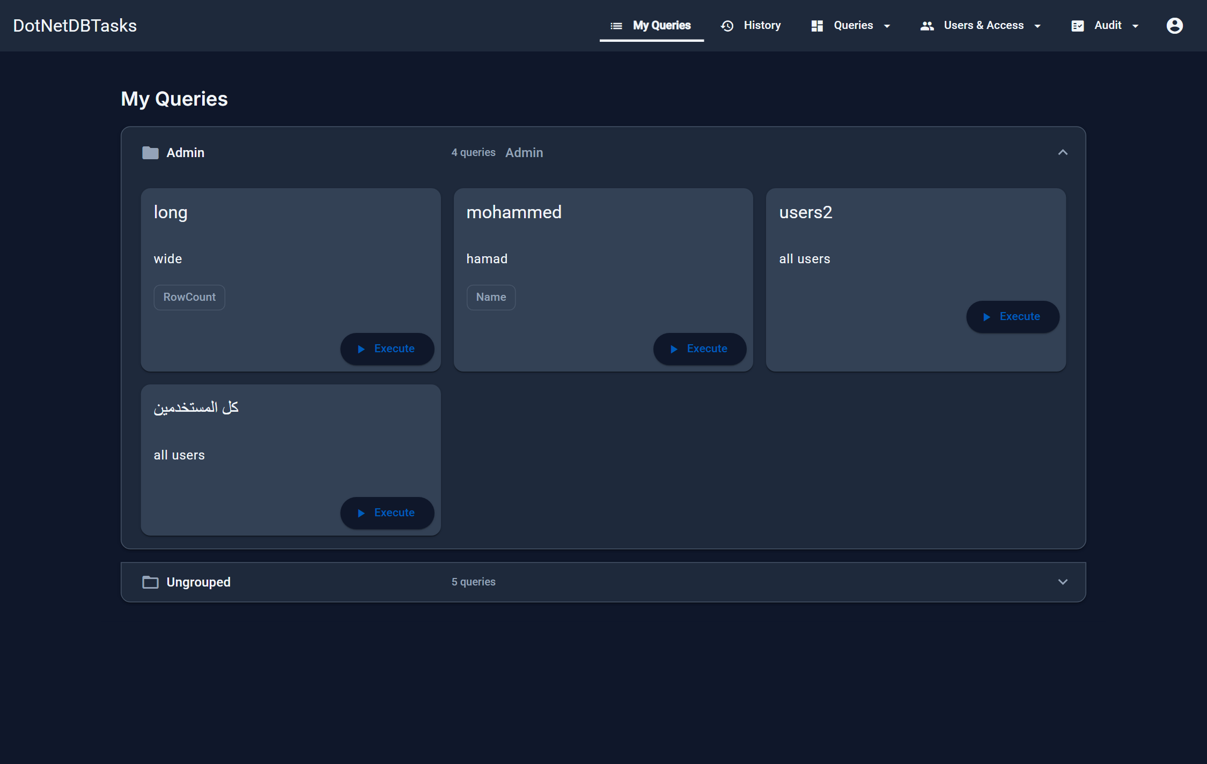
Figure 2. The application as an administrator sees it: My Queries, History, and the Queries, Users & Access and Audit menus, with the account menu at the end.
The navigation is grouped into three drop-down menus plus the always-visible personal pages:
Menu | Contains | Visible to
My Queries | The queries assigned to you | Everyone
History | Your own execution history | Everyone
Schedules | Status of scheduled tasks you were named on | Users (hidden for Admin and Auditor, who use the full Scheduled Tasks page)
Queries | Manage Queries, Query Groups, Schedules | Admin, Access Manager, Auditor (each sees only its own entries)
Users & Access | Users, User Groups, AD Users, DB Users | Admin, Access Manager
Audit | Logs, System Audit | Admin, Auditor
Account | Language, theme, Settings, Website logo, Logout | Everyone

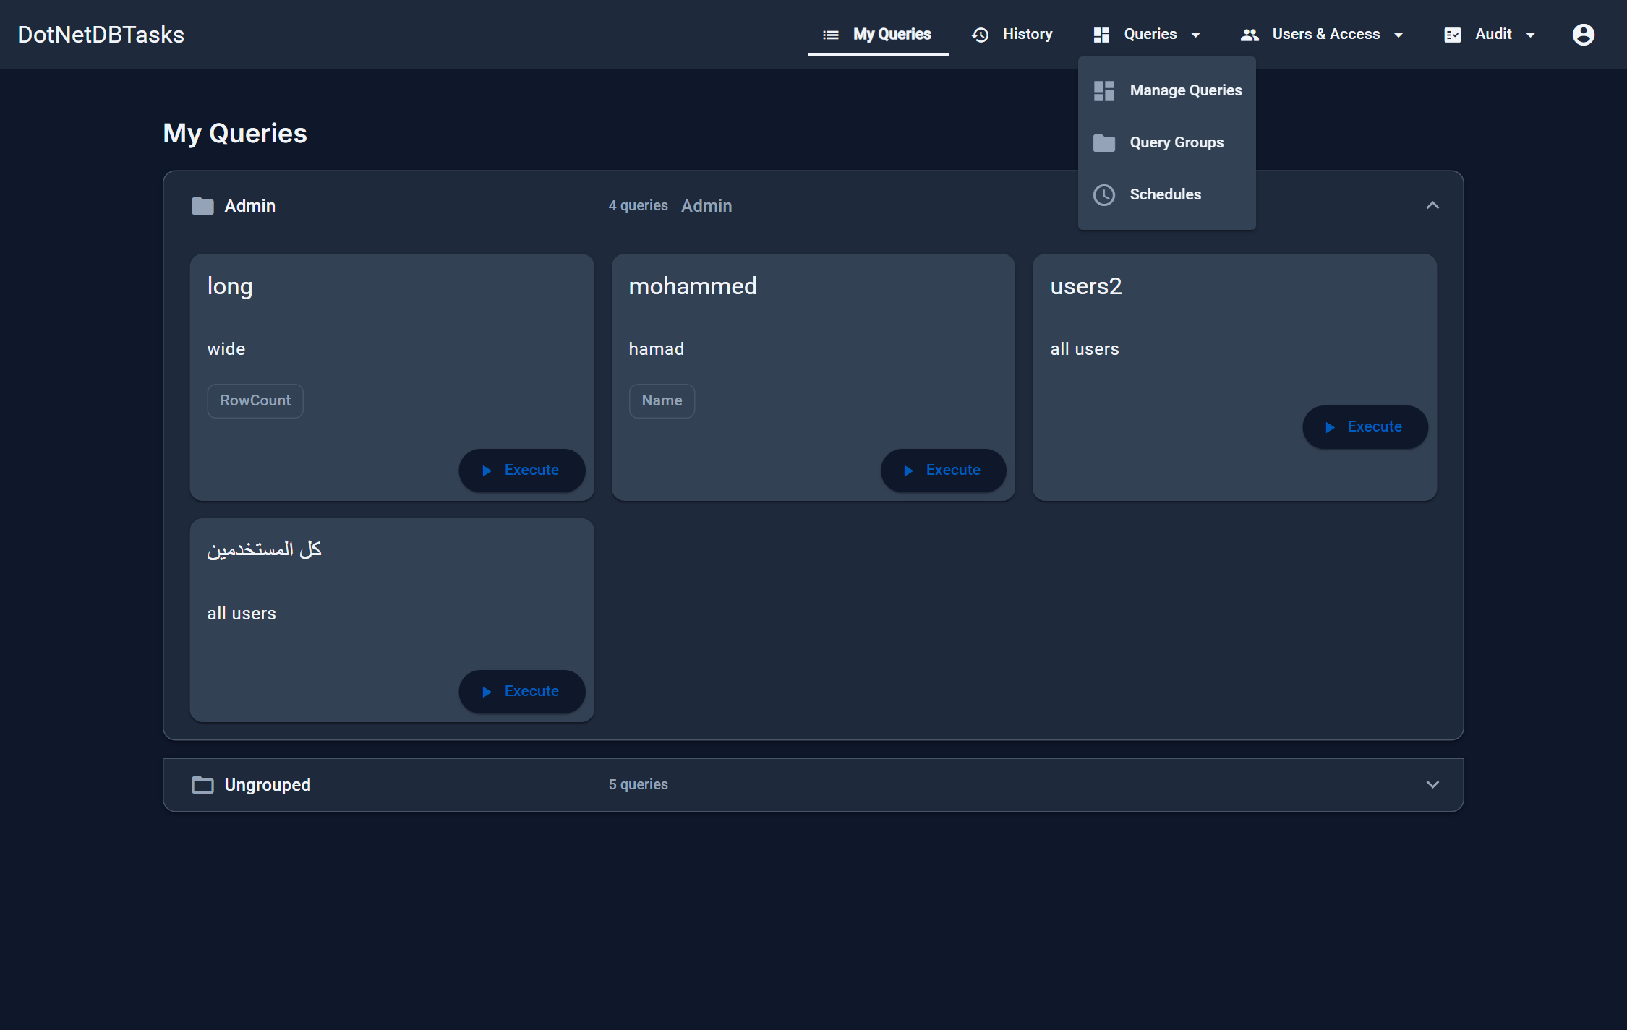
Figure 3. The Queries menu. An Access Manager sees only the first two entries; an Auditor sees only Schedules.
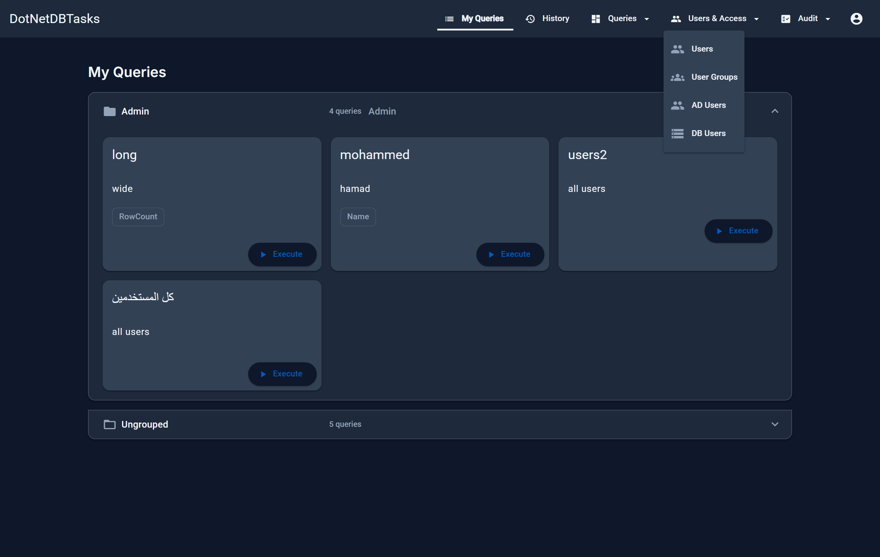
Figure 4. The Users & Access menu. An Access Manager sees Users and User Groups; AD Users and DB Users are administrator-only. AD Users also disappears entirely when the Active Directory features are switched off in Settings.
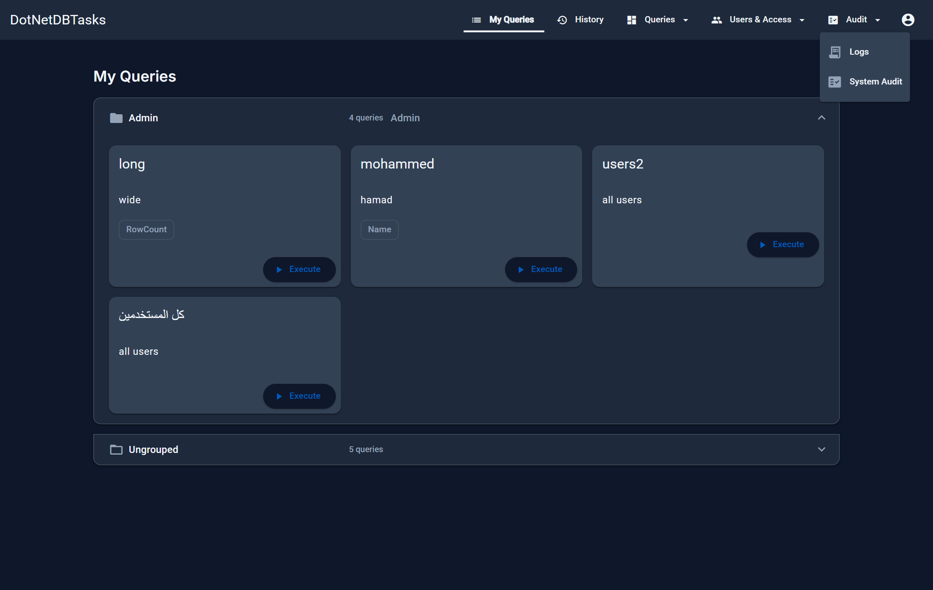
Figure 5. The Audit menu — the two read-only trails, for Admin and Auditor.

3.3 The account menu
The circular icon at the end of the bar opens the account menu. It shows who you are signed in as and holds the personal settings.
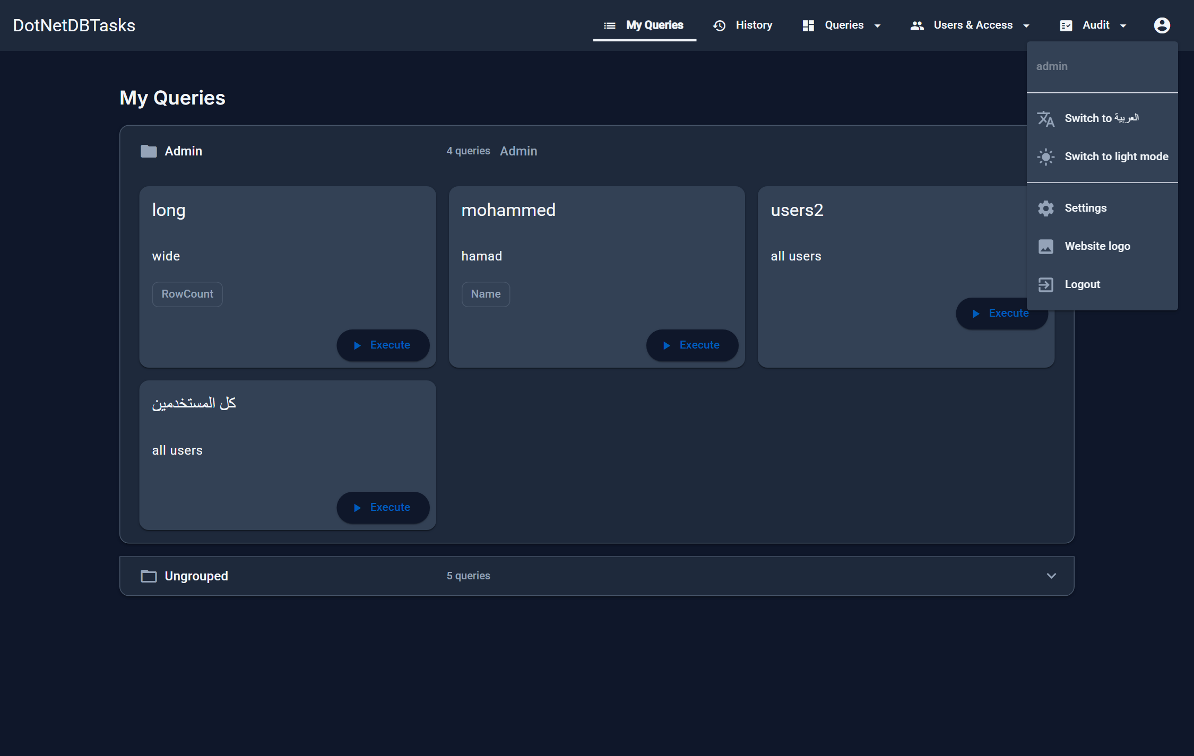
Figure 6. The account menu as an administrator sees it. Settings and Website logo appear only for administrators.
- Switch to العربية / English — changes the interface language. The page reloads.
- Switch to dark / light mode — changes the colour theme immediately; the menu stays open so you can compare.
- Settings — system-wide toggles (administrators only, see Chapter 14).
- Website logo — upload or remove the logo in the top bar (administrators only, see Chapter 13).
- Logout — signs out and returns to the sign-in page.

3.4 Language and reading direction
The interface ships in English and Arabic. Switching language flips the whole layout between left-to-right and right-to-left, including menus, tables and dialogs. Your choice is remembered on that browser.
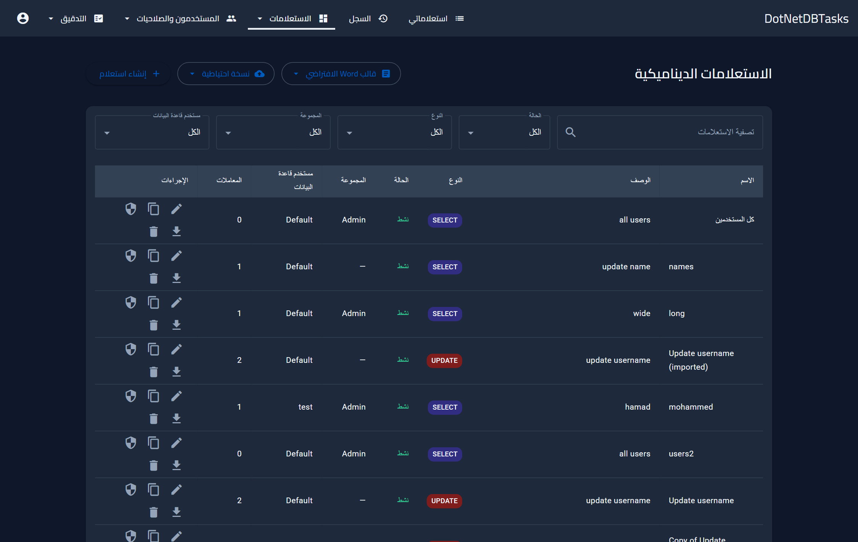
Figure 7. The same page in Arabic. The layout mirrors: navigation, table columns and the account menu all move to the opposite side.
Note. Data is shown in its own direction regardless of the interface language — an Arabic query name reads correctly in the English interface and vice versa. SQL, file paths and connection strings always stay left-to-right.

3.5 Light and dark themes
This manual is illustrated in the dark theme. The light theme carries exactly the same pages and controls.
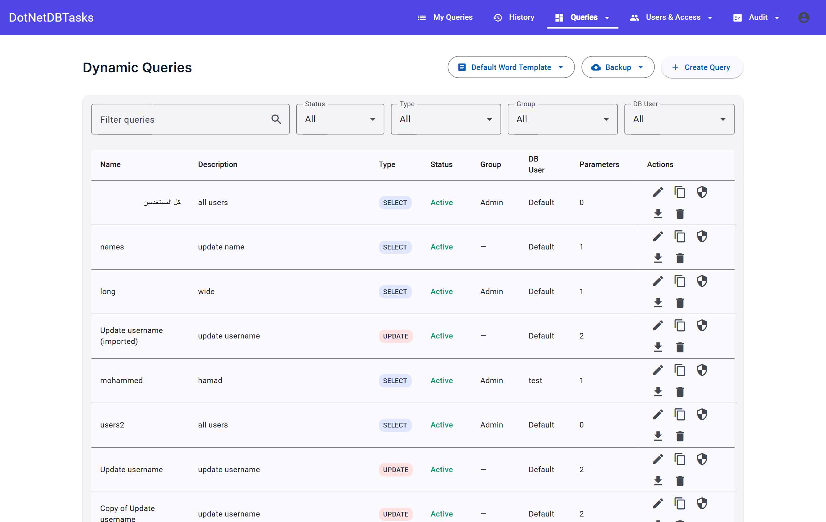
Figure 8. The light theme. Every page, dialog and message supports both; the choice is per browser, not per account.

4. Roles and permissions
This chapter is the authoritative reference for who can do what. Permissions are enforced by the server on every request — the interface hides what you cannot use, but hiding is a convenience, not the control.

4.1 The roles that ship with the system
A role is a named set of permissions, and both parts are editable. Four roles are supplied; an administrator can add more, and can change what any of them may do on Settings → Permissions (Chapter 14). What follows is what each one holds out of the box, not a description of what it must always be.
One account may hold several roles, and its permissions are the sum of them.
Role | Purpose
Admin | Full control: authors queries, grants access, schedules tasks, manages accounts and connections, and reads both audit trails.
User | Runs the queries assigned to them and reads their own history. The everyday role.
Auditor | Reads the execution logs, the before-change snapshots, the system audit trail and the scheduled-task history. Holds no permission that changes anything, and none that runs a query.
AccessManager | Decides who may reach which queries and manages user accounts and user groups. Holds neither the permission to read a query's SQL nor to edit or run one.

4.2 The permission catalogue
Every capability the system can grant, and which roles hold it when the system is first installed. A tick is a default, not a fact: all of these are editable on Settings → Permissions, and the Admin column cannot be changed at all.
Capability | Admin | Auditor | AccessManager | User
See the query list | ✓ | — | ✓ | —
Read a query's SQL | ✓ | — | — | —
Create and edit queries | ✓ | — | — | —
Export and import query definitions | ✓ | — | — | —
Run queries | ✓ | — | — | ✓
Grant an individual query | ✓ | — | — | —
Grant a query group | ✓ | — | ✓ | —
Create and edit query groups | ✓ | — | — | —
See the user list | ✓ | — | ✓ | —
Create and edit users | ✓ | — | ✓ | —
See user groups | ✓ | — | ✓ | —
Create user groups and set membership | ✓ | — | ✓ | —
See directory data | ✓ | — | ✓ | —
Search and import from Active Directory | ✓ | — | — | —
Manage database connections | ✓ | — | — | —
See every scheduled task | ✓ | ✓ | — | —
Create and run scheduled tasks | ✓ | — | — | —
Download scheduled task files | ✓ | — | — | —
Read execution logs | ✓ | ✓ | — | —
Read the system audit trail | ✓ | ✓ | — | —
Change the site logo | ✓ | — | — | —
Change system settings | ✓ | — | — | —
Manage roles and permissions | ✓ | — | — | —

Three of these are worth reading twice. “See the query list” and “Read a query's SQL” are separate, which is what lets a role manage access without reading the queries. “Run queries” is what puts My Queries and History in the top bar at all. And “Manage roles and permissions” is the one that edits this table — grant it sparingly.

4.3 Rules that hold whatever the matrix says

Admin always holds everything
The Admin column on the Permissions tab is shown but locked, and the role cannot be deleted. This is not a convenience: it is what prevents an installation from editing away the last account able to open that page. The server answers for Admin without consulting the matrix at all, so even a half-saved one leaves someone able to put it right.

A role that cannot run queries grants none
Every role appears in the access pickers, including ones you create. Assigning a query to a role that does not hold “Run queries” leaves it unrunnable: the server drops such roles when working out who may run what, so the assignment is inert rather than refused. Grant that permission first, or assign the query elsewhere.
Important. “Run queries” is not held by Auditor or Access Manager, and that separation is the reason those roles exist — but it is a default, not a law. An administrator can grant it to either of them deliberately, and the grant is recorded in the audit trail.

Reading a query and reading its SQL are separate
“See the query list” opens the list and the access pages; “Read a query's SQL” is what lets the text itself through. A role with the first and not the second — which is how Access Manager is set up — can decide who reaches a query without ever reading it. Exports carry the SQL, so they follow the export permission, not the list one.

Nobody grants themselves
A non-administrator cannot modify an account holding the Admin role, cannot grant that role, cannot edit their own roles, and cannot add their own account to a user group. The last two matter most: without them, anyone who manages permissions could hand themselves a capability and use it a moment later.
Important. Someone who can create users can still create a separate account and sign in as it. That is inherent in one role both creating users and controlling access — but unlike a self-grant it leaves an account and an audit entry behind.

Changes take effect immediately
Permissions are read on every request, not taken from the token issued at sign-in. Revoking one stops the next click; nobody has to sign out and back in.

4.4 What each role sees
The navigation is built from your roles, so the quickest way to tell what an account can do is to look at its top bar. Compare the administrator's bar in Figure 2 with the Auditor's below.
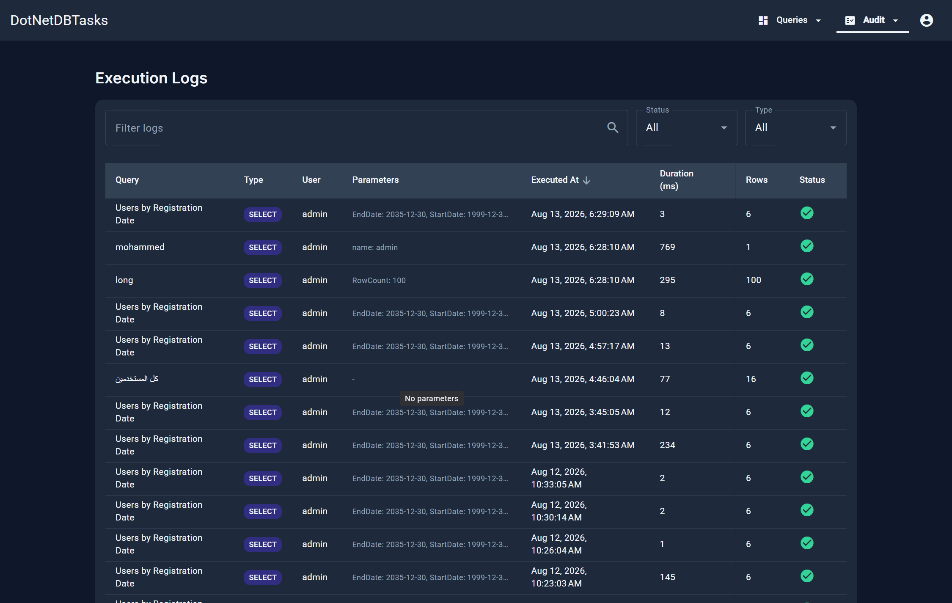
Figure 9. An Auditor signs in to the execution logs. The bar carries only Queries (containing the read-only scheduled tasks) and Audit. My Queries and History are absent: the role can never be granted a query, so both pages could only ever be empty.
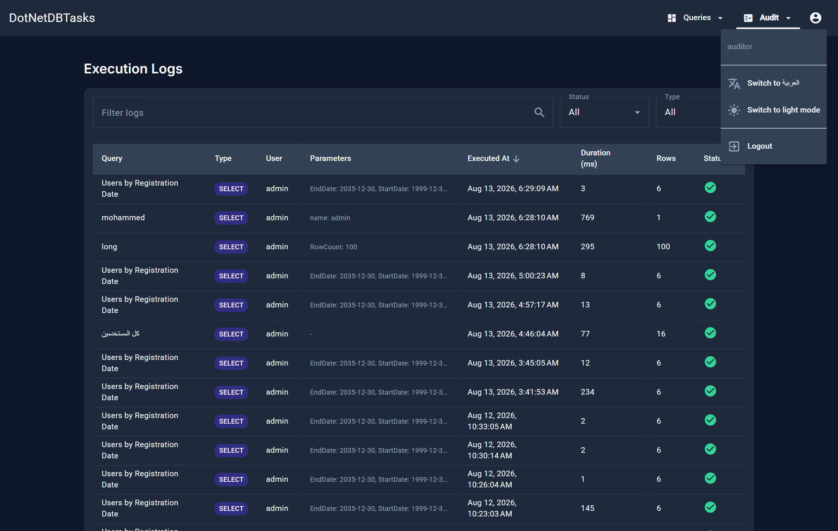
Figure 10. The Auditor's account menu: language, theme and logout only — no Settings and no Website logo.
Note. The same applies to an Access Manager. Typing the address of one of those pages does not get around it — the application returns you to the page your role does have. An account holding a second role that does grant queries keeps both pages.

4.5 How access to a query is decided
A user may run a query when at least one of these is true. They add up — there is no ordering or precedence between them.
Route | Granted on
Role | The query (or its group) is assigned to a role the user holds — and that role holds “Run queries”.
User group | The query (or its group) is assigned to a user group the user belongs to.
Named user | The user is assigned to the query (or its group) individually.
Group | Anything granted on a query group applies to every query inside it.
Administrator | An administrator reaches every query without an assignment.

Note. A query must also be Enabled to be runnable, and the user must be allowed to use the database connection the query runs through (Chapter 11). Both are checked on every run, not just when the page is opened.

4.6 Page-by-page permission reference
Which capability opens each page. Roles are not named here on purpose — any role holding the capability opens the page, including one you created.
Page | Address | Capability needed
My Queries | /user/queries | Run queries
Run a query | /user/queries/…/execute | Run queries, and the query must be assigned
My History | /user/history | Run queries
My Schedules | /user/schedules | Users named as task viewers
Manage Queries | /admin/queries | See the query list
Create / edit query | /admin/queries/create, /edit/… | Create and edit queries
Manage query access | /admin/queries/…/roles | Grant an individual query
Query Groups | /admin/query-groups | See the query list
Create / edit group | /admin/query-groups/create, /edit/… | Create and edit query groups
Manage group access | /admin/query-groups/…/access | Grant a query group
Scheduled Tasks | /admin/scheduled-tasks | See every scheduled task
Create / edit task | /admin/scheduled-tasks/create, /edit/… | Create and run scheduled tasks
Task run history | /admin/scheduled-tasks/…/runs | See every scheduled task
Execution Logs | /admin/logs | Read execution logs
System Audit | /admin/system-audit | Read the system audit trail
Settings | /admin/settings | Change system settings, or manage roles
Users | /admin/users | See the user list
User Groups | /admin/user-groups | See user groups
Create / edit user group | /admin/user-groups/create, /edit/… | Create user groups
AD Users | /admin/ad-users | Search and import from AD
DB Users | /admin/database-users | Manage database connections

5. Running queries
For: Users, and administrators running their own queries.

5.1 My Queries
My Queries lists everything you have been granted, arranged by query group. Queries that belong to no group appear together at the end. Each card shows the query's name and description and a button to run it.

Figure 11. My Queries. Groups act as folders; the count next to each heading is the number of queries you can reach inside it.
If the page is empty, nothing has been assigned to you yet — ask an administrator or an Access Manager to grant the query or its group to you, or to a user group you are in.

5.2 Filling in parameters
Opening a query shows a form built from the parameters the administrator declared. Required parameters are validated before the Execute button becomes usable.
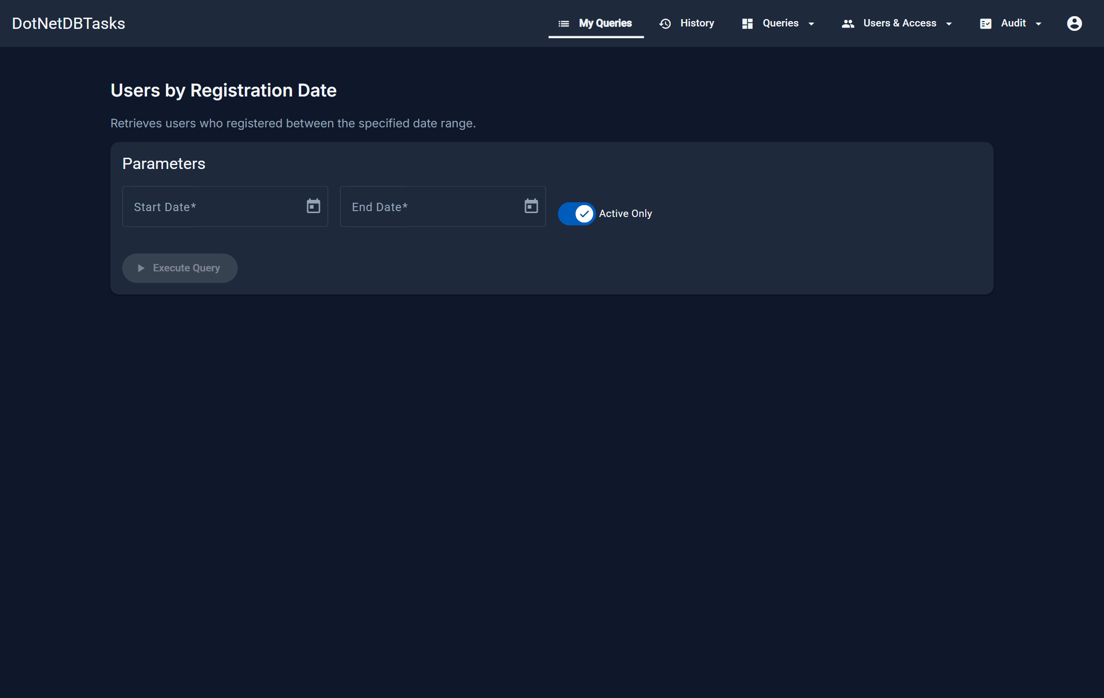
Figure 12. A query's parameter form. Dates get a picker, booleans get a switch, and required fields report their own errors.
Parameter type | How it appears | Notes
String | A text box | Rejects SQL keywords and special characters.
Number | A numeric box | Accepts digits only.
Date | A box with a calendar picker | Pick from the calendar or type.
Boolean | A switch | Off unless the administrator set a default.
Dropdown | A list of choices | Choices are either a fixed list or the live result of another query.

A parameter may carry a default value, which is filled in for you and can be changed. Dropdowns whose choices come from a query show a progress bar while they load.

5.3 Multi-value parameters
A String or Dropdown parameter can be marked as accepting several values. A String parameter then takes a comma-separated list; a Dropdown becomes a multiple-selection list. Each value is bound separately, so the query matches any of them.
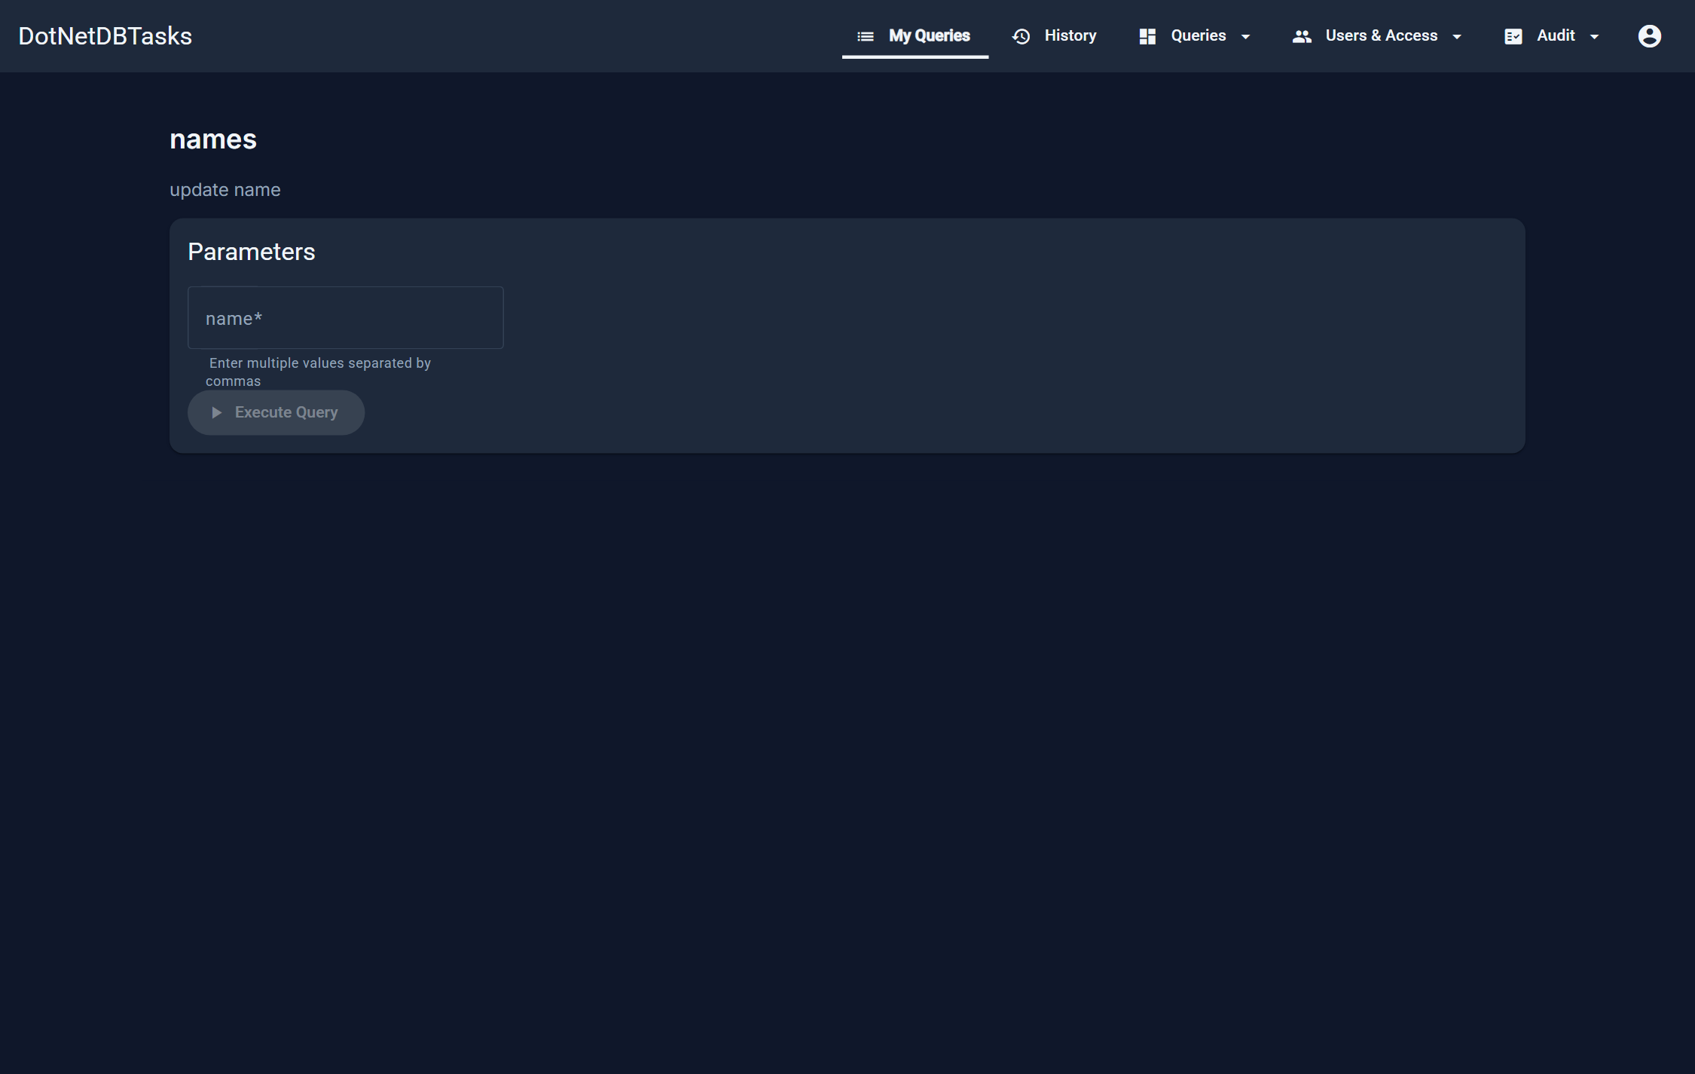
Figure 13. A multi-value String parameter. The hint under the box explains the comma-separated format.

5.4 Reading the results
A read query runs once. The complete result is held on the server, and the grid asks for one page at a time — so paging, sorting and filtering never re-run the query and never ship the whole result to your browser.
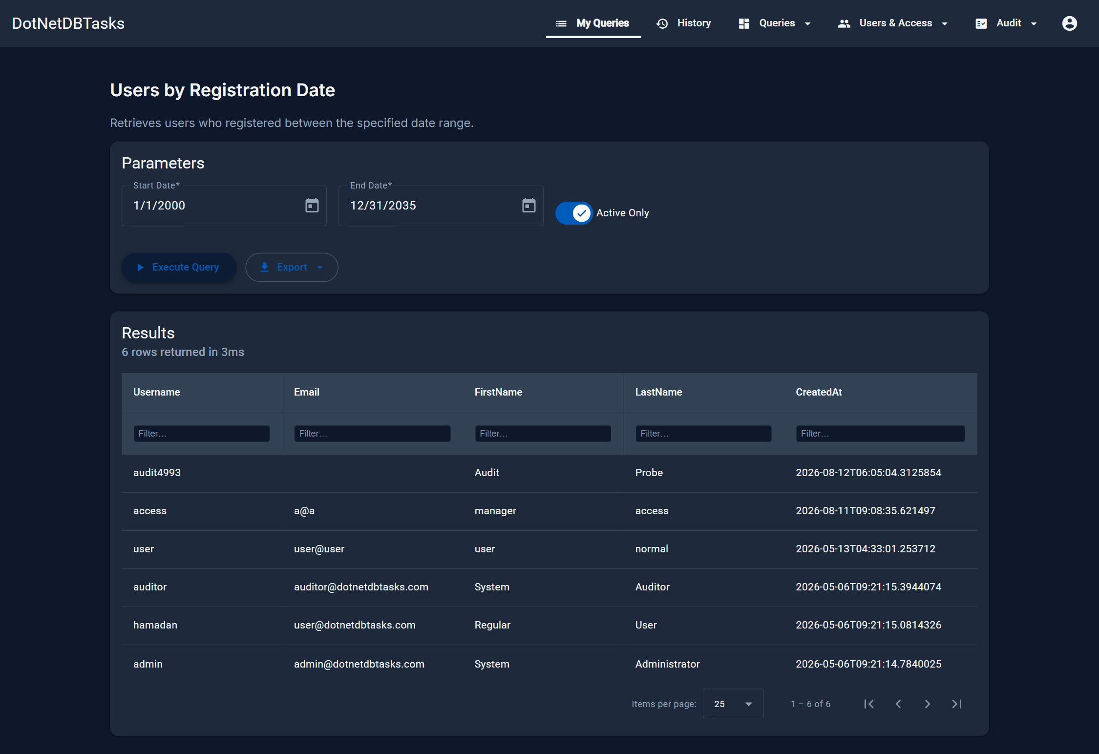
Figure 14. The result grid. The subtitle reports the row count and how long the query took; the second header row filters each column.
- Sort — click a column header. Sorting is applied to the whole result, not just the page on screen.
- Filter a column — type in the box under its header. Filters are case-insensitive “contains” matches and combine across columns.
- Page — the pager at the bottom; 10, 25, 50 or 100 rows per page.
- Row counts — the subtitle shows the total, and how many rows match the filters when they differ.
Note. Leaving the results page releases the stored result on the server. Use the browser's Back button and the result is gone — re-run the query to get it back.

5.5 Exporting results
Export builds the file from the result already held on the server, so exporting after viewing costs no second run of the query. The whole result is exported, not just the page on screen.
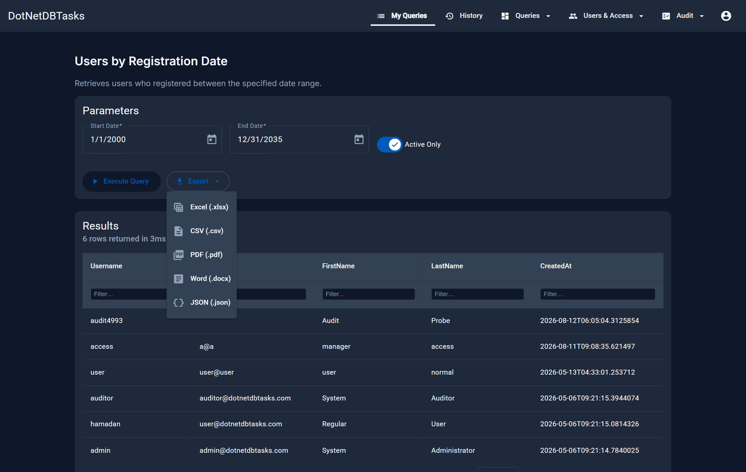
Figure 15. The five export formats.
Format | Use it for
Excel (.xlsx) | Further analysis; the default choice for tabular data.
CSV (.csv) | Loading into another system.
PDF (.pdf) | Sending a fixed, printable copy.
Word (.docx) | A formatted report. Uses the query's own Word template when the administrator uploaded one, otherwise the system default.
JSON (.json) | Feeding another program.

5.6 Long-running queries
A query an administrator marked long-running is submitted to run in the background instead of holding the page open. While it runs you see an elapsed timer, and a Cancel button appears beside it.
Cancelling is real: it stops the statement on the database rather than merely abandoning the page. This mode exists so that slow queries are not cut off by a network gateway; the only limit that still applies is the query's own timeout.

5.7 Queries that change data
A query may be an INSERT, UPDATE or DELETE. These run in two phases so you can see the impact before anything is committed.
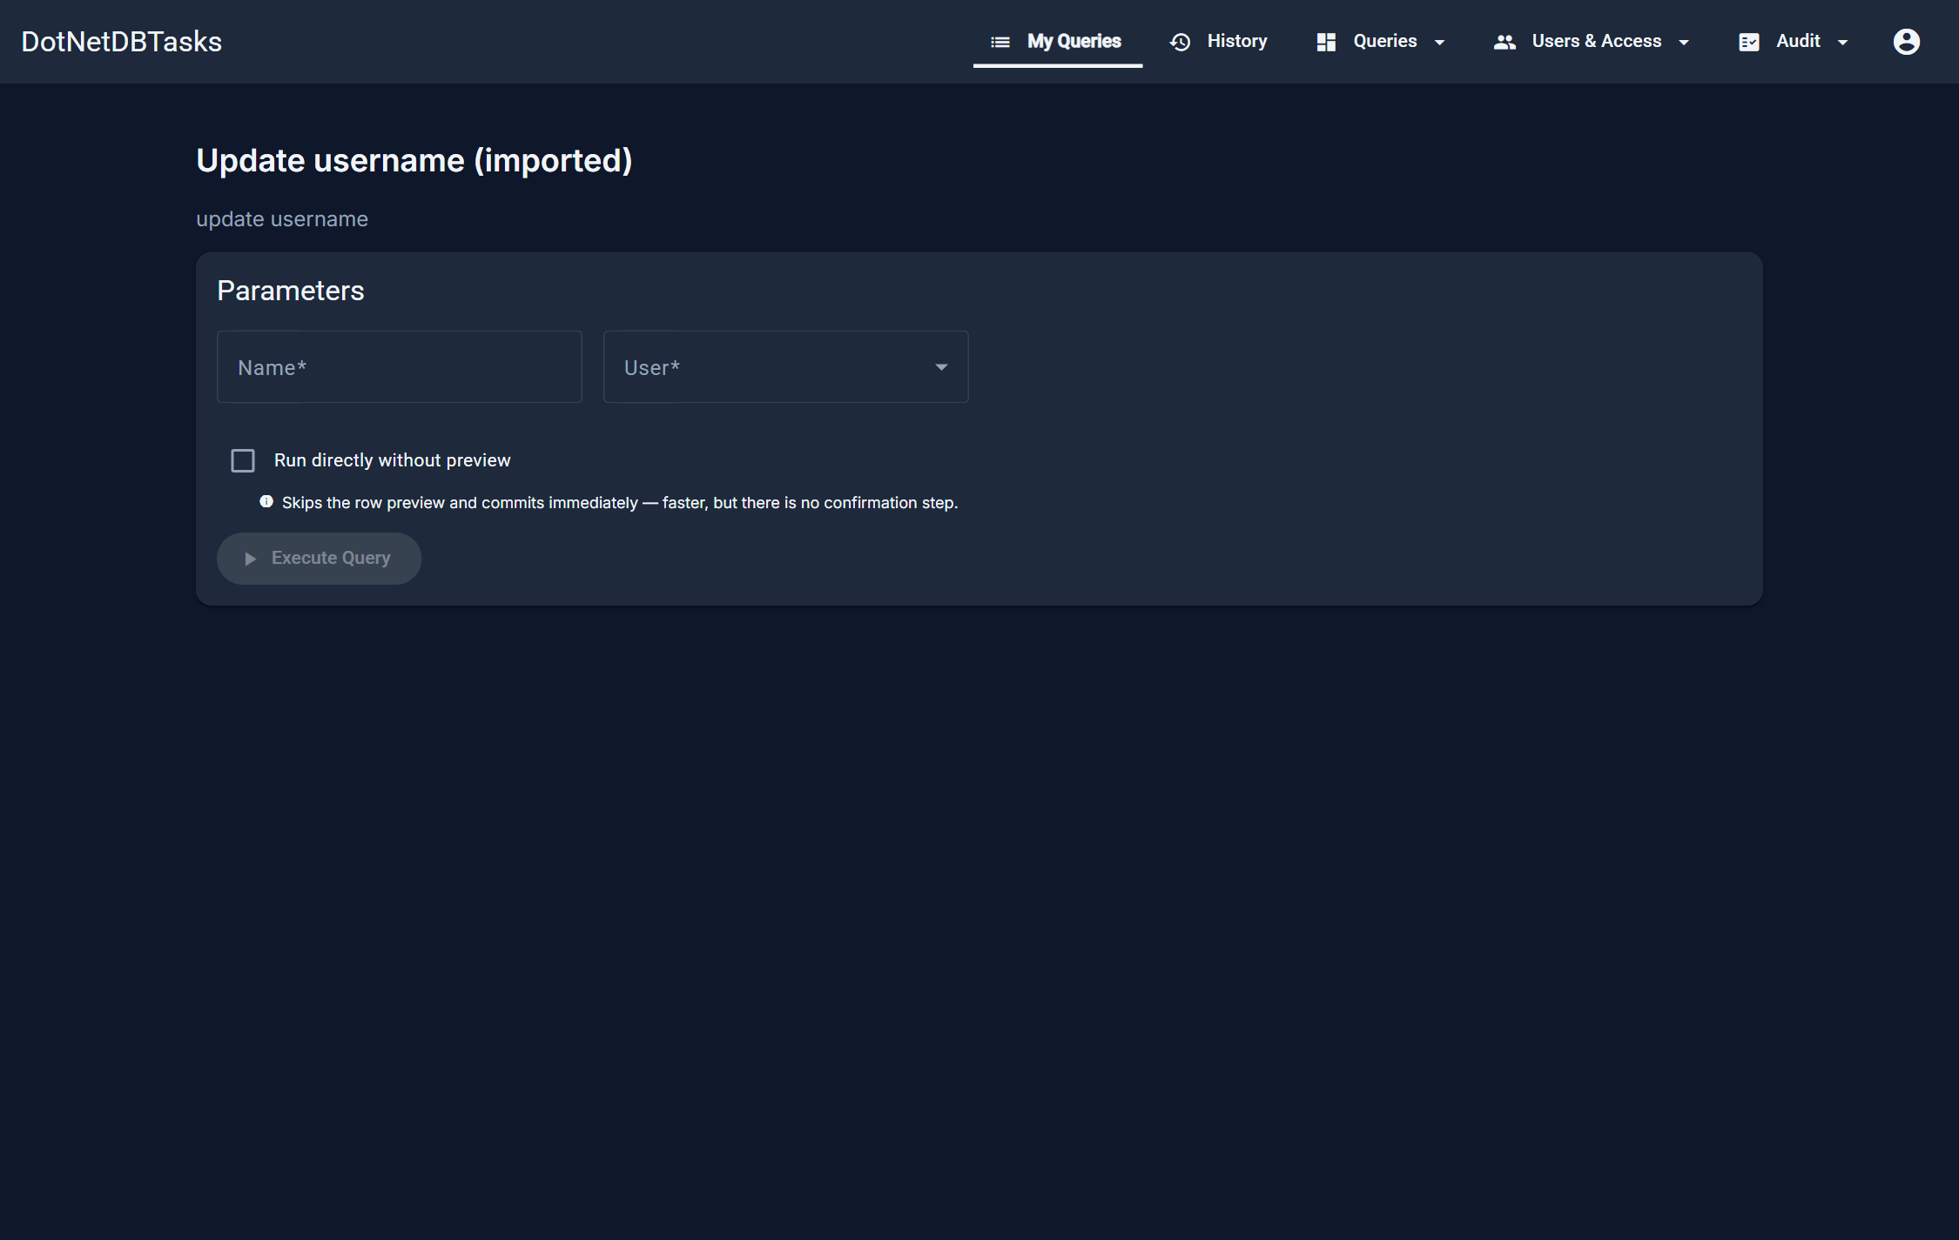
Figure 16. A write query's form. It looks like any other query; the difference appears after you run it.
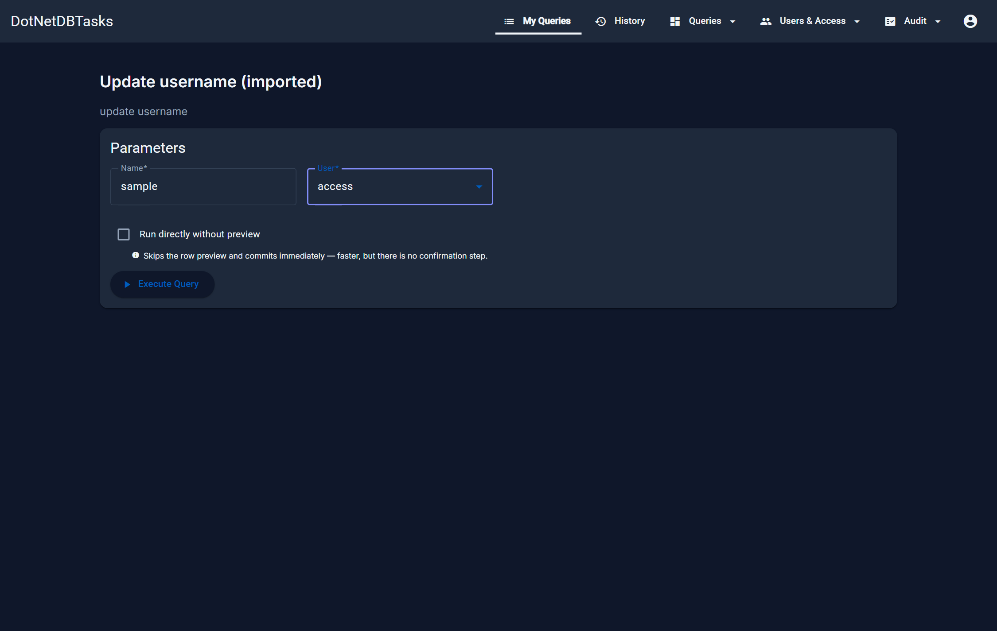
Figure 17. The same form with its parameters filled in.
- Press Execute. The statement runs inside a transaction that is then rolled back — nothing has changed yet.
- The confirmation panel reports how many rows would be affected, and for UPDATE and DELETE lists the actual rows that would change.
- Press Confirm & Commit to run it for real, or Cancel to walk away. Cancelling leaves the data exactly as it was.
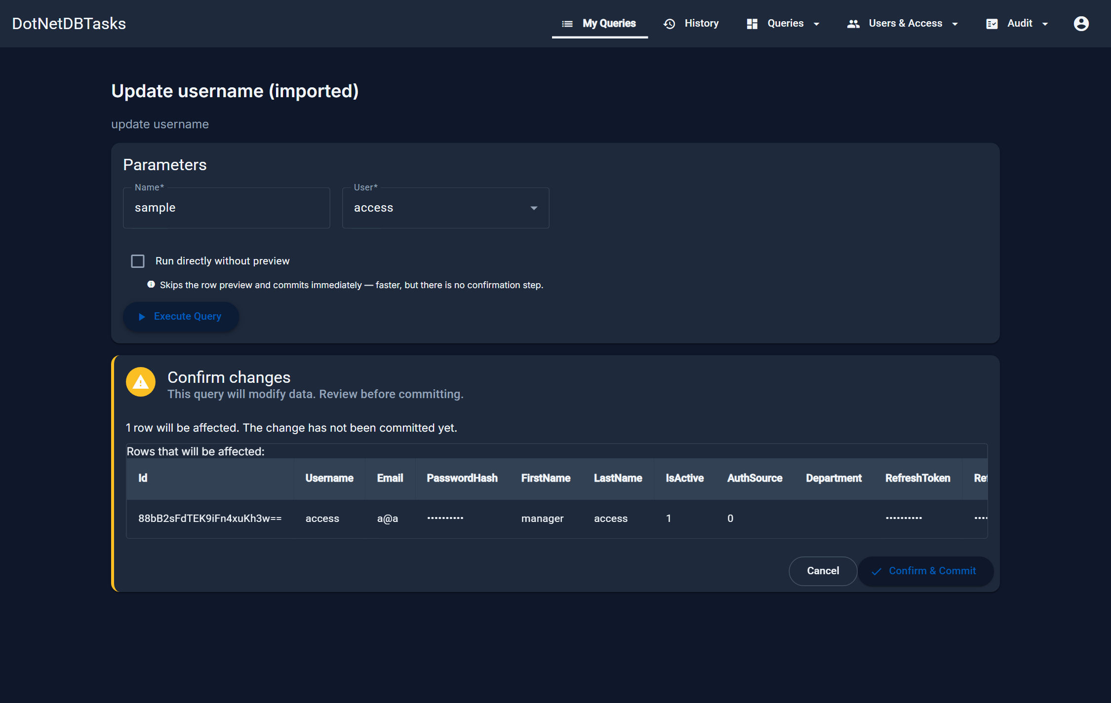
Figure 18. The confirmation panel. The row count and the rows themselves come from a real execution that was rolled back.
Note. Nothing is committed until you press Confirm & Commit. Closing the page at the preview stage is always safe.

5.8 Running without the preview
The preview costs two extra round trips and can be slow on large tables. When an administrator has allowed it for a query, a “Run directly without preview” checkbox appears above the Execute button. Ticking it commits the change in one pass — the button turns red and reads Run & Commit, and the note beneath warns that there will be no confirmation step.
Important. With the checkbox ticked there is no second chance. Leave it clear unless you run the same query often and know exactly what it changes.

5.9 Your execution history
History lists every query you have run: when, with which parameters, how long it took, how many rows came back, and whether it succeeded. A failed run shows the error message.
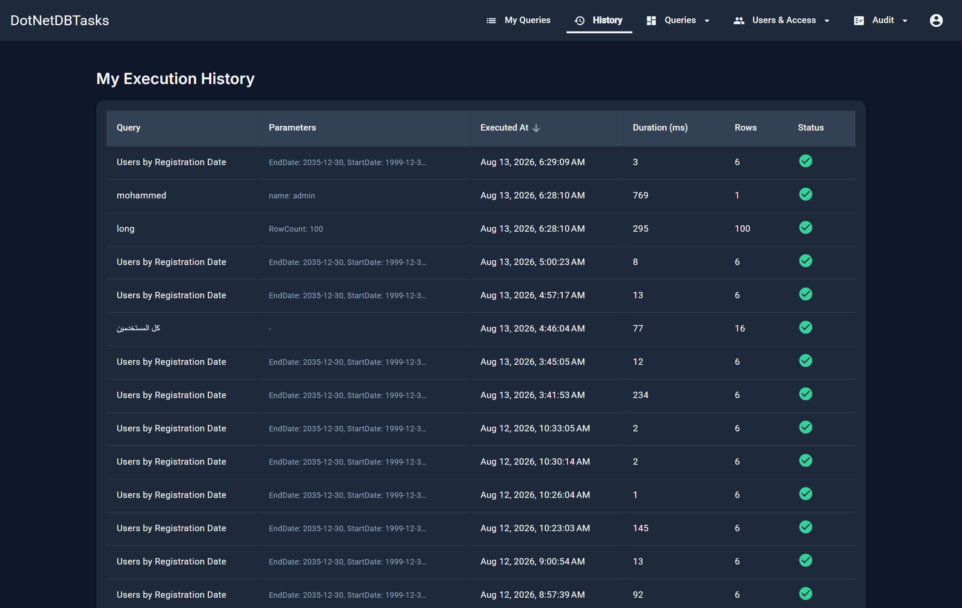
Figure 19. My Execution History. For UPDATE and DELETE runs, the row count is a link that opens the values as they were before the change.

5.10 Scheduled task status
If an administrator named you as a viewer of a scheduled task, a Schedules entry appears in your navigation. It shows each run's start time, status, which trigger started it, and the files it produced. You can download those files only if you were also named as a downloader.

6. Managing queries
For: Administrators. Access Managers see the list but cannot create, edit, delete or export.

6.1 The query list
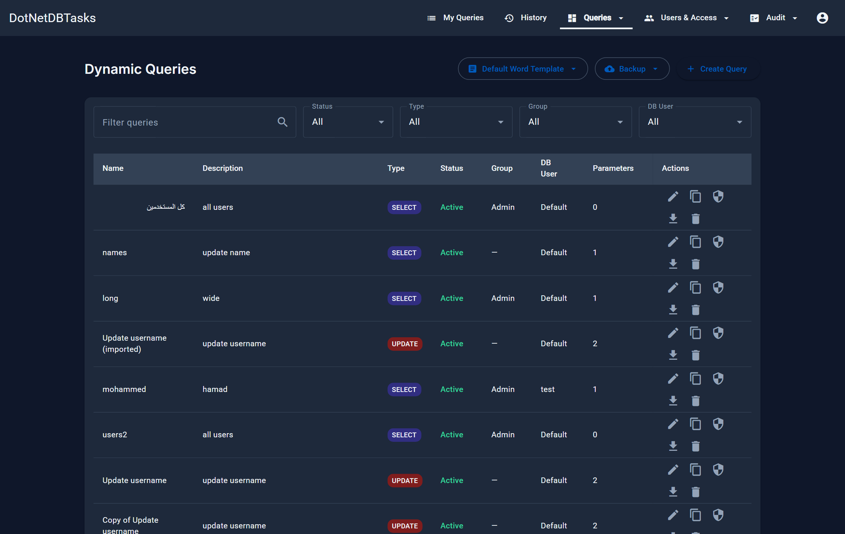
Figure 20. Manage Queries. Filters across the top, one row per query, and the actions for each row at the end.
The columns are Name, Description, Type, Status, Group, DB User and the number of parameters. Five filters narrow the list and are remembered when you navigate away and come back:
- Search — matches name, description, group and database connection.
- Status — All, Active or Disabled.
- Type — SELECT, INSERT, UPDATE, DELETE or Other.
- Group — one group, or Ungrouped.
- DB User — the database connection the query runs through.
A Clear filters button appears whenever anything is narrowing the list, so a remembered filter cannot be mistaken for missing queries.
Row action | What it does | Who sees it
Edit | Opens the query for editing | Admin
Copy | Opens the create form pre-filled from this query | Admin
Manage access | Assign roles, user groups and users | Holders of “Grant an individual query”
Export | Downloads this query as a JSON definition | Admin
Delete | Deletes the query, its parameters and its access assignments | Admin

6.2 Creating a query
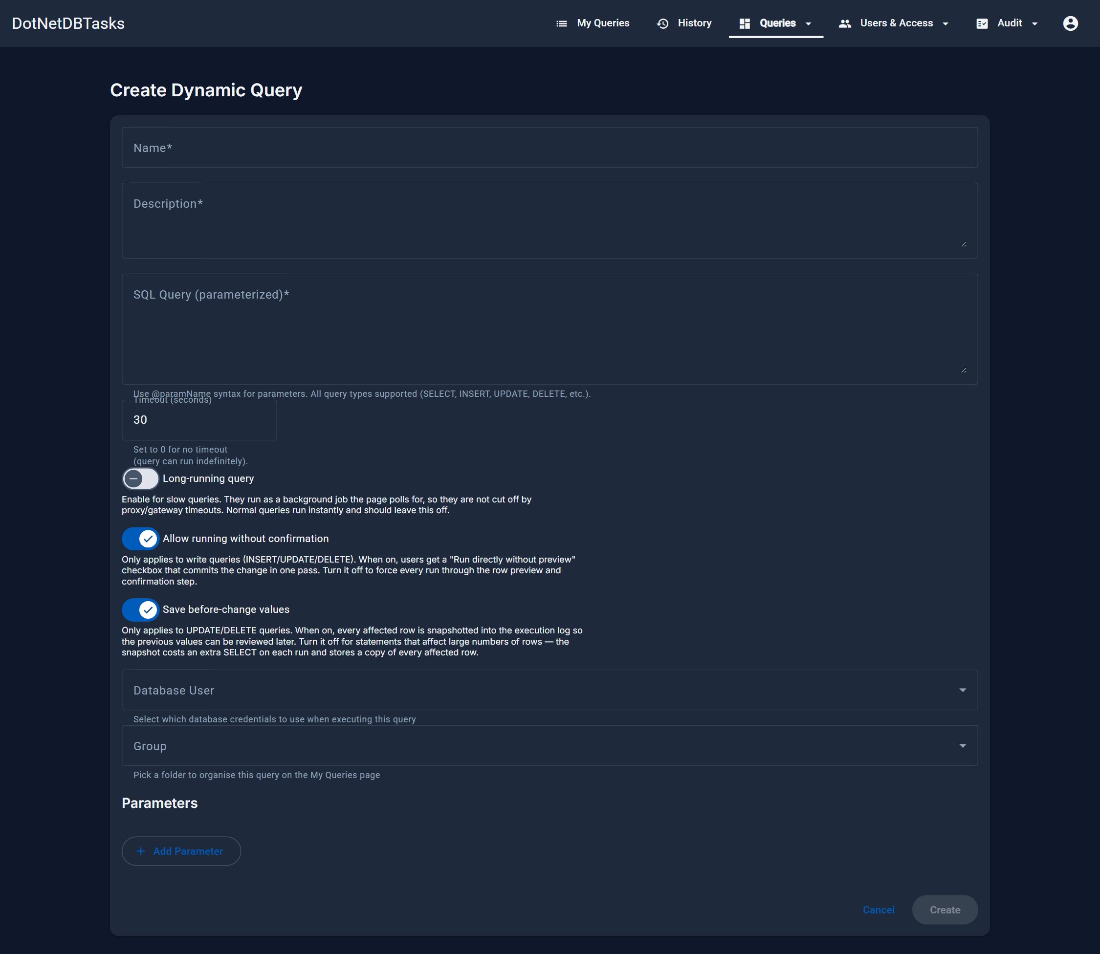
Figure 21. The Create Dynamic Query form.
Field | Meaning
Name | How the query appears to users. Required.
Description | Shown under the name on My Queries. Required.
SQL Query | The statement. Write parameters as @name. All statement types are supported.
Timeout (seconds) | How long the query may run. 0 means no limit.
Long-running query | Runs the query as a background job with an elapsed timer and a Cancel button. Use for slow queries; leave off otherwise.
Allow running without confirmation | Write queries only. Offers users the “Run directly without preview” checkbox. On by default.
Save before-change values | UPDATE and DELETE only. Stores every affected row as it was, with the execution log. On by default; turn it off for statements that touch very many rows.
Database User | Which connection the query runs through. Default uses the system connection.
Group | The folder the query appears under on My Queries.
Enabled | Editing only. A disabled query cannot be run by anyone.

Note. The statement type is worked out from the SQL when you save, not taken from anything you choose — so the Type column and the write-query preview can never disagree with the SQL they describe.

6.3 Declaring parameters
Add Parameter appends a parameter card. Each one needs a name — the @name used in the SQL — and a display name, which is the label the user sees.
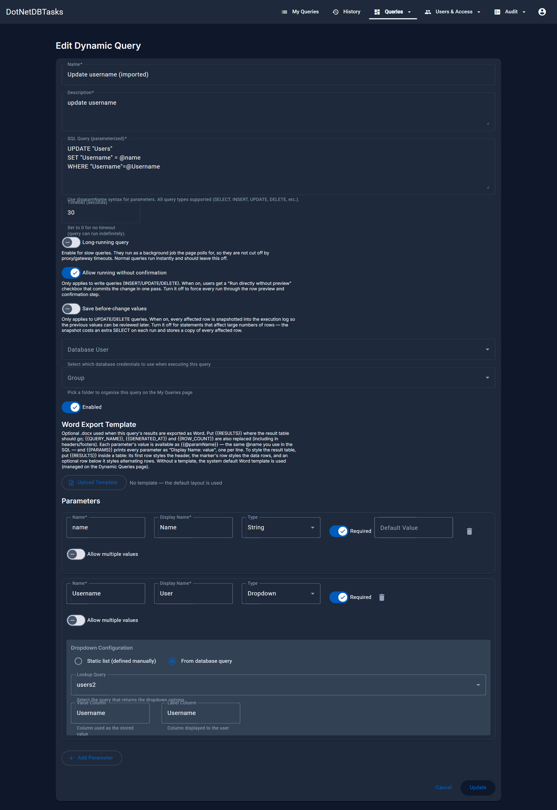
Figure 22. The parameter editor, showing a Dropdown parameter whose choices come from another query.
- Type — String, Number, Date, Boolean or Dropdown.
- Required — the user cannot run the query until it is filled in.
- Default Value — pre-filled for the user, and still editable by them.
- Allow multiple values — String and Dropdown only. The user supplies several values and the query matches any of them; write the SQL as WHERE col IN (@name).

Dropdown parameters
A Dropdown parameter draws its choices from one of two sources:
- Static list — label/value pairs you type in. The value is what reaches the SQL; the label is what the user reads.
- From database query — pick another stored query and name the column that supplies the value and the column that supplies the label. The list is fetched fresh each time the form is opened.

6.4 Word export templates
When a user exports results to Word, the layout comes from a template. A query can carry its own; otherwise the system default is used.
- Per query — upload a .docx on the query's edit form. Buttons to download or remove it appear once one is attached.
- System default — the Default Word Template menu on the query list.
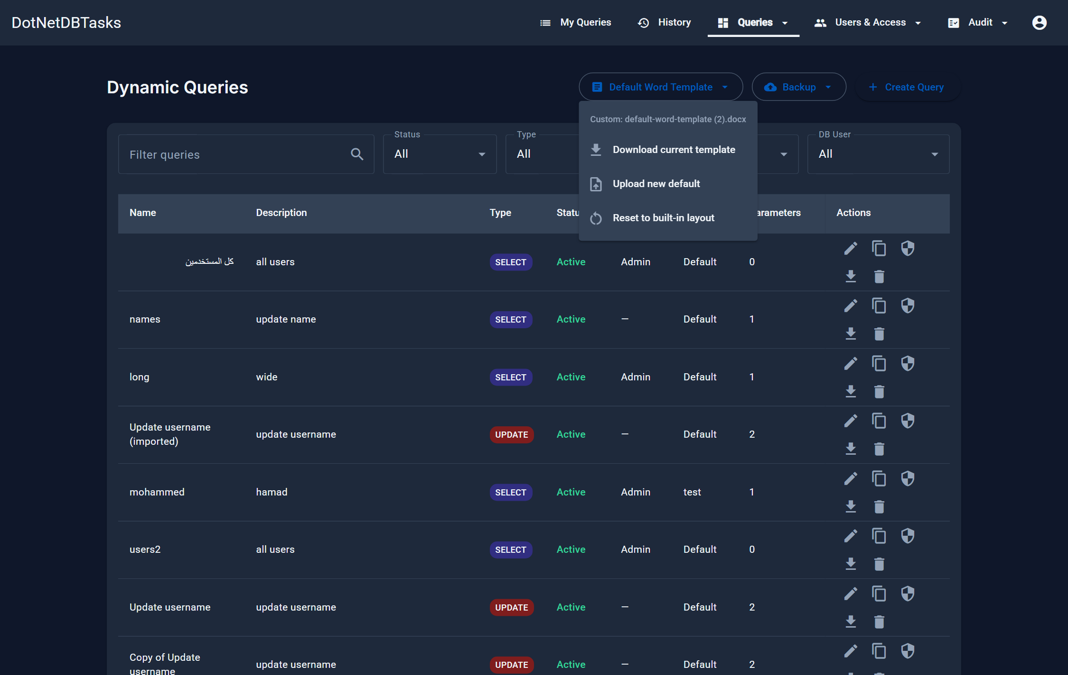
Figure 23. The Default Word Template menu. The line at the top says whether the built-in layout or an uploaded template is currently in use.
Inside a template, these markers are replaced when the file is produced:
Marker | Replaced with
{{RESULTS}} | The result table. Put it inside a table to style the output: the row above styles the header, the marker's own row styles data rows, and a row below it styles alternating rows.
{{QUERY_NAME}} | The query's name.
{{GENERATED_AT}} | When the file was produced.
{{ROW_COUNT}} | The number of rows.
{{@paramName}} | The value the user entered for that parameter.
{{PARAMS}} | Every parameter as “Display Name: value”, one per line.

Markers in headers and footers are replaced too.

6.5 Backing queries up and restoring them
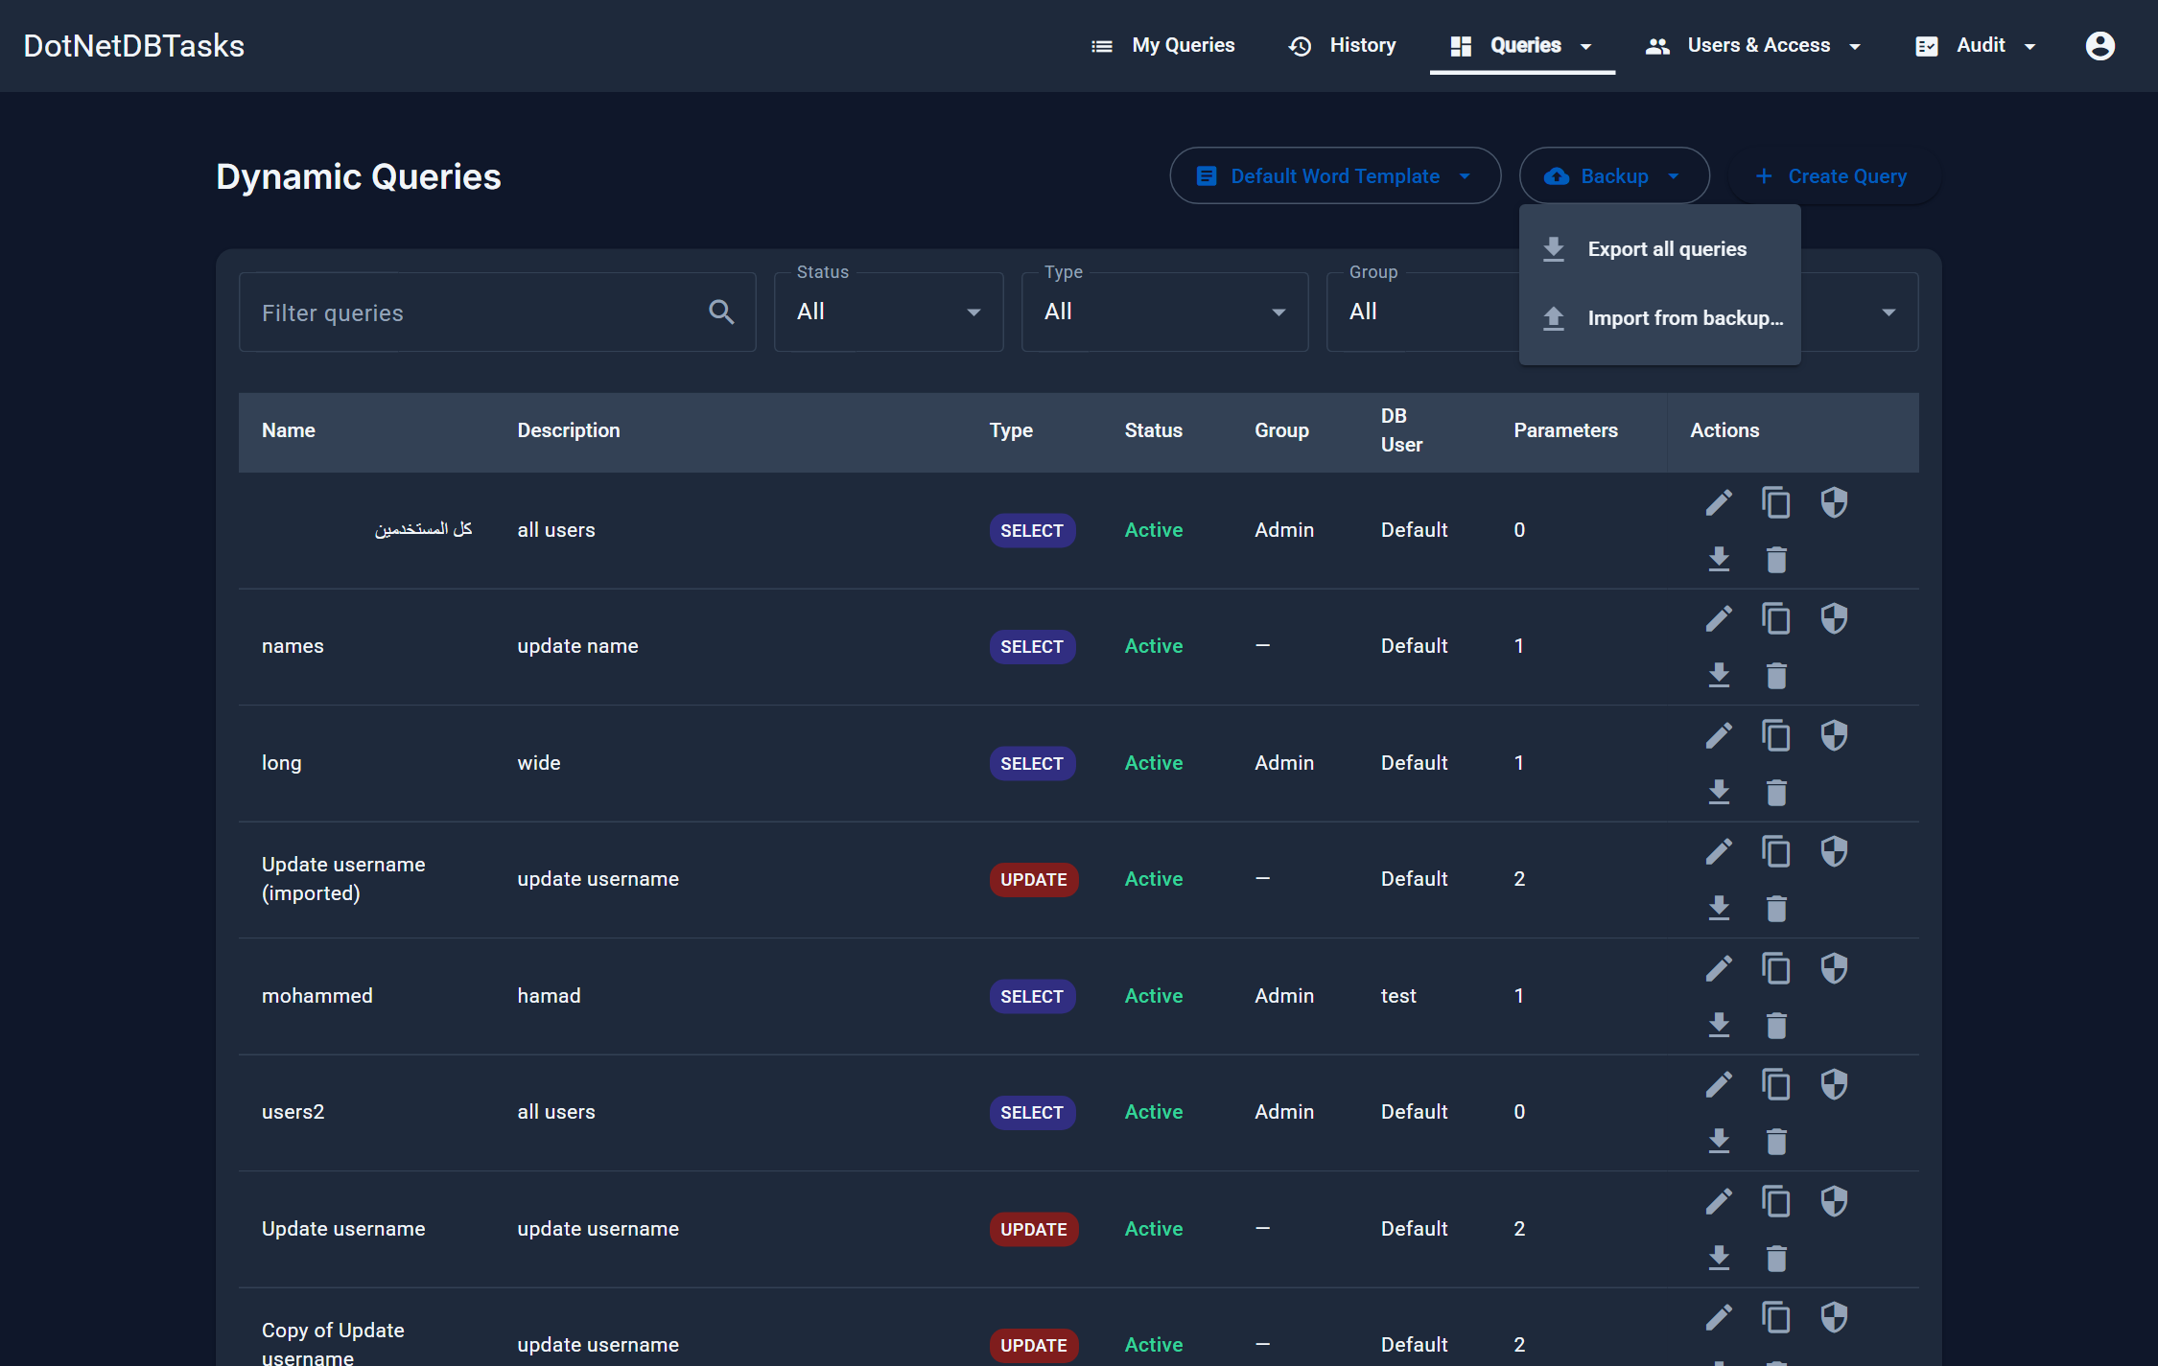
Figure 24. The Backup menu on the query list.
- Export all queries — downloads every query as one JSON file.
- Export (row action) — downloads a single query as JSON.
- Import from backup… — restores from an export file. Administrators only.
Everything in an export refers to related records by name rather than by internal identifier, so a backup can be restored onto a different installation:
Reference | On import
Query group | Matched by name, and created if it does not exist.
Database connection | Matched by name. If it is missing, the query lands on the default connection and a warning is reported.
Roles and users | Matched by name; assignments that do not match are dropped and reported.
User groups | Matched by name; grants to a group that does not exist here are dropped and reported. Membership is never exported.
Dropdown source query | Resolved after every query in the file exists, so a dropdown can point at another query from the same backup.

Note. Import never overwrites. A query whose name is already taken is imported as “Name (imported)”, so a mistaken import is undone by deleting what it added. The result dialog lists everything imported, everything renamed and every reference that could not be resolved.

Important. Database passwords are never written to an export file — only the connection's name. After restoring onto a new installation, create the connection there with its own credentials and the name match reconnects it.

7. Query groups
For: Administrators create and edit them; Access Managers grant access to them.
A query group is a folder. It organises My Queries for users, and — more importantly — it is the unit of access an Access Manager works with: granting a group grants every query inside it.
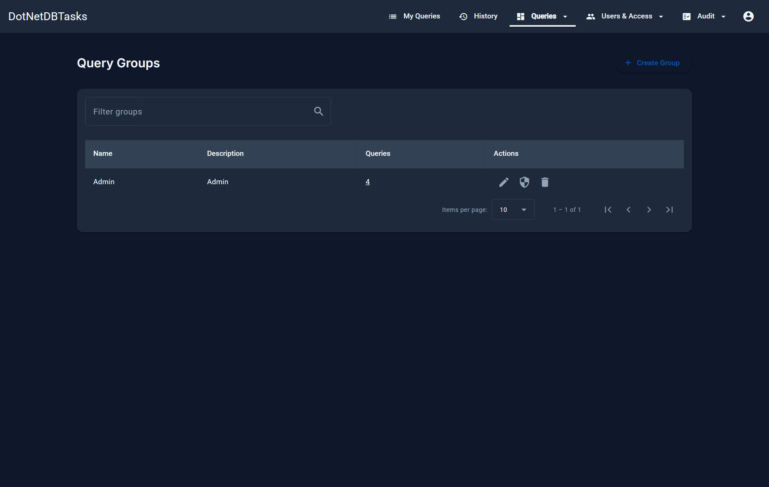
Figure 25. Query Groups. The Queries column counts the queries in each group and links to the list filtered to that group.
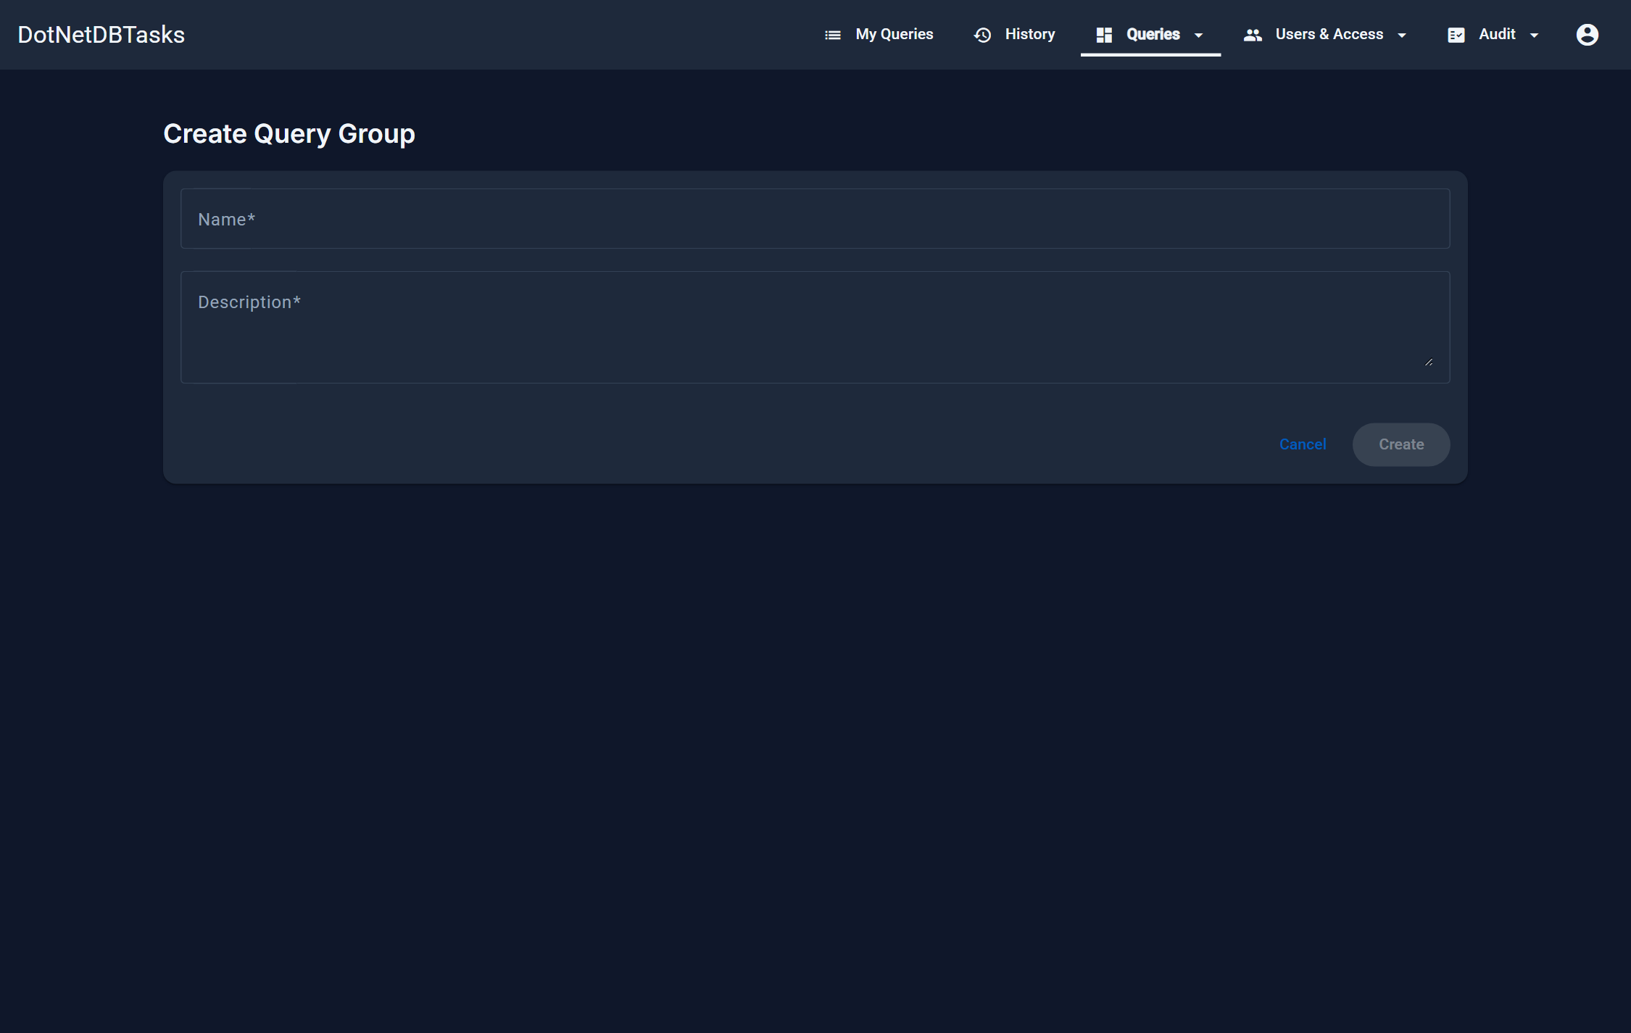
Figure 26. Creating a group: a name and a description.
Note. Deleting a group does not delete its queries. They stay, and become ungrouped.

8. Granting access
For: Administrators, and Access Managers.

8.1 Access to a single query
The shield icon on a query row opens Manage Query Access, which has three tabs. Each tab saves independently — the button under a tab saves only that tab.
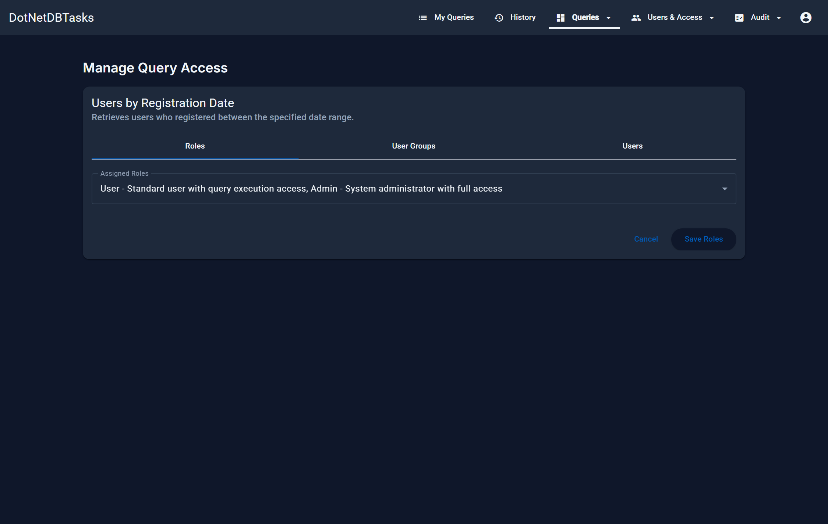
Figure 27. The Roles tab. Auditor and AccessManager are deliberately absent: neither can be granted a query.
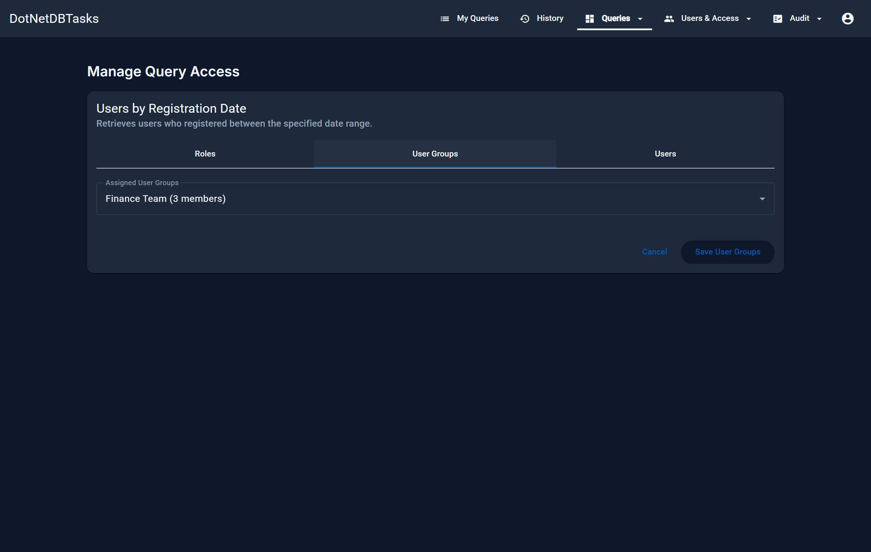
Figure 28. The User Groups tab. Every member of a group listed here gets the query, and the member count is shown beside each group.
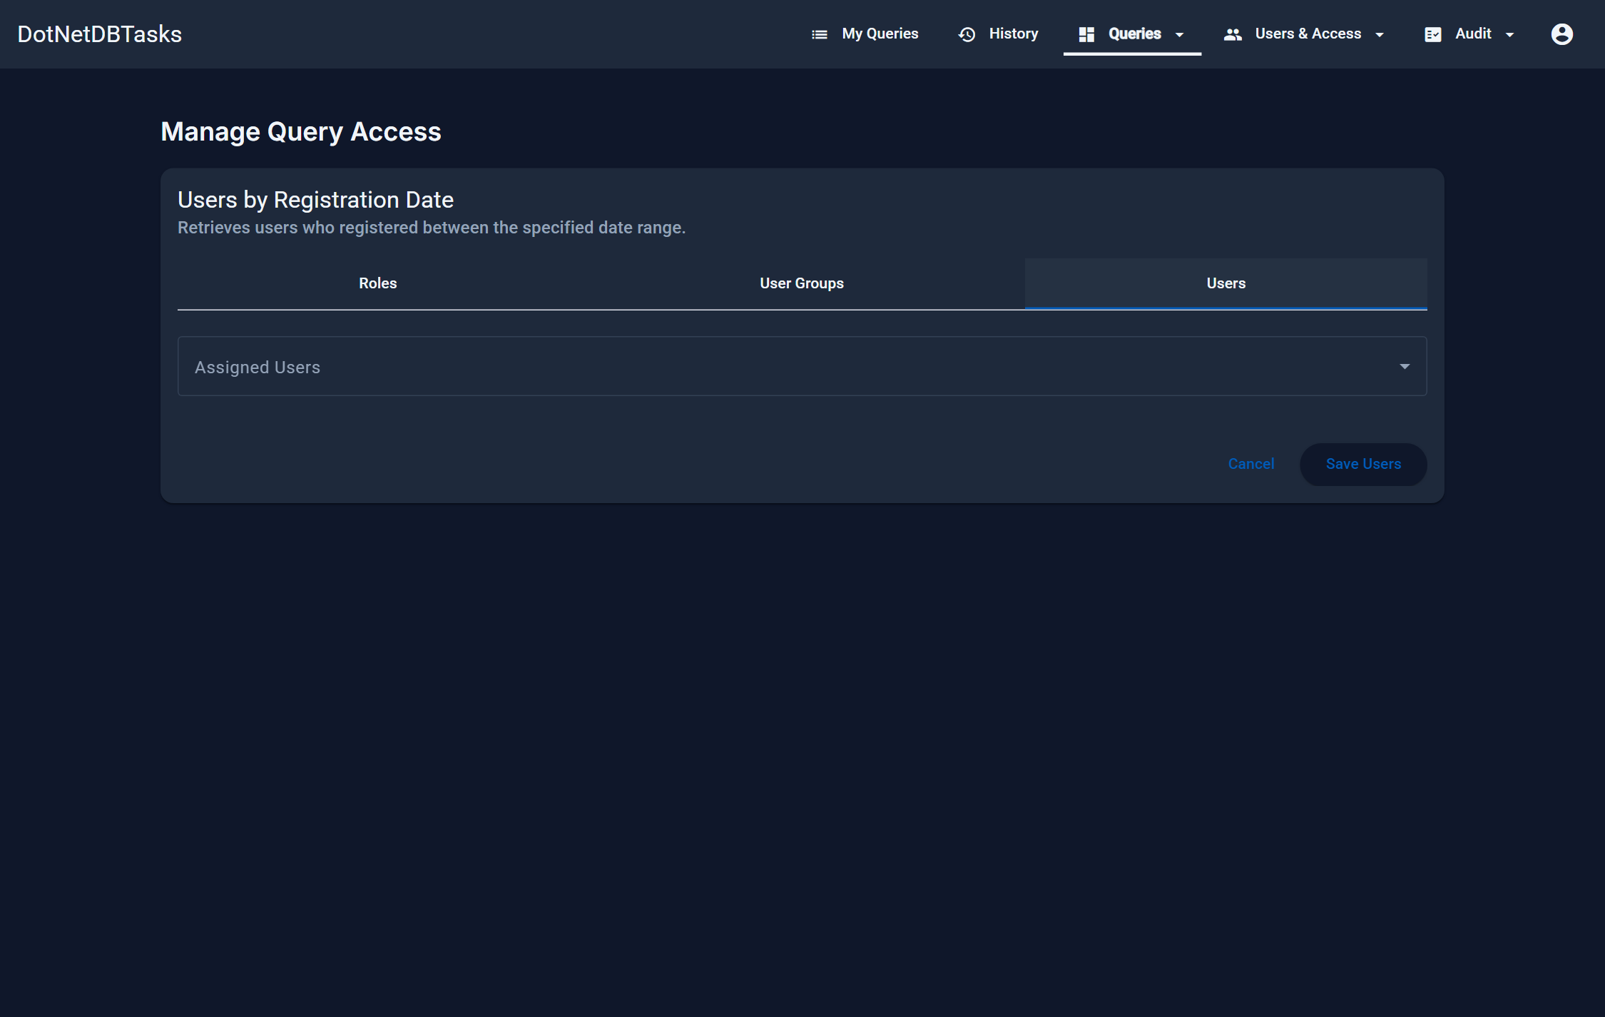
Figure 29. The Users tab, for granting the query to named individuals.

8.2 Access to a group
Manage Group Access works the same way, with the same three tabs, and applies to every query in the group. This is the page an Access Manager uses by default.
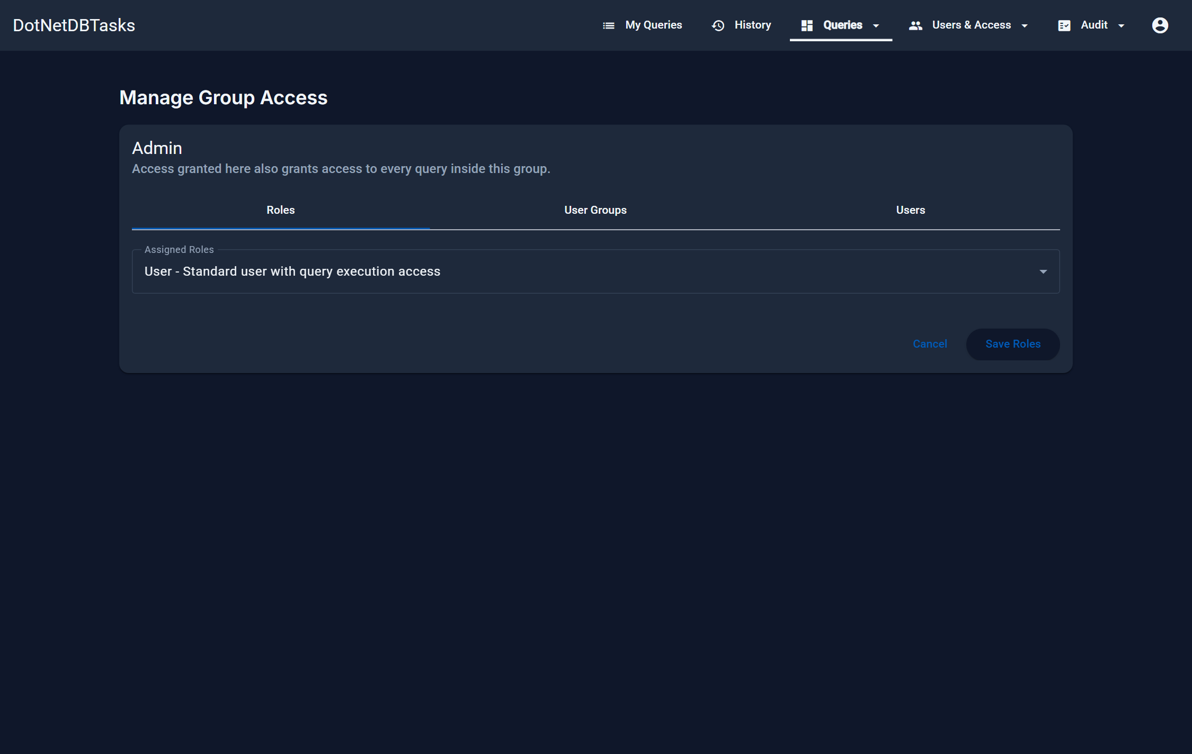
Figure 30. Manage Group Access.

8.3 How the grants combine
Grants add up and there is no “deny”. A user reaches a query if any one of the following is true: a role they hold is granted the query or its group; a user group they belong to is granted it; they are granted it by name; or they are an administrator. Removing one route leaves the others in place — to remove access completely, check all three tabs on both the query and its group, and the membership of any group that was granted it.

9. Scheduled tasks
For: Administrators create and run them; Auditors read them; named users see their status.
A scheduled task runs one or more queries unattended on a timetable and writes the results to files on the server.

9.1 The task list
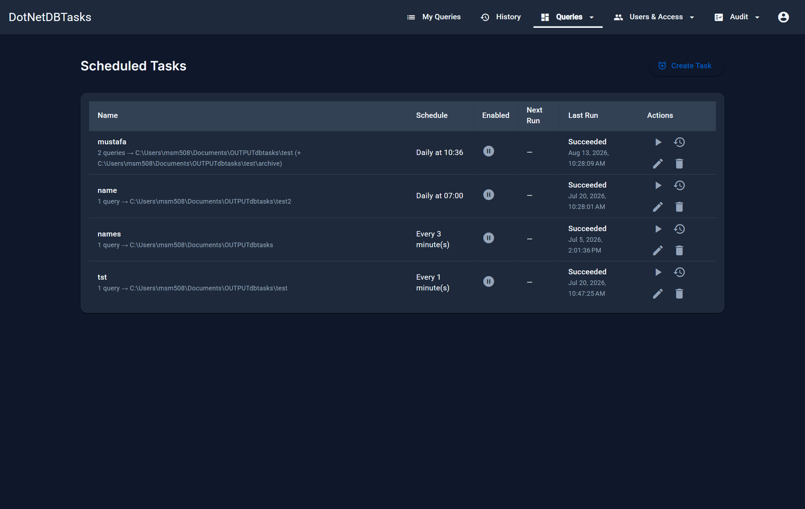
Figure 31. Scheduled Tasks, with the next and last run times for each task.
- Run now — starts the task immediately without waiting for a trigger.
- Run history — opens the record of past runs.
- Edit / Delete — administrators only. Deleting a task also deletes its run history.
- Enabled — a disabled task keeps its definition but no trigger fires.

9.2 Creating a task
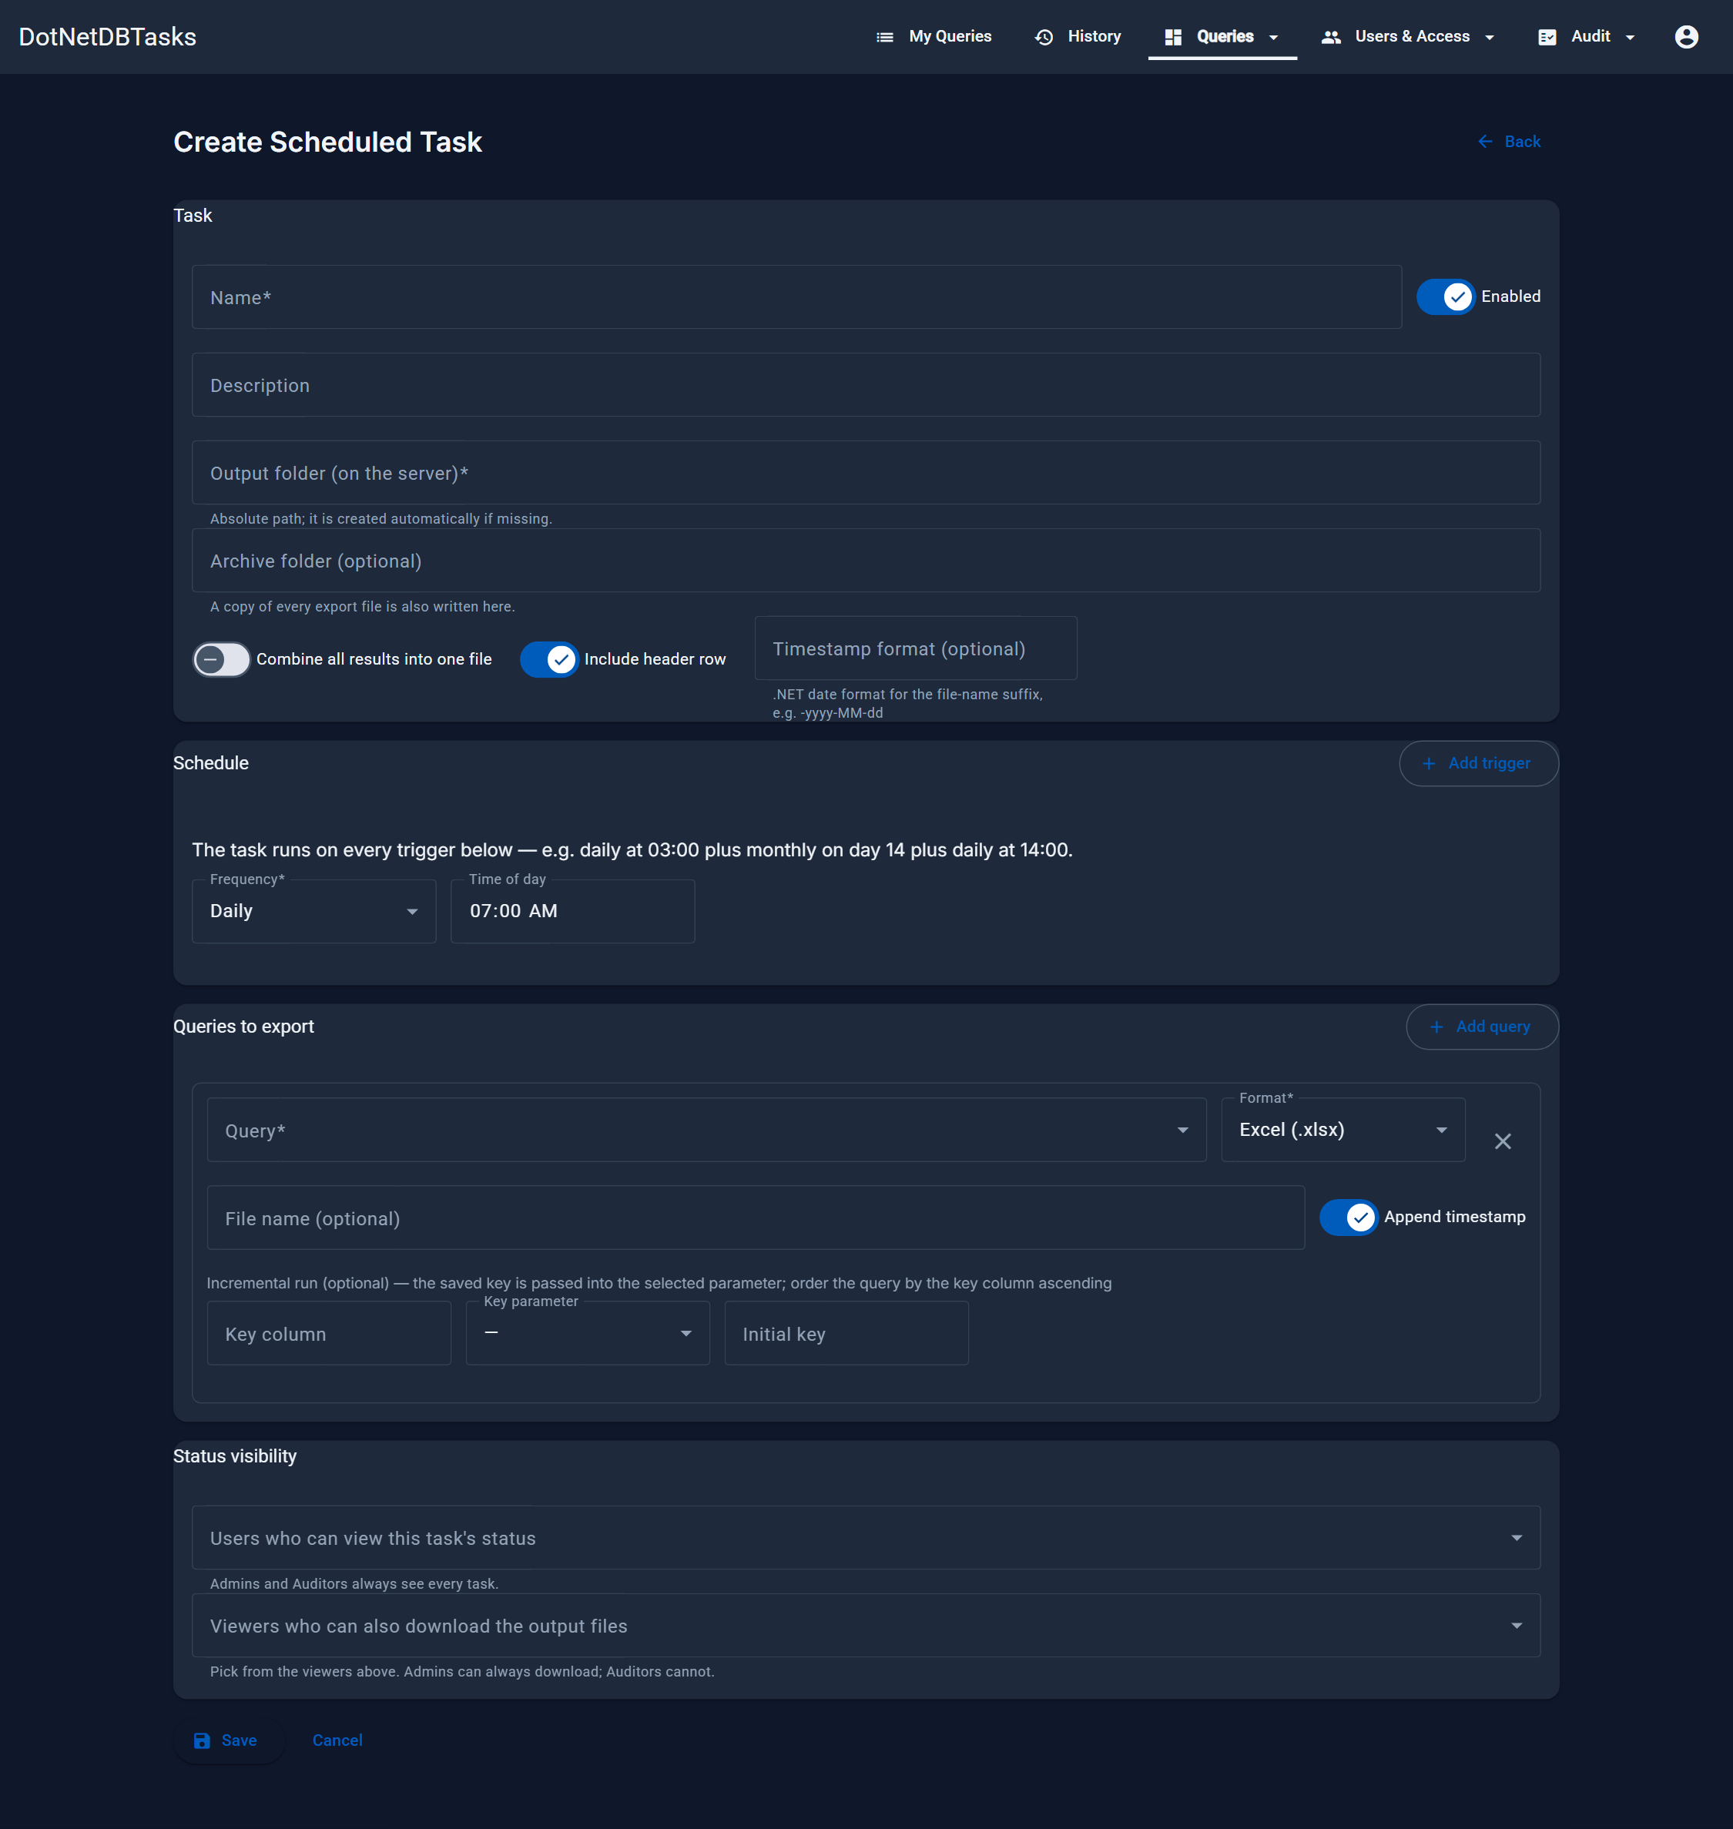
Figure 32. The Create Scheduled Task form.

Task
Field | Meaning
Name | Identifies the task. Required.
Output folder | Absolute path on the server where files are written. Created automatically if it does not exist. Required.
Archive folder | Optional. A copy of every file is also written here.
Combine all results into one file | Appends every query's result into a single file, in query order.
Include header row | Off means CSV and Excel files contain data rows only.
Timestamp format | A .NET date format appended to file names, e.g. -yyyy-MM-dd. Without a timestamp the same file is overwritten on every run.

Schedule
A task can carry several triggers and runs on every one of them — for example daily at 03:00 plus monthly on day 14. Each trigger is one of:
Frequency | Additional settings
Every N minutes | Interval in minutes
Daily | Time of day
Weekly | Day of week and time of day
Monthly | Day of month and time of day

Queries to export
Add one row per query. For a read query you also choose:
- Format — the export format for that query's file (with a separator option for CSV).
- File name — defaults to the query's name.
- Append timestamp — on to keep each run's file; off to overwrite one file.
- Incremental run — optional. Name a key column, the parameter that receives it, and a starting value: each run passes the highest key from the previous run into that parameter, so only new rows are exported. Order the query by the key column ascending.
- Parameter values — fixed values for the query's parameters, since there is no one present to type them.
Important. A write query can be scheduled too. It executes and commits on every run — there is no preview step and no output file, only the affected-row count in the run status.

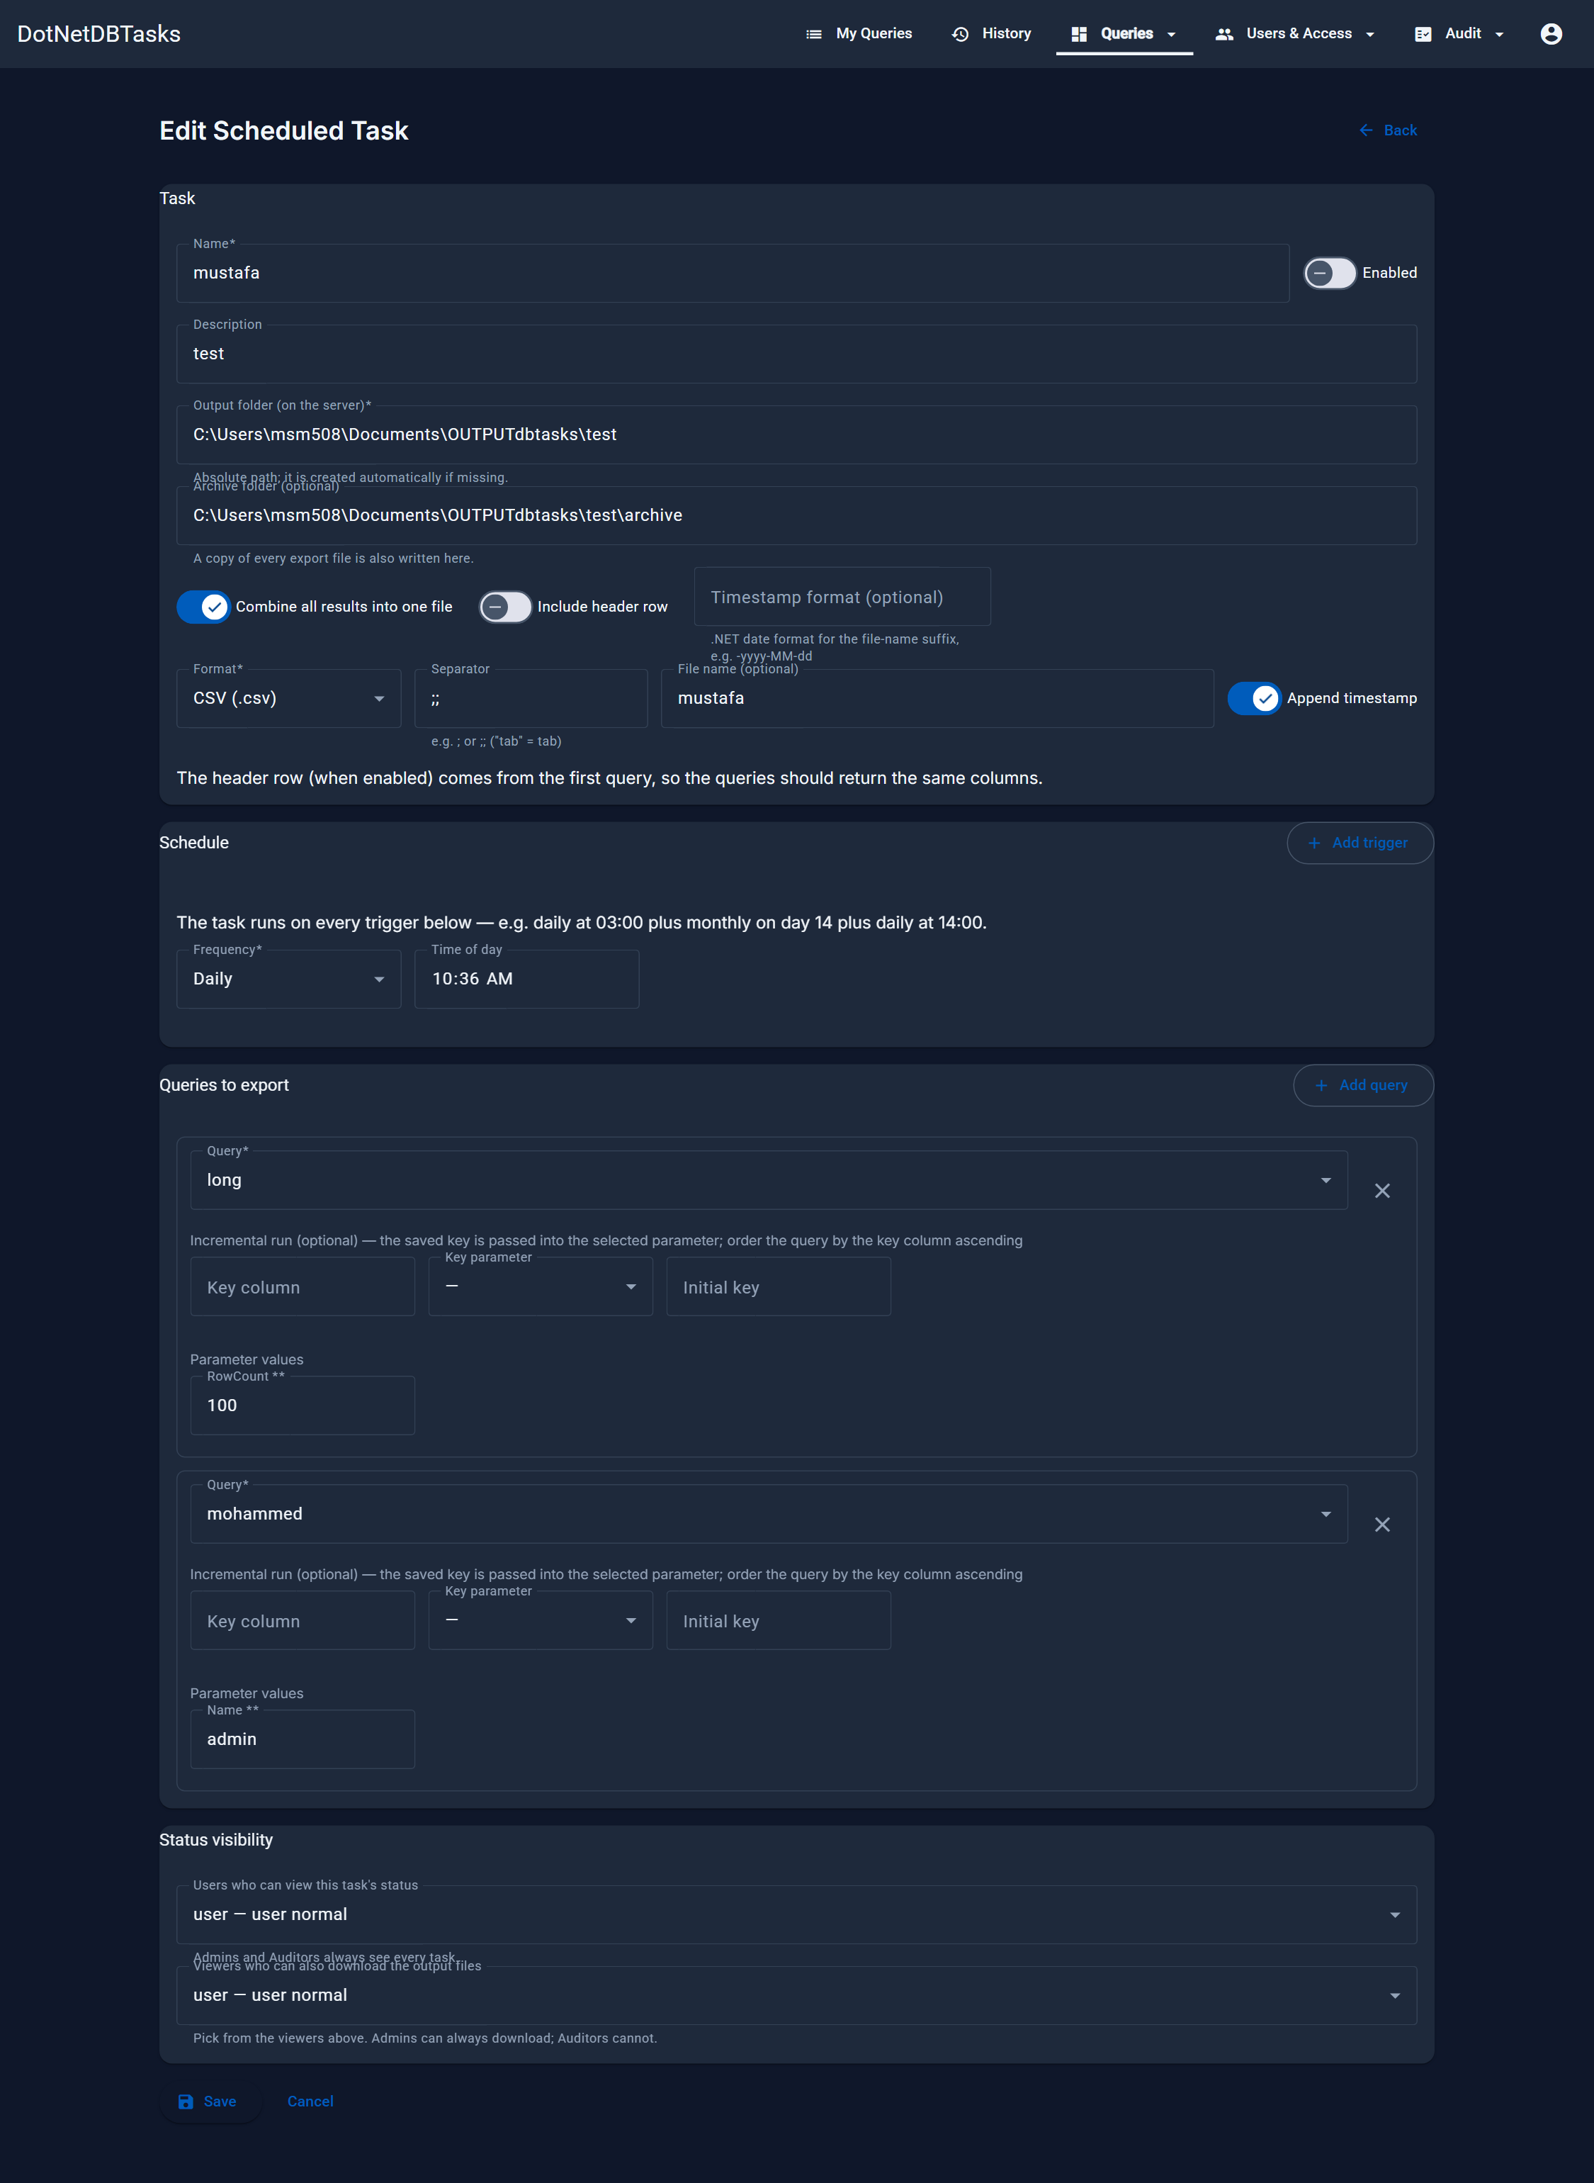
Figure 33. An existing task, showing its triggers, its queries and their parameter values.

Status visibility
Two lists at the bottom of the form decide who, outside the administrators, can see the task:
- Users who can view this task's status — these users get the Schedules page and see the task's runs. Administrators and Auditors always see every task.
- Viewers who can also download the output files — chosen from the viewers above. Administrators can always download; Auditors never can.

9.3 Run history
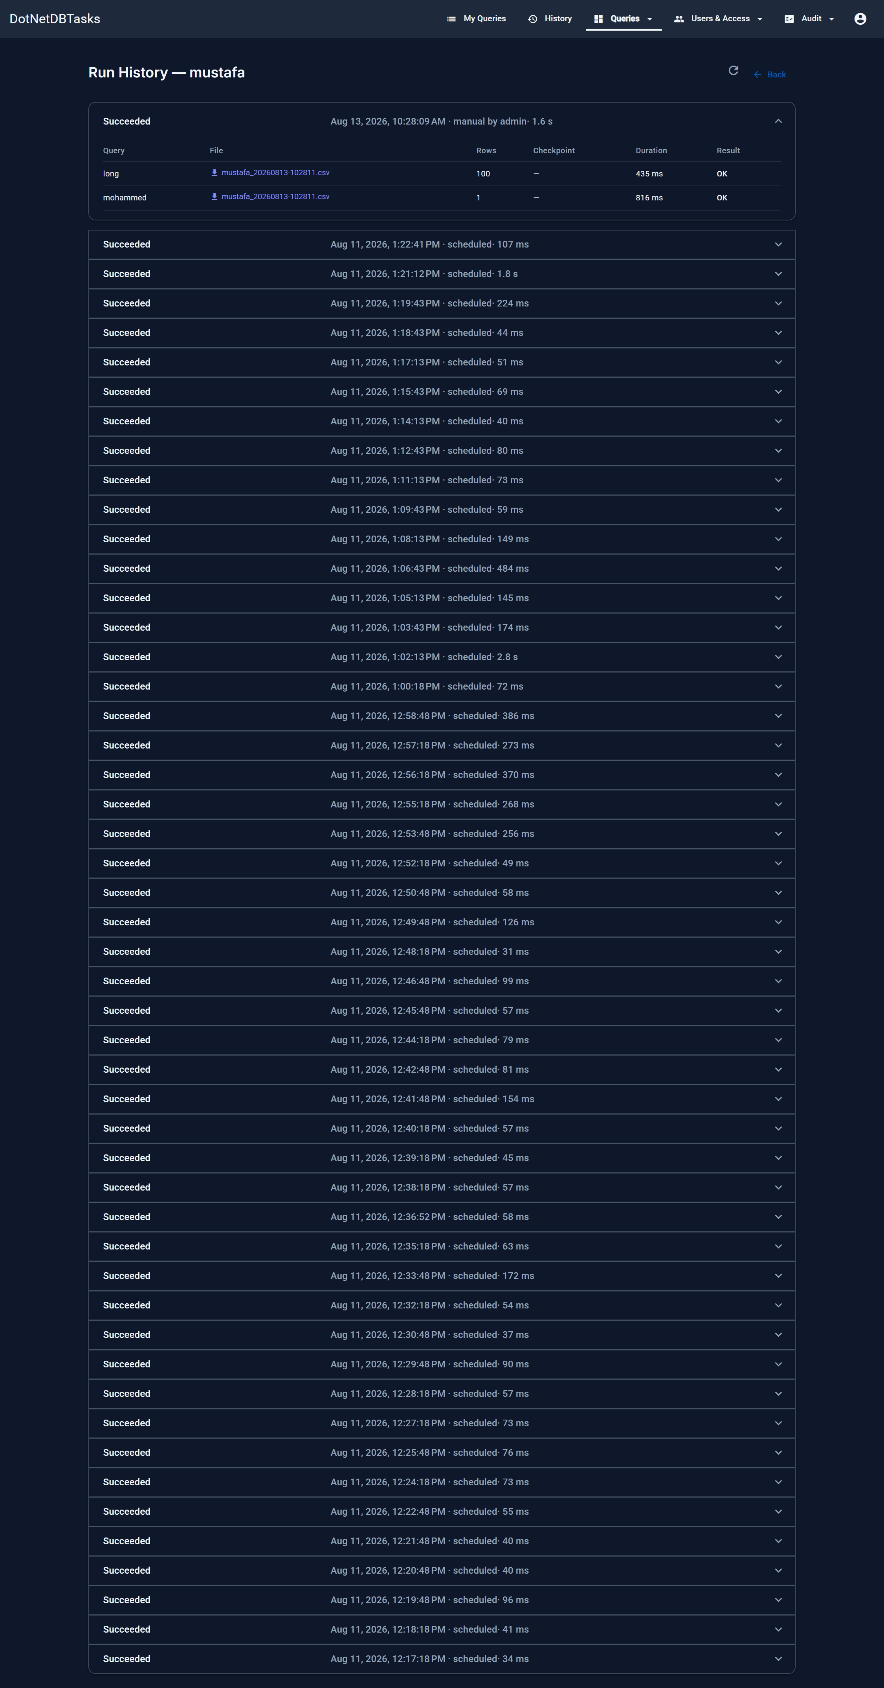
Figure 34. Run history. Each run expands to show the queries it executed, the files it wrote, row counts, durations and any error.
- Download — fetches a file the run produced. If the file has since been moved, deleted or overwritten by a later run, the download reports that instead.
- Cancel — appears on a run that is still going, and stops the running query on the database. Administrators only.
- Checkpoint — for an incremental query, the key value the run finished at, which the next run starts from.
Note. Only one run panel is open at a time — opening another closes the first.

10. Users, user groups and Active Directory
For: Administrators. Access Managers can use the Users page with restrictions.

10.1 User management
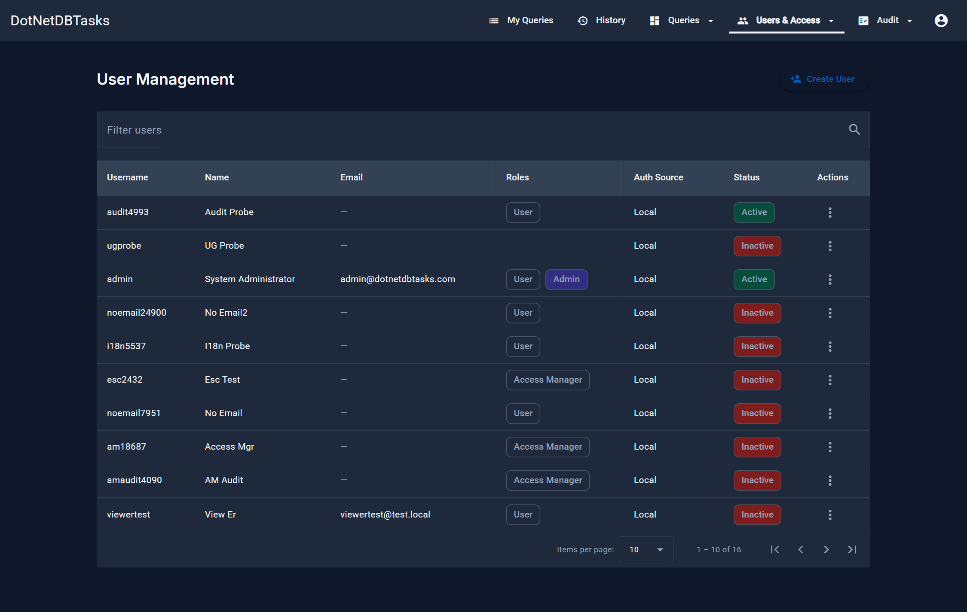
Figure 35. User Management. The list shows each account's roles, whether it is local or came from Active Directory, and whether it is active.
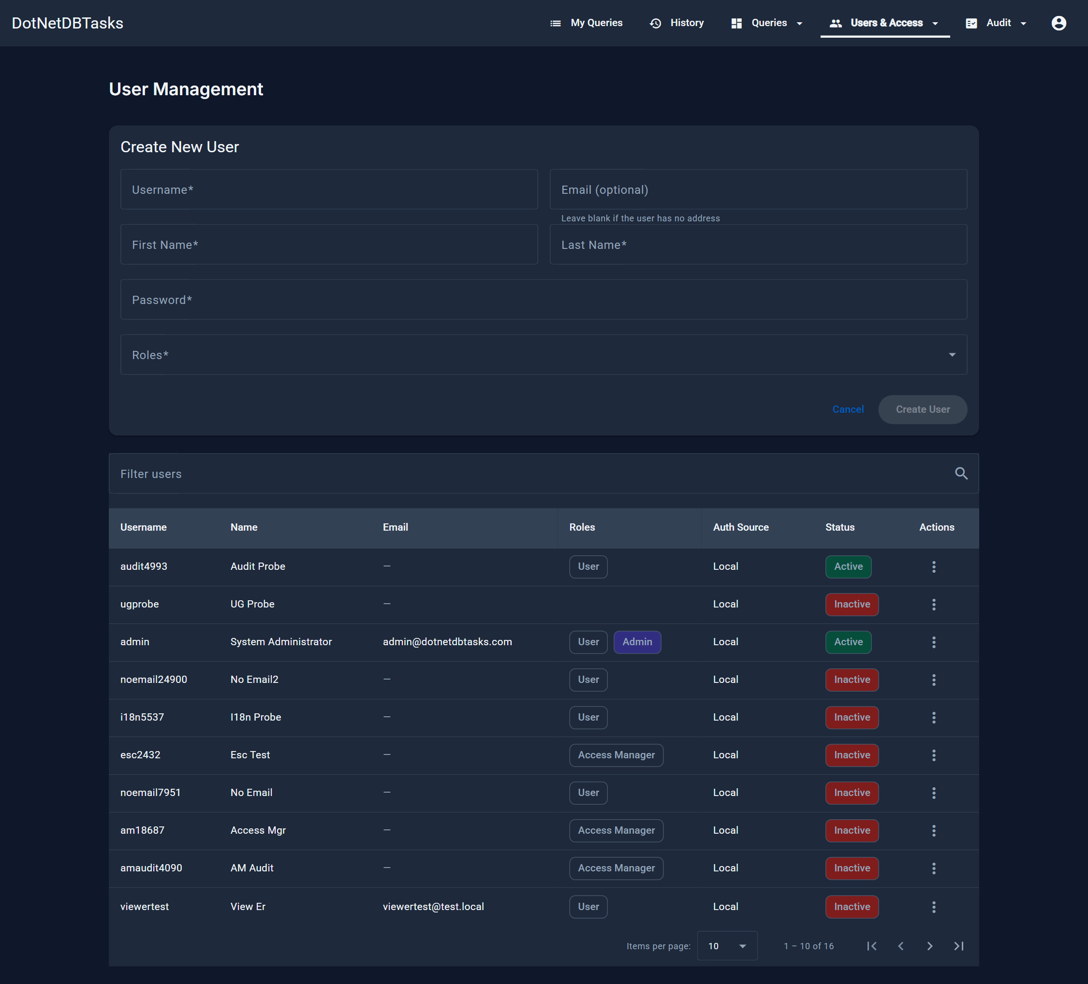
Figure 36. Creating a local user. Email is optional. Access comes from the roles chosen here and from any user group the account is later added to.
Action | Effect
Create User | Adds a local account with a password and roles.
Edit | Changes the username, the roles, or both.
Reset password | Replaces the account's password with a temporary one you must pass on. The old password stops working immediately.
Deactivate / Activate | A deactivated account is signed out and blocked from signing in until reactivated.

Important. An Access Manager may use this page but cannot modify any account holding the Admin role, cannot grant the Admin role, and cannot change their own roles. An attempt is refused and the refusal is recorded in the system audit trail.

10.2 User groups
A user group is a named list of people, kept inside this application. Granting a query or a query group to a user group grants it to every member — which is how one change gives a whole team access, and one change takes it away again.
Note. These groups are not Active Directory groups and do not mirror the AD department. Membership is whatever an administrator set here, so it covers accounts created locally as well as imported ones, and a reorganisation in the directory does not silently change who can reach a query.

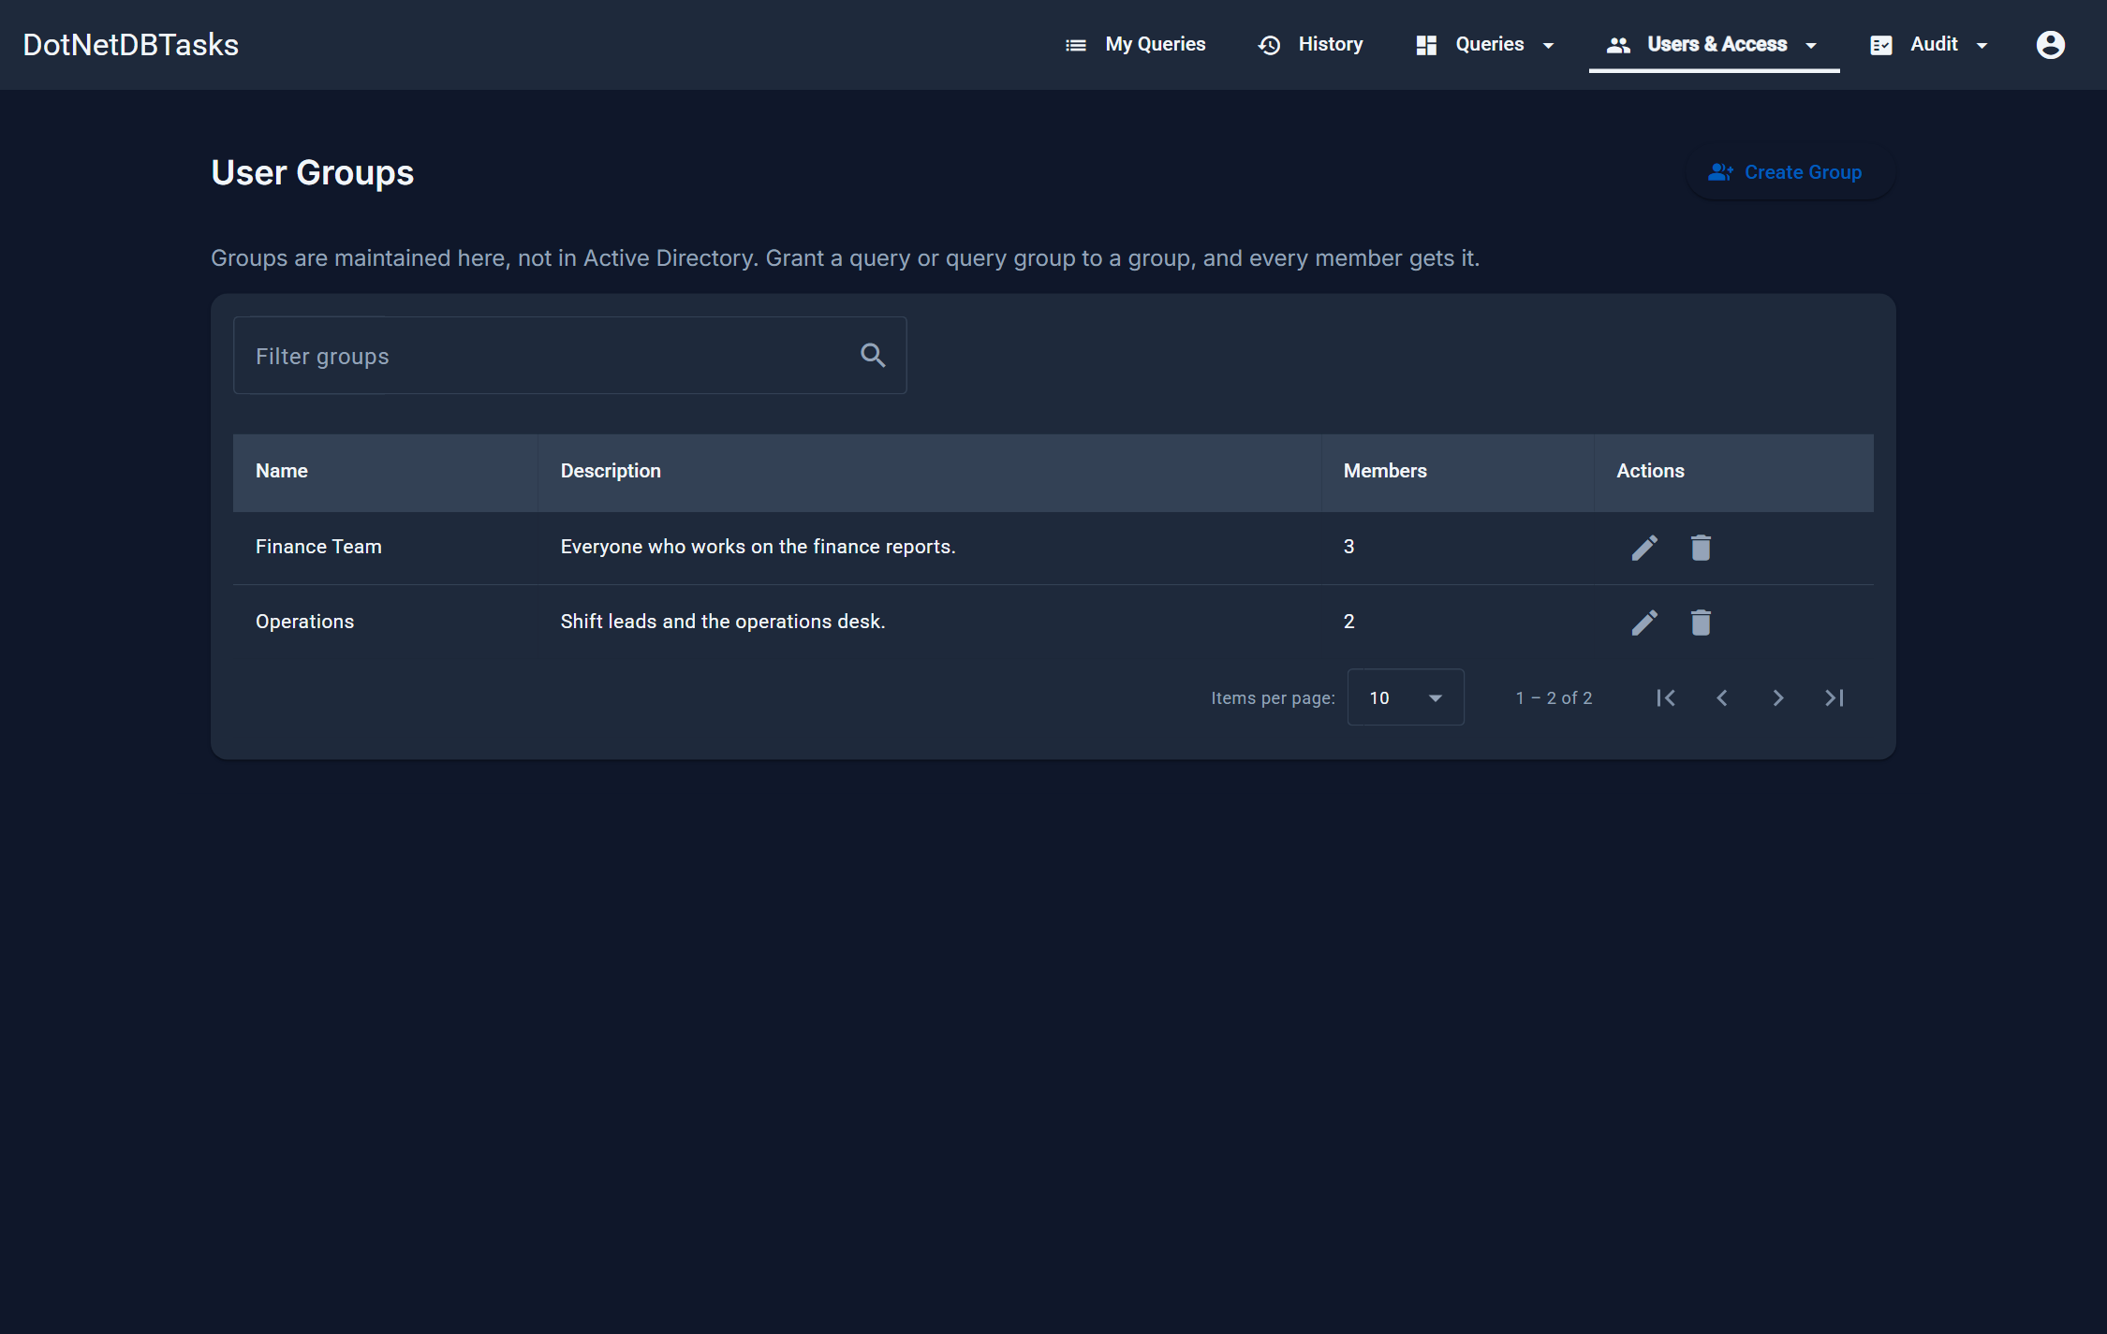
Figure 37. User Groups. The Members column is the number of people a grant to that group would reach; the filter searches member names too.
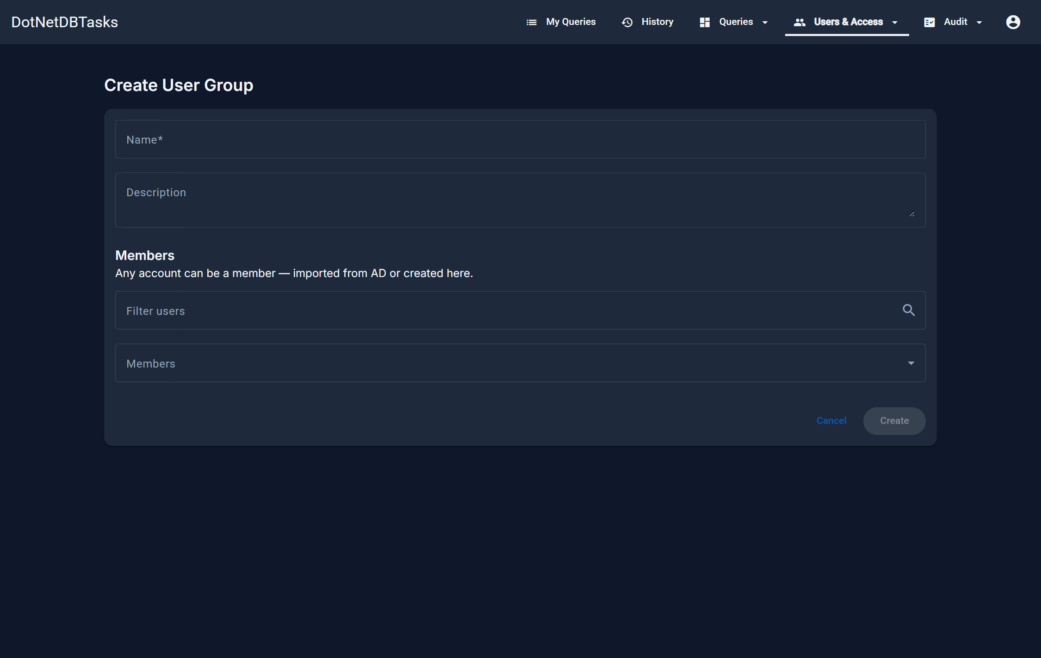
Figure 38. Creating a group. Filter the account list, then tick the members; the field reports how many are selected.
Action | Effect
Create Group | Adds a group with a name, a description and its starting members. Names are unique.
Edit | Renames the group or changes who is in it. Removing someone takes away every query the group grants them, on their very next request — they do not have to sign out and back in.
Delete | Deletes the group and every grant made to it. The member accounts themselves are untouched.

Administrators and Access Managers both run this page: deciding who is in a group is the same job as deciding what the group may reach. Query groups are a different thing — only an administrator creates, edits or deletes those.
Important. Nobody may add their own account to a group — the option is greyed out, and the server refuses it. Otherwise an Access Manager could grant a query to a group and then walk into it, which is the same self-grant that stops them editing their own roles. An administrator can add them; from then on they can save the group, and leave it, without being blocked.

10.3 Active Directory
AD Users imports accounts from the directory so they can be granted queries — directly, or by putting them in a user group. It has three tabs.
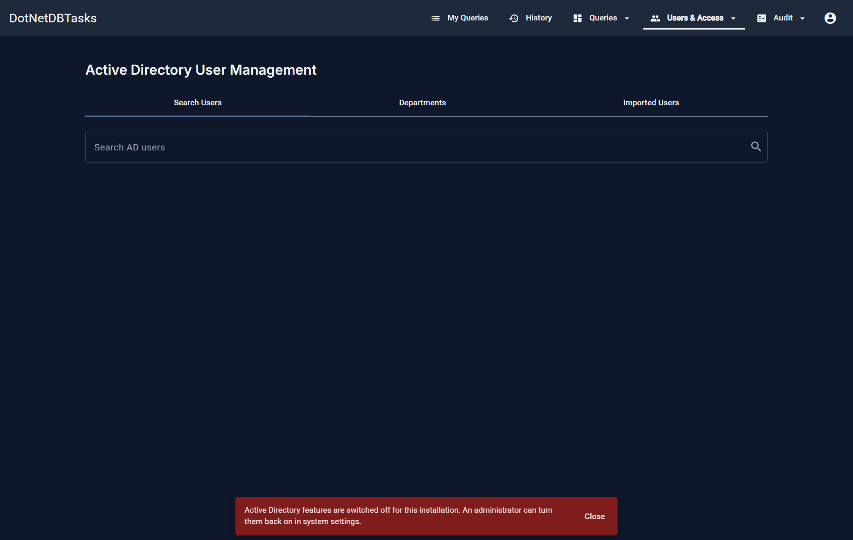
Figure 39. Search Users. Type at least two characters, tick the accounts to import, then press Import Selected Users. Already-imported accounts cannot be selected again.
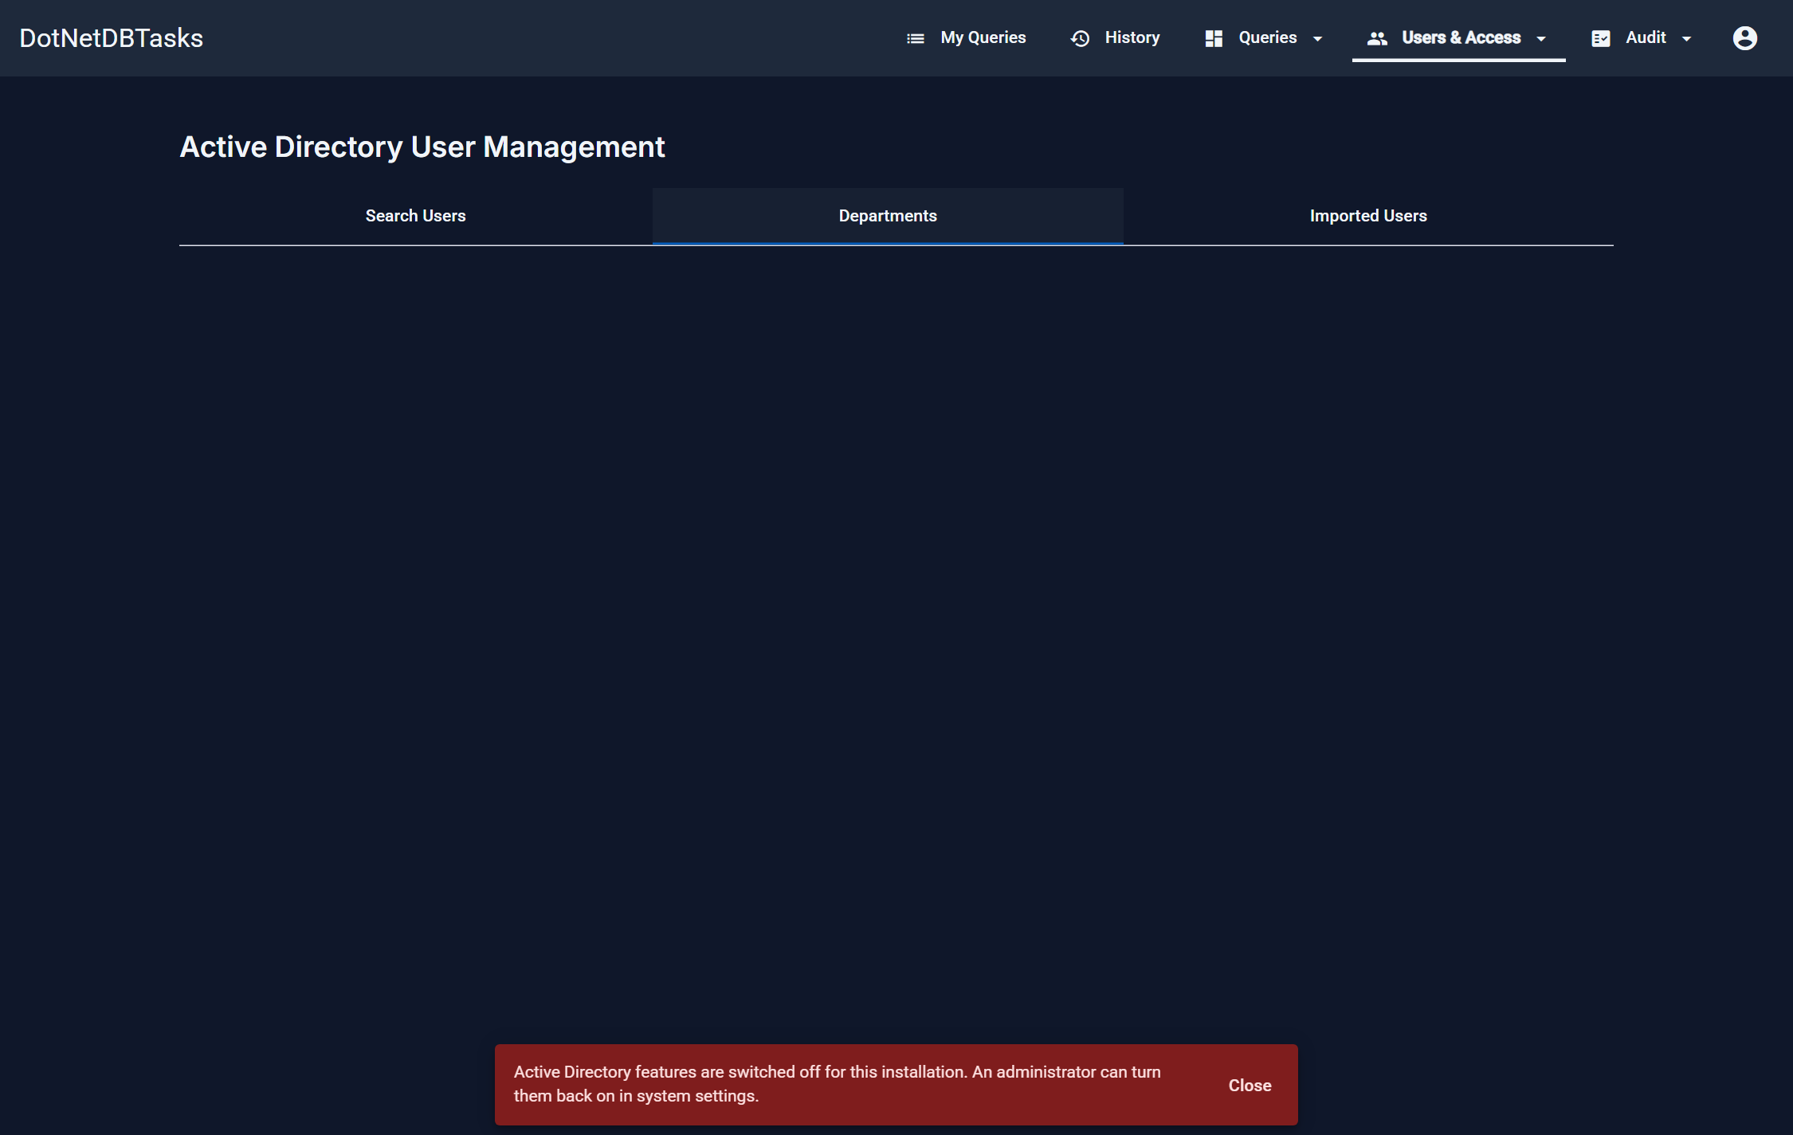
Figure 40. Departments. View a directory department's members, or import all of them at once. This is the only page that reads AD departments — they bring accounts in, they do not grant anything.
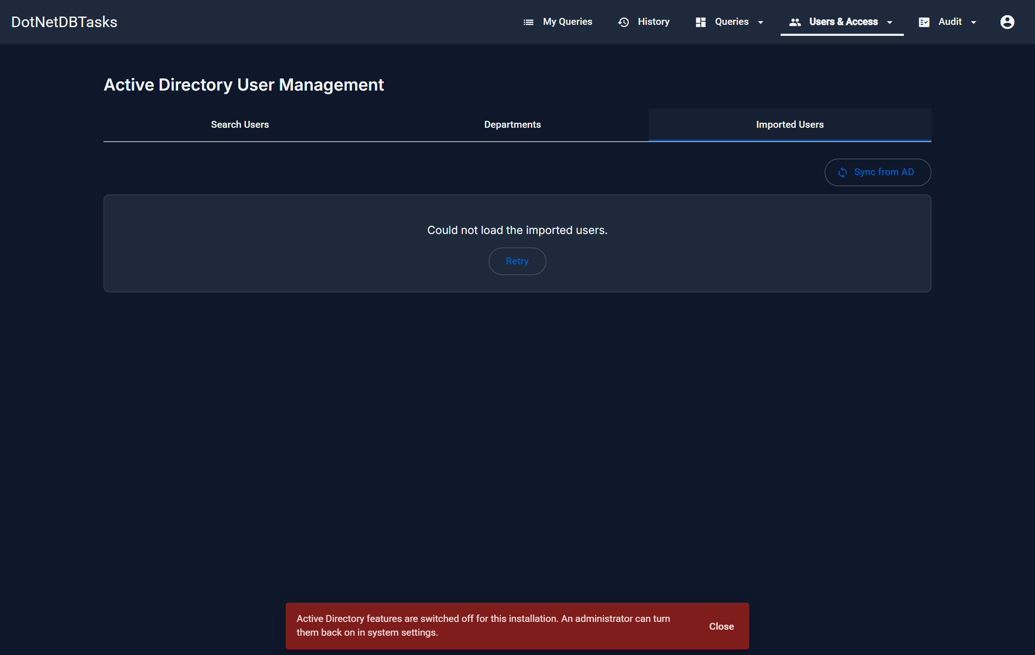
Figure 41. Imported Users — the accounts already in the system, with Sync from AD to refresh their details.
- Sync from AD — refreshes names, emails and departments for accounts already imported. It does not change group membership or anyone's access.
- Revoke access — an imported user immediately loses access to the application. Reversible from the same page.
- Restore access — puts a revoked account back.

11. Database connections
For: Administrators only.
A database connection — shown as a “DB User” — is the set of credentials a query runs through. Keeping several lets different queries reach different databases, or the same database with different privileges.
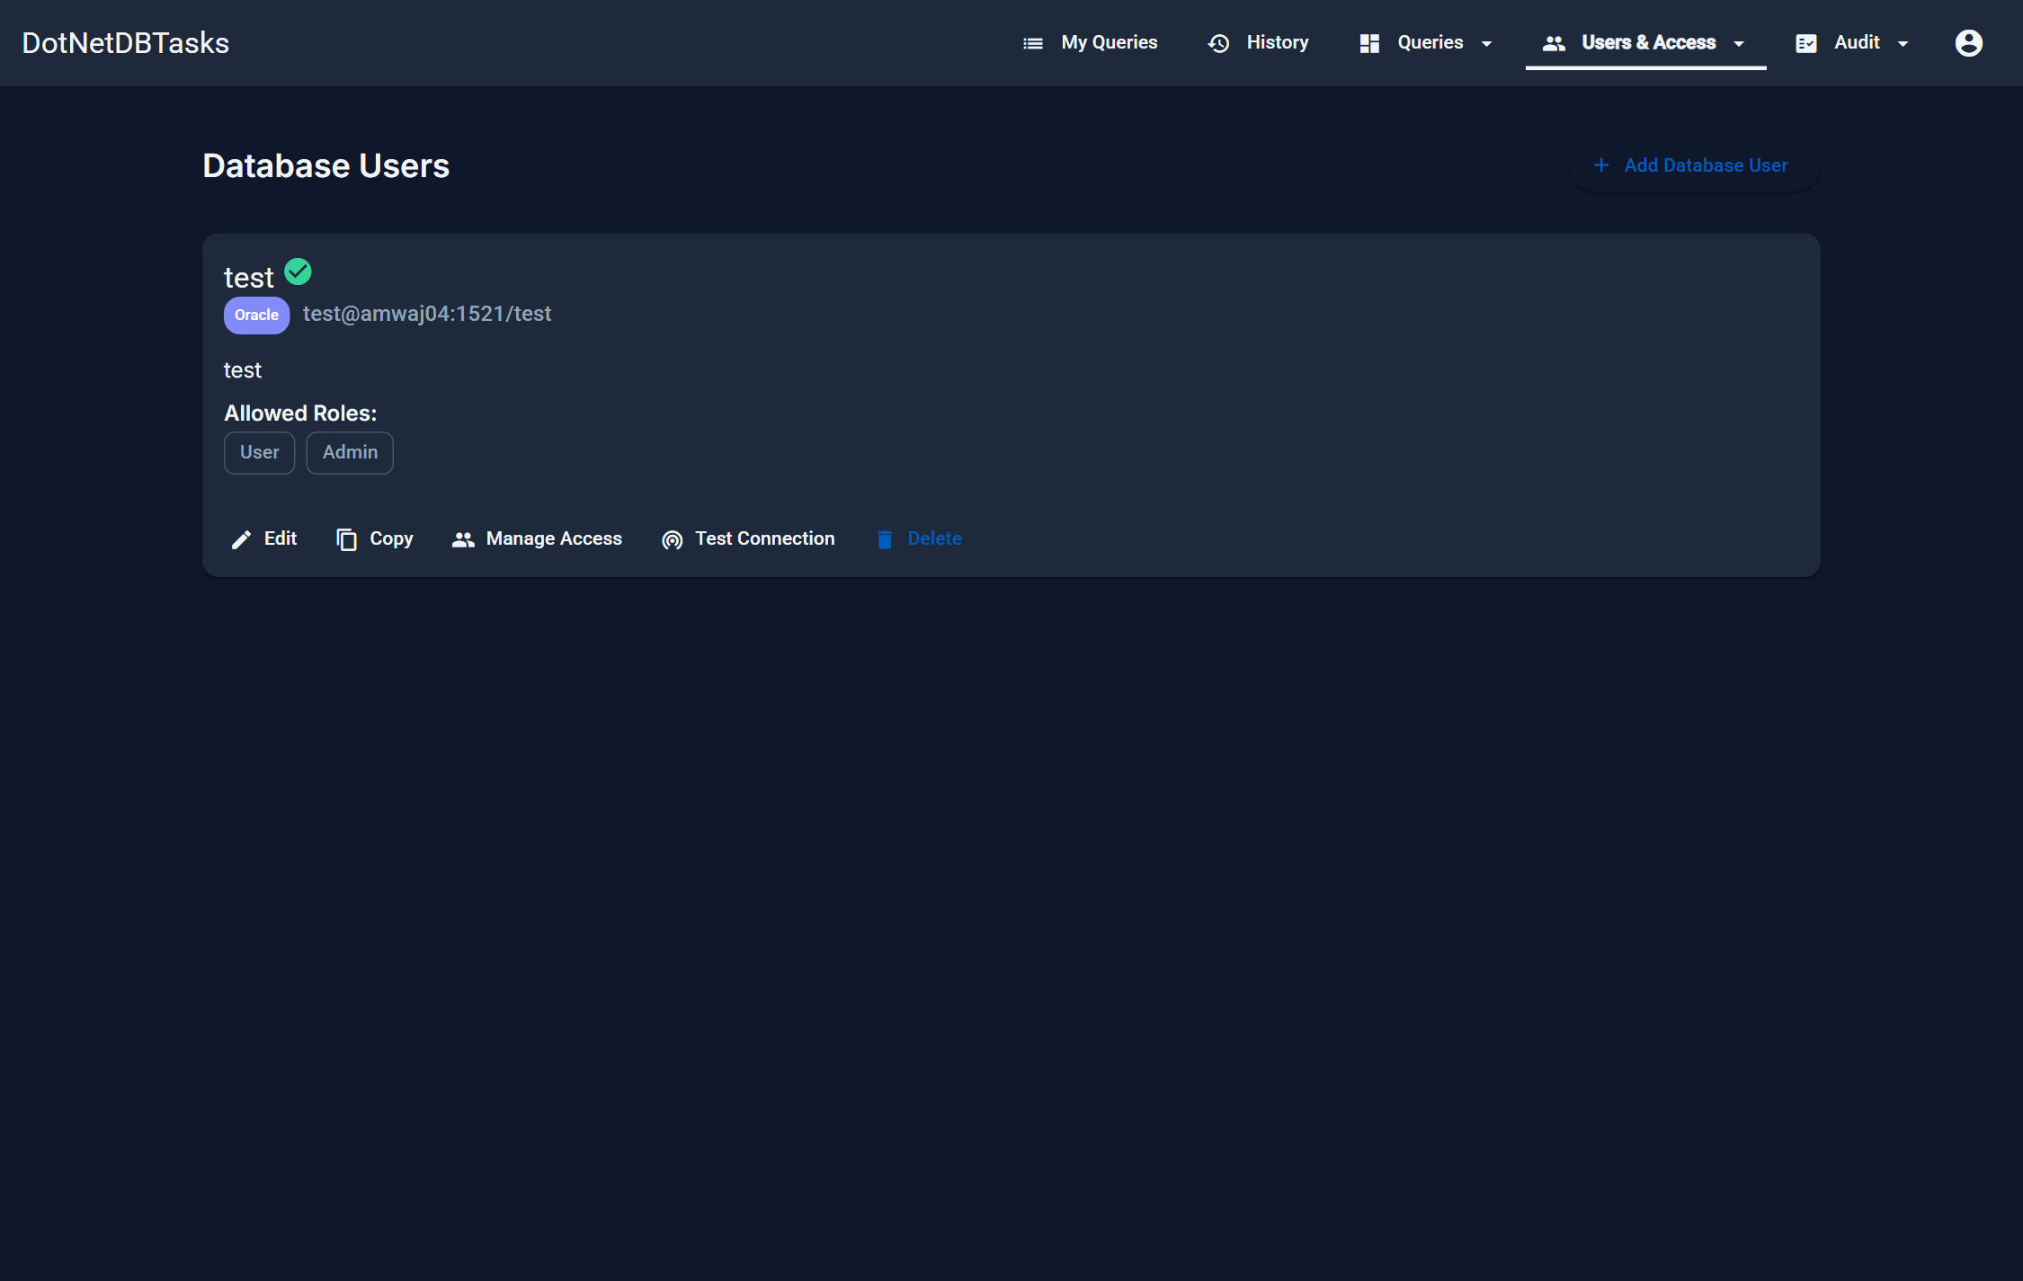
Figure 42. The database connections list.
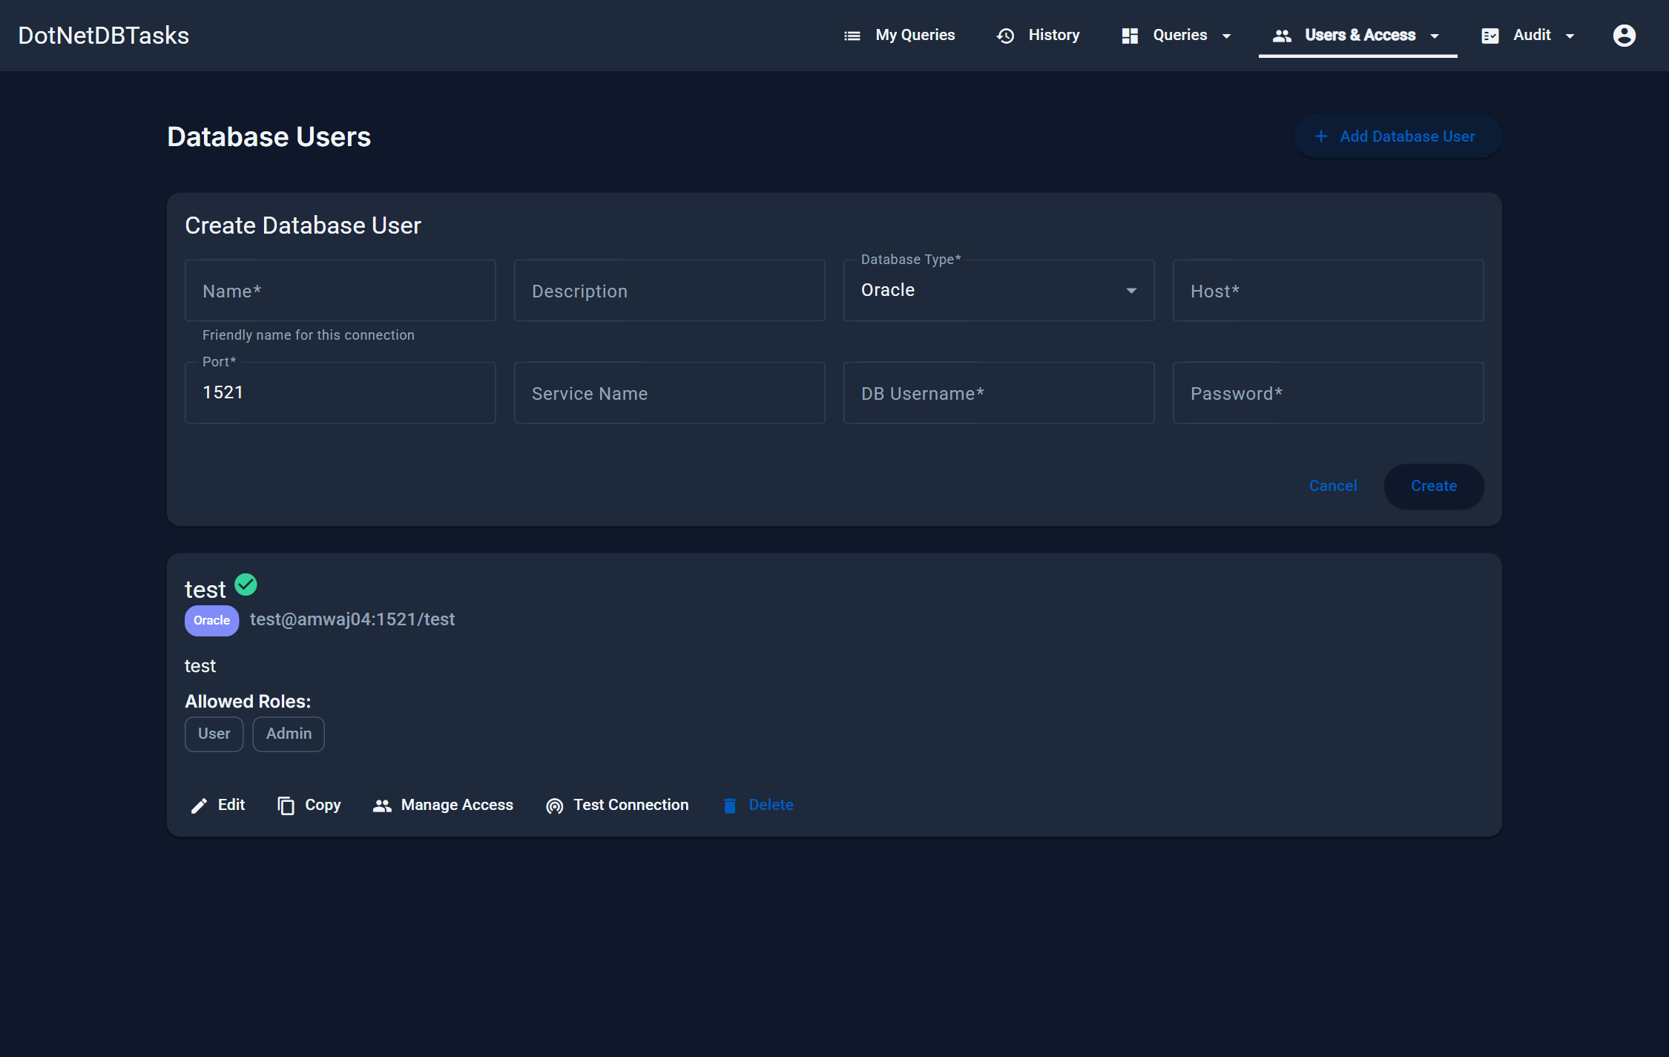
Figure 43. Creating a connection. The fields shown depend on the database type.
Field | Meaning
Name | A friendly name, e.g. “Production read-only”. This is the name a query refers to, and the name carried in an export file.
Database Type | Oracle, SQL Server, MySQL or PostgreSQL.
Host / Port | Where the server is.
Service Name / Database Name | Which database — the field shown depends on the type.
DB Username / Password | The credentials. The password is encrypted at rest and, when editing, is left unchanged if you leave the box blank.

- Test Connection — checks the settings against the real server before you save.
- Manage Access — chooses which roles may execute queries that use this connection. A user needs access both to the query and to its connection.
- Copy — creates a new connection pre-filled from this one.
- Delete — any query using the connection falls back to the default system connection.

12. Audit trails
For: Administrators and Auditors.
There are two separate trails, and the distinction matters: the execution logs answer what people ran, and the system audit answers what people changed.

12.1 Execution logs
Every execution writes a row — successes, failures and preview attempts alike. The list filters, sorts and pages on the server, so it stays fast on a large history.
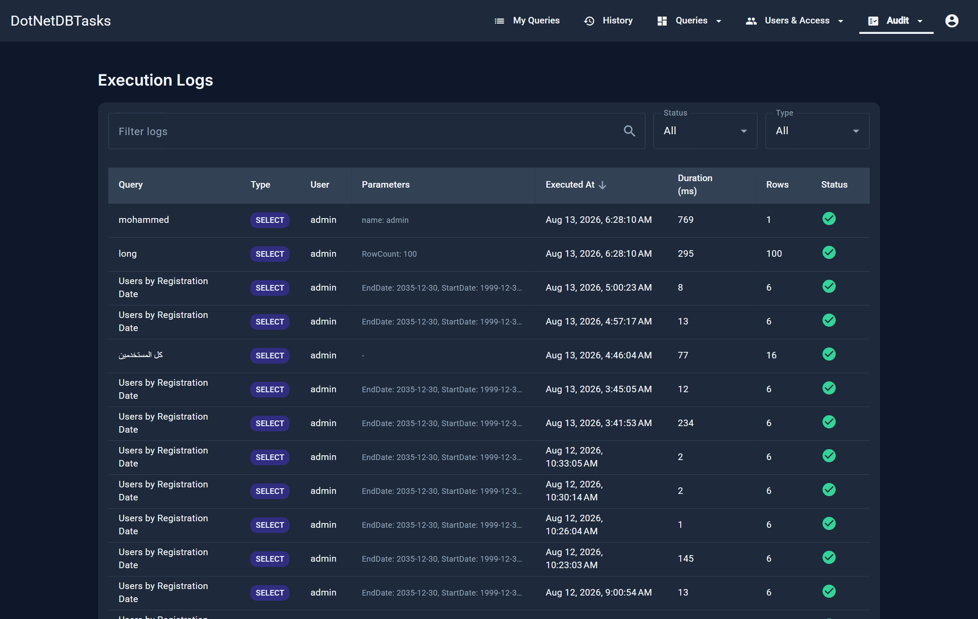
Figure 44. Execution Logs. Each row records the query, its type, who ran it, the parameters, when, how long it took, how many rows and whether it succeeded.
- Search — matches query name, user, parameters and error text.
- Status — successful or failed runs.
- Type — SELECT, INSERT, UPDATE, DELETE or Other.
- Before-change values — for an UPDATE or DELETE run, the row count is a link that opens the affected rows as they were before the change. It is available only when the query had “Save before-change values” switched on at the time.

12.2 System audit
Every administrative change is recorded here: accounts created, permissions granted, queries edited, tasks run, settings changed.
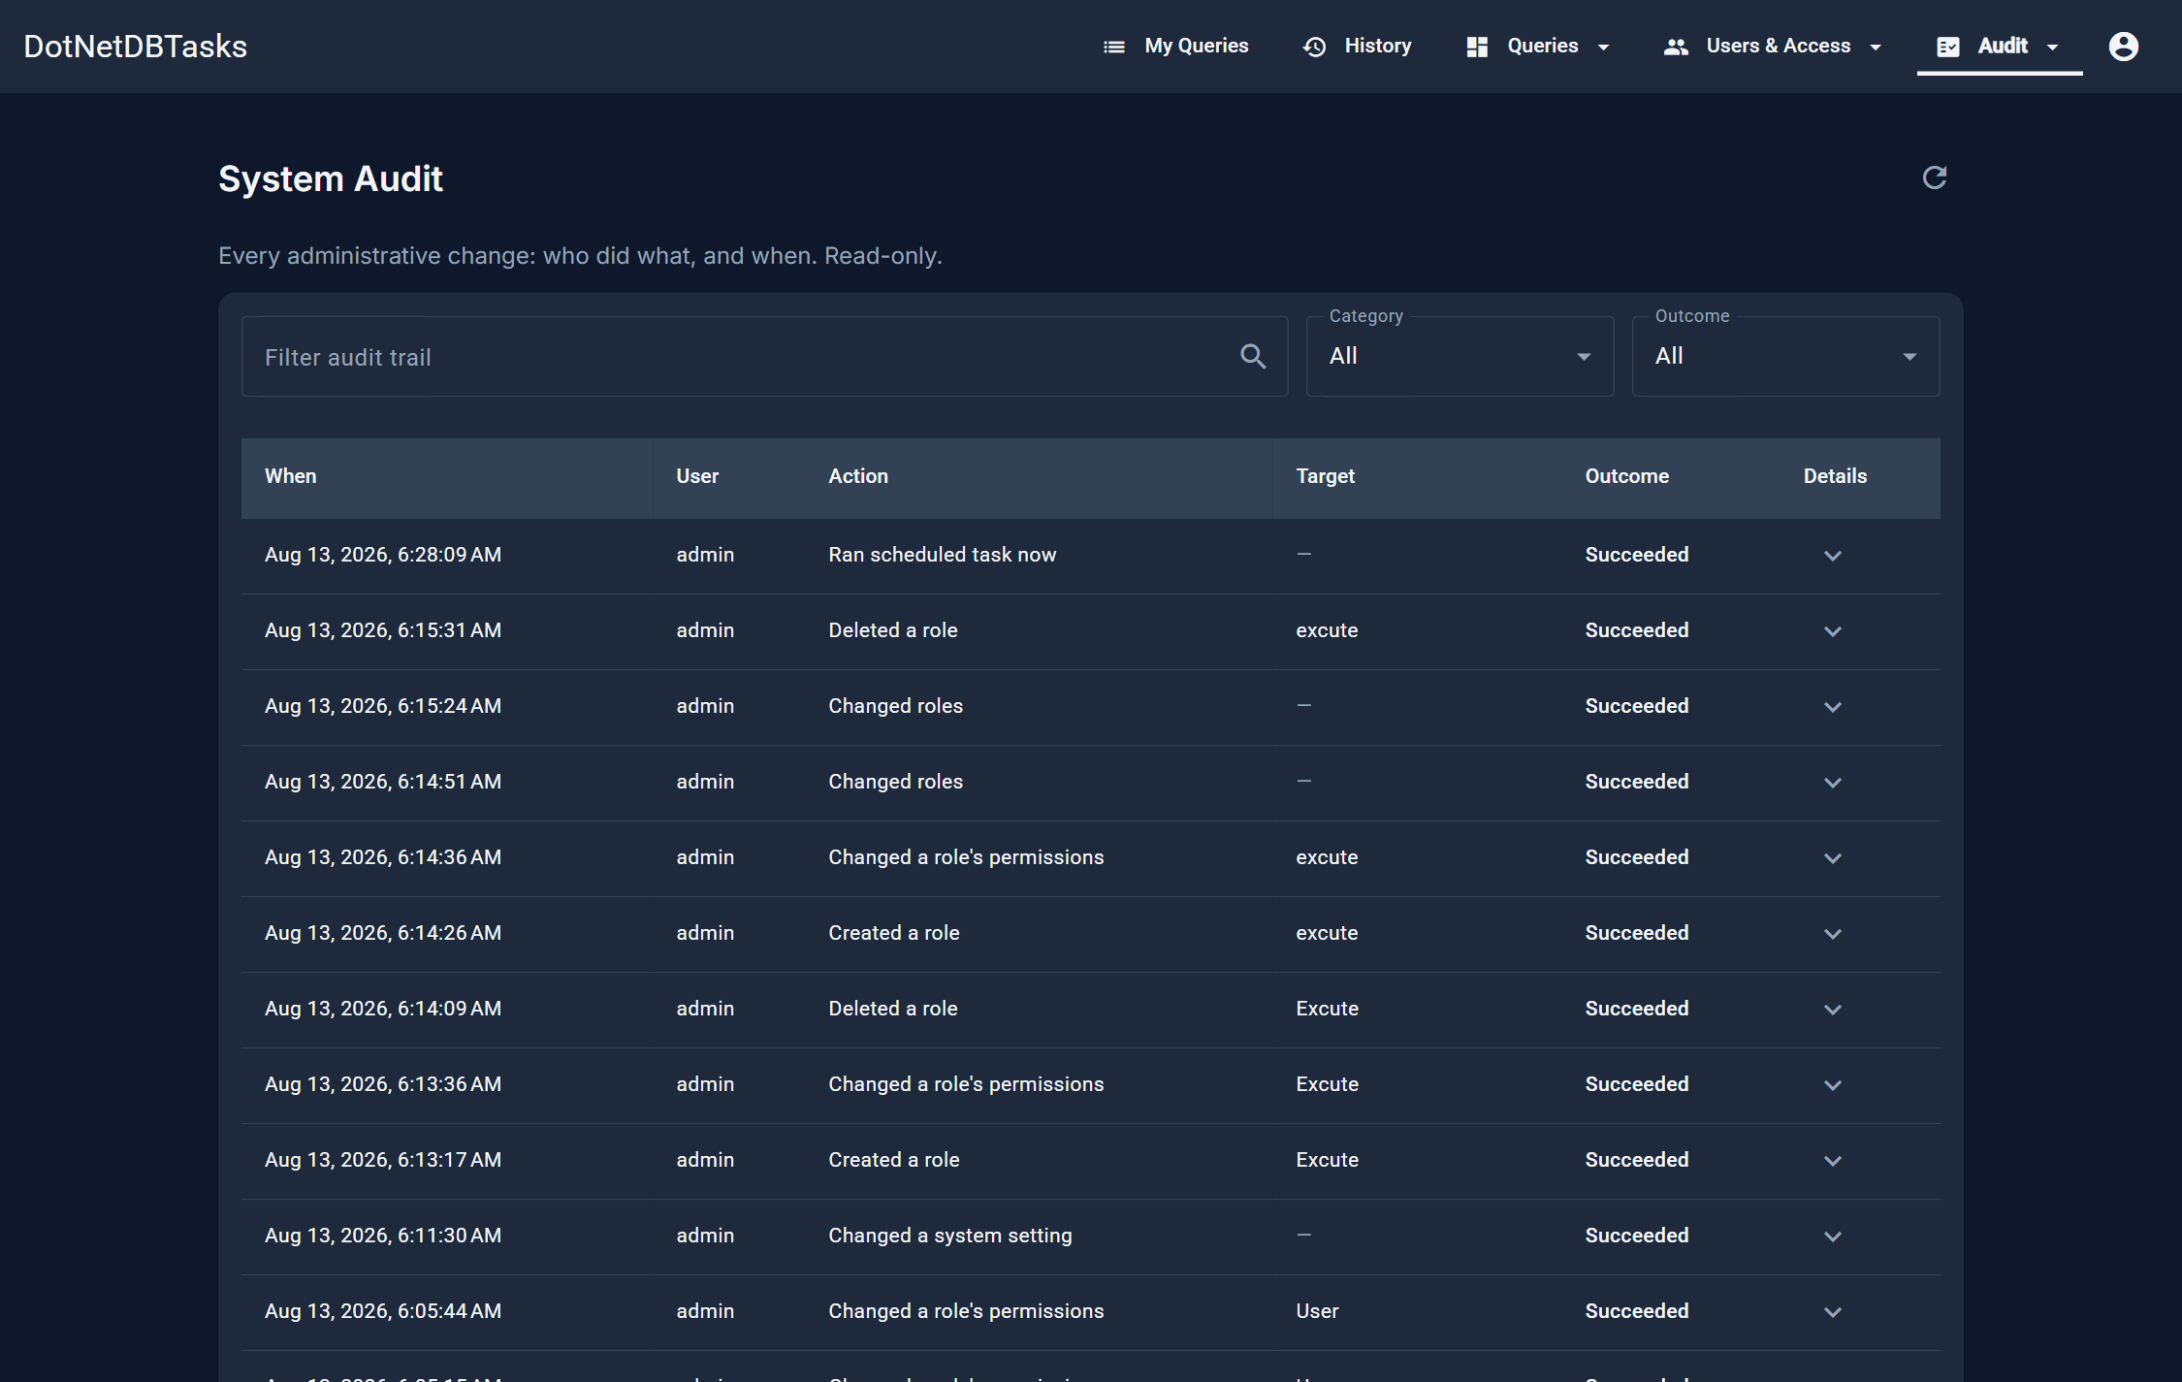
Figure 45. System Audit. Filter by category and by outcome; Details expands the recorded values for an entry.
- Categories — Users, Queries, Query groups, Permissions, Database connections, Scheduled tasks, Active Directory, Branding, Settings, Other.
- Outcome — Succeeded or Refused. Refusals are recorded deliberately — “an Access Manager tried to reset an administrator's password and was refused” is often the entry that matters.
- Details — the values submitted with the change.
Note. The trail is read-only through the application: there is no way to edit or delete an entry. Passwords, tokens, connection strings and similar values are replaced with *** before an entry is stored, and uploaded file contents are omitted.

Important. There is no automatic pruning — the table only grows. Plan a housekeeping job for a long-lived installation.

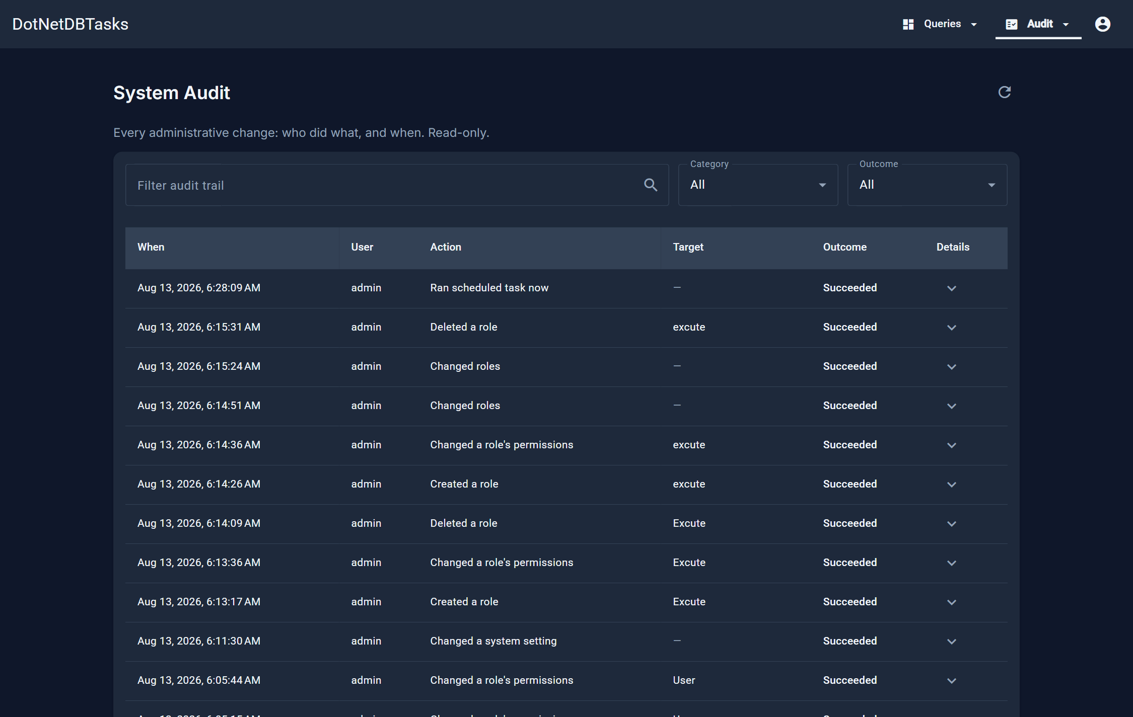
Figure 46. The same page seen by an Auditor. The content is identical; the navigation around it is not.

13. The website logo
For: Administrators only.
The top bar shows an uploaded logo in place of the application name. Open the account menu and choose Website logo.
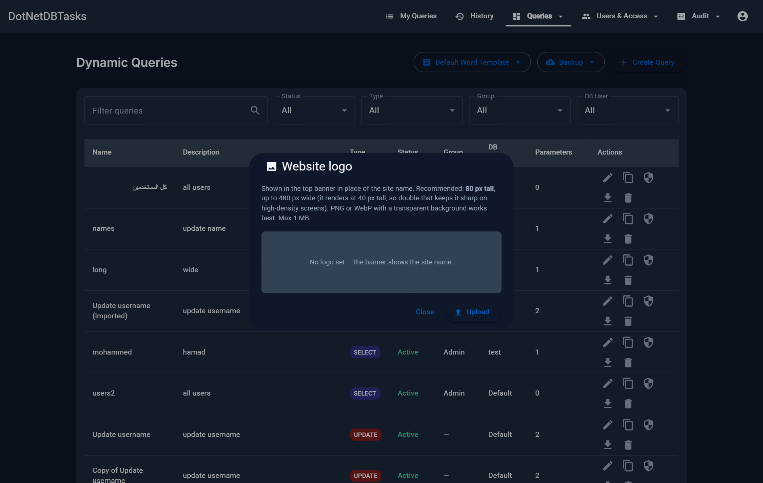
Figure 47. The logo dialog, with a preview and the recommended dimensions.
- Formats — PNG, JPG or WebP, up to 1 MB. SVG is not accepted.
- Size — the bar renders the logo 40 pixels tall; 80 pixels tall is recommended so it stays sharp on high-resolution screens. Width is capped at 200 pixels.
- Warnings — the dialog warns before uploading if the image is too short, below the recommended resolution, or so wide it will be cropped by the cap.
- Remove — with no logo stored, the bar falls back to the application name, so it is never blank.
Important. Remove takes effect at once, with no confirmation step. Keep a copy of the logo file before you open this dialog.

14. System settings
For: holders of “Change system settings” or “Manage roles and permissions”.
Settings holds the choices that apply to the whole installation — what a role is permitted to do, how long a sign-in lasts, and which features are available. They take effect immediately, without a restart, and each change is recorded in the system audit trail. Switches save the moment you flip them; the numbers are edited together and saved with the button beneath them.

14.1 System
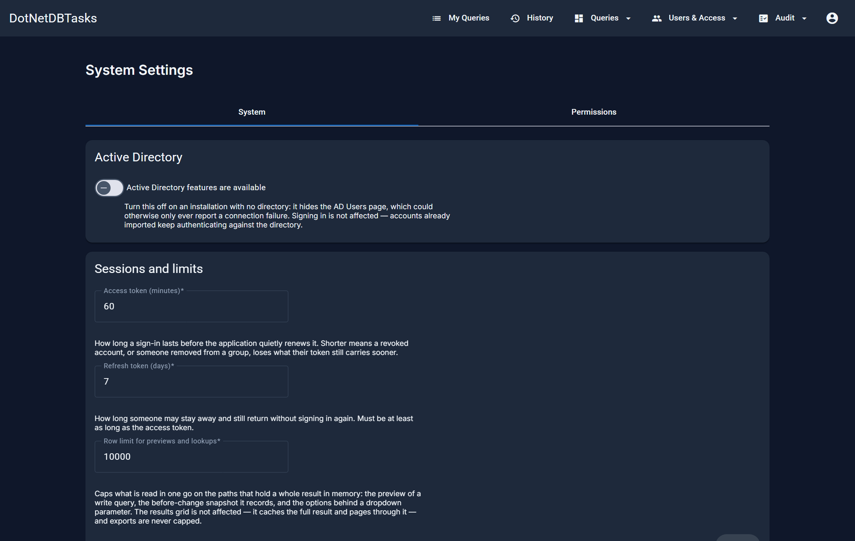
Figure 48. System Settings.
Setting | Default | Effect
Active Directory features are available | On | Turn it off on an installation with no directory: the AD Users page is hidden rather than left to report a connection failure. Signing in is not affected.
Access token (minutes) | 60 | How long a sign-in lasts before it is quietly renewed, between 5 and 1440. Shorter means a revoked account, or someone removed from a group, loses what their token still carries sooner.
Refresh token (days) | 7 | How long someone may stay away and still return without signing in again, between 1 and 90.
Row limit for previews and lookups | 10000 | Caps what is read in one go where a whole result is held in memory: a write query's preview, the before-change snapshot it records, and the options behind a dropdown parameter. The results grid and exports are not affected.

Important. The numbers are checked against their limits when you save; a value outside them is refused with a message naming the range. Shortening the access token does not end sessions that are already open — it applies from the next sign-in or renewal.

14.2 Permissions
The second tab is the whole authorization model in one grid: every capability the system offers down the side, every role across the top, and a tick where the role holds it. Everything any role may do is decided here.
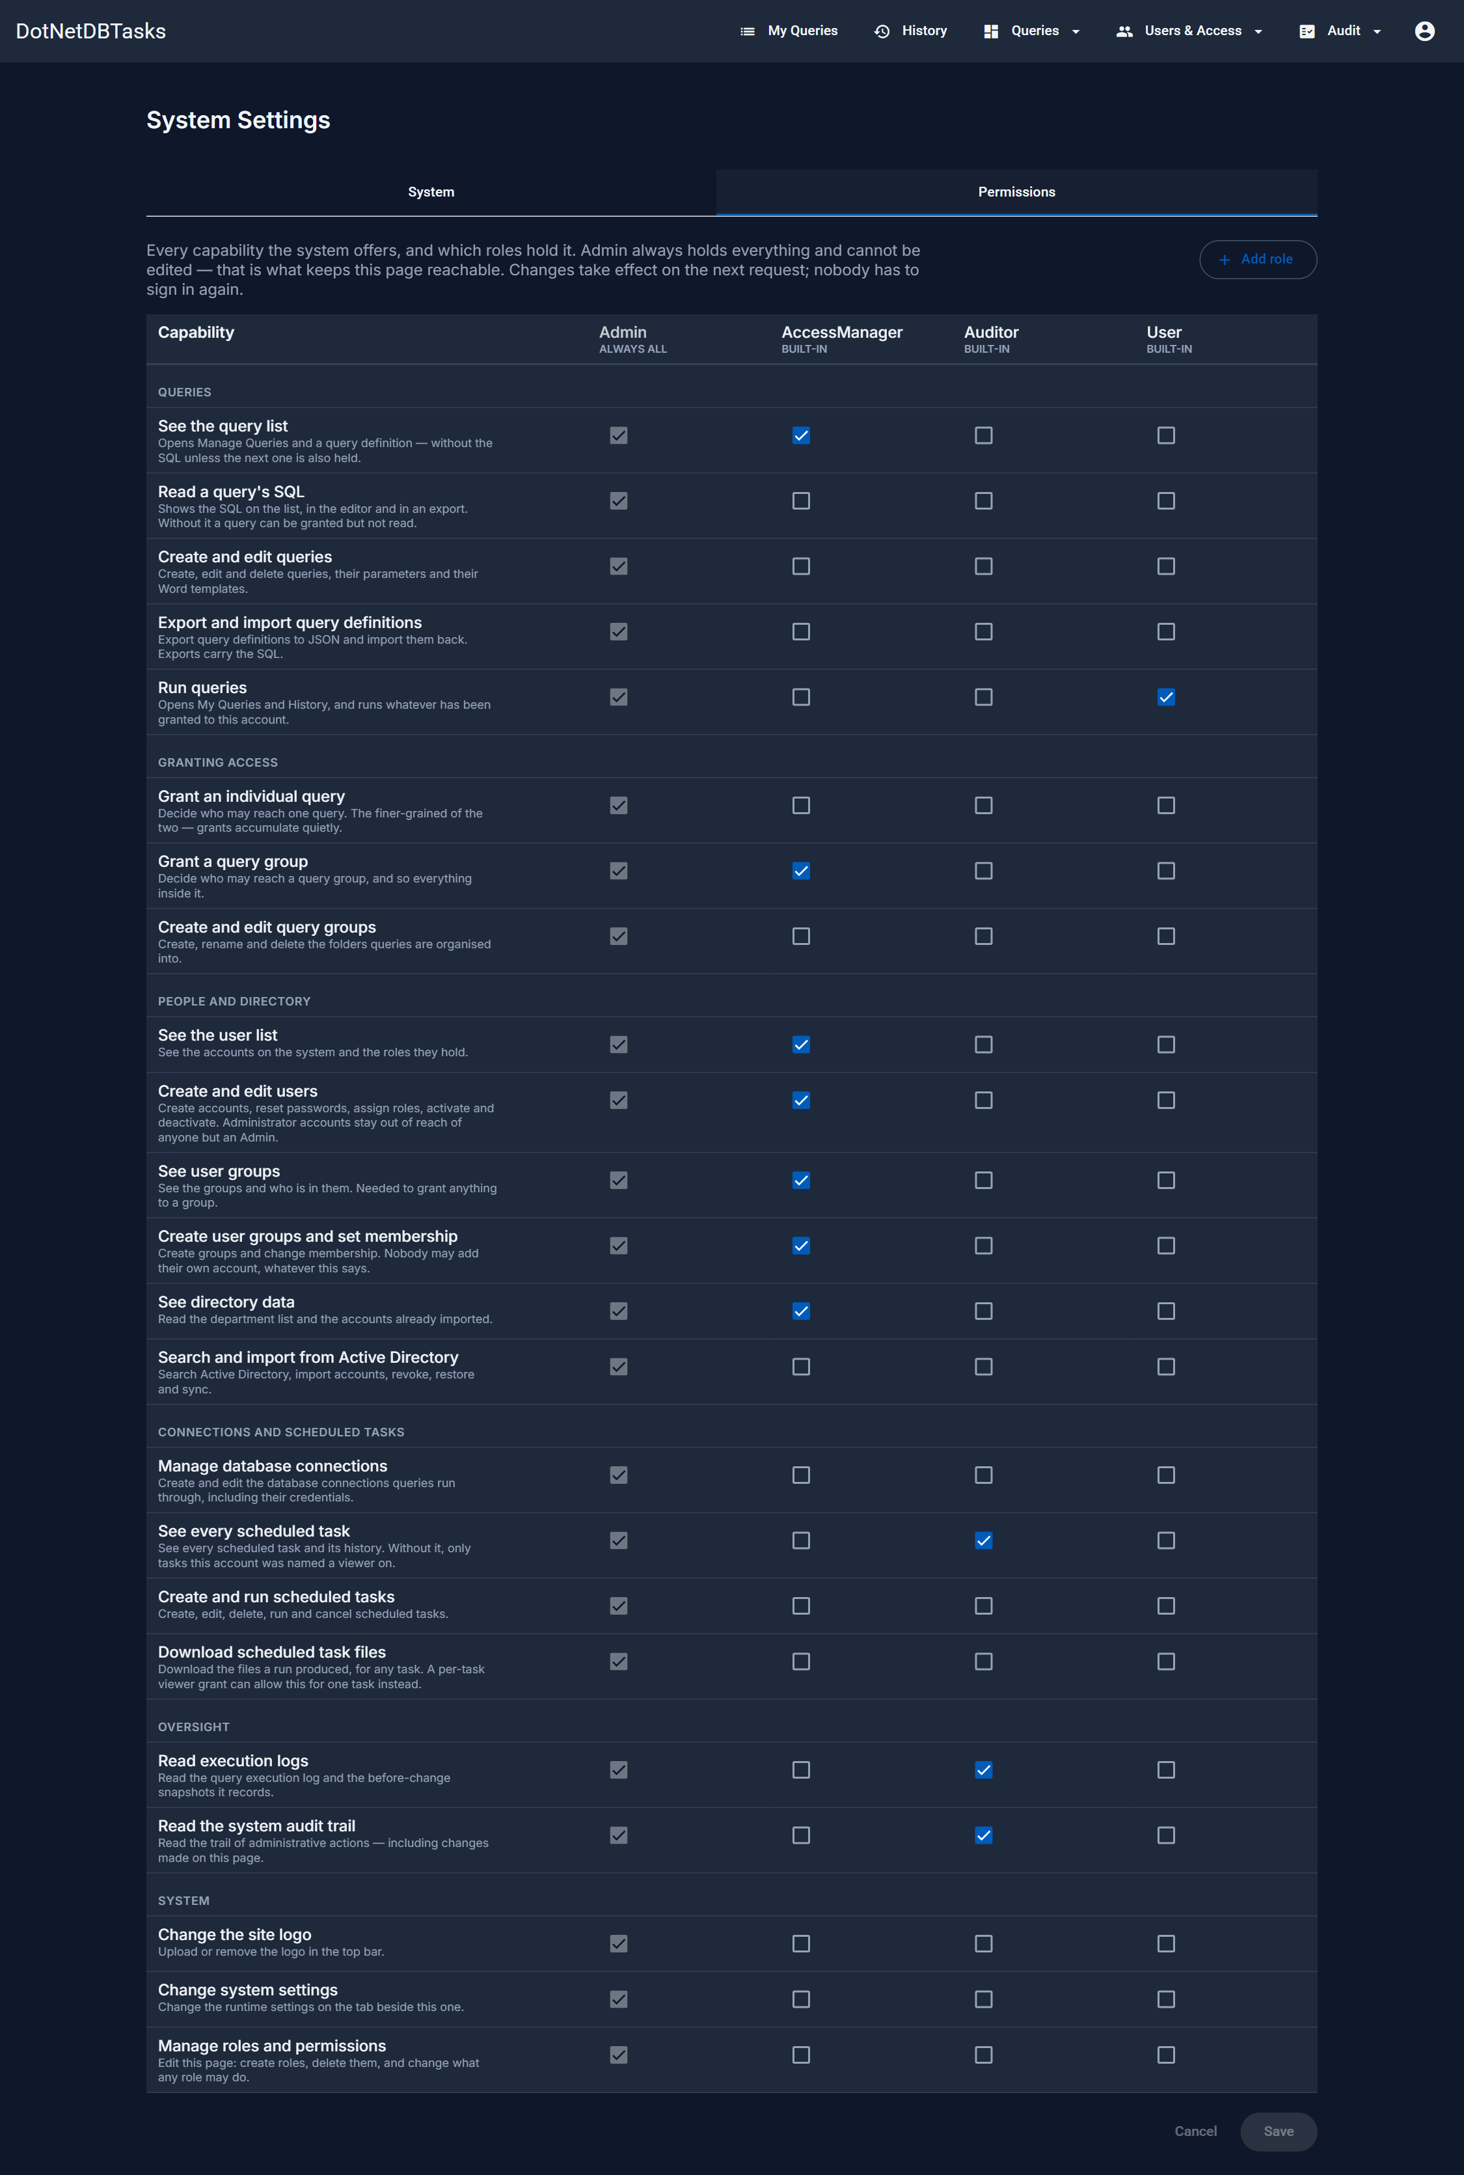
Figure 49. Settings → Permissions. Admin's column is ticked and locked; the rest are yours to set.
- Tick or clear the capabilities you want a role to have. Nothing is sent yet — the count of changed roles appears at the bottom.
- Press Save. Only the roles you touched are written, and each change is recorded in the system audit trail with what was granted and what was revoked.
- The change applies to everyone holding that role on their next request. Nobody has to sign out.
Add role creates a role with no permissions at all; tick what it may do and save. A role you created can be deleted from the header of its column — but not while any account still holds it, because moving those people somewhere is a decision, not a side effect of a delete.
Important. The four supplied roles can be re-permissioned but not renamed or deleted, and Admin cannot be edited at all. That last rule is what guarantees somebody can always open this page.

15. Appendix A — Frequently asked questions
Question | Answer
My Queries is empty. | Nothing has been assigned to you. Ask an administrator or Access Manager to grant you the query or its group, directly or through a user group.
I can see a query but cannot run it. | It may be disabled, or you may not have access to the database connection it uses. Both are checked at run time.
I pressed Back and my results are gone. | Leaving the results page releases the stored result on the server. Re-run the query.
Export only gave me part of the result. | It does not — export always writes the complete result, not the page on screen. The grid shows one page at a time by design.
I confirmed a write query by mistake. | The change is committed. Use the execution log's before-change values to see what the rows held previously.
A scheduled file will not download. | The file was moved, deleted, or overwritten by a later run. Run the task again, or check the output folder on the server.
I am an Auditor and cannot run anything. | That is by design. The Auditor role can never be granted query access. If you also need to run queries, ask for the User role in addition.
My imported query is named “… (imported)”. | A query of that name already existed. Import never overwrites — reconcile the two and delete the one you do not want.

16. Appendix B — Regenerating this manual
This document is generated, not hand-maintained. After a change to the application, rebuild it so the screenshots and text match what shipped.
- Start the API and the Angular client (see the project README).
- From docs/user-manual, run: npm install (first time only)
- Run: npm run manual
That recaptures every screenshot in both languages into docs/user-manual/screenshots and rewrites both documents. The text lives in build-docx.py; the screenshot list lives in capture-screenshots.js. Neither script modifies application data — the capture run blocks every write request at the network layer.
Open the finished document in Word, right-click the Contents table and choose Update Field to fill in the page numbers.

