**TOPIC NAME:**

**STUDENT NAME:**

**UNIVERSITY NAME:**

**COURSE NAME:**

**INSTRUCTOR NAME:**

**DATE OF SUBMISSION:**

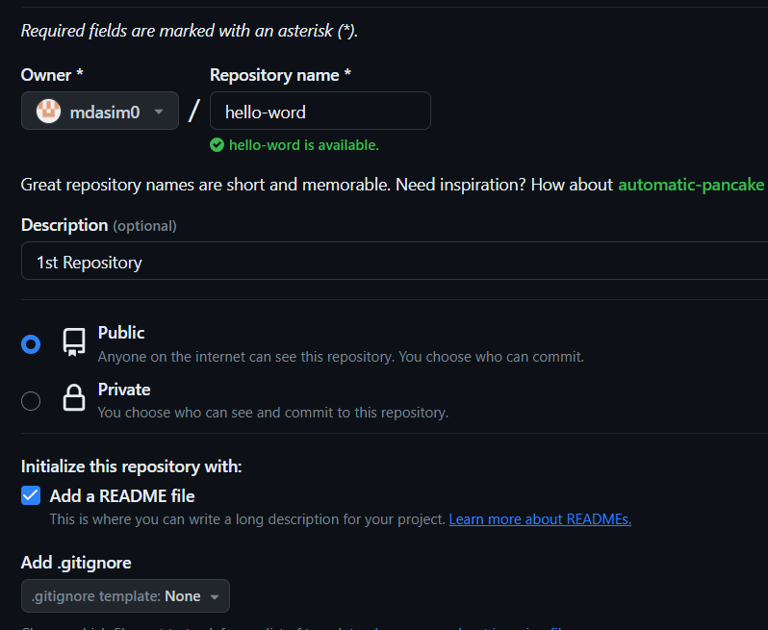

**Figure 1:Creating the 1st repository (Created by author)**

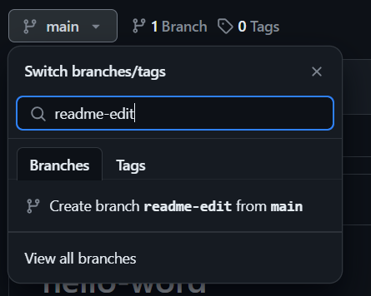

**Figure 2:Creating a branch(created by author)**

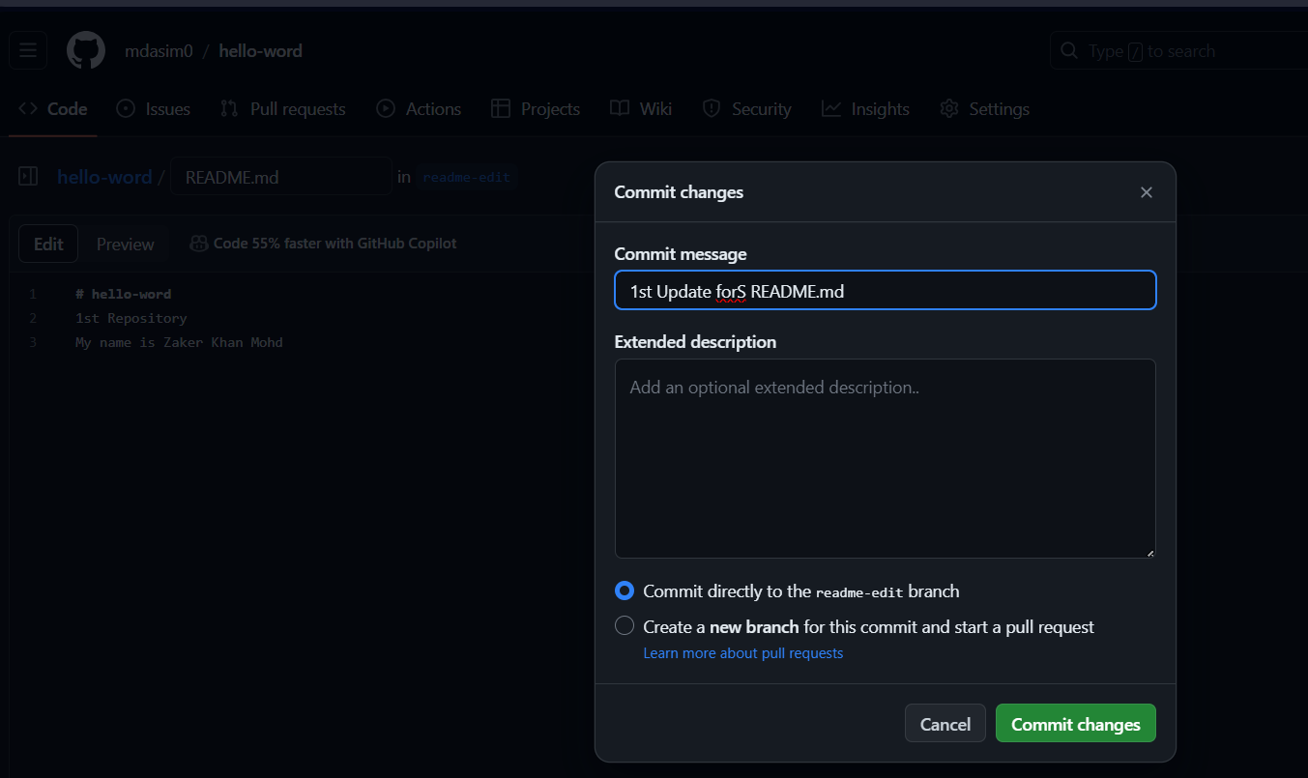

**Figure 3: Making changes for the readme file(created by author)**

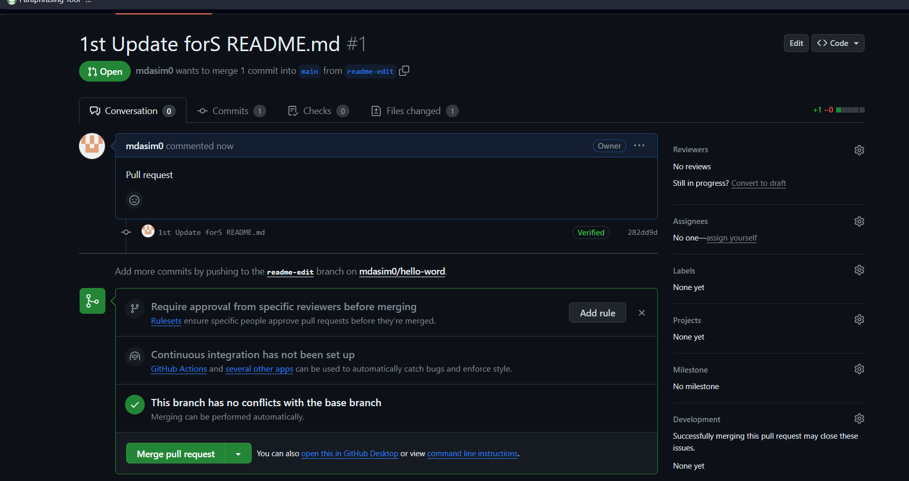

**Figure 4:Created pull request(created by author)**

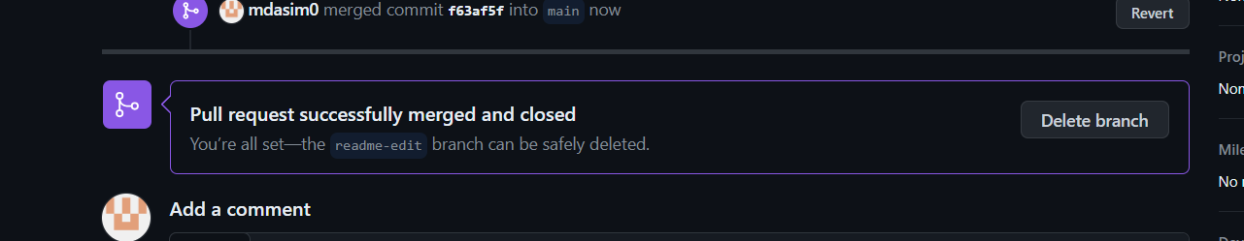

**Figure 5: Pull request merged with main(Created by author)**

**How long did you spend on this assignment?**

For completing this assignment I took around 30 minutes to complete this whole assignment.

**Based On your effort, what letter grade would you say you earned?**

Based on my effort, I think I should get and A+ grade. A I have successfully completed all the assignments in less time.

**Based On your solution, what letter grade would you say you earned?**

Based on my solution I think I should get A+ grade as I have completed all the tasks successfully and got the desired results.

**Provide a summery of what doesn’t work in your solution, along with an explanation of how you attempted to solve the problem and where you feel it.**

While completing this task the only place that I have faced an issue was in creating the pull request.

I have solved that issue by going through the provided materials thoroughly and seen some video. Doing those things help me in solving the issue that I was facing.