**Minor Project**

**on**

**Customized Web Development**

Submitted to

**DEPARTMENT OF COMPUTER SCIENCE AND ENGINEERING AMITY SCHOOL OF ENGINEERING AND TECHNOLOGY**

**Under the guidance of**

Dr. Pooja Khanna

(Asst. Professor)

Department of CSE

ASET , AUUP, Lucknow

**Submitted by:**

Roushan Kumar

A7605217086



AMITY UNIVERSITY, UTTAR PRADESH

2020

i

**Declaration**

I, Roushan Kumar, student of B.Tech (C.S.E.) hereby declare that the project titled “**Customized Web Development**” which is submitted by me to Department of Computer Science and Engineering, **Amity School of Engineering Technology**, Amity University Uttar Pradesh, Lucknow , in partial fulfillment of requirement for the award of the degree of Bachelor of Technology in Computer Science and Engineering, has not been previously formed the basis for the award of any degree, diploma or other similar title or recognition.

The Author attests that permission has been obtained for the use of any copyrighted material appearing in the Dissertation / Project report other than brief excerpts requiring only proper acknowledgement in scholarly writing and all such use is acknowledged.

Date: __________________

Roushan Kumar

A7605217086

Sem. 7th, CSE (2017-21)

ii

**CERTIFICATE**

On the basis of report submitted by Roushan Kumar, student of B. Tech (CSE), I hereby certify that the report “**Customized Web Development**” which is submitted to Department of Computer Science and Engineering, Amity University Uttar Pradesh in partial fulfillment of requirement for the award of the degree of Bachelor of Technology (CSE) is an original contribution with existing knowledge and faithful record of work carried out by him/her under my guidance and supervision.

To the best of my knowledge this work has not been submitted in part or full for any Degree or Diploma to this University or elsewhere.

Date-

Dr. Pooja Khanna

(Asst. Professor)

Department of CSE, ASET,

AUUP, Lucknow.

iii

**ABSTRACT**

Web programming, also known as web development is the creation of dynamic web applications. There are two broad divisions of web development front-end development (also called client-side development) and back-end development (also called server-side development).

Front-end development refers to constructing what a user sees when they load a web application. The content, design & how you interact with it. This is done with three codes-HTML, CSS & JavaScript. Back-end development controls what goes on behind the scenes of a web application. A back-end often uses a database to generate the front-end. back-end scripts are written in many different coding languages & frameworks, such as PHP, Ruby on Rails, Java, Node.JS, Python. Without going into more detail, that’s really all there is to web development. So now, here are the best ways to start learning it.

iv

**ACKNOWLEDGEMENT**

I would like to thank my university for giving me this golden opportunity to research on such an interesting topic. Next, I want to thank my faculty guide Dr. Pooja Khanna (Asst. professor) for guiding me throughout the course of this research paper. I would also like to thank the internet and the library for the knowledge I acquired with its help. Lastly, I want to thank my family for supporting me entirely.

Roushan Kumar

v

TABLE OF CONTENT

Title Page. i

Declaration by the student. ii

Certificate by the faculty. iii

Abstract. …….iv

Acknowledgement. .v

**CHAPTER 1: INTRODUCTION**

1. 1 Overview. 2

1.2 Objective and Goal 2

**CHAPTER 2: BACKGROUND AND TECHNOLOGY USED**

2.1Front-End Development & software used…………………………………………3

2.2 Back-End Development & software…………………………………………………....4

2.3 Database……………………………………………………………………………4

**CHAPTER 3: WORKING AND FUTURE ENHANCEMENT**

3.1 Working………………………………………………………………………………5

3.2 Scope for Future Enhancement……………………………………………………….5

**CHAPTER 4: SCREENSHORT**……………………………………………………………6-7

**CONCLUSION**.........................................................................................................................8

**REFERENCES**……………………………………………………………………….….…..9

**Introduction**

**overview**

website development has come to be one of the fastest growing industries all through the beyond few a long time on this world. With growing aggressive marketplace international, website development industry is challenging a primary function in this field. preserving the appropriate level of first-rate is a high task for the designers in growing a internet site. over the last few many years, studies has passed through the diverse stages to predict high-quality of a internet site from a high stage design description. The nice of a website is directly inclined to the knowledge of developer and the first-class approaches used for the duration of layout and development. developers want to have thorough expertise of the website design and development technique, internet site excellent, business enterprise behaviour, generation improvements and website standards / guidelines, and Many More. In website development the main and most important activity is planning. as we know that website development is mainly in two part first one is front-end & second one is backend. front in mainly a visual part this is GUI part of website through which a user can interact with website. so this is become very important to make it very attractive and beautiful. in front end as selection for front end we use HTML and for making it beautiful and atteractive we use css and bootstrap. by using HTML we create main frontend part base of the site and after that for making it creative and attractive we use css . and as we know that for backend we can use any coding language and framework. here we are using python language and django as a framework. by using these things we will develop the backend. backend is a website part which is noty visible through which we can create the website working part. and through which can maintain the working of the website. and for live action performance we will using the JavaScript. in our website by which we can make our site more interactive with user. In current Time website development is one of major work in the IT industry and this is very useful for everyone. My website is mainly job portal website.

**OBJECTIVE AND GOAL**

There is always a objective and Goal behind each activity so same in the case of website development. many time seen that success rate of website development is decreases because of unclear objective and goal. if the objective of developing website is clear then success rate of website is increase because in that way developer have clear working idea and due to clear objective they have clear Goal. as we know that websites is develop for different purpose. main purposes of the website development is fulfil the Clint requirements. once the objective clear the other activities planning focused around it. Goal means the mainly acivement from the website development. Both Objective & Goal of the website development should be clear & in documented form. My website Objective are to make easy way to get job though online way. Goal is to make easy way for the job skiers fresher.

**Background & Technology used**

one of the most concern parameter in website development is technology uses in website making. their is two parts of website development 1st one is frontend and 2nd one is backend. there is many technology use frontend and backend. there is many language such as script programs and coding language is use like HTML, CSS, JavaScript, Bootstrap ,sqlit, python, MySQL, etc.

**Front-End Development & software used**

For front-end, user can be shown the entire interface which is responsible for visual elements .all the designs, visual effects and layout of a website is being made by front end developer. most people think front end developer as “web developer” but they are wrong because back-end developers are responsible for programming a function to collect data and they deals with the functionality of website that can help in logical application and integration of the front end’s work.

**Software**

For the front end purpose, we have used three software namely HTML, CSS and JavaScript. One by one we will tell about it.

**HTML:-** Firstly comes HTML, HTML full form is Hyper Text Markup Language. It is the building blocks to create web pages. The latest version of HTML is HTML 4.01 and recently comes HTML5 which solves some issues regarding creating web pages for developers. I have done some of the basic work while creating web pages like changing font size, background, add tables, enter URL, and add images. It also helps me to create structured and meaning web pages by adding a heading, paragraph, images links by using tag attributes. But should remember to close the tag attribute <tag>…..</tag>. All the responsible layout like header footer, navigation link, a section tab, article tag can be easily manipulated using HTML.

**CSS:-** CSS full form is cascading style sheet. It is a language of the sheet within a sheet that is used to design the elements of the web pages like colour, font, and layout. We can format or cascade different pages by the same technique simultaneously. It also helps to separate the trendsetters by content and presentation. It is easier to represent same markup pages in different style like on-screen, in print and can only be used in voice based search option to improve the interaction between user and hardware. I have also used CSS in following different style like margining, border, background, creating links, display moving objects, overflow create table, float, align pseudo-class and pseudo-element with opacity.

**Java Script:-**JavaScript is a programming language that allows a user to design complex things of websites and WebPages. It is a scripting language that is used to create dynamical content, animated image, enhance multimedia and roll down any text or image over a web page. It is also a client-side language and is totally used in websites for performing a large number of web-based things or material in the past. It is totally coder choice whether the code is to reach to the client side or only serve onto the server.

**Back-End Development & software**

Back-End developer is a type of developer who designs and manages the logical patterns, software or information systems and logical computation of a web page. The developers create a pathway for accessing to front-end application. Back-End developers create and emphasize the core functions of logic and operations used as a software application. Back-End developer uses C ++, Java orderly high-level computing language. The motive or another essential role of back-end developer is to ensure whether the data is delivered by programming way i.e.; in the form of package requested by front-end system or software. It consists of a database application, integration, core application logic, API etc. they also test and debug any failure in accessing from the server. If we find any difficulty in accessing the application it is the fault of the backend as in the case of slow application, crashes, and error.

**software**

Some of the back-end software is PHP, MySQL, Ruby, Python, and Java etc. we will using the python as backend in our website designing :

**Python:-** Python is a high-level backend programming language used by startup whoever wants to develop app quickly with prototype. It also integrates data and statically technique in the web pages designing. According to statistics, Stack Overflow had said Python is one of the most loved languages by the developer because it is more readable, flexible and suitable to extract and export exposed data. It is efficient because it creates balance between programmer’s runtime and system resources. The philosophy given by the former of python having biased that “there should be one and preferable only one obvious way to do something”. Code readability is one of the key features of python to be introduced. and as frame work we are using django.

**framework used**

**Django:-**Django is python-based web framework that allow us to create wonderful website in quik time & in less effort. this framework also called batteries include framework because Django provides built-in features for everythings including database as SQLite3,Admin interface etc.Django provide ready made compoment to use and rapid the website development works. Django is based on the MVT(Model View Template) architutre. as we know that MVT Software is design for developing a web application.

**DATABASE**

Python can also be deployed with database applications. The most common database which the python uses is SQLite. Database generally stores information of our application in table format where each row has a unique key in order to differentiate from others. There storing data ability in structured way can increase performance of application. Other databases like PostgreSQL or SQLalchemy can also be used regarding working with web applications or where we require large numbers of update and delete operations from a table. In order to use database, we have first implement database API by writing import statement followed with database name. Psycopg2 is the connection which we need to maintain in order to use PostgreSQL. Here connection is made through connect keyword in which we must pass postgres id, password and port number in order to connect to a server. After connecting to the database, we can pass every single database query which is supported by SQLite like Select, Where, From etc. After that we have to make changes to the connection. Once the work is completed, we must successfully close the connection using.close(). If we want to undo the changes then we can call rollback through rollback(). SQLite is the inbuilt database of python it can use the only drawback it has is it can be control by only one connection at a specific time. As python is a object oriented programming language certain methods can be defined inside a class regarding insertion, deletion, updation, read(fetchall or fetchone) and selection, these methods contain the database queries in execute block along with cursor object reference so that during the method call the specified query can compute its result. Cursor are generated by connection.cursor() package, therefore they can perform sql query. Once they are developed, they connect to the connection for their whole life. When the application is connected with database then we can add any amount of data to its local server.

**working & feature Enhancement**

for Building the job portal website we have created two file first frontend and second backend. frontend hold the GUI part of the website and backend hold the Database and functional part of the website. we have developed the job portal website in which a fresher or job skiers can get the job through this site. this website consist of the menu bar which is consist of six apps first Home second About Third Blog Forth Contact fifth ‘Post a job’ and sixth ‘want a job’. through this website a person can search the jobs by using search box where they have to fill the job title, then category and then location and after that click the Search Button by which we can search the jobs. in same way if some one want to find the candidate or want to post the job they can also do this on this website in which they have to fill the form in which they have to Mention the type of job, job title, company Name, job types, location and job description. and then click post button. in About section we mention about the our website information. and related stuff. and mention about the our happy clients. and at the end of each page of website i mention the contact Number of website admin his gmail and instagram id for supporting and helping the website users.



**scope for future Enhancement**

In my website there is lots of scope of Enhancements that I will do in my site in future like I will include a app in my site that mainly helpful for fresher. with name ‘support’ in which one individual can create their resume easy way and lot more things they can do here, like some time we require to convert the pdf file to word file or vice versa that we can do here and we can also extract text from the image.

**screenshots**

There is some screenshots of the job portal website:-

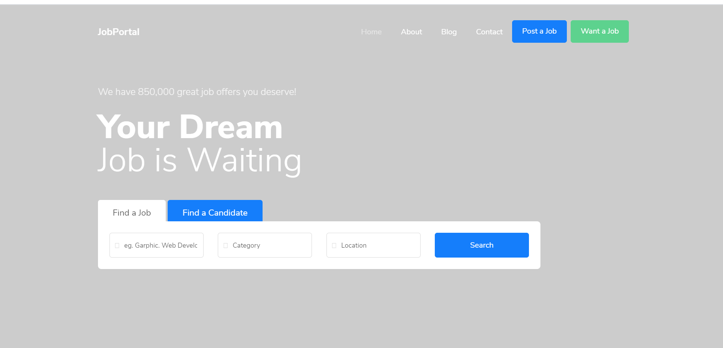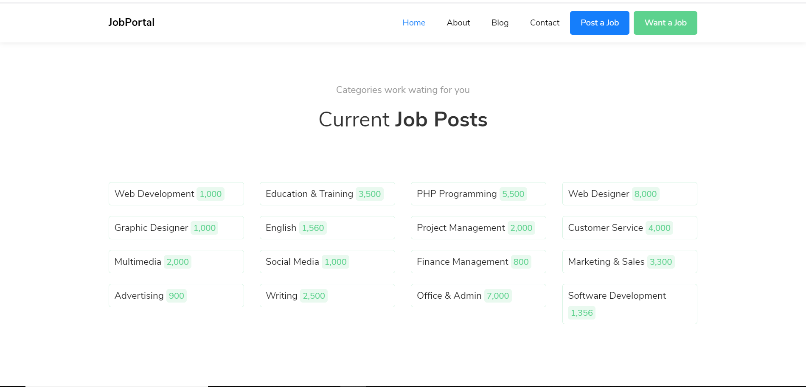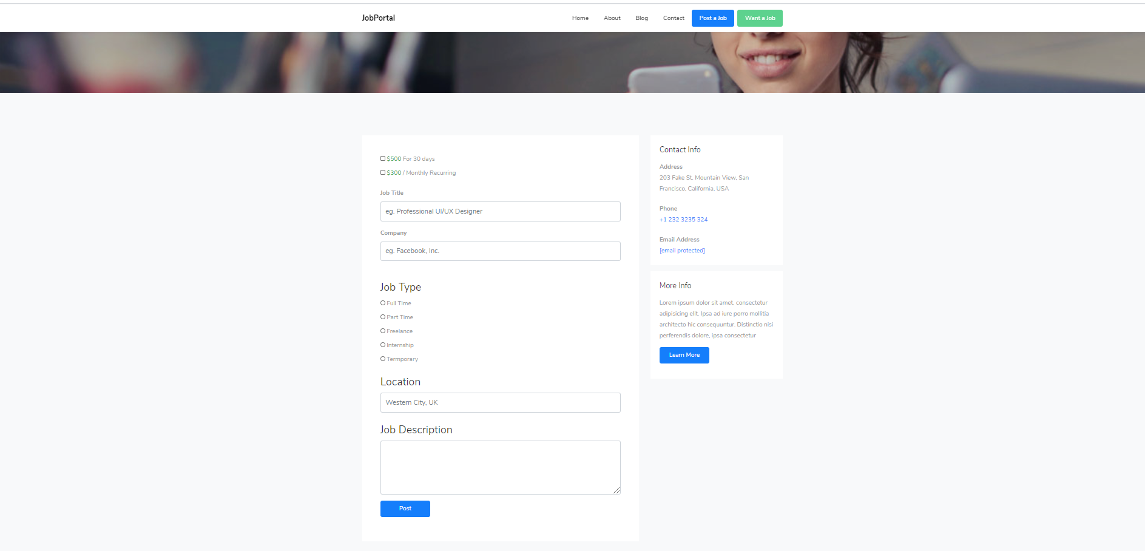

**Conclusion**

This NTCC project makes me understand on the fundamental understanding of the models that website redesign and development project.

Websites can be build by using right tools and informative technical. Standarzation is one of the crucial and important factors of using web development. It’s no matter which Brower are we using, interface of tat web page is quite similar to each other. It is mandatory to use right resource in order to make our job more interactive and contemporary. Integration of this software is useful for designing. It’s an amazing deal of my work to work in web development as it enhances my skills on the most deliberated platform which is used in our day to day life. Use of the entire internet based thing, I’m not talking about network side but saying about server side or client side as how ease and interaction of user is with machine. First of all learning with html enhances my basic skills as I’ve worked with text, border, images and link. Then comes css which also give me great idea on cascading background and helps me in designing the elements of the web pages like color, font, and layout. Same markup pages are easier to read in different style like on-screen, in print and can use voice search option to improve the interaction between user and hardware. Then I work with JavaScript which really enhances my imaginative and animate field for designing in web development. It is one of the most used client server language which is used to create dynamical content, animated image, enhance multimedia and roll down any text or image over a web page. From then I’ve come to back end mode there I come to learn about server side language. What is going on inside a server while reloading or texting that your password is wrong like that. It designs and manages the logical patterns, software or information systems and logical computation of a web page. That wraps my story on web development as my NTCC project. It’s also a great journey to be a part of it learn some essential topic used in creating web pages.

**References**

1. [www.w3schools.com](http://www.w3schools.com)
2. [www.greekforgreeks.com](http://www.greekforgreeks.com)
3. [www.studytonight.com](http://www.studytonight.com)
4. django documentation
5. www.bootstrap.com

.